Community Priorities Focus Group
Engagement Summary
March 2026



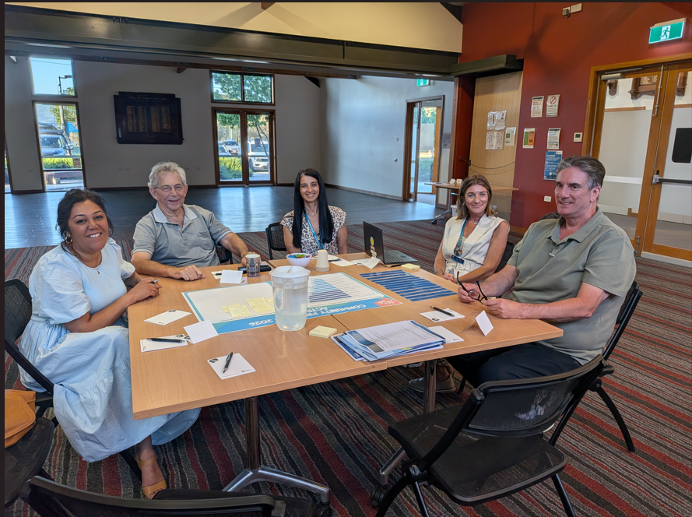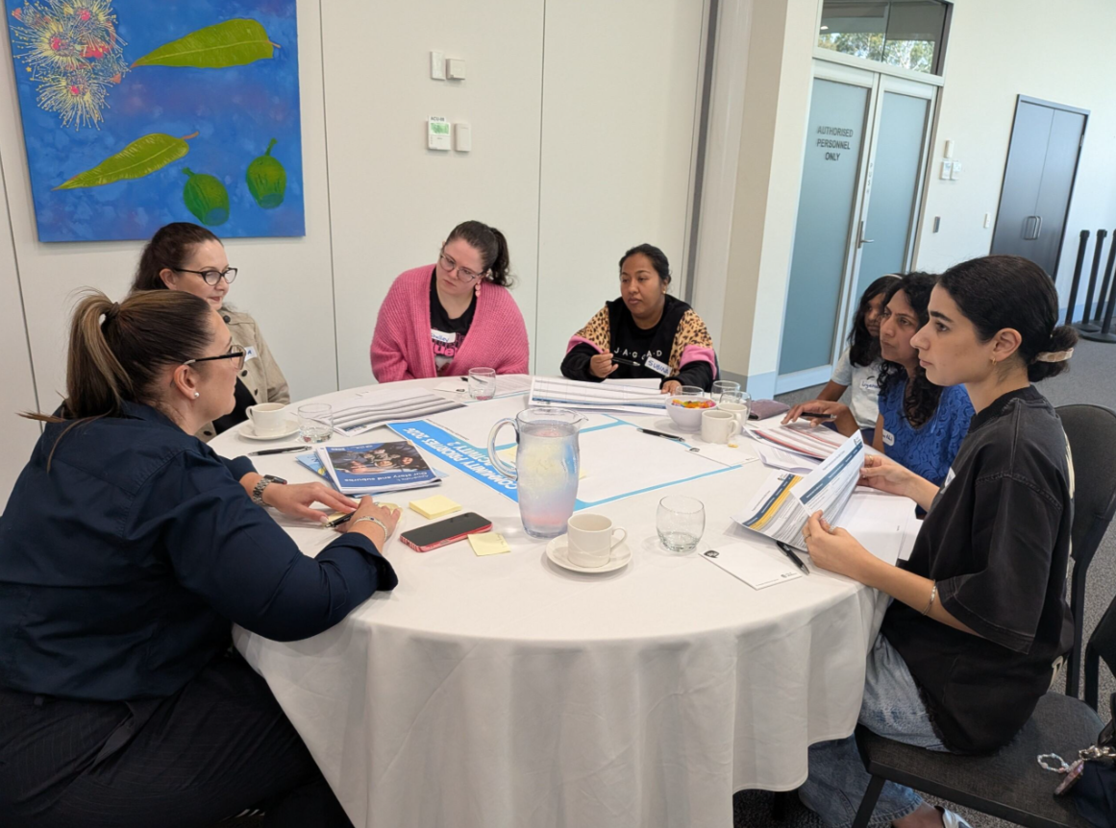

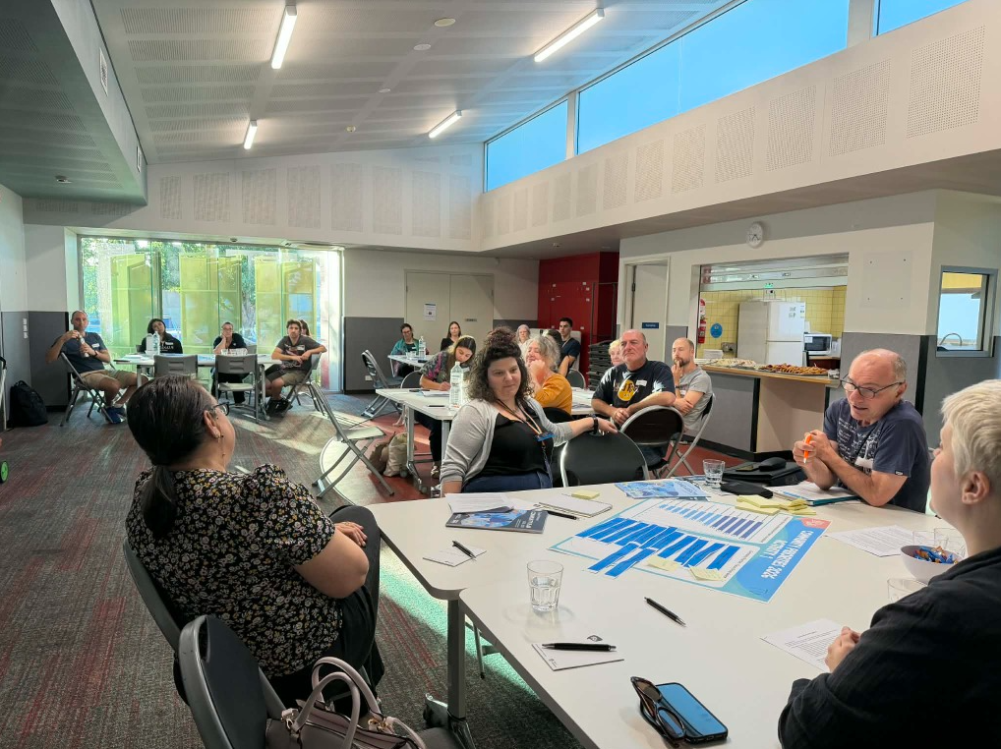

Introduction
The City of Whittlesea is currently developing the 2026-27 Budget, Community Action Plan 2026-27, and Economic Growth Strategy 2026-36.
To involve the community in shaping these key plans, community focus groups were established to provide opportunity for valuable insights to be shared that will help identify, assess, and prioritise community interests. This approach will help us to achieve balanced outcomes that are informed by the community's perspectives.
The focus groups followed two phases of community consultation in which we heard from 1,263 people who identified what matters most to them across the municipality. The information shared through these phases informed content presented to community focus group participants.
How we engaged you
For this third phase of consultation, Council held three identical community focus groups in different locations across the municipality reducing travel for participants and enabling a place-based lens to the feedback captured.
Recruitment for the focus groups took place via an Expression of Interest (EOI) from on the project page on the Engage Whittlesea platform from 1 September 2025 to 31 December 2025. The opportunity was promoted via various channels including the Engage Whittlesea platform, Councils social media channels, electronic direct mail to registered multicultural, senior and sporting clubs.
The project page on the Engage Whittlesea platform featured general information about the focus groups including the purpose of the consultation as well as a project timeline. Focus Group Terms of Reference (Appendix 1) were developed and published on the project Engage page along with a digital EOI form. Flyers and digital promotion were developed and shared with registered groups and displayed on digital screens at Council facilities (see below).
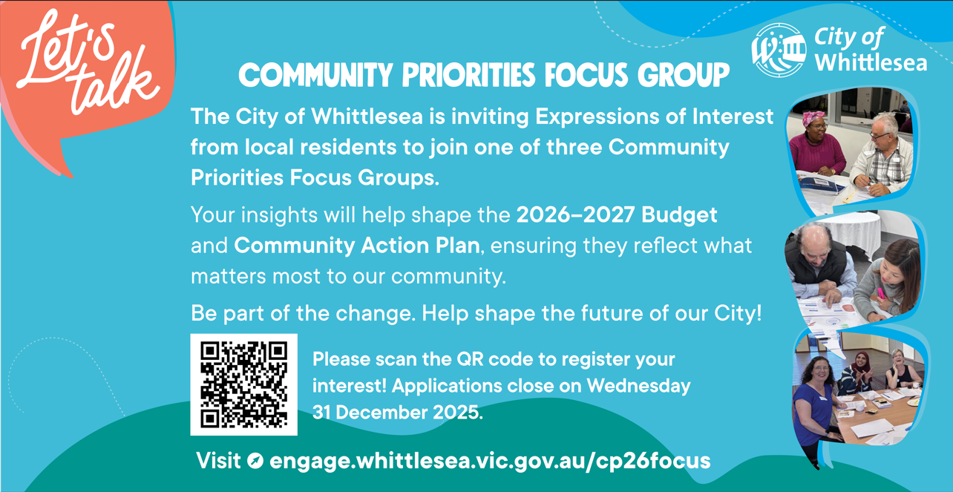

Three focus groups were held during February, as below:
- Whittlesea Community Activity Centre, Tuesday 10 February, 6.30pm to 9.00pm
- Civic Centre, South Morang, Saturday 14 February, 9.30am to 12:00pm
- Lalor Library, Thursday 19 February, 6.30pm to 9.00pm.

Confirmed participants were sent a pre-reading information pack that was anticipated to take 30 minutes to complete (refer to Appendix 2).
Format of the focus groups
Each focus group ran for three hours and included three small table group activities.
Activity 1
The first activity centred on re-prioritising the Community Priorities as determined through the first phase of community engagement. Each group was provided with a written description of each Community Priority to assist with the exercise. Working in table groups, participants were asked to discuss each priority and then agree on the order in which they should be prioritised. The list order would constitute each table groups Community Priorities.
Example of Activity 1 worksheet below
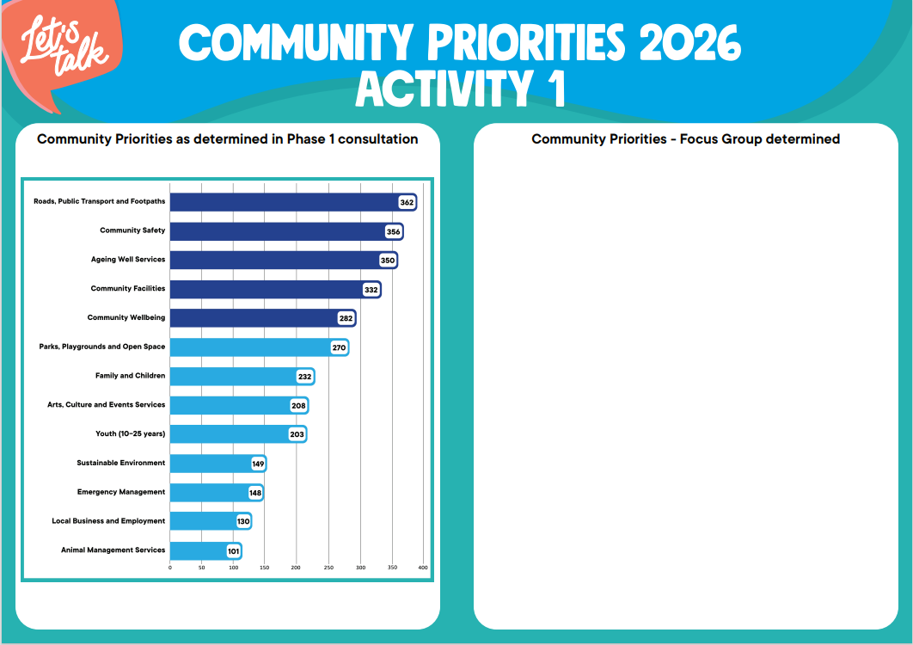

Activity 2
The second activity looked at the 2026-27 draft Community Priority Actions List. Provided as pre-reading, participants were asked to work in their table groups to identify any Action List gaps and any Action List ideas. If a gap was identified the groups were asked to identify the Action List number.
Example of Activity 2 worksheet below
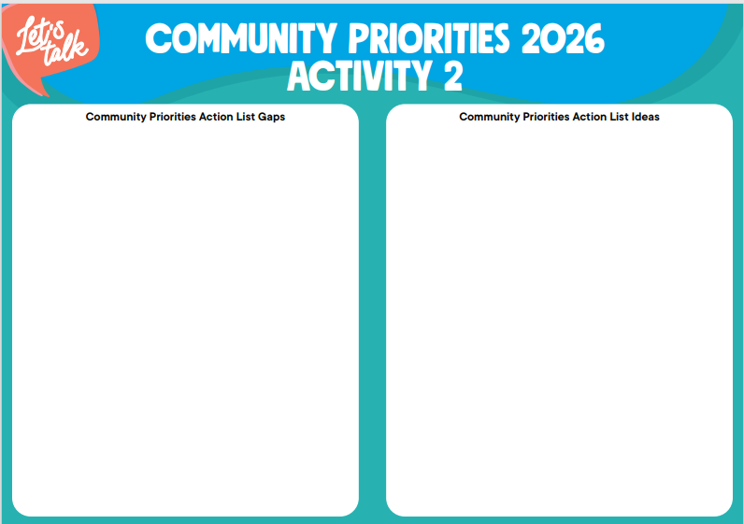

Activity 3
The third activity asked the groups how they would like to see the Community Action Plan address the health/disability matrix
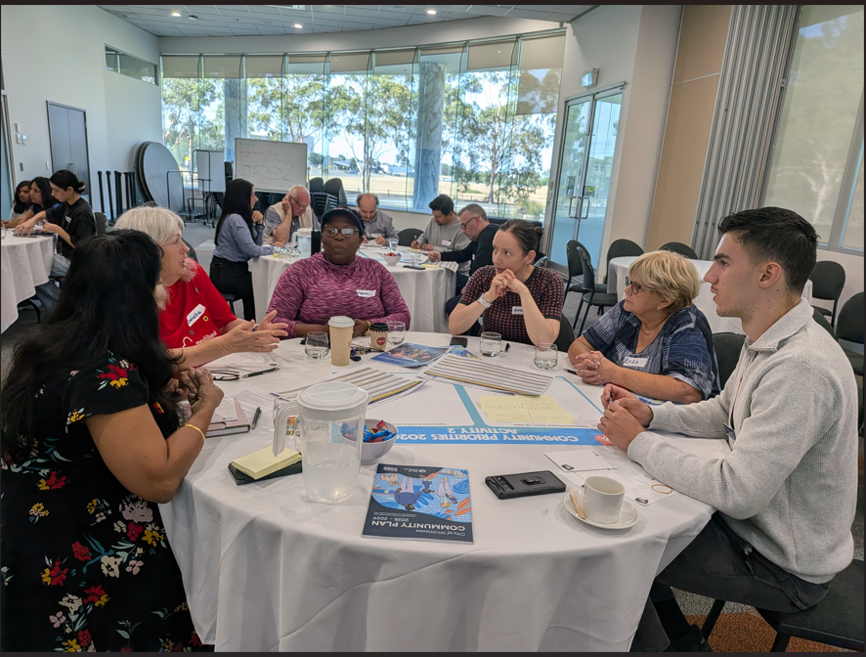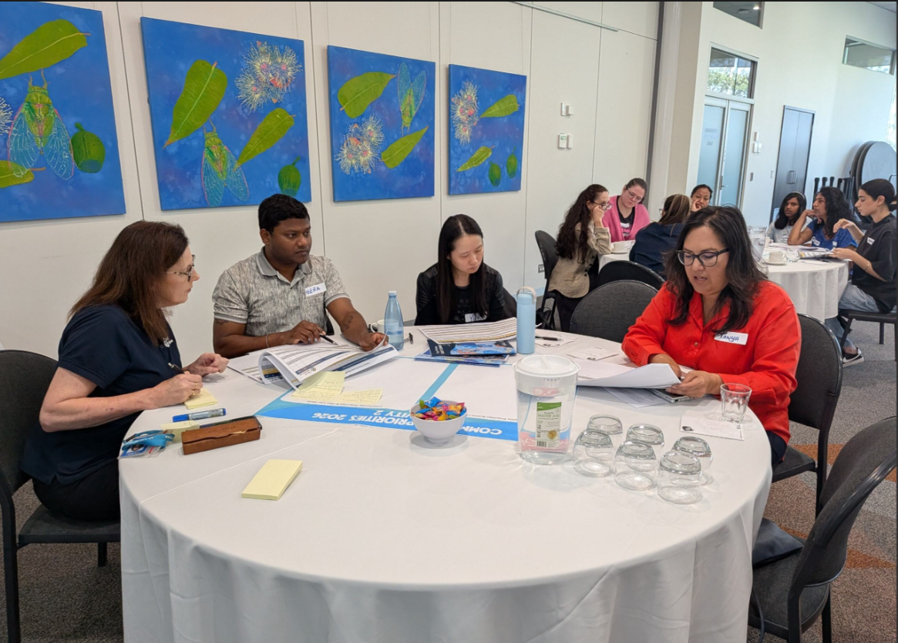
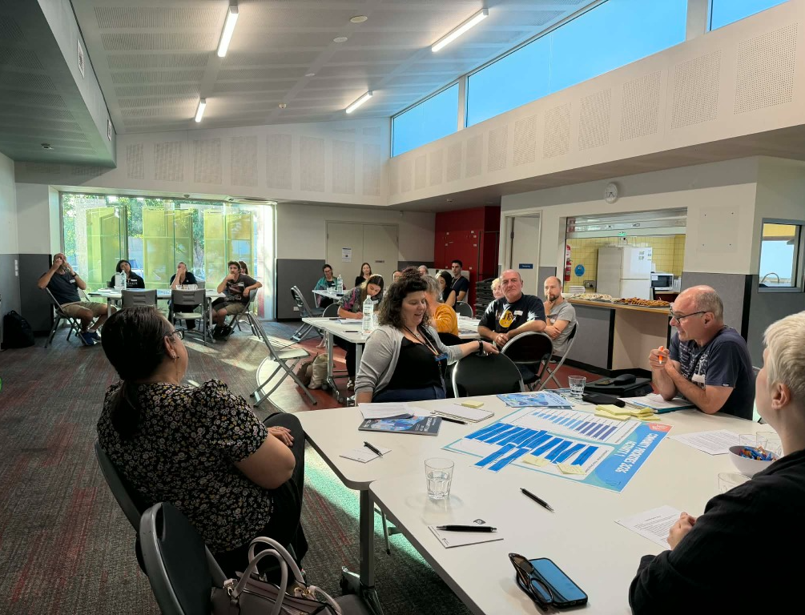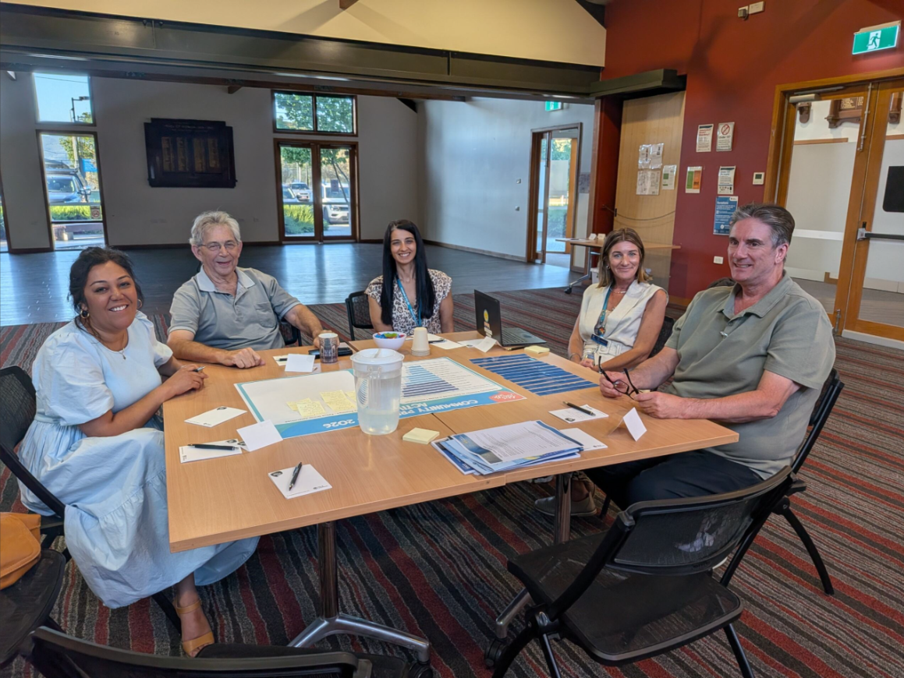
Above: Focus Groups sharing ideas

Participation
A total of 46 community members participated in the three community focus groups. The sessions with the highest number of participants were South Morang and Lalor with 17 participants followed by Whittlesea with 12 community members participating.
While there was a mix of ages and demographics, the following were some key statistics of the participation.

 |  |  | 
4% of participants were living with or caring for a person with a disability | 63% Female, 37% Male | While there was a diverse age range, the main age groups represented were 45-54 years (33%) and  35-44 years  (30%) | 28% of participants spoke a language other than English at home.
 |  | 
45% of participants described their household structure as a couple with children | 9% identified as members of the LGBTQIA+ community | Participants lived in 11 suburbs across the municipality

What we heard
Community Focus Group participants had the opportunity to discuss the three activities with the other group members and project staff. They gained a better understanding of the Community Priorities categories, the Strategic Priority actions for inclusion in the draft Community Action Plan 2026-27 and the action touchpoints with respect to the Municipal Public Health and Wellbeing Plan and Disability Action Plan, both of which form part of the larger Community Action Plan 2026-27.
Participants, working in small table groups generated 207 ideas in response to the three questions posed in the session related to priorities of the community to inform the draft Community Action Plan 2026-27.

At the completion of the focus groups participants commented that the workshop was well structured with a clear purpose and appreciated the opportunity for discussion. Council staff were seen as friendly and welcoming with participants feeling included and supported. The facilitator and project staff were clear and concise with directions, they were helpful and understanding when assisting and participants felt valued and listened to.
- 98% gained much more/ little more informed about the priorities of the community
- 89% felt much more/ little more informed about the challenges faced in developing Community Action Plan 2026-27
- 82% will definitely/are highly likely to participate in future community focus groups.
Activity 1 – Communities Priorities Discussion
The first activity focused on Community Priorities; participants were provided the list of Community Priorities as determined in through the first two phases of community engagement. In addition, service category descriptors were provided to assist groups in determining their priorities. Each table group spent 30 minutes talking through the community priorities and re-prioritising the service categories.
Table groups were asked to consider:
- if they were happy with the order as determined through the first two phases on community engagement
- if there were they any priorities that needed to be reshuffled/reordered
- reasons why they did not agree with the order captured through the first two phases of engagement
- if anything has anything been missed?
Participants on 11 tables across three community focus groups told us that the top five priorities are:
- Community Safety
- Roads, Public Transport and footpaths
- Community Wellbeing
- Youth
- Community Facilities.
Council Officers worked with table groups to capture any ideas discussed related to the priority service categories. In total There were 39 additional ideas captured across the three focus groups relating to Community Priorities. These are grouped below in the order of most popular based on similar ideas and the support for these ideas.

There were eight ideas/comments related to Emergency Management, these have been themed below:
- new residents in rural areas needing training/information about living safely in rural area
- more education around safely using fire pits
- upgrade to Mernda-Whittlesea Rail Trail for emergency services access
- encouraging more spot checks on rural properties.

There were eight ideas/comments relating to Community Safety, these have been themed below:
- the categories of Community Safety and Emergency Management are connected
- increased lighting, maintenance of landscaping
- concern that there is no police station in Wollert and others are closing/unstaffed earlier than previously
- a reduction in crime will increase wellbeing and there needs to be more done to support the community and more information of what Council is doing to create a feeling of safety.

There were four ideas/comments relating to Community Wellbeing, these have been themed below:
- community connection is important
- Council should concentrate on connecting community with services and promoting available services in the local area (whether they are Council run or independently run).
There were three ideas/comments relating to Youth, these have been themed below:
- the service categories of Safety and Youth are connected, particularly when it comes to engaging youth
- need for more local Youth trade traineeships particularly given we are in a growth corridor.
There were three ideas relating to Parks and Open Space, these have been themed below:
- the maintenance of parks and open spaces should be a priority for Council
- encouraging the designing of improved multi-use parks and gardens to encourage more activity and create a feeling of safety.
Other comments captured focussed on the environment (2), housing (2), local businesses (2), family and children (2) disability (1), ageing well and youth departments working together more, and general comments on the priority service categories featured in the Community Priorities consultation being interconnected (3).

Activity 2 – Action List aligning with Community Priorities
The second activity participants undertook focussed on the 2026-27 draft Action List. Table groups were provided a copy of the Action List and asked to identify if the community priorities captured throughout the previous phases on community engagement and presented in the first activity align with the draft Action List. Participants were asked to identify any gaps in the action items presented as well as share any new ideas/ways of improving the list.
What are the Action List gaps?
When asked to identify any gaps in the Action List, a total of 59 gaps were captured across 11 tables in the three focus groups. These were topics participants were concerned with or wanted Council to focus on, although some of the suggestions are outside of Council’s remit. These are themed below in the order of most popular based on support by participants. A more extensive list of what we captured is available in Appendix 3.
There were nine ideas relating to communication, with participants keen to ensure opportunities to join activities in their local community were broadly publicised using traditional and digital media as well as community noticeboards.
There were eight ideas relating to Sport and Recreation, with participants keen to ensure sporting opportunities are available across the municipality and that there are appropriate female change facilities at sporting locations.
There were five ideas relating to Ageing Well, with participants keen for additional support for older residents to navigate the ageing process and have easy access to information using traditional or hard copy communications as many older people may not be online.
There were five ideas relating to Community Facility opportunities including upgrades, libraries and pools.
There were five ideas relating to Community Safety, with a focus on passive surveillance as well as education around domestic violence and support for victims of violence.
There were five ideas relating to Community Wellbeing, with participants suggesting opportunities including promoting local events, community gardens and gambling harm awareness.
Other comments focussed on homelessness (4), parks and open spaces (4), roads, footpaths and parking (3), arts (2) family and children (2), local employment (2), youth (2), food safety (1), cross integration of services (1) and waste (1).

What are the Action List ideas?
When asked to share any ideas related to the Action List, a total of 52 ideas were captured across 11 tables in the three focus groups. These are themed below in the order of most popular based on support by participants. These were topics participants were concerned with or wanted Council to focus on, although some of the suggestions are outside of Council’s remit. These are themed below in the order of most popular based on support by participants. A more extensive list of what we captured is available in Appendix 3.
There were nine ideas relating to Communication ideas, with participants keen to ensure local art and cultural events were broadly publicised. Participants also suggested Council exploring hosting an expo at the Whittlesea Showgrounds that encourages sporting clubs to join Council services area to promote themselves and their offerings to the local community
There were seven ideas relating to Waste Management, with participants suggesting ways Council could combat the illegal dumping of rubbish. Participants also suggested Council introducing a recycling program for fabric and clothes as is available in some other neighbouring municipalities.
There were six ideas relating to Roads, transport and footpaths, with the suggestion of bicycle repair stations to encourage cycling and using Council’s minibus to assist residents in accessing Council run events. Participants also discussed speed limit reductions on some roads, although most roads mentioned are not managed by Council (i.e.: Childs Road).
There were five ideas relating to Community Safety, with participants encouraging Council to increase communications around what it is already doping in this space. Participants also suggested repurposing under-utilised council facilities as safe houses for immediate assistance for those in the community escaping domestic violence
There were four ideas relating to Community Wellbeing, with participants keen for additional activities to be made available on weekends at Community Centres and libraries. Some participants who are a part of the Community Christmas Choir also encouraged Council to introduce a year-round community choir for people to connect.
There were three ideas relating to Animal Management Services, with participants keen for Council to further support pet desexing through subsidies for multiple pets.
Other comments focussed on local business and employment (3), sport and recreation (3), community facilities (2), parks and open space (2) arts (1), disability (1), and Council Budget (1).

Activity 3 – Action List addressing Municipal Public Health and Wellbeing Plan and Disability Action Plan Matrix
The third and final activity participants undertook focussed on the Municipal Public Health and Wellbeing Plan and Disability Action Plan Matrix. Table groups were provided with a copy of the matrix and asked how they would like to see the action list address the health/disability matrix.
When asked to identify any ideas of how the Action List addresses the health/disability matrix, a total of 57 ideas were captured across 11 tables in the three focus groups. These are themed below in the order of most popular based on support by participants.
There were eight ideas relating to Ageing Well programs for older residents, these have been themed below:
- more partnerships/grants with community groups that check in on elderly/isolated community
- volunteerism - increase of capacity of community to support community needs
- helping with elderly to get around/participate in active living activities (i.e.: similar bus services are available in Sorrento area)
- add healthy eating as part of higher quality of life
- run minibuses to Mernda market for elderly to shop
There were six ideas relating to Road, Transport and Footpaths, these have been themed below:
- offering local bus services to participate activities and events including shows at PRACC and local markets
- need for increased maintenance of walking paths as there are accessibility challenges due to leaves and branches blocking them
- improvements to the transport network to help older people get around
- improved road connectivity - east to west to improve social connection.
There were five ideas relating to Sport and Recreation and Leisure Activities, these included
- desire for the Mernda RSP and pool to be constructed quicker
- actions to increase girls’ participation of sport is included in the Community Plan as a priority action, but group are not aware of any actions that have been undertaken
- increased car parking at sporting grounds as parents are often fined for supporting children in local sports due to parking illegally
- increased indoor sports options needed across the municipality.
There were four ideas relating to Social Connection and Programs, these have been themed below:
- better utilisation of Council facilities to host more Council initiated programs to encourage health, wellbeing and social connections
- support of the proposed Youth Hub
There were four ideas relating to Local Employment Opportunities, these have been themed below:
- partner with local businesses to support local youth employment to address the trade shortage
- more support for and increased awareness of local jobs available (i.e.: new Beveridge intermodal development)
There were seven ideas relating to the presentation of the Community Priority Action List, these have been themed below:
- all relevant strategic priorities need an associated action to describe how it is linking to the Municipal Public Health and Wellbeing Plan and Disability Action Plan and not just a tick
- bold the key words in the description, add Theme/Key words in a separate column, link the Strategic Priorities to the top priorities
- including a summary for each priority would be helpful to understand
- it is hard to make connections with projects at planning stage
- supportive of integrating the Municipal Public Health and Wellbeing Plan and Disability Action Plan in the Community Plan as there is a lot of overlap, so it makes sense.

Next steps
Feedback captured through the focus groups is being collated and will help to inform the development of several draft documents. These include the:
- The proposed 2026-27 Budget which will be available for exhibition and formal community submissions from 22 to 28 April 2026.
- The draft Community Action Plan 2026-27 will be available for viewing and community feedback from 22 April to 6 May 2026.
- Further consultation to inform the development of the Economic Growth Strategy 2026-36 will take place later this year.
Council delivers over 140 services and feedback captured can help shape these. Some suggestions may be outside the remit of Council, but we can use the ideas in our advocacy efforts or to support other authorities to deliver their services.
Thank you again to everyone who participated in the community engagement by sharing comments, feedback and participating in activities and focus groups. The community will be updated on further developments via the Community Priorities | Engage City of Whittlesea project page. We encourage you to register and follow the page to be kept updated on the project.
Appendix 1 – Focus Group Terms of Reference
City of Whittlesea Community Priorities Focus Group - Terms of Reference

1. Purpose
The purpose of the Focus to provide valuable insights to help inform the 2026-2027 Budget, the Community Action Plan 2026-2027 as well as informing other key documents that will guide Council’s essential activities over the next 5-10 years.

2. Participation
Participation in the Community Priorities Focus Group will be capped at 30 people per session and participants will be chosen to reflect the diversity of the City of Whittlesea community. This diversity will include ages, genders, abilities, cultural backgrounds, suburbs and household structures.
To be eligible to be a participant of the Community Priorities Focus Group you will need to
- Be a resident of the City of Whittlesea and aged 18 years and over
- Be willing and able to complete any pre-session reading, assistance can be organised for those requiring it
- Declare membership of any special interest group, community groups, networks such as sporting clubs, craft and hobby groups, seniors' groups, schools etc.
- Not be a current staff member, contractor or Councillor of Whittlesea Council.
If a participant believes that they may have a financial interest in any of the projects discussed during the focus groups, they must discuss that interest with the facilitator. Should the facilitator decide that the financial interest gives rise to a conflict, the participant will not be permitted to contribute to discussions regarding that project.

3. Role of the Community Priorities Focus Group
The 2026 Community Priorities Focus Group will help inform the 2026-27 Budget, the Community Action Plan 2026-2027 as well as informing other key documents that will guide Council’s essential activities over the next 5-10 years.
We will capture valuable insights from our Focus Group participants to help us identify, assess, and prioritise community interests. This approach will enable us to achieve balanced outcomes that are informed by the community's perspectives.

4. Code of Conduct
All participants are expected to abide by the City of Whittlesea Code of Conduct and:
- Operate with integrity, objectivity, accountability, honesty and openness
- Participate and provide feedback that is in the best interest of the City of Whittlesea as a whole
- Declare any potential conflict of interest (including financial) to the facilitator if it arises during the focus group sessions
- Dedicate appropriate time and effort to the focus groups – approximately 3 hours in total over the project period
- Prepare for focus groups by completing pre-reading and actively participate in all three focus group sessions
- Maintain effective and respectful relationships with other participants and facilitators.

5. Focus group sessions
Focus Group participants will be required to undertake pre-reading and attend one of three in-person focus groups and will receive a participatory gift voucher for their time. We will be holding several identical sessions across the municipality. The session dates and times will be advised as soon as confirmed but will be held between within the first two weeks of February 2026.

Agenda and session pre-reading
The agenda and any pre-reading will be provided to Focus Group members one week in advance of the session. A summary of what we heard will be provided to participants following the focus group session.

Participatory Gift
Focus Group participants will be required to complete all pre-reading and attend the in-person focus group session and will receive a participatory gift voucher for their time.

6. Requirements of participants
Confidentiality
Focus Group participants are expected to maintain confidentiality and refrain from publicly sharing any information related to the focus group materials.

Public Statements
Focus Group participants are not authorised to issue public statements on behalf of Council.

Rescinding members
The City of Whittlesea retains the right to revoke the inclusion in the focus group of any individual who violates the Terms of Reference or Code of Conduct. This includes if you are elected as a Councillor for the City of Whittlesea.

Appendix 2 – Workshop resources
Pre-reading
- Community Plan 2025-29
- Appendices: Community Action Plan
- Community Action Plan 2025-26
- Community Priorities 2026 Phase 1 Engagement Summary

Activity 1 – City of Whittlesea Key Service Categories
Ageing well (AW)
We support older residents to age well by providing services, programs and activities such as delivered meals, domestic assistance, personal care, seniors' clubs support, positive ageing programs and social connection. We help older residents to access user‐directed aged care services and facilitate partnerships for services and infrastructure.

Youth (YS)
Our Youth Services provide a range of programs, activities and events for young people
aged 10‐25 years and their families. Council also facilitates networks and advocates for inclusive social and physical infrastructure that support all young people and work closely with a range of external organisations.

Family and Children (FC)
We aim to improve health, social and educational outcomes for children and families within the City of Whittlesea. We provide high quality, evidence‐based services, programs and activities to strengthen family wellbeing, capacity and connection. Key services include maternal and child health and early years management and support.

Public health and safety (PHS)
We protect and enhance community health, safety and wellbeing by:
• educating the community about their responsibilities to contribute to public health and safety
• enforcing state and local laws
• delivering immunisation programs
• working with emergency service agencies to plan and respond to emergencies
• deliver evidence‐based projects and programs to address major health and wellbeing
issues faced by the community

Animal management (An M)
We ensure people, and their pets can live together harmoniously and safely in our
community. We reunite lost pets with their owners, facilitate pet adoptions, operate the wat djerring Animal Facility, investigate animal incidents and complaints, establish and monitor measures put in place to mitigate the risks posed by dangerous and restricted breed dogs, attend to wandering livestock, and audit animal‐related businesses to ensure welfare standards are upheld. We keep a register of cats and dogs that live in the City of Whittlesea and promote responsible pet ownership through a series of communication campaigns and events each year.

Community strengthening (CS)
We build inclusive, empowered and connected communities through the planning and
delivery of evidence‐based place‐based programs and services in partnership with relevant stakeholders.

Creative communities (CC)
Through arts and culture, we bring people together and provide great experiences, regardless of background, income, age or ability.
Our strategic approach:
• enables a creative sector that is vibrant and viable
• delivers events that showcase and celebrate our strengths and cultural diversity
• preserves and promotes our history, our living traditions and the co‐creation of cultures
• ensures that Aboriginal, historic cultural and natural heritage places, assets and features are retained, conserved and integrated into the urban design and neighbourhood character of our municipality.

Waste management (WM)
We provide sustainable solutions for the collection, disposal and recovery of waste
materials generated within the community and through our own operations. We develop strategic policy, education programs and operational maintenance activities to avoid, minimise and recover waste and keep our city clean, healthy and safe. We undertake compliance and enforcement for illegal waste dumping in our municipality. We support and empower the community transition to a circular economy.

Local business support (LB)
We support our businesses by guiding and making it easy for them to engage with Council, promoting funding and employment opportunities, facilitating networking with complementary businesses, promoting business initiatives to increase customer base, coordinating special rate schemes, supporting trader associations, and case managing
issues and planning applications.

Biodiversity, land management, sustainable planning and design (Bio)
Through our role as a statutory authority, we play a crucial role in delivering an environmentally sustainable city. We facilitate sustainable land management and biodiversity conservation on public and private land across urban and rural areas. We educate and empower the community to undertake biodiversity conservation activities and sustainable land management.

Appendix 3 – Action list activity
What are the Action List gaps?
When asked to identify any gaps in the Action List, a total of 59 gaps were captured across 11 tables in the three focus groups. These are themed below in the order of most popular based on similar gaps and the support for these gaps by participants.

There were nine ideas relating to communication gaps, these have been themed below:
- installation of information board on construction sites
- increased promotion of activities taking place on Council’s social media channels
- feeling that Local Scoop is not regular enough as many activities are not promoted through this
- introduction of more notice boards at libraries to share Council activities, programs and services
- Community Priority Action List needs to have clear initiatives that are measurable.
There were eight ideas relating to Sport and Recreation gaps, these have been themed below:
- concern around the timing of Mernda RSP pool development
- belief that having separate female changerooms at all sporting facilities to improve female participation in sport
- improving female bathroom facilities at sporting venues as some facilities have repurposed male bathrooms to be used by females but still feature a urinal which isn’t appropriate.
- Thomastown is lacking indoor sporting facilities.
There were five ideas relating to Ageing Well gaps, these have been themed below:
- support for community members to navigate the ageing process
- need for the changing of batteries on smoke alarms to be offered to aged services clients
- concern that information isn’t easily shared with older residents as they are not online and rely on hard copies. This has become more of an issue since the local newspapers went online.
There were five ideas relating to Community Facility gaps, these have been themed below:
- need for a leisure centre (pool) and full-sized library for the Mernda and Doreen area
- need to ensure that facilities in older/established areas are replaced/upgraded rather than just focussing on newer areas
- need to improve library offerings across the municipality.
There were five ideas relating to Community Safety gaps, these have been themed below:
- increase in passive surveillance is required across the municipality
- encourage Council to rollout to the wider community (and not just sporting clubs) the education programs on violence being delivered as part of the new Fair Access Policy
- there should be education and support for victims of violence available.
There were five ideas relating to Community Wellbeing gaps, these have been themed below:
- need for more promotion of events available at all of the Community Centres
- introduce community gardens and teach people to garden – this will improve community wellbeing
- more gambling education as this is still an issue within the local community.

Other comments focussed on homelessness (4), parks and open spaces (4), roads, footpaths and parking (3), arts (2) family and children (2), local employment (2), youth (2), food safety (1), cross integration of services (1) and waste (1).

What are the Action List ideas?
When asked to share any ideas related to the Action List, a total of 52 ideas were captured across 11 tables in the three focus groups. These are themed below in the order of most popular based on similar gaps and the support for these gaps by participants.

There were nine ideas relating to Communication ideas, these have been themed below:
- Action Plan to provide more detail
- desire for more communication about what’s on at PRACC, Youth Services programs and local art exhibitions
- suggestion to host an expo at the Whittlesea Showgrounds that encourages sporting clubs to join Council services area to promote themselves and their offerings to the local community
- Action Plan needs to align to the Council Budget.
There were seven ideas relating to Waste Management, these have been themed below:
- introduce a recycling program for fabric and clothes as is available in some other neighbouring municipalities
- consider placing large bins in areas where rubbish is dumped regularly to combat the issue of dumped rubbish
- introduce a Neighbourhood Watch/ style program that focusses on reducing illegal dumping with community members taking on the role of Waste Champion in their local area.
There were six ideas relating to Roads, transport and footpaths, these have been themed below:
- introduce bicycle repair stations across the municipality to encourage bike travel
- utilise a Council minibus to assist older resident and youth to get to Council run events
- consider reducing the speed limit on some roads (i.e.: reduce Childs Road to 50kph (not a Council managed road)).
There were five ideas relating to Community Safety, these have been themed below:
- under-utilised council facilities to be used as safe houses for immediate assistance for those in the community escaping domestic violence
- increased communication about what Council is doing to increase community safety.
There were four ideas relating to Community Wellbeing, these have been themed below:
- increase the number of activities available on weekends at Community Centres and other Council facilities and libraries
- introduce a community choir for people to connect all year round and not just at Christmas time.
There were three ideas relating to Animal Management Services, these have been themed below:
- supporting the community to have pets desexed through subsidies for multiple pets.
Other comments focussed on local business and employment (3), sport and recreation (3), community facilities (2), parks and open space (2) arts (1), disability (1), and Council Budget (1).

