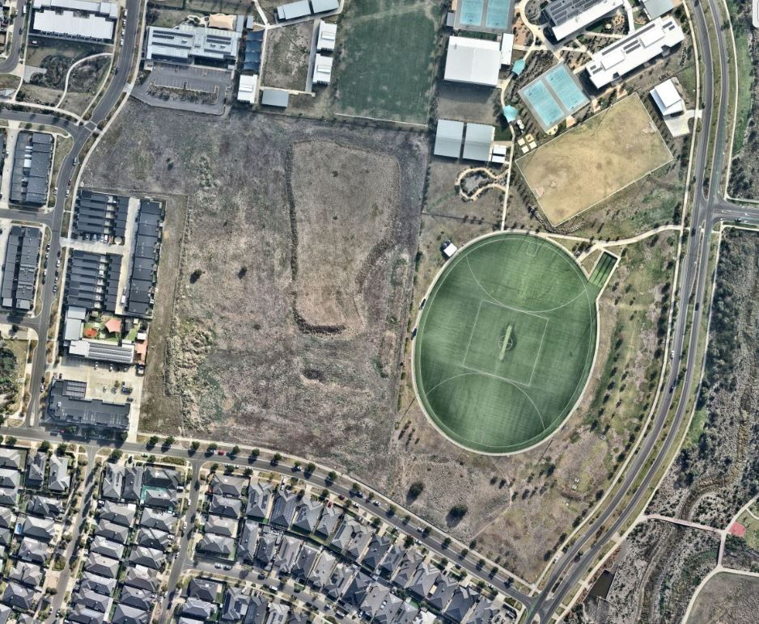

Engagement Summary
11 August 2025 – 29 August 2025
EDGARS CREEK RECREATION RESERVE

Introduction
The City of Whittlesea has undertaken community engagement to inform and consult with residents on the transformation of Edgars Creek Recreation Reserve in Wollert into a welcoming and accessible space where people can play organised and informal sport, relax and socialise. The redevelopment of Edgars Creek Recreation Reserve represents an important investment in the community’s health, wellbeing and future.

The proposed upgrades will enhance community infrastructure and provide greater opportunities for organised sport, informal recreation and social connection. Key elements of the endorsed business case include:

A second competition-compliant AFL/cricket oval

Four netball courts, including two dedicated courts and two multi-lined courts for multi-sport use

A multipurpose sports pavilion available for community hire

New sports lighting, walking paths and a fitness station

New roundabouts on Steen Avenue and Macedon Parade to improve traffic flow and safety

An extension of the car park at Ganbu Gulinj Community Centre

These improvements will support increased participation in sport and recreation, while creating a more accessible, functional and vibrant community space for residents of Wollert and the surrounding areas.

Council sought feedback from people who live near or visit Edgars Creek Recreation Reserve to gauge support for the proposed concept plan and understand user needs when prioritising features. The engagement focused on gathering community input on key recommendations for the play space, sports court and fitness equipment. Insights gathered will inform any final design adjustments before works commence. A key objective was to ensure consultation opportunities were accessible and inclusive, enabling community members to easily share their feedback.
How we engaged you
The Edgars Creek Recreation Reserve consultation was open for community comment from 11 August to 29 August 2025. Feedback was gathered online through Council’s Engage Whittlesea platform.

The Engage Whittlesea platform utilises an accessibility add-on ensuring that it is as accessible as possible for all users. The platform also has an in-built translation tool to mitigate any language barriers to participation, allowing the page to be translated into the top fifteen languages spoken within the municipality.

Project promotion
The opportunity to participate in the community engagement was promoted through:
- A dedicated project page on Council’s digital engagement platform Engage Whittlesea
- Five A2 signs with QR code to participate in the project at various locations around Edgars Creek Recreation Reserve
- Social media posts on Council’s social media channels

Participation
A snapshot of the community contributions received as part of the Edgars Creek Recreation Reserve engagement:
Survey Contributions:

33 people participated
online via the Engage Whittlesea platform.

Snapshot of participant demographics
Gender Identity | Age | Suburb
 |  | 
68% Male, 29% Female and 3% preferred not to say. | All age brackets participated with the top three represented being 35-44 years (35%), 45-54 years (26%) and 25-34 years (15%). | As expected, Wollert was highly represented (79%), with other minor contributions from Mernda and Epping (9% each), and Bundoora (3%).

LGBTIQA+ Community | First Nations Community | Multicultural Community | Community members living with or caring for someone with a disability
 |  |  | 
3% of participants identified as members of the LGBTIQA+ community. | 3% of participants identified as being an Aboriginal or Torres Strait Islander person. | 44% of participants spoke English as a second language. | 9% of participants identified as living with a disability or an unpaid carer of an older person or someone living with a disability.

What we heard
Below is a summary of what we heard from the community through online engagement.

Participants were invited to share additional comments as part of the survey. The feedback received has been grouped into key themes, with selected quotes and graphs included below to illustrate common views and experiences captured.
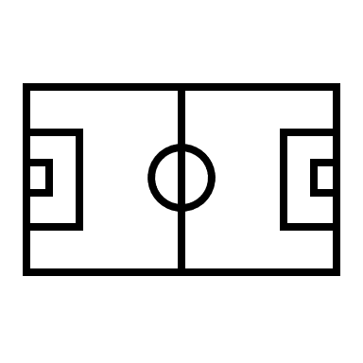 | Do you use the current sporting facilities at Edgars Creek Recreation Reserve (oval on school ground)?  Responses indicate a split in usage of the existing sporting facilities at Edgars Creek Recreation Reserve, with 59% of respondents reporting use and 41% indicating they do not use the reserve.
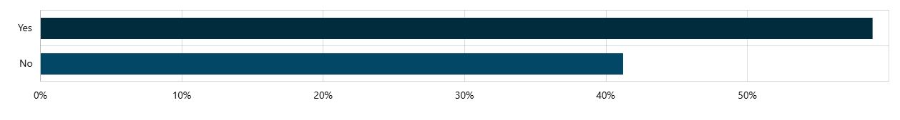

 | Do you currently participate in any of the following sport activities WITHIN the City of Whittlesea? (Multi-choice)  Cricket was the most commonly selected sporting activity (32%), followed by AFL (24%) and netball (12%). A substantial proportion of respondents either did not participate in sporting activities (44%) or travelled outside the municipality to participate (15%).
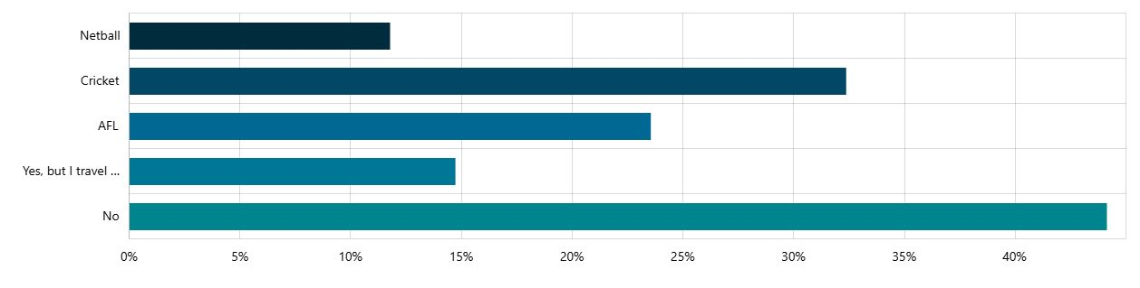

 | What is the main reason you don't participate in these sport activities within the City of Whittlesea? (Multi-choice)  Many respondents indicated that they do not participate in formal sport (30%) or instead participate in other sporting codes (25%). Limited access to local sporting facilities (25%) and specialised facilities (10%) were also identified as barriers to participation. A significant proportion of respondents selected ‘other’ (45%), with a selection of open-ended responses provided below:  “My children are currently too young to play such sports, but this is something I have been hoping would happen in Wollert for when they are old enough to participate. THRILLED to see some multi-purpose courts being constructed.”  “We need an Aquatic centre in Wollert as there is plenty of council land available to do so, in the whole region of Epping/Wollert/Donnybrook and surrounding areas there is not one aquatic centre which is greatly needed.”  “I play cricket and blind cricket in sport for disability.”
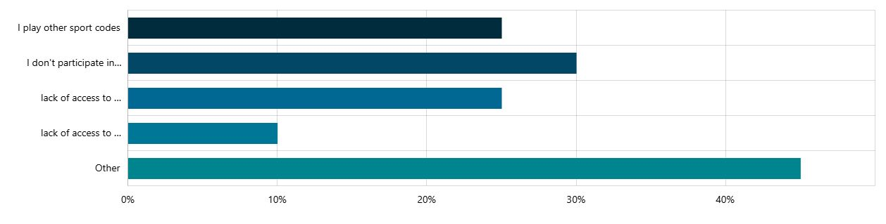

 | Do you use the Ganbu Gulinj Community Centre?  When asked whether they used the Ganbu Gulinj Community Centre, 88% of respondents reported using the facility, compared to 12% who reported non-use.
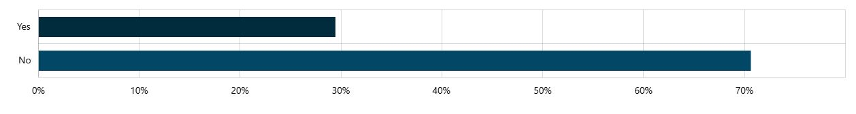

 | Are you happy with the proposed concept design for the reserve?  When asked whether they are happy with the proposed concept design for the reserve, 88% of respondents selected yes, while 12% indicated no.  The question was followed by open text for feedback and the sentiment has been themed into the following categories with selected verbatim comments following:  Need for greater clarity and detail  Several respondents sought more information about the project, including the delivery timeline, how different facilities (e.g. AFL and netball) will be integrated, and whether there will be access to the school oval.  Requests for additional and diverse facilities  There was strong interest in expanding the range of facilities, including:  - Walking and cycling tracks  - Playground infrastructure, particularly all-abilities and water play features  - Indoor or all-weather multipurpose spaces  - Futsal and additional turf cricket wickets  Design, layout and functionality considerations  Feedback highlighted the importance of practical and user-friendly design, including:  - Better integration between social spaces and changerooms  - Inclusive and flexible changeroom facilities  - Adequate seating for show courts  - Connectivity within the reserve (e.g. entry points, links between facilities)  - Modern and contemporary design outcomes  Traffic, parking and safety concerns  Concerns were raised about increased traffic and congestion, particularly along Macedon Parade, as well as:  - Unsafe parking behaviours  - Need for traffic calming measures (e.g. speed bumps)  - Impacts during peak school times  Amenity and neighbourhood impacts  Some respondents noted potential impacts on nearby residents, including noise from nighttime training and inappropriate behaviour, as well as concerns about misuse of the space.  Support for community and sporting opportunities  Overall, there was positive sentiment about the development, particularly the opportunity to enhance local sporting participation and provide multipurpose community spaces.  “We should have more walking and cycling tracks, currently there is nothing on this side of Edgar road."  “I would love for the playground to be all-abilities accessible and for it to include water play. Please consider including unique play equipment, such as a flying fox (eg. as exists at the Barry Road Playground), climbing walls, metal standing chimes, BBQ areas, mesh tunnels, fancy slides etc.."  “Yes, all the parking space facing Macedon parade will create congestion on this road, which is already very busy during school hours and create alot of noise traffic around this residential area.”  “If lights are to be placed for the oval, will they be timer controlled for nighttime.”  “Would there be access to the school oval or is that considered a separate oval, as clubs grow the need for more access grows and grows and will goal netting be in place at both ends of the ground?”
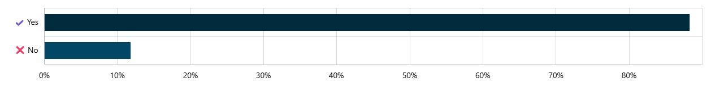

 | What kind of sports line configurations would you like to see on the multi-use courts?  When asked about sports line configurations, there was a strong preference for tennis, basketball and netball line markings. Futsal, four square and shuffleboard received fewer responses, indicating lower overall preference for these options.
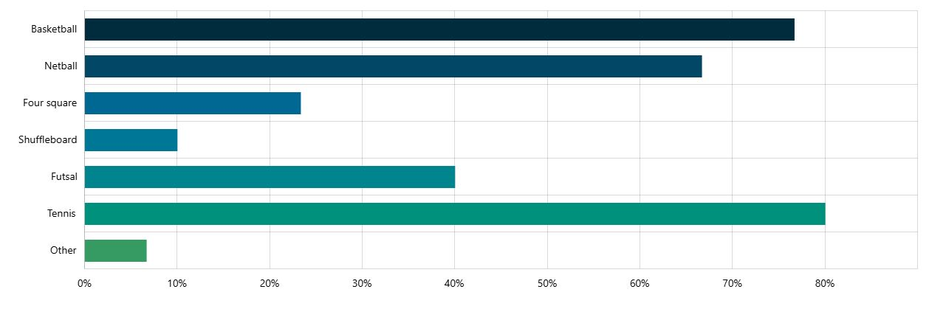

 | What kind of equipment would you like to see in the fitness circuit?  When asked about equipment for the fitness circuit, all options received strong support. The most preferred items were cardio equipment, strength equipment, parkour elements and hanging elements. Climbing and balancing elements received comparatively lower levels of support, although the difference was not significant.
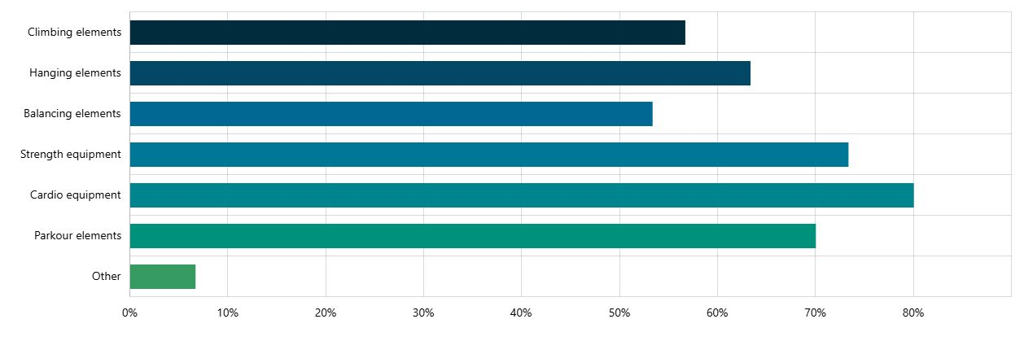

 | Do you have any further comments about the concept design that you would like to share with Council?  Key Themes from additional community feedback:  Connectivity and active transport  There was strong interest in improving access to the reserve through:  - Dedicated bicycle paths connecting to the broader network  - Wider footpaths and bike lanes  - Improved pedestrian and cyclist safety, particularly for school children  Traffic, access and safety concerns  Respondents raised ongoing concerns about traffic and movement in the area, including:  - Congestion around schools and key roads  - The need for safer intersections (e.g. Edgars Road / Steen Avenue)  - Better utilisation and communication of car parking  - General safety within and around the reserve  Desire for additional and diverse facilities  Feedback highlighted demand for a broader mix of facilities, including:  - Playground spaces for young children  - Soccer pitch and turf cricket wickets  - Aquatic/leisure facilities (noting a perceived gap in the region)  - Community infrastructure such as a small library  Support for project and community benefits  There was strong overall support for the project, with recognition that it will:  - Support local sporting clubs and participation  - Benefit a growing population  - Create opportunities for a wide range of sports and activities  Design, amenity and aesthetics  Respondents expressed interest in:  - High-quality, modern and visually appealing design  - Increased landscaping, greenery and tree planting  - Lighting to improve usability during darker months  - Further detail on design outcomes  “On behalf of the NFNL, we strongly encourage this project to progress, as it will not only support our growing clubs within the Whittlesea LGA but also drive increased participation in both Netball and AFL across Wollert and the surrounding suburbs.”  “Would like to have lighting (solar or otherwise) to increase availability in the darker months.”  “Increase safety for school kids walking to Edgar’s creek primary. And maybe wider footpaths or bike lanes as there a lot of kids using electric scooters or biking on the footpath."  “Would be nice if there was a plan to hook this up to a dedicated bicycle path for those that want to ride to this area.”  “I think now it is okay, but I am curious to see more of an artistic design of the building and oval.”

Next Steps
Thank you to everyone who participated in the community engagement by sharing comments and feedback.
The project has now moved into the detailed design phase. Feedback received will help shape updates to the Edgars Creek Recreation Reserve concept plan.
Once complete, the final design will be made available for public viewing.
We encourage you to follow the project Engage page to stay up to date with the progress of this project.
Community feedback may also inform other Council plans, strategies, and projects, contributing to the vision of making the City of Whittlesea A Place for All.

