Whittlesea Public Gardens Dog Off Leash – Refurbished Dog Park
Engagement Summary
August 2024

Introduction
The City of Whittlesea is refurbishing the dog off leash area at Whittlesea Public Gardens in Lalor for the many dog owners in our vibrant and growing community.
Council consulted with people who live, work or visit the project area to gather support for the proposed concept plan and understand the needs of our residents and their pets with prioritising features offered in the concept.
A total of 154 people participated in the consultation by completing a survey on the Engage Whittlesea platform or visiting the on-site community-based pop-up, with 84% indicating satisfaction with the concept plan (selecting I like it a lot or I like it). Almost 90% of participants indicated that the upgrade would encourage them to use the off leash area, while a further 8% indicated they do not currently own a dog. The feedback gathered through the engagement will be used to make any adjustments as needed prior to finalising the design and works beginning.

How we engaged you
The Whittlesea Public Gardens Dog Off Leash park consultation was open for community comment from 15 July to 12 August 2024. Community feedback was sought online through Council’s Engage Whittlesea platform and through direct conversation onsite at Whittlesea Public Gardens. The Engage Whittlesea platform utilises an accessibility add-on ensuring that it is as accessible as possible for all users. The platform also has an in-built translation tool to mitigate any language barriers to participation, allowing the page to be translated into the top ten languages spoken within the municipality.
Engage page
On the project’s Engage page, participants were provided with the draft concept plan, a list of project negotiables and non-negotiables and were invited to participate in a survey. The survey asked residents what they thought about the draft concept plan and what their top three features of the concept plan were. The survey will assist the project team to identify the main features the community would like to see in the park.

Community-based pop-up
The project team hosted a community-based pop-up onsite at Whittlesea Public Gardens on 10 August 2024, scheduled to coincide with Park Run. Hosting the pop-up onsite enabled the project team to speak with participants in Park Run as well as current users of the park The in-person consultation activity mirrored the information being sought through the digital consultation survey activity, with participants provided with four sticky dots. One dot was used to indicate their level of satisfaction with the design and the other three to indicate the main features they’d like to see included. There was also opportunity for them to add additional suggestions and talk through any concerns they around the proposed design with the project team.
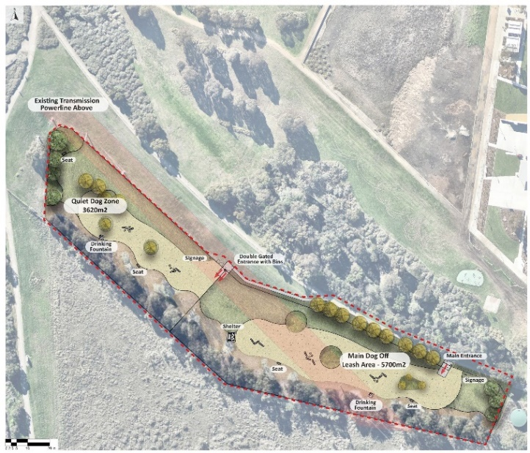
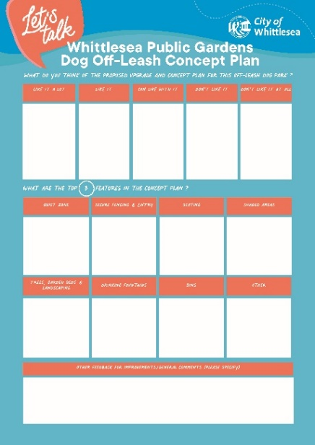

Above: Activity board and concept plan used at the Whittlesea Public Gardens community-based pop-up

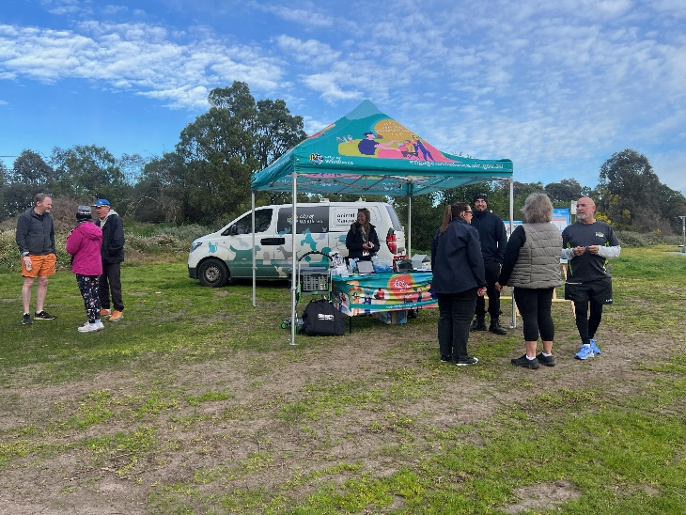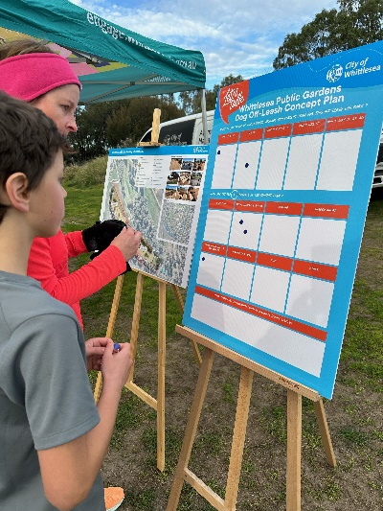
Above: Whittlesea Public Gardens DOLA pop-up on 10 August 2024
Project Promotion
The opportunity to participate in the community engagement was promoted through a range of channels to have a widespread reach across the project area including:
- Council’s digital engagement platform Engage Whittlesea
- Social media – we shared 6 posts across Council’s social media channels (Facebook, LinkedIn, and Instagram)
- Direct email to key stakeholder groups
- Direct mail out to registered dog owners in Lalor and Thomastown
- Flyers and posters displayed at local pet store and vets.

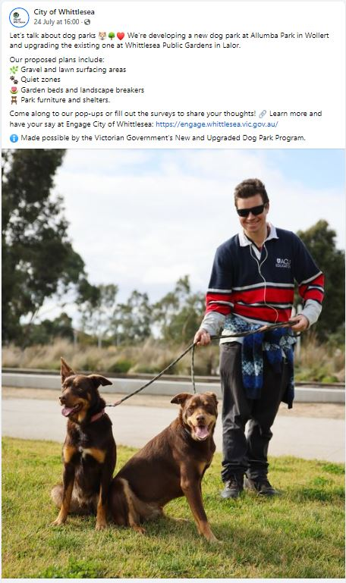
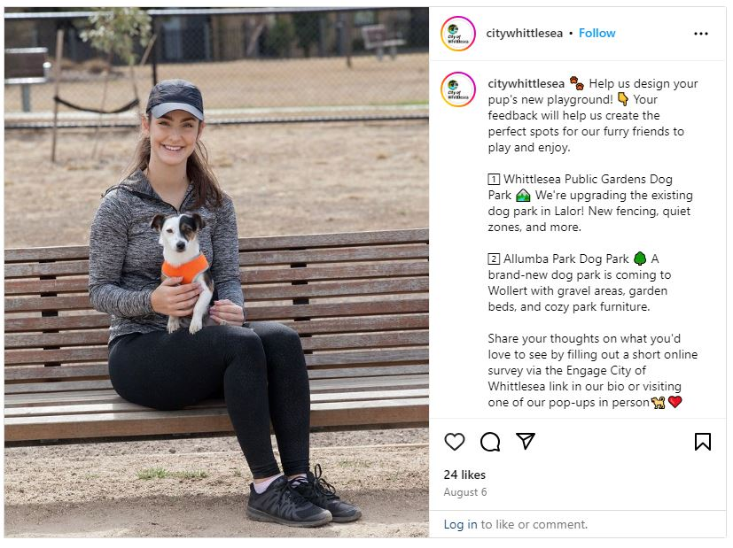

Above: Whittlesea Public Gardens DOLA social posts

Participation
Participants could contribute to the engagement in two ways, in person at the Whittlesea Public Gardens pop-up with the priority dot board activity, or via the Engage Whittlesea platform. Community members were also invited to give their feedback via phone or email if they were unable to attend a pop-up session or contribute online. Results from the survey and in-person conversations will help Council understand the priorities of dog owners and park users in our community.
Community participation
 | Organic posts reached 15,973 people and were engaged with 1,066 times which generated 15% of traffic to the online Engage page. The Engage campaign received 193 direct views from our community generating 67% of contributions.
 | We hosted an onsite community-based pop-up at Whittlesea Public Gardens with 29 people participating in our engagement activity.
 | A total of 125 participants completed the online survey (activity mirrored in the in-person community pop ups).
 | 49% of participants indicated they currently use the existing off leash dog area at Whittlesea Public Gardens.

What we heard
In total, 154 people participated in the consultation, 125 by completing a survey on the Engage Whittlesea platform and 29 by visiting the on-site community-based pop-up. Feedback captured was similar from both the online and in-person consultation, with a combined 84% indicating satisfaction with the concept plan (selecting I like it a lot or I like it). The feedback gathered through the engagement will be used to make any adjustments as needed prior to finalising the design and works beginning.
When asked their thoughts of the concept plan for the upgrade to the off leash area at Whittlesea Public Gardens 84% were supportive (selecting either I like it or I like it a lot). Refer to graph below for full figures.

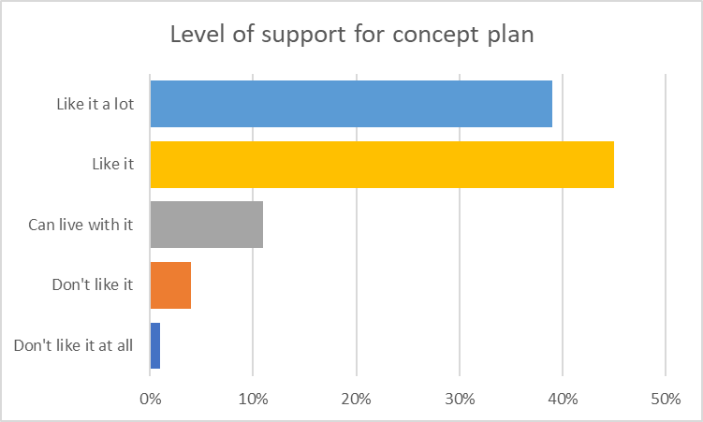

Participants were asked if they currently use the dog off leash area at Whittlesea Public Gardens, with 49% selecting yes and almost 10% advising they do not currently own a dog. The remaining 41% indicated that they do not currently utilise the off leash dog area.

Participants who indicated they do not currently use the off-leash area were asked if the upgrade would encourage them to use it. In total, 86% of respondents indicated that the upgrade would encourage them to use the area.
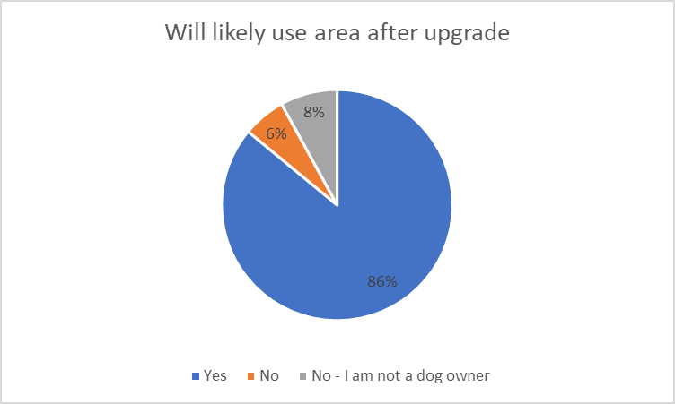

Participants were asked to select the top three features they wanted to see in the design. Secure fencing and entry was ranked as the highest priorty, followed by shaded areas (shelters) and quiet zones rounding out the top three priorities of participants. The graph below shows full data captured.
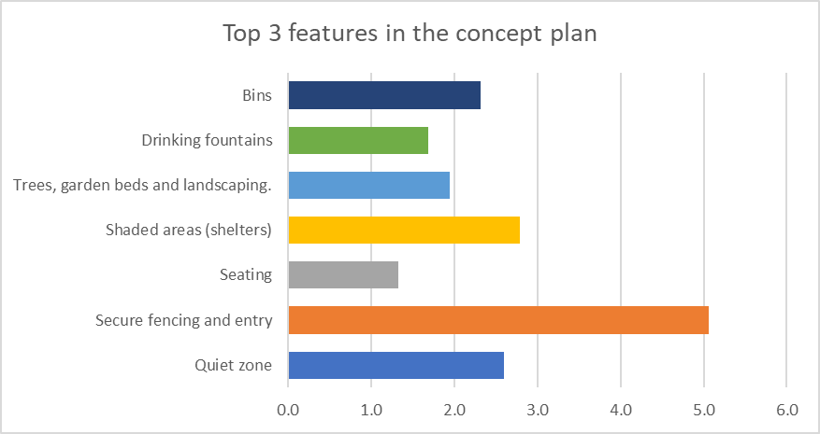

Participants of the consultation had the opportunity to provide additional comments on how the proposal could be improved as well as any other general comments. A total of 103 participants took up the opportunity to comment on how the proposal could be improved, and 63 participants added additional general comments, the main themes of what was raised through these two online questions are below along with an accompanying technical response to provide context.

 | Infrastructure and maintenance  - Lighting - requests for improved lighting to make the park usable in early mornings and evenings, especially during winter.  - Drainage – concern around poor drainage leading to flooding and mud, which means the park is currently seen as unusable during wet seasons.  - Fencing - requests for higher, secure fencing to prevent dogs from escaping and to protect small dogs. Participants also indicated that fencing should keep out wildlife like kangaroos.  - Pathways and surfaces - desire for flat surfaces without potholes, and a preference for grass over gravel, which is harsh on dogs' paws and problematic in different weather conditions.  - Maintenance - emphasis on regular maintenance, including filling holes, mowing grass, emptying bins, and removing grass seeds that harm dogs.  - Bins and waste management – participants requested additional bins with attached dog waste bags to encourage clean-up, and ensuring bins are regularly emptied.  - Shelter – request for additional shelter to be installed.  “Wish there were brighter lights and cameras to ensure safety”.  “Too much gravel. Needs to be more grass, gravel is too harsh on dogs pads and hard if they fall. Plus hotter in summer muddier in winter”.  “It’s a great to see upgrades can you also have split the dog park area small dogs park and large dogs so they have a separate area with some cover of shade”.  “Off lead dog areas need high fencing, like a tennis court. Dogs can easily jump low fencing and that makes it stressful for everyone”.  “I love that you have included new fences as these are currently lacking”.  “Keep it maintained please. Too many grass seeds get stuck to my dogs. Need vet attention”.  “Bins at both ends of the park”.  “Aware of budget issues - but not having shelter in the quiet dog zone will make me not use it. My dogs cannot be in the normal dog zone. So it’s pointless going to this dog park if there is no shelter from the sun or rain”.  Technical response:  Due to budget constraints, lighting is not included in this project scope. Currently, no dog parks in the City of Whittlesea is equipped with lighting. A trial will be conducted at Allumba dog park before considering lighting for other parks.  The design will address drainage issues through methods such as regarding the area and constructing a swale to divert water away from the dog park.  To ensure the dog park remains well-maintained with surfaces that are free of holes and free-drained, an alternative to lawn will be used. After considering the potential impact of granitic gravel on dogs' paws, the Council has selected a softer material to improve comfort.  Three bins which will be emptied regularly will be installed throughout the dog park. Dog waste bags will not be provided, as it is the responsibility of dog owners to carry their own bags when taking their dogs out in public.
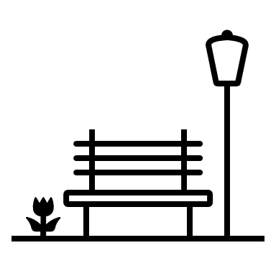 | Park design and features  - Zoning for different dogs:  - Quiet zones - support for a quiet dog zone, though suggestions include making it smaller to allow more space for active dogs.  - Separate areas for small and large dogs – there was a clear preference for separate areas to ensure safety and comfort for both small and large dogs.  - Agility equipment - many current users appreciate existing agility equipment and request more variety and maintenance of such features.  - Shade and shelter – suggestion for more shaded areas, both natural and constructed, to protect from sun and rain.  - Water features - requests for water areas like shallow pools for dogs to cool off in hot weather.  - Additional amenities – suggestions included bike racks, picnic areas, and more accessible seating and sheltered spots.  “A separate fenced area within the dog park for smaller dogs. There are lots of big, intimidating, aggressive dogs in this area so having a separate area for smaller dogs would be beneficial”.  “Considering that there are dog breeds of different sizes and personalities, it is recommended to divide such a large area into three small areas, so that more dogs can enter conveniently without interfering with each other”.  “Thank you for considering a “quiet dog zone” with a separate gate. This will give dog owners more capacity to utilise the area based on their pets’ individual temperament and needs”.  “Move the quiet zone entrance further down as dogs in the main area will follow and bark as you walk past and it's hard to avoid with a reactive dog”.  Technical response:  Based on feedback, the size of the quiet dog zone has been reduced from 3000m² to 2500m².  An audit of the existing agility equipment has also been completed, and any equipment deemed safe and in good condition will be retained as part of the upgrade.  A shelter will be installed in the main dog zone, while additional trees and natural shade will be provided in the quiet dog zone.  Water features have not been included in the design due to budget and maintenance limitations. Additionally, the use of water in dog parks is a debated issue, as some owners prefer their dogs not return home wet or muddy.  Additional amenities are available in the broader park area. Council does not provide facilities such as picnic areas within dog parks to discourage users from bringing food into the space.
 | Safety and behaviour management  - Education and enforcement - comments highlight the need for better education or enforcement around picking up dog waste and ensuring dogs are well-behaved.  - Reactive and aggressive dogs - recommendations for restricted, time-limited areas for reactive dogs, with secure entry to avoid conflicts.  - Signage - suggestions for clear signage to remind owners of their responsibilities, dog health, and behaviour expectations.  - Reporting and accountability - ideas suggested included an owner reporting system, larger signs, and random council inspections to ensure responsible dog ownership.  “Provide waste bags and signage of the dangers of leaving their dogs waste to encourage people to pick up their dogs’ poop”.  “Have bigger, better signs to keep irresponsible dog owners accountable. Or a owner reporting system where you can upload videos as evidence.”.  “Signage owners to pick up after their dog, dog waste bags like other councils connected to the bins.”.  Technical response:  Council is committed to maintaining a safe and enjoyable environment and relies on park users to follow the rules outlined in the signage, including cleaning up after pets and ensuring dogs are well-behaved. While random inspections will be undertaken by Council’s Animal Management Officers, Council will also review the current signage to provide clearer reminders of responsibilities. Council will continue to monitor the park and consider future improvements, such as options for reactive dogs and providing information on how to report incidents.
 | General Feedback  - Positive feedback - many users are appreciative of the upgrades and excited about the new features, particularly the quiet dog zone and fencing improvements.  - Concerns – there were some concerns around the size and space allocation in the new design, particularly the reduction in space for active, large dogs.  “Can’t wait for it to happen sooner! Woohoo”.  “This will give dog owners more capacity to utilise the area based on their pets’ individual temperament and needs.”  “Thank you so much for upgrading the dog park. It's been a long time coming. It's a great area, awesome dog park size. It just needed more done. Can't wait to be able to use it more”.  “I think the quiet dog area too large. As one of the only off leash areas in the area, I rely on having a large space for my active dog to run”.  “Maybe improve the obstacle course, if it stays”.  Technical Response:  Minor amendments have been made to the design to address feedback. Due to the high support for the proposal, Council has maintained the overall intent behind the design.
Next steps
The feedback captured will inform any changes or adjustment to the Whittlesea Public Gardens Dog Off-Leash Area concept plan. The feedback may also be used to inform the development of other key plans and strategies Council are working on to make Whittlesea A Place for All.

Thank you again to everyone who participated in the community engagement by sharing feedback. The plans for this project will be further refined in the next few months. Construction is scheduled to commence early in 2025.

