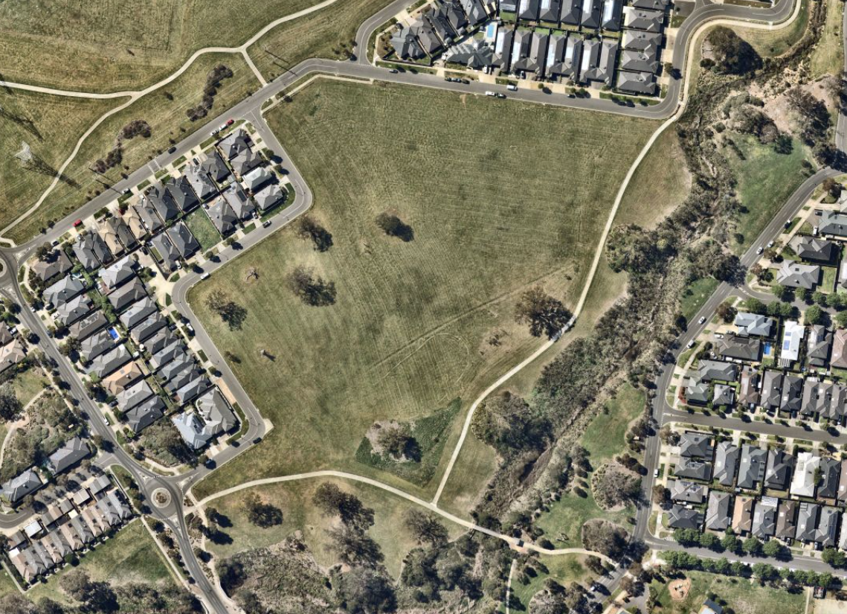

Engagement Summary
17 November 2025 – 14 December 2025
ASHLEY PARK RECREATION RESERVE REVITALISATION

Introduction
The City of Whittlesea has undertaken community engagement to inform and consult with residents on the transformation of Ashley Park Recreation Reserve in Doreen into a welcoming and accessible space where people can play organised and informal sport, relax and socialise. The Ashley Park Recreation Reserve revitalisation represents an investment in our community’s health, wellbeing and future in the City of Whittlesea. Community feedback gathered during this process will directly shape the final plan, including:
- Play space areas
- Sports court
- Fitness equipment.
Council sought feedback from people who live near or visit Ashley Park Recreation Reserve to gauge support for the proposed concept plan and understand user needs when prioritising features. The engagement focused on gathering community input on key recommendations for the play space, sports court and fitness equipment. Insights gathered will inform any final design adjustments before works commence. A key objective was to ensure consultation opportunities were accessible and inclusive, enabling community members to easily share their feedback.
How we engaged you
The Ashley Park Recreation Reserve consultation was open for community comment from 17 November to 14 December 2025. Feedback was gathered online through Council’s Engage Whittlesea platform, via direct mail to residents directly adjacent to and within 500 metres of the reserve, and through in-person conversations at two on-site pop-up events at Ashley Park Recreation Reserve.

The Engage Whittlesea platform utilises an accessibility add-on ensuring that it is as accessible as possible for all users. The platform also has an in-built translation tool to mitigate any language barriers to participation, allowing the page to be translated into the top fifteen languages spoken within the municipality.

In-person engagement activities
The project team hosted two community pop-up sessions on site at Ashley Park Recreation Reserve, Doreen, using the Let’s Talk branded Engagement Van to increase visibility in the open space, resulting in 18 face-to face interactions.
The in-person activities mirrored the questions asked in the online consultation, aiming to understand what the community valued most in the proposed concept design, and to identify preferred features for the new play space, sports court and fitness equipment. Participants were invited to place three sticky dots on their top priorities, share additional suggestions, and discuss any concerns with staff about the proposed concept design.

Details of the community-based session are as below:
Date | Time | Where | Address/location
Wednesday 3 December | 4.30pm – 6pm | Ashley Park Recreation Reserve | Soapstone walking path and Moonstone Street bend
Saturday 13 December | 10.30am – 12pm | Ashley Park Recreation Reserve | Soapstone walking path and Moonstone Street bend

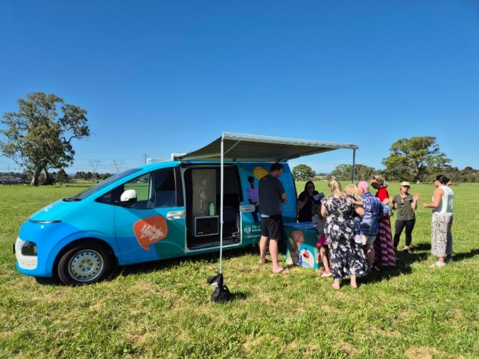
Above: The project team engaging with the community at Ashley Park Recreation Reserve

Project promotion
The opportunity to participate in the community engagement was promoted through a range of channels to reach both targeted community members and also those that visit the area. Promotion included:
- A dedicated project page on Council’s digital engagement platform Engage Whittlesea
- Direct mail to residents adjacent to Ashley Park Recreation Reserve and neighbouring streets (approx. 1,100 residents)
- Five A2 signs with QR code to participate in the project at various locations around Ashley Park Recreation Reserve
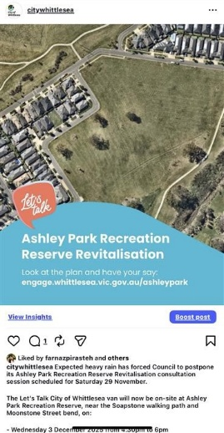
- Social media posts on Council’s social media channels
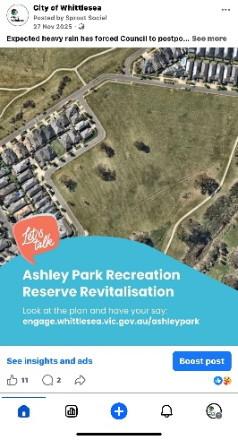

Above: Social media posts promoting the Ashley Park Recreation Reserve Revitalisation during the consultation period (One Instagram social post with 1,869 views, nine interactions and four links. One Facebook social post with 11,050 views and 342 interactions).

Participation
A total of 89 community contributions were received as part of the Ashley Park Recreation Revitalisation engagement.

Snapshot of community participation
 | 
18 people participated in-person across the  two community-based pop-up events. | 71 people participated  online via the Engage Whittlesea platform.

Snapshot of participant demographics
Gender Identity | Age | Suburb
 |  | 
53% Female, 42% Male and 6% preferred not to say. | All age brackets participated with the most represented being 25-34 years (35%) and 35-44 years (29%). | As expected, Doreen was highly represented (73%), with other minor contributions from Wollert (3%), Epping, Mill Park and Whittlesea Township (1%).

LGBTIQA+ Community | First Nations Community | Multicultural Community | Community members living with or caring for someone with a disability
 |  |  | 
2% of participants identified as members of the LGBTIQA+ community. | 4% of participants identified as being an Aboriginal or Torres Strait Islander person. | 7% of participants spoke English as a second language. | 7% of participants identified as living with a disability or an unpaid carer of an older person or someone living with a disability.

What we heard
Below is a summary of what we heard from the community through online engagement and in-person engagement activities.

Participants were invited to share additional comments at the community-based pop-up sessions, and as part of the survey. The feedback received has been grouped into key themes, with selected quotes and graphs included below to illustrate common views and experiences captured.
 | Are you happy with the overall proposed concept design for the reserve?  The support for the concept plan is split with 52% supporting the concept design and 48% indicating non-support. Supportive comments highlighted the opportunity to provide additional recreational facilities, particularly recognising that more sporting fields could support growing local participation in sports such as soccer and basketball. Respondents also supported community-focused infrastructure, including a pavilion that could be used by a range of community groups (e.g. dance or calisthenics), as well as seating around sporting fields. Key reasons for non-support included concerns about impacts on wildlife and the natural environment. Many respondents also felt there are already sufficient soccer fields in the surrounding area.  “The Pavilion area needs a large space to be hired out to other community groups, such as calisthenics and dancing. These areas of activity and community-focused groups often get overlooked, and I think it's important to create a space where not only those who support soccer can benefit, but also other community sport groups.”  “Ashley park development needs more opportunities for basketball as you can never have enough courts.”  “The reserve is already a beautiful area of open land, which is used happily by everyone, and home to so many kangaroos.”  “Don’t think we need another playground? There are already a heap around. The playground space could be used for extra sporting activities like tennis or more basketball rings”.

 | What kind of equipment would you like to see in the playground area?  Many respondents indicated a strong preference for barbecue and picnic facilities in the playground area. There was also strong support for nature-based play elements, including nature play climbing, with many expressing a preference to retain a natural feel that reflects and enhances the existing environment valued by the community.  “Keep the playground with a natural feel (e.g. Olivine in Donnybrook).”  “For the Ashley park Recreation reserve, I love everything you are doing as it will draw in a friendly area for family’s.”

 | What kind of equipment would you like to see in the fitness circuit?  When asked what equipment the community would like to see in the fitness circuit, there was a strong preference for strength, cardio and multi-use equipment. However, some in-person pop-up feedback questioned whether an additional fitness circuit was needed, given another circuit is located nearby, and suggested the funds could be better used elsewhere such as a bouldering wall or splash park rather than duplicating facilities.  “Fitness equipment is good for older people to do cardio and strength without having to go to the gym. Can workout while the grandkids play.”  “Feel wasted money on the Fitness Equipment - local one not used.”

 | What kind of sports line configurations would you like to see on the sports court?  When asked about sports line configurations, there was a strong preference for basketball, tennis and netball line markings. Half-court, four square and shuffleboard received fewer votes, indicating lower overall preference for these options. Other suggestions were for Pickle ball and Futsal line markings instead.  “Is there a chance you can consider putting some tennis courts in also as it is very limited for courts in the area.”  “Tennis or basketball court at same time.”

 | Which parts of the concept plan are you concerned about?  Community feedback highlighted concerns about the loss of the open, natural environment and the impact on kangaroos and other wildlife that currently inhabit the area. Respondents also raised concerns about increased noise and traffic resulting from the installation of two soccer pitches, noting that many feel the site is not suited to a development of this scale. Environmental impacts were a key theme throughout the feedback, with 13 respondents also indicating that there are already sufficient soccer fields in the surrounding area.  “One of the things that drew us to the area was the natural open spaces. This is too much for this space. This is a quiet area and a small pocket of housing in the surrounding streets. The impact of additional traffic in the area for training or sporting events would be significant on those smaller residential roads.”  “This area is filled with local residents walking and enjoying nature. Sporting grounds and a pavilion in the middle would reduce the appeal.”  “I have a number of concerns over the impact on native wildlife such as all the bird species and kangaroos that call this area home."
Next Steps
Thank you to everyone who participated in the community engagement by sharing comments, feedback, and taking part in activities.
The project has now moved into the detailed design phase. Feedback received will help shape updates to the Ashley Park Recreation Reserve Revitalisation concept plan. A list of FAQs will be posted to the project engage page to address some of the key questions raised during consultation.
Once complete, the final design will be made available for public viewing.
We encourage you to follow the project Engage page to stay up to date with the progress of this project.
Community feedback may also inform other Council plans, strategies, and projects, contributing to the vision of making the City of Whittlesea A Place for All.

