Integrated Transport Plan – Phase 2
Engagement Summary
May 2024
Introduction
The City of Whittlesea is developing an Integrated Transport Plan (ITP) to guide transport planning and advocacy in the City of Whittlesea over the next 10 years. It will allow Council to strategically plan for, and respond to, future challenges and opportunities, inform advocacy for our transport needs and guide the development and expansion of the transport network in the City of Whittlesea.
The draft ITP aims to support a transport system in the City of Whittlesea which offers the community a greater range of viable, attractive and alternative transport choices, so that road infrastructure is most efficiently used by those that have the greatest need to drive.
Between December 2023 and February 2024 Council consulted with people who live, work, study or visit the municipality to understand what was important to them when they think about the transport needs of the municipality for the next 10 years. A place-based engagement approach was designed to ensure feedback was captured from a diverse range of community members. Intelligence gained through this first phase of consultation was used to inform the development of a draft ITP. In our second phase of the engagement, we presented the draft ITP to the community to check back in to ensure the plan was appropriately addressing identified needs. This report presents the feedback of this second phase of the consultation.
The project team managed expectations by clearly identifying what is in Council’s remit to deliver and what is out of scope and would be considered as part of our Advocacy efforts. This messaging was included as part of all engagement activities,
How we engaged you
The Phase 2 Integrated Transport Plan consultation was open for community comment from 22 April to 19 May 2024. Community feedback was sought online through Council’s Engage Whittlesea platform and through direct conversation and activities at community-based pop-ups. The Engage Whittlesea platform utilises an accessibility add-on ensuring that it is as accessible as possible for all users. The platform also has a in-built translation tool to mitigate any language barriers to participation, allowing the page to be translated into the top ten languages spoken within the municipality.
Engage page
On the project’s Engage page, the vision, guiding principles, and focus areas were articulated through infographics for ease of community consideration. Participants were also invited to participate in a survey that asked:
- What do you think about the Draft ITP?
- Do you have any suggestions for improvement for the Draft ITP?
- Do you have any other comments on the Draft ITP?

The survey questions were designed to understand what is most important to the community in relation to future planning of the transport needs in the City of Whittlesea.
Community-based pop-ups
In Phase 2 the project team co-facilitated six community-based pop-ups in high foot traffic locations across the municipality. The in-person consultation allowed deeper discussion with project team members with an opportunity to add additional suggestions.
Participants at community-based pop-ups were provided with the Draft Integrated Transport Plan information board (Appendix 1) and were asked to visit the Engage platform to complete the survey and access further information. Three Engagement iPads were made available for staff to assist those community members unable to access the Engage platform to improve accessibility opportunities. A total of 56 people participated in the consultation at the pop ups.
The community-based pop-ups were held on the following dates in the following locations:
Date | Location
Tuesday 30 April | Thomastown Library 52 Main Street, Thomastown
Wednesday 1 May | Galada CAC 10A Forum Way, Epping
Thursday 2 May | Mernda CAC 70 Mernda Village Drive, Mernda
Thursday 2 May | Laurimar CAC 110 Hazel Glen Drive, Doreen
Wednesday 8 May | Whittlesea CAC 57-61 Laurel Street, Whittlesea
Monday 13 May | Mill Park Library 394 Plenty Road, Mill Park

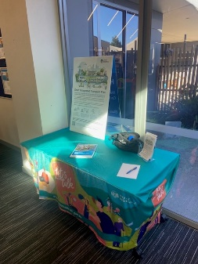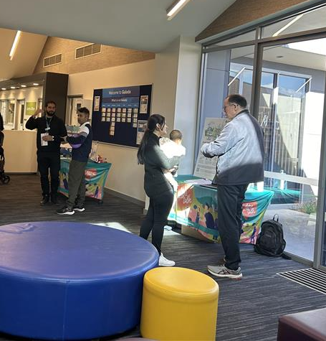
Above: Integrated Transport Plan pop-up at Galada Community Activity Centre

Project promotion
The opportunity to participate in the community engagement was promoted through a range of channels to have a widespread reach across the municipality including:
- Council’s digital engagement platform Engage Whittlesea
- Social media – we shared three posts across Council’s social media channels (Facebook, LinkedIn, and Instagram)
- Direct email to key stakeholder groups
- Flyers and posters displayed at Council facilities and libraries.

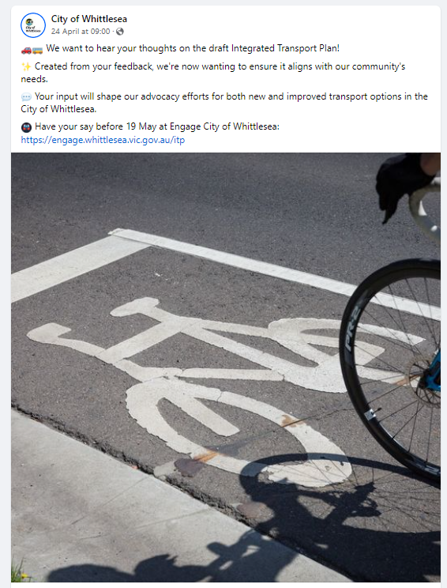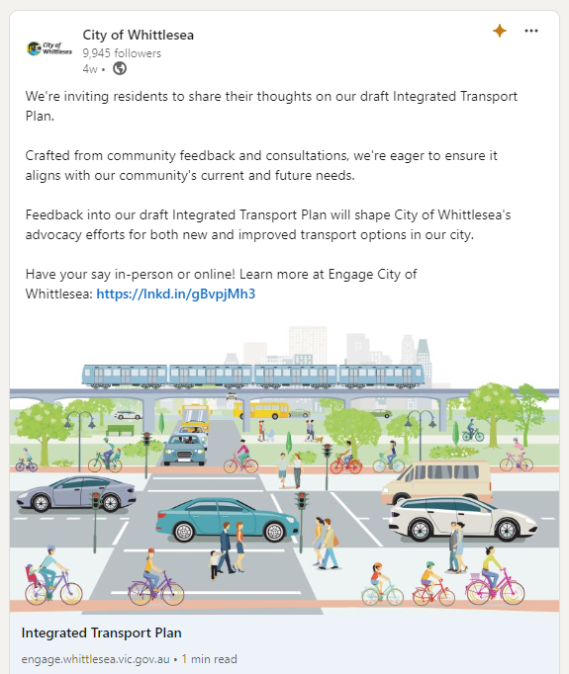

Above: Instagram and LinkedIn Integrated Transport Plan social posts.

Participation
A total of 81 community members participated in the phase 2 consultation. Participants were given the opportunity to contribute in two ways; in person at scheduled pop-up locations and via the Engage Whittlesea platform via an online survey. The survey was designed to present the Draft Integrated Transport Plan that has been informed by the phase 1 consultation and the Background and Directions papers. The survey results will help Council confirm transport priorities in our community have been reflected in the document and make any adjustments to the Integrated Transport Plan prior to council endorsement.
Community participation
 | Organic posts reached 7,882 people and were engaged with 371 times, generating 30% of traffic to the online Engage page. The Engage campaign received 873 direct views from our community generating 47% of contributions.
 | We hosted six community-based pop-ups across the municipality with over 56 people attending the information/engagement opportunity.
 | The online survey had 25 contributions.
What we heard
At community-based pop-ups conversation centred around requests for new cycling routes, better access and connectivity, improved bus services, improved crossing points and requests for Wollert Rail extension. This feedback mirrored what was heard from the community in phase 1.
Online we asked community their thoughts on the draft Integrated Transport plan (ITP) through a survey on the Engage platform that had three questions that were developed based on information captured in Phase 1 of the engagement.
Comments received throughout phase 2 of the consultation have been themed below for each of the three questions asked.
Firstly, we asked what the community thought about the Draft ITP with the comments received reflecting a diverse range of opinions and priorities among residents, balancing the need for car-friendly infrastructure with the desire for improved public transport and safer, more sustainable travel options.
 | Transportation Preferences and Needs  - Car Dependency: Many comments highlight a strong preference for car travel, emphasising the need for more parking spaces, better road infrastructure, and faster speed limits. Residents express a desire for their car-centric lifestyle to be accommodated rather than shifted towards alternative transport modes.  “If a person is to use public transport to do a grocery shop neither the Rail system or Bus system is adequately setup to make it work”.  “Grocery shopping for a family also requires a car - you just can't carry that much”.  - Public Transport Improvements: Some comments call for enhancements in public transport, such as increased express trains, better connectivity, and improvements in the train and bus services, particularly for areas like Wollert.  "Limited access to public transport and the consequent traffic congestion and long commute times have a serious impact on the wellbeing of families and individuals. A train line is essential to support the business growth and development in Epping and Wollert areas”.  “Train to Wollert is a must! We require an increase in express trains which surpass the inner city or stations close to the city to ensure a faster/smoother journey for those who live further out”.  Technical response:  The ITP is intended to provide the community greater choices without mandating sustainable transport options. The ITP acknowledges that due to various factors some people will still be dependent on their car as their primary form of transport, and to manage this Council will continue to advocate to the State Government for targeted arterial road upgrades.  A Parking Management plan is proposed to provide a consistent coordinated approach to parking in the municipality. Also, we will explore the role of smarter parking technologies to better manage the supply and demand of parking space in the municipality.  Public Transport delivery is the responsibility of the state government and as an action in the ITP Council will continue to advocate for improved bus services, including better frequencies and extensions into growth areas as well as better integration between public transport modes. Council will also continue to advocate for the Wollert Rail extension.
 | Infrastructure Development  - Parking Solutions: Suggestions include building multi-level car parks at train stations and addressing the need for parking near bus stops to make public transport more viable for activities like grocery shopping.  “There is no mention of addressing the need for more car parking adjacent to bus stops”.  “It’ll work once you tidy up the parking & traffic congestion issues alongside Thomastown station on high street”.  - Road and Traffic Management: Calls for improvements in traffic congestion, particularly at problematic intersections and entry/exit points on major roads like the Hume Freeway. There's also a push for making roads safer for both cars and cyclists.  “Entry and exit from the Hume freeway needs to be improved there's always accidents and a lot of congestion, compromising safety and longer journeys.”  “As a person who uses multiple ways of transport (car, bike riding and walking) I feel this is way overdue but also a little too late”.  “The concept of an ITP is good to help support the provision of choice of transport options, including active transport”.  Technical response:  The ITP indicates Council’s role in the transport system, noting that public transport and arterial roads are the responsibility of the State Government. Parking at train stations is also the responsibility of State Government.  Car parking is not typically provided at bus stops as they are often located to enable walking and cycling to the stop.  Council will continue to advocate for targeted arterial road upgrades around the municipality and will explore the role of emerging technologies and data to provide information about congestion pinch-points, queue lengths and delay to assist with improving planning and advocacy.  The ITP has identified that a large proportion of trips are under 5km. Some of these trips could be undertaken by walking or cycling, freeing up capacity on the road network for those who need to drive.
 | Community and Environmental Considerations  - Opposition to High-Density Development: Some residents express concerns about Whittlesea becoming similar to high-density inner-city areas and prefer maintaining the suburban, family-friendly character of the municipality.  “We do not want to become like the inner-city high density built places. The reality is that we are car dependant as we have to travel across town. It is our choice to live in Whittlesea and our choice to have bigger roads, bigger car parking spaces and faster speed limits”.  - Environmental Impact: There are mentions of using land more effectively, such as giving back land to nature by building multi-level car parks and improving pedestrian and cyclist paths for recreational purposes.  “I strongly support it, based on many of its focuses - better land use integration with transport, reduction in car dependency (to ease financial and sustainability burdens on residents that dependency imposes), and to support more affordable, healthy living”.  “Instead of using vast amounts of land for car parking at train stations, start building multi-level carparks. Give the land back to nature and the community”.  Technical response:  Through the ITP, the aspiration is to advocate for increased densities along rail corridors and the walkable catchment of activity centres and public transport. A greater diversity of housing types will enable improved transport choices for our residents and potentially reduce car dependency. This will also assist with managing affordability issues.  Whilst Council will continue to advocate for targeted arterial road upgrades, speed limits are reflective of the road type and environment. Exploratory work on reduced speed limits is proposed as a way of improving road safety within local areas.  Parking at train stations falls within the remit of the State Government. Council proposes to develop a coordinated and consistent approach to parking through developing a Parking Management Plan.
 | Feedback on the Integrated Transport Plan (ITP)  - Support for Guiding Principles: Positive feedback on the ITP’s principles, such as reducing car dependency, better land use integration, and promoting active transport options like walking and cycling.  “At a high level, this appears to be a sensible approach”.  “It makes some good points, conveying a need + possibility to improve things”.  - Implementation Concerns: Comments stress the importance of detailed and actionable plans, with some noting that current actions are too vague or not ambitious enough to address the area's growing needs. There's a call for more short-term goals and specific actions to be outlined and implemented effectively.  “The key will be in monitoring progress with implementation of the various actions that have been described.”  Technical response:  The actions have been developed with the intention to be balanced, realistic and clear. These have been assigned short, medium or long term based on our priorities and targeting more achievable ‘quick wins’ in the short term, with other items, such as our advocacy, cited as long-term actions.  The action plan will be reviewed and updated every two years to ensure it is effective.  The delivery of the ITP actions plan will be monitored and evaluated against outcome indicators that link back to Council’s Integrated Planning Framework.
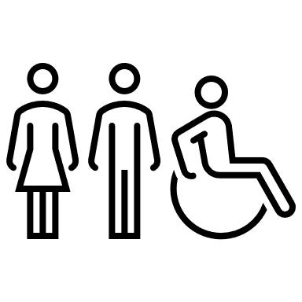 | Safety and Accessibility  - Traffic Safety: Emphasis on the need for safer roads, better pedestrian crossings, and improved cyclist infrastructure to ensure all road users are protected.  “There is no mention of making roads safer for cyclists where bicycle lanes stop before roundabouts and start again after them”.  “Get rid of bicyclist or put them on a separate road away from cars”.  “A focus on safety is paramount, obviously”.  - Accessibility of Transport Options: Support for making transport options more accessible and addressing issues like the lack of parking at bus stops, which hampers the use of public transport for daily activities.  “There is no mention of addressing the need for more care parking adjacent to bus stops”.  “There is nowhere to park near most bus stops, carrying groceries from a bus stop is not a viable option along Plenty Road to Whittlesea”.  Technical response:  The ‘Road Network’ chapter covers road safety, including the preparation of a new Road Safety Plan. Council’s advocacy for targeted arterial road upgrades also includes safe and connected walking and cycling infrastructure provision, noting that vulnerable road users will continue to be a particular focus.  It is also proposed through the ITP that Council will also examine upgrades to targeted local roads, collector roads and intersections.  Walking and cycling are both sustainable and Council supports greater opportunities for Whittlesea residents to use these options to meet some of their daily needs.  Council supports the improvement of walking and cycling connections, including to access public transport, rather than providing parking to access bus stops.  Accessibility is planned to be addressed by incorporating best practice walking and cycling infrastructure design, providing connected footpaths and safe crossings and ensuring bus stops are DDA (Disability Discrimination Act) compliant.

The second question asked participants if they had any suggestion for improvements to the Draft ITP. The comments received reflect a community that is deeply invested in the practicalities of their daily commute and transport infrastructure, with a significant emphasis on maintaining and enhancing car accessibility while cautiously supporting improvements in public and active transport options.

 | Action Plan and Cost Management  - Realistic Planning and Cost Identification: Several comments emphasise the need for a clear identification of costs associated with actions in the plan. They advocate for a realistic and phased approach, distinguishing between short, medium, and long-term goals.  “I'd suggest to identify costs associated with actions, to plan realistic action in short, medium and long term. Priority should be given to increasing parking sizes, bigger and wider roads”.  - Evaluation and Accountability: Residents suggest establishing an evaluation framework to regularly monitor progress, with measurable goals and frequent reviews to ensure accountability and adaptability over time.  "Council needs to establish an evaluation framework and plan to regularly monitor progress with implementation of the various actions described in the plan”.  “The Directions Paper included objectives with measurable goals, which seem to have been removed from the draft ITP. These should be included to enable Council to hold itself and other stakeholders accountable through annual evaluation and reporting on progress with implementation”.  Technical response:  The ITP has a range of actions, which have been assigned short, medium or long term delivery timeframes. The action plan will be reviewed every 2 years during the lifetime of the ITP and revised as necessary. The majority of actions are covered within the Council’s internal operating budget.  Each of the ITP focus areas has been linked with an outcome indicator from Council’s Integrated Planning Framework (IPF) which will be used to monitor progress of the ITP.
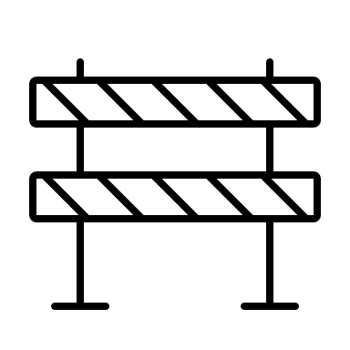 | Infrastructure and Road Improvements  - Priority on Car Infrastructure: There is a strong push for wider roads, bigger parking spaces, and higher speed limits. Many residents emphasise their reliance on cars and the need for infrastructure that supports this lifestyle.  “We need bigger car parks because our cars are bigger”.  “Fix and wider the roads before putting over 300 plus houses in newer estates’.  “Limiting the speed limits in our network will only create further congestion”.  - Road Safety and Efficiency: Comments call for improvements in road safety, especially around major intersections and local roads. Specific suggestions include better lighting, line of sight on paths, and smoother transitions at freeway entry and exit points.  “Hume freeway connectivity needs to be improved. Smoother transition to enter and exit the freeway particularly from the ring rd. Traffic is always sprawling onto the ring road causing others even more delays”.  “There are currently no safe east-west bicycle corridors in the north of Findon Road to connect Plenty Road and Epping Road”.  “The M80 shared trail between Plenty Rd and Greensborough could have better line of sight and lighting”.  Technical response:  Whilst it is acknowledged that the many in the community are dependent on the car for mobility, the ITP aims to improve transport choices so that residents are not forced into car dependency and are able to use other methods, such as walking, cycling or public transport, to undertake some of their trips.  Council continues to advocate to the State Government for targeted arterial road upgrades including enhancing safe walking and cycling provision. Council is also advocating for improvements to public transport.  With our growing population, road safety continues to be a focus in the municipality. Council is committed to ensuring that everyone can travel safely on our network. Therefore, as an ITP action, Council will prepare a new Road Safety Plan and also explore the potential for reduced speed limits on Council-owned local roads.
 | Public and Active Transport  Public Transport Enhancements: Residents express the need for better public transport options, including more frequent bus services, direct bus routes, and express train services. There is a call for improved connectivity, particularly for areas like Wollert and connections to major train lines.  “A focus on advocacy with the state government for improved bus services. Specifically, direct, straight routes where possible, bus rapid transit operations and frequent service operations (every 10 mins) to support uptake of services”.  “Roads section, include new action – On local roads, ensure pedestrians can safely cross major intersections in one movement (and advocate for this on state roads)”.  Active Transport Facilities: Some comments support the expansion of walking and cycling paths, but stress the need for these paths to be safe, well-lit, and separate from high-speed roads. There is also advocacy for connected cycle paths across shire borders to promote safer and more extensive cycling networks.  “Proposed On-Road bike lane for Bridge Inn Road is a dangerous proposition. There is heavy truck traffic from the tip and quarry in both directions on that section. Painting a bike lane will not reduce that risk substantially”.  “One significant disadvantage at the moment is that cycle paths are not connected to other shires, forcing riders onto dangerous roads. This should be addressed, to grow this connectivity”.  Technical response:  Council is advocating to the State Government for improvements to public transport, including extensions into our growing suburbs and higher frequencies on all routes.  The ITP also includes an action around investigating improvements to crossing facilities to better ensure pedestrians can undertake a crossing in one movement and will advocate for this on State Government controlled roads.  Council will continue to explore opportunities to expand and develop our active transport network, with a focus on providing safe and separated cycling infrastructure. Council will also seek opportunities to expand the Northern Trails network to better connect the municipality with neighbouring areas.
 | Community and Environmental Considerations  - Community Consultation and Inclusion: Comments suggest more inclusive community consultations, particularly in underrepresented areas like Donnybrook. There is a desire for the council to better understand and reflect the needs of families and working-class residents.  “Have a community consultation as well in Donnybrook”.  “There has been no consultation of families in this report”.  “Get rid of sustainable transport. we are too old to cycle. our kids don’t work close and need their cars”.  - Environmental and Social Spaces: Some residents propose integrating social and green spaces into the transport plan, suggesting multi-level car parks to free up land for community use and nature, and designing walkable areas around activity centres.  “It needs to include social spaces the residents want to come to (beautifully designed hospitality districts), connecting Mernda and Craigieburn North to the bypass instead of via a 1 lane Craigieburn Road, improved efficiency of traffic lights”.  Technical response:  The consultation included the option for residents to view the ITP on Council’s Engage Page and complete an online survey. There were also six pop-up events scheduled around the municipality, which provided the opportunity for residents to ask questions and provide in-person feedback. The pop-up events were at different times of day to be more inclusive and allow a greater range of resident involvement, noting that people have different circumstances.  The ITP absolutely supports the role of sustainable transport in providing greater transport choices through sustainable transport (walking, cycling and public transport) which will allow people with healthier options compared to driving. Greater use of sustainable transport will also relieve some of the costs associated to car ownership and provide options to those who do not own a car.  Council supports improved access to recreation through the ITP and the Northern Trails Strategy and will look at improving access and connectivity to high foot traffic areas, including activity centres.  The increasing role of technology is proposed through the ITP to investigate improvements to traffic management in the municipality.
 | Opposition to Sustainable Transport  - Resistance to Cycling and Walking Initiatives: A segment of the community expresses strong opposition to initiatives aimed at promoting cycling and walking. They argue that such measures are impractical for their lifestyle and call for more car-centric solutions instead.  “If people want to ride a bike, there should be separate bicycle lanes”.  - Criticism of High-Density Planning: There is resistance to planning concepts like 20-minute cities, with residents arguing that these ideas are incompatible with their car-dependent lifestyle and the suburban character of Whittlesea.  “We heard rumours of designing small 20 min cities but that wont work because we still have to drive. Stop with this sustainability crap”.  “Neither the council nor state govt will ever have enough capital to make an adequate transport options that will support families to get around the municipality”.  Technical response:  Walking and Cycling are considered to be important, both for transport purposes and for recreation. Both options have considerable health and wellbeing aspects and many short trips in the municipality could be undertaken on foot or by bicycle. The ITP will explore options to continue to expand our walking and cycling network, including opportunities to provide safe and separated cycling infrastructure.  Congestion in our growing municipality is an ongoing challenge. 20 minute neighbourhoods provide better opportunities for people to meet their daily needs within a short distance of where they live, reducing car dependency and providing transport choices including walking, cycling and public transport.
 | Specific Concerns and Suggestions  - Local Traffic Issues: Specific traffic issues are highlighted, such as the congestion around Thomastown station and the need for a clearway to improve traffic flow.  “Please include high street Thomastown the traffic between Station Street & Heaughton Avenue is terrible the wait time to get over those boom gates is most times 15 minutes to cross over.”  “Strongly consider making the parking on high street outside Thomastown primary where the double lane turns to one into a clear way with the shop parking there bus congestion is very bad & traffic flow is dangerously bad: parking outside those shops needs to be a clear way from 3pm until 7pm”.  - Safety for School Children: There is a call for safety upgrades near schools, such as crossing supervisors or traffic lights to ensure children can cross busy roads safely.  “Crossing supervisor at Gordons Rd South Morang (btw Badal street and Pipit Cct) /or traffic lights: to allow safe crossing of children especially on this busy peak hour road”.  - Integration with State Plans: Residents urge the council to work closely with state government plans to ensure local needs are addressed, such as advocating for the removal of level crossings and improving connectivity to major transport hubs.  “I urge for advocacy towards implementing a bus service to Wollert, specifically for areas like Rathdowne Estate”.  “Lobby for the removal of level crossings between Settlement Road and Childs Road”.  Technical response:  The ITP does not detail actions for specific locations, with these to be considered on a case-by-case basis.  In the context of our growing population, improving convenient transport choices for our residents will help to manage the ongoing issue of congestion.  The ITP also seeks to improve parking management in the municipality, to provide a balanced approach to the parking needs of our growing community in a way which is equitable and inclusive.  Council is fully supportive of safe walking and cycling as options for children to travel to school. Therefore, we work closely with schools and the State Government in the adequate provision of supervised school crossings.  Council continues to advocate for the Wollert Rail extension (by 2030) and for improvements to local bus services. The level crossing removal project at Keon Park station is nearing completion.

Participants were afforded the opportunity to provide any other comments on the Draft ITP in the final question. The themes of the feedback captured reflect a community deeply concerned with practical and immediate transport needs, local governance and representation, financial feasibility, and the balance between maintaining a car-centric infrastructure and promoting sustainable and active transport options.

 | Stakeholder Management and Governance  - Managing Expectations with External Stakeholders: Several comments emphasise the importance of identifying stakeholders outside of the Council's control, such as state and federal governments, to manage expectations regarding major transport decisions and funding.  “Identify stakeholders that are out of control of council to manage expectations, like state and federal budget decisions on rail, road and other major transport decisions”.  - Local Representation and Decision-Making: There is a strong sentiment that only local ratepayers should provide feedback on the ITP, with concerns about non-residents influencing decisions. Some residents express distrust in the Council's responsiveness to local complaints and suspect decision-makers do not reside within Whittlesea.  “I hope rate payers are the only ones who can respond to this. It would be unfair and discriminatory if advocacy groups and people who do not live in the council provide feedback”.  Technical response:  The ITP provides the strategic context, by documenting the roles and responsibilities of different tiers of Government, as well as the key policies and strategies at each level, that are relevant to the ITP.  Two phases of consultation were provided to enable the community to provide their input in the development of the ITP. In addition, a range of key stakeholders were identified and invited to participate, in order to further inform the development of the ITP.  Major transport infrastructure needs have been identified through a suite of plans and strategies and from community feedback. Funding for major transport infrastructure projects are largely a responsibility of the State Government. Accordingly, Council continues to advocate for these projects.
 | Infrastructure and Transport Planning  - Traffic Congestion and Commuting: Residents acknowledge that traffic congestion, especially around schools, is a top priority. There is a call for more actions supporting active travel to school and addressing school travel infrastructure.  “Traffic congestion is consistently reported as one of the top priorities for residents, including for commuting and around school precincts. Commuting is largely outside Council control, but can more easily influence school travel”.  - Parking and Road Management: Comments highlight the need for better management of traffic and parking, particularly with new apartment developments exacerbating the issue. There is a preference for maintaining large parking spaces and improving road conditions.  “We need to have a better transport plan catering on the growth corridor”.  “With the building now commencing with the apartments on high street traffic & parking is a nightmare”.  Technical response:  Congestion around school precincts is an ongoing challenge. Through the ITP, and Walking and Cycling Plan, Council continues to identify opportunities to improve walking and cycling connections to school precincts and partner with schools, and other stakeholders, in the delivery of behaviour change promotions and pilot projects to test new ideas to improve walking and cycling participation and reduce reliance on car travel for school drop-offs and pick-ups. Council also welcomes new or expanded school bus options.  The ITP covers the entire municipality and needs to balance the different needs of our diverse landscape and community. New technologies and improved transport data may assist Council with better understanding vehicle delay and queue lengths and exploring smarter parking management. The ITP also contains an action to develop a Parking Management Plan, which is based around providing an equitable, inclusive and balanced approach to the parking needs of our growing community.
 | Environmental and Community Focus  - Green Spaces and Biodiversity: There is a desire for more trees and gardens in open areas to support biodiversity and create attractive spaces for residents. Comments emphasise land use for community benefit rather than for parking.  “Land use should be given to community and to improve biodiversity, not for parking cars”.  - Social Connectivity and Local Business: Some comments suggest improving social spaces with a focus on local businesses, cafes, and restaurants to enhance community connectivity and support small businesses.  “Improve social connectivity as well, think of how Europe (or little athens-oakleigh square) is set out with cafes/restaurants without the beaches of course”.  “I am glad you are considering so many important things, like the environmental impacts, safety, convenience, accessibility, health and well being, and future growth and needs”.  Technical response:  Council’s Sustainable Environment Strategy sets Council’s environmental priorities. As part of transport projects Council is committed to improving tree planting along shared paths.  Great streets is a guiding principle within the ITP and have the potential to provide opportunity for social interaction and cohesion, to support and drive business activity and serve as urban parks for local residents. The application of Council’s Place and Movement Plan framework will help the integration of placemaking and design initiatives to activate streets.
 | Public and Active Transport  - Public Transport Improvements: Suggestions include enhancing bus services, particularly routes that connect to train stations, shopping centres, and schools. There is support for dedicated school buses to reduce congestion.  “Less focus on busses however it will be important to have frequent bus services to train stations and hubs such as plazas/shopping centres, high-schools”.  “Add action(s) supporting active travel to school (infrastructure in addition to existing behaviour change action)”.  “Dedicated school buses for major public schools which only serve the school children (so parents feel safe). This will reduce school congestion + incentivise walking to bus stop”.  - Cycling and Walking Infrastructure: Residents advocate for more off-road cycling and walking paths, improved safety measures for pedestrians and cyclists, and integrating these paths with major hubs. There are also calls for better lighting, shading, and greenery along these paths.  “More off-road bike and walking paths included into future plans (than are there). Have these intersect with major hubs like shopping centres and libraries. Keep them green with sprinklers and shaded with trees”.  “As part of land management would also like to see more trees and gardens planted on open grassed areas. This will support biodiversity growth, and also be more attractive for residents to interact with these spaces”.  Technical response:  Council will continue to advocate for improved bus services, including school buses, to serve our expanding population. Council will also seize opportunities to expand and improve our walking and cycling network and to work in partnership with schools and other stakeholders in the participation and delivery of behaviour change promotions and programs.  Council will advocate for funding to expand and develop the Northern Trails network, to improve walking and cycling opportunities around the municipality and to neighbouring Councils both for transport and recreation. Improved shade and lighting are also priorities when designing these improvements.  Walking and cycling connections to and from activity centres and public transport hubs is also a priority.
 | Financial Considerations and Feasibility  - Realistic Financial Planning: Concerns are raised about the feasibility of proposed investments in the current fiscal environment. Residents question whether the required increase in per capita investment for sustainable changes is realistic.  “According to the paper, this would require a 10-fold increase in investment per capita (i.e., from $5 (current) to $50). Is this realistic in the current fiscal environment?”  - Expenditure Forecasting: The need for detailed expenditure forecasts over the 10-year period of the ITP is emphasised to ensure transparency and accountability in financial planning.  “Include more discussion of need to secure funding for walking infrastructure”.  “There is no detail in the draft ITP on forecast of expenditure over the 10 year period”.  Technical response:  The Sustainable Change scenario was developed as part of a Directions Paper by a consultant on behalf of Council. This was one of several future scenarios based on future land use and investment. The ITP aims for future outcomes commensurate with Sustainable Change, which is also understood to be a ‘best-case’ scenario.  The majority of actions within the ITP will be undertaken within Council’s internal operating budget. In terms of capital needs, Council will continue to identify internal funding, and advocate for external funding, to continue to build and expand our walking and cycling networks and improvements to the local road network.
 | Health and Safety Concerns  - Accident and Safety Statistics: Residents request detailed data on where crashes occur to validate research findings and improve safety measures. There are concerns about the impact of increased scooter and bike use on local hospitals.  “Limited access to public transport and the consequent traffic congestion and long commute times have a serious impact on the wellbeing of families and individuals”.  “Show where crashes occur to prove research and findings”.  “Has CoW considered how the Northern Hospital is going to deal with the spike in serious scooter and bike admissions? Look at the Hospital stats in inner Melbourne over the last 2 years”.  - Pedestrian and Cyclist Safety: Emphasis is placed on the importance of pedestrian and cyclist safety, advocating for safe crossing points and dedicated paths to reduce accidents and promote active transport.  “More needs to be done to improve the cycling lanes and maybe the Whittlesea trail from Whittlesea to Mernda would be a great idea”.  “Pedestrian and cyclist safety should be of the most importance”.  Technical response:  Traffic congestion is an ongoing challenge within the City of Whittlesea. Council continues to advocate for improved public transport to provide greater transport choices to reduce car dependency, relieve affordability issues and improve health outcomes.  Road safety continues to be a focus in the municipality, particularly given our growing population and increased numbers of residents moving around. A new Road Safety Action Plan is currently under development, which will review crash trends and provide detailed actions on how to reduce road trauma and ensure that everyone can travel safely within Whittlesea.  Pedestrian and cyclist safety is of paramount importance and is prioritised in the design of new infrastructure. Council also has a role to advocate for safe and connected pedestrian and cyclist infrastructure as part of State Government major transport projects.
 | Specific Suggestions and Concerns  - Improving Specific Routes and Services: Comments include specific suggestions for route improvements, such as the 356 bus route and the introduction of a train line to Wollert.  “A Suggestion improve the bus service on 356 route. A new route amendments will also fit into Victorian Governments Bus Plan”.  “Simple New CIRCULAR route suggestions”.  “A train line is essential to support the business growth and development in Epping and Wollert areas".  - Short-Term Action and Realistic Goals: There is disappointment with the lack of short-term actions in the ITP, and a call for more immediate and achievable goals to address pressing issues.  “Disappointing ITP with a lack of short-term actions to address avenues for change”.  Technical response:  Council is advocating to the State Government for improved public transport, including better bus services and the Wollert rail extension.  The ITP contains short, medium and long term actions to reflect community priorities and needs over the plan’s lifetime. The timeframes are also assigned depending upon the nature of the work involved and what can be feasibility achieved. The action plan will be reviewed every two years providing the opportunity to re-assign timeframes, if necessary, as well as add new actions or remove redundant ones.

Next steps
The information captured through phase 2 consultation will inform the development of the final Integrated Transport Plan 2024, which is expected to be considered by Council in July 2024. The feedback captured has also been used to inform the development of other key plans and strategies Council are working on to make Whittlesea A Place for All.
Thank you again to everyone who participated in both phases of the community engagement by sharing comments, feedback and participating in activities and focus groups.

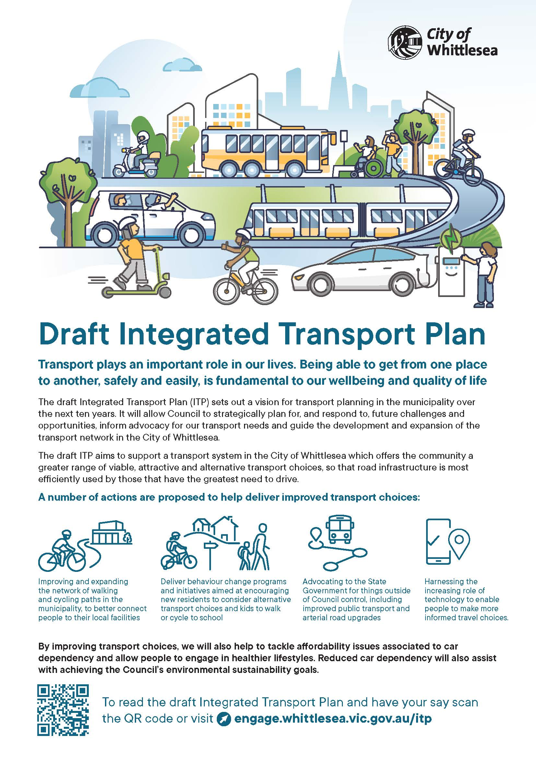Appendix 1:

