Buildings and Facilities Asset Management Plan

APRIL 2022

Document Control
Version | Date | Revision Details | Author | Reviewed
1.0 | Nov 2013 | Initial plan completion | WE
1.1 | Jul 2014 | Review and Updated | WE
1.2 | Oct 2015 | Review and Updated | WE
1.3 | May 2016 | Review and Updated | WE
1.4 | Sep 2017 | Review and Updated | WE
2.0 | Jun 2018 | Format review, update of modelling, clarification of service levels, plan improvements. | MB/RZ | PA
3.0 | Apr 2022 | Updated to suit outsourced FM service, new condition and component data, and new modelling. | MB | DH/ND

Asset Management Plan Alignment
This document has been prepared in accordance with:
- Local Government Act Victoria (2020)
- Local Government Asset Management Better Practice Guide (2015)
Local Government Victoria,
- Asset Management Accountability Framework (2016)
Victoria State Government – Treasury and Finance,
- ISO 55000 Series – Asset Management (2014)
International Standards,
- International Infrastructure Management Manual (2020)
Institute of Public Works Engineering Australasia.
- Local Government Act (2020).
Table of Contents
1. Executive Summary 6
2. Introduction 8
3. Strategic Objectives 10
4. Asset Overview 12
4.1. Service Category 14
4.2. Major Service Facility Responsibility 14
5. Levels of Service and Performance Indicators 15
6. Asset Condition and Degradation 17
7. Operations 20
8. Maintenance 21
9. Capital Renewal / Refurbishment 22
10. New Assets and Capital Upgrades 23
10.1. Overview 23
10.2. Private Developments 23
10.3. Infrastructure Contributions Projects 24
10.4. Councils 4-15 Year New Works Program 25
11. Transfers and Disposal Plan 26
12. Lifecycle Costs - Annualised 27
13. Financial Indicators 28
14. Risk Management 29
15. Improvement Plan 30
Appendix A: Building Assets 15 Year Financial Plan ($,000) 32

List of Tables
Table 1.1 – Building Asset Portfolio Overview ($,000) 6
Table 3.1 – Building Asset Related Documents and Systems 11
Table 4.1 – Building Asset Portfolio Overview ($M) 12
Table 4.2 – Componentisation and Data Confidence 13
Table 5.1 – Level of Service 16
Table 6.1 – Condition Descriptors 17
Table 6.2 – Asset Lives and Intervention Levels 17
Table 7.1 – Operational Activities and Expenditure (2021, $,000) 20
Table 8.1 – Maintenance Expenditure (2021, $,000) 21
Table 9.1 – Renewal Expenditure, Requirements and Backlog ($,000) 22
Table 12.1 – Indicative Lifecycle Costings ($) 27
Table 12.1 – Critical Strategic Risks 29
Table 15.1 – Buildings Asset Management Improvement Plan 30

List of Figures
Figure 1.1 –Building Asset Condition Distribution 7
Figure 1.2 – 15 Year Rolling Backlog Forecast ($, millions) 7
Figure 1.3 – Building Financial Indicators for 2021/22 Financial Year 7
Figure 2.1 – Asset Management Framework 9
Figure 6.1 – Current Condition by Component for Administration, Community, Family, and Heritage Service Categories. 18
Figure 6.2 – Current Condition by Component for Investment, Library, Public Toilet and Recreation Service Categories. 19
Figure 10.1 – Anticipated Additional Buildings Constructed from ICPs/DCPs 24
Figure 10.2 - Capital Expenditure 25

Executive Summary
The City of Whittlesea manages its building portfolio to facilitate the delivery of services in a way that meets the community’s expectations in a safe, effective, and cost-efficient manner. This portfolio had a replacement cost of $473.4 Million as of 30 June 2021.
Melbourne is one of the fastest growing cities in Australia and, according to the Federal Government’s 2021 Population Statement, is predicted to be the most populated city in Australia by 2030. The City of Whittlesea is a growth area council that will contribute to providing the communities this population growth will require. This creates a unique management challenge; to protect the long-term sustainability and service provision of our asset base, we must ensure that existing assets continue to be proactively maintained as new assets are handed over to Council.
This plan provides a strategic overview of the services that the City of Whittlesea provides through the management of building assets, the associated costs, and the risks and mitigation measures in providing those services. This plan outlines Council’s adopted approach and its implications. Several scenarios were modelled in developing this plan and are available as an interactive digital dashboard here: City of Whittlesea Digital Asset Dashboard.
Table 1.1 shows the annual average operational, maintenance, renewal and upgrade/new construction expenditure on assets and the anticipated funding gap over the next 15 years.

Table 1.1 – Building Asset Portfolio Overview ($,000)
Service Category | Annualised Operations & Maintenance¹ | Annualised Renewal Budget¹ | New Assets & Upgrades¹ | Backlog² 2022/23 | Backlog² 2036/37
Administration | 1,548 | 3,186 | 20,829 | 27 | 3,889
Community | 2,704 | 3,186 | 20,829 | 22 | 4,655
Family | 2,229 | 3,186 | 20,829 | 2 | 4,269
Heritage | 63 | 3,186 | 20,829 | - | 37
Investment | 281 | 3,186 | 20,829 | 11 | 1,228
Library | 365 | 3,186 | 20,829 | - | 1,434
Public Toilet | 412 | 3,186 | 20,829 | 2 | 166
Recreation | 4,271 | 3,186 | 20,829 | 20 | 9,767
Other | 25 | 3,186 | 20,829 | - | 3,625
Total | 11,899 | 3,186 | 20,829 | 84 | 29,070
Note:
^{1.} Budget figures are a 15-year average. Refer Appendix A for details.
^{2.} ‘Backlog’ refers to works that are beyond the desired intervention level, but funding is not available to undertake those works.
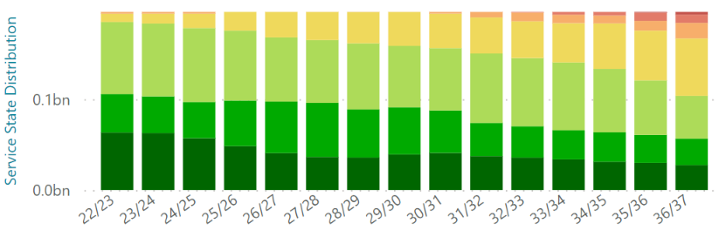

Figure 1.1 –Building Asset Condition Distribution

Figure 1.2 – 15 Year Rolling Backlog Forecast ($, millions)
The existing backlog is addressed within the first year of this plan, and future backlog does not start to arise until 2030/31. Council is aware of this future requirement, will monitor the performance of the building assets, and will review funding availability in the later years.
Asset Sustainability Ratio  22%  $$\frac{Renewal Expenditure}{Annual Depreciation}$$  A measure of the sustainability of current asset renewal practice. | Asset Renewal Funding  95%  $$\frac{Funded Renewals}{Desired Renewals}$$  A measure of how much of the required renewal funding is available. | Remaining Service Potential  60%  $$\frac{Fair Value}{\begin{aligned}Current Replacement \\ Cost\end{aligned}}$$  A measure of the remaining service life of assets. | Average Annual Asset Consumption  1.38%  $$\frac{Annual Depreciation}{Replacement Cost}$$  A measure of the rate of Building asset consumption.

Figure 1.3 – Building Financial Indicators for 2021/22 Financial Year
Whilst the asset sustainability ratio is relatively low, it needs to be considered in the context of backlog, the asset renewal funding ratio, and annual depreciation relative to the timing of renewal requirements. Depreciation is calculated as an annualised rate from replacement value, rather than renewal works, and does not follow the same year-on-year profile as required renewal expenditure. It is expected that the year-on-year depreciation-based sustainability ratio will fluctuate. The renewal funding ratio shows Council’s current funding is meeting current annual renewal requirements.

Introduction
The City of Whittlesea is committed to providing effective and efficient services to the community. Council is proactively managing its asset portfolios to ensure the level of service provided meets the community’s expectations in the most cost-effective manner and has invested in systems, processes, and personnel to achieve this. This plan gives an overview of current practices and their long-term implications on service delivery to inform decision making and resource prioritisation.
This plan is broken into four sections addressing key long term sustainability questions:
Why does Council have building assets and what do we have?
Section 3 – Strategic Objectives
Section 4 – Asset Overview
Section 5 – Levels of Service and Performance Indicators
Section 6 – Asset Condition and Degradation
How do we manage our assets throughout their lifecycle and what does it cost?
Section 7 – Operations
Section 8 – Maintenance
Section 9 – Capital Renewal
Section 10 – New Assets and Capital Upgrades
Section 11 – Transfers and Disposal Plan
Section 12 – Lifecycle Costs - Annualised
Section 13 – Financial Indicators
What are the risks in delivering the desired services and how do we mitigate them?
Section 14 – Risk Management
How will we continue to get better at managing our building assets?
Section 15 – Improvement Plan
This building and facilities asset management plan is part of Council’s overall Asset Management Framework. This framework defines the overall context for the management of community assets and ensures that the asset lifecycle activities link back to the community’s desired level of service as per the Whittlesea 2040 Community Strategic Plan. The framework is depicted in Figure 2.1.

Asset Management Strategy
Whittlesea 2040
(10+ year focus)
Community Plan
(4 year focus)
Operational Plan
(1 year focus)
Informs
Informs
Asset Management System/Database
Asset Inspections
Annual Report
Planning Reports
Asset Revaluation
Resourcing Strategy
Strategic Plans/ Documents
Asset Management Plans
Asset Management Plans
Asset Management Plans
All Plans
Drives

Figure 2.1 – Asset Management Framework

Strategic Objectives
The City of Whittlesea’s Shaping Our Future Whittlesea 2040 Community Strategic Plan outlines the community’s vision for living and working in the City of Whittlesea. The Council have developed the Community Plan 2021-2025 which outlines how they plan to achieve that vision during their term.
The City of Whittlesea is responsible for both urban and rural areas and therefore is considered an interface Council. The municipality will experience significant population growth over the next 20 years, increasing from approximately 242,000 to 382,900 residents and thus is also considered a growth Council. This creates unique challenges in providing the required services for both established and rapidly developing areas to address today’s needs with consideration of our community’s ultimate demographic profile.
The City of Whittlesea has a comprehensive community consultation process for the development and update of the Community Strategic Plan and Community Plan that is validated with ongoing community surveys. This Buildings and Facilities Asset Management Plan utilises the outcome of those consultation processes and has been placed on public display to ensure this plan aligns with the vision of the community. Future iterations of this plan will use deliberative engagement practices to bring the community into its further development and update.
The strategic objectives Council achieves through the operation, maintenance, renewal, and upgrade of building assets align with Whittlesea 2040 as follows:
- Liveable Neighbourhoods:
2.2 Well-designed neighbourhoods and vibrant town centres.
- Sustainable Environment:
4.3 Leaders in clean, sustainable living.
Council has developed policies, strategies and plans to assist with facilitating, providing, and advocating for these objectives. It has also adopted systems to manage the quantum of data. A summary of these documents and systems is shown in Table 3.1.

Table 3.1 – Building Asset Related Documents and Systems
 | Document/System | Content
Corporate Framework | Victoria Building Act 1993 | Legislation governing construction and use of buildings including essential safety measures requirements.
Corporate Framework | Victoria Disability Act 2006 | Specifies requirements relating to disabled access to buildings.
Corporate Framework | Victorian Occupational Health & Safety Act 2004 | Specifies responsibilities in relation to providing a safe work environment for workers.
Corporate Framework | Victorian Residential Tenancies Act 1997 | Specifies responsibilities relating to leased buildings.
Corporate Framework | Community Strategic Plan | Outlines the community’s long-term vision.
Corporate Framework | Council Plan | Outlines how the Council will achieve the community’s vision during their term.
Corporate Framework | Council Action Plan | Outlines how Council will achieve the community’s and councillor’s priorities.
Corporate Framework | Whittlesea Planning Scheme | Sets out the rules for how land is used, can be developed, and can be protected within the City of Whittlesea.
Corporate Framework | Asset Management Policy | Outlines how Council will manage assets holistically.
Service Provision Strategies | Established Areas Infrastructure Planning for families, children, and young people | Guides the delivery of social and physical infrastructure to enable the provision of quality services and programs for children, young people, and families.
Service Provision Strategies | Major Leisure and Aquatic Facility Strategy | Identifies additionally required aquatic and leisure facilities and redevelopment of existing facilities.
Service Provision Strategies | National Construction Code | Specifies requirements for occupation under the approved Building Class.
Service Provision Strategies | Recreation Strategy | Guides internal roles, responsibilities, priorities and work plans.
Service Provision Strategies | Sports and Leisure Infrastructure Plan | A planning framework for the planning, design, and delivery of sporting and leisure infrastructure.
Service Provision Strategies | Victorian Building Regulations 2006 | Specify a range of requirements with respect to the design, construction, maintenance, use and demolition of buildings including fire safety, pool safety, and registration of cooling towers.
Manuals, Guides | Precinct Structure Plans and Development Cons. Plans | Defines the building facilities required from developers and Council through the delivery of new subdivisions.
Manuals, Guides | Major Facilities Contracts | Recreational facility specific contracts that define the roles and responsibilities of the parties involved in its management.
Data Management Systems | ESRI | Geographic Information System that holds the spatial data.
Data Management Systems | Assetic | Asset Information Management System that contains the asset register, condition ratings, and used to model future renewals.
Data Management Systems | CAMMS | Project management software that holds the 4/15 year new works program and current project management information.
Data Management Systems | Dynamics | Financial Management System.
Data Management Systems | SharePoint | Document Management System that holds correspondence and other documentation.
Data Management Systems | Inform | Contractors System for asset, works, and cost data.

Asset Overview
Council owns and manages its building portfolio for a variety of reasons such as to directly provide services to the community, to facilitate service delivery by providing facilities that can be operated by other specialists to provide services, or to provide facilities to support Council staff, plant, equipment, and materials in delivering services.
There are currently 112 precincts with a total of 197 service categories within the portfolio. Some buildings within a precinct provide more than one service, such as a Community Activity Centre which can be comprised of community, family, and public toilets facilities. Table 4.1 shows the number of service categories provided with their associated value as of 30 June 2021.

Table 4.1 – Building Asset Portfolio Overview ($M)
Service Category | Number | Footprint (sq.m) | Current Replacement Cost ($) | Fair Value ($) | Annual Dep. ($)
Administration | 15 | 16,380 | 61.8 | 36.2 | 0.9
Community | 31 | 17,685 | 89.9 | 62.6 | 1.2
Family | 60 | 19,784 | 91.6 | 60.1 | 1.4
Heritage | 2 | 595 | 8.7 | 1.9 | 0.05
Investment | 10 | 5,806 | 15.1 | 8.8 | 0.2
Library | 4 | 5,113 | 28.7 | 17.2 | 0.4
Public Toilet | 21 | 398 | 4.4 | 1.9 | 0.06
Recreation | 54 | 47,514 | 173.2 | 91.4 | 2.4
Total | 197 | 113,275 | 473.4 | 280.1 | 6.61
Council also has a service category of ‘Other’ that is used for maintenance and renewal activities on components that are common to multiple service categories. A HVAC system, solar panels, or rainwater tanks are examples of components common to multiple services within a building and are included in this category. It is noted that Council’s valuation methodology does not use this category and assigns these components to the primary service category of a building.
Council’s current degree of building componentisation and data confidence is outlined in Table 4.2. Council’s Facilities Management Service, including much of the operational and maintenance activities, was contracted out during the 2020/21 Financial Year. This contract also included a complete stocktake and condition audit of the existing asset register to ensure it was complete and accurate which has given Council a high level of confidence in the dataset.

Table 4.2 – Componentisation and Data Confidence
Asset Group | Data Confidence Levels¹ | Scope
Building | High | Floors, internal and external walls, doors, windows, ceilings, roof.
Electrical | High | Power distribution, solar panels, lighting, emergency exit signage.
Fire | High | Fire alarm system, fire suppression systems, smoke exhaust system, portable fire equipment.
Furniture / Fixtures and Equipment | High | Internal fit out and fixtures such as kitchens, bathrooms, telecommunication equipment, and general office furniture.
Hydraulics | High | Water supply, hot water systems, gas supply, and rainwater treatment.
Mechanical | High | Heating and cooling systems, ventilation.
Recreational | High | Aquatics, gym, or internal sports equipment.
Security | High | CCTV, building access systems, alarms.
Note:
^{1.} Data confidence colour-coding: Green = desired level, Orange = improvement desired, Red = improvement required.
Council has a proactive inspection and auditing process to ensure the buildings are managed effectively and efficiently. This includes complete condition audits and component stocktake undertaken every 2 years that verifies the register is complete and accurate and general inspections every 6 months to identify maintenance requirements and prioritise minor capital works.

Service Category
The service category has been established to facilitate the effective management, prioritisation, resource allocation, and response times suitable to the usage of each category. The descriptors of the service categories are outlined in Table 4.1.

Table 4.3 – Service Category
Service Category | Description
Administration | An asset that supports the operation of Council, such as the Civic Centre or Epping Depot.
Community | An asset that provides services and facilities for the general community to use, such as community centres or community halls.
Family | An asset that provides services to families such as preschools, kindergartens, and maternal and child health.
Heritage | Buildings with historical and cultural value that are being preserved for our history and an insight into the lifestyle of earlier generations.
Investment | A building that has been purchased with the intention of leasing or future sale at a profit to fund capital works or service delivery.
Library | A building leased to library service providers for the community to access a variety of media.
Public Toilet | A toilet block that is intended for use by the public, generally located in recreational reserves, parks, or shopping precincts.
Recreation | A facility designed to facilitate passive or active recreation such as aquatic centres or sport pavilions.
Other | Used for maintenance and renewal, this category is for components of buildings that support multiple service categories. Examples are a HVAC system or solar panels on the roof on a community activity centre.

Major Service Facility Responsibility
Council provides a diverse range of services to our community. Some of these services require specialised skills whereby Council engages suitable specialists to manage the provision of those services. Major Facilities such as the Growling Frog Golf Course or Recreation and Aquatic Centres are some examples of such facilities managed by suitable specialists.
It is noted that while these Major Facilities have contracts in place specifying the terms and conditions of their management, ultimate funding of lifecycle costs (operational, maintenance, renewal, upgrade/new, and disposal) resides with Council. Throughout this plan these facilities have been included as per all Council building portfolio assets.

Levels of Service and Performance Indicators
A key objective of asset management planning is to match the levels of service (LoS) the organisation delivers with the level of service expectations of customers. Council therefore looks at level of service through the following perspectives:
- Community Level of Service: Relates to the service or experience expected by the community utilising the asset. This covers attributes such as quality, reliability, responsiveness, sustainability, timeliness, accessibility, and cost effectiveness; and
- Technical Level of Service: Relates to how the Council delivers the community level of service and the specific technical indicators that measure whether the minimum requirements have been met.
Council recognises that the ongoing development of the municipality requires not just the provision, but also the advocacy for and facilitation of building assets to deliver these services. This includes, but is not limited to, upgrade of the existing facilities and the provision of new building and community services. The Victorian State Government specifies that “A better service, not a better asset, is a key indication of successful asset management”, thus Council’s levels of service consider service delivery through advocacy and facilitation, in conjunction with asset performance.
The levels of service align with the organisation’s Strategic Objectives in Section 3, specifically the Whittlesea 2040 goals as follows:
- Liveable Neighbourhoods:
2.2 Well-designed neighbourhoods and vibrant town centres.
- Sustainable Environment:
4.3 Leaders in clean, sustainable living.
The number references for these goals have been cited in Table 5.1 to ensure the measured levels of service relate to the Community’s 2040 vision.

Table 5.1 – Level of Service
 | W2040 Goal | Community Level of Service | Technical LoS | Score
Condition | 2.2 | Assets are in a condition to effectively support services that are delivered at the premises. | Assets are maintained at condition 3 (average) or better. | 97%
Capability | 2.2 | Aquatic Facilities are appropriate and desirable for community use. | Number of visits to aquatic facilities per head of municipal population | 0.77
Capability | 2.2 | Buildings and Facilities are appropriate to meet our community’s needs. | Buildings are accessible for all members of the community and are DDA compliant. | Under Assessment
Capability | 2.2 |  | Buildings support gender equity best practice and inclusive measures. | Under Assessment
Capability | 2.2 |  | Buildings have spaces that are supportive of the diverse cultural and religious needs of our community. | Under Assessment
Capability | 4.3 | Buildings are efficient to operate and minimise their impact on the environment. | Buildings that have solar panels installed. | 32.5%
Capability | 4.3 |  | Buildings that have rainwater tanks installed. | 34.5%

Asset Condition and Degradation
Council collects asset specific condition and degradation indicators to assess asset and component performance throughout their lifecycle. For valuation, reporting, and overall network monitoring these indicators are aggregated into a standard condition rating as shown in Table 6.1.

Table 6.1 – Condition Descriptors
Assetic Condition Index | Condition Descriptor
0 | New or as new asset.
1 | Excellent - minimal maintenance may be required.
2 | Good - minor maintenance work may be required.
3 | Average - standard maintenance work required.
4 | Poor - renewal required. Asset provides poor level of service.
5 | Very Poor - urgent renewal required. Asset is unsafe or unusable.
6 | Failed – asset has reached end of life and cannot be used.
The intent of Council is to undertake renewal works on an asset at the most cost-effective point in the asset lifecycle to deliver the community’s desired level of service. The intervention level of service (LoS) as per Table 6.1 and their associated lives are shown in Table 6.2.

Table 6.2 – Asset Lives and Intervention Levels
Asset Group | Intervention Level (LoS) | Service lives (yrs)¹ | Useful Lives (yrs)
Building | 4 | 7-60 | 10-90
Electrical | 4 | 7-50 | 10-75
Fire | 4 | 7-40 | 10-60
Furniture/Fixtures and Equipment | 4 | 7-50 | 10-75
Hydraulics | 4 | 7-50 | 10-75
Mechanical | 4 | 7-25 | 10-38
Recreational | 4 | 7-30 | 10-45
Security | 4 | 7-25 | 10-38
Note:
^{1.} Service life is the length of time an asset meets the desired level of service and determines the life to renewal. Useful Life is the anticipated time the component is available for use, regardless of condition.
^{2.} Refer to table 4.2 for componentisation of Asset Group i.e. Asset Group, Building is scoped with Floors, internal and external walls, doors, windows, ceilings, roof.
Component condition data was collected in 2020/21 and shows that, overall, Council’s buildings are in a reasonably good condition. Figure 6.1 and Figure 6.2 show the current condition distribution per component by Building Service Category.

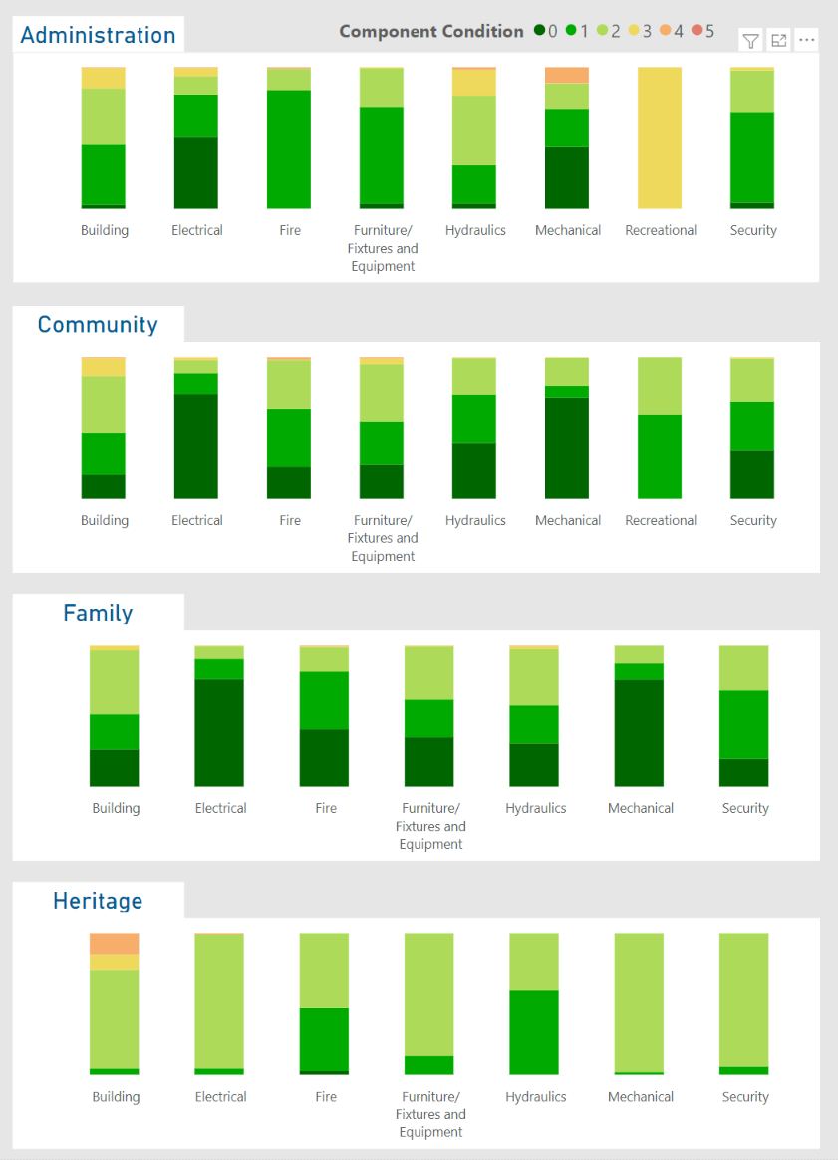

Figure 6.1 – Current Condition by Component for Administration, Community, Family, and Heritage Service Categories.
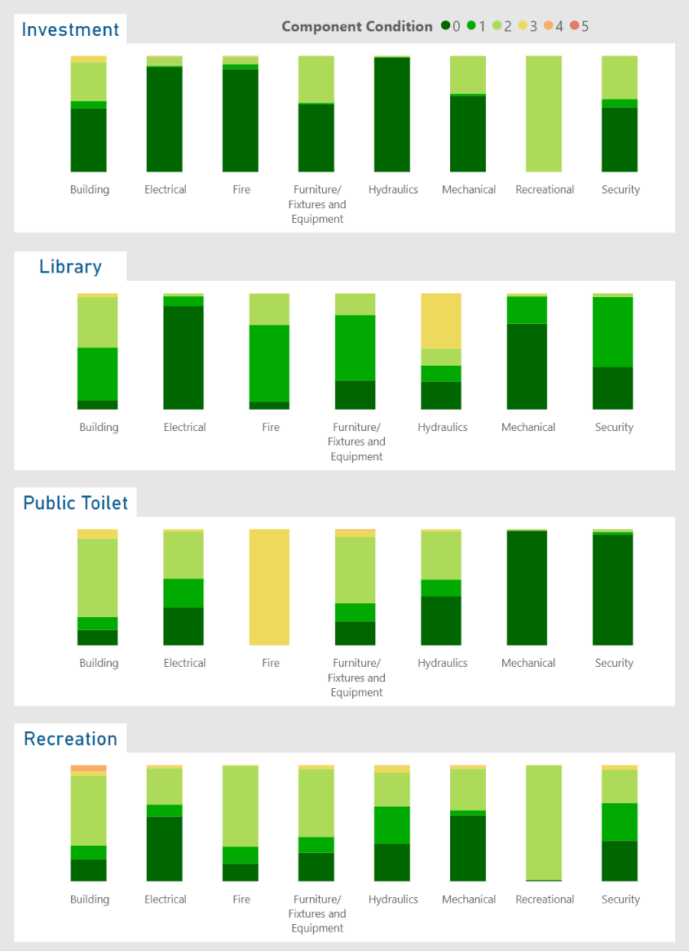

Figure 6.2 – Current Condition by Component for Investment, Library, Public Toilet and Recreation Service Categories.

Operations
Operational activities are the ongoing, day to day actions and overheads required for the asset to operate effectively and safely in delivering the desired level of service. This includes utilities, condition inspections, and cleaning. The overview of current operational activities across all facilities and their associated costs are shown in Table 7.1.

Table 7.1 – Operational Activities and Expenditure (2021, $,000)
Activity Type | Cost
Contract Cleaning | 1,802
Utilities - Electricity | 1,020
Utilities - Water | 320
Utilities - Gas | 405
Insurance | 524
Security Systems | 149
Total | 4,220
Part of the operational requirements of managing buildings is undertaking inspections and audits. This is to ensure that the desired level of service is being met and to ensure compliance with legislative requirements designed to ensure user safety. The frequencies of inspections are shown in Table 7.2 below.

Table 7.2 – Building Inspection Type and Frequency
Inspection type | Description | Frequency
Essential Services Audits | Audit of essential services such as Emergency lighting, Fire panels, Fire extinguishers, Paths of travel, and Hydrostatic hydrant tests. | Quarterly
Routine Inspections | Check for any maintenance issues that have arisen since the last inspection.  Undertake legislated or critical inspections such as HVAC or Mechanical services audits. | 6 Monthly
Condition Inspections | Assess condition, assess for impairment, and inform renewal projections. | 2 Yearly
Asbestos Audits | Inspection and monitoring of asbestos within buildings to ensure that it is stable and health risks are minimised. | 5 Yearly

Maintenance
Maintenance activities refer to the ongoing, day to day actions that are necessary to ensure the assets provide the level of service desired and reach their anticipated useful life. As assets degrade, maintenance activities and their associated costs increase. This is as poorer condition assets require additional intervention to maintain the desired level of service. Maintenance activities are demarcated into two categories for budgeting purposes:
- Planned/Routine Maintenance: Planned maintenance works are any necessary periodic works carried out to ensure the reliability or to sustain the design life of an asset. Typical planned maintenance activities include servicing of HVAC systems and servicing of lifts.
- Reactive Maintenance: Reactive maintenance works are undertaken in response to inspections, assessments, or customer requests where an asset is identified as non-functional or damaged. Typical reactive maintenance activities for buildings include clearing a blocked sump, repairing a flickering light, patching a hole in a wall, or replacing minor fixed plant and equipment after a breakdown.
Where possible, Council intends to manage assets in such a way that maximises planned maintenance and minimises reactive maintenance. This provides the best service for the community with the fewest disruptions, reduces the asset lifecycle cost and mitigates risk.
Current maintenance costs by service category are shown in Table 8.1.

Table 8.1 – Maintenance Expenditure (2021, $,000)
Service Category | Annual Cost
Administration | 667
Community | 1,086
Family | 1,009
Heritage | 35
Investment | 213
Library | 159
Public Toilet | 190
Recreation | 1,950
Other | 19
Total | 5,328

Capital Renewal / Refurbishment
Capital renewal and refurbishment primarily refers to any works required to replace or restore an existing asset to a new or as new condition. Common examples include painting internal walls, replacing the HVAC system, or the refurbishing of fit out and finishes without expanding the services provided. Council undertakes renewals to meet the desired levels of service defined in Table 5.1 by undertaking works at the end of service life as per Table 6.2.
The service lives defined are the averaged life for an asset component, thus each individual asset may have some variance from that averaged life. Renewal programs are reviewed, and specific components are physically inspected during the 6-montly inspection cycles, so work prioritisation can be adjusted for any environmental impacts that extend or reduce service life.
An analysis has been undertaken to assess assets that will degrade to their intervention level and are unable to be funded in the year their renewal is modelled to be required. This is defined as backlog and is shown in Table 9.1. The available funding is not all explicitly designated by the service categories, so where possible it has been allocated to the planned category, otherwise funding priorities are determined by the best return on investment. Factors such as community need, external funding opportunities, or environmental factors may change the allocation of funding in future years to best deliver the level of service the community requires, and this is reviewed through the works planning process. Further detail is provided in Appendix A.

Table 9.1 – Renewal Expenditure, Requirements and Backlog ($,000)
Service Category | Annualised Renewal Budget¹ | Annualised Required Works¹ | Annualised Average Gap¹ | Current Backlog | 15 Year Backlog
Administration | 3,186 | 603 | 257 | 27 | 3,889
Community | 3,186 | 768 | 309 | 22 | 4,655
Family | 3,186 | 941 | 284 | 2 | 4,269
Heritage | 3,186 | 20 | 2 | - | 37
Investment | 3,186 | 178 | 81 | 11 | 1,228
Library | 3,186 | 164 | 96 | - | 1,434
Public Toilet | 3,186 | 30 | 11 | 2 | 166
Recreation | 3,186 | 1,813 | 650 | 20 | 9,767
Other | 3,186 | 601 | 242 | - | 3,625
Total | 3,186 | 5,118 | 1,932 | 84 | 29,070
Note:
^{1.} Budget figures are a 15-year average. Refer Appendix A for details.
The existing backlog is addressed within the first year of this plan, and future backlog does not start to arise until 2030/31. Council is aware of this future requirement, will monitor the performance of the building assets, and will review funding availability in these later years.

New Assets and Capital Upgrades

Overview
New assets are defined as assets that are created to meet an additional or previously unaddressed service level requirement, such as provision of additional public toilets or a new aquatic centre. Capital upgrades are defined as works that are undertaken to enhance the level of service delivered by an existing asset, such as the upgrade and expansion of the Mill Park Leisure Services Centre.
The City of Whittlesea has three primary ways new assets and capital upgrades are undertaken:
- Private Developments: When private development of land parcels occurs, the required infrastructure is constructed by the developer or their representative. This is completed in alignment with Precinct Structure Plans/Development Plans and is primarily Transport and Parks and Open Space related assets.
- Infrastructure Contributions Projects: Private developments increase the demand on the wider building services through generating new communities with service needs. Precinct Structure Plans/Development Plans contain an infrastructure contribution plan which specifies the financial contribution each development must make towards providing the required buildings and facilities. Council is then required to undertake or facilitate the delivery of these works and is liable for managing any shortfalls during delivery.
- Council 4-15 Year New Works Program: Council has a New Works Program that addresses the need for new or upgraded assets throughout the municipality. This is primarily funded by Council with the opportunity to source additional funding via grants. To ensure clarity in the planning cycle and when all infrastructure is being provided, Infrastructure Contribution Projects are also scheduled in this program with the funding noted as coming from the development process.
Precinct Structure Plans, Development Plans, and Infrastructure Contribution Plans can be accessed at the Victorian Planning Authority Website: https://vpa.vic.gov.au/about/project-list/

Private Developments
Private developments do not directly affect the growth of the building assets portfolio as the assets constructed by developers are primarily transport or parks and open space related. However, private developments do increase the demand on existing building facilities through new residents accessing services through those facilities, and thus often new facilities are required to be constructed within Infrastructure Contribution Projects to meet this increased level of demand on services. Council undertakes an analysis of the most effective time to deliver additional facilities within private development areas; they need to be delivered early enough to ensure that residents moving into new subdivisions have access to services, but not so early that the facilities are underutilised, or the facility is overservicing the community.
The rate of private developments and associated population growth is anticipated to continue through to at least 2040 when the anticipated population of approximately 382,900 is realised, and the rate of acquisition of new buildings and facilities is anticipated to continue through this period.

Infrastructure Contributions Projects
Infrastructure Contributions Projects (ICPs) are identified in Precinct Structure Plans (PSP) with a defined scope of works. These projects include a cost estimate determined by the Victorian Planning Agency (VPA) as at the time the PSP is adopted, and Council collects this from the developments as part of their development process.
Council plans for ICPs in the New Works Program alongside prioritised capital works on an as needs basis or, if deemed beneficial to the community, will negotiate the delivery of this infrastructure by developers whilst they are on site constructing their own works. There are currently 40 new building projects identified within the New Works Program that are ICP related and are anticipated to be delivered within the next 15 years, as per Figure 10.1.

Figure 10.1 – Anticipated Additional Buildings Constructed from ICPs/DCPs
It is noted that there is a significant liability to Council that has been identified within the ICPs. This is caused by the contribution amounts being determined when the PSPs were adopted and changing design standards and construction costs increase the current day cost of the required works. The extent of this and the risk posed to Council is under review.

Councils 4-15 Year New Works Program
Council plans the construction of building capital works, as determined from changing desired levels of service for a growing municipality, through the 4-15 Year New Works Program. This program covers the next 15 years of capital works and is assessed and reviewed in conjunction with the annual budget review process. Available funding is balanced between all asset classes on an as needs basis per year.
The major projects that Council is currently undertaking are listed on Council’s website available at Major Council projects - Whittlesea Council.
The distribution of this funding for Building assets between Expansion, Renewal, Upgrade, and New throughout the first 10 years of the program is as per Figure 10.2. Whilst the program covers 15 years, this funding breakdown is currently only available for the first 10 years.

Figure 10.2 - Capital Expenditure
Whilst the new works program lists the anticipated new, expansion, and upgrade of existing buildings and the associated costs, there is currently limited details on the specifics of each facility’s design within the program. This makes projecting the operating and maintenance costs for the buildings challenging. A typical building footprint has been used per facility type for strategic planning purposes. Future iterations of this plan will identify proposed building footprints for more accurate budget projection purposes.

Transfers and Disposal Plan
Council’s building portfolio has a range of building categories that all serve a different role in the delivery of services by Council to the community. This includes facilities Council directly operates, facilities managed by other organisations to deliver services on behalf of Council and buildings held for future potential financial gain.
The role the building fulfils for Council’s service delivery defines the method of disposal. For example, buildings that Council uses regularly to deliver services will require replacement or relocation to ensure the continuation of those services, while buildings held for future economic benefit will be sold on the market at a period where the best return will be realised or when funding is required to address specific community needs.
At this stage, there are no buildings or facilities identified for disposal.

Lifecycle Costs - Annualised
To ensure effective planning of future capital works and that the additional operational and capital costs generated from vested assets is understood and accounted for, Council undertakes an assessment of the annual cost of managing the current asset portfolio. Operational and Maintenance expenditure is reviewed against the current portfolio to determine a unit rate per square meter of floor space. Council’s buildings are in a variety of conditions, from near-new to approaching need for refurbishment, so the existing costs give an indicative estimate of the future costs a new building will impose on Council throughout its lifecycle.
Depreciation is used as a proxy assessment for capital renewal requirements. With service lives ranging between 7-60 years, and useful lives being up to 90 years, the assessment period for future renewals can have a significant impact on the lifecycle renewal requirements. Depreciation is applied consistently throughout the life of the asset and gives Council the capacity to calculate future financial ratios for different long term financial plan and capital delivery scenarios.
Table 12.1 shows the current assessment of the building asset lifecycle costing.

Table 12.1 – Indicative Lifecycle Costings ($)
 |  | Annual Costs ($)
Service Category | Unit | Ops and Mtnce | Depreciation Cost | Total Cost
Administration | Per sqm | 75.9 | 55.2 | 131.1
Community | Per sqm | 122.3 | 67.6 | 189.9
Family | Per sqm | 90.7 | 71.6 | 162.3
Heritage | Per sqm | 86.7 | 89.3 | 176.0
Investment | Per sqm | 36.7 | 32.8 | 69.4
Library | Per sqm | 57.3 | 73.8 | 131.2
Public Toilet | Per sqm | 835.1 | 150.9 | 986.0
Recreation | Per sqm | 72.4 | 49.5 | 121.9

The ‘Other’ Service Category, as used for building components common to multiple services, does not have a footprint and thus a unit rate cannot be calculated. The cost associated has been distributed across the other service categories to account for this.

Financial Indicators
Council uses financial indicators to reflect on the past year’s performance of its current asset management practices. This assists with identifying if there are specific areas that need attention or if the current practice is appropriate for the organisation and community.
Asset Sustainability for 2021/22:
$\frac{\$1.45M}{\$6.55M}$ = 22%
The Asset Sustainability ratio is a financial estimate of whether assets are being replaced at the same rate that they are deteriorating. It is calculated by dividing the annual renewal expenditure by annual depreciation and is generally targeted at around 100%.
Whilst the result of 22% is significantly below the target, this ratio should be considered alongside the asset renewal funding ratio and rolling backlog. The low ratio here is due to the long life of infrastructure assets meaning that a low volume of work is required now, but there will be a high volume required in the future as can be seen from the projected backlog.
Asset Renewal Funding for 2021/22:
$\frac{\$1.45M}{\$1.54M}$ = 95%
The Asset Renewal Funding ratio is a measure of how effectively Council is currently funding renewals by comparing the available renewal funding against the currently identified deliverable bank of works within the Asset Management Plan. It is calculated by dividing the Net Present Value of the funded renewal works by the Net Present Value of the desired capital renewal works.
Remaining Service Potential for 2021/22:
$\frac{\$285M}{\$473M}$ = 60%
The Remaining Service Potential is a financial estimate of the overall aged condition of a local government’s assets. It gives an approximate percentage remaining life of the network and is calculated by dividing the Fair Value by the Current Replacement Cost.
Average Annual Asset Consumption for 2021/22:
$\frac{\$6.55M}{\$473.38M}$ = 1.38%
The Average Annual Asset Consumption assesses the rate at which assets are being consumed and are losing their service potential. It is calculated by dividing the annual depreciation by the depreciable replacement cost.

Risk Management
Council is committed to providing and maintaining a healthy and safe environment for the internal and external community. Council has determined a Hazard Identification, Risk Assessment and Control (HIRAC) procedure to outline how to assess and mitigate risks. In this plan’s context, the risks relate to business planning, management, service delivery and physical asset failure; that is, the risks in the building assets achieving the desired strategic objectives discussed in Section 3 and levels of service discussed in Table 5.1. The key strategic risks are outlined in Table 12.1.

Table 12.1 – Critical Strategic Risks
Risk | Consequence | Severity | Control Measures | Residual Severity
Failure to meet Levels of Service. | Resident unrest and frustration, reputational damage, economic loss within municipality, health and safety risk. | High | Ongoing monitoring of delivery of service levels and community expectation, prioritisation of actions to meet levels of service. | Low
Insufficient funding allocated to asset renewals. | Service levels decline, unprotected assets degrade faster than anticipated, user safety declines, resident unrest. | High | Prioritise renewal of ‘protective’ assets, review conditions and funding annually, monitor network performance. | Low
Vested asset quality doesn’t meet standards. | Increased cost liability, user safety declines, reputational damage. | High | Clearly define design and performance standards for new assets, suitably resource vested asset supervision and defect assessment processes. | Low
Construction costs of Infrastructure Contributions Projects exceed collected funds. | Construction of development required buildings at Council’s cost, limited ability to fund other required works. | High | Identify projects, update project costs, manage development construction stage timings, monitor estimated costs of delivering works against available funding. | Medium
Insufficient public gathering spaces for community. | Lack of community meeting spaces, inability for community to come together, resident unrest. | High | Ongoing monitoring of buildings and facilities utilisation, proactively providing service solutions (advocacy, public-private partnership, new assets). | Low
Technological advancements. | Extensive building network unsuited to task, inability to quickly adjust to changes in user behaviour. | Unknown | Monitor technological advancements, actively utilise Internet of Things opportunities, work with industry leaders in technological development. | Unknown

Improvement Plan
The City of Whittlesea recognises that there is opportunity to improve asset management processes to ensure that the services provided by Council match the services desired by the community in the most effective means. Council has adopted an iterative, continual improvement approach to its asset management processes to achieve this.
General improvement actions have been outlined in the Asset Management Strategy. Further to these, buildings asset specific improvement actions are listed in Table 15.1.

Table 15.1 – Buildings Asset Management Improvement Plan
Opportunity/Action | Responsibility | Timeframe | Progress (%)
Monitor building component deterioration through inspection and condition audit processes and ensure that modelling and funding projections reflect the performance of the components. | Assets Team  Service Providers | Ongoing | Ongoing
Review the anticipated delivery timeframes and details of buildings from developments and Council’s Capital Works Program and update future modelling to suit. | Assets Team  Service Providers | Ongoing | Ongoing
Monitor and update building service criteria and level of service metrics to ensure they accurately reflect the community requirements. | Assets Team  Service Providers | Ongoing | Ongoing
Expand levels of service to have a specific metric for the performance of each of the Service Categories. | Assets Team  Service Providers | Jun 2023 | 0%
Identify and record the critical buildings for Council service delivery within the Asset Management System. | Assets Team  Service Providers | Jun 2023 | 0%
Ensure that emergency response facilities are identified and prioritised in available funding modelling. | Assets Team  Service Providers | Jun 2023 | 0%
Improve the integration between Council’s Asset Information Management System (Assetic) and the contractors for timely update of asset condition data and works orders. | Assets Team | Jun 2023 | 0%
Undertake an assessment of projects in the New Works Program for years 11-15 for renewal/upgrade/expansion/new to refine the projections for those years. | Project Management Office | Jun 2023 | 0%


City of Whittlesea
Civic Centre: 25 Ferres Boulevard, South Morang
Office Hours: Monday to Friday, 8.30am to 5pm
Mail: Locked Bag 1, Bundoora MDC 3083
Telephone: 9217 2170 (24 hours)

TTY: 9217 2420 Fax: 9217 2111 Email: info@whittlesea.vic.gov.au
Web: www.whittlesea.vic.gov.au

Appendix A: Building Assets 15 Year Financial Plan ($,000)
Year | 2022/23 | 2023/24 | 2024/25 | 2025/26 | 2026/27 | 2027/28 | 2028/29 | 2029/30 | 2030/31 | 2031/32 | 2032/33 | 2033/34 | 2034/35 | 2035/36 | 2036/37 | Average
Operations Budget¹
Cleaning | 1,802 | 1,850 | 1,976 | 2,053 | 2,229 | 2,264 | 2,332 | 2,579 | 2,721 | 2,739 | 2,739 | 2,739 | 2,739 | 2,739 | 2,739 | 2,416
Security | 149 | 152 | 160 | 165 | 178 | 182 | 187 | 204 | 213 | 215 | 215 | 215 | 215 | 215 | 215 | 192
Utilities - Electricity | 1,020 | 1,038 | 1,095 | 1,129 | 1,220 | 1,244 | 1,279 | 1,394 | 1,458 | 1,471 | 1,471 | 1,471 | 1,471 | 1,471 | 1,471 | 1,314
Utilities - Water | 320 | 326 | 343 | 354 | 383 | 390 | 401 | 437 | 458 | 462 | 462 | 462 | 462 | 462 | 462 | 412
Utilities - Gas | 405 | 412 | 435 | 448 | 485 | 494 | 508 | 553 | 579 | 584 | 584 | 584 | 584 | 584 | 584 | 522
Insurance | 524 | 533 | 562 | 580 | 627 | 639 | 657 | 716 | 749 | 756 | 756 | 756 | 756 | 756 | 756 | 675
Total | 4,220 | 4,311 | 4,571 | 4,729 | 5,122 | 5,213 | 5,364 | 5,883 | 6,178 | 6,227 | 6,227 | 6,227 | 6,227 | 6,227 | 6,227 | 5,530
Maintenance Budget¹
Administration | 667 | 672 | 679 | 670 | 688 | 686 | 696 | 680 | 689 | 708 | 710 | 716 | 722 | 736 | 751 | 698
Community | 1,086 | 1,186 | 1,394 | 1,508 | 1,720 | 1,716 | 1,802 | 2,104 | 2,334 | 2,364 | 2,368 | 2,378 | 2,388 | 2,409 | 2,435 | 1,946
Family | 1,009 | 1,017 | 1,027 | 1,014 | 1,165 | 1,238 | 1,253 | 1,290 | 1,305 | 1,333 | 1,336 | 1,345 | 1,355 | 1,375 | 1,398 | 1,231
Heritage | 35 | 35 | 36 | 35 | 36 | 36 | 37 | 36 | 36 | 37 | 37 | 38 | 38 | 39 | 39 | 37
Investment | 213 | 215 | 217 | 214 | 220 | 219 | 222 | 217 | 220 | 226 | 227 | 229 | 231 | 235 | 240 | 223
Library | 159 | 160 | 162 | 160 | 164 | 164 | 166 | 239 | 241 | 246 | 246 | 248 | 249 | 252 | 256 | 208
Public Toilet | 190 | 191 | 193 | 191 | 196 | 195 | 198 | 194 | 196 | 202 | 202 | 204 | 206 | 210 | 214 | 199
Recreation | 1,950 | 1,965 | 2,069 | 2,085 | 2,290 | 2,324 | 2,461 | 2,520 | 2,655 | 2,774 | 2,780 | 2,798 | 2,816 | 2,855 | 2,900 | 2,483
Other | 19 | 19 | 19 | 19 | 20 | 20 | 20 | 19 | 20 | 20 | 20 | 20 | 21 | 21 | 21 | 20
Total | 5,328 | 5,461 | 5,796 | 5,896 | 6,499 | 6,597 | 6,854 | 7,299 | 7,696 | 7,909 | 7,926 | 7,975 | 8,024 | 8,131 | 8,255 | 7,043
Renewal and Upgrade Budget²
New Works Program – Renewal | 1,454 | 5,335 | 6,344 | 6,369 | 2,800 | 3,130 | 1,300 | 2,100 | 1,680 | 1,900 | 3,241 | 3,420 | 3,228 | 2,917 | 2,572 | 3,186
Total | 1,454 | 5,335 | 6,344 | 6,369 | 2,800 | 3,130 | 1,300 | 2,100 | 1,680 | 1,900 | 3,241 | 3,420 | 3,228 | 2,917 | 2,572 | 3,186
New Assets and Upgrade Budget²
New Works Program – Expansion | 0 | 500 | 1,500 | 0 | 0 | 0 | 250 | 2,750 | 0 | 0 | 625 | 703 | 729 | 632 | 632 | 555
New Works Program – New | 2,010 | 3,601 | 21,074 | 62,370 | 12,980 | 1,200 | 16,695 | 28,000 | 12,474 | 15,477 | 17,588 | 19,146 | 20,700 | 20,663 | 16,492 | 18,031
New Works Program – Upgrade | 1,787 | 1,167 | 3,995 | 2,055 | 3,575 | 2,345 | 1,325 | 3,275 | 2,295 | 475 | 2,229 | 2,274 | 2,384 | 2,223 | 2,240 | 2,243
Total | 3,797 | 5,268 | 26,569 | 64,425 | 16,555 | 3,545 | 18,270 | 34,025 | 14,769 | 15,952 | 20,442 | 22,123 | 23,813 | 23,518 | 19,364 | 20,829
Grand Total Expenditure | 14,798 | 20,374 | 43,279 | 81,419 | 30,976 | 18,484 | 31,789 | 49,307 | 30,323 | 31,988 | 37,837 | 39,745 | 41,293 | 40,793 | 36,418 | 36,588
Rolling Backlog | 84 | 0 | 0 | 0 | 0 | 0 | 0 | 0 | 1,707 | 5,936 | 10,212 | 12,360 | 12,611 | 20,560 | 29,070
Note:
^{1.} Operations and Maintenance budgets include the anticipated additional costs for the new building assets in Section 10 as per the lifecycle costs in Section 12.
^{2.} Categorisation of works in the New Works Program between Renewal, Upgrade, Expansion, and New is not currently available for 32/33 to 36/37. These years use an average of the preceding 10-year period to ensure that renewal and backlog projections are visible outside of the 10-year Long Term Financial Planning Period.

International Infrastructure Management Manual, IPWEA, 2020.
Guidelines for Developing an Asset Management Policy, Strategy and Plan, Department for Victorian Communities, 2004.

