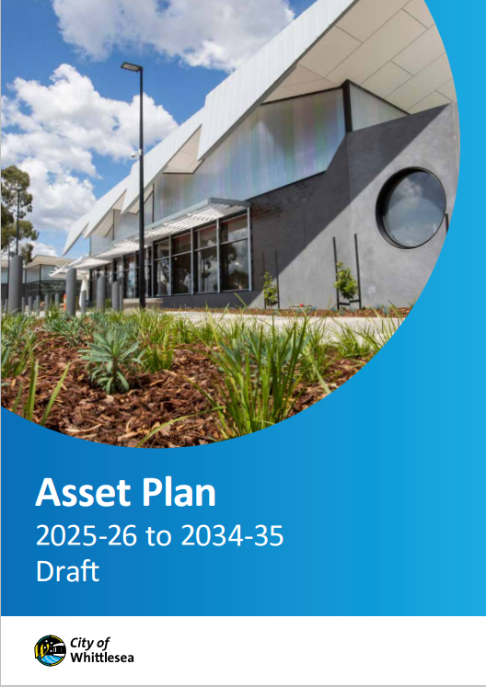
Draft Asset plan 2025-26 TO 2034-35
Engagement Summary
16 April – 11 May 2025

Introduction
The City of Whittlesea’s proposed Asset Plan 2025-26 to 2034-35 is a document that outlines how the City of Whittlesea will plan, build, manage and maintain our assets over the next ten years to ensure they meet the needs of our growing community now and into the future. This document will update our Asset Plan 2022-32 and covers all of Council’s physical assets including roads, footpaths, playgrounds, storm water, open spaces and buildings.

The proposed Asset Plan was developed considering feedback received during a comprehensive engagement program tailored to the project and as part of the Community Priorities engagement program that heard from over 900 participants across 13 community-based pop-ups combined, a community check in consultation and 5 Focus Groups held between August 2024 to February 2025.

The proposed Asset Plan was presented to community for feedback between 16 April and 11 May 2025 with participants asked whether they supported the Plan and if they didn’t to explain why. Participation was available online through the Engage Whittlesea platform or in-person at a series of eight community-based pop-up stalls scheduled across the municipality in high foot traffic locations.

To avoid consultation fatigue, the project was co-located with the Proposed Budget 2025-26, Proposed Financial Plan 2025-26 to 2034-35, Rate and Revenue Plan 2025-26 to 2028-29, and, Community Vision Review projects that were also open for comment.

Sixty-six people participated in the consultation and told us that majority (95%) supported the proposed Asset Plan 2025-26 to 2034-35. Those that were not supportive of the draft indicated a need to address community safety, cleaner neighbourhoods and cost of living via the use of our assets as their reason.

Project Promotion
The opportunity to participate in the community engagement was promoted through a range of channels to have a widespread reach across the municipality including:

- Council’s digital engagement platform Engage Whittlesea
- Social media – organic posts accounted for 12% of traffic to the Engage page
- Email with direct link to the project page accounted for 37% of traffic to the page and was sent to:
- Ageing well and multicultural groups data base
- Sports and Aquatic Clubs
- Youth Services network
- Library and Community Hubs users
- Ageing Well database
- Whittlesea Disability Network (WDN) via the WDN Hub on the Engage Whittlesea platform
- First Peoples network
- Community Priorities Focus Group participants
- Promotion on screens at Civic Centre, Libraries and aquatic centres.

How we engaged you
The proposed Asset Plan 2025-26 to 2034-35 project page on the Engage Whittlesea platform encouraged participants to share whether they supported the draft plan. There was also free text space provided for participants to add further comments if they selected no as a response.
The Engage Whittlesea platform utilises an accessibility add-on ensuring that it is as accessible as possible for all users. The platform also has an in-built translation tool to mitigate any language barriers to participation, allowing the page to be translated into the top fifteen languages spoken within the municipality. ​
As the Asset Plan is a technical document, we made it easy for community to easily identify key inclusions and understand the plan. Activity boards (image below) were used at in-person engagement activities that presented six key inclusions as dot points and used an infographic to highlight the types of assets Council manages. This information was mirrored on the project Engage Whittlesea page.
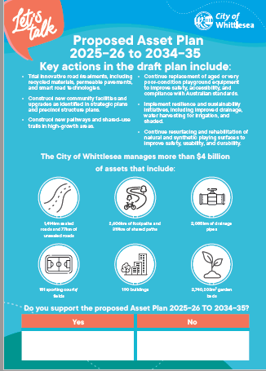
Above: Image of the activity board used at community-based pop-up stalls
To inform community and to ​hear from a diverse range of community members and increase participation, the project team hosted eight in-person engagement activities across the municipality.
Date | Time | Where | Address/location
16 April 2025 | 5pm-7pm | Kirrip Community Centre | 135 De Rossi Blvd, Wollert
28 April 2025 | 9.30am -11.30am | Lalor Library | 2a May Rd, Lalor
28 April 2025 | 2.30pm -4.30pm | Thomastown Library | 52 Main St, Thomastown
29 April 2025 | 9.30am -11.30am | Westfield Plenty Valley | 415 McDonalds Rd, South Morang
29 April 2025 | 2.30pm -4.30pm | Laurimar Shopping Centre | 101 Hazel Glen Drive, Doreen
30 April 2025 | 9.30am -11.30am | Shared Cup Café | 995 Donnybrook Rd, Donnybrook
30 April 2025 | 2.30pm- 4.30pm | Mernda Village Shopping Centre | 59 Mernda Village Drive, Mernda
2 May 2025 | 9.30am -11.30am | Coles University Hill | 2 Janefield Drive, Bundoora

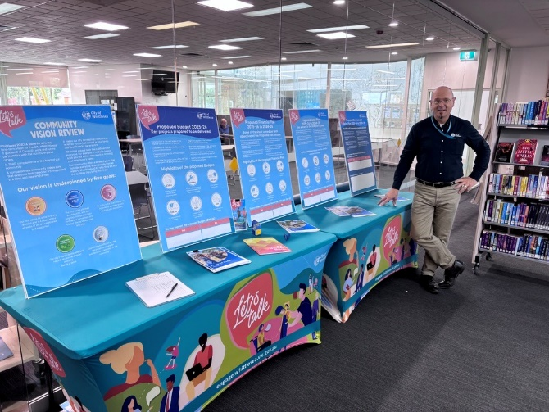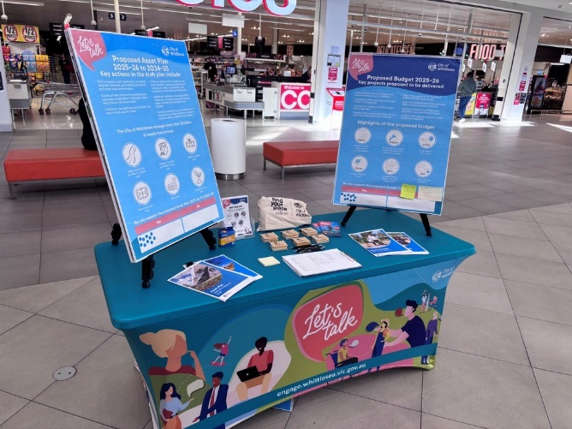
Above: Images form the community pop up stalls

Participation

Snapshot of Community Participation in this final phase of the engagement on the Asset Plan
Key highlights from the community consultation included:

Downloads | Community-based Pop-Ups | Digital Engagement | In-person Engagement
 |  |  | 
108 Downloads of the proposed document | Hosted 8 community-based pop-ups | 187 views  167 visits  4 contributions | 62 in-person contributions

Snapshot of demographics of the broader community consultation
A total of 66 community members participated in the consultation, four online and 62 at in-person community-based pop-up stalls. Below is a snapshot of the diversity of participation in the community engagement, which is representative of our broader community:
Gender Identity | Age | Suburb
 |  | 
45% Female, 53% Male  2% did not say | All age brackets participated with the most represented being 35-44 years (22%) and 45-54 years (18%) | Participants came from 12 suburbs, with the highest participation coming from Mernda (21%) and Wollert (15%)
LGBTIQA+ Community | Multiculatural community
 | 
6% of participants identified as members of the LGBTIQA+ community | 52% of participants spoke English as a second language
First Peoples | People with disability
 | 
6% of participants identified as first people | 8% of participants were people with a disability or carers of a person with disability
What we heard from the community consultation

Do you support the proposed Asset Plan 2025-26 to 2034-35?
Majority of the 66 participants were supportive of the proposed Asset Plan 2025-26 to 2034-35. What we heard is as below:
 
94% Yes 6% No
One of the four online participant commented the reason they didn’t support the proposed Asset Plan was because it didn’t mention the Mernda to Whittlesea rail trail.
Other comments captured at the community-based pop-up stalls
There were 14 additional comments captured at in-person engagement activities that focused on themes such as community safety, cleaner more appealing neighbourhoods and cost of living.
“Increase in crime - need to increase safety in the community and neighbourhoods”
“Shared pathways on Plenty Road not used properly by e-scooters. they need to have a horn to warn others when travelling fast past pedestrians. Plus, they should have speed limits to abide by””
“Need cleaner, neater neighbourhoods”
“Affordable housing needed in area”

Next Steps
Thank you to everyone who shared feedback through our proposed Asset Plan 2025-26 to 2034-35 with us either in-person at a community-based pop-ups or online through the Engage Whittlesea platform. Your feedback will be considered as we prepare the final plan that will be presented to Council for endorsement at the Council Meeting scheduled 17 June 2025. We will share the final documents and encourage you to follow the project Engage page
(www.engagewhittlesea.vic.gov.au/assetplan25) to be kept up to date as these are finalised.

