City of Whittlesea

Draft Asset Plan

May 2022

Table of Contents
Introduction 4
What is an Asset? 5
Asset Management Framework 5
Purpose of the Asset Plan 6
Scope of the Asset Plan 6
State of our Assets 7
Our Assets 7
State of the Asset Reports 9
Financial Plan 11
Transport AMP Overview 12
Parks and Open Space AMP Overview 13
Buildings and Facilities AMP Overview 14
Future Risks and Challenges 15
Improvement Plan 17
Assumptions 17

Introduction
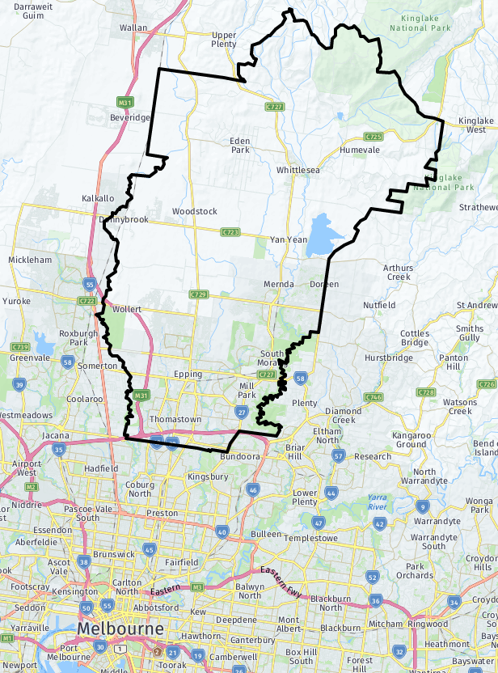
The City of Whittlesea is in Melbourne’s north, approximately 20 kilometres from the Melbourne CBD. It is one of the largest metropolitan municipalities that covers an area of approximately 489km², with about 30 per cent urban area and the remaining 70 per cent rural. The population is currently 249,100 and is forecast to increase to 382,900 by 2040.
The City of Whittlesea is made up of the suburbs and rural localities of Beveridge, Bundoora, Donnybrook, Doreen, Eden Park, Epping, Humevale, Kinglake West, Lalor, Mernda, Mill Park, South Morang, Thomastown, Whittlesea, Wollert, Woodstock, and Yan Yean. The highest growth areas over the next 20 years are anticipated to be Epping North, Wollert, and Donnybrook.
There is a rich pool of language and cultural heritage in the community, with approximately 36 per cent of residents born overseas, almost half of all residents speaking a language other than English at home, and the second largest Aboriginal and Torres Strait Islander population in metro Melbourne.

Figure 1 – City of Whittlesea
The City of Whittlesea is a family-friendly place. We have a higher proportion of families with children compared to the Northern Melbourne region and Metropolitan Melbourne. Although the population will age into the future, the community will remain predominantly younger families.

What is an Asset?
The most basic definition of an asset is something that has value to a person, organisation, or community. Assets can be tangible, meaning that they are physical and can be touched, or they can be intangible, like financial assets or intellectual property. This plan covers the tangible infrastructure assets managed by the City of Whittlesea.
There are a significant number of assets within the municipality that are managed by other government bodies such as freeways and arterial roads managed by the Department of Transport, major drainage systems managed by Melbourne Water, or National Parks managed by Parks Victoria. These assets are managed by their respective organisations and are not included in this plan.

Asset Management Framework
The City of Whittlesea manages assets to deliver the services our community desires. A Strategic Asset Management framework is utilised to provide a systematic approach that delivers outputs and outcomes meeting both our corporate objectives and community needs and expectations.
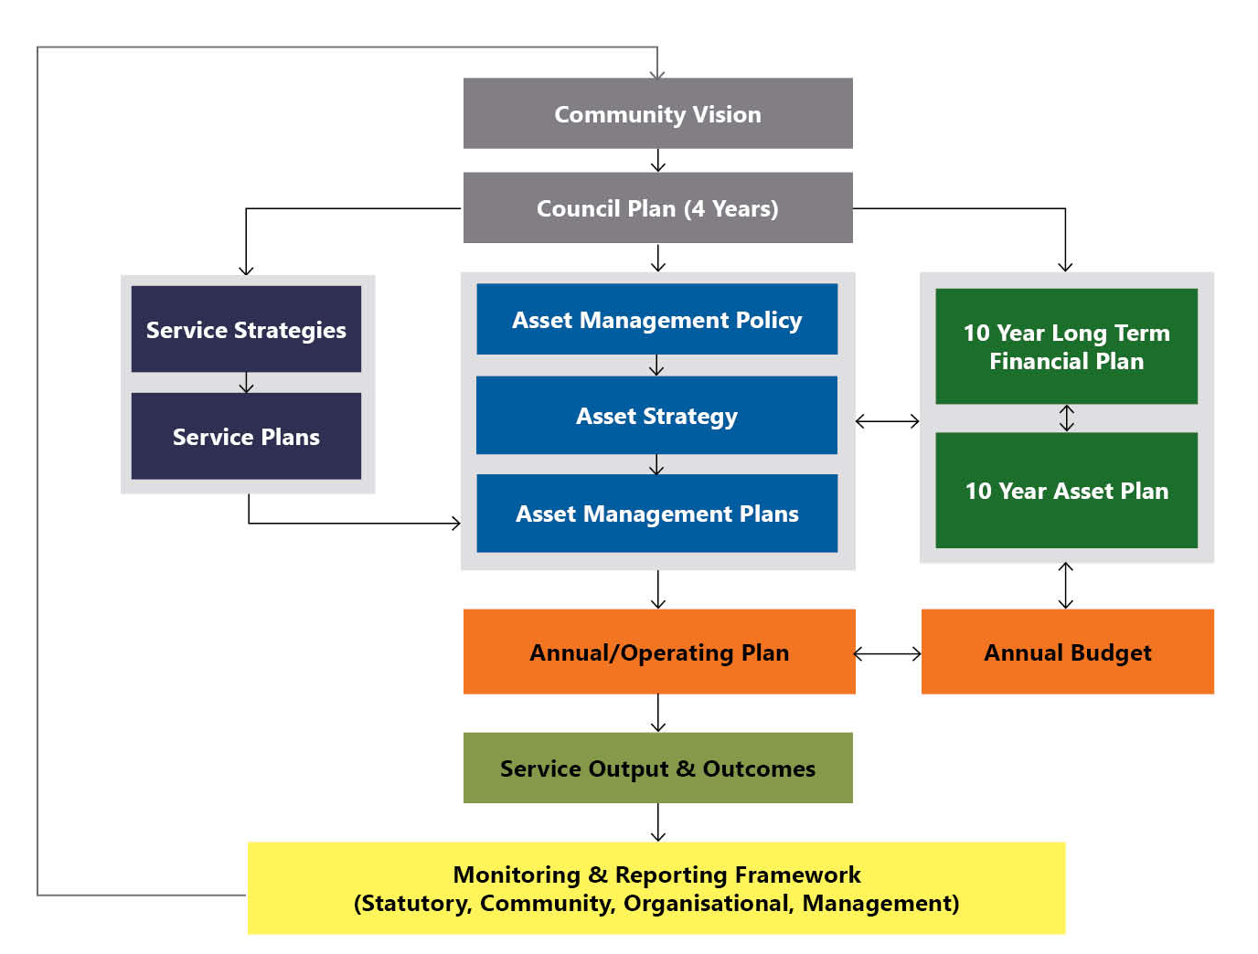
Figure 2 – Strategic Asset Management Framework
Figure 2 provides an overview of that framework, demonstrates the interrelationship between key elements and serves to highlight the various opportunities for community engagement that serve to guide and influence Council’s strategic planning for and management of its asset portfolio.
The Community Vision is known as Whittlesea 2040 – a place for all, and the Council Plan is known as the Community Plan 2021-2025.

Purpose of the Asset Plan
With over $3.2 billion worth of infrastructure assets across the municipality, it was important to develop an over-arching plan that supports our Community Plan to ensure our assets are strategically managed to meet our community’s current and future needs.
In accordance with the Victorian Local Government Act 2020, the Asset Plan is a strategic public facing document that informs the community on how council-controlled infrastructure is to be managed to achieve the Whittlesea 2040 goals.
In keeping with the ‘enabling nature’ of the Act, the purpose of the Asset Plan is to:
- better inform the community on the type of assets under council management.
- improve the efficiency and effectiveness of asset management practices through a more engaged community and informed council.
- show how we will responsibly manage our assets to meet the service delivery needs of our community into the future in a cost-effective way.
- summarise the operating and capital expenditure requirements for our assets.
- ensure that there is integration between our asset management planning outcomes and our strategic objectives, Financial Plan, and Budget.
- maximise alignment with Council, Regional and Government Strategies, Policies and Plans that affect the management of our assets.
- make sure that we comply with our legislative obligations.
Assumptions and forecasts will change based on enhancement of our asset knowledge along with the ever evolving internal and external drivers. This Asset Plan will be actively monitored and updated to reflect any major changes.

Scope of the Asset Plan

While we manage an extensive portfolio of assets, this Asset Plan only covers the infrastructure that is under the control of Council. Our infrastructure assets are managed through three portfolios as follows:
Transport: Assets associated with getting from A to B, such as roads, bridges, pathways, and public lighting for our community to get around, or drainage to facilitate stormwater getting to waterways and water bodies without blocking roads and impedeing our community movements.


Parks and Open Space: Assets associated with conserving our native flora and fauna, managing our green assets such as trees and gardens, and providing places and spaces for recreational use. Recreation use can be either passive, such as local parks or walking trails, or active such as sporting facilities.
Buildings and Facilities: Assets that deliver services either directly through buildings such as kindergartens, maternal child health, and pavilions, or indirectly through providing operational spaces for and places to engage with Council staff such as the Civic Centre or works depots.

State of our Assets

Our assets
We manage a total portfolio of assets worth over $4.75 billion. This includes all our land, property, plant and equipment, and infrastructure. These assets have been built up over many years in response to service provision needs, either to provide services directly or in supporting service delivery indirectly.
Our infrastructure assets covered by this Asset Plan are collectively worth close to $3.2 billion. A breakdown of the infrastructure asset types by their value is shown in Figure 3.

Figure 3 – Asset Types by Value
Council manages the data for these assets in its Asset Information Management System, Assetic. There are currently around 475,000 assets registered in the system, each with their own valuation and work order history. This level of detail enables Council to know what it is responsible for, monitor the asset performances, revalue them in accordance with accounting requirements, keep maintenance records against each specific asset, and ensure that all assets are managed appropriately in the most cost-effective manner.
The quantity and value of assets that Council manages are shown in Table 1.
Table 1 – Asset Quantity and Value by Type
Asset Type | Quantity | Replacement Cost ($M) | Fair Value ($M)
Bridges | 43 Concrete Bridges  42 Bridge sized Culverts | $21.3 | $13.8
Drainage | 1,897km of drainage pipes  73,170 drainage pits | $609.8 | $485.0
Footpaths and Cycleways | 1,824km Pathways | $223.0 | $180.5
Public Lighting | 13,257 non-standard light poles with 15,362 lights attached | $30.0 | $13.0
Roads | 1,275km of Sealed Road  85.4km of Unsealed Road | $1,467.7 | $1,181.2
Telecommunications | 582km of fibre optic cables | $26.5 | $19.7
Parks, Open Space and Streetscape | 1,632ha of Passive Open Space  180ha Active Open Space  Includes 259 Playgrounds, 74 Sporting Ovals and over 100,000 trees | $308.8 | $201.6
Buildings | 197 Buildings | $473.4 | $285.0
Replacement Cost is the anticipated cost to construct the same asset, or an asset using modern construction methods and materials that provides the same service, in a greenfield environment; that is, constructing a new asset without having to remove the existing asset, use extra safety measures designed to protect the public, or have complex survey and design processes to account for existing infrastructure.
Fair Value is what the assets are currently valued at and what the asset could theoretically be sold for if there was a market for it. This considers the replacement cost, age of the asset, its current condition, and the loss of value through depreciation over the time the asset has been in use and the condition has deteriorated.

State of the Asset Reports
Council’s Asset Management Strategy, Achieving Whittlesea 2040, outlines the principles of how assets are to have their ability to deliver the required services assessed. The three elements of this assessment are:
- Condition: the physical state of the asset - this assessment is used to assess the level of service the asset delivers based on its physical condition and how long until the optimal time for replacement is.
- Capability: how fit for purpose the asset is - this assessment is used to determine how effective the asset is at meeting the service need.
- Capacity: the quantity of assets available or the volume of services the assets can accommodate - this assessment is used to determine whether more assets need to be acquired or if there are too many assets and some need to be disposed.
Council currently has processes and procedures in place to assess condition across all the asset types and is developing the required processes to assess capability and capacity. These two criteria are used in specific planning and service delivery analysis; the work that is underway is how to translate the existing processes to undertake an assessment of all asset types in a consistent and comparable manner.
The condition rating scale used by Council is shown below in Table 2.
Table 2 – Condition Rating Scale
Condition Rating | Condition Descriptor
0 | New or as new asset.
1 | Excellent - minimal maintenance may be required.
2 | Good - minor maintenance work may be required.
3 | Average - standard maintenance work required.
4 | Poor - renewal required. Asset provides a reduced level of service.
5 | Very Poor - urgent renewal required. Asset provides a significantly reduced level of service and is approaching end of life in terms of safety and usability.
6 | End of Life – asset has reached end of life and cannot be safely used.
Figure 4 shows the distribution of Council’s assets between the conditions described in Table 2. The proportion of assets in condition 0 is due to the high rate of assets being constructed by developers and handed over to Council, or Council constructing new assets to provide services to the growing community. For these new assets, and for some assets that are more challenging to condition audit the full network, such as drainage, age data has been used to calculate the anticipated condition within this report.

Figure 4 – State of the Assets Scorecard
Council’s intent is to manage the assets in the most cost-effective manner to deliver the services the community desires. This includes renewing assets when their condition is poor but, as can be seen from figure 4, some assets are currently at this condition or worse. This is known as backlog and Council has proactive plans to manage this as per the following section.

Financial Plan
Council’s annual expenditure can be summarised into two categories:
- Operational Expenditure, and
- Capital Expenditure.
Operating expenditure is expenses that are incurred within a financial year that do not provide a lasting asset for Council, whilst capital expenditure generates or renews an asset that Council keeps for multiple years and is responsible for managing into the future. Within asset management, the activities that fall under these categories are as follows:

Table 3 – Expenditure Activities and Descriptions
Expenditure Type | Asset Management Activity | Description
Operational | Operations | Recurrent expenditure that is required to use an asset such as utility costs, audit and inspection programs, cleaning, or fees paid to other organisations.
Operational | Maintenance | Scheduled work to keep assets operating at the required level of service, or reactive work to repair defects and ensure that assets meet their service life and don’t require early renewal.
Capital | Renewal | Works on assets that are at the end of life that restore their ability to deliver or facilitate the delivery of the desired service.
Capital | Expansion | Works that increase the quantity of the same services that can be delivered through an existing asset.
Capital | Upgrade | Works that increase the quality of the existing service that can be delivered through an existing asset.
Capital | New | Works that generate an asset that can provide a service that does not currently exist.
The allocation of budgets to each of these activities is managed through existing operational or capital budget processes and are reviewed each year. The currently planned budgets and how they are modelled to impact on the assets are summarised on the following pages. For more details, refer to the specific Asset Management Plans (AMPs).

Transport AMP Overview
The transport network includes roads, pathways, bridges, and drainage systems. Significant work has been undertaken over the past few years to ensure that funding levels are appropriate, and Council anticipates all roads will be in an acceptable condition by 2033/34. The remaining backlog is modelled to be in pathways and drainage, with work underway to collect further information to plan how to best address this into the future.
Total Expenditure Overview
15-Year Capital Expenditure
$464M
15-Year Operational Expenditure
$358M
Final Backlog
$14.1M
Starting Backlog
$50.5M

Projected Condition Change over Time
Asset Growth: 5-year annual average
Roads
+38.5kms/year
Pathways
+ 56.9kms/year
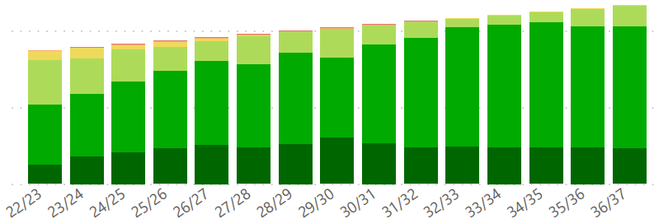
Drainage Pipes
+52.8kms/year

Parks and Open Space AMP Overview
The parks and open space network includes active areas such as sportsgrounds, passive areas such as local parks, and conservation areas. Council has focused on improving the quality of the data that informs the asset management processes over the past few years, has updated future planning as information is available, and is now actively working to determine how to address the backlog that this data is showing will arise around 2030/31.
Total Expenditure Overview
15-Year Capital Expenditure
$160M
15-Year Operational Expenditure
$85M
Final Backlog
$83M
Starting Backlog
$19M

Projected Condition Change over Time
Asset Growth: 5-year annual average
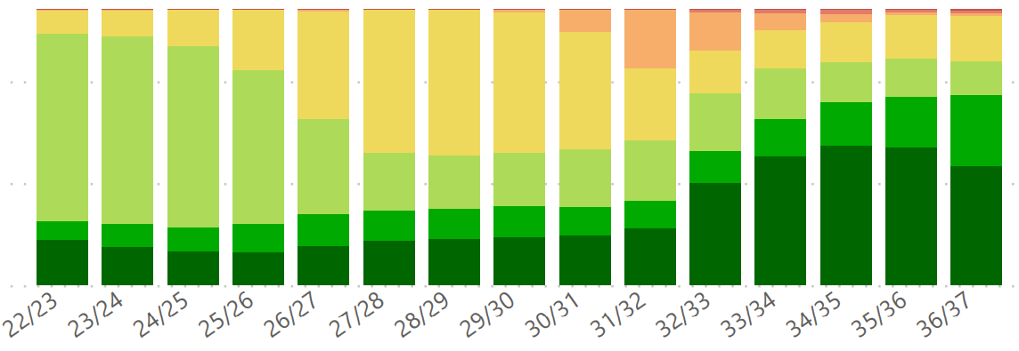
Parks Site Area
+44.7ha/year
Playgrounds
+5/year

Buildings and Facilities AMP Overview
Buildings and facilities include major facilities operated by others such as aquatic centres, buildings where services are delivered such as kindergartens or MCH, or Council offices. Council outsourced the building operational activities in 2020/21 which included a full condition audit, and that audit data indicates that Council buildings are suitably funded through to 2030/31. Council will review funding availability for the later years.
Total Expenditure Overview
15-Year Capital Expenditure
$360M
15-Year Operational Expenditure
$189M
Final Backlog
$29M
Starting Backlog
$0M

Asset Growth: Projected annual average additional buildings
Projected Condition Change over Time
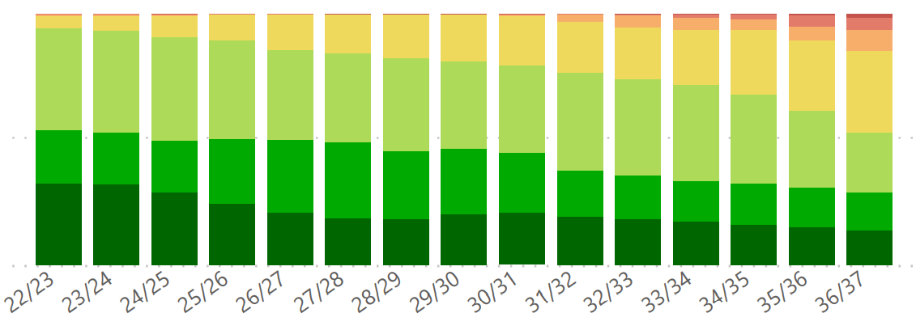
Council Constructed Buildings
+1/year

Development Buildings
+2.7/year

Future Risks and Challenges
As the City of Whittlesea continues to grow and develop, Council will need to understand the challenges and opportunities in shaping the city to meet the vision of our residents in both the established and developing areas. The Asset Management Strategy was adopted by Council in December 2018 and has identified five key themes that will need to be monitored and managed to ensure that Council can continue to provide the services our community desires in the most cost-effective manner.

Demographics
The City of Whittlesea is rapidly growing, with the population expected to almost double by 2040. This increase in our community’s population will largely be facilitated by private developers constructing the required infrastructure and vesting, or gifting, it to Council to maintain and renew. This imposes a financial burden on Council that comes with the extra revenue the growing population will generate through rates.

Service Demand Change
As the city’s population grows, the services and requirements of the community may also change. Strong population growth will remain the major factor in determining the management of assets, and the biggest change will be in the volume of services required. Council will need to resource the ongoing maintenance of the services provided through assets and continue to ensure that assets are properly managed in the established suburbs as well as the growth areas.

Technology Change
Technological advancements provide significant risk as well as opportunities for the management of assets. The high replacement value of infrastructure makes it challenging to adopt new infrastructure technology quickly, so Council will retrofit existing infrastructure with new technology primarily during the renewal of assets and utilise emerging technology to better capture data on the performance of our assets to deliver more effective and efficient services.
New and emerging technologies that may impact on the management of assets include the Internet of Things, automated vehicles, online services, interactive information portals, and augmented reality. Council will continually monitor technological developments and assess how they could be used to improve day-to-day operations.

Climate Change
Climate change means that we can expect more extreme weather events like bushfires, heatwaves, droughts, or flooding. The effect will be felt on the natural environment, but also on the health and wellbeing of our residents. The risk to assets is twofold; firstly, they need to be suitable to support our community through the extreme weather events, and the extreme weather events will impact on the lifecycle, and thus the costs, of managing our assets. Council is prioritising green services and resources, such as focusing in on enhancing tree canopy cover to reduce the urban heat island effect, and new assets will be built with climate change in mind.

Economic Climate
The City of Whittlesea is one of the fastest growing municipalities in Australia. While this rapid growth is good for the municipality, it also poses new economic challenges. Council is required to manage the delivery of State Government endorsed Precinct Structure Plans and Development Plans, which often include the collection of funds through Infrastructure Contribution Plans to deliver infrastructure that addresses the broader impact of a growing community. There is a risk that these plans have not costed the works correctly, so the funds collected may not cover the full cost of works and Council will need to fund the gap.
Another economic risk is the new assets that Council will need to manage. These new assets impose additional operational, maintenance, and renewal requirements that Council will need to fund. New developments also provide additional urban residential lots that generate rate income for Council, but it is unknown if the additional rate income is sufficient to cover the costs of the associated infrastructure.
Finally, new developments are primarily delivered by private developers. Council works closely with developers to understand the design, delivery, and timing of these works and ensure they meet Council’s standards. Council also prioritises its own Capital Works Program in consideration of these developer works and the associated additional services that will be required. Given that developers are seeking to make a profit, external economic climate and market influences can heavily impact on their work and may change Council’s forecast priorities.

Improvement Plan
High priority action and improvement items have been identified as follows:
- Update the transport and parks and open space projections to assess the developments that are anticipated to be delivered over the next 10-15 years rather than using the last five-years averaged annual growth for future asset acquisition planning.
- Formalise the assessment methodology for capacity and capability indicators, collate the information in the Asset Information Management System, and collect any missing indicators.
- Include capacity and function information (when available) into future revisions of the Asset Plan and supporting detailed asset management plans.
- Enhance lifecycle and predictive modelling for asset classes with capacity and functionality considerations in works planning.
- Continually monitor the renewal program against the predicted required works and update the lives and costs of assets to suit how they are performing.
Further detailed improvement plan items can be found within the detailed asset management plans for each asset class.

Assumptions
The assumptions made for the projected asset costs in this Asset Plan are consistent with our Financial Plan and reflect the issues that may impact on our activities in the next fifteen years. These assumptions underpin our determination of the most likely scenarios for management of key assets, and the significant decisions on expenditure over the period of this Asset Plan.
Council will continue to advance the maturity of the asset management system and processes, and any changes will be updated within future iterations of this Asset Plan.

