Green Wedge Management Plan – Project Overview

G
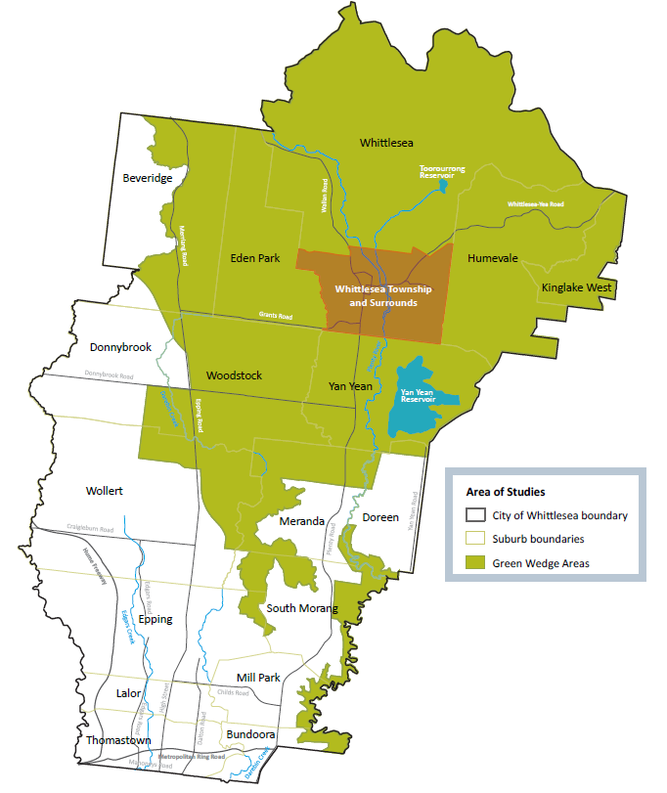
What is the Green Wedge?

More than 60% of the City of Whittlesea is rural or non-urban land protected from urban development. This land is known as the Green Wedge and it covers an area that’s more than three times the size of Phillip Island.

The Green Wedge is defined as the non-urban areas of metropolitan Melbourne that lie outside the Victorian Government’s defined Urban Growth Boundary (UGB)

Almost half of the Green Wedge in the City of Whittlesea is public land home to much-loved national parks, forests and reservoirs.

It is also used for:
- agriculture
- rural living and small settlements
- recreation and tourism
- scenic landscapes
- Aboriginal and European heritage places
- resources such as sand, gravel and stone.

What is a Green Wedge Management Plan?

The Green Wedge areas of the City of Whittlesea are dynamic and constantly evolving. We have a Green Wedge Management Plan (GWMP) which sets the vision and objectives for how Council manages this land.

The current plan due to be renewed and we are asking our community for their input. Between May - June 2021, you can help shape the future of the Green Wedge by telling us what you value about these areas and what you believe should be the key priorities.

In August – September 2021 after reviewing all the feedback received, we will come back to the community with a draft plan for further comment.

The plan will not involve any changes to the Urban Growth Boundary as this is set by the Victorian Government. Individual planning proposals within the Green Wedge are also outside of the scope of the plan.

How can I have my say?

Over the next couple of months, we’ll be providing a variety of opportunities in person and online for you to have your say. We have created a Discussion Paper to help guide your thinking and you can also fill in the survey on our website at engage.whittlesea.vic.gov.au/green-wedge.

We want to know:

- What do you value the most about our Green Wedge?
- Which opportunities identified in the Discussion Paper do you support?
- How should Council act upon the opportunities that you support?
- What is your vision of our Green Wedge?
Upcoming opportunities

Workshop with morning tea
Saturday 29 May 10am - 11.30am, Whittlesea Community Activity Centre, 57-61 Laurel Street, Whittlesea (register at engage.whittlesea.vic.gov.au or call 9217 2170)

Online session
Wednesday 2 June 12pm – 1pm (register at engage.whittlesea.vic.gov.au or call 9217 2170)

Drop-in Sessions
- Whittlesea Community Activity Centre - Saturday 29 May, 2pm-4 pm, 57-61 Laurel Street, Whittlesea
- Whittlesea Monday Market - Monday 7 June, 9am to 12pm, Whittlesea Showgrounds, 36 Whittlesea-Yea Rd, Whittlesea
- Pacific Epping - Friday 4 June, 9am to 12pm, 571-583 High St, Epping
- South Morang Farmers and Makers Market – Saturday 19 June, 9am to 12pm, 25 Ferres Blvd, South Morang

Find out more at engage.whittlesea.vic.gov.au. We are committed to ensuring we are inclusive in our consultation so if you have a particular need to enable you to participate fully, please contact us via email at strategic.planning@whittlesea.vic.gov.au or call us on 9217 2170.

