Targeted engagement of street name request
Engagement Summary
25 November 2025 – 28 December 2025
PRINCE ANDREW AVENUE, LALOR
Introduction
Council received a request from a property owner in Prince Andrew Avenue, Lalor to change the street name. In accordance with Geographic Names Victoria guidelines, a road name change is considered only where there is a strong justification, such as the name causing offence or no longer reflecting community values, and where there is clear majority support from affected residents and property owners.

How we engaged you
The City of Whittlesea consulted with residents and property owners of Prince Andrew Avenue in Lalor between 25 November and 28 December to determine the level of support for a name change.

To ensure each resident was provided with an opportunity to have their say, Council used both digital and in-person engagement methods including the Engage Whittlesea platform and doorknocking.

The Engage Whittlesea platform utilises an accessibility add-on ensuring that it is as accessible as possible for all users. The platform also has an in-built translation tool to mitigate any language barriers to participation, allowing the page to be translated into the top fifteen languages spoken within the municipality.

A bilingual staff member also attended the in-person door knocking on the 25 November and spoke to some of the older Greek residents in the street in language, so they could participate more easily.

Engagement methods:
- Online engagement via Engage Whittlesea platform on a private page accessible only through QR code or direct URL given to residents.
- Council staff visited residences in the street on two occasions to survey in-person
- Letters to property owners who lived elsewhere as well as for any residents who were not home during our visits invited them to provide their feedback via our Engage Whittlesea website.

Details of the in-person door knocking are as below:
Date | Time | Address/location
Tuesday 25 November 2025 | 10.30am – 2 pm | Prince Andrew Avenue, Lalor
Tuesday 16 December 2025 | 5 pm – 6.30pm | Prince Andrew Avenue, Lalor
Project promotion
The opportunity to participate in the community engagement was only offered to directly affected residents/owners of Prince Andrew Avenue, Lalor through an official City of Whittlesea letter containing a QR code and URL to access a private Engage Whittlesea page.

Participation
There are 40 properties on Prince Andrew Avenue. 58 people, including resident owners/owner occupiers, non-resident owners and tenants were provided the opportunity to have their say. 39 votes were received. 31 of the 39 people did not support a name change, with eight people supporting a change. 19 people did not provide their position.
Owner Description | Number of properties | Yes | No | Failed to vote
Resident owner (owner occupier) | 18 | 4 | 12 | 2
Non-resident owner | 18 | 4 | 6 | 8
Tenant* | 22 | 0 | 13 | 9
Totals | 58 | 8 | 31 | 19
* Please note that the higher number of tenants reflects that some non-resident owners own multiple properties in Prince Andrew Avenue.

What we heard
Below is a summary of what we heard from the residents and non-resident owners of properties located in Prince Andrew Avenue through online engagement and in-person engagement activities about a potential street name change.
The feedback received has been grouped into support and non-support, with selected verbatim feedback included.
 | Do you support the request to change the name of Prince Andrew Avenue, Lalor?  Almost 80% of affected residents and property owners in Prince Andrew Avenue, Lalor do not support renaming the street. Key reasons included the cost and inconvenience of updating personal and service provider details, and a lack of association between the street name and the individual after whom it was named or his actions.
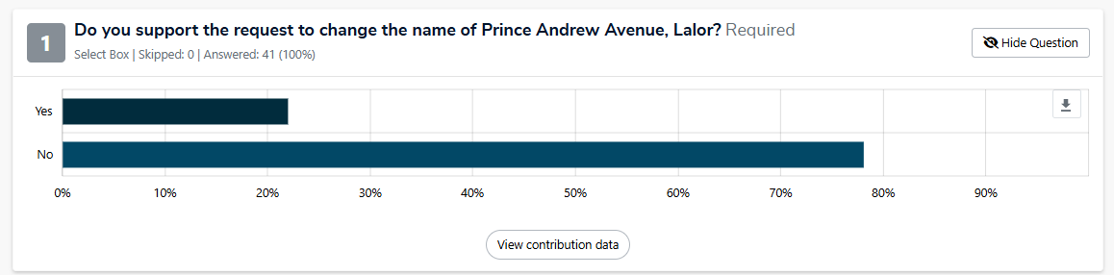

 | Indicating an opposition to street renaming  Community feedback indicated strong opposition to renaming the street, largely due to the significant cost, time and administrative burden involved. Residents highlighted the inconvenience of updating addresses across legal documents, banks, utilities, government agencies, workplaces and personal contacts, as well as concerns about confusion for visitors, deliveries and service providers. These impacts were seen as particularly challenging for older residents, long-term households and those without internet access or support to manage the changes.  Many respondents expressed emotional attachment to the existing street name, noting its long history and familiarity within the community. Others questioned the need for change, stating they did not associate the name with the individual’s actions or felt there was no strong or urgent reason to proceed. Overall, the feedback reflects a clear preference to retain the current street name to avoid disruption, cost and loss of historical continuity.  “I am not against the community opinion, however it is too much hassle to change everything such as informing all family members, friends and changing documents addressed to it.”  “A big NO, this is very inconvenient. If this is changed then we have to pay for all the legal docs that we have, passport, driver’s license, insurance because they need to be changed too. And also the utilities and other stuff like delivery address for online shopping etc… they need to be changed.”  “We have been here for 60 years and do not wish to have the name changed. This issue will pass and will be forgotten in time. Why do people insist on changing history. It is what it is. Our street name does not define who we are as people. We do not want the hassle of changing addresses as we are elderly and will have to rely on our family to make the changes.”  “At 86 years of age living alone, no interest in changing the name at all.”
 | Indicating a preference to rename the street  Although in much smaller proportion, we note that there was some support for a street name change. This was primarily driven by concerns about association with Prince Andrew and the values the name represents. Many respondents referenced well-publicised allegations and controversies, stating that retaining the name was inappropriate, distressing, or inconsistent with contemporary community values. Several noted feelings of embarrassment or discomfort when sharing their address and expressed a desire to avoid ongoing association with the individual.  Others highlighted the symbolic importance of street names reflecting integrity, safety and inclusivity. Some respondents viewed renaming as an opportunity to align with broader social movements that reassess historical naming practices.  “Even when we bought the house back in 2020 we already had people saying “that’s unfortunate” when we told them the name of the street we live on. It’s become an open joke with our friends that the name should change for the entire time we’ve lived here. It’s frankly a little embarrassing to live on a street named after him.”  “As a community, we believe the names of our public streets should reflect the values, identity, and aspirations we share. In recent years, Andrew Mountbatten (formerly Prince Andrew) has been associated with serious controversies that conflict with the principles of integrity, respect, and safety that our community strives to uphold. Keeping the name would be distasteful and retaining the name may be distressing for survivors of sexual abuse or those advocating for victims' rights. There's also the risk of subconscious bias from people - affecting safety and discrimination issues.”  “Please change it. Better to have small pain of changing now and no more snickers from people.”

Next Steps
Thank you to everyone who participated in the community engagement by sharing comments and feedback. Council has reviewed all responses received. The feedback shows strong opposition to a name change, and the majority of residents do not support the request.
In accordance with the advice of Geographic Names Victoria, a majority of affected residents must support the request for it to proceed. As a result, the street name will not be changed.
An official letter has been sent to resident owners, non-resident owners and tenants advising of community engagement outcome, and the Engage Whittlesea page will be updated with a summary of information.

