Community Vision Review
Engagement Summary
3 April – 4 May 2025

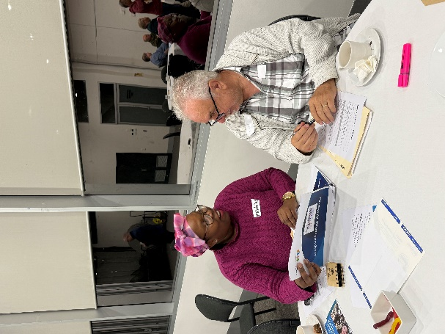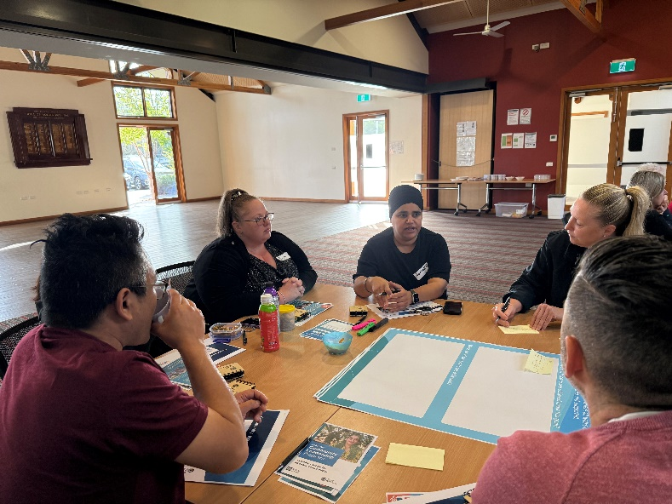

Introduction
As a newly-elected Council and in accordance with the Local Government Act 2020, we undertook a review of the City of Whittlesea community vision – Whittlesea 2040: A Place for All - to check in with our community to ensure that it is still relevant, aligned to current community needs and supported.
The Community Vision is underpinned by five strategic goals which are:
- Connected community
- Liveable neighbourhoods
- Strong local economy
- Sustainable environment and
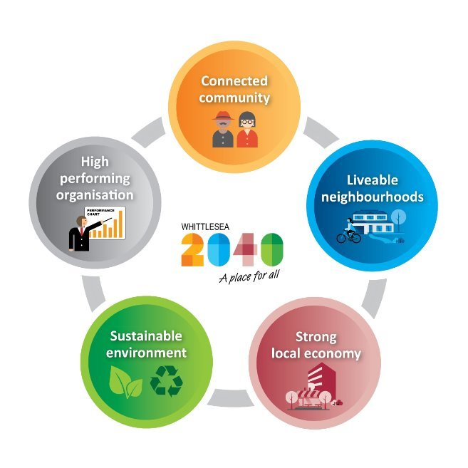
- High performing organisation

To involve the community in reviewing the Community Vision, a community focus group was established that was representative of our diverse community to support a comprehensive review process.

A broader community consultation was also undertaken between 3 April and 4 May 2025 which saw us ask community whether the vision was still relevant and still aligned with communities’ current needs. Participation was available online through the Engage Whittlesea platform or in-person at one of 13 community-based pop-up stalls held across the municipality.

To avoid consultation fatigue within the community, the project was co-located where possible with other key strategic documents that were open for consultation including the Proposed 2025-26 Budget, Proposed Financial Plan 2025-26 to 2034-35, Proposed Rates and Revenue Plan 2025-26 and the Draft Asset Plan 2028-29 2035-36.

One hundred and twenty people participated in the consultation with an additional 31 community members participating in the Community Focus Group. Through the consultation, the majority of participants told us that they feel the Community Vision is still relevant (93%) and it is still aligned with current community needs (94%).

Focus group participants shared with us what they love most about living in the City of Whittlesea including lovely green spaces, strong neighbourhood connections, public safety, access to information and services, and multi-cultural community and events. They also shared their aspirations for the municipality under each of the strategic goals as well as what they hope to see achieved under each of the goals. A destination for people of all ages and backgrounds to easily live work and play was a common theme across the goals which supports the current vision of A Place for All. The aspirations and hopes captured in themes are presented in this report.

Project promotion
The opportunity to participate in the community engagement was promoted through a variety of channels to ensure widespread reach across the municipality including:

- Council’s digital engagement platform Engage Whittlesea
- Social media
- Engage Whittlesea campaign to 1500 platform users
- E-newsletters or personalised email with direct link to the project page was sent to:
- Senior & multicultural groups
- Sports and Aquatic Clubs
- Youth Services network
- Library and Community Hubs users
- Ageing Well database
- Whittlesea Disability Network
- First Peoples network
- Promotion on screens at Civic Centre, libraries and recreation facilities.

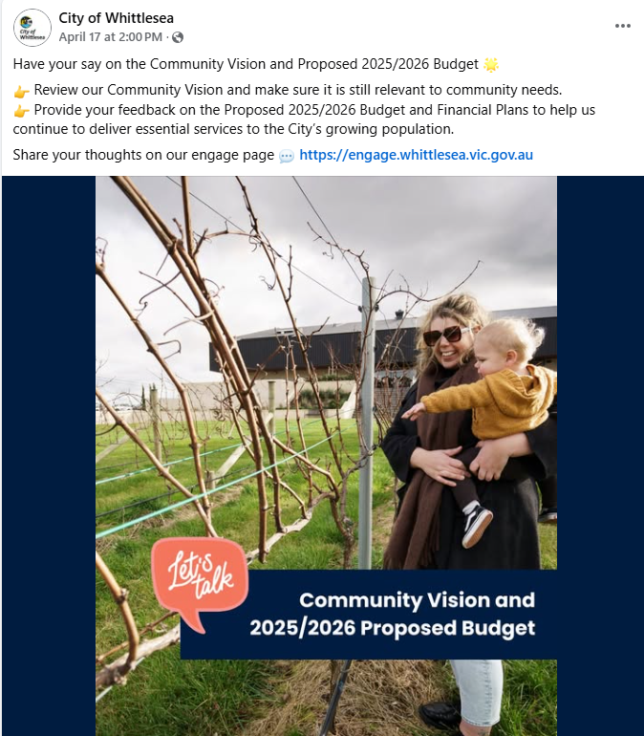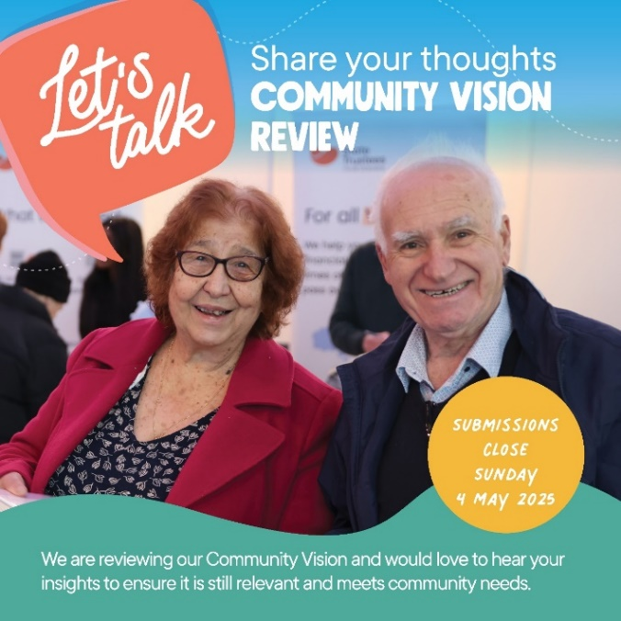

Above: Images of social media posts/reels

How we engaged you
Community Focus Groups
Council held two community focus groups in different locations reducing travel for participants and offering both a weekend and weeknight opportunity. The focus groups were representative of the diversity of our municipality.

Details of the two focus groups are as below:
- Civic Centre, South Morang, Thursday 3 April, 6.45pm – 9pm
- Whittlesea Community Activity Centre, Saturday 5 April, 9.30am -11.30am.

Format of the focus groups
Focus groups were designed to facilitate deliberative discussions around the Community Vision with a focus on the five strategic goals that underpin our vision. Working in small groups, participants had the opportunity to evaluate and consider various information, perspectives, inputs, and evidence to build consensus as a group to make community recommendations as Council reviews its Community Vision. Each session ran for two hours and included an ice-breaker as well as five activities, one focussing on each of the strategic goals.

The activities were duplicated for each of the five strategic goals and required participants to have table conversations and answer two questions. The group was asked what they hoped to see achieved under each goal (their vision) and what they would hope to see delivered under each goal (the deliverables). Table groups were then asked to deliberate and reach consensus on the top two ideas for the two questions for each goal.

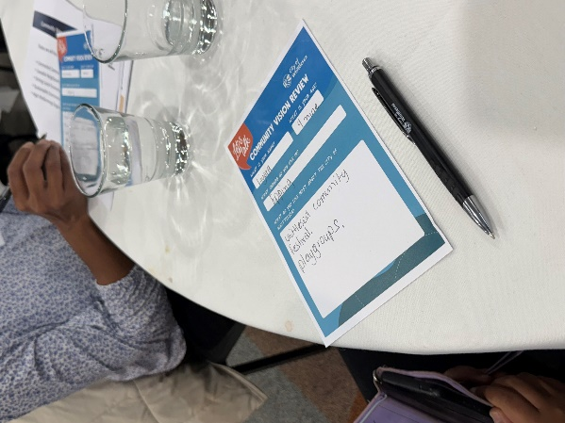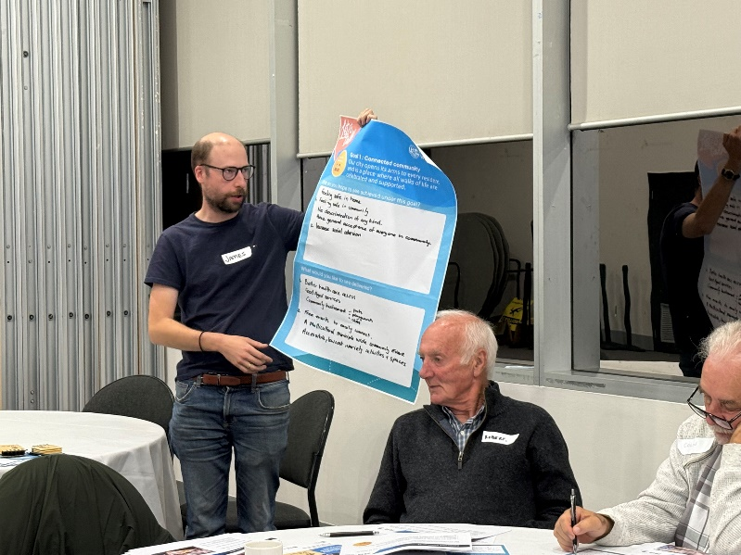
Above: Images of focus group activities
Broader community consultation ​
The wider community were encouraged to share feedback on the Community Vision by visiting the project page on the Engage Whittlesea platform or at one of the community-based pop-up stalls. Participants were asked if the Community Vision was still relevant to them and whether it still aligned to community needs. There was also free text space provided for participants to add further comments if they selected no as a response to either of the questions. Refer to Appendix 1 to see the activity boards used at in-person engagement activities.
The Engage Whittlesea platform utilises an accessibility add-on ensuring that it is as accessible as possible for all users. The platform also has an in-built translation tool to mitigate any language barriers to participation, allowing the page to be translated into the top fifteen languages spoken within the municipality. ​
To inform community and to ​hear from a diverse range of community members and increase participation, Council hosted 13 in-person engagement activities across the municipality.
Date | Time | Where | Address/location
4 April 2025 | 12.30pm-2.30pm | Whittlesea Services Hub | 63 Church St, Whittlesea
8 April 2025 | 9.30am-11.30am | Westfield Plenty Valley | 415 McDonalds Rd, South Morang
9 April 2025 | 9.30am-11.30am | The Stables | 314-360 Childs Rd, Mill Park
9 April 2025 | 2.30pm -4.30pm | Mernda Town Centre | 180 Riverdale Blvd, Mernda
11 April 2025 | 10am-12pm | Galada Community Centre | 10a Forum Way, Epping
16 April 2025 | 5pm-7pm | Kirrip Community Centre | 135 De Rossi Blvd, Wollert
17 April 2025 | 9.30am-10.30am | Thomastown Village | 235 High St, Thomastown
17 April 2025 | 11.30am -12.30pm | Woolworths Lalor | 395 High St, Lalor
28 April 2025 | 9.30am -11.30am | Lalor Library | 2a May Rd, Lalor
28 April 2025 | 2.30pm -4.30pm | Thomastown Library | 52 Main St, Thomastown
29 April 2025 | 2.30pm -4.30pm | Laurimar Shopping Centre | 101 Hazel Glen Drive, Doreen
30 April 2025 | 9.30am-11.30am | Shared Cup Café | 995 Donnybrook Rd, Donnybrook
2 May 2025 | 12.30pm -2.30pm | Coles University Hill | 2 Janefield Drive, Bundoora
Participation

Snapshot of community participation

Downloads | Community-based Pop-Ups & Focus Groups | Digital Engagement | In-person Engagement | Focus Group
 |  |  |  | 
71 Downloads of the Council Vision | Hosted 13 community-based pop-ups and 2 Focus Groups | 360 views  318 visits  20 contributions | 100 in-person contributions | 31 people participated in the focus group

Snapshot of demographics
Below is a snapshot of the diversity of participation in the community engagement, which is broadly representative of our community:
Gender Identity | Age |  | Suburb
 |  |  | 
51% Female, 48% Male | All age brackets participated with the most represented being 36-45 years (24%), over 65 (17%) 26-35 years (15%) and 56-65 years (15%) |  | Participants came from 15 suburbs across the municipality, with the highest participation coming from Wollert (16%), and Mernda (14%).
LGBTIQA+ community | Multicultural community |  | People with disabilities
 |  |  | 
5% of participants identified as members of the LGBTIQA+ community | 51% of participants spoke English as a second language |  | 11% of participants were people with a disability and or carers

What our community told us
What we heard at the focus groups
Ice-breaker – what I love most about the City of Whittlesea.
All participants presented and provided a brief written response identifying what they love most about living within the City of Whittlesea. The majority of responses fit into one of five key themes which were lovely green spaces, strong neighbourhood connections, public safety, access to information and services, and multi-cultural community and events.
- “I love… that I feel valued in this municipality. Community involvement enhances my sense of belonging.” (Resident, Epping, aged 20 years)
- “I love… that anyone can be anything they want here…” (Resident, Whittlesea Township, aged 77 years)
- “Largely quiet and family orientated. We feel safe and secure in Mernda.” (Resident, Mernda, aged 49 years)
- “The geographic location has good amenity and access to the services and transport options I need.” (Resident, Bundoora, aged 68 years).
- “Open space - walking tracks, parks, walking the dog, running, spending time with family”. (Resident, Wollert, aged 62 years)
Activities: key themes from community feedback specific to the five strategic goals.
Below are the top ideas generated through the small table groups that participated across the two focus group sessions. The ideas are presented for each of the five strategic goals have been themes and are presented along with a selection of comments that were captured as below:
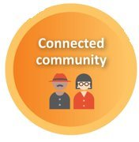

Connected Community

What do you hope to see achieved under this goal (your vision)
Participants generated 25 ideas with the main themes being access to public safety, education, social tolerance and becoming a destination of choice.
- “Safety and a sense of community by coming together to respect each other regardless of culture, sex orientation, religion, lack of understanding of cultures”
- “Learning about our Communities culture and heritage”
- “More visibility of our first nations community for community to learn and connect”
- “Destination for people of all ages to live, work and play”.
- “We hope to see a well-connected happy community and [deepened] sense of community”
- “I hope to see stronger neighbourhood connections”
- “We hope to have more events that connect community to each other including First Nations”

What do you hope to see delivered under this goal (the deliverables)
There were 36 ideas generated with the main themes being community events, access to local information and services, and education opportunities.

- “Leadership courses to create next leaders”
- “Deliver a welcome pack to new residents that introduces services and community groups of interest”
- “More events to connect community to each other including first nations”.

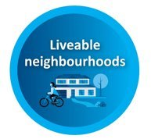

Liveable neighbourhood

What do you hope to see achieved under this goal (your vision)
Participants generated 46 ideas with the main themes being access to public transport, having what you need close by, and places for social connection.

- “Walkable neighbourhoods i.e.: 20 minute cities”
- “Good local connected public transport to make it easier to commute within local area”
- “The city feels connected to each other and all suburbs have access to the facilities they want/need”
- “Places where you can go for a walk and have a coffee in open spaces”.

What do you hope to see delivered under this goal (the deliverables)
There were 46 ideas generated with the main themes being cost of living, safer and upgraded open spaces, access to shared spaces, and vibrant town centres.

- “Town Centres close to where people live”
- “Council to advocate for more emergency clinics like the one at Epping Plaza so less people have to go to the emergency department”
- “Upgrade parks and playgrounds with more toilets, BBQ facilities, regular maintenance and water fountains”
- “Need more Social Housing”
- “Shared free working spaces for students, small business”
- “We would like safer public spaces through CCTV and improved lighting”

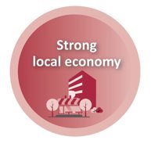

Strong Local Economy

What do you hope to see achieved under this goal (your vision)
Participants generated 41 ideas, the theme of which focused on City of Whittlesea becoming a thriving business community that is attractive to invest in.
- “Make City of Whittlesea more attractive for business to establish in the LGA”
- “Unique and diverse local shopping precincts”
- “Thriving small business community”.

What do you hope to see delivered under this goal (the deliverables)
There were 45 ideas generated with the main themes being technology and co-funding opportunities for mutual benefit.
- “Increase business permits / reduce red tape”
- “Partner with local businesses to help co-fund local projects to obtain mutual benefits i.e.: Whittlesea Rail Trail”
- “Technology hubs (state of the art) and networks/clubs/start-ups”.
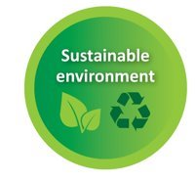

Sustainable Environment

What do you hope to see achieved under this goal (your vision)
Participants generated 32 ideas with the main themes of more green spaces, energy efficiency in housing, and promoting our green spaces.
- “Increase our green spaces with a variety of appropriate trees”
- “City of Whittlesea open spaces are recognised as a key asset of the area and people tour to our area to visit them”
- “Variety of housing types to support energy efficiency.”

What do you hope to see delivered under this goal (the deliverables)
There were 42 ideas generated with the main themes being electric charging points, banking solar power, and protecting our green zones from housing development.
- “Increase Electric Vehicle charging points”
- “Protect green zones - commitment to keeping certain areas non-developable”
- Battery farms - power banking of solar power.”

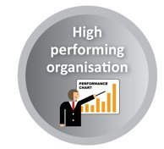

High Performing Organisation

What do you hope to see achieved under this goal (your vision)
Participants generated 36 ideas with the main theme focussing on more participation and connection with community with a well-managed and trustworthy council.
- “Participating community who takes ownership of community initiatives”
- “Council is connected to the community and responsive to changing needs”
- “More transparency at Council – sharing what is happening within Council with the community, both positive and negative”
- “A well-managed and functioning Councillor/Council Officer relationship that community can trust”
- “Well informed financial spending strategies and sharing with community the breakdown on decision making (explaining the reason why).”
What do you hope to see delivered under this goal (the deliverables)
There were 39 ideas were generated with the main themes focussing on transparent decision making in line with community needs, efficient resourcing, and better connection between community and Council.
- “Future proof Council and share with community the plans, growth and forecasts”
- “Easier access to local Councillors for community members with initiatives such as a Community Listening Post"
- “Transparent with sharing information about Councils expenses”
- “Get to know your Council days – ability for community to meet representatives from each department”
- “Efficient use of resources and buildings.”

What we heard from the broader community consultation
We heard from 120 community members as part of the broader community consultation, with feedback captured from 100 people in-person and 20 people online.

Is the Community Vision relevant?
 
93% Yes 7% No
The six online respondents that didn’t feel the Community Vision was still relevant took the opportunity to provide additional comments. These comments focussed on safety initiatives for the newly arrived and vulnerable, better use of rates, and a vision that is measurable.
“Hence the Vision to include Safety such as Food security; Health; Shelter; Economic; Cyber; Social/community security”
“Why is the council spending money on silly upgrades like Gorge Road that removed parking for the traders”
“…unmeasurable and ultimately impossible to keep council accountable to.”

Is the Community Vision still aligned with current community needs?
94% Yes 6% No
The six online respondents that didn’t feel the vision still aligns with current community needs took the opportunity to provide additional comments. These comments focussed on road traffic improvement, less green initiatives, beautifying Whittlesea Township, acknowledging newly arrived and vulnerable members of the community, and education options.
“The council should beautify the township - the main streets frequently travelled (Whittlesea yea Rd/Wallan Rd/church St), the park land, the show grounds- encouraging tourism and hence $$$ into the council”
“Fix the roads and upgrade them”
“While the overall goals are positive, the Vision needs to better acknowledge and respond to the immediate needs of newly arrived and vulnerable families.”

Is there anything else you would like to share about the Community Vision?
Sixteen online participants took the opportunity to provide additional feedback about the Community Vision. Comments focussed on the use of technology, more targeted funding and grants, cleaner and more beautifully presented neighbourhoods, cost of living, and performance measures.
“How is Council measuring and reporting against each strategy, and how is performance transparent with our community?”
“…we need better training for whoever's planting our curb side trees”
“Technology can help build a vibrant community connection, like a neighbourhood service referral network”

Council captured an additional 74 comments at in-person engagement opportunities that have been themed as below:
- Community safety matters (19 comments)
“Increase in crime means we need to increase safety in the community and neighbourhoods”
“Shared pathways on Plenty Road not used properly by e-scooters. E-scooters should have a horn to warn others when travelling fast past pedestrians. Plus, they should be speed limits they have to abide by.”
- Cleaner and more visually appealing neighbourhoods (16 comments)
“Need cleaner, neater neighbourhoods”
“Beautifying the environment decreases Domestic Violence”
- Key services for the community (15 comments)
“More health services for first peoples, with a focus on domestic violence and safety”
“There is a gap in communications and ability for seniors who don't have mobile phones or computers, it is difficult for them to download and print forms i.e.: disability parking forms”
- Cost of living (9 comments)
“Affordable housing needed in area” “Homelessness - Squatters in vacant houses”

Next Steps
Thank you to everyone who shared feedback through our Community Vision review either in-person at a community-based pop-up, online through the Engage Whittlesea platform or as part of our Community Focus Group. The feedback and community recommendations will be considered as we review our Community Vision and will help to shape our new Community Plan.

We will share the final Community Vision once it is adopted by Council and encourage you to follow the project Engage page (engage.whittlesea.vic.gov.au/visionreview) to be kept up to date as the project progresses.

Appendix 1: activity boards used at in-person engagement activities
