Human Services Needs Analysis Survey Results

2024-25

Table of Contents
Executive Summary 4
Purpose 4
Results 5
Conclusion 6
Introduction 6
Profile of City of Whittlesea 6
Human Services Needs Analysis Survey 8
Methodology 8
Respondents 8
Service Delivery 11
Increasing demand for services 11
Managing demand 11
Complexity of Need 13
Challenges facing Human Services providers 13
Volunteers 13
Complexity of needs of service users 14
Funding environment 14
The Service System 16
Emerging Issues 16
Mental Health services and pathways 17
Cost of Living Impacts 18
Family Violence 19
Challenges with Transport 19
Reducing availability of Affordable Housing 20
Collaboration across the Sector 22
Collaboration between organisations 22
Priorities for collaboration and advocacy 22
Conclusion 23
Next Steps 23

Executive Summary

Purpose
This report is the fifth iteration of the City of Whittlesea’s Human Service Needs Analysis (HSNA) Organisation Survey. The HSNA provides an opportunity to document change over time and acknowledges that, in the growth areas, gathering data to establish unmet demand and hidden needs can be challenging.

In the past the HSNA has consisted of four parts:
- Human Services Organisation Survey – a survey completed by organisations from the human services sector delivering services in the City of Whittlesea
- Analysis of demographic and service-oriented data (secondary research) – provides context to and analysis of priorities and challenges identified by respondents
- Human Services Organisation focus groups and/or interviews – this adds richness and depth to the quantitative survey and helps to ensure the report is reflective of the experience of sub-sectors that are difficult to connect with via survey tools.
- Service user focus groups or interviews – this helps to provide balance to the findings and further context around the challenges of the human services system.

Due to timing and resource requirements, the current report addresses parts a) and to some extent b).

However, even though this iteration is abridged, as with previous versions completed in 2011, 2014, 2019 and 2023, this survey report is designed to inform strategic planning and advocacy for the City of Whittlesea and its partners.

The aim of the fifth HSNA is to:

- understand the human service needs of the municipality

- capture information about the human services sector in the municipality

- understand the emerging challenges and priorities for service providers

This analysis process considered: existing demand; population growth; the demographic profile of the municipality; perceived service needs; and, health and wellbeing outcomes for the community.

Results
While this iteration of the survey gathered more respondents than previous iterations, the respondents to the survey are not representative of the breadth of the sector. The results in this report reflect the perspectives and observations of the respondents. These results remain valuable but need to be utilised with care.

The results of the 2025 Human Services Needs Analysis survey were broadly in line with the results of the three previous iterations. They indicate that while service delivery is growing along with the population, there remain significant challenges in access and availability of some services, for example, mental health and psychology services. The results offered the following themes.

Increased Demand
Most services reported experiencing increased demand over the twelve months to February 2025. While respondents report the community sector is currently managing demand, respondents to the survey also reported that current funding is not covering the full cost of services.

Complexity of Need
Service providers who responded to the survey report that they are currently experiencing increased complexity of needs of service users and also that they have more service users with multiple and complex needs. Service providers are perceiving this as an emerging trend and expect to see the increased complexity of need continue to be a challenge over the next three years.

Cost of Living
This theme is recurring from the previous Human Services Needs Analysis. Respondents to the survey highlighted the cost of living as a key driver of demand, contributor to the increasing complexity of need and also affecting the availability and motivation of volunteers.

Mental health services and pathways
Respondents highlighted mental health services and pathways as a key emerging need for service users in the next three years. Council has recognised this through the 2023-25 Advocacy Prospectus.

Working together
92% of respondents to the survey reported their services and programs are engaged in collaborative practices across the sector across a range of activities. The sector appears to be working well together and engaged in supportive collaborative behaviour that fosters positive outcomes for both organisations and service users.

Conclusion
This report offers broad insights into the experiences of human services providers in the City of Whittlesea. Though there are some limitations in generalising the data, there is consensus among the respondents around the current challenges for providers, the perceived experiences of service users and emerging issues for the human services system.

Introduction
The City of Whittlesea has conducted the Human Services Needs Analysis about every four years over the past fifteen years. During this time, the research has been outsourced to a consultant, completed internally and a combination of both. The reports have informed strategic and service planning for Council and supported improved service outcomes for residents by informing service providers of common and emerging experiences, challenges and needs.
This iteration of the Human Services Needs Analysis was designed initially with limited scope and a truncated timeline, to support collaborative activities between Council and providers of human services in the City of Whittlesea and provide key emerging themes to support service planning.

Profile of City of Whittlesea
The City of Whittlesea is one of Melbourne’s largest municipalities and is the proud home to a fast-growing and diverse community.
Located in the north of Melbourne, our municipality spans approximately 490 square kilometres with a mix of established suburbs, growth areas and rural communities.
Currently we estimate the population is 257,000. By 2040, the City of Whittlesea’s population is expected to increase to just over 355,000 residents.

To accommodate our new residents, the City of Whittlesea will see around 40,000 new homes built across the municipality. These will be made up of a mix of new housing types to meet our community’s growing and diverse needs.

The City of Whittlesea has one of the largest First Peoples population in metropolitan Melbourne. Adding to the rich culture and heritage of our municipality is a multicultural community so diverse that 45 per cent of our residents speak a language other than English at home. Also, 8 per cent of our population identify as belonging to the LGBTIQA+ community. It is important that our human services meet the needs of the diversity of our population.

More and more families are calling the City of Whittlesea home with more than half of our households comprising of families with children. Every week, around 61 babies are born into families living in the City of Whittlesea.

Our community’s largest age group are those aged 30-39 followed by children aged 9 and under. People aged 65 years and older currently make up 12 per cent of our population. We expect the population aged over 65 to grow to approximately 17% of our population by 2040.

Human Services Needs Analysis Survey

Methodology
The 2025 HSNA was developed by analysing demographic data from the 2021 Census and population projections compiled by .id, original data derived through an online survey with human services providers, and secondary research to support and ground the observations reported by human services providers.

A detailed survey was sent to organisations that provide health and human services in the City of Whittlesea. A total of 87 responses were returned from at least 42 organisations (13 respondents did not specify an organisation). There were 11 organisations that provided more than one response to the survey.

The online survey, partially based on the 2019 and 2023 surveys was sent to key human services organisations delivering services in City of Whittlesea. Survey invitations were sent to 526 potential participants representing 194 organisations. The survey was in field 30 January 2025 to 24 February 2025.

To support improved response rate and data quality, the logic of the survey was modified so that questions about facilities and funding were only completed by organisational leaders and service-specific questions were reserved for those who identified themselves as mostly working in direct service provision (with clients) or as practitioners.

Respondents
The 87 respondents were mostly representing not-for-profit organisations (78%) that provided cohort specific and population wide services, as demonstrated in the chart below.

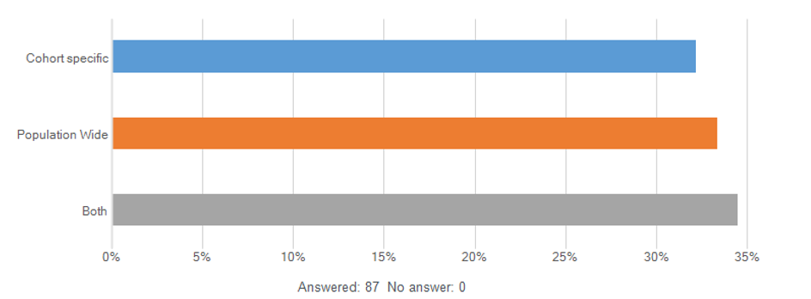

Most respondents reported the catchment area for their services covered the whole municipality (every suburb) and in many cases, the organisation was providing the same services in other local government areas as well.

Two thirds of respondents delivered services from a fixed address within the City of Whittlesea, while just 16% provided services from a fixed address located outside the municipality. Around 18% of responding organisations deliver services through community settings.

  - Suburb/s in the City of Whittlesea included in the catchment area for services (respondent could choose more than one response)
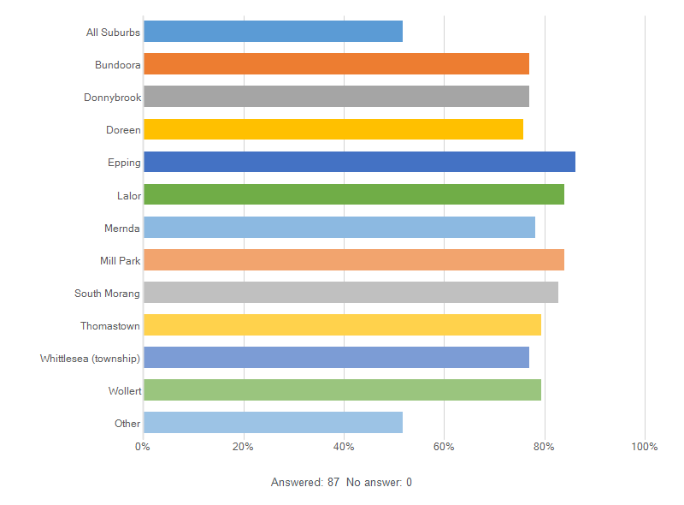

Of those that responded to the survey, 56% were the manager or organisational leader, and 40% were mostly engaged in direct service provision. The services represented by the respondents were limited and this needs to be considered in the analysis and reporting of results. 45% of respondents were primarily working in Family safety and Family support and Children and Youth services. Less than 2% of the respondents were mostly involved with Disability services. We have observed that this is not reflective of the sector and therefore the service specific responses have a service bias, as shown in the following chart.

The respondents represented organisations that provide a wide range of services. The chart below shows the areas of services provided directly by the respondent and by the organisations they work for.

The list of services provided by respondents and their organisations shows low representation from various service types. Reasons for these gaps include staff too busy or not willing to participate in the survey and gaps in distribution lists for the survey.

Service Delivery

Increasing demand for services
More than three quarters of respondents reported that service demand had increased in the twelve months to February 2025. For those that reported the increase, respondents provided several perspectives on the drivers of demand. There were contributions of ‘natural’ demand increase through population growth and policy & systemic change. The demand increase through population growth is more significant in this municipality in comparison to Greater Melbourne due to the current housing developments. Some respondents noted the positive driver of demand of increased awareness of both need and service availability. For example, increased promotion of what constitutes violence and abuse has led to increased help-seeking behaviour. Increased promotion and visibility of services has also improved help-seeking behaviour. A significant number of respondents also cited the current cost of living crisis as a key driver of demand.

  - Demand for the services increased, decreased, or stayed the same over the last 12 months.
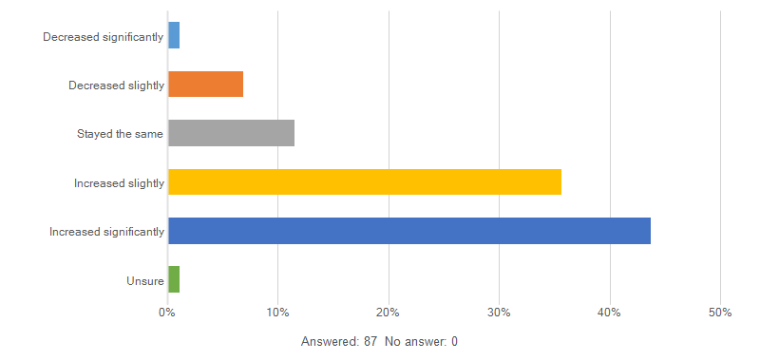

Managing demand
While service providers report that demand is increasing, they also report that the community sector is working to meet this increase as far as possible. 88% of respondents to the organisational survey reported the number of service users their service is able to support has increased or stayed the same in the last twelve months. 72% of respondents report their service is mostly or completely able to meet demand. As a comparison, in 2019, the Australian Council of Social Service published a snapshot of demand in the community sector report. Only 35% of respondents to that survey at the time, responding to the same question as in our organisational survey, reported that their service was able to mostly or completely meet demand. Even allowing for some sector variance and statistical error, it appears that the human services sector in City of Whittlesea is managing the demand fairly well at this point in time.

While there are waiting lists in the sector, very few services reported having longer than one month wait before being able to engage with service-users. However, 29% of respondents report having difficulty referring service users to appropriate services. Services utilise a wide variety of methods to manage demand, as demonstrated in the following.

  - Programs or services have managed demand in the following ways over the last 12 months (Note: respondent could choose more than one response) 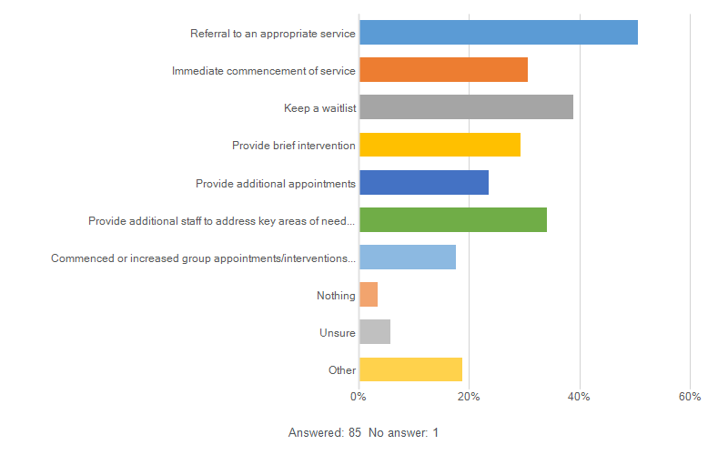

Complexity of Need
A significant number of respondents to the organisational survey (82%) reported that the complexity of service user needs has increased. Respondents (80%) also reported the number of service users with multiple and complex needs has increased. When asked about emerging needs in the service system, several respondents also mentioned the increasing complexity of need or service users.

Challenges facing Human Services providers

Volunteers
35% of respondents reported that their program or service involved volunteers. 83% of those stated that their program or service had 19 or less volunteers engaged. Based on data from our Community Insights Study (CIS), we estimate that 38% of people in the municipality are engaged in volunteering. When asked about barriers to volunteering, respondents to the CIS stated that work or study commitments were the primary obstacle.
In the HSNA organisation survey, when asked about the impacts of the cost of living, one respondent recognised the implications of increased cost of living on current and future volunteers:
“Volunteers are not affording to drive to volunteer and are taking on two or three jobs to make ends meet. Volunteering has dropped for people who want to support community because they are working over time. The increase of EOIs of people wanting to volunteer is mainly coming from people who are wanting to get into employment.”
This quote highlights a potential shift in the motivation of volunteers that may encountered by other organisations currently or in the near future as the cost of living crisis continues to impact.

Complexity of needs of service users
The increased complexity of need, as highlighted under the service delivery section previously, presents a challenge for service providers. Individuals or families with complex needs often refers to people who have a combination of health and social needs, recognising the interplay of these factors can contribute to greater or cumulative harm. The nature of complex needs is that they tend to require increased levels of wraparound or individualised support alongside connection and cooperation of service providers across the health and community services sectors to meet the different service needs to ensure that individuals and families get the right support at the right time. Complexity of need as a theme connects to broader issues facing service users such as transport links and cost and lack of affordable housing. Both of these challenges have been highlighted as emerging issues and are outlined further in that section.

Funding environment
Organisations in the human services sector are largely not for profit organisations, many with primary funding from Federal or State government. In the City of Whittlesea, there appears to be consistency with Community Services across Australia more broadly in the way in which services are funded, as demonstrated in the chart below.

Organisational funding by funding type in the 12 months to February 2025 (Note: respondent could choose more than one response)
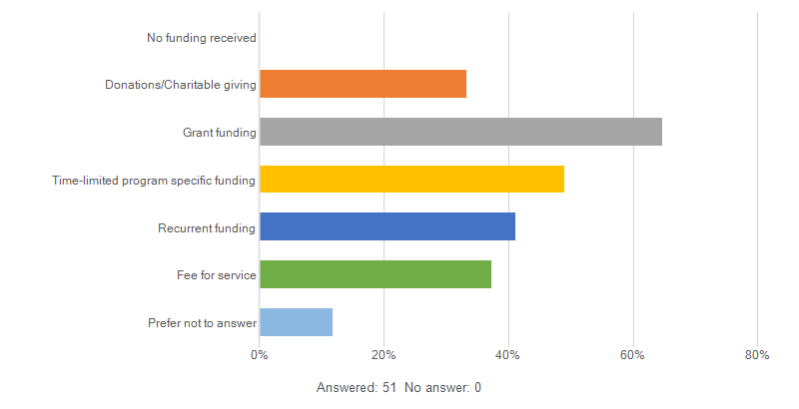
While respondents to the organisational survey reported that services were mostly able to meet demand (71.8%) and were able to support the same or increased numbers of service users (88%), they also reported that funding was not sufficient to meet demand and did not cover the full costs of service delivery, as shown in the following chart.

  - Thinking about your current funding arrangements, how much do you agree or disagree with the following statements?

This suggests that organisations are currently working to meet the demand and needs of the community and are working to improve efficiency, but this level of service may need to be adjusted into the future. This presents an opportunity for discussion, collaboration and potential partnerships between organisations in advocacy for service levels and funding.

The Service System

Emerging Issues
Respondents identified their perceived emerging needs of service users in the survey. The perception and insights offered by service providers, as subject matter experts, are valued and appropriate. Many of the comments in relation to emerging needs highlighted the increased demand and complexity of need that have previously been addressed in this paper. In addition to these comments, five of the key emerging needs highlighted were:

- Increased need for mental health services and pathways
- Increased cost of living impacts
- Increasing rates of Family Violence
- Challenges with transport
- Reducing availability of affordable housing

These themes have also been affirmed by other research, as outlined below.

Mental Health services and pathways
The broader data affirms the perceptions of the respondents to the organisational survey, particularly highlighting the needs for more mental health services for young people.

Through our Community Insights Study, the City of Whittlesea found that in 2024, 9% of people in Whittlesea reported feeling lonely often or always. For 15–24-year-old this percentage was 22%. Residents who were surveyed as part of the Community Insights Study in 2025 also reported that 20% of the time the appointment gained for mental health services was not timely. While travel did not appear to be a great barrier, more than 40% of respondents reported that the provider was not local to them. In the twelve months to October 2025, around 23% of households had at least one member who needed to access mental health services at least once. The greatest barrier to accessing mental health services cited was cost.

These statistics are consistent with nation-wide data that shows : 3% increase in people experiencing social isolation from 2016-2022. In males aged 15-24, 25% reported feeling socially isolated in 2022, up from 14% in 2016.

The City of Whittlesea 2023-25 Advocacy Prospectus highlights the need for enhanced adolescent mental health services:
In 2018, the Eastern Melbourne Primary Health Care Network (EMPHN) identified the City of Whittlesea as ‘an area of high need’ with:
• fewer adolescent mental health services than other
municipalities in the region;
• the highest rate of emergency department presentations
with anxiety in the network catchment.
Demand for mental health services continues to exceed availability. Services report:
• an increase in the number of young people seeking mental health support, with 15% experiencing a high level of psychological distress – higher than the State average of 13%;
• an increase in the number of risk assessments conducted each week; and
• wait times of up to four weeks for an initial assessment and eight months for ongoing counselling.
Youth Enhances Service provider reports:
• an increase in the number of referrals from individuals and from Child and Adolescent Mental Health Services (CAMHS);
• an increase in the complexity and risk in the referrals they receive; and
• an increase in the number of referrals they are unable to accept.

Cost of Living Impacts
Cost of living was highlighted in the 2022 HSNA report as a key theme and emerging challenge. In 2025, the organisational survey respondents highlighted cost of living as a priority for the next three years, but the survey also asked a specific question on cost of living. Through both questions, respondents to the survey reported that cost of living is having a significant impact on service users at the moment and is anticipated to continue to be a challenge into the future. The broader data trends affirm the perceptions of the respondents to the organisational survey that cost of living is continuing to impact services and service users.
Through our Community Insights Study, 42% of residents of the City of Whittlesea who were surveyed reported it was difficult to meet financial needs in terms of transport, housing, food, clothing and other necessities in the twelve months to October 2025.
In the twelve months to the September 2024 quarter, cost of living rose between 2.8% and 4.7%. Financial services, including mortgage interest rates and insurance are key contributors to the continued cost of living pressure. While the interest rate increases are slowing, it expected that the cost of living will continue to rise in the shorter term as expired fixed rate home loans rollover to higher variable rate home loans. The cost of living is particularly affecting homeowners with debt, which makes up a large percentage of our municipality. In 2021, 43% of households in the City of Whittlesea were being purchased by a mortgage, compared with 36% in Greater Melbourne.
While people are continuing to make mortgage repayments, we understand that the cost of living increases are impacting food security, spending on arts and entertainment and changes in energy consumption (ie not turning on heating or cooling). In 2024, 10% of residents in the City of Whittlesea reported running out of money to buy food, compared to 5.9% in Victoria.
Cost of living is also impacting childcare availability and access, as an increasing number so people are looking to enter or re-enter the labour market.

Family Violence
There were 1,149 reported family violence incidents per 100,000 in 2024. “Family, domestic and sexual violence (FDSV) can affect any individual, family or community in Australia. The majority of people who experience these forms of violence are women, and gender inequality is considered to be an underlying driver”.

While the rate of reported family violence incidents per 100,000 people has fallen since 2017-18, the population growth over the same period means that the number of reported incidents has remained relatively stable. There are links between experiencing family violence and accessing homelessness services. There were 2,888 reported violence incidents in 2023-24. In the same time period 1055 clients of homelessness services had experienced family violence that led to their lack of housing.

Only a small percentage of residents that participated in our Community Insights Study had experience with family or domestic violence services in the last twelve months. But of those that did, more than half reported that the provider of support services was not local to them.

Challenges with Transport
Transport difficulties are regularly identified as a factor that restricts Australian families’ capacity to use services and participate in activities. The Communities and Families Clearinghouse Australia reports that these difficulties include limited or no access to public transport, non-family friendly transport options, and not being able to afford, or experiencing stress as a result of, the cost of transport (including the cost to maintain a vehicle).

The respondents to the survey highlighted that for some people who use human services in the City of Whittlesea, transport accessibility, availability, and cost, are barriers to using services and building social inclusion.

Reducing availability of Affordable Housing
Respondents to the survey cited housing affordability as an emerging need for their service users in the next three years.

Most City of Whittlesea residents live in mortgaged owner-occupied housing. Purchasing a home in the City of Whittlesea has changed substantially over the last fiver years. In the twelve months to December 2019, almost 94% of properties on the market were affordable for moderate income households. In the twelve months to December 2024, only 52.3% of properties were affordable for moderate income households.

Rental affordability has also decreased substantially, particularly since 2022. The SGS rental affordability index demonstrates that the average household that is renting in City of Whittlesea found rents ‘acceptable’ or ‘affordable’ in Q1 2022. In Q1 2024, that index had shifted, with the majority of the municipality ‘acceptable’ and Wollert, Mernda and Doreen as ‘moderately unaffordable’. By the following quarter (Q2 2024) there were additional areas classified as ‘moderately unaffordable’: South Morang, Bundoora and the rural north (including Whittlesea township).

When the data is analysed by household income level, the households most impacted by rental affordability are those on low and very low incomes. In December 2022, 80.9% of rental properties on the market in the City of Whittlesea were affordable for low income households. In two years, that percentage dropped to 48.5%. Over the same time period, moderate income households only experienced a 1% reduction in properties that were affordable (99.6% of rental properties on the market in Dec 2022, and 98.6% of properties on the market in Dec 2024 were affordable). This means, particularly since 2022, that the availability of affordable rental properties for low income families has substantially reduced, while moderate income families may not have experienced a significant change.

Collaboration across the Sector

Collaboration between organisations
92 % of respondents to the survey reported their services and programs are engaged in collaborative practices across the sector, as demonstrated in the chart on the below.

  - Areas of service collaboration between organisations
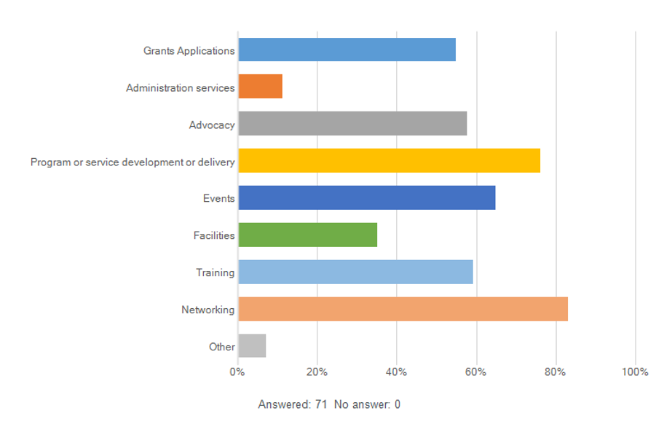

Priorities for collaboration and advocacy
When asked about areas for future collaboration or collective problem-solving, respondents offered priorities under the following themes:
- Access / availability of services
- Affordable Housing & homelessness
- Families, parenting and early years support
- Social Isolation and loneliness
- Cost of Living impacts and food security
- Impacts of family violence
- Employment pathways (including training opportunities)
- Mental Health and wellbeing
- Youth Engagement and support

Conclusion
This report offers broad insights into the experiences of human services providers in the City of Whittlesea. Though there are some limitations in generalising the data, there appears to be consensus among the respondents around the current challenges for providers, the perceived experiences of service users and emerging issues for the human services system.

Next Steps
- To strengthen and deepen the insights highlighted in this report, additional engagement with service providers and service users is suggested:

- Interviews with service providers from sub-sectors to confirm the themes and priorities and additional context

- Recognising that most service providers are experts in their field but are also providing services to City of Whittlesea and beyond, there is an opportunity for Council to add value. To support service providers to tailor programs and understand the unique needs and challenges of different areas within the municipality, Council could provide annual sessions offering localised information.

ABS Estimated Resident Population based on 2021 Census, compiled by .id, 2024.
ABS Estimated Resident Population based on 2021 Census, compiled by .id, 2024.
ACOSS, 2019, Demand for Community Services Snapshot, December 2019 - ACOSS, (accessed 28/04/2025)
ACOSS, 2019, Demand for Community Services Snapshot, December 2019 - ACOSS, (accessed 28/04/2025)
City of Whittlesea, 2024, Community Insights Survey Wave 1.2 July 2024
City of Whittlesea, 2024, Community Insights Survey Wave 1.2 July 2024
Social Policy Evaluation and Research Unit, 2015, Families with Complex Needs: International Approaches, NZ Government, accessed: Families-with-complex-needs.pdf (20/05/2025)
ACOSS 2019, Findings from the 2019 Australian Community Sector Survey, p33, 2020-ACSS_final-3.pdf (accessed 20/05/2025)
51.8% of respondents reported they were mostly able to meet demand, 20% of respondents reported they were completely able to meet demand.
29.4% could support he same number, 35.3%, ability to support slightly increased numbers, 23.5% were able to support significant increase in service users.
City of Whittlesea, Community Insights Study, Wave 2.3, October 2025
City of Whittlesea, Community Insights Study, Wave 2.3, October 2025
City of Whittlesea, Community Insights Study, Wave 2.3, October 2025
Social isolation and loneliness - Mental health - AIHW
Bell, T, Mendoza, J, Stretton, A, and Salvador-Carulla, L, 2018, EMPHN integrated mental health and AOD service atlas (East and North East Melbourne) – Final report.
Whittlesea Community Futures, 2021, Lockdown Survey June 2021.
City of Whittlesea, Community Insights Study, Wave 2.3, October 2025
ABS Cost of Living Index
Housing.id based on 2021 Census
Factors associated with FDSV - Australian Institute of Health and Welfare (aihw.gov.au)
Family Violence Dashboard | Crime Statistics Agency Victoria
City of Whittlesea, Community Insights Study, Wave 2.3, October 2025
Rosier & MacDonald 2011, The relationship between transport and disadvantage in Australia, https://aifs.gov.au/sites/default/files/publication-documents/rs4_2.pdf (accessed 27/05/2025)
Affordability Monitor, Affordability Monitor | City of Whittlesea | housing monitor , Compiled and presented by .id using data from PropTrack Pty Ltd.
SGS Rental Affordability Index, https://sgsep.com.au/projects/rental-affordability-index , (accessed 2/6/2025)

