Community Priorities Focus Group
Engagement Summary
February 2025



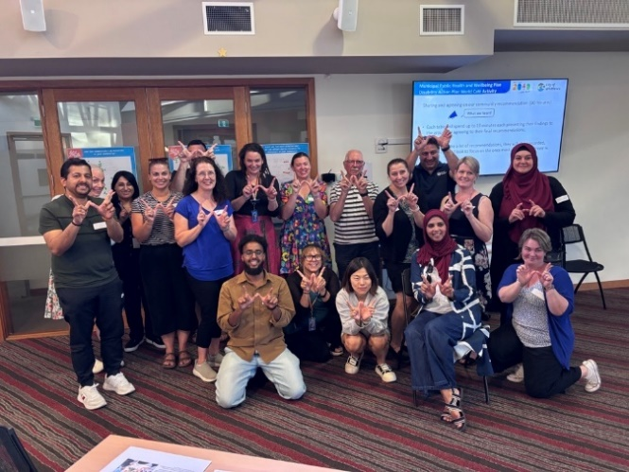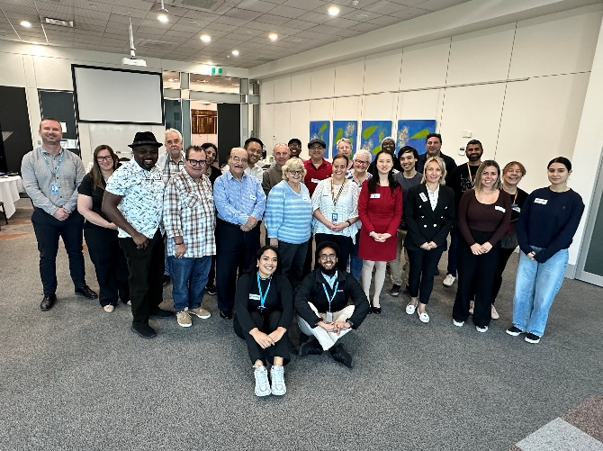

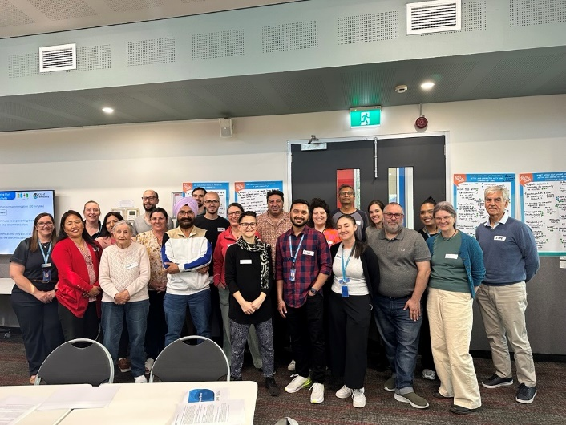

Introduction
The City of Whittlesea is currently developing the 2025-26 Budget, Council (Community) Plan 2025-29, Financial Plan 2026-35, Municipal Public Health and Wellbeing Plan and the Disability Action Plan.
To involve the community in shaping these key plans, focus groups were established to provide opportunity for valuable insights to be shared that will help identify, assess, and prioritise community interests. This approach will enable us to achieve balanced outcomes that are informed by the community's perspectives.
The focus groups followed two phases of community consultation in which we heard from 1,060 people who identified what matters most to them across the municipality. The information shared through these phases informed content presented to focus group participants.
How we engaged you
For this third phase of consultation, Council held three identical community focus groups held in different locations across the municipality reducing travel for participants and enabling a place-based lens to the feedback captured.
Recruitment for the focus groups took place via an Expression of Interest (EOI)
from 5 August 2024 to 13 January 2025 with recruitment placed on hold during the official caretaker period between 17 September and 26 October 2024. The opportunity was promoted via various channels including the Engage Whittlesea platform, Councils social media channels (LinkedIn and Facebook), electronic direct mail to registered multicultural, senior and sports clubs and in newsletters distributed by local area networks and the Hume Whittlesea local learning and employment network.
The project page on the Engage Whittlesea platform featured general information about the focus groups including the purpose of the consultation as well as a project timeline. Focus Group Terms of Reference (Appendix 1) were developed and published on the project Engage page along with the digital EOI form.
Three focus groups were held during February, as below:
- Whittlesea Community Activity Centre, Tuesday 11 February, 6-9pm
- Civic Centre, South Morang, Saturday 15 February, 9am – 12pm
- Lalor Library, Thursday 20 February, 6-9pm.

Confirmed participants were sent a pre-reading information pack that was anticipated to take 30 minutes to complete.
Format of the focus groups
Each focus group ran for three hours and included two small group activities. The first activity centred on development of the Municipal Public Health and Wellbeing Plan and the Disability Action Plan and saw table groups generate ideas for three key questions with participants asked to place dots on the ideas generated by others that they supported.

The questions posed for deliberation were:
- What would help you be socially active and connected with your community?
- What are the most effective ways we can improve mental wellbeing for individuals in your community?
- How can we prevent homelessness in your community?
The second activity looked at various Council service areas and participants explored which were their particular focus for increased Council priority and investment. The group also weighed up the cost of delivering services and an understanding that all could not increase and remain within the budget amount.
These service areas were:

- Ageing well
- Children and family
- Resource recovery and waste management
- Community strengthening
- Biodiversity, land management, sustainable planning and design
- Animal management
- Public health and safety
- Youth services
- Creative communities
- Local business.

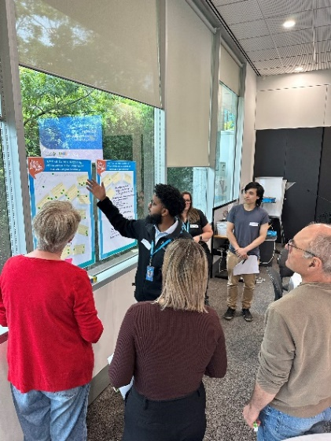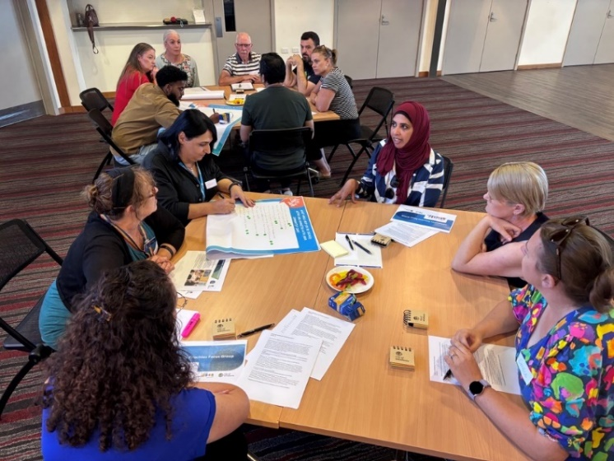
Above: Exploring Council service areas

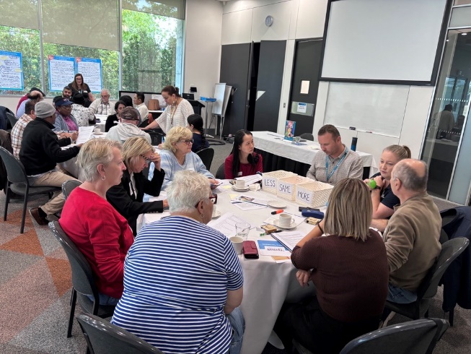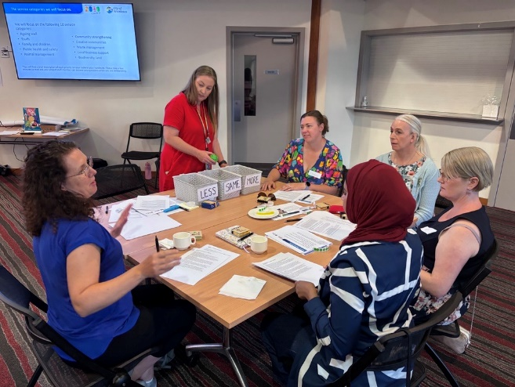
Above: Deliberating priorities

Participation
A total of 46 community members participated in the three focus groups. The session with the highest number of participants was South Morang with 19 participants, followed Lalor with 15 participants and lastly Whittlesea with 12 community members participating.
While there was a mix of ages and demographics, the following were some key statistics.

 |  | 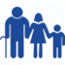 | 
24% of participants were living with or caring for a person with a disability | 56% Female, 44% Male | While there was a diverse age range, the main age groups represented were 36-45 years (35%) and  46-55 years  (26%) | 41% of participants spoke a language other than English at home.
 |  | 
30% of participants described their household structure as a couple with children | 4% identified as members of the LGBTQIA+ community and 41% did not answer. | Participants lived in 14 suburbs across the municipality

What we heard
Participants attended the workshops and deliberated with other community members and project staff, they gained a better understanding of the service categories level expectations and challenges faced. Participants told us that they would like to see an increased focus on local business, youth services, public health and safety, waste management and ageing well.
Participants, working in small groups generated 192 ideas in response to the three questions related to health and wellbeing priorities. These ideas predominantly centred around education and awareness campaigns, social connection initiatives, housing options, addressing financial barriers, safety in the community and specific research.

At the completion of the focus groups participants commented that the workshop was well structured with clear directions and appreciated the opportunity for discussion. Council staff were seen as friendly and welcoming with majority of participants feeling included and displaying respectful behaviour. The facilitator and project staff were clear and concise with directions, they were helpful and understanding when assisting and participants felt valued and listened to.
- 93% gained much more/ little more informed about health and wellbeing priorities
- 93% felt much more/ little more informed about the challenges faced when developing a Community Plan and a Financial Plan
- 96% will definitely/highly likely to participate in future focus groups.
At the workshop
The first activity focused on health and wellbeing priorities, with three questions posed to participants. Each table group spent 10 minutes deliberating each question in a world café style activity. Each rotation invited participants to use a sticky dot to show support of comments already captured and/or to add new comments. Below are the ideas generated by participants for each of the questions. All ideas captured can be seen in appendix 3.
What would help you be socially active and connected with your community?
A total of 73 ideas were captured across the three focus group.

We have themed the ideas below in order of the most popular based on number of similar ideas and level of support as shown.

Other themes included community volunteers (6), green spaces (6), markets and events (4), financial barriers (3), safety (3), neighbourhood connection (1), employment opportunities (1).

The most suggested/supported theme was activity programs/group with a total of 14 ideas suggested with 35 people in support of these ideas.
- Create simple activities/groups such as board games, social meet ups and low socialisation activities
- Connection for youth – larger variety of activities offered at an array of times
- Group activities such as hiking and walking groups.

There were 12 ideas captured that related to infrastructure with 30 people in support of these ideas.
- More flexibility - spaces and places for culturally sensitive activities
- Community market stalls need to be more accessible as well as parking
- Utilising existing spaces.

Participants suggested 14 Ideas related to information/promotion of available health and wellbeing services with 28 people in support.
- Let community know what’s available for them to access
- Promotion of activities i.e.: at local shopping centres
- Create a community calendar with all events
- More communication boards in central spaces.
How can we prevent homelessness in your community?
A total of 66 recommendations were captured across the three focus groups.

We have themed the ideas below in order of the most popular based on number of similar ideas and level of support as shown through participant support via sticky dots.

Other themes included child safety (5), elder abuse (2), empower community (2), planning (2), advocacy (1), police involvement (1).

Support services was the most suggested/supported themed idea with 17 ideas suggested and 38 in support.
- Mental health supports
- Increase in support programs available in language that address the factors of homelessness
- Increase knowledge of where support can be accessed i.e.: food banks and soup kitchens.

There were 13 ideas captured relating to infrastructure and 15 in support.
- Increase the use of temporary building as housing options i.e.: heritage buildings
- Need an emergency bed access point and crisis accommodation in City of Whittlesea
- Portable dwellings at the back of properties.

Participants suggested seven ideas related to housing options with 15 in support.
- Better consideration surrounding rooming house regulations and more programs to ensure rooming houses are at standards and more affordable. If rooming houses were at better standards, and less costly, it could prevent a lot more homelessness in the community.
- More support for multi-generational housing.

What are the most effective ways we can improve mental wellbeing for individuals in your community?
A total of 51 recommendations were captured across the three focus groups.

We have themed the ideas below in order of the most popular based on number of similar ideas and level of support as shown through participant support via sticky dots.

Other themes include support – school focused (5), youth services (5), translated (3), social connection (2), seniors' social connection (1) and social research (1).

The most suggested/supported theme for improving mental wellbeing was creating awareness campaigns. The total level of support was 65 which included ideas generated and support for ideas. Some ideas were similar in nature and were combined.
- Fight stigma - encourage talking about mental health to normalise it and know you're not alone
- Creating awareness -
- Promote inclusion
- Information about prevention/ lifestyle choices.

There were 11 ideas captured related to support services and 41 in support.
- Intentional programs that meet the needs of a variety of cultures
- More awareness/prevention about community programs
- Help with access to services to give more confidence accessing them (not just transport)
- More frequent walking groups, new resident packs tailored to each area
- Respite for carers and parents.

Activity 2 – Levels of service
The second activity focused on the ten service areas the community told us mattered most to them through the first two phases of consultation. Each table was presented with ten coloured balls that were each labelled with a different service area. Each table group spent 30 minutes deliberating and placing their balls into one of three tubs to indicate the level of focus they thought Council should have on each area. Not surprisingly, participants wanted to see more of a focus on many of the service areas, with all nine groups coming in over budget when the value of each ball was revealed. The second part of the activity required groups to deliberate to trade off the level of focus of each service area to balance the financial impact of the budget, revealing the service areas they saw as highest priority.
Overall, the group emphasised local business, youth services, public health, waste management, ageing well, children and families and biodiversity as their key priority areas.
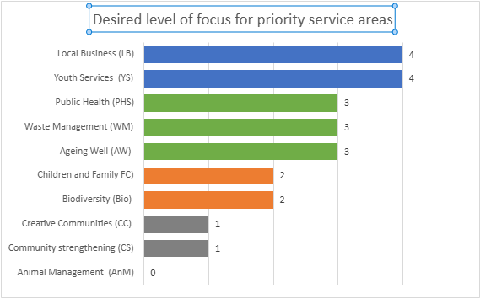

Next steps
Feedback captured through the focus groups is being collated and will help to inform the development of several draft documents. These include the:
- The proposed 2025-26 Budget which will be available for further comment in April 2025
- The proposed Financial Plan 2026-35 which will be available for further comment in April 2025
- The draft Community Plan 2025- 29 that will feature the Municipal Public Health and Wellbeing Plan and the Disability Action Plan, which will be available for further comment in June/ July 2025
Council delivers over 140 services and feedback captured can help shape these services. Some suggestions may be outside the remit of Council but will use the ideas in our advocacy efforts or to support other authorities to deliver their services.
Thank you again to everyone who participated in the community engagement by sharing comments, feedback and participating in activities and focus groups. The community will be updated on further developments via the Community Priorities | Engage City of Whittlesea project page. We encourage you to register and follow the page to be kept updated on the project.

Appendix 1 – Focus Group Terms of Reference

City of Whittlesea Community Priorities Focus Group - Terms of Reference

1. Purpose
The purpose of the Focus to provide valuable insights to help inform the 2025-26 Budget and other key documents that will guide Council’s essential activities over the next 5-10 years.

2. Participation
Participation in the Community Priorities Focus Group will be capped at 25 people and participants will be chosen to reflect the diversity of the City of Whittlesea community. This diversity will include ages, genders, abilities, cultural backgrounds, suburbs and household structures.
To be eligible to be a participant of the Community Priorities Focus Group you will need to:
- Be a resident of the City of Whittlesea
- Be willing and able to attend all three focus group sessions
- Be willing and able to complete any pre-session reading, assistance can be organised for those requiring it
- Declare membership of any special interest group, community groups, networks such as sporting clubs, craft and hobby groups, seniors' groups, schools etc.
- Not be a current staff member, contractor or Councillor of Whittlesea Council.
If a participant believes that they may have a financial interest in any of the projects discussed during the focus groups, they must discuss that interest with the facilitator. Should the facilitator decide that the financial interest gives rise to a conflict, the participant will not be permitted to contribute to discussions regarding that project.

3. Role of the Community Priorities Focus Group
The 2025 Community Priorities Focus Group will help inform the 2025-26 Budget and other key documents that will guide Council’s essential activities over the next 5-10 years.
We will capture valuable insights from our Focus Group participants to help us identify, assess, and prioritise community interests. This approach will enable us to achieve balanced outcomes that are informed by the community's perspectives.

4. Code of Conduct
All participants are expected to abide by the City of Whittlesea Code of Conduct and:
- Operate with integrity, objectivity, accountability, honesty and openness
- Participate and provide feedback that is in the best interest of the City of Whittlesea as a whole
- Declare any potential conflict of interest (including financial) to the facilitator if it arises during the focus group sessions
- Dedicate appropriate time and effort to the focus groups – approximately 9-12 hours in total over the project period
- Prepare for focus groups by completing pre-reading and actively participate in all three focus group sessions
- Maintain effective and respectful relationships with other participants and facilitators.

5. Focus group sessions
Focus Group participants will be required to undertake pre-reading and attend one of three in-person focus groups and will receive a participatory gift voucher for their time. We will be holding several identical sessions across the municipality. The session dates and times will be advised as soon as confirmed but will be held between within the first two weeks of February 2025.

Agenda and session pre-reading
The agenda and any pre-reading will be provided to Focus Group members one week in advance of the session. A summary of what we heard will be provided to participants following the focus group session.

Participatory Gift
Focus Group participants will be required to complete all pre-reading and attend the in-person focus group session and will receive a participatory gift voucher for their time.

6. Requirements of participants

Confidentiality
Focus Group participants are expected to maintain confidentiality and refrain from publicly sharing any information related to the focus group materials.

Public Statements
Focus Group participants are not authorised to issue public statements on behalf of Council.

Rescinding members
The City of Whittlesea retains the right to revoke the inclusion in the focus group of any individual who violates the Terms of Reference or Code of Conduct. This includes if you are elected as a Councillor for the City of Whittlesea.

Appendix 2 – Workshop resources
Activity 1 – health and wellbeing information for questions posed
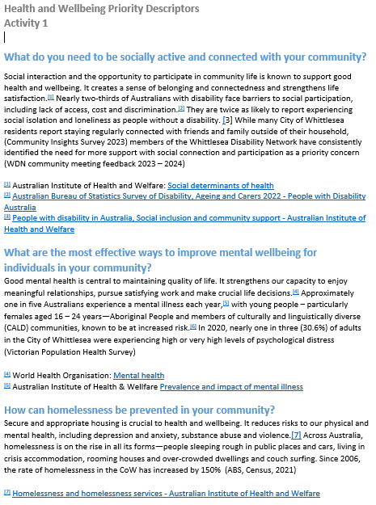

Activity 2 – service category descriptions
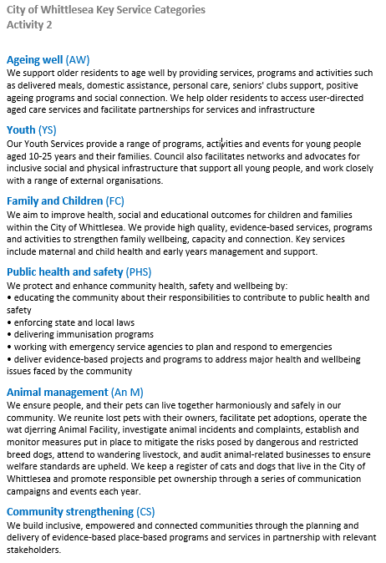

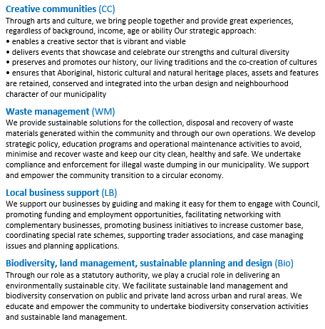

Appendix 3 – Focus Group recommendations from Activity 1
What would help you be socially active and connected with your community?

WCAC (21 Recommendations)
Dots | Recommendation | Theme
2 | Using mobilised wheelchairs need more access | Accessibility
1 | Accessibility for people with disabilities | Accessibility
4 | Create simple activities/ groups such as board games, social meet ups and low socialisation activities | Activity Programs/Groups
3 | Donnybrook feeling isolated want more support for advertising and accessibility for different groups - builds momentum - not enough activities geographically challenged | Activity Programs/Groups
5 | Connection for Youth - activities more choices and flexibility, more different times to access | Activity Programs/Groups
1 | Volunteer opportunities - more information to involve community | Community Volunteers
1 | Let community know what’s available for them to access | Information / Advertising
3 | Advertise more | Information / Advertising
4 | How to reach out with others in the community - carers or parents of children with disabilities are isolated and limited to connect with community limited disability focused events | Information / Advertising
3 | APPs- have tools in these to provide information to community and connecting others | Information / Advertising
8 | More flexibility - spaces and places for culturally sensitive | Infrastructure
3 | outdoor areas are difficult to use- need shade | Infrastructure
3 | Infrastructure of roads -lack of road safety - pedestrian crossings | Infrastructure
2 | Community market stalls need to be more accessible as well as parking | Infrastructure
3 | Access to parking places | Infrastructure
1 | Build positive acceptance and awareness in the community | Social awareness
1 | Interact with different places such as schools, scouts | Social awareness
2 | Access to NDIS for social participation | Support Services
1 | More support for those who want to exercise such as cycling | Support Services
1 | Need more carers to be available | Support Services
10 | More walkable places to attend | Walkability
Civic - Fountain View Room (23 recommendations)
 | Bus drivers now drive with a ramp and need more training | Accessibility
 | Website is not disability friendly. Doesn’t meet standards - look for USERWAYS | Accessibility
6 | Accessible public transport and more options (no bus after 9pm) | Accessibility
5 | Face to face education opportunities with group discussion with interpreters | Activity Programs/Groups
 | More online groups versus too many online groups | Activity Programs/Groups
 | More free activities in community, recreation and leisure | Activity Programs/Groups
 | Leadership program for seniors and youth | Activity Programs/Groups
 | Connecting more with neighbours and more support improving connections such as meet your neighbour and or street party activities | Community Connection
3 | Not easy to volunteer | Community Volunteers
 | More employment opportunities for PWD | Employment Opportunities
 | Council to approach gymnasium to link activities for community with financial disadvantage | Financial barriers
1 | Cost barriers for recreation and leisure attendance - create opportunity such as positive ageing activity | Financial barriers
3 | Information to become active in the community | Information/Advertising
2 | Information by Council to help integrate and provide information about activities | Information/Advertising
 | All free gym activities equipment and their locations and how to access it | Information/Advertising
7 | Lack of road safety: dedicated crossing at lake boulevard, DDA compliant for growth area and growing fear of violence | Road Infrastructure
8 | Streetlights and lack of safety: bridge inn Rd, Findon Rd, South Morang and Donnybrook station pathway not accessible | Road Infrastructure
2 | PWD feeing unsafe with increasing assaults community reluctant to support | Safety
5 | Education around disability and awareness | Social Awareness
6 | Lack of support system | Support Services
3 | Establishing link to provide support | Support Services
4 | Technology education with people with disabilities versus a void retention in technology | Technology
3 | Technology for communications but none for socialising | Technology
Lalor Library (29 recommendations)
2 | More parking / accessible spaces will encourage people to use parks | Accessibility
2 | More free spaces for community to access i.e., local parks | Activity Programs/Groups
2 | More opportunities to connect - i.e., street meets (bring a dish, multicultural) | Activity Programs/Groups
1 | Group activities such as hiking and walking groups | Activity Programs/Groups
1 | Weekend activities fitness focused | Activity Programs/Groups
6 | Cultural activities to increase social connection open to all | Activity Programs/Groups
3 | Connect to walking groups | Activity Programs/Groups
3 | More sports activities available for community to access - suburbs to compete against each other | Activity Programs/Groups
 | Encourage connection in green spaces | Green Spaces
4 | Plan for more green corridors | Green Spaces
 | Better promotion of activities ie at local shopping centres | Information/promotion
5 | Create a community calendar with all events | Information/promotion
1 | create a central Facebook page of available activities | Information/promotion
 | More communication boards in central spaces | Information/promotion
1 | promotion of service and activities libraries offer | Information/promotion
 | Visibility of PPTS/ promotion of events | Information/promotion
3 | Promotion of community gardens policy | Information/promotion
 | More participation and use of available facilities such as dog parks | Infrastructure
 | More lighting (sustainable options) | Infrastructure
 | More visibility of community centres | Infrastructure
7 | More public toilets to use | Infrastructure
1 | Utilising existing spaces | Infrastructure
2 | More libraries in the northern half of the municipality | Infrastructure
1 | Common public areas to be well maintained such as TRAC | Infrastructure
2 | More community markets - i.e. crafts, utilising existing spaces | Markets, Events
 | More free music events that are family friendly | Markets, Events
4 | Water bubbler available at cycling/walking tracks | Park Amenities
3 | Availability of bins in local parks to increase participation | Park Amenities
1 | Social outreach opportunities | Support Services

What are the most effective ways we can improve mental wellbeing for individuals in your community?

WCAC (9 recommendations)
Dots | Recommendation
5 | Celebrate diversity | Awareness Campaign
7 | Fighting stigma - encourage talking about mental health, you're not alone, normalise mental health | Awareness Campaign
9 | Creating awareness - through comms strategy and social media | Awareness Campaign
15 | Promote inclusion (promotion and awareness were key words) | Awareness Campaign
9 | Creating safe spaces - in person, online, sporting venues, youth programs, physical health venues/ hospitals, culturally safe spaces | Infrastructure
8 | Physical wellbeing- how to incorporate physical health to improve mental health | Physical wellbeing
1 | Supporting parents | Support - Schools
1 | Early intervention - focus on youth and school programs | Support - Schools
1 | More connection with community development officers | Support Services
5 | Promote existing services | Support Services
Civic Centre – Fountain View Room (24 recommendations)
2 | Information about prevention/ lifestyle choices – alcohol policy | Awareness Campaign
2 | Alcohol – awareness and addressing the issue | Awareness Campaign
 | Gambling and addressing its harms via policies | Awareness Campaign
0 | Social media literacy | Awareness Campaign
3 | More understanding, less stigma about common mental health problems | Awareness Campaign
3 | Mental health literacy | Awareness Campaign
5 | Age-appropriate messaging to acknowledge the stressors | Awareness Campaign
0 | More awareness about the use of vapes and its harms | Awareness Campaign
7 | Music festival, painting and art competitions | Community Activities Creative/Arts
2 | More culturally responsive mental health services – cultural awareness/cohort appropriate | Cultural Awareness
4 | Encouraging multiculturalism within the mental health space | Cultural Awareness
1 | Mental health aid courses | Education/Training
0 | More use of open spaces | Infrastructure
0 | Increase collaboration – young people and seniors | Intergenerational opportunities
1 | Access to sport/active living opportunities | Physical wellbeing
1 | More engagement for social connection and active living opportunities for seniors | Seniors - social connection
3 | Mental health services need to connect in better to promote what is available | Service Promotion
0 | Directory of social groups | Service Promotion
5 | Dialogue what services are available – partnerships/ create services to promote social gatherings | Service Promotion
 | More social interaction to avoid social isolation | Social Connection
1 | Mental health research | Social Research
 | School age session/mental health (partnerships) | Support - Schools
2 | Intentional programs that meet the needs of a variety of cultures | Support Services
4 | Getting people together who have similar situation the bond, help and support each other | Support Services
3 | More information regarding dementia – how to slow it down, help for carers | Support Services
5 | More awareness/prevention about community programs | Support Services
2 | Information sessions to help navigate NDIS that is culturally appropriate | Support Services
2 | Programs available in variety of languages | Translated material
1 | Avenues for youth to express themselves | Youth services
2 | Mental health expression opportunities for youth – festivals etc | Youth services
Lalor Library (18 recommendations)
1 | Lack of awareness to available information | Awareness Campaign
2 | Regular community activities | Community Activities (Creative/Arts)
2 | Multicultural activities to link community | Community Activities (Creative/Arts)
11 | Activities that can break isolation such as garden clubs, craft clubs, coffee catch ups, music, home visits | Community Activities (Creative/Arts)
9 | Mental health first aid training | Education/Training
15 | More and better green space that encourage better access building confidence to get outside, user friendly with shaded spaces, more seating and more maintenance of spaces such as cleaning up of Darebin Creek | Infrastructure
1 | More pedestrian areas | Infrastructure
8 | Intergenerational links (youth - elders) | Intergenerational opportunities
9 | Exercise - using open space, parks for free activities that are fun and connect youth | Physical wellbeing
8 | Community safety - police patrol | Safety
1 | Promotion of spaces, activities, neighbourhood houses and services | Service promotion
2 | AOD resourcing with links to information | Service promotion
5 | Promoting more hub facilities where you can find peer support, volunteer opportunity and capacity building | Service promotion
1 | Link to community leaders | Social Connection
1 | Help with access to services to give more confidence accessing them (not transport only) | Support Services
4 | More and more frequent walking groups, new resident packs tailored to each area | Support services
8 | Respite for carers and parents | Support Services
6 | Help with shopping - social activities (elderly/lonely) | Support Services

How can we prevent homelessness in your community?

WCAC (18 recommendations)
Dots | Recommendation | Theme
2 | Better access to education to enable employability | education/employment programs
4 | Sense of safety for children in homes | Child safety
4 | Prevention of family violence is key to preventing homelessness | Family violence
6 | Family violence is the cause and there is an element of cost living | Family violence
5 | Cost of living since Covid is a cause. More regulation of rental spikes from landlords | Financial barriers
3 | Fulltime employers not able to afford a home | Financial barriers
2 | People living in caravans | Housing options
3 | Council venues not being used should be repurposed for people experiencing homelessness | Infrastructure
2 | Facility for homeless people in Whittlesea | Infrastructure
1 | Police should move people on | Police involvement
5 | Focus on prevention | Social Research
5 | Council should know and inform community | Social Research
 | Understanding causes - cultural lens | Social Research
4 | More awareness around navigation of homelessness services | Support Services
5 | Agency Directory: pre, during and post crisis | Support Services
1 | Substance abuse | Support Services
5 | Mental health supports | Support Services
 | Family mediation support services | Support Services
Civic Centre – Fountain View Room (15 recommendations)
3 | Increase education amongst community that homelessness is an issue | Awareness Campaign
 | Increase in number of programs for all people to tackle unemployment | education/employment programmes
 | Increase knowledge in budgeting and financial skills | education/employment programmes
1 | Increase in number of programs for young people to help with employment pathways | education/employment programmes
1 | Strengthen importance of family unit & empower community | Empower community
2 | Educate and target men in existing spaces to help tackle family violence. | Family Violence
 | Increase education to men and boys on family violence, particularly targeting schools. | Family Violence
2 | Increase the use of temporary building as housing options i.e., heritage buildings | Infrastructure
 | Increase in more social housing | Infrastructure
2 | More affordable housing options | Infrastructure
1 | Advocate to D.O.H for more social housing options | Infrastructure
2 | Conduct research into the actual causes of homelessness (focus on data) | Social Research
1 | Find out the true number of people living rough in City of Whittlesea | Social Research
3 | Increase in support programs available in language that address the factors of homelessness | Support Services
3 | Increase knowledge of where support can be accessed i.e. food banks and soup kitchens | Support Services
Lalor Library (33 recommendations)
1 | More advocacy for emergency / crisis housing | Advocacy
1 | More advertising for where/ when / how to get help- at phone boxes, council website, bus stops, pamphlets | Awareness Campaign
1 | More protection for elderly - elder abuse | Elder abuse
1 | Domestic violence is a major issue | Family Violence
1 | Better consideration surrounding rooming house regulations and more programs to ensure rooming houses are at standards and more affordable. If rooming houses were at better standards, and less costly, it could prevent a lot more homelessness in the community. | Housing options
4 | Affordable housing for everyone, students, new arrivals, people fleeing family violence, low-income earners | Housing options
 | More support for multi-generational housing | Housing options
 | Supported accommodation such as Queen St Lodge | Housing options
 | Decrease in social housing, more co-operative housing (state/corp managed) will help those studying without any stress | Housing options
2 | Diversity of housing - affordable and social | Housing options
5 | Cap on Air B'n'B in Council areas as it reduces long term tenancy opportunities | Housing options
2 | Are there enough emergency beds in the City of Whittlesea | Infrastructure
2 | Transitional housing- people who have been released from prison or rehab | Infrastructure
3 | Need an emergency bed access point in City of Whittlesea, crisis accommodation | Infrastructure
1 | Portable dwellings at the back of properties | Infrastructure
 | Providing land and services- Council to free up land for affordable housing | Infrastructure
2 | Address unused dwellings | Infrastructure
 | Council land should only be sold for social and affordable housing | Infrastructure
 | Supply/demand | Planning
 | Fast track planning on affordable/ social housing | Planning
1 | Need to recognise the multi-faceted factors that lead to homelessness | Social Research
1 | Orange van providing services | Support Services
3 | Subsidising the orange van service | Support Services
4 | Support for over 50's female/women who find themselves homeless, super, savings, financial literacy, budgeting, understanding basic financial implications | Support Services
 | Substance abusers more support | Support Services
2 | Access to financial advice, pro bono work | Support Services
 | Donation drives in prominent areas | Support Services
1 | Access to services, blankets, food banks, clothing | Support Services
1 | Assertive outreach in Cow, rough sleepers targeted services to help with housing | Support Services
1 | Wrap around services/ supports | Support Services
3 | Recognising that some people living rough want to, but still need services to keep them safe, eat, shower, clothing, protection from rain-e.g., drop-in centres at unused shops | Support Services
3 | Multicultural communities, some women are unaware of how to manage finances | Targeted education
2 | Working with schools, young women financial literacy | Targeted education

