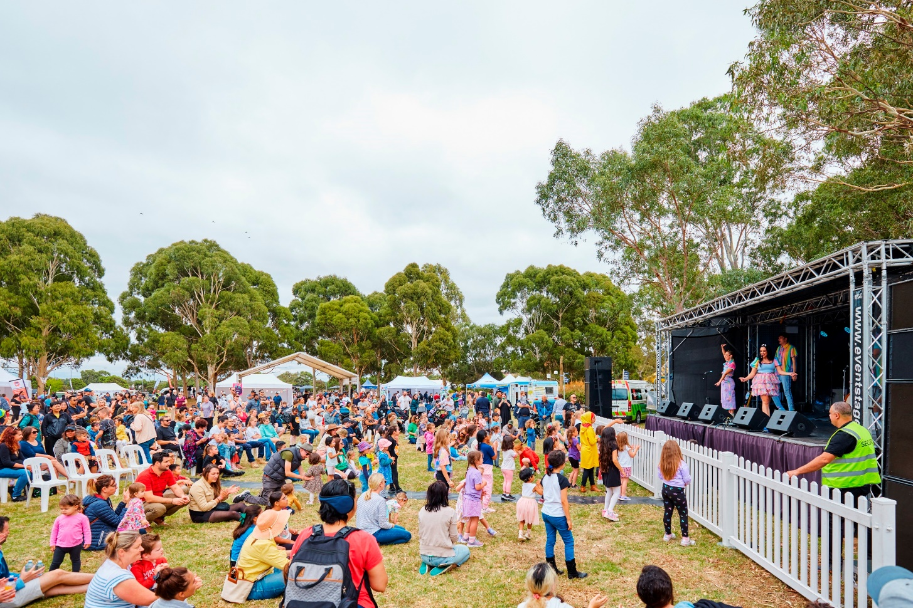
community priorities 2025
Engagement Summary
September 2024

Introduction
Each year Council releases an annual Budget for the investment and delivery of critical services and essential infrastructure to support our rapidly growing community. We need to balance the delivery of ongoing services and programs while also building infrastructure and facilities to cater to our growing population.
The budget is developed to align to our long-term financial plan which balances our current spending on projects and services for the community and strengthens our long-term financial sustainability.
We need to know what services and assets our community value most now and for the future to help us shape key documents that will guide Council’s activities over the next 5-10 years.
Council undertook community consultation with people who live, work, study or visit the City of Whittlesea to understand community issues and needs across the municipality. As the municipality has diverse residents and needs, the consultation was designed to understand what is most important to the community and areas that they felt budget funding would be best allocated.
The feedback received will inform the 2025-26 Budget, Community Plan 2026-29, Asset Plan 2026-35, Financial Plan 2026-35, Road Management Plan 2026-29 and Revenue and Rating Plan 2026-29.
This first phase of consultation included digital engagement, 13 community-based pop-ups and two stakeholder group presentations. The opportunity to participate was promoted via social media, emails to targeted stakeholder groups and flyers. During phase one there was a total of 881 contributions from a diverse cross-section of our community who told us that the top five priorities for our community across the municipality are:
- Roads, public transport and footpaths
- Parks, playgrounds and open space
- Community facilities
- Community safety
- Arts, culture and events.

How we engaged you
The community engagement to inform these key documents will be delivered in five phases as below:
Phase 1: Broad community consultation (5 August to 4 September 2024)
Phase 2: Broad community pulse check/consultation – (December 2024-January 2025)
Phase 3: Deliberative engagement – focus groups (early 2025)
Phase 4: Proposed budget released for community feedback (2 to 11 April 2025)
Phase 5: Adoption of 2025-26 Budget and closing the loop with community (May 2025).

This report focuses on phase one community consultation undertaken between 5 August and 2 September 2024. Community feedback was sought online through Council’s Engage Whittlesea platform and through direct conversations and activities at community-based pop-ups.

Engage page
On the Community Priorities Engage page, participants were invited to share their priorities for the future through a survey and/or submit their interest in being a part of a focus group to be held in early 2025.
The survey required participants to select the three areas most important to them from the possible thirteen and were then asked additional questions based on their selection. The additional questions were designed to delve deeper into the communities’ priorities to understand the specific areas of importance for each of the priority areas they selected. There was free text space provided for participants to add further comment as part of the additional questions.
The Engage Whittlesea platform utilises an accessibility add-on ensuring that it is as accessible as possible for all users. The platform also has an in-built translation tool to mitigate any language barriers to participation, allowing the page to be translated into the top ten languages spoken within the municipality.
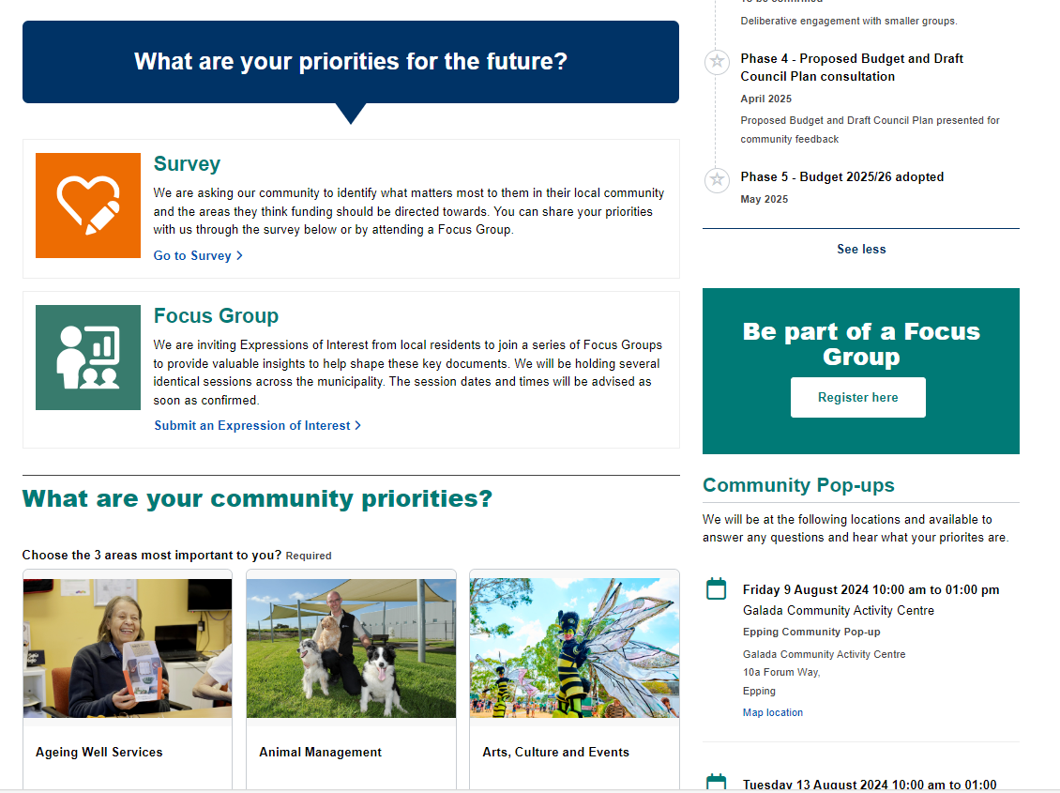
Above: screen grab of consultation activity on project Engage Whittlesea page.
Community-based pop-ups
The project team hosted 13 community-based pop-up stalls at targeted high foot traffic locations within the municipality. The in-person consultation activity mirrored the information being sought through the digital consultation survey activity; specifically, capturing their top three priorities with participants asked to place a sticky dot on their choices and then complete a hard copy survey or complete the survey on an available iPad to provide a deeper level of insight.

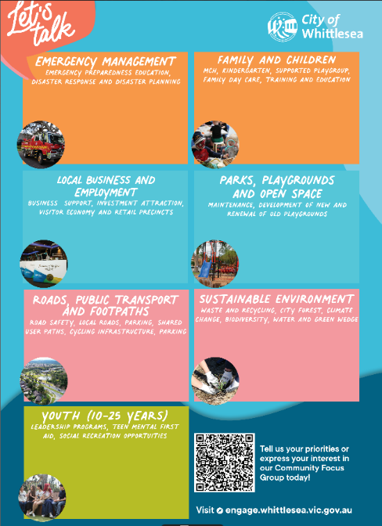
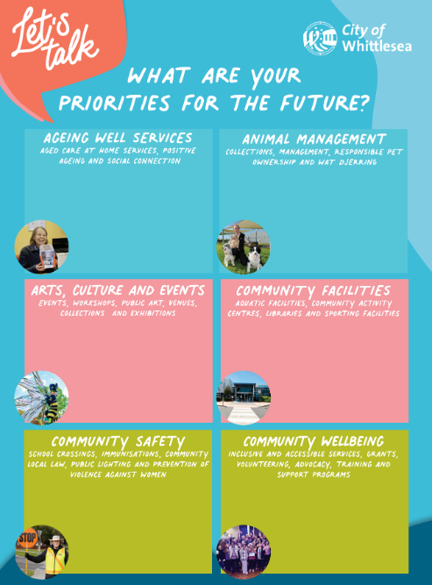

Left: dot boards used at community-based pop-ups

The community-based pop-ups were held on the following dates at the following locations:
Date | Time | Where | Address/location
Friday 9 August | 10- 1pm | Galada Community Activity Centre (Immunisation session) | 10a Forum Way, Epping
Tuesday 13 August | 10am-1pm | Outside Whittlesea Service Hub | 63 Church St, Whittlesea
Thursday 15 August | 10am-2pm | Lalor Library | 2A May Rd, Lalor
Thursday 15 August | 5.30pm-7.30pm | Mill Park Library | 394 Plenty Road, Mill Park
Friday 16 August | 11am-2pm | Coles Uni Hill | 224 Plenty Road, Bundoora
Tuesday 20 August | 1.30pm-4.30pm | Mernda Town Centre | 180 Riverdale Blvd, Mernda
Wednesday 21 August | 5pm-7pm | Kirrip Community Activity Centre (Immunisation session) | 135 DeRossi Blvd, Wollert
Friday 23 August | 2.30pm-4.30pm | Laurimar shops, outside Woolworths | 95 Hazel Glen Rd, Doreen
Monday 26 August | 9.30am-12.30pm | Olivine Estate outside Shared Cup Café | 995 Olivine Blvd, Donnybrook
Tuesday 27 August | 1.30pm-4.30pm | Westfield Plenty Valley | 415 McDonalds Road, South Morang
Wednesday 28 August | 9am-12pm | Thomastown Recreation and Aquatic Centre | 52 Main St, Thomastown
Friday 30 August | 2.30pm-4.30pm | Mill Park Stables Shopping Centre | 314-360 Childs Rd, Mill Park
Saturday 31 August | 6pm – 9pm | Walking Thomastown | Main Street Recreation Reserve, Thomastown

The project team also presented at the City of Whittlesea Sports club Forum held at Meadowglen International Athletics Stadium from 6.30 to 8.30pm on Wednesday 28 August and to the City of Whittlesea Youth Council on Monday 2 September.

Project Promotion
The opportunity to participate in the community engagement was promoted through a range of channels to have a widespread reach across the municipality including:
- Council’s digital engagement platform Engage Whittlesea
- Social media – organic posts reached more than 21,000 people and were engaged with 1,070 times which generated 22% of visits to the project Engage page.
- Engage Whittlesea campaign to platform users - the two campaigns had a combined click-through rate of 6.28% and accounted for 16% of visitors to the project Engage page.
- Direct email to targeted stakeholder groups including CALD groups, seniors’ groups, Whittlesea Disability Network, Whittlesea Reconciliation Group and other advisory groups
- Flyers and posters displayed at Council facilities and libraries.

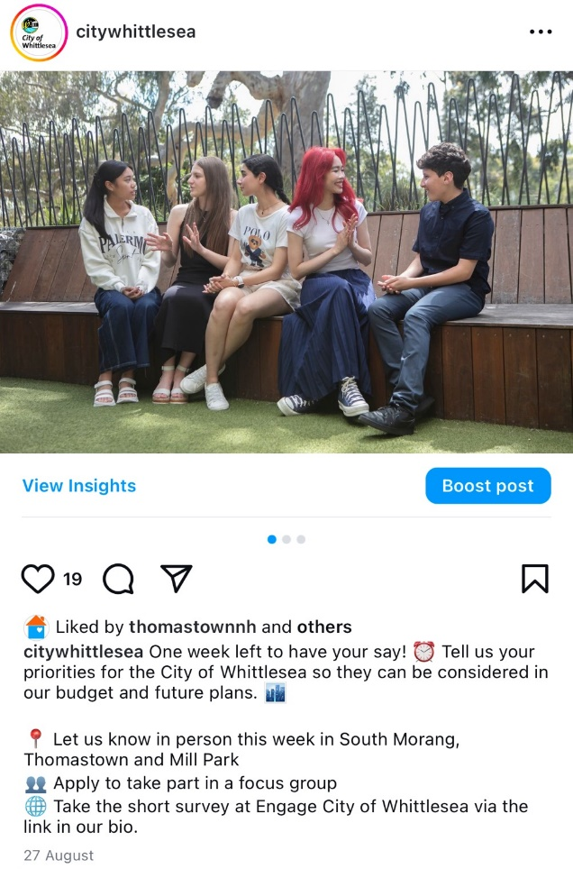
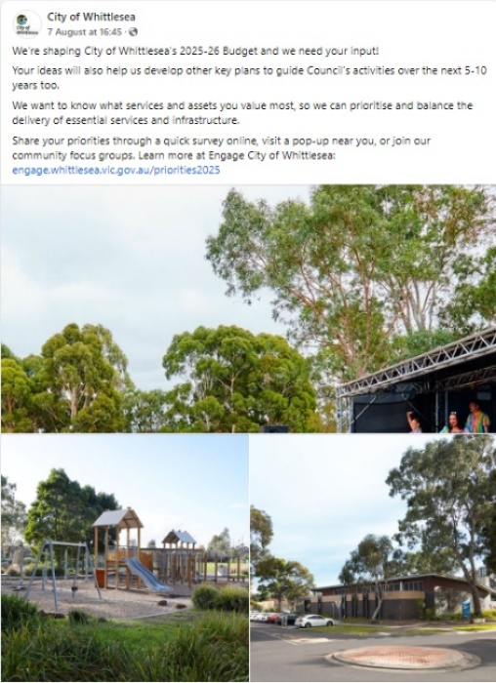

Above: selection of social media posts

Participation
In phase one there was a total of 881 contributions, 542 of which were captured at community-based pop-ups and 339 contributions made on our Engage Whittlesea platform. Highlights from the consultation included:


Hosted 13 community-based pop-ups | Two stakeholder group presentations | 339 digital contributions | 542 in-person contributions

Below is a snapshot of the diversity of participation:
 |  | 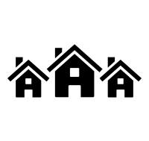 | 
57% female, 40% male and 3% prefer not to answer | 22% aged 35-44 years, 15% aged 0-14 years, 15% aged 25-34 years  14% aged 45 – 54 years  13% aged 65-74 years | Respondents live in each of the 15 suburbs across the municipality with 17 % of participants from Thomastown and 10% from Doreen | 23 people indicated they are a person with a disability, 14 are an unpaid carer of a person with a disability, and 10 people are an unpaid carer of an older person
 |  |  | 
Four participants identified as Aboriginal and one as Torres Strait Islander | 28 people identified as members of the LGBTIQA+ community. | 30% speak a language other than English at home | 46% were couples with youngest child under 18, 19% couples with no children and 10% were single

Below is a snapshot of the diverse languages spoken at home by participants, emphasising the rich multicultural community in our municipality.
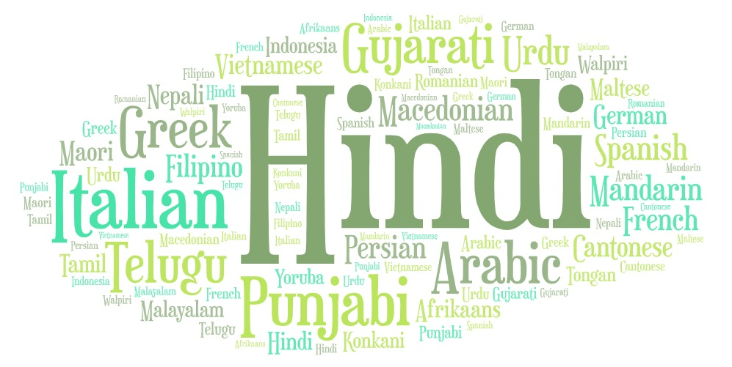

What we heard
After hearing from 881 community members from a diverse cross-section of our community across all areas in the City of Whittlesea, we learnt that the top five priorities for our community across the municipality are:
- Roads, public transport and footpaths including road safety, local roads, shared user paths, cycling infrastructure and parking
- Parks, playgrounds and open space including maintenance, development of new and renewal of old playgrounds
- Community facilities including aquatic facilities, community activity centres, libraries and sporting facilities
- Community safety including school crossings, immunisations, community local law, public lighting and prevention of violence against women
- Arts, culture and events including events, workshops, public art, venues, collections and exhibitions.
The graph below shows the number of responses received for each priority area. It is worth noting that there was an increase in priority votes for arts, culture and events following the Walking Thomastown event as 24% of the total contributions made to the consultation were captured at the event.
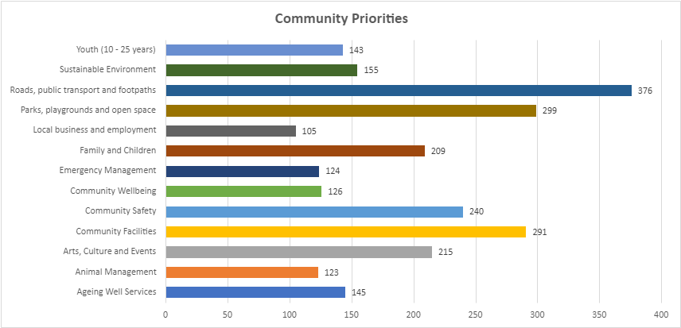

Participants in the digital survey were asked additional questions based on their selection of top priorities. These questions were designed to delve deeper into the communities’ priorities to understand the specific areas of importance for each of the priority areas they selected. There was free text space provided for participants to add further comment as part of the additional questions. Below are the results for each of the sub-categories as well as the themes from free text comments. Graphs showing what we heard for each priority area can be found in Appendix 2.
Ageing well services
The 56 participants that selected Ageing Well services as a priority area were asked to identify which service type was most important to them. Services were found to be equally important with Aged Care at home care services such as domestic assistance, delivered meals and personal care etc (80%) and positive ageing and social connection including social support and seniors’ clubs etc (79%).
Eighteen participants took the opportunity to add additional comment through this priority area, highlighting confusion around available services and how to access them. Participants also recognised the value of the services as well as suggesting other ideas such as additional social connection opportunities, more support for carers and new services including bus transport and annual cleaning of high areas for aged residents.
“There seems to be a great divide in what is seen to be offered and what can actually be offered by Council. For example, year on year is a mystery if maintenance and gardening is on or off the table.”
“The Ageing Care service in the City of Whittlesea has given us the chance to be well cared for and assisted in our own home.”
“Obtaining reasonable priced once a year cleaning for things too high and dangerous to be on a ladder. Eg ceiling fans, high cupboards, oven cleaning, windows.”

“It would be great to know that services were advertised in community languages and that CALD community groups were consulted about needs.”
Animal Management
Twenty-six participants provided additional information and identified responsible pet ownership programs (77%) as the highest priority service area for animal management services. Animal management (62%), wat djerring Animal Facility (54%) and animal collections followed (42%). Three participants suggested other important service areas including new dog parks and enforcing pet laws such as picking up after your dog, walking dogs on leads and roaming cats.
Eight participants took the opportunity to add additional comment through this priority area highlighting the desire for increased enforcement of pet related laws and suggesting extended services including the provision of steel council tags and education sessions.
“There is no signage to educate about picking up dog poop or that dogs must be on lead. People leaving dog poop and having dogs off lead are big problems at my local park (Lyndarum) and make it unpleasant and even dangerous to me and my dogs.”
“Animal bylaws need to be upheld in this Municipality, there is far too many animal owners getting away with animal control laws that need desperately to be enforced!”
“Having a ranger presence at off lead areas to deal with dog/owner issues”
“Steel animal council tags. The plastic ones break all the time and I'm sick of paying for new ones through no fault of mine.”
“Offering animal welfare education to people seeking to adopt from the pound…Free education sessions for people considering specific breeds, eg: working dogs (seem to be over represented in pounds and rescue orgs).”

Arts, Culture and Events
A total of 131 participants that selected Arts, Culture and Events as a priority area identified Plenty Ranges Arts and Convention Centre as the service type most important to them (34%). Festivals and events such as the Community Festival, Walking Thomastown and Carols by Candlelight were also important to participants (29%), followed by public art (17%) and community arts programs and workshops (15%). Less important were Ziebell's Farmhouse Museum and Heritage Garden (8%) and the municipal art collection and exhibitions (6%). Three participants also took the opportunity to suggest a standalone/dedicated art gallery be introduced within the municipality.
Twenty-six participants took the opportunity to add additional comment through this priority area highlighting the need for PRACC to be refurbished, for events to be promoted earlier and for additional community art and performing art opportunities.
“…I think promotion is difficult and I seem to find out about events too late.”
“As a long-time community member, I’ve seen how PRACC has played a vital role in bringing us together, but it’s clear the venue is now outdated and in need of a refresh. Please create a welcoming and creative space that we can all be proud of and that will attract more events and activities for everyone to enjoy. Investing in these updates is an investment in our community’s future.”
“Less metal sculptures more street art.”
“I wish there were more opportunities for local performing arts groups to perform to the community.”

Community Facilities
The 128 Participants that selected Community Facilities as a priority area were asked to identify which service type was most important to them. Sporting facilities (64%) and aquatic facilities (54%) were the highest priority service areas with libraires (34%) and community activity centres (33%) following.
Sixty-nine respondents took the opportunity to add extra comments, 24 of which related to not having appropriate sporting or community facilities close to home. A further 23 comments identified the facilities as being old and run down. Fifteen participants took the opportunity to suggest ways to improve community facilities and five comments related to libraries.
“Look at storage lockers at centres/libraries - community spaces for homeless people to store items”
"Facilities at Redleap are old and dilapidated. Not fit for female participation or growth. Would love to see a 2nd oval constructed where the dam is built at Redleap and new pavilion built in the middle to have facilities similar to Laurimar, Mernda, South Morang and Thomastown."
“Yes, please, please provide us with a Library in Epping Central asap. 54 years as an Epping resident is a very long time to wait for Library services close to home!”

Community Safety
Seventy-nine respondents provided further information about what was important to them in relation to community safety. The lighting of public spaces (77%), education and enforcement of Community Local Law (66%) and the prevention of violence against women - access to prevention programs (58%) were the most important service areas within community safety. School crossings (41%) and immunisation services (27%) followed. Four participants suggested other ideas including gang and youth violence prevention, better bike rider safety and Police or security presence at local shops.
Twenty-eight people provided additional comments, with key topics raised being road safety (8), local law enforcement with dumped rubbish, parking and cat curfew (7), lighting, community safety and an increase in crime.
“Too many pockets of Whittlesea that are not a safe place. Crime is growing and nothing is being done preventatively to slow it especially for young people.”
“Road rage is increasing in our local roads. I've been pushed off the road twice on the last 6 months. Drivers don't respect rules and are impatient and aggressive.”
“Prevention of vandalism”

Community Wellbeing
Reflective of the current climate, financial vulnerability/cost-of-living support and preventative programs (56%) was the most important service area to those that identified community wellbeing as a priority area. Other service areas seen as most important within this priority area were inclusion and participation of persons with a disability (51%), food insecurity and healthy eating - access and education (44%), volunteering (44%), inclusive and accessible services including Aboriginal Services, CALD, disability and LGBTIQ+ (38%), and homelessness and affordable housing advocacy (38%). Community grants (33%), community participation and leadership programs and training (31%) and gambling harm minimisation preventative programs and advocacy (15%) were also important to participants. Three people provided other suggestions of wellbeing for the elderly, air quality with smoke from chimneys, veteran welfare and suicide prevention.
There were 15 additional comments provided with most being about support services available and having more community groups or activities, knowledge of how to connect to services and inclusion.
“Adequate emergency services, protection & accommodation, especially to women & children from abusive environments.”
“I believe that community wellbeing is a fundamental part to ensuring the members of municipal are engaged, willing to participate, and feel safe doing so.”
“How do we connect people with services? Ideas for digital literacy. Why don't we have pop up council services information booths at libraries or community facilities. People could ask questions more easily”

Emergency management
A total of 38 participants identified their priority area within the Emergency Management service area. Located on the regional fringe emergency preparedness education and resilience (61%) was most important to those that selected emergency management as a priority area. Emergency activity and response to disasters (55%) and disaster planning – preparation and mitigation (45%) were also important.
A total of 48% of respondents answered yes to feeling prepared in the event of an emergency, with 21% responding they were “sort of” prepared and 36% saying they weren’t prepared.
With participants provided additional comments with most focused on having more emergency services in the area and funding for additional fire stations and equipment.
“Increased spending on Emergency Coverage and equipment is desperately needed and more Stations need to be built!”

Family and Children
Kindergarten (70%) and Maternal Child Health services (57%) were most important to those that indicated family and children is a priority area. The other service areas of training and education (46%) supported playgroups (43%), and family day care (30%) followed. Other suggestions included out-of-hours care for children of single parents and childcare in general.
Seventeen people provided additional comments on topics such as accessibility to longer day care, subsidised hours of child be increased and more information and training sessions for families.
“There needs to be more training to help raising kids in particular about screen time and cyber safety”
"More enhanced Maternal health”
“More kinders with longer days that can accommodate full work day (not just daycare as an option if working 8:30-4 and then a commute)"

Local business and employment
Participants that selected local business and employment as a priority area identified business support (59%) investment attraction (59%) and retail precincts including night-time economy (57%) as the most important service areas to them. Visitor economy followed with 30% identifying this service area as most important. Four people listed other things of importance including recruitment, activity centre zoning in Epping and tourism.
A total of 18 participants provided additional comments about topics such as local employment opportunities, investment attraction, the importance of visual aesthetics and cleanliness in business area surrounds, network events and local employment support and work experience opportunities.
“Support local business groups and local business owners to be employee ready. Support them to help grow employment opportunities for the youth of our area. Get them working together through a work experience program or similar”
“Keep public space clean and tidy, good presentation attracts business opportunities, and makes locals feel proud of their surroundings. More opportunities for youth employment, connect local schools with career pathways offered locally.”

Parks, playgrounds and open space
Participants that selected parks, playgrounds and open space as a priority area were asked to identify which service type was most important to them. There was an equal importance of maintenance (74%) and the development of new playgrounds and renewal of existing playgrounds (69%). Nine percent of responses were for other open space services such as creating more green spaces, new dog and pet friendly spaces, BBQ’s, toilets in playgrounds and workout/fitness equipment.
Sixty-eight people told us what their favourite park was and the top five within the municipality were Mill Park All Abilities Playground, Plenty Gorge Parklands, Whittlesea Public Gardens, Quarry Hills and Redleap Park/Peter Hopper Lake.
Fifty-one people provided details on where they would like parks renewed or new parks built.
There were sixty-eight additional comments for parks, playgrounds and open space. The most raised topic related to maintenance (24) followed by updating existing parks (15). Nine participants mentioned toilets, bins and other facilities and a further eight mentioned areas for new park opportunities. Other topics raised included dirt bike rider issues, walking tracks, exercise equipment, more trees, accessibility, dog parks and the Quarry Hills and Granite Hills Park areas.
“There's a lot of graffiti which pops up regularly, and they are often used as a dumping ground for rubbish which is sad.”
“There needs to be more shade, seated areas and bins in local parks around South Morang. More bins= less dog waste on walking paths and surrounds”
“Love the work that you have already done in Granite Hills.”
"Coventry Park is old, tired and in desperate need of an upgrade. Our Park is at least 25 years old and when equipment breaks you don't even bother to replace it, you just take it away. All the Parks around Mill Park Drive have had some significant improvement over the last 10 years except this Park and it is a disappointing as it is used regularly by the school and kinder children."

Roads, public transport and footpaths
The 154 participants that selected Roads, public transport and footpaths as a priority area were asked to identify which service type was most important to them. Local road maintenance and renewal (64%), road safety and traffic management (56%) and footpath and shared user path maintenance and renewal (56%) were the most important service areas for these participants. Transport planning (45%), public transport advocacy (40%), parking (39%) and cycling infrastructure and new shared user paths (28%) followed.
There were 90 participants who took the opportunity to share extra comments. Almost a third of the comments related to road maintenance, closely followed by road safety and road planning. Respondents also shared details about missing or damaged footpaths, traffic management suggestions, cycling infrastructure and parking.
“Need more footpaths with lighting. Also need more regular bus services”
“The sheer amount of potholes on donnybrook road, with the increase in residential and trades traffic is causing mayhem. The duplication of this road is required to maintain safe roads within the region”
“Bikes are the transport of the future, so continue investing in bike infrastructure.”
“Yes, it would be great to have roads completed before allowing so many new estates pop up. Make the developers contribute more towards the roads necessary to facilitate their estates.”

Sustainable Environment
Forty-five people who selected Sustainable Environment as a community priority answered additional questions. City forest - urban greening (76%) was the most important service area to those that identified sustainable environment as a priority area. Also important were climate change (58%), biodiversity (53%) and waste and recycling (53%).
The 24 participants that selected waste and recycling as an important service area told us that recycling (71%), dumped rubbish (58%), hard waste collections (42%), kerbside rubbish and recycling (38%) and education and awareness campaigns (38%) were the most important part of waste and recycling.
Nineteen respondents provided additional comments which included topics such as recycling, environmental consideration, tree planting, dumped rubbish and education campaigns.
“Better trees in urban areas to reduce the impact of extreme heat”
“Some people dispose hard rubbish by the creek. More education is needed regarding the importance of the creek and native vegetation. It can be very hot walking in the area without enough tree canopies, I’m happy to volunteer planting trees on Sundays.”

Youth (10-25 years)
There were forty-two participants that identified the most important service area to them within the Youth service area. Social recreation including movie nights, youth takeover nights and karaoke nights were seen as the most important service area by 81% of those that selected youth as a priority area. Youth leadership and personal development including programs such as the Young Women’s Leadership Program and teen Mental First Aid (57%) were also important.
Nineteen participants provided additional comments with key themes being connection to activities and community, youth employment, social opportunities and promotion of activities.
“Need more advocacy groups working on social issues in our community”
“Promote youth events in the spaces that they occupy (including social media) so that young people are aware that this exists.”
“Youth activities that have been of interest are often only for health care card holders or too far away from our home or at inappropriate time for age group.”

Next steps
Thank you again to everyone that participated in the community engagement by completing our top three priorities activity and/or registering their interest to be a part of a future focus group.
The information captured through consultation will inform the development of the 2025-26 Budget, Community Plan 2026-29, Asset Plan 2026-35, Financial Plan 2026-35, Road Management Plan 2026-29 and Revenue and Rating Plan 2026-29 which are being developed and will be considered by Council in 2025. The valuable insights captured may also be used to inform the development of other key plans and strategies Council work on to make Whittlesea A Place for All.

Thank you again to everyone who participated in the community engagement by sharing comments, feedback and participating in activities and focus groups. The community will be updated on further developments via the Community Priorities Engage Whittlesea page. We encourage you to register and follow the page to be kept updated on the project.

Appendix 1
Options presented for participants to select from when identifying their top three priorities (13 options to choose from) as well as the sub-categories presented through the digital survey.
Ageing well services
- Aged care at home services including domestic assistance, delivered meals, personal care and property maintenance
- Positive ageing and social connection including social support, seniors clubs and planned activity programs

Animal management
- Animal collections - services relating to good animal welfare, such as reuniting lost pets with their owners and attending to stray animals (i.e.: wandering livestock)
- Animal management - responding to and investigating animal-related incidents and nuisances and auditing animal businesses to ensure welfare standards are upheld.
- Responsible pet ownership programs - encouragement for people to enjoy the pleasure derived from animal companionship, within a framework of responsible pet ownership. This includes conducting pet adoptions, education on pet registrations, microchipping, tips on breeding and desexing pets and keeping your pet safe at home.
- wat djerring Animal Facility - the wat djerring Animal Facility is our city’s animal pound. We conduct pet adoptions. We manage the facility in partnership with Merri-bek and Darebin councils.

Arts, Culture and Events
- Festivals and Events such as Community Festival, Walking Thomastown and Carols by Candlelight
- Community arts programs and workshops
- Public art (Murals and sculptures)
- Municipal art collections and exhibitions
- Managing arts centres and heritage places in accordance with adopted conservation principles.
- Ziebell’s Farmhouse Museum and Heritage Garden
- Plenty Ranges Arts and Convention Centre (PRACC)

Community Facilities
- Aquatic facilities - we offer three local pools and leisure centres that cater to all your fitness and recreational needs
- Community Activity Centres - we have many community centres, offering unique spaces and services. From halls to community hubs, these centres provide facilities, activities and resources to support and connect the local community
- Libraries - we have five library branches and two hubs which are open, accessible, inclusive and free to all residents of Victoria.
- Sporting facilities - we offer an extensive array of sports and leisure facilities to promote an active lifestyle for all residents. From well-maintained grounds for football, cricket, soccer, and basketball to accessible tennis courts and programs, our facilities cater to various interests and age groups.

Emergency Management
- Emergency preparedness education and resilience - we ensure communities are safer, better prepared and more resilient through improved, more inclusive and diverse partnerships as well as increased access to information, education and connections
- Emergency activation and response to disasters - we ensure Council staff are trained, available, and able to respond appropriately to emergency events.
- Disaster planning - we ensure emergency preparedness and response plans are fit for purpose, multi-hazard, gender sensitive and guide integrated preparedness, response and recovery actions.

Community Safety
- School crossings - our city has 160 children’s school crossings. Most are supervised by School Crossing Supervisors, who help young children cross the road safely on their way to and from school
- Immunisation Services - community vaccination services from birth to adulthood
- Education and enforcement of Community Local Law with a focus on community amenity and public safety - the Law aims to make the community safer by taking care of public property and enhancing local neighbourhoods in turn making the City of Whittlesea a welcoming place for everyone
- Lighting of public spaces
- Prevention of Violence Against Women - access to prevention programs.

Community Wellbeing
- Inclusive and accessible services including Aboriginal Services, CALD, disability and LGBTIQ+
- Food Insecurity and Healthy Eating - access and education
- Financial vulnerability/cost-of-living - support and preventative programs
- Community participation and leadership - programs and training
- Gambling harm minimisation - preventative programs and advocacy
- Inclusion and participation of persons with a disability
- Community grants
- Volunteering
- Homelessness and affordable housing advocacy.

Family and Children
- Maternal and Child Health (MCH) services - our MCH service provides free and confidential support for families with children from newborn to school age.
- Kindergarten - kindergarten (also called preschool) is an educational program for children delivered by qualified early childhood teachers. It's delivered in the two years before children start school.
- Supported playgroup - playgroup is a group of parents or caregivers with their babies, toddlers and preschool children who get together regularly for play and social interaction. Playgroups meet in a range of community venues, offering a supportive space where guardians and caregivers stay with their children, allowing them to connect with other families and build a sense of community.
- Family Day Care - Family Day Care is a registered service providing home based childcare for a small group of children, aged from 6 weeks to 12 years old.
- Training and education - our training and education sessions help families and professionals learn new skills. We run programs for parents and carers and a separate professional development program for early childhood educators.

Youth (ages 10-25 years)
- Youth Leadership and personal development - programs such as the Young Women's Leadership Program and Teen Mental First Aid
- Social recreation - our Youth Services team provide social activities for people aged 10-25 throughout the year including school holidays. These include movie nights, youth takeover nights and karaoke nights.

Local employment and support for local business
- Business support - including business grants, networking and business promotions and concierge assistance with the permit process
- Investment attraction - increase local jobs and provide careers and pathways by attracting more business to the area.
- Visitor economy - attracting visitors and awareness of the things to see and do in the area
- Retail precincts - shopping, dining and night-time economy.

Parks, playgrounds and open spaces
- Maintenance
- Development of new playgrounds and renewal of existing playgrounds.

Roads, public transport and footpaths
- Road safety and traffic management
- Local road maintenance and renewal
- Footpath and shared user path maintenance and renewal on Council owned land
- Cycling infrastructure and new shared user paths - cycling is a healthy and sustainable travel option and we have a network of bicycle lanes and paths.
- Transport planning - identifying and planning for future transport needs for our growing community.
- Parking - parking permits, regulations for long and heavy vehicles and safety around schools.
- Public Transport advocacy - we advocate to the Victorian Government regularly on behalf of our residents to improve the public transport services in the municipality.

Sustainable environment
- Waste and recycling - supporting the community to avoid unnecessary waste to landfill, improving resource recovery and supporting the circular economy
- City forest (urban greening)- increasing tree canopy and vegetation in open spaces and our streets
- Climate change - the long-term shift in the Earth’s temperature and weather patterns, primarily caused by human activities such as burning fossil fuels, waste generation, land clearing and farming. Our overarching vision is by 2036, the City of Whittlesea is a net zero emissions municipality
- Biodiversity – biodiversity is the number and variety of living things on the planet. It is the mix of plants, animals, and other organisms that make up landscapes from deserts to oceans. Our goal is to protect and improve local biodiversity.
- Water – water is an essential element to support life, healthy landscapes and ecosystems, as well as the community’s wellbeing. Humanity’s interference with the water cycle demands this precious resource to be managed in an integrated way, considering freshwater security, stormwater management and wastewater treatment amongst priorities.
- Green wedge – protected area outside the Urban Growth Boundary that supports productive agricultural land, scenic landscapes, heritage places, National Parks, rural living, waterways and reservoirs as well as significant flora and fauna.

Appendix 2
Graphs showing what we heard for each of the 13 priority areas and the sub-categories presented through the digital survey.
Ageing well services
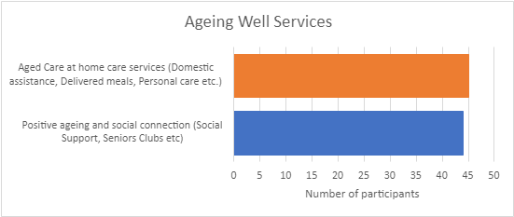

Animal Management
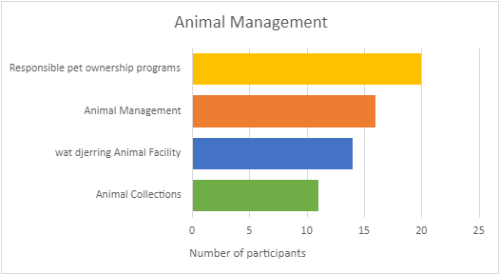

Arts, Culture and Events
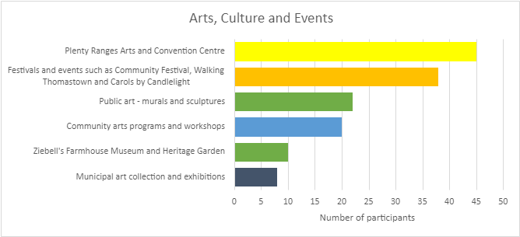

Community Facilities
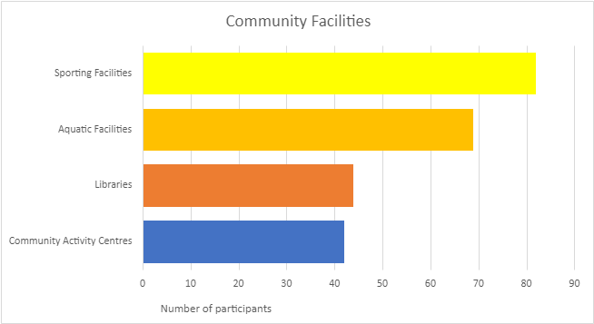

Community Safety
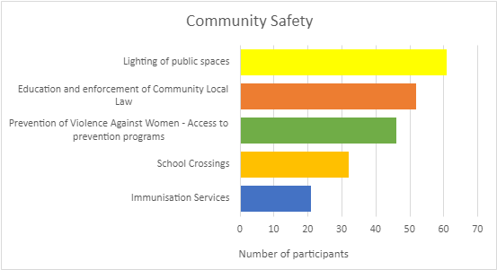

Community Wellbeing
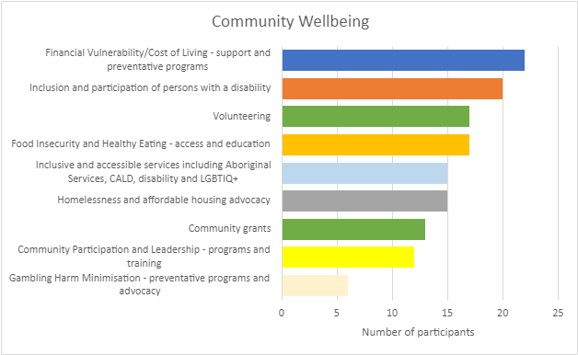

Emergency management
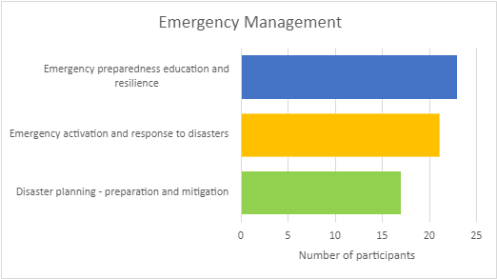

Family and Children
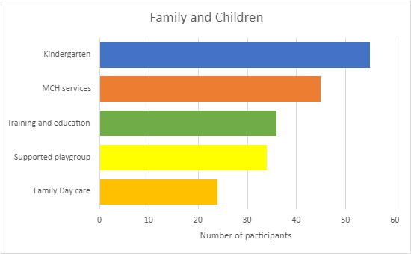

Local business and employment
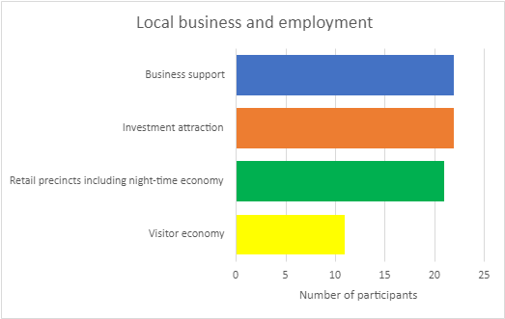

Parks, playgrounds and open space
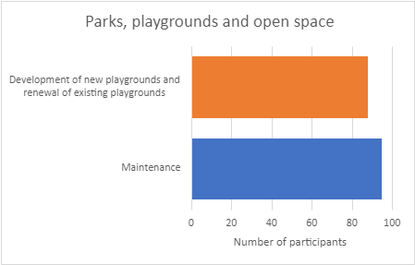

Roads, public transport and footpaths
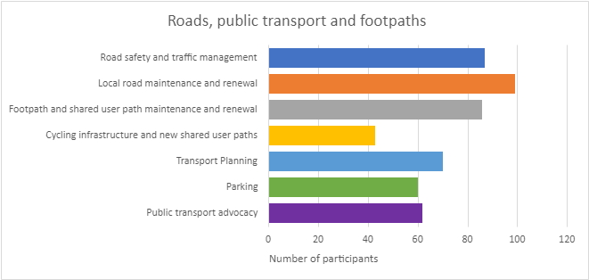

Sustainable Environment
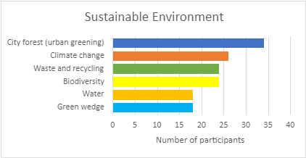
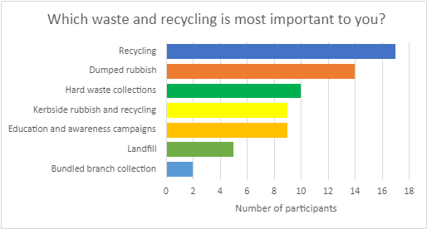

Youth (10-25 years)
