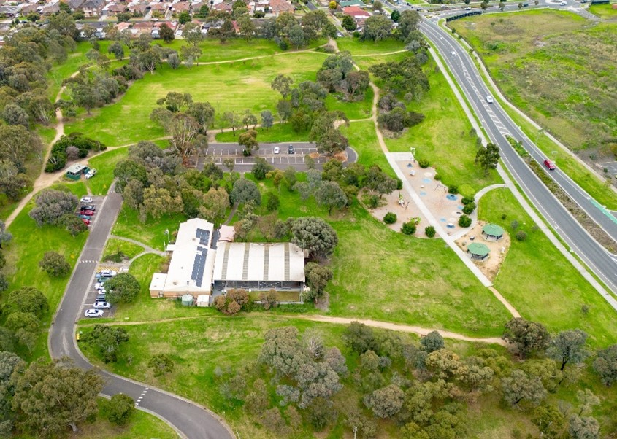
VR MICHAEL rESERVE MASTER PLAN
Phase 2 Engagement Summary
May 2024

Introduction
VR Michael Reserve is one of the City of Whittlesea’s open space reserves in Lalor, an established area of the municipality.
In response to a petition from the Lalor United Bocce and Social Club, Council resolved in December 2022 to upgrade the offsite parking (east of VR Michael Reserve entrance) and provide an all-weather pedestrian connection from the parking area to the clubrooms as part of the 2023/24 capital works program. The future upgrade of the carpark will improve accessibility for all individuals using the facility. Council also agreed to develop a reserve master plan, including features that help our community get active, socialise, and enjoy the outdoors. The master plan will include medium and long-term improvements to be delivered over the next 10 years.
The VR Michael Recreation Reserve master plan is a high-level document providing a broad vision for the entire reserve. The master plan does not focus on one specific item or user group, but instead looks at all features, equipment, and users of the reserve. The master plan aims to find a balance between the needs of all current and future user groups and the facilities required. It will outline the improvements required to achieve this balance in a staged action plan.
How we engaged you
We consulted with our community to inform the development of the masterplan and again to seek feedback on the draft. Consultation was undertaken over several years.
This report summarises the community engagement undertaken as part of phase 2; following the first phase undertaken in mid-2023 and summarised below.

Phase 1: Gathering Ideas – Monday 26 June to Monday 24 July 2023
The VR Michael Recreation Reserve Phase 1 master plan consultation was open for community comment from Monday 26 June to Monday 24 July 2023.
The purpose of this engagement was to assist Council to identify key issues, challenges and opportunities of the site and discover the key ideas for improvement.
The community was able to have their say via the Engage Whittlesea page or in-person at two community-based pop-ups.
Residents within 400m of the reserve, received a letter to update them on project status and invite them to share their feedback through the project Engage Whittlesea page or at one of the community-based pop-ups.
Feedback from the community and stakeholders in phase 1 informed the draft VR Michael Reserve Master plan.
During this phase, a total of 172 contributions were made to the consultation, 131 of which were captured at community-based pop-ups, 41 online through the Engage Whittlesea page. A total of 305 people visited the project Engage Whittlesea page. Feedback captured from the community and stakeholders in phase 1, informed the VR Michael Reserve master plan that was presented in phase 2.

Contributors in phase 1 included Lalor United Bocce & Social Club members, students from nearby school, parents, grandparents, dog walkers and daily walkers/runners. Safety was an overarching theme, specifically the lack of lighting, uneven paths and obstruction of paths, the close proximity of the playground to Deveny Road and anti social behaviour at the reserve. This feedback from community in Phase 1 was integral in the development of the draft master plan and Phase 2 recommendations by Council.

Phase 2: Sharing the draft master plan for community feedback – Monday 22 April to Monday 20 May 2024
During this phase we shared the VR Michael Reserve draft master plan with key stakeholders previously consulted in phase 1, as well as the wider community to understand if the proposed draft plan meets community expectations and the current and future needs of groups currently using the space.
The community was able to view the draft master plan and have their say online via the Engage Whittlesea page or at the in-person community-based pop-ups.
Online Engagement
The project page on the Engage Whittlesea platform featured three engagement activities, a survey, an interactive view of the draft master plan and an open forum to share your favourite feature of the master plan. The Engage Whittlesea page presented a summary of opportunities captured from the community through the phase 1 consultation period and offered visitors a chance to learn more about the key recommendations of the plan. Visitors to the page were also encouraged to complete a short survey to let us know how they feel about the proposed thirteen master plan recommendations.
Below: interactive map, open forum and Council’s recommendations from proposed VR Michael Reserve draft master plan on Engage Whittlesea page
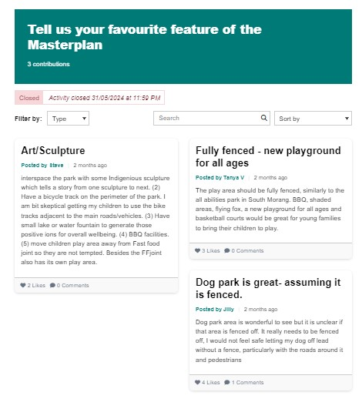
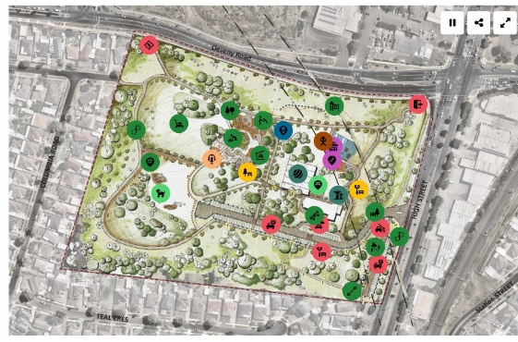

Proposed recommendations by Council
- Realign and upgrade main paths within the reserve to concrete paths
- Relocate the toilet block in proximity to the proposed play space and picnic area
- Upgrade and realign the existing path to connect the central car park to the Bocce Club
- Proposed lighting along the extended carpark
- Proposed integrated and upgraded carpark, comprising over 65 car parking spaces
- Proposed drop-off area next to the Bocce Social Club
- Proposed multi-use space comprising smaller areas with social seating, drinking fountain and shade trees
- Proposed relocated play space further away from Deveny Road including a range of play experiences and nature play
- Proposed open unstructured dog off-leash area with seats, shelter, and a fountain
- Proposed additional park furniture including drinking fountains, bins, and social seating
- Establish interpretive signage along the proposed main paths that provide education on the history of VR Michael
- Proposed diverse informal recreational facilities beneath the future Wollert rail overpass including a half basketball court, table tennis tables, skate features, bouldering wall, native pollinator, garden, and outdoor gathering space (the proposed activities beneath the rail will be delivered as part of the future Wollert Rail project).
In-person Engagement
During phase 2 consultation the project team held two community-based pop-ups and one drop-in session:
- Pop –-up at VR Michael Reserve on Tuesday 7 May from 9.30am to 12pm
Here we captured a range of demographics, including families with young children and seniors who regularly attend the Lalor United Bocce & Social Club, some who also take grandchildren to the park and gather with friends and family.

- Drop-in Session at Epping Memorial Hall on Thursday 16 May from 10am to 12pm
As an outcome of consultation phase one, we learned that women and girls are reluctant to use VR Michael Reserve due to its poor reputation and antisocial behaviour. Furthermore, as part of conducting a Gender Impact Assessment, we decided to engage with culturally and linguistically diverse groups to ensure that the open space and park we design are inclusive and meet their needs.

We invited 15 groups to participate in a targeted drop-in session at Epping Memorial Hall. The invited groups were:

- Zenobia Association
- Libyan Women’s Association
- St Anthony Senior Club
- St Marys Multicultural Club
- Iraqi Women’s Group in Epping North and Arabic playgroup in Thomastown
- Lalor Carers Support Group
- Multicultural Women’s Association
- Whittlesea Community Connection
- Alawi Islamic Association
- Thomastown Neighbourhood House Craft group and Arabic playgroup
- Thomastown Library Manager
- Epping Wollert Nepalese Community
- Sikh Community
- Al- Siraat College
- Nepalese Neighbourhood community

Of the 15 groups invited, unfortunately none were able to attend on the day, however members of the Greek Cypriot group who were attending an event at Epping Memorial Hall on the same day, participated in the consultation. We acknowledge the need to refine our approach to engaging with CALD groups, as highlighted by our experience with VR Michael consultation.
Pop- Up at Epping Plaza on Friday 17 May from 2.30pm to 4.30pm
Council staff attended Epping Plaza on Friday 17 May to share the draft master plan with community. We were able to capture data from a younger demographic, including students from local schools, parents, and young adults.
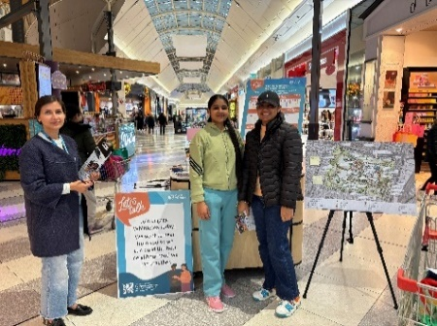
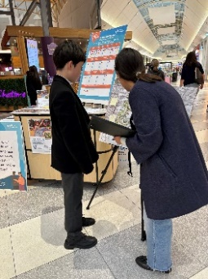
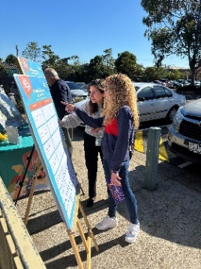
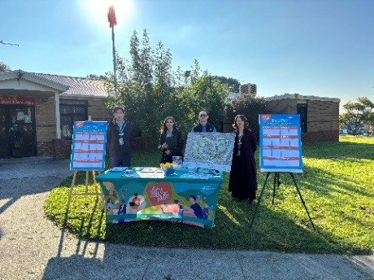
Below: Council project team at VR Michael Reserve pop-up on Tuesday 7 May, Epping Memorial Hall on Thursday 16 May, and Epping Plaza on Friday 17 May 2024

At the in-person community-based pop-ups, respondents were presented with a summary of key recommendations that mirrored the Engage Whittlesea page and were encouraged to share their top four priorities (of 13 recommendations) for the upgrade. There was also an opportunity to provide additional comments about the proposed draft master plan.
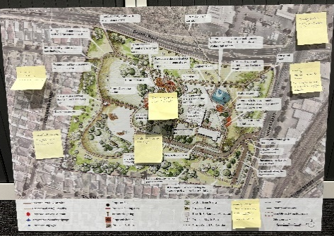
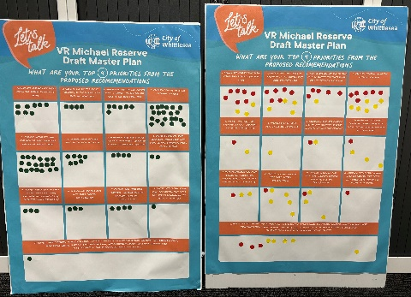
Below: draft VR Michael Master plan and dot boards used at community-based pop-ups

Residents within 400m of the reserve received a letter to update them on the project status and invite them to view the draft master plan and share their feedback through the Engage Whittlesea page or at one of the community-based pop-ups.
Visitors to the reserve were alerted to the consultation through large corflute signage installed at the main entry point to the reserve. The signage featured the QR code directing them to the Engage Whittlesea page.
The opportunity to participate in the community engagement and community-based pop-ups was shared on Council’s social media channels including Facebook and Instagram.
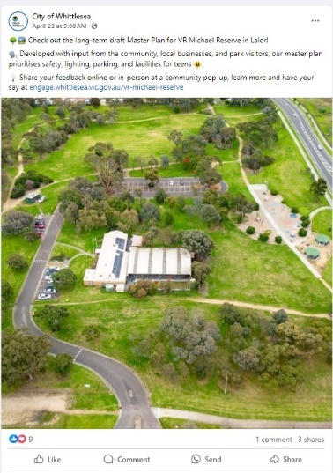
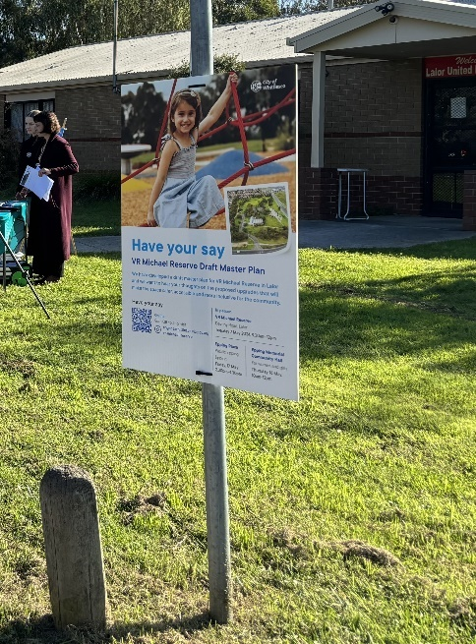
Left: VR Michael Reserve Facebook post and large corflute signage at the entry point to the reserve promoting the consultation period

The Engage Whittlesea platform utilises an accessibility add-on which enables users to easily switch to screen reader mode or easily adjust settings such as font size, contrast, dyslexia friendly options to improve the overall accessibility of the site. The platform also has an in-built translation tool to reduce language barriers to participation, allowing the page to be translated into the top ten languages spoken within the municipality.

Subscribers to the Engage Whittlesea platform that had previously indicated an interest in parks and/or the Epping and Lalor areas were sent a project update by email and encouraged to visit the project page and share their feedback.

Youth Council
During phase 2 consultation, the project team presented the draft master plan at City of Whittlesea’s Youth Council meeting on 6 May. The Youth Council reviewed the draft master plan and offered feedback and recommendations on behalf of the youth of City of Whittlesea, with the feedback and recommendations outlined later in this report.

Targeted Engagement

Council invited community groups to participate in the in-person VR Michael consultation. Location, illness, and clashes with timetable made it difficult for some members of the community to attend. These groups were also invited to submit their feedback via the project Engage page and email. Council will review and conduct further investigation on ways we can better connect with these groups face to face for future projects, in particular local schools, and CALD female groups. See below for groups invited to participate.

- CALD women and girl groups detailed on page 3 of this report
- Epping Primary school
- Peter Lalor Secondary College
- Lalor Primary School
- Lalor Secondary College
- Lalor Bocce Social Club committee and members
- Residents within 400m
- Youth Council

Participation

During Phase 2, a total of 85 contributions were received, 67 of which were captured at the community-based pop-ups and the remaining 18 contributions made on the Engage Whittlesea page. To gather feedback from the youth of City of Whittlesea, Council presented the draft master plan at a Youth Council meeting.

A total of 226 unique visitors to the project Engage page, 5of which opted to follow the page to receive project updates.

Below is a snapshot of engagement activity.

 | Two organic posts across Facebook and Instagram, reaching 4731 accounts with 70 engagements linking through to the Engage page.
 | Three community-based pop-ups were held and saw 67 people share their feedback through surveys, dot boards and conversations with Council staff.  - 38 completed a dot board activity and survey  - 29 completed a survey only  - 10 provided additional comments
 | The Engage Whittlesea page was viewed 348 times during the consultation period, with 18 people participating in the online survey and 5 participants opting to use the open forum to share their comments.
Below is a snapshot of in-person Community participation demographics:
  A total of 58.2% identified as female and 41.8% as male. |   A total of 71% of in-person participants were 66 years of age and over. |   A total of 49.2% of in-person participants live in Epping and Lalor.

What we heard
Survey results
When asked how do you feel about the overall draft master plan for VR Michael Reserve? 54 participants responded indicating if they liked/liked a lot, can live with it or don’t like/don’t like at all the draft master plan.
  85% |   11% |   3.7%
I like it a lot/I like it | Neutral | I don’t like it

The 54 survey participants were also asked how they feel about the 13 recommendations proposed by Council for the reserve upgrade.
There was an overwhelming positive response to the 13-recommendations proposed by Council. The most liked by community are:
- Proposed lighting along the extended carpark (96%)
- Proposed multi-use space comprising smaller areas with social seating, drinking fountain and shade trees (92%)
- Proposed additional park furniture including drinking fountains, bins, and social seating (92%)
- Upgrade and realign the existing path to connect the central car park to the Bocce Club (91%)
- Relocate the toilet block in proximity to the proposed play space and picnic area (88%)
- Proposed relocated play space further away from Deveny Road including a range of play experiences and nature play (88%)
- Proposed fitness and exercise station with equipment arranged in groups to allow for socialising (83%)

Some members of community had a neutral response to the proposed recommendations, not reacting positively or negatively.
- Proposed drop-off area next to the Bocce Social Club (13%)
- Proposed multi-use space comprising smaller areas with social seating, drinking fountain and shade trees (13%)
- Relocate the toilet block in proximity to the proposed play space and picnic area (10%)
- Proposed relocated play space further away from Deveny Road including a range of play experiences and nature play (10%)
- Establish interpretive signage along the proposed main paths that provide education on the history of VR Michael Reserve (10%)
A total of 26% of all survey participants expressed a negative sentiment towards the proposed open unstructured dog off-leash area with seats, shelter. “Unstructured” was the main concern as expressed by a participant below.
“The off-leash dog area in the draft master plan doesn’t seem to be fenced, I would suggest fencing this area as it’s close proximity to the children’s play space and presents a risk to child safety”
See graphs below for a full breakdown of how community feel about the thirteen proposed recommendations for VR Michael reserve.

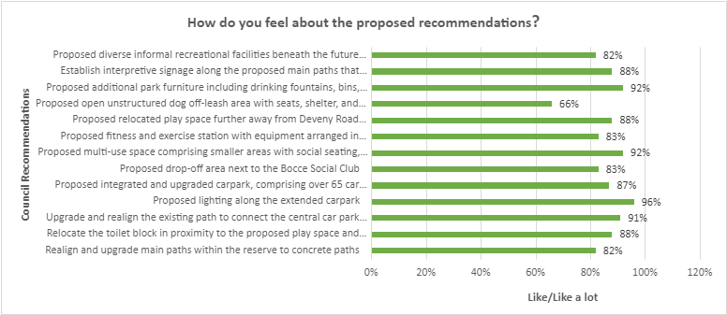

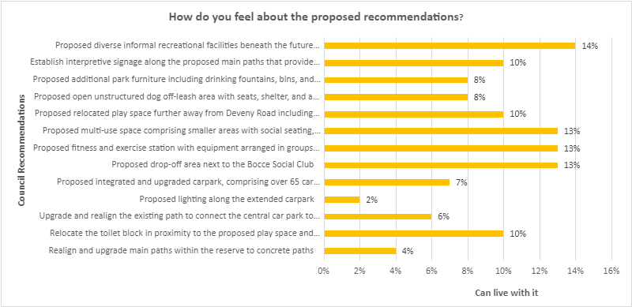

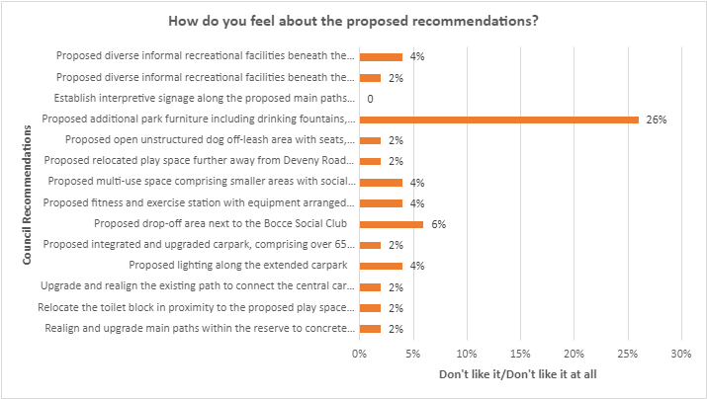

In person community engagement activity
A total of 38 people participated in the dot board activity across the two community-based pop-ups, choosing their top four recommendations (out of thirteen) for improvement. Additional lighting around the carpark was the top priority for improvement (33 dots). See top four recommendations below:
- Propose lighting along the extended carpark (33 dots)
- Proposed integrated and upgraded carpark, comprising over 65 car parking spaces (20 dots)
- Realign and upgrade main paths within the reserve to concrete paths (18 dots)
- Relocate the toilet block in proximity to the proposed play space and picnic area (14 dots)
During discussions with project staff, further comments were shared related to the project.
Online Open Forum
Four participants opted to use the open forum on the VR Michael Reserve Project Engage Page to share other comments related to the project.
“Interspace the park with some Indigenous sculpture which tells a story from one sculpture to next”
“Have a bicycle track on the perimeter of the park. I am bit sceptical getting my children to use the bike tracks adjacent to the main roads/vehicles”
“Have small lake or water fountain to generate those positive ions for overall wellbeing”
“BBQ facilities”
“move children play area away from McDonalds so they are not tempted. Besides McDonalds also has its own play area.”
“The play area should be fully fenced, similarly to all abilities park in South Morang. BBQ, shaded areas, flying fox, a new playground for all ages and basketball courts would be great for young families to bring their children to play.”
“Dog park area is wonderful to see but it is unclear if that area is fenced off. It really needs to be fenced off, I would not feel safe letting my dog off lead without a fence, particularly with the roads around it and pedestrians”
“For the safety of the kids and the dogs, please fence this park. I too wouldn’t feel comfortable taking my dog to an unfenced dog park - especially with so many cars on high street!”

Feedback received by email from a women’s group unable to attend the drop-in session
“From my side for any park to make inclusive and attractive following things to consider:
- Having parking available, especially for special needs with enough parking facilities.
- Exercise area gym, running space
- Toilets and change area with drinking water access.
- BBQ and picnic spots with shade
- Garden and electric space which we can hire”

The Youth Council
The City of Whittlesea Youth Council provided valuable feedback on three main categories with recommendations from the project team in response on page nine of this report:
Youth targeted areas within the reserve:
“By providing spaces for sport, recreation, socialisation, and study, the reserve becomes a hub for youth engagement, physical activity and community building. by investing in youth targeted areas within the reserve contributes to the physical, social and emotional wellbeing of young people and strengthens the sense of community within the municipality. Through sporting facilities, specifically, basketball courts, soccer pitch, exercise machines, foot and bike tracks, and skate parks are likely to attract youth who are interested in sports and physical activities”
Popular Leisure/sports activities for youth:
“Some of the more popular leisure and sports activities that may attract youth to this reserve include, basketball, skateboarding, volleyball, tennis and general outdoor exercising using gym equipment, additional facilities such as playgrounds, modern seating areas, solar powered tables for studying outdoors, and shaded picnic areas”
Challenges to youth utilisation and safety concerns:
“Some safety considerations that may discourage youth from engaging in this area is inadequate lighting, and surveillance. Surrounding foliage and lack of visibility from nearby roads contribute to this issue, potentially deterring young visitors from utilising the park after dark”.
Refer to appendix 1 for more detailed information and page 9 for response from the project team
Key messages from community feedback
Participants were invited to share their thoughts on the proposed draft master plan and offered potential future opportunities for VR Michael Reserve, some of which may be out of scope of this project. Below are the themed comments received through both online and in-person engagement activities.

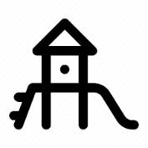 | Playground– Moving the playground away from busy Deveny road and upgrading the existing playground with a play space for all ages and abilities was a priority for respondents.  “Separate area for babies/toddlers to play”  “The play area should be fully fenced, similarly to all abilities park in South Morang. BBQ, shaded areas, flying fox, a new playground for all ages and basketball courts would be great for young families to bring their children to play”  “Toddler safe slides and climbing sections”  “Sandpit in the playground area”  Technical response: We will provide a range of play experiences for different age groups as part of the proposed playspace.
 | Accessible – upgrading paths and adding additional all ability car parks and equipment to make the playground and Lalor Bocce Club accessible to all is a priority for respondents  “It says over 65 car parking spots, doesn't specify the exact amount and how many disabled car parking spots there will be. The more car parking the better. I don't understand why the new proposed path from the lower car park to the social club isn't more direct instead of going up and then coming back. The elderly struggle to walk up the hill from the lower car park”  “As a regular visitor to the Bocce club and having a disabled sticker, better parking facilities are essential. Walking out at night after an event and having to walk to the bottom of the hill as could not find parking closer to club house is very dangerous”  “Enable an delivery access path to the club delivery door located on the eastern side of the pavilion”  Technical response: Specify the number of car park spaces that could be allocated from the additional proposed car parking space outlined in the Disability Discrimination Act (DDA).  Note: The National Construction Code specifies the number of DDA compliant car parking spaces based on the classification of the associated building. It mandates one space for every 50 car parking spaces. However, considering the demographics of the Lalor United Bocce & Social Club members, we propose increasing this requirement to three DDA compliant car parking spaces.  We have investigated the opportunity for providing a vehicle entry node from Deveny Road; however traffic on Deveny Road, VR Michael Reserve’s limitation due to the future rail corridor, site topography, and existing trees restrict this opportunity. Additionally, the main facilities, such as the playspace and picnic area, will be relocated to further away from Deveny Road to the central area of the reserve, which will have good access from the proposed extended car park.  We will provide a delivery access path and a trolley loading area to the club delivery door located on the eastern side of the Lalor United Bocce & Social Club
 | Sustainable and Nature-Inspired Park Enhancements – community would like to see recycled materials used in the upgrade and the existing grassed area maintained.  “Have small lake or water fountain to generate those positive ions for overall wellbeing”  “It would be nice to have a dedicated space, like a rainforest, with ferns, shade trees and a small pond. Walking amongst nature is important for people's mental therapy”  “A water play area would be fantastic”  Technical response: It is not possible to include a waterbody such as a lake or pond in the reserve because VR Michael Reserve is located on the site of an old landfill. As part of the development of New Epping, the existing wetland and a section of Edgars Creek in this vicinity will be transformed into public open space. Situated adjacent to the Northern Hospital Epping on the south side of Cooper Street, it is approximately 600m west of VR Michael Reserve on Deveny Road. This development will offer significant opportunities for accessing public open space with natural water features for the local communities of Lalor and Epping

 | Facilities – Respondents highlighted the need for additional shade, seating areas and drinking fountains to encourage family and friend gatherings at the park.  “More gathering places for adults/parents when they are supervising their kids rather than standing on the path (bikes etc ride past quickly. Especially at the play area people come from McDonalds and they struggle to find a place to sit”  “Have a bicycle track on the perimeter of the park. I am bit sceptical getting my children to use the bike tracks adjacent to the main roads/vehicles”  “Shelter for families. Grass nearby to sit on a picnic mat”  “A drinking fountain next to the proposed half basketball court”  Technical response: We will investigate the potential provision of a number of additional features including a bicycle track/loop or an informal learn to ride loop as part of the proposed paths, and the integration of public art in the reserve and murals along the Wollert rail corridor.  We will provide additional seating next to the proposed play area and an additional drinking fountain next to the proposed half-basketball court.
 | Safety and lighting – introducing additional lighting, a lockable toilet block, new fencing, safe playground equipment and car park improvements to make users feel safe and help to deter anti-social behaviour.  “Safety needs to be paramount”  “Have any spaces where there is seating to be visible and have clear lines of vision. This will help women feel safer and provide passive surveillance”  “Is there the opportunity to create a secondary vehicular entry on Deveny Road? Visitors coming from the north or west will be required to do a U-turn on High Street to access the High Street car park entry”  “Provide lighting along the path on the north side of the reserve connecting the entrance from High Street to the entrance from Bellarine Drive”.  Technical response: We will investigate lighting opportunities for evening/after dark use activities such as dog-off lead park and informal recreation activities beneath the Wollert rail corridor as lighting was raised by both the local community and Youth Council.  Note: the public toilet will be closed during evening hours and night time, so no lighting is required for this area and the access path.
 | Future Wollert Rail Overpass – community have questions about the impact of the proposed future rail overpass and the impact on VR Michael Reserve and nearby residents.  “If the proposed Wollert Rail extension is ever built, the project will claim much of VR Michael Reserve for construction activities. During construction, access into the reserve from High St (e.g., the driveway to the social club) will likely be severely impacted, possibly even completely blocked.  The timeline. When will all this start and how will it be impacted by a future railway? Will the council be spending money on amazing features for it only be destroyed when the train line is finally built? Can the council actively and vocally advocate for it to be built sooner?  Technical response: The master plan recommendations are staged into short to medium term, long-term and post-rail coming stages to address community priory needs and have less interfere with the future Wollert Rail corridor project.  Regarding the timeline of the Future Wollert Rail corridor project, Council’s Advocacy Prospectus 2023-25 advocates for the construction of the rail corridor by 2030, however at the time of writing this report, the Victorian Government has not committed to the timing or funding of this project. The master plan justifies the council's advocacy for the proposed facilities beneath the rail to be funded by the state government and to be delivered as part of the Future Wollert Rail project (we can add this green section).
 | Off-leash Dog Park – Community would like to see the inclusion of a fenced dog park area.  “Dog park area is wonderful to see but it is unclear if that area is fenced off. It really needs to be fenced off, I would not feel safe letting my dog off lead without a fence, particularly with the roads around it and pedestrians”  “Unless the dog area is closed off by fencing, it's too close to the area that our members BBQ and seating area”  Technical response: We will investigate the provision of a fence around the designated area for the dog off-leash park.
 | Inclusive Play space – Community would like to see a range of play experiences for different age groups.  “It is important for the reserve to meet the diverse needs and interests of young people in the municipality. By providing spaces for sport, recreation, socialisation, and study, the reserve becomes a hub for youth engagement, physical activity, and community building. by investing in youth targeted areas within the reserve contributes to the physical, social, and emotional wellbeing of young people and strengthens the sense of community within the municipality. Through sporting facilities, specifically, basketball courts, soccer pitch, exercise machines, foot and bike tracks, and skate parks are likely to attract youth who are interested in sports and physical activities”  Technical response: Provide a range of play experiences for different age groups as part of the proposed playspace.

The following recommendations are being considered as part of the feedback received from the Youth Council.
Youth-targeted areas/activities:
- Council to advocate for the proposed youth-oriented facilities beneath the rail to be delivered by the state government as part of the future Wollert rail project.
Note: The proposed sports court including a half basketball court, tennis tables and a bouldering wall as well as a skate feature area offer opportunities for recreation, exercise, and social interaction among young people.
Outdoors studying spaces:
- Investigate opportunities for solar-powered tables/shelters in the proposed gathering area, providing renewable energy for device charging, Wi-Fi connectivity and outdoor studying opportunities.

Lighting and security cameras:
- As mentioned above, we will investigate lighting opportunities for evening use activities.
Note: The proposed and relocated facilities provide passive surveillance opportunities across the reserve. While the ability to propose activities on the eastern interface is limited due to the topography and steepness of the site, the proposed shared path from High Street and the new entry from the corner of High Street and Deveny Road will activate this interface and provide additional passive surveillance opportunities. Council does not have an established CCTV program for the implementation of CCTV in public open space, which is paramount in ensuring privacy of park users.

Next steps
Thank you to everyone that visited the project Engage page and contributed through the online survey or at in-person community engagement opportunities.

The project team will review the feedback received and develop a revised master plan with amendments that where possible address concerns raised by the community.

The final master plan design will be presented to Council for endorsement on August 22. The community will be kept updated on further developments via the VR Michael Recreation Reserve project page.
Appendix 1: Feedback from City of Whittlesea Youth Council

Youth Targeted areas within the reserve

It is important for the reserve to meet the diverse needs and interests of young people in the municipality. By providing spaces for sport, recreation, socialisation, and study, the reserve becomes a hub for youth engagement, physical activity and community building. by investing in youth targeted areas within the reserve contributes to the physical, social and emotional wellbeing of young people and strengthens the sense of community within the municipality. Through sporting facilities, specifically, basketball courts, soccer pitch, exercise machines, foot and bike tracks, and skate parks are likely to attract youth who are interested in sports and physical activities. These areas offer opportunities for recreation, exercise, and social interaction among young people. Moreover, playgrounds equipped with modern and inclusive facilities, such as the basketball courts, gyms and 'grown up' playgrounds, can cater to the diverse interests and age groups of youth. These spaces provide opportunities for fun, physical activity and socialisation. In addition, areas designed for hanging out, such as large benches, shaded seating areas, and solar powered tables are essential for fostering social connections among the youth. These spaces offer opportunities for relaxation, study, and social interaction in a natural outdoor setting. importantly, ensuring easy access to the reserve through sidewalks, signs and driveways are crucial for attracting youth. improving accessibility can address potential barriers to youth engagement, such as lack of transportation or awareness of the reserve's locations.

Popular Leisure/Sports Activities for Youth
Some of the more popular leisure and sports activities that may attract youth to this reserve include, basketball, skateboarding, volleyball, tennis and general outdoor exercising using gym equipment, additional facilities such as playgrounds, modern seating areas, solar powered tables for studying outdoors, and shaded picnic areas are also appreciated. These facilities play a key role in supporting the physical health, social interaction, mental wellbeing and skill development of young people and others. Through the social and recreational appeal, it is likely to attract the youth to utilise these facilities.
Challenges to youth utilisation and safety concerns
Challenges to youth utilisation and safety concerns are crucial aspects to ensuring that the Michael reserve is accessible and welcoming to our diverse youth community. Some safety considerations that may discourage youth from engaging in this area is inadequate lighting, and surveillance. Surrounding foliage and lack of visibility from nearby roads contribute to this issue, potentially deterring young visitors from utilising the park after dark. A possible solution to this issue is enhancing lighting infrastructure throughout the reserve to improve safety and visibility during evening hours. Implementing low-energy lighting solutions placed strategically can address safety concerns while preserving the park's natural ambiance. Without adequate surveillance, the reserve may be vulnerable to vandalism and antisocial behaviour, discouraging other young members in the community from engaging in this area. If there is a lack of security cameras and patrols, it can diminish the sense of safety for our youth park users. A possible solution to this is placing security cameras around the premises, and warning signs.

