Henderson Creek Wetland Park and Playground Renewal
Engagement Summary
September 2024

Introduction
The City of Whittlesea has developed a concept plan for the renewal of Henderson Creek Wetland Park and playground to offer improved choices for recreational activities locally.
Council is supported by the State Government Better Parks and Playgrounds program to renew Henderson Creek Wetland Playground by creating a more accessible and larger playground and an exercise area.
The concept plan includes moving the play area to a more accessible and practical area, shelter and seating, drinking fountains, safer pedestrian crossing, landscaping and new exercise area.
Council consulted with people who live, work or visit the project area to gain feedback on the concept plan. A total of 75 people participated in the consultation by completing a survey on the Engage Whittlesea platform or visiting one of the two community-based pop-ups held nearby the project area, with 94% indicating satisfaction with the concept plan (selecting I like it a lot or I like it). The feedback captured through the engagement will be used finalise the plan for the Henderson Creek Wetland Park and playground Renewal.

How we engaged you
The Henderson Creek Wetland Playground Renewal consultation was open for community comment from 19 August to 8 September 2024. Community feedback was sought online through Council’s Engage Whittlesea platform and through direct conversation at two scheduled pop-up dates. The Engage Whittlesea platform utilises an accessibility add-on ensuring that it is as accessible as possible for all users. The platform also has an in-built translation tool to mitigate any language barriers to participation, allowing the page to be translated into the top ten languages spoken within the municipality.

Engage page
On the project’s Engage page, participants were provided with a map of the proposed concept plan, with before and after images, an explanation and images of the type of upgrades planned for the area for visual reference. Residents were also invited to participate in a survey. The survey asked residents how they felt about the Henderson Creek Park and playground concept plan, if there was anything they didn’t like about the plan, if they use the existing BBQ's at Henderson creek park, and if they support the proposed zebra crossing and bollards. The survey results aim to help the project team identify top priorities from a community and resident perspective.

Community-based pop-ups
The project team hosted two community pop-ups nearby the project area. The first at Mill Park Village on Thursday 22 August in the afternoon to take advantage of after school crowds, and then a second at The Promenade shops in South Morang on Wednesday 4 September mid-morning, which took advantage of a large variety of residents using and/or visiting the space.
The project team supplied large scale maps of the area (appendix 1) and spoke to residents in detail about any concerns they had and made sure they understood the planning process and how decisions were made. There was also opportunity for them to voice additional suggestions to the project team.
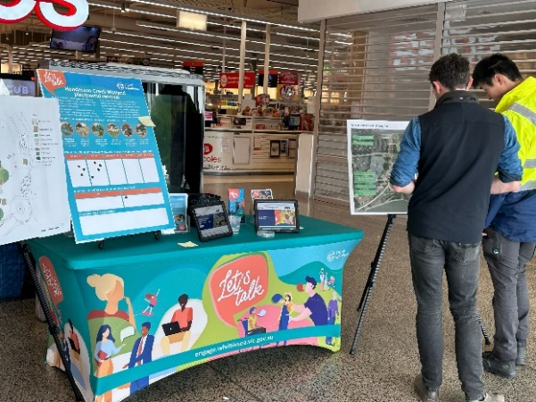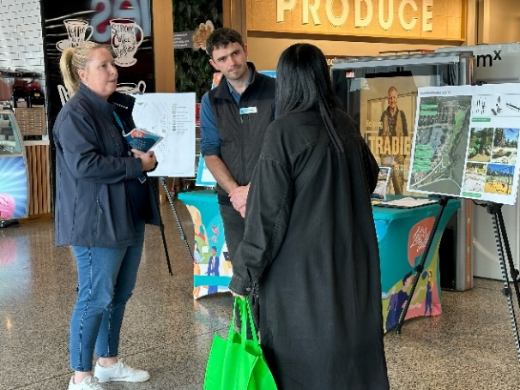
Above: Henderson Creek Wetland Playground Renewal pop-up at Mill Park Village

Residents who attended the community pop ups were provided with Henderson Creek Wetland Playground Renewal consultation inclusions listed on a dot board (see below). Participants were provided with two dots and asked to place a dot to indicate their level of support for the concept plan ranging from I like it a Lot to I don’t like it at all, and use the second dot to identify whether they use the current BBQ area. There was also an area for them to add additional comments.
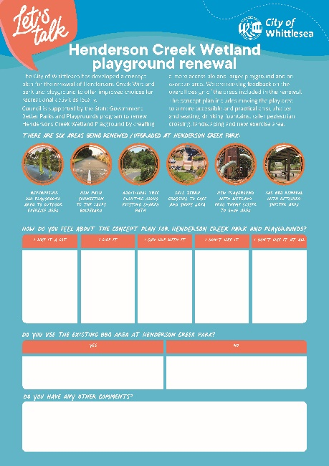

Above: Activity board used at the Henderson Creek Wetland Park and playground upgrade community-based pop-ups

Project Promotion
The opportunity to participate in the community engagement was promoted through a targeted campaign including:
- Council’s digital engagement platform Engage Whittlesea
- Direct mail through a letterbox drop to homes adjacent to the project area (map in appendix 2).

Participation
 | We hosted two community-based pop-ups with 45 residents taking the opportunity to speak with the project team members.
 | A total of 30 contributions were made to the online survey.
 | 60% of participants resident within South Morang the remainder live elsewhere in the municipality and visit the project area for work or leisure
 | 61% of participants were female and 39% male
 | We heard from all age groups as part of the consultation with 23% of participants aged 25-34 years, 20% aged 35-44 years and 20% aged 45-54 years. It is worth noting that 10% of participants were aged 10-14 years who will be the main users of the playground.

What we heard
Participants at the community-based pop-ups spoke to project team members about their likes and concerns regarding the Henderson Creek Wetland Park and playground proposed improvements.
A total of 75 people participated in the consultation, with 94% indicating satisfaction with the concept plan (selecting I like it a lot or I like it). The graph below shows all results.
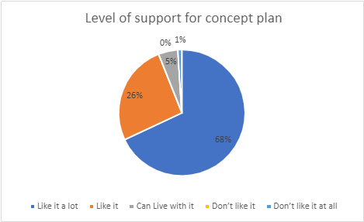

Majority of participants (88%) indicated that they do not use the BBQ area. Of the nine participates who indicated that they use the existing BBQ area, two commented that they use it monthly or a couple of times a year in warmer months.
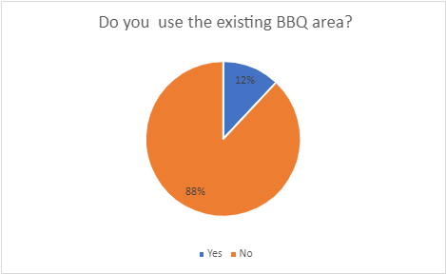

All online participants were asked if they support the proposed Zebra crossing and bollards leading from the wetland to the shops. All online participants were supportive of this concept plan inclusion.
Participants of both the in-person and online consultation had the opportunity to provide additional comments. A total of 29 participants took up the opportunity, the main themes of what was raised are below along with an accompanying technical response to provide context.

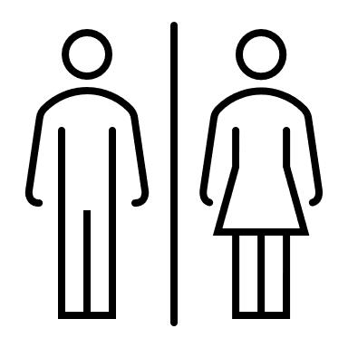 | Public toilets  - Many comments emphasised the lack of public toilets in the proposed plans, highlighting that their inclusion would encourage more frequent and extended use of the park. Toilets are seen as essential, particularly for families, and would support the overall enjoyment of the space.  “I don’t like that no public toilets are proposed in the plan. Toilets are necessary as this encourages people to better utilise the area. e.g., meet at the park, buy a coffee or snack, use the new park facilities, and enjoy the company of others knowing toilets are available”.  “We need public toilets. We do not have any open spaces in Mill Park Lakes that have toilets. Everything is great but you continue to omit toilets from your open spaces”.  Technical response:  Based on Council’s Open Space Strategy, Henderson Creek Wetlands is classified as a Neighbourhood level open space. Neighbourhood level open spaces are designed for an expected stay time of 30-60 minutes and do not include provisions for public toilet facilities.  Public toilets are planned for in a manner that Council can maintain into the future with the limited resources available. Council has a responsibility to balance the need and reasonable public expectation for public toilets against the upfront and ongoing financial costs.  Typically, public toilets are placed in parks and reserves that are a higher hierarchy with a larger catchment of users.
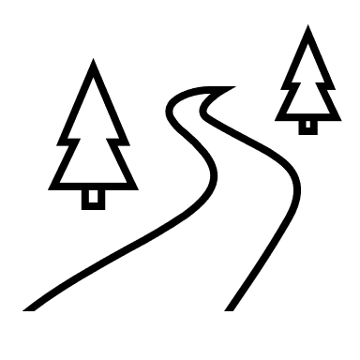 | Aesthetic and functional enhancements  - Requests to improve the streetscape with more tree planting, seating and better planning for cars to avoid dangerous interactions with pedestrians.  “The area for the path connection would be improved with additional tree planting, where possible”.  “The circular area adjacent to playground requires trees and some seating.”  Technical response:  Additional tree planting and seating will be considered, particularly near the proposed pedestrian crossing.
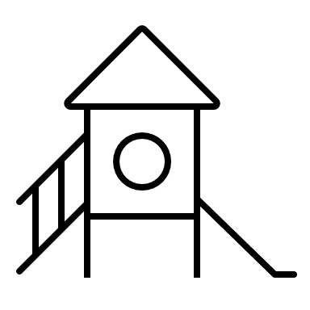 | Playground relocation & accessibility  - The relocation of the playground away from the side road is appreciated, with a recommendation to include all-abilities equipment.  “Relocation of playground is a good move away from the side road”.  “Will there be all abilities equipment ie swing? The standards for playgrounds need to include equipment suitable for those with additional needs.”  Technical response:  The proposed design includes rubber surfacing with flush access from the concrete paths to provide accessible areas to the playground.
 | Safety concerns  - Suggestions for the inclusion of additional safety measures including zigzag judder markings on the road surface near the zebra crossing and preventing cars from parking near the crossing.  “So dangerous cars racing into park near cafe shop letterbox etc with pedestrians dodging cars".  “As children may use playground whilst adults are at cafe the road surface either side of zebra crossing needs zigzag judder markings”.  Technical response:  The area either side of the pedestrian crossing will be looked at closely to ensure this becomes a place that people feel safe crossing. The location of the accessible parking bays will also be considered in this design. Surface treatments, signage and other traffic management strategies will all be considered to achieve the safest and best possible result in this area
 | BBQ area & rubbish bins  - Suggestions for additional rubbish bins throughout the park and shopping strip, particularly near the playground.  - There was feedback both in support of and against the inclusion of a BBQ area. Some participants have seen families use the existing BBQ, while others feel it is unnecessary and suggest supporting local businesses instead.  “Please provide more bins in the area. The amount of rubbish around the shops and along the lake near the shops is terrible”.  “Removing bbq is good as I’ve never seen anyone use that and cheap food across the road so should support local biz’.  “The BBQ area should be moved closer to the new playground”.  Technical response:  Additional bins next to the new playground space will be considered.
 | Parking concerns  - Participants highlighted the dangerous parking behaviour around the proposed location of the zebra crossing and footpaths near the shops. Suggestions to improve parking safety included bollards, better signage and the introduction of no-standing zones to ensure pedestrian safety.  “Happy to add a zebra crossing, but what about the cars that park up there on the footpath between the milk bar and the cafe. You will need to make it a no standing zone or you will have cars reversing through a high traffic area. Perhaps that's where the bollard placement will be??”.  “Cars should be prevented from parking in driveway area immediately adjacent to zebra crossing. Major safety concern”.  “Everything I love, only issue not addressed is the parking on the footpath on both sides of the proposed zebra crossing”.  Technical response:  Bollards and signage will form part of the solution to making the pedestrian crossing a safer area and one that prioritises pedestrian movements. Accessible parking bays that are clearly marked and signed will be considered in the area in front of the cafe.
 | General feedback  - Many participants are excited about the renewal and feel the new design will make the area more practical and family friendly. Some also appreciate the improvements to the connection paths and playground placement.  “The area needs an update, and it looks great”.  “It's much more practical. Look forward to seeing it complete”.  “I mostly like the park amendments and applaud the changes”.

Next steps
The feedback captured will be used to finalise the design for the Henderson Creek Wetlands Park and Playground renewal. The feedback may also be used to inform the development of other key plans and strategies Council are working on to make Whittlesea A Place for All.
Thank you again to everyone who participated in the community engagement by sharing feedback.
The plans for this project will be further refined in the next few months. Construction is scheduled to commence early in 2025 and be complete by May 2025.

Appendix 1
Concept plans presented on the project Engage page and at the community-based pop-ups.
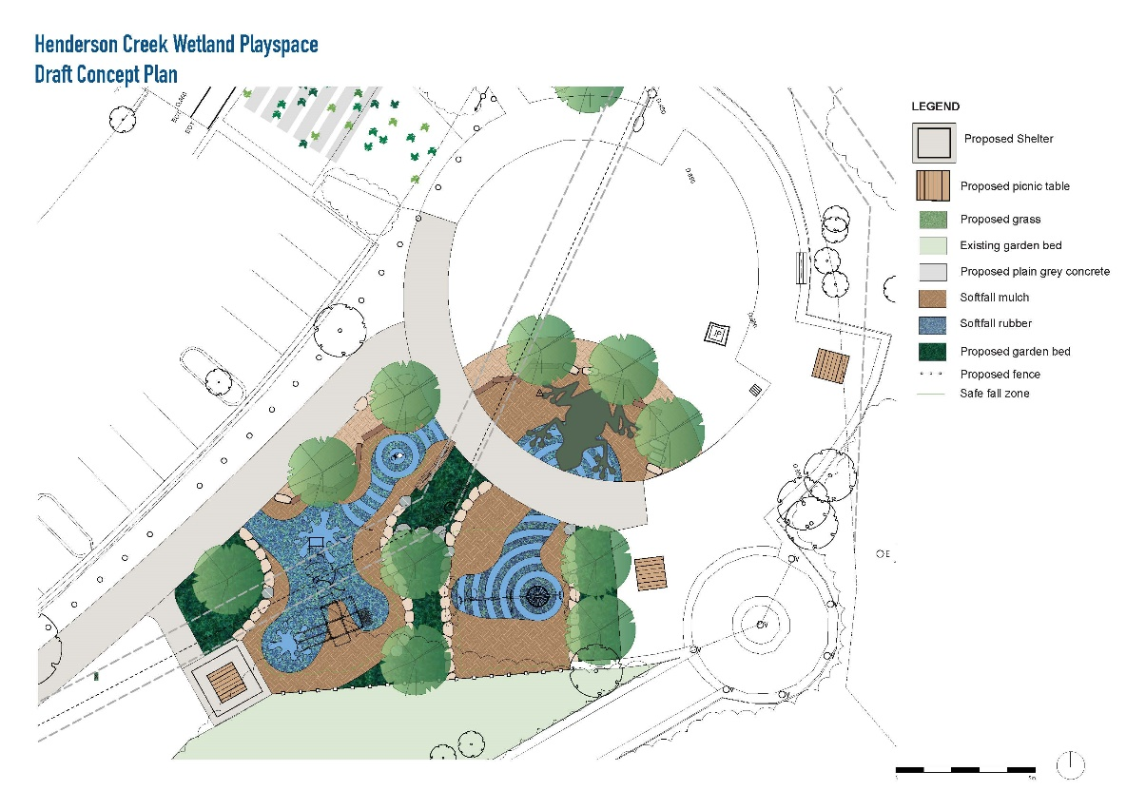

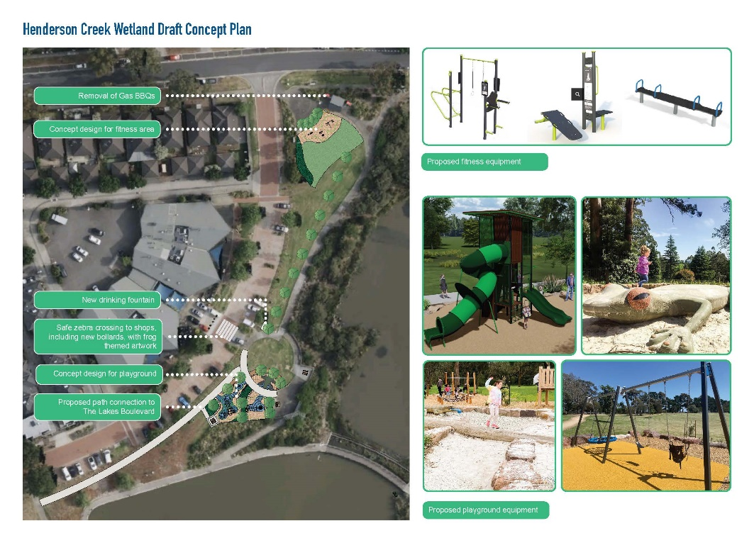
Appendix 2
Map indicating properties letterbox dropped to promote the consultation.

