Transport Asset Management Plan

APRIL 2022

Document Control
Version | Date | Revision Details | Author | Reviewed
1.0 | Dec 2014 | Initial plan completion | WE
1.1 | Jun 2015 | Review and Updated | WE
1.2 | Oct 2015 | Review and Updated | WE
1.3 | Mar 2017 | Various sections updated and clarified | WE
2.0 | Feb 2018 | Format review, update of modelling, clarification of Service Levels, plan improvements. | MB | BH
2.1 | Mar 2018 | Update as per comments from Asset Management Working Group. | MB | BH
3.0 | Mar 2022 | Updated to suit requirements of Local Government Act 2020 and updated condition data. | MB | DH/ND
3.1 | Apr 2022 | Updates and clarifications as per discussions with Councils Assets team. | MB | DH

Asset Management Plan Alignment
This document has been prepared in accordance with:
- Local Government Act Victoria (2020)
- Local Government Asset Management Better Practice Guide (2015)
Local Government Victoria,
- Asset Management Accountability Framework (2016)
Victoria State Government – Treasury and Finance,
- ISO 55000 Series – Asset Management (2014)
International Standards,
- International Infrastructure Management Manual (2020)
Institute of Public Works Engineering Australasia.
Table of Contents
1. Executive Summary 6
2. Introduction 8
3. Strategic Objectives 10
4. Asset Overview 12
4.1. Road Hierarchy 14
4.2. Pathway Hierarchy 16
4.3. Drainage Hierarchy 16
5. Levels of Service and Performance Indicators 18
6. Asset Condition and Useful Lives 20
7. Operations 22
8. Maintenance 23
9. Capital Renewal 25
10. New Assets and Capital Upgrades 27
10.1. Overview 27
10.2. Private Developments 27
10.3. Infrastructure Contributions Projects 28
10.4. Councils 4-15 Year New Works Program 29
11. Transfers and Disposal Plan 30
12. Lifecycle Costs - Annualised 31
13. Financial Indicators 32
14. Risk Management 33
15. Improvement Plan 35
Appendix A: Transport Assets 15 Year Forecast Expenditure (2021 $, 000) 37

List of Tables
Table 1.1 – Transport Asset Expenditure Overview ($,000) 6
Table 3.1 – Transport Asset Related Documents and Systems 11
Table 4.1 – Asset Overview and Hierarchy (2021 $M) 12
Table 4.2 – Data Confidence and Frequency of Collection 13
Table 5.1 – Levels of Service 19
Table 6.1 – Condition Descriptors 20
Table 6.2 – Asset Lives and Intervention Levels 20
Table 7.1 – Annual Operational Activities and Expenditure (2021 $,000) 22
Table 7.2 – Four-Yearly Operational Activities and Expenditure ($,000) 22
Table 8.1 – Planned Maintenance Activities and Frequencies 23
Table 8.2 – Maintenance Activities Costs (2021 $,000) 24
Table 9.1 – Renewal Expenditure, Requirements and Backlog (2021 $,000) 25
Table 12.1 – Indicative Lifecycle Costings ($) 31
Table 14.1 – Critical Strategic Risks 33
Table 14.2 – Critical Assets 34
Table 15.1 – Transport Asset Management Improvement Plan 35

List of Figures
Figure 1.1 – 15 Year Projected Transport Asset Condition Distribution 7
Figure 1.2 – 15 Year Rolling Backlog Forecast (2021 $, millions) 7
Figure 1.3 – Overall Transport Financial Indicators for 2021/22 Financial Year 7
Figure 2.1 – Asset Management Framework 9
Figure 4.1.1 – Map of Road Hierarchy 15
Figure 4.3.1 – Map of Drainage Hierarchy 17
Figure 6.1 – Current Condition By Component, Asset Type, and Hierarchy 21
Figure 8.1 – Work Orders by Condition per Kilometre of Road (2021) 24
Figure 9.1 – 15 Year Projected Road Oxidation Condition Distribution 25
Figure 10.1 – PowerBI Asset Growth Dashboard 28
Figure 10.2 - Capital Expenditure 29

Executive Summary
The City of Whittlesea manages a transport network to provide accessibility in, out and around our city. Council’s priority is to manage assets in a way that meets the community’s expectations in a safe, effective, and cost-efficient manner. This network had a replacement cost of $2.35 Billion as of 30 June 2021 and Council has been vested an average of $79.3 Million in transport assets from developments per year over the past 3 years.
Melbourne is one of the fastest growing cities in Australia and, according to the Federal Government’s 2021 Population Statement, is predicted to be the most populated city in Australia by 2030. The City of Whittlesea is a growth area council that will contribute to providing the communities this population growth will require. This creates a unique management challenge; to protect the long-term sustainability and service provision of our asset base, we must ensure that existing assets continue to be proactively maintained as new assets are handed over to Council.
This plan provides a strategic overview of the services that the City of Whittlesea provides through the management of transport assets, the associated costs, and the risks and mitigation measures in providing those services. This plan outlines Council’s adopted approach and its implications. Several scenarios were modelled in developing this plan and are available as an interactive digital dashboard here: City of Whittlesea Digital Asset Dashboard.
Table 1.1 shows the current (21/22 FY) operational, maintenance, renewal, and upgrade/new construction expenditure on assets and the anticipated funding gap over the next 15 years.
Table 1.1 – Transport Asset Expenditure Overview ($,000)
Asset | Annualised Operations & Maintenance¹ | Annualised Renewal Budget¹ | Annualised New Assets & Upgrades¹ | Backlog² 2022/23 | Backlog² 2036/37
Roads Incl. Kerb & Channel | 12,803 | 14,420 | 13,428 | 50,545 | -
Pathways | 4,684 | 132 | 2,282 | - | 5,893
Bridges and Major Culverts | 50 | - | - | - | -
Drainage | 1,005 | 12 | 683 | - | 8,240
Telecommunication | - | - | - | - | -
Public Lighting | 4,790 | - | - | - | -
Total | 23,332 | 14,564 | 16,393 | 50,545 | 14,133
Note:
^{1.} Budget figures are 15-year average. Refer Appendix A for details
^{2.} ‘Backlog’ refers to works that are beyond the desired intervention level, but funding is not available to undertake those works.

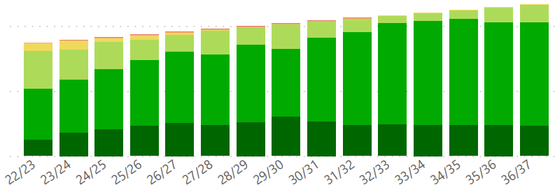

Figure 1.1 – 15 Year Projected Transport Asset Condition Distribution
Complex assets, like roads, are made up of multiple components and may have some components in good condition and others in a poor condition that average to the asset reporting as acceptable, even though renewal work is required.

Figure 1.2 – 15 Year Rolling Backlog Forecast (2021 $, millions)
The road backlog is addressed by 2033/34, where the Pathways and Drainage backlog starts to rise. Work is underway to collect further information to plan how to address this into the future.
Asset Sustainability Ratio  66%  $$\frac{Renewal Expenditure}{Annual Depreciation}$$  A measure of the sustainability of current asset renewal practice. | Asset Renewal Funding  25%  $$\frac{Funded Renewals}{Desired Renewals}$$  A measure of how much of the required renewal funding is available. | Remaining Service Potential  80%  $$\frac{Fair Value}{\begin{aligned}Current Replacement \\ Cost\end{aligned}}$$  A measure of the remaining service life of assets. | Average Annual Asset Consumption  1.04%  $$\frac{Annual Depreciation}{Replacement Cost}$$  A measure of the rate of Transport asset consumption.

Figure 1.3 – Overall Transport Financial Indicators for 2021/22 Financial Year
Council has been gradually increasing the investment into road renewal since 2018/19, and in 2022/23 this will be approximately 500% of the starting amount. This funding will address the relatively low asset renewal funding ration, which is expected to improve in coming years.

Introduction
The City of Whittlesea is committed to providing effective and efficient services to the community. Council is proactively managing its asset portfolios to ensure the level of service provided meets the community’s expectations in the most cost-effective manner and has invested in systems, processes, and personnel to achieve this. This plan gives an overview of current practices and their long-term implications on service delivery to inform decision making and resource prioritisation.
This plan is broken into four sections addressing key long term sustainability questions:
Why does Council have transport assets and what do we have?
Section 3 – Strategic Objectives
Section 4 – Asset Overview
Section 5 – Levels of Service and Performance Indicators
Section 6 – Asset Condition
How do we manage our assets throughout their lifecycle and what does it cost?
Section 7 – Operations
Section 8 – Maintenance
Section 9 – Capital Renewal
Section 10 – New Assets and Capital Upgrades
Section 11 – Transfers and Disposal Plan
Section 12 – Lifecycle Costings
Section 13 - Financial Indicators
What are the risks in delivering the desired services and how do we mitigate them?
Section 14 – Risk Management
How will we continue to get better at managing our transport assets?
Section 15 – Improvement Plan
This transport asset management plan is part of Council’s overall Asset Management Framework. This framework defines the overall context for the management of community assets and ensures that the asset lifecycle activities link back to the community’s desired level of service as per the Whittlesea 2040 Community Strategic Plan. The framework is depicted in Figure 2.1.

Asset Management Strategy
Whittlesea 2040
(10+ year focus)
Community Plan
(4 year focus)
Operational Plan
(1 year focus)
Informs
Informs
Asset Management System/Database
Asset Inspections
Annual Report
Planning Reports
Asset Revaluation
Resourcing Strategy
Strategic Plans/ Documents
Asset Management Plans
Asset Management Plans
Asset Management Plans
All Plans
Drives

Figure 2.1 – Asset Management Framework

Strategic Objectives
Whittlesea 2040 – A Place For All is the City of Whittlesea’s Community Strategic Plan that outlines the community’s vision for living and working in the City of Whittlesea. The Council have developed the Community Plan 2021-25 which outlines how they plan to achieve that vision during their term.
The City of Whittlesea is responsible for both urban and rural areas and therefore is considered an interface Council. The municipality will experience significant population growth over the next 20 years, increasing from approximately 242,000 to 382,900 residents and thus is also considered a growth Council. This creates unique challenges in providing the required services for both established and rapidly developing areas to address today’s needs with consideration of our community’s ultimate demographic profile.
The City of Whittlesea has a comprehensive community consultation process for the development and update of the Whittlesea 2040 and Council Plan that is validated with ongoing community surveys. This Transport Asset Management Plan utilises the outcome of those consultation processes and has been placed on public display to ensure this plan aligns with the vision of the community. As Council’s asset management practice continues to mature the consultation process will become more rigorous.
The strategic objectives Council achieves through the operation, maintenance, renewal, and upgrade of transport assets align with Whittlesea 2040 as follows:
2. Liveable neighbourhoods:
- Smart, connected transport network
- Well-designed neighbourhoods and vibrant town centres
Council has developed policies, strategies and plans to assist with facilitating, providing, and advocating for these objectives. It has also adopted systems to manage the quantum of data. A summary of these documents and systems is shown in Table 3.1.
Table 3.1 – Transport Asset Related Documents and Systems
 | Document/System | Content
Corporate Framework | Road Management Act | Legislated powers and requirements in road management.
Corporate Framework | Whittlesea 2040 | Outlines the community’s long-term vision.
Corporate Framework | Council Plan | Outlines how the Council will achieve the community’s vision during their term.
Corporate Framework | Council Action Plan | Outlines how the organisation will achieve the communities and councillors’ priorities.
Corporate Framework | Asset Plan | Outlines how Council will manage assets holistically.
Service Provision Strategies | Integrated Transport Strategy 2014 | Defines an integrated approach for the provision of transport services within the Municipality (Local and State Gov.).
Service Provision Strategies | Road and Public Transport Plan | Identifies the high priority roads, intersection improvements, public transport, cycling and walking priorities.
Service Provision Strategies | Road Safety Strategy 2017 | Identifies and outlines strategic safety priorities.
Service Provision Strategies | Whittlesea Walking Strategy | Identifies priority pedestrian routes and missing infrastructure.
Service Provision Strategies | Whittlesea Bicycle Plan | Identifies priority cycling routes and missing infrastructure.
Service Provision Strategies | Non-Standard Public Lighting on Streets in Subdivisions | Defines policy for non-standard lighting on public roads in new subdivisions.
Service Provision Strategies | Public Lighting Code 2015 | Outlines and regulates the provision of public lighting by setting requirements of distributors and public lighting customers.
Operational Plans, Manuals, Guides | Precinct Structure Plans and Development Cons. Plans | Defines the infrastructure required from developers and Council through the delivery of new subdivisions.
Operational Plans, Manuals, Guides | Operational Service Standards | Defines the standards during the provision of operational services, such as frequencies and extent of works.
Operational Plans, Manuals, Guides | Road Management Plan | Defines the maintenance priorities and timeframes to rectify hazards within the road corridor.
Operational Plans, Manuals, Guides | Stormwater Management Plan | Outlines actions required to be taken to mitigate the threats from urban runoff into waterways.
Operational Plans, Manuals, Guides | Register of Public Roads | Outlines the roads and footpaths that are Council’s assets.
Operational Plans, Manuals, Guides | Engineering Design and Construction Manual (EDCM) | Sets the engineering guidelines for development in Growth Area Municipalities.
Operational Plans, Manuals, Guides | Guidelines for Urban Development | The specific application of the Engineering Design and Construction Manual for the City of Whittlesea.
Data Management Systems | ESRI | Geographic Information System that holds asset spatial data.
Data Management Systems | Assetic | Asset Information Management and Maintenance System.
Data Management Systems | CAMMS | Project management software that holds the 4/15 year new works program and current project management information.
Data Management Systems | Magiq | User Interface system that interacts with the financial system, plan reporting system, risk register and resource planning.
Data Management Systems | Authority | Financial Management System.
Data Management Systems | SharePoint | Document Management System that holds correspondence and other documentation.

Asset Overview
Council provides the municipality with a vast and complex transport infrastructure network to meet the community’s needs relating to pedestrian, cyclist, motorist, public transport, freight, and stormwater movements. The extent and value of this network as at 30 June 2021 is shown in Table 4.1.
Table 4.1 – Asset Overview and Hierarchy (2021 $M)
Asset Type | Hierarchy | Dimension | Current Replacement Cost ($) | Fair Value ($) | Annual Dep. ($)
Sealed Roads | Link | 40.8 km | 66.4 | 46.1 | 0.5
Sealed Roads | Collector | 263.4 km | 281.2 | 207.4 | 1.8
Sealed Roads | Access | 971.0 km | 826.6 | 644.3 | 5.7
Sealed Roads | Parking Bays | 100.3 km | 27.3 | 27.1 | 0.04
Unsealed Roads | Collector | 5.2 km | 2.2 | 1.6 | 0.03
Unsealed Roads | Access | 80.2 km | 30.4 | 23.6 | 0.4
Total Roads |  | 1,360.0 km | 1,234.4 | 950.1 | 8.5
Kerb and Channel | All | 2,314.7 km | 216.7 | 212.9 | 2.1
Pathways | Hierarchy 1 | 18.9 km | 2.2 | 1.5 | 0.02
Pathways | Hierarchy 2 | 1805.2 km | 216.2 | 175.3 | 2.3
Bridges | All | 43 units | 14.6 | 8.8 | 0.15
Bridge Sized Culverts | All | 42 units | 6.7 | 4.9 | 0.08
Drainage Pipes | Pipe Culverts | 1,889.8 km | 455.1 | 362.4 | 4.4
Drainage Pipes | Box Culverts | 7.2 km | 9.6 | 8.5 | 0.1
Drainage Pits | All | 73,086 units | 141.4 | 110.8 | 1.4
Drainage Pits | Gross Pollutant Trap | 184 units | 0.8 | 0.7 | 0.01
Public Lighting¹ | Poles | 13,257 units | 16.1 | 6.7 | 0.2
Public Lighting¹ | Lanterns | 15,362 units | 11.7 | 4.7 | 0.14
Telecommunications | All | 582.7 km | 26.5 | 19.7 | 0.2
Total Road Corridor Assets |  |  | 1,117.6 | 916.9 | 11.1
Grand Total |  |  | 2,352.0 | 1,867 | 19.6
Note:
^{1.} Standard Public Lighting is owned by AusNet Services or Jemena with Council funding the Operations, Maintenance and Renewal (OMR) via the OMR recurrent budget. Non-standard lights are Council assets.
This network interacts with other service providers such as VicRoads, Public Transport Victoria (PTV), Yarra Valley Water, Melbourne Water, and private road owners within the municipality. Council’s extent of authority regarding road assets is defined within the City of Whittlesea’s Register of Public Roads and Road Management Plan, both available from Council’s website. Drainage asset ownership is less clearly defined where Melbourne Water is responsible for all assets with catchments greater than 60 hectares, and smaller catchment areas by negotiation. Ownership of drainage assets is captured in Council’s Asset Information Management System, Assetic.
Council’s digital work order processes are undertaken through the Asset Information Management System and requires works to be registered against the specific asset the works are undertaken on. This means the data is reviewed in the field as works occur and any required updates are reported and actioned.
Council currently has various levels of asset data due to the accessibility, practicality, and benefit of collecting that data. Data confidence, and the frequency of collecting data, is outlined in Table 4.2.
Table 4.2 – Data Confidence and Frequency of Collection
Asset Type | Data Confidence Levels¹ | Data Confidence Description | Condition Audit Frequency
Roads, Kerb and Channel | High | Complete database of all known assets including GIS data and componentisation, new assets attribute data is captured upon completion of works and the network is condition assessed on an ongoing basis. | Every four years
Pathways | Medium | Complete database of all known assets, good GIS data but it lacks shared path/ cycle path/ pedestrian path identification, new assets attribute data is captured upon completion of works and the network is condition assessed on an ongoing basis. | Every four years
Bridges and Major Culverts | Medium | Good database of all known assets, good GIS data, new assets attribute data is captured upon completion of works and level 2 bridge inspections are undertaken every four years. | L2 Inspection every four years, L3 as required.
Drainage | Medium | Complete database of all known urban assets, good GIS data, suitably componentised, new assets attribute data is captured upon completion of works. No condition data captured and limited rural culvert data. | Ad hoc
Public Lighting | Satisfactory | Complete database of all known assets, good GIS data, limited age data, no condition data. Managed under State Government negotiated OMR charges. | Nil
Telecommunication | Satisfactory | Complete database of all known assets, good GIS data, no condition data. Not actively utilised or managed by Council. | Nil
Note:
^{1.} Data confidence colour-coding is as follows:
Green = desired level, Orange = improvement desired, Red = improvement required

Road Hierarchy
A hierarchy has been established for roads and pathways to assist with their management, prioritisation, resource allocation and response times appropriate to the function of each asset. The road hierarchy is defined as follows:
- Freeway: These roads provide the principal routes for the movement of people and goods between population centres, metropolitan activity centres, major freight terminals, and tourist areas in both rural and metropolitan areas. All assets related to freeways are the responsibility of VicRoads or their elected private operator, i.e., toll roads.
- Arterial Roads: Much the same as freeways, arterial roads provide the principal routes for the movement of people and goods. The delineation between freeway and arterial roads is made by VicRoads. Unlike freeways, arterial roads are the responsibility of VicRoads from back of kerb to back of kerb, with all other assets within the road reserve such as paths, service roads, and roadside landscaping the responsibility of Council.
- Link Roads: Roads of this classification provide linkages between places and the arterial road network or linkages between places. Examples of places are township, suburb, shopping precinct, major sporting venue, industrial area, agricultural area, tourist attraction and any places of interest. These are the responsibility of Council.
- Collector Roads: Roads of this classification primarily provide a route between and through residential, industrial, commercial, and agricultural areas. They convey traffic from Access roads to a Link Road and/or Arterial roads. These are the responsibility of Council.
- Access Roads: Roads of this classification include a road, service road, street, court, laneway, or extended driveway, which primarily provides direct access for abutting residential, industrial, commercial, and rural properties. They provide access from Link, Collector or Arterial Roads to local residential, commercial, or industrial areas. There is minor to no through traffic on Access roads. These are the responsibility of Council.
Typical road sections, road corridor layout, and design vehicles per day for each Road Hierarchy can be found in Council’s Guidelines for Urban Development available on Council’s website.
The road hierarchy is shown in Figure 4.1.1.
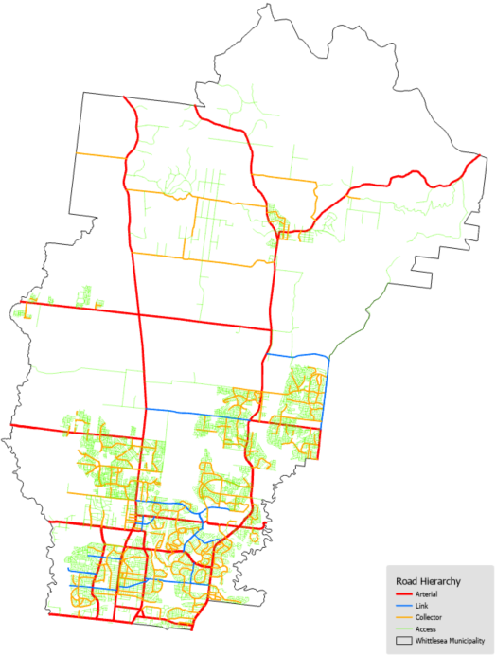

Figure 4.1.1 – Map of Road Hierarchy

Pathway Hierarchy
Pathway assets are included in both the road reserves and parks and open space asset management plans as determined by the services they provide; this plan covers those in the road reserve. Pathways use a two-tiered hierarchy based on their proximity to commercial areas, shopping plazas or public transport interchanges such as train stations. Specific maps of Hierarchy 1 pathways are available in the Register of Public Roads.

Drainage Hierarchy
Council has an extensive drainage network that is approximately 50% greater by length than the road network. A hierarchy has been established for drainage assets to assist with management, prioritisation, and resource allocation. The initial adoption of this is based on pipe size, with further iterations planned to confirm the hierarchy matches the intent. This is shown in Figure 4.3.1 and defined as follows:
- Main Lines – Defined as assets greater than or equal to 825mm dia (pipes) or 825mm width (boxes), these mains convey flow from the whole subdivision or catchment area to creeks or Melbourne Water mains.
- Branch Lines – Defined as assets 375 to 750mm dia (pipes) or 375 to 750mm width (boxes), these lines capture multiple street lines and convey the flow to the drainage main lines. These assets service approximately 100-150 properties.
- Street Lines – Assets less than or equal to 300mm dia (pipes) or width (boxes), these lines are in streets and court bowls and have relatively small catchment areas of roads and properties. These assets service approximately 15-20 properties.
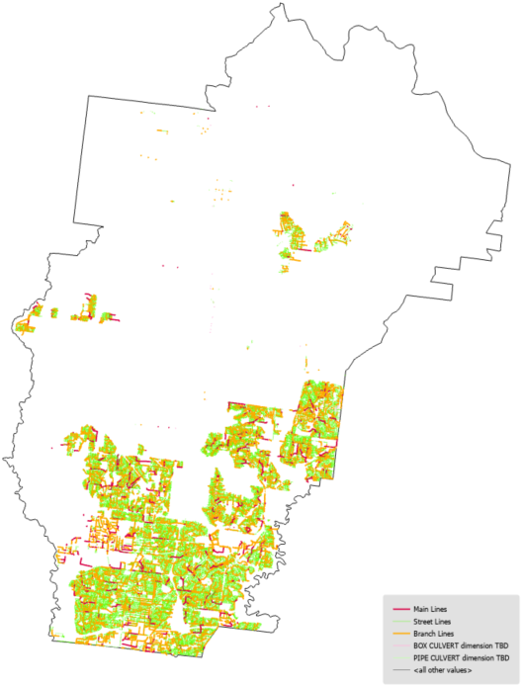

Figure 4.3.1 – Map of Drainage Hierarchy

Levels of Service and Performance Indicators
A key objective of asset management planning is to match the levels of service (LoS) the organisation delivers with the level of service expectations of customers. Council therefore looks at level of service through the following perspectives:
- Community Level of Service: Relates to the service or experience expected by the community utilising the asset. This covers attributes such as quality, reliability, responsiveness, sustainability, timeliness, accessibility, and cost effectiveness; and
- Technical Level of Service: Relates to how the Council delivers or assesses performance on meeting the desired community level of service.
Council recognises that the ongoing development of the municipality requires not just the provision of, but also the advocacy for and facilitation of, transport assets to deliver these services. This includes, but is not limited to, upgrade of the arterial road network by VicRoads and the provision of train, tram and bus infrastructure and services by PTV. The Victorian State Government specifies that “A better service, not a better asset, is a key indication of successful asset management”, thus Council considers service delivery through advocacy and facilitation, in conjunction with asset condition.
It is noted that timeliness and responsiveness to health and safety risks generated by hazards and defects are covered by legislation, and the City of Whittlesea’s Road Management Plan defines how Council complies with this and is a large contributor to delivering the desired community level of service. These activities are considered operation and maintenance within the context of this asset management plan and are referenced in Section 7 and Section 8.
The levels of service align with the organisation’s Strategic Objectives in Section 3, specifically the Whittlesea 2040 goals as follows:
2. Liveable neighbourhoods:
- Smart, connected transport network
- Well-designed neighbourhoods and vibrant town centres
The number references for these goals have been cited in Table 5.1 to ensure the measured levels of service relate to the Community’s 2040 vision.

Table 5.1 – Levels of Service
 | W2040 Goal | Community Level of Service | Technical Level of Service | Score
Condition | 2.1 | Assets are in a condition to effectively support movements throughout the municipality. | Assets are maintained at condition 3 (average) or better. | 91.4%
Condition | 2.1, 2.2 |  | Our community reports a satisfaction level of average or higher on Sealed Local Roads in the annual satisfaction survey. | 79%
Condition | 2.1, 2.2 |  | Our community reports a satisfaction level of average or higher on Local Streets and Footpaths in the annual satisfaction survey. | 79%
Capability | 2.1, 2.2 | Our community can safely and efficiently reach their destinations by their preferred transport method. | Our community reports their work/study commute is less than 90 minutes within the municipality. | 97.6%
Capability | 2.1 |  | The number of sealed local road requests received by council per 100 kilometres of sealed local road. | 27.3
Capability | 2.1 |  | The proportion of urban residential properties within 400m of a Bus Stop or 800m of a Train Station. | 13% Train, 81% Bus
Capability | 2.1 |  | Household rating for ease of local walking and cycling. | 5.7/10
Capacity | 2.1, 2.2 | The transport network is appropriate to support our growing municipality and changing climate. | Our community reports a satisfaction level of average or higher with how Council is managing traffic throughout the municipality and around construction sites in the annual satisfaction survey. | 65%
Capacity | 2.1, 2.2 |  | The proportion of our roads that are carrying less than their designed traffic volumes. | 95%


Asset Condition and Useful Lives
Council collects asset specific condition and degradation indicators to assess asset performance throughout their lifecycle. For valuation, reporting, and overall network monitoring these indicators are aggregated into a standard condition rating as shown in Table 6.1.
Table 6.1 – Condition Descriptors
Assetic Condition Index | Condition Descriptor
0 | New or as new asset.
1 | Very Good – minimal maintenance required.
2 | Good – minor maintenance work may be required.
3 | Average – standard maintenance work required.
4 | Poor – renewal required. Asset provides poor level of service.
5 | Very Poor – urgent renewal required. Asset is unsafe or unusable.
6 | Failed – asset has reached end of life and cannot be used.
The intent of Council is to undertake renewal works on an asset at the most cost-effective point in the asset lifecycle to deliver the community’s desired level of service. The intervention levels as per Table 6.1 and their associated lives are shown in Table 6.2.
Table 6.2 – Asset Lives and Intervention Levels
Asset Component | Hierarchy | Intervention Level (LoS) | Service Life (yrs)¹ | Useful Life (yrs)¹
Road Seal | Link & Collector | 4 | 27 | 30
Road Seal | Access | 4 | 27 | 30
Sealed Road Pavement | Link & Collector | 4 | 57 | 65
Sealed Road Pavement | Access | 4 | 85 | 100
Gravel Pavement | All Roads | 4 | 13 | 15
Kerb and Channel | All Roads | 4 | 85 | 100
Pathways (concrete) | All Pathways | 4 | 85 | 100
Bridges | All Road Bridge | 4 | 85 | 100
Major Culverts | All Culverts | 4 | 67 | 80
Drainage | All Drainage | 4 | 85 | 100
^{1.} Service life is the time an asset is expected to be available at the desired level of service before renewal. Useful life is the length of time an asset can be used, regardless of the level of service the asset provides.
Where Figure 1.1 showed the overall asset condition, Figure 6.1 shows the detailed component condition. Where condition data wasn’t available, this figure uses valuation information to simulate what the condition would be given its age and service life.
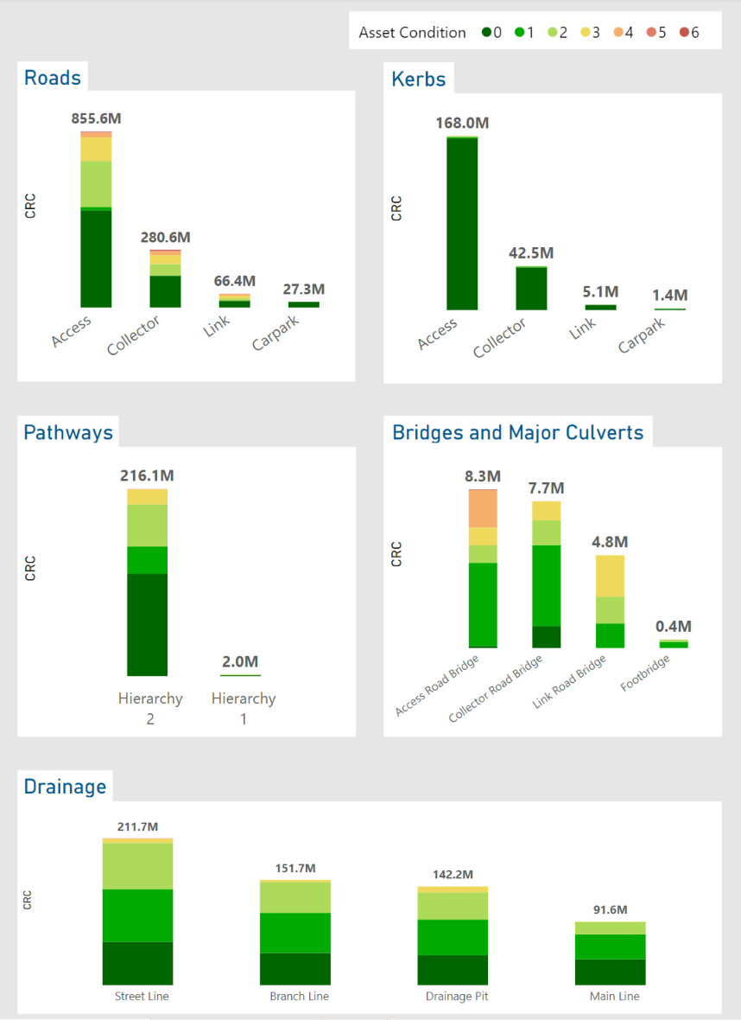

Figure 6.1 – Current Condition By Component, Asset Type, and Hierarchy

Operations
Operational activities are the ongoing, day to day overheads required for the asset to operate effectively and safely in delivering the desired level of service. This includes Public Lighting energy charges, management expenses, condition inspections, and other associated overheads.
Public Lighting is managed through an Operations, Maintenance and Renewal (OMR) budget that address all expenditure activities and future expenditure is projected from a historical basis. Council is required to provide Public Lighting for safety and amenity reasons as defined in the Public Lighting Code, and the cost of doing so is dictated by the State Government. The cost of providing these services to the community is captured in this plan under Operations.
Telecommunication does not currently have operational or maintenance requirements, as it is conduits only leased to, and operated by, other agencies or remain idle pending acquisition by another agency.
Annual expenditure on operational activities is shown in Table 7.1.
Table 7.1 – Annual Operational Activities and Expenditure (2021 $,000)
Asset | Activity | Cost
Roads, Kerb and Channel | Inspection as per Road Management Plan | 132
Roads, Kerb and Channel | Roadside Mowing, Vegetation Management | 577
Roads, Kerb and Channel | Street Sweeping | 795
Pathways | Inspections as per Road Management Plan | 116
Pathways | Hierarchy 1 Pathways Sweeping | 304
Drainage | Stormwater Pit and Gross Pollutant Trap inspections and cleaning | 313
Road Corridor | Litter Collection and Graffiti Removal | 3,940
Public Lighting | Operations, Maintenance, Renewal | 3,809
Traffic Signals & Pedestrian Lighting | Electricity utility costs | 21
Traffic Signals & Pedestrian Lighting | Department of Transport Monitoring Fees | 17
 | Total | 10,024

Table 7.2 – Four-Yearly Operational Activities and Expenditure ($,000)
Asset | Activity | Cost
Roads, Kerb and Channel, and Footpaths | Complete Condition Audit | 300
Bridges | Complete Level 2 Audit | 80
 | Total | 380

Maintenance
Routine maintenance activities are the ongoing, day to day actions that are necessary to ensure the assets provide the level of service desired and reach their anticipated useful life. It is noted that as assets degrade, maintenance activities and their associated costs increase. This is as poorer condition assets require additional intervention to maintain the usability and safety of the assets. Maintenance activities are demarcated into two categories:
- Planned Maintenance: Programmed or cyclic works that have an ongoing program such as bridge furniture maintenance or road line marking maintenance.
- Reactive Maintenance: Works identified and required through the activities defined in the Road Management Plan, in response to customer service requests or another source identifying risks. Examples include pothole patching, crack sealing, and guardrail repair/replacement.
Council’s transport assets are maintained by the Maintenance and Operations Department, except for telecommunications and Public Lighting. Specific services, frequencies and key performance indicators are defined in the Operational Service Standards. This document was internally compiled in 2008 and is reviewed on an ongoing basis for relevance against customer service requirements.
Table 8.1 – Planned Maintenance Activities and Frequencies
Asset | Activity | Activity Frequency
Vehicular Transport |  | Link/Collector | Access
Sealed Roads, Kerb and Channel | Hazard mitigation as per RMP | Refer RMP | Refer RMP
Sealed Roads, Kerb and Channel | Street Sweeping | 8 per year | 8 per year
Sealed Roads, Kerb and Channel | Roadside Mowing/Bushfire Prevention | As Required | As Required
Sealed Roads, Kerb and Channel | Crack sealing, pothole repairs, guidepost replacement | Refer RMP | Refer RMP
Unsealed Roads | Hazard mitigation as per RMP | Refer RMP | Refer RMP
Unsealed Roads | Maintenance grading | 4 per year | 2 per year
Bridges and Major Culverts | Bridge Furniture Maintenance | Refer RMP | Refer RMP
Roadside Furniture | Sign Maintenance | Refer RMP | Refer RMP
Active Transport |  | Hierarchy 1 | Hierarchy 2
Pathways | Defect mitigation as per RMP | Refer RMP | Refer RMP
Pathways | Pathway Sweeping | Every 6 weeks | -
Stormwater Transport |  | High Priority | Low Priority
Drainage | Pit inspections and cleaning | Every 3 years | Reactive
Drainage | Gross Pollutant Trap Cleaning | 4 per year | 2 per year

Where possible, Council intends to manage assets in such a way that maximises planned maintenance and minimises reactive maintenance. This provides the best service for the community with the fewest disruptions, provides the best maintenance cost throughout the lifecycle of the asset, and mitigates risk.
Table 8.2 – Maintenance Activities Costs (2021 $,000)
Asset | Cost
Roads | 3,657
Kerb and Channel | 192
Hydrant Maintenance and Repair | 138
Line and Pavement Marking | 486
Unsealed Roads | 564
Signs and Multipurpose | 1,255
Pathways | 3,470
Drainage | 582
Bridges and Major Culverts | 50
Traffic Signals and Guard Rails | 270
Total | 10,664
Maintenance work orders can be tracked against the condition of the assets the works are undertaken on to understand how maintenance requirements may change as the transport network condition increases or decreases. An example of maintenance effort on assets by their conditions as per Table 6.1 is shown in Figure 8.1. This is used in predictive modelling to optimise services delivery at minimal total expenditure across maintenance and renewal activities.

Figure 8.1 – Work Orders by Condition per Kilometre of Road (2021)

Capital Renewal
Capital renewal refers to any works required to replace or restore an existing asset to a new or as new condition. Common examples include resealing a road, rehabilitating a road pavement, or replacing a pathway. Council undertakes renewals to meet the desired levels of service defined in Table 5.1 by undertaking works at the end of service life as per Table 6.2.
It is noted that the service lives defined in Table 6.2 are the averaged life for an asset component, thus each individual asset may have some variance from that averaged life. The next 4 years of anticipated renewals are physically inspected and prioritised during the annual budget process to account for any variation in lives due to environmental impacts, then a prioritised annual capital renewal works program is generated.
To optimise road renewal expenditure, multiple criteria have been collected and are used to inform both the timing and types of treatments that are recommended. This includes roughness, rutting, linear and crocodile cracking, defects, and oxidation. Each criterion is assessed and modelled and projected to change over the following 15 years as works are complete or roads deteriorate further. Figure 9.1 depicts this change for oxidation as an example.
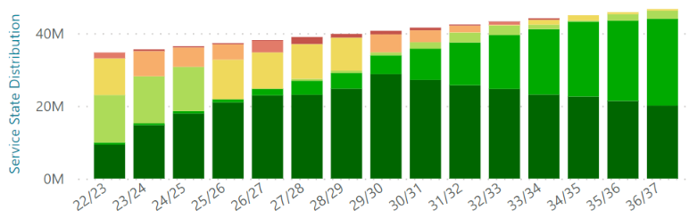

Figure 9.1 – 15 Year Projected Road Oxidation Condition Distribution
An analysis has been undertaken to assess assets that will degrade to their intervention level and are unable to be funded in the year their renewal is modelled to be required. This is defined as backlog and is shown in Table 9.1.
Table 9.1 – Renewal Expenditure, Requirements and Backlog (2021 $,000)
Asset | Annualised  Renewal Budget¹ | Annualised  Required Works¹ | Average Annual Gap¹ | Current Backlog | 15 Year Backlog
Roads Incl. Kerb and Channel | 14,420 | 11,050 | -3,370 | 50,545 | -
Pathways | 132 | 524 | 392 | - | 5,893
Drainage | 12 | 561 | 549 | - | 8,240
Bridges and Major Culverts | - | tbd | tbd | - | -
Total | 14,564 | 12,135 | -2,429 | 50,545 | 14,133
Note:
^{1.} 15-year averaged figures.
Drainage and Pathway modelling has a lower level of confidence and is primarily aged based. Condition audits are planned that will improve the understanding and accuracy of these projections and enable more accurate modelling to understand their future renewal requirements.
Bridges and Major Culverts have not been modelled at this stage. Level 2 audits were completed in 2017, any minor defects that were identified have been rectified, and the next level 2 assessments are due in 2022/23. Council’s bridge network is completely concrete and regular level 2 audits are undertaken and, where necessary, those are escalated to level 3 audits. Once the next round of level 2 audits are complete, the forecast will be updated.

New Assets and Capital Upgrades

Overview
New assets are defined as assets that are created to meet an additional or previously unaddressed service level requirement, such as infrastructure in a new subdivision or a new pathway along a desired pedestrian route. Capital upgrades are defined as works that are undertaken to enhance the level of service delivered by an existing asset, such as widening an existing road to provide an additional travel lane.
The City of Whittlesea has three primary ways new assets and capital upgrades are undertaken:
- Private Developments: When private development of land parcels occurs, the required infrastructure is constructed by the developer or their representative. This is completed in alignment with Precinct Structure Plans/Development Plans under the supervision of Council’s Engineering Design & Construction Department and handed over to Council once Council Officers are satisfied it complies with Council’s requirements, standards, and development specific conditions.
- Infrastructure Contributions Projects: Private developments increase the demand on the wider transport network through generating additional transport requirements. Precinct Structure Plans/Development Plans contain an infrastructure contribution plan which specifies the contribution that each development must make towards upgrading the wider transport network. Council is then required to undertake or facilitate the delivery of these works and is liable for managing any shortfalls.
- Councils 4-15 Year New Works Program: Council has a New Works Program that addresses the need for new or upgraded assets throughout the municipality. This is primarily funded by Council with the opportunity to source additional funding via grants.
Precinct Structure Plans, Development Plans, and Infrastructure Contribution Plans can be accessed at the Victorian Planning Authority Website: https://vpa.vic.gov.au/about/project-list/

Private Developments
Given the rapid development occurring in the municipality, most new assets are handed over to Council from new subdivisions. Council has received an average of 35.3km of road and associated infrastructure per year for the past 10 years, and it is anticipated that this will continue over the next five years. It is difficult to predict development beyond this due to the uncertainty of market conditions, however it is anticipated significant growth will continue through to at least 2040 when the anticipated population of approximately 382,900 is realised.
In addition to ensuring the design and construction of these assets is in accordance with Council requirements, Council monitors the addition of new assets via a series of interactive dashboards for strategic asset planning, reporting, and service delivery purposes. An example of a dashboard monitoring asset growth is shown in Figure 10.1.

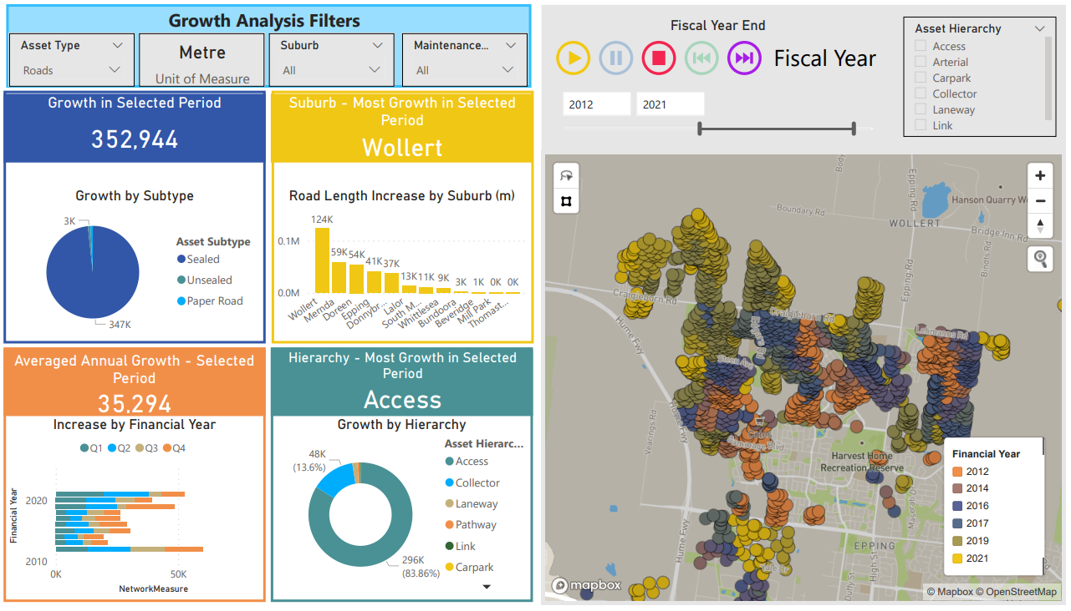

Figure 10.1 – PowerBI Asset Growth Dashboard

Infrastructure Contributions Projects
Infrastructure Contributions Projects are identified in Precinct Structure Plans (PSP) with a defined scope of works. These projects include a cost estimate determined by the Victorian Planning Agency (VPA) as at the time the PSP is adopted, and Council collects this from the developments as part of their development process.
Council plans for Infrastructure Contributions Projects in the New Works Program alongside prioritised capital works on an as needs basis or, if deemed beneficial to the community, will negotiate the delivery of this infrastructure by developers whilst they are on site constructing their own works.
It is noted that there can be significant liability to Council within the Infrastructure Contributions Projects. This is caused by the contribution amounts being determined when the PSPs were adopted, then changing design standards, materials or costs increase the current day cost of the required works. The extent of this and the risk posed to Council is under review.
Further details are available on Council’s website: https://www.whittlesea.vic.gov.au/building-planning-development/building-and-construction-approvals/development-infrastructure-and-open-space-contributions-to-local-suburbs/

Councils 4-15 Year New Works Program
The 4-15 Year New Works Program covers the next 15 years of Council managed capital works and is assessed and reviewed in conjunction with the annual budget review process. Available funding is balanced between all asset classes on an as needs basis per year.
The major projects that Council is currently undertaking are listed on Council’s website available at Major Council projects - Whittlesea Council.
The distribution of this funding for Transport assets between Expansion, Renewal, Upgrade, and New throughout the first 10 years of the program is as per Figure 10.2.

Figure 10.2 - Capital Expenditure

Transfers and Disposal Plan
Council’s transport assets have been constructed and developed in response to transport needs within the municipality. Approximately 45% of the transport network has been constructed since 2005 and as such has been constructed on an as needs basis for commercial benefit by private developers. The remaining 55% (approx.) is in the established areas and has responded to the needs and demands of the community over time. As such, there are no redundant transport assets identified for decommissioning at this stage.
Council’s transfer and disposal plan for transport assets is thus dependant on the transference of assets to other authorities.
When the rate of urban development quickened in the early 2000’s Council had the foresight to require the installation of fibre optic conduits in new subdivisions. These telecommunication assets are intended to be leased or acquired by relevant authorities in the provision of future internet services. As this is a commercial partnership, this leasing or acquisition is difficult to anticipate and, at this stage, Council is not actively pursuing this.

Lifecycle Costs - Annualised
To ensure effective planning of future capital works and that the additional operational and capital costs generated from vested assets is understood and accounted for, Council undertakes an assessment of the annual cost of managing the current asset portfolio. Operational and Maintenance expenditure is reviewed against the current portfolio to determine a unit rate per unit of each asset. Council’s transport network is in a variety of conditions, from near-new to approaching need for renewal, so the existing costs give an indicative estimate of the future costs new transport assets will impose on Council throughout their lifecycle.
Depreciation is used as a proxy assessment for capital renewal requirements. With service lives ranging between 13-85 years, and useful lives being up to 100 years, the assessment period for future renewals can have a significant impact on the lifecycle renewal requirements. Depreciation is applied consistently throughout the life of the asset and gives Council the capacity to calculate future financial ratios for different long term financial plan and capital delivery scenarios.
Table 12.1 shows the current assessment of the transport asset lifecycle costing.
Table 12.1 – Indicative Lifecycle Costings ($)
 |  |  | Annual Costs
Asset | Hierarchy | Unit | Ops and Mtnce | Depreciation Cost | Total Cost
Sealed Roads (incl. K&C) | Link | km | 10,857 | 11,776 | 22,633
Sealed Roads (incl. K&C) | Collector | km | 8,358 | 6,945 | 15,303
Sealed Roads (incl. K&C) | Access | km | 6,519 | 5,717 | 12,236
Public Lighting | All | each | 115 | 23¹ | 138
Pathways | All | m2 | 2,132 | 1,290 | 3,422
Drainage | All | Each pit² | 12.20 | 79.30 | 92
Note:
^{1.} Standard lighting are not a Council asset and there is no depreciation cost associated. However, some estates have been constructed with decorative, non-standard lighting which Council is liable to pay the cost to change over to current standard lighting.
^{2.} The drainage network is made up of pits and pipes, but pits have been used as a proxy here for the whole network lifecycle costs.

Financial Indicators
Council uses financial indicators to reflect on the past year’s performance of its current asset management practices. This assists with identifying if there are specific areas that need attention or if the current practice is appropriate for the organisation and community.
Asset Sustainability for 2021/22:
Roads: 113% | Drainage: 1% | Pathways: 21% | Bridges: 0%
Overall: $\frac{\$12.5M}{\$19.0M}$ = 66%
The Asset Sustainability ratio is a financial estimate of whether assets are being replaced at the same rate that they are deteriorating. It is calculated by dividing the renewal expenditure by annual depreciation and is generally targeted at around 100%.
Asset Renewal Funding for 2021/22:
Roads: 24% | Drainage: 100% | Pathways: 100% | Bridges: 100%
Overall: $\frac{\$12.5M}{\$50.5M}$ = 25%
The Asset Renewal Funding ratio is a measure of how effectively Council is currently funding renewals by comparing the available renewal funding against the currently identified deliverable bank of works within the Asset Management Plan. It is calculated by dividing the Net Present Value of the funded renewal works by the Net Present Value of the desired capital renewal works.
Remaining Service Potential for 2021/22:
Roads: 80% | Drainage: 80% | Pathways: 81% | Bridges: 65%
Overall: $\frac{\$1,837M}{\$2,293M}$ = 80%
The Remaining Service Potential is a financial estimate of the overall aged condition of a local government’s assets. It gives an approximate percentage remaining life of the network and is calculated by dividing the Fair Value by the Current Replacement Cost.
Average Annual Asset Consumption for 2021/22:
Roads: 1.23% | Drainage: 0.96% | Pathways: 1.04% | Bridges: 1.06%
Overall: $\frac{\$2.35M}{\$225.3M}$ = 1.04%
The Average Annual Asset Consumption assesses the rate at which assets are being consumed and are losing their service potential. It is calculated by dividing the annual depreciation by the depreciable replacement cost.

Risk Management
Council is committed to providing and maintaining a healthy and safe environment for the internal and external community. Council has determined a Hazard Identification, Risk Assessment and Control (HIRAC) Procedure to outline how to assess and mitigate risks. In this plan’s context, the risks relate to business planning, management, service delivery and physical asset failure; that is, the risks in the transport assets achieving the desired strategic objectives discussed in Section 3 and levels of services discussed in Table 5.1. The key strategic risks are outlined in Table 14.1.
Table 14.1 – Critical Strategic Risks
Risk | Consequence | Severity | Control Measures | Residual Severity
Failure to meet Levels of Service | Resident unrest and frustration, reputational damage, economic loss within municipality, health and safety risk. | High | Ongoing monitoring of delivery of service levels and community expectation, prioritisation of actions to meet levels of service. | Low
Insufficient funding allocated to asset renewals. | Service levels decline, unprotected assets (e.g., pavements) degrade faster than anticipated, user safety declines, resident unrest. | High | Prioritise renewal of ‘protective’ assets (i.e. seals), review conditions and funding annually, monitor network performance, investigate Special Rate Variation. | Low
Vested asset quality doesn’t meet Council standards. | Increased cost liability, user safety declines, reputational damage. | High | Suitably resource vested asset supervision, determine minimum pavement and seal designs. | Low
Construction costs of Development Contribution Plan projects exceed collected funds. | Construction of development required infrastructure at Councils cost, limited ability to fund other required works. | High | Identify projects, update project costs, manage construction timings, limit out of sequence development. | Medium
Insufficient transport options for community. | Resident unrest, failure to meet community service levels. | Significant | Advocate for public transport options, proactively provide capital upgrades for transport. | Low
Technological advancements, driverless cars. | Extensive transport network unsuited to transport task, inability to quickly adjust to changes in user behaviour. | Unknown | Monitor technological advancements, actively utilise Internet of Things opportunities, work with industry leaders in technological development. | Unknown
In assessing the key strategic objective risks, critical assets or asset components can be identified. Critical assets are defined as those which have a high consequence of failure, be it in service delivery directly or through the economic impact of premature asset failure.
Table 14.2 – Critical Assets
Asset / Component | Consequence of Failure | Control Measures
Road Seal | Poor quality trafficable service for asset users.  Loss of waterproof protection to road pavement components.  Dust and gravel in urban areas causing damage to health or property.  Lack of sufficient skid resistance leading to unsafe driving conditions | Prioritisation of reseal program with renewal budget.  Maintenance program undertaking pothole repairs and crack sealing.
Bridge and Drainage Assets | Non-trafficable streams or creeks, incomplete road network, inability for road users to access essential services, poor visibility of failed assets to road user resulting in accidents.  Environmental damage from blocking or pollution of creeks. | Inspections of bridge assets as per inspection regime.  Inspection of drainage assets as per risk profile, to be determined.

Improvement Plan
The City of Whittlesea recognises that there is opportunity to improve the asset management processes to ensure that the services provided by Council matches the services desired by the community in the most effective means. Council has adopted an iterative, continual improvement approach to its asset management processes to achieve this.
General improvement actions have been outlined in the Asset Management Strategy. Further to these, Transport asset specific improvement actions are listed in Table 15.1.
Table 15.1 – Transport Asset Management Improvement Plan
Opportunity/Action | Responsibility | Timeframe | Progress (%)
Review the Asset Management Plan in conjunction with service delivery activities and customer service requests to ensure relevance and accuracy. | Assets Team  Service Providers | Ongoing | -
Review and update Modelling upon receipt of updated condition assessment data and delivered renewal works. | Assets Team | Ongoing | -
Undertake Road, Kerb, and Pathway Condition Audit. | Assets Team | June 2023 | 0%
Undertake Bridge Level 2 Audits. | Assets Team | June 2023 | 0%
Assess viability of collecting Traffic Control Devices within the next Road Condition Audit. | Assets Team | June 2023 | 25%
Implement valuation of guard rails once condition audit is received from maintenance contractor. | Assets Team  Service Provider | June 2023 | 25%
Review planning and future subdivision information to estimate future transport asset acquisitions rather than using the historic rate of acquisition to forecast future funding requirements. | Assets Team  Planning Team | June 2023 | 0%
Utilise Bridge Level 2 Audits to set a proposed renewal date against each bridge’s major components. | Assets Team  Service Provider | June 2024 | 0%
Review service and useful lives as per updated condition data. | Assets Team | June 2024 | 0%
Determine specific critical assets (roads, bridges, drainage) as per Table 14.2 | Assets Team  Service Provider | June 2024 | 0%
Develop Condition Inspection Manual as per condition audit methodology. | Asset Team | June 2024 | 10%



City of Whittlesea
Civic Centre: 25 Ferres Boulevard, South Morang
Office Hours: Monday to Friday, 8.30am to 5pm
Mail: Locked Bag 1, Bundoora MDC 3083
Telephone: 9217 2170 (24 hours)

TTY: 9217 2420 Fax: 9217 2111 Email: info@whittlesea.vic.gov.au
Web: www.whittlesea.vic.gov.au

Appendix A: Transport Assets 15 Year Forecast Expenditure (2021 $, 000)
Year | 2022/23 | 2023/24 | 2024/25 | 2025/26 | 2026/27 | 2027/28 | 2028/29 | 2029/30 | 2030/31 | 2031/32 | 2032/33 | 2033/34 | 2034/35 | 2035/36 | 2036/37 | 15 Year Average
Operations Budget²
Roads (Incl. Kerb and Channel) | 5,125 | 5,258 | 5,395 | 5,535 | 5,679 | 5,827 | 5,978 | 6,134 | 6,293 | 6,457 | 6,625 | 6,797 | 6,974 | 7,155 | 7,341 | 6,172
Pathways | 420 | 431 | 442 | 454 | 465 | 477 | 490 | 503 | 516 | 529 | 543 | 557 | 571 | 586 | 602 | 506
Drainage | 313 | 321 | 330 | 338 | 347 | 356 | 366 | 375 | 385 | 395 | 405 | 416 | 426 | 437 | 449 | 377
Bridges and Major Culverts | - | - | - | - | - | - | - | - | - | - | - | - | - | - | - | -
Traffic Signals | 38 | 39 | 40 | 41 | 42 | 43 | 44 | 45 | 47 | 48 | 49 | 50 | 52 | 53 | 54 | 46
Public Lighting¹ | 3,809 | 3,931 | 4,056 | 4,186 | 4,319 | 4,457 | 4,599 | 4,746 | 4,898 | 5,054 | 5,215 | 5,382 | 5,553 | 5,731 | 5,914 | 4,790
Total | 9,705 | 9,980 | 10,263 | 10,554 | 10,853 | 11,161 | 11,477 | 11,803 | 12,138 | 12,483 | 12,837 | 13,202 | 13,577 | 13,963 | 14,359 | 11,890
Maintenance Budget²
Sealed Roads (Incl. Kerb and Channel) | 3,849 | 3,720 | 3,632 | 3,626 | 3,646 | 3,664 | 3,873 | 3,880 | 3,864 | 3,953 | 4,036 | 4,128 | 4,395 | 4,548 | 4,744 | 3,970
Multipurpose, Signage, and Pavement Markings | 1,742 | 1,787 | 1,833 | 1,881 | 1,930 | 1,980 | 2,031 | 2,084 | 2,138 | 2,194 | 2,251 | 2,310 | 2,370 | 2,431 | 2,495 | 2,097
Unsealed Roads | 564 | 564 | 564 | 564 | 564 | 564 | 564 | 564 | 564 | 564 | 564 | 564 | 564 | 564 | 564 | 564
Pathways | 3,470 | 3,560 | 3,653 | 3,748 | 3,845 | 3,945 | 4,048 | 4,153 | 4,261 | 4,372 | 4,486 | 4,602 | 4,722 | 4,845 | 4,971 | 4,179
Drainage | 582 | 596 | 611 | 626 | 626 | 626 | 626 | 640 | 640 | 640 | 640 | 640 | 640 | 640 | 640 | 628
Hydrant Maintenance and Repair | 138 | 142 | 145 | 149 | 153 | 157 | 161 | 165 | 169 | 174 | 178 | 183 | 188 | 193 | 198 | 166
Bridges and Major Culverts | 50 | 50 | 50 | 50 | 50 | 50 | 50 | 50 | 50 | 50 | 50 | 50 | 50 | 50 | 50 | 50
Traffic Signals and Guard Rails | 270 | 277 | 284 | 292 | 299 | 307 | 315 | 323 | 332 | 340 | 349 | 358 | 367 | 377 | 387 | 325
Total | 10,664 | 10,695 | 10,772 | 10,935 | 11,113 | 11,293 | 11,668 | 11,860 | 12,019 | 12,286 | 12,554 | 12,835 | 13,295 | 13,647 | 14,047 | 11,979
Renewal Budget
Roads (Incl. K&C) | 11,959 | 14,750 | 15,500 | 14,500 | 14,500 | 14,500 | 14,500 | 14,500 | 14,500 | 14,500 | 14,371 | 14,612 | 14,598 | 14,508 | 14,509 | 14,420
Pathways³ | 500 | 500 | 500 | - | - | - | - | - | - | 40 | 154 | 119 | 81 | 39 | 43 | 132
Drainage³ | 40 | 40 | 40 | - | - | - | - | - | - | 18 | 14 | 11 | 8 | 5 | 6 | 12
Bridges and Major Culverts³ | - | - | - | - | - | - | - | - | - | - | - | - | - | - | - | -
Total | 12,499 | 15,290 | 16,040 | 14,500 | 14,500 | 14,500 | 14,500 | 14,500 | 14,500 | 14,558 | 14,539 | 14,743 | 14,688 | 14,553 | 14,558 | 14,564
Capital Improvements Budget
Capital Works Program - New | 4,747 | 10,561 | 6,305 | 6,954 | 13,115 | 11,422 | 4,081 | 11,331 | 9,615 | 6,266 | 8,440 | 8,809 | 8,634 | 8,867 | 9,058 | 8,547
Capital Works Program - Upgrade and Expansion | 2,961 | 1,913 | 674 | 1,110 | 1,121 | 904 | 2,946 | 4,660 | 27,141 | 30,213 | 7,563 | 8,049 | 8,690 | 9,523 | 10,223 | 7,846
Total | 7,708 | 12,474 | 6,978 | 8,064 | 14,236 | 12,326 | 7,026 | 15,990 | 36,755 | 36,478 | 16,003 | 16,857 | 17,324 | 18,390 | 19,281 | 16,393
Rolling Backlog
Drainage | - | - | - | 45 | 239 | 486 | 774 | 1,219 | 1,811 | 2,411 | 3,146 | 4,030 | 5,211 | 6,494 | 8,240
Pathways | - | - | - | 342 | 512 | 581 | 661 | 972 | 1,336 | 2,037 | 2,799 | 3,410 | 3,863 | 4,530 | 5,893
Roads | 50,545 | 71,640 | 59,691 | 53,071 | 42,112 | 29,749 | 18,095 | 45,988 | 32,416 | 18,843 | 5,597 | - | - | - | -
Total | 50,545 | 71,640 | 59,691 | 53,458 | 42,863 | 30,816 | 19,530 | 48,180 | 35,563 | 23,291 | 11,542 | 7,440 | 9,074 | 11,024 | 14,133
Grand Total Expenditure | 40,576 | 48,439 | 44,053 | 44,053 | 50,702 | 49,280 | 44,671 | 54,153 | 75,412 | 75,804 | 55,932 | 57,637 | 58,884 | 60,552 | 62,245 | 54,826
Note:
^{1.} Public Lighting includes all Operations, Maintenance, and Renewal charges as per the Public Lighting Code by the Essential Services Commission.
^{2.} Network growth has been incorporated in these projections as per Section 10. Further, maintenance also incorporates the expected increase or decrease in condition as renewal works are complete or assets are consumed.
^{3.} Pathways and Drainage Renewals are currently based on aged-based data. Condition based data is scheduled for collection in the next few years.
^{4.} Categorisation of works in the New Works Program between Renewal, Upgrade, Expansion, and New is not currently available for 32/33 to 36/37. These years use an average of the preceding 10-year period to ensure that renewal and backlog projections are visible outside of the 10-year Long Term Financial Planning Period.

International Infrastructure Management Manual, IPWEA, 2020.
Guidelines for Developing an Asset Management Policy, Strategy and Plan, Department for Victorian Communities, 2004.

