Road Safety Action Plan 2024 - 2034 Engagement Summary
April 2024
Introduction
The City of Whittlesea is developing a Road Safety Action Plan, a 10-year roadmap for improving road safety in our community.
Council consulted with people who live, work, study or visit the municipality to understand the road safety issues that matter and help us prioritise our actions to improve road safety for all road users in our community. The feedback gathered through the engagement will be used to inform the development of the Road Safety Action Plan 2024-2034. It will also guide Council’s advocacy efforts to the Victorian Government on improvements needed to the arterial road network.

How we engaged you
The Road Safety Action Plan 2024-2034 consultation was open for community comment from 15 March to 14 April 2024. Community feedback was sought online through Council’s Engage Whittlesea platform and through direct conversation at the City of Whittlesea Community Festival on the 17 March 2023. The Engage Whittlesea platform utilises an accessibility add-on which enables users to easily switch to screen reader mode or easily adjust settings such as font size, contrast, dyslexia friendly options to improve the overall accessibility of the site. The platform also has an in-built translation tool to reduce language barriers to participation, allowing the page to be translated into the top ten languages spoken within the municipality.

Engage page
On the project’s Engage page, participants were invited to take part in two activities, a survey and a social map activity. The survey asked residents what their preferred mode of travel for work, education, recreation, and daily errands is; how safe they feel on local roads and shared paths; their thoughts on speed limits on residential roads; and, how they thought road safety could be improved in the city of Whittlesea. The survey results aim to help the project team identify top road safety priorities from a community and resident perspective.

Our community was also given an opportunity to participate in a social map activity – adding a marker on the map to let Council know about an area that they feel is safe or unsafe in the City of Whittlesea's road network, and then leaving a comment to elaborate. The survey and social map activity were designed to understand what is most important to the community in relation to future planning of road safety needs in the City of Whittlesea.

Community-based pop-ups
The project team hosted a community-based pop-up at the City of Whittlesea Community Festival on the 17 March 2023, an event attracting thousands of local residents. The in-person consultation activity mirrored the information being sought through the digital consultation survey activity, specifically to identify top road safety priorities with participants able to place up to five sticky dots on their top priorities. There was also opportunity for them to add additional suggestions

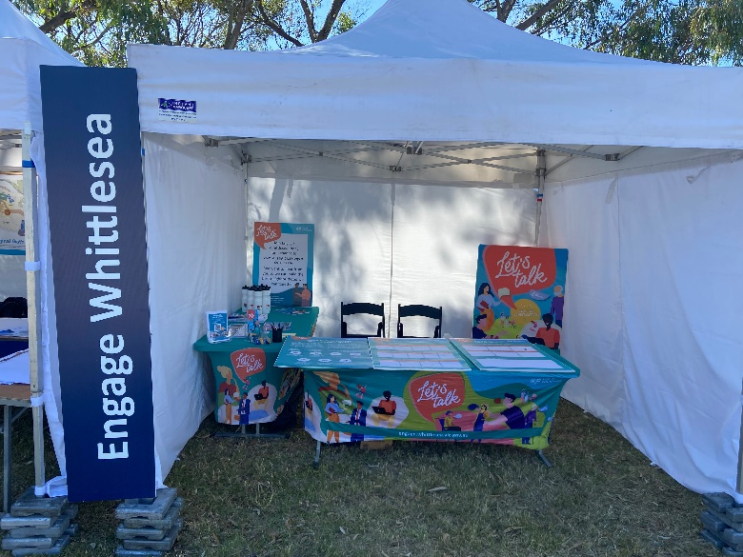
Above: Road Safety Action Plan pop-up at City of Whittlesea Community Festival

Project Promotion
The opportunity to participate in the community engagement was promoted through a range of channels to have a widespread reach across the municipality including:
- Council’s digital engagement platform Engage Whittlesea
- Social media – we shared three posts across Council’s social media channels (Facebook, LinkedIn, and Instagram)
- Direct email to key stakeholder groups
- Flyers and posters displayed at Council facilities and libraries.
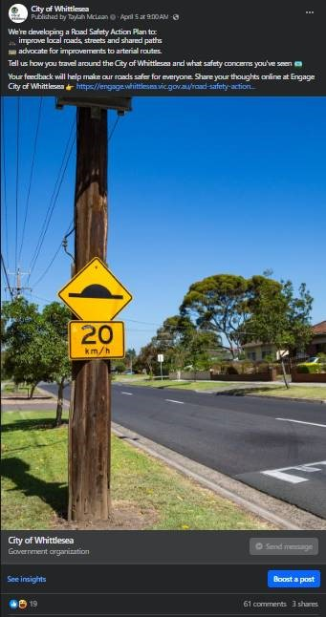
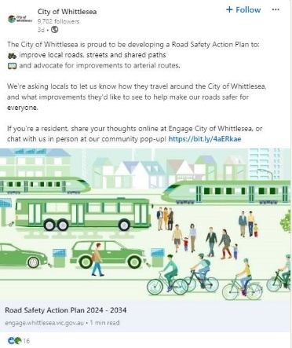

Above: Road Safety Action Plan social posts.

Participation
There was a total of 373 contributions, 71 of which were captured at the Whittlesea Community Festival pop-up and 302 contributions made through the Engage Whittlesea platform. Contributions came from various suburbs across the municipality, with 40% of participants speaking a language other than English at home, reflecting our rich multicultural community. Participation in the consultation saw notably higher participation by women than previous consultations in the transport planning space, reflecting a broader range of community perspectives. Below is a snapshot of community participation in this consultation.

Community participation

 | Social media posts reached 9,800 people and had 826 interactions, generating 54% of the total visitors to the online Engage page. The Engage campaign received 202 direct views from our community, leading to 32% of contributions.
 | We hosted one community-based pop-up with over 70 people participating in our engagement activity.
 | The social map activity was utilised by 210 participants with a further 92 participants completing the online survey (activity mirrored in the in-person community pop up).

Below: Community Participation Demographics snapshot
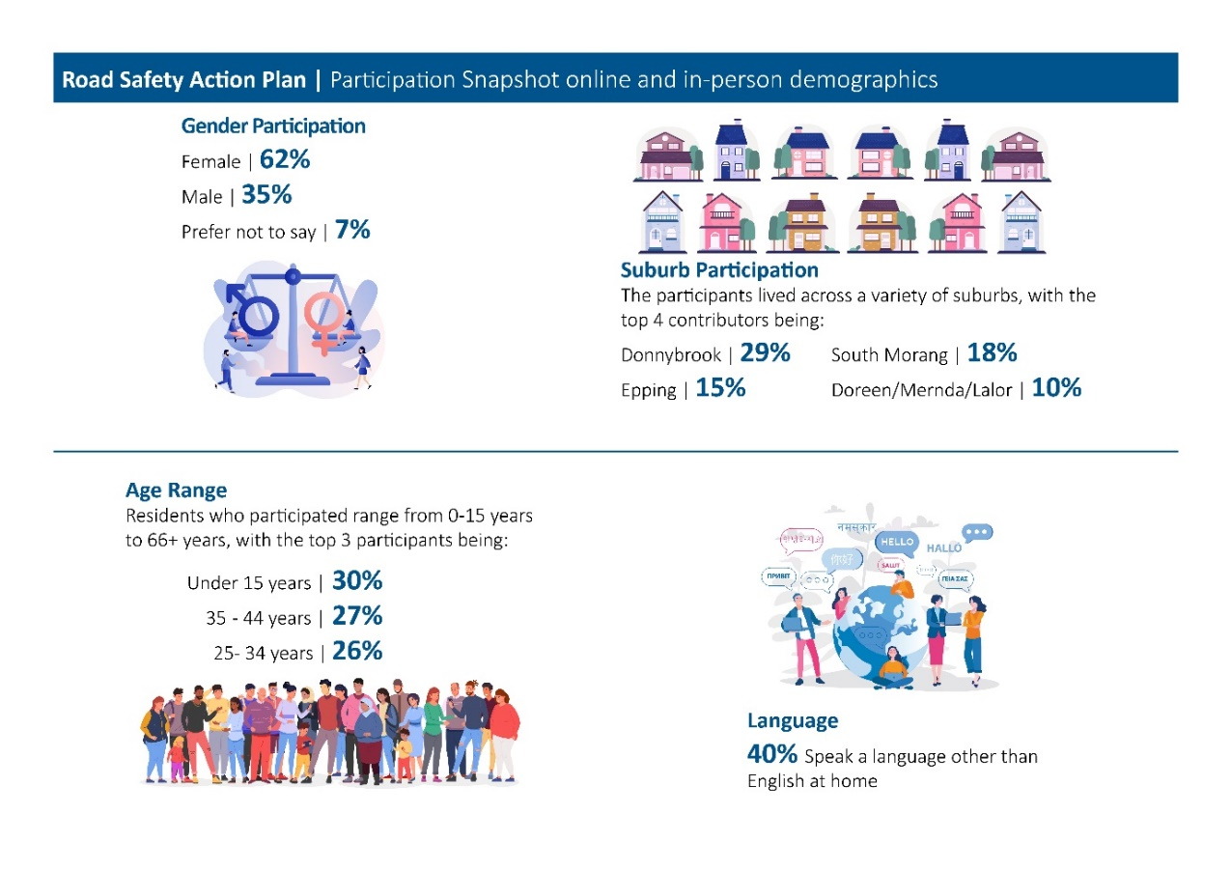
What we heard
Attendees of the Whittlesea Community Festival that visited the project stall at the community festival were provided with The Road Safety Action Plan 2024-2034 and a range of road safety options listed on a dot board (see below). Participants were provided with four dots and asked to place a dot in each question series rating their level of agreement on each topic, as well as an opportunity to leave extra comments if needed.

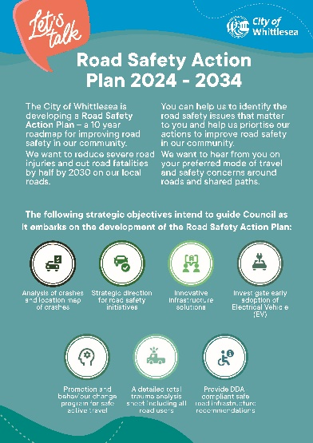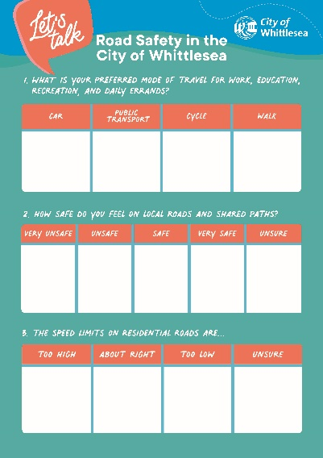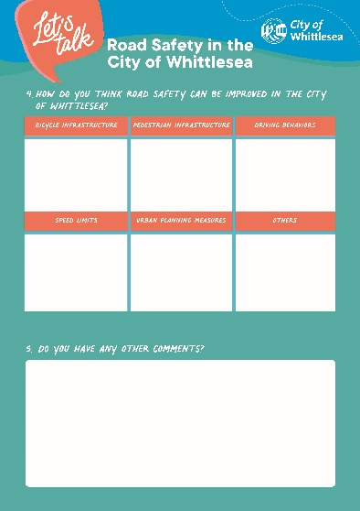
Above: Activity boards used at the community-based pop-up

These activities were designed to understand community sentiment regarding road safety in the City of Whittlesea. A total of 71 dots were placed on the activity board at the event, which highlighted the following community sentiment as the top five most important topics when considering road safety in the City of Whittlesea:

- I feel safe on local roads and shared paths (63%)
- The speed limits on residential roads are about right (63%)
- Road safety can be improved with driving behaviours (35%)
- Road safety can be improved with urban planning measures (19%)
- Road safety can be improved with bicycle infrastructure (17%).

The online survey mirrored the dot board activity and was completed by 92 community members. The online survey displayed similar results to those that were captured at the community festival with the exception of online participants having a higher proportion of feeling unsafe on local roads and shared paths.
The top five most important topics when considering road safety in the City of Whittlesea captured through the online survey were:

1. The speed limits on residential roads are about right (67%)
2. Road safety can be improved with driving behaviours (60%)
3. Road safety can be improved with urban planning measures (54%)
4. I feel unsafe on local roads and shared paths (46%)
5. Road safety can be improved with pedestrian infrastructure (47%).

The digital Engage page also hosted a social map activity for participants to drop a pin on an area that they felt was unsafe or safe across the City of Whittlesea. The activity received 210 contributions that were spread across the municipality as follows:
0.5%
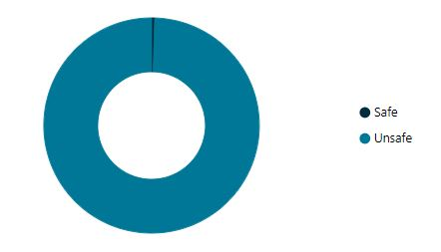
99.5%

The top four locations that received the most pin drops for unsafe roads, paths and other reasons are as follows:

- South Morang (15%)
- Wollert (14%)
- Donnybrook (13%)
- Epping (11%).

Comments added to the dropped pins included unsafe traffic conditions at intersections, incomplete bike paths, request for traffic management devices such as speed humps and general comments on areas for road safety improvements for the City of Whittlesea community.

Community comments have been themed and presented below along with a representative selection of comments and a technical response.

 | School Crossing safety  - There is a strong demand for the installation of school crossings at various locations to ensure the safety of children walking to and from school. Requests for school crossings at Doreen Primary School, Yan Yean Road roundabout, Bridge Inn Road, and other specific locations to improve safety for children.  ‘Raised pavements at school crossings (control the speed of cars)’.  ‘Pedestrian crossing with lights required on gorge road opposite Morang South primary school. It’s absolutely hell to try and cross the road there at any point of the day. 60km is TOO HIGH for gorge road’.  ‘School crossing for Doreen primary school. Many children walk from the tennis courts on the corner of Bridge Inn Road and Yan Yean Road up to the school. It is dangerous for the children to cross at the roundabout with peak hour traffic and waiting for a car to give way’.  Technical response:  The Road Safety Action Plan 2024-2034 prioritises the safety of vulnerable road users in the Goals section.  The safety of vulnerable road user groups, such as school aged children, is a key priority for the City of Whittlesea. To ensure maximum safety for this group, Council’s advocacy includes lowering speed limits around schools, the provision of safe and connected walking and cycling infrastructure and road safety awareness campaigns for all road users.  It is important to consider that the Yan Yean Road and Bridge Inn Road intersection is the responsibility of the State Government in terms of infrastructure provisions as both are arterial roads. The role of council is to advocate for the provision of facilities and Council will continue advocating for necessary safe infrastructure upgrades on state roads including enhancing walking and cycling provision within the municipality.
 | Traffic Management and Flow  - Community feel there is a need to optimise traffic flow through better infrastructure planning, adjusting traffic light timings, and converting problematic roundabouts to traffic lights, removing or upgrading speed humps, improving traffic light timings, and better planning to handle traffic volumes (e.g., High Street and Rufus Street, Donnybrook Road).  ‘Putting traffic lights to replace the roundabout where Bunnings Thomastown is located. It's a nightmare going through this especially peak time’.  ‘Shared bike pathways need a speed limit posted, totally unsafe when bicycle riders think it’s the Tour de France’.  ‘Clearways or no stopping for busy roads like High Street and Cooper Street during peak hour’.  Technical response:  The Road Safety Action Plan 2024-2034 commits to safeguarding the principles of safe systems and also indicates Council’s role in the transport system, noting that arterial roads are the responsibility of the State Government.  Council will continue focusing on the safety of all road users by considering speed management treatments on both state managed and local roads in collaboration with TAC and Department of Transport and Planning. Council will continue advocacy for targeted arterial road upgrades around the municipality and will explore the role of emerging technologies and data to provide information about congestion pinch-points, queue lengths and delays to assist with improving road safety, planning and advocacy.  Council will also explore opportunities to expand and develop our active transport network, with a focus on providing safe and separated cycling infrastructure. Council recently endorsed its Integrated Transport Plan (ITP) which seeks opportunities to expand the Northern Trails network to better connect the municipality with neighbouring areas.
 | Road Maintenance and Upgrades  - Many roads require significant maintenance and upgrades to improve driving conditions, safety, and accommodate increasing traffic volumes. Issues with potholes, gravel roads, inadequate lighting, and the need for road duplications (e.g., Donnybrook Road, Craigieburn Road, Epping Road).  ‘Maintenance of the bushes around the edges of the road. We can't see the upcoming vehicle because of long grass’.  ‘Bridge Inn Road, heading West to Epping Road, needs better lighting, the road to be cleaned more often to see line markings from the dirt trucks bring out from the quarry, and to be duplicated’.  ‘More access in and out of Donnybrook Road near the freeway’.  Technical response:  The Road Safety Action Plan 2024-2034 realises the significance of providing safe roads and provides information about road characteristics that contributed to high and medium-high infrastructure risk in the City of Whittlesea  By using the findings of risk analysis data provided in summary of crashes in the plan, Council will advocate for road improvements on state managed roads where risks have been identified with the regular crash history and black spots to reduce the severity and likelihood of future crashes.
 | Speeding and Reckless Driving  - Residents are concerned about speeding and reckless driving, advocating for increased enforcement, more speed control measures, and better driver education.  ‘People drive too fast and without consideration for other road users. There seems to be very little enforcement of road rules or education on safe driving’.  ‘There needs to be speed cameras set in place. Also, drivers that block our view when reversing because the local aged care facility won't provide extra car park for visitors to visit’.  ‘Gordons Road between Great Eastern Way roundabout to Lakes Boulevard roundabout (Coles) is absolutely terrible for speeding cars’.  Technical response:  By collaborating with government agencies such as Department of Transport and Planning, Victoria Police, TAC, and other stakeholders within the City of Whittlesea a targeted road safety program and driver behaviour change program could be initiated.
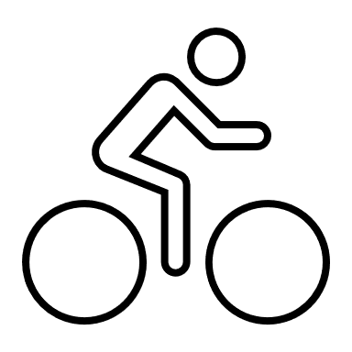 | Pedestrian and Cyclist Safety  - There is a need for better pedestrian and cyclist infrastructure, including footpaths, lighting, and dedicated cycling lanes to ensure safety and promote active transport.  ‘Donnybrook Rd needs significant upgrades, including bicycle lanes and pedestrian paths, to cope with the exploding population. Plans for these upgrades need to start now’.  ‘More cycling safety and. Dedicated paths away from the road. There is not nearly enough EV infrastructure’.  ‘The bike paths are fantastic around South Morang, but there are a few sections and transitions that just end abruptly or are difficult to navigate’.  ‘Roads are not adequate for traffic in Mernda and surrounding areas’.  ‘Also would like to enquire about a bicycle path along old railway tracks from Mernda to Whittlesea would be beneficial rather than plenty road’.  Technical response:  Safety of cyclists and pedestrians is a priority area in the Road Safety Action Plan 2024-2034. Key considerations such as separation of cyclists from high traffic areas, provision of shared paths, cycle lanes and allied infrastructure for the facilitation and safety of vulnerable road users will be a focus in future developments.  Council will also explore opportunities to expand and develop our active transport network, with a focus on providing safe and separated cycling infrastructure. The ITP 2024-2034 and Walking and Cycling plan 2022-2027 both seek opportunities to expand the Northern Trails network to better connect the municipality with neighbouring areas.
 | Infrastructure for New Developments  - New developments require better pre-planned infrastructure, including roads, footpaths, and public transport, to meet the needs of growing populations with complaints about inadequate infrastructure planning in new estates, lack of access roads, footpaths, and public transport options (e.g., Donnybrook Road, Olivine Estate).  ‘Pedestrian and cycle paths need to be a priority along with public transport. New estates in the northern part of CoW urgently need buses’.  ‘I live in Olivine Estate off Donnybrook Road, I would love to cycle to the station for environmental reasons but it's very dangerous’.  ‘Can we please have road infrastructure before building new estates. Donnybrook road is a nightmare’.  ‘You planned the community and the estates, but somehow didn't plan or factor in the infrastructure’.  Technical response  In the context of our growing population, improving convenient transport choices for  our residents will help to manage the ongoing issue of congestion.  Walking and Cycling are important, both for transport purposes and for recreation. Both options have considerable health and wellbeing aspects and many short trips in the municipality could be undertaken on foot or by bicycle. The ITP will explore options to continue to expand our walking and cycling network, including opportunities to provide safe and separated cycling infrastructure. Additionally, the Road Safety Action Plan, will help us to develop safer roads for people who live, work and travel throughout the City of Whittlesea.
 | Public Transport and Planning  - Enhancing public transport options and improving access to existing services are necessary to support growing communities and reduce car dependency. Calls for better public transport connections, extension of train services, and improved access to train stations, especially in rapidly growing areas.  ‘There's no footpaths from the station, so you have people walking dangerously on the side of the road in all kinds of weather’.  ‘People would be far more likely to use the train if they could actually access it, but walking or biking along Donnybrook road is incredibly unsafe’.  ‘The train services barely caters for the amount of ppl trying to get to the city, and it's been the most unreliable train service that I have ever known’.  Technical response:  Advocacy for better public transport is a key priority, and we are committed to advocating for more efficient and effective public transport network including both buses and trains for the community.

Next steps
The information gathered through community consultation will support ongoing development and allow for adjustments to the Road Safety Action Plan 2024-2034 as needed. The feedback captured has also been used to inform the development of other key plans and strategies Council are working on to make Whittlesea A Place for All.

Thank you again to everyone who participated in the community engagement by sharing feedback.

