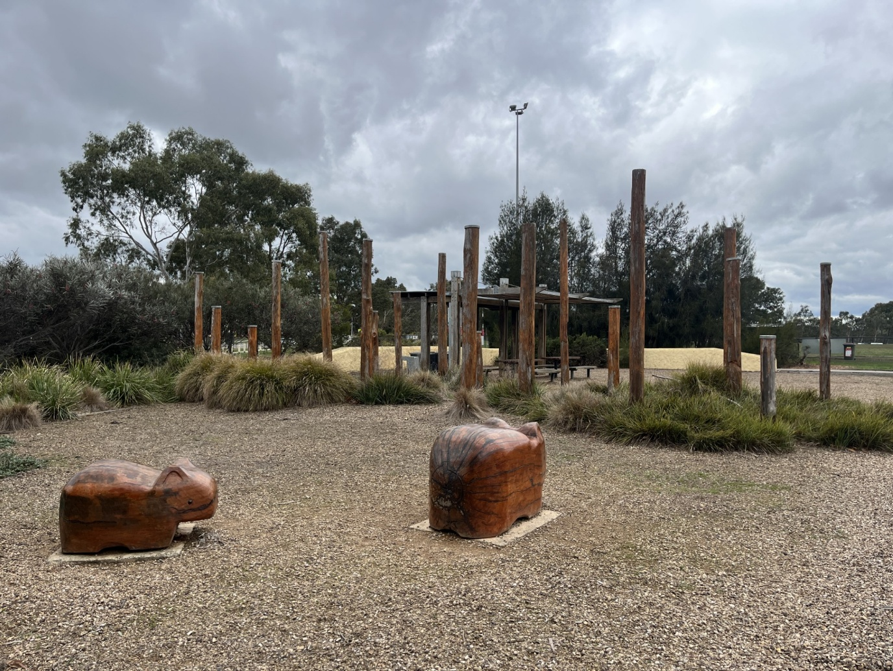
Mill park lakes recreation reserve playspace
Engagement Summary
20 August to 14 September 2025

Introduction
The City of Whittlesea is developing a plan to renew the existing play space and construct a municipal-scale playground at Mill Park Lakes Play Space in South Morang.
The current playground is located adjacent to the sporting ground and the plan being developed aims to improve safety, accessibility, and community enjoyment. The renewed playspace will meet current safety standards and better reflect the needs and preferences of children and families, in line with Council’s Playground Renewal Program.

How we engaged you
The local community were encouraged to share feedback on the draft Concept Plan by visiting the project page on the Engage Whittlesea platform or at one of the community-based pop-up stalls. Participants were asked if they supported the draft Concept Plan and to indicate which of the proposed 13 play elements, they liked the most. Participants could also provide further comments if they chose to.

The Engage Whittlesea platform utilises an accessibility add-on ensuring that it is as accessible as possible for all users. The platform also has an in-built translation tool to mitigate any language barriers to participation, allowing the page to be translated into the top fifteen languages spoken within the municipality. ​
To inform community and to ​hear from a diverse range of community members Council hosted two in-person engagement activities at the location:

Date | Time | Where | Address/location
Friday 22 August | 4.30pm -6.30pm | South Morang Football Club Pavilion | 170 The Lakes Boulevard, South Morang
Thursday 4 September | 3.30pm-5.30pm | Mill Park Lakes Reserve Play Space | Corner Plenty Valley Grove and The Lakes Boulevard, South Morang

Project Promotion
The opportunity to participate in the community engagement was promoted through a range of channels to have a widespread reach across the South Morang Ward including:
- dedicated project page on Council’s digital engagement platform Engage Whittlesea
- Engage Whittlesea campaign sent to 1,322 registered users who have expressed interest in the topic of parks and/or the South Morang area
- direct email sent to targeted stakeholders including the South Morang Football and Cricket Clubs, Mill Park Lakes Preschool and Kindergarten, Merriang Special Development School and The Lakes South Morang College.
- letterbox drop to over 650 residents living within a 700m radius from the playspace
- onsite signage - four A2 size corflutes displayed around the reserve
- targeted social medial post on Council’s Facebook account.

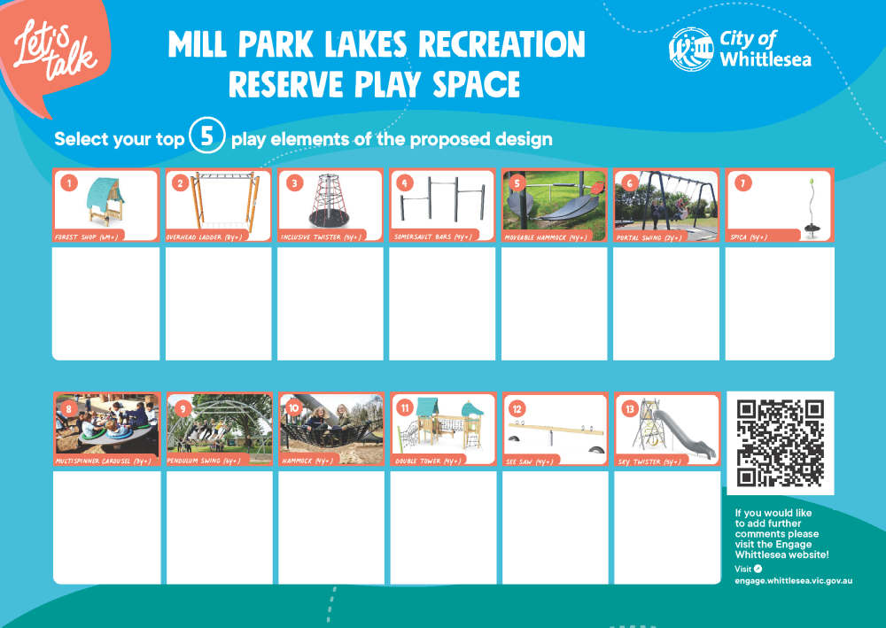
Figure 2: dot board activity with the proposed play elements used at community-based pop-ups

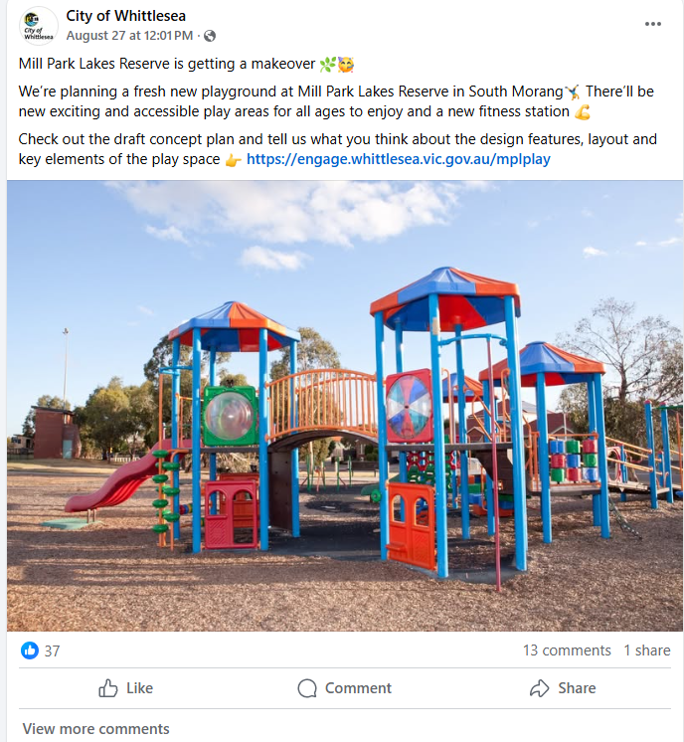
Image 1: project promotion through Facebook post

Participation
A total of 67 people participated in the consultation. Participants were given the opportunity to contribute in two ways; in person and online via the Engage Whittlesea platform. We spoke to 24 people in-person at pop-up activities and 43 people participated online via the project engage page.

Snapshot of Community Participation
Highlights from the community consultation included:
Contributions | In-person activities | Digital engagement | Downloads
 |  |  | 
Total of 67 contributions | Hosted two onsite pop ups | 496 views, 437 visits and 43 contributions on Engage Whittlesea platform | 62 Downloads of the draft concept plan.

Snapshot of Demographics
Below is a snapshot of the diversity of participation in the community engagement:
Gender Identity | Age | Live nearby
 |  | 
40% Male, 60% Female | All age brackets participated with the most represented being aged between 35-44 years (21%) and 25-34 years (11%) | 71% lived in the targeted area of South Morang

What we heard
A total of 58 community members participated in the community engagement by providing feedback through a survey online (43 people) or at one of two onsite pop-ups (15 people). A further nine community members identified their favourite play elements at the onsite pop-ups by completing a dot board activity.

Satisfaction with the concept plan
A total of 58 participants answered the question ‘how satisfied are you with the concept plan?’ with almost three-quarters of participants (74%) indicating they were satisfied or very satisfied with the concept plan. Full breakdown of what we heard is as below:
 |  | 
Very Satisfied/satisfied | Neutral | Not Satisfied/Not Satisfied at All
74% | 14% | 12%
Play elements
A total of 67 told us which of the play elements they likes, with the top three play elements being the Sky Twister,, the Double tower and the Portal swing. Below is what we heard in order or least to most liked play elements.
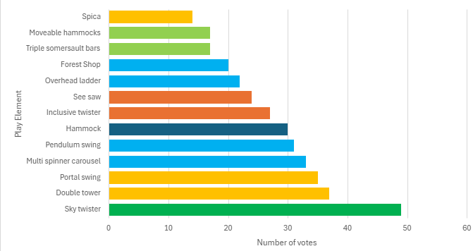
Location of the fitness equipment?
A total of 58 participants answered the question ‘are you happy with the location of the fitness equipment?’ with majority (89%) indicating they were happy.
Yes | No
89% | 11%
What are you not happy with?
Participants were asked to provide comment on anything they were not happy with in the concept plan, with six participants taking up the opportunity to provide comment. The comments related to the location of the fitness equipment and in particular the desire for it to be in a shaded area or closer to the children’s playground so parents can supervise their children. The desire for a basketball ring to be included in the design was also highlighted. There were three comments captured that weren’t related to project negotiables such as car parking, public toilets, traffic management and access to the play space for people with mobility restrictions.
“Been wanting a basketball facility for a long time”
“I’d prefer if it was closer to the kid’s playground so parents can watch over their kids”
“I’d prefer it in a sheltered area.”
Other comments
Online participants had the opportunity to provide other comments with 32 community members sharing feedback. The desire for a basketball ring was identified again, as were other suggestions including fencing around the playground, the need for shading, play elements for older children, a place for bikes/scooters to be parked and a bike track. Participants also took the opportunity to provide support for the design. There were also comments that were not related to the project negotiables such as the car parking, public toilets, traffic management and access from the road to the play space for people with mobility restrictions,
“Yes, a basketball court. Or half court. It is seriously needed in this area”
“Provide post and rails on perimeter so children chasing balls have a visual cue, so they think about not going beyond the perimeter”
“There must be overhead cover to shade people and help keep the temp of the surfaces usable in hot sunny weather”
“A large number of playgrounds in Whittlesea LGA are not suitable for kids six and up.”
“Children often come to the playground using their bikes/scooters, will there be somewhere to park bikes?”
“Also, a proper bike track for the kiddies would be great!”
“Good and awesome” and “I love it”
“I'm a parent of a child with disabilities and am a teacher at a local Special Development School. I'm very pleased about the consideration given to activities/ equipment that cater for children of all abilities”
“Wheelchair access needs to be looked at not very easy to access the play space from neighbouring streets”.
A further 11 comments were captured in-person at the onsite pop-up stalls. These comments included concern for access and safety as well as seating and running lanes on the path. There were three comments that were not related to the project negotiables such as public toilets and traffic management.
“Please fence off so kids don’t run onto the street” and “more seating options”
“Running lanes on the path, ninja course and spinning cup”
“Please fence off so kids don’t run onto the street”
“Need public toilet, the ones at the football club are always closed - no toilets over 10km jog”
“Speed humps in adjacent streets”.

Next Steps
Thank you to everyone who shared feedback either in-person at a community-based pop-up or online through the Engage Whittlesea platform.
You will be able to access the final concept plan on the project Engage page engage.whittlesea.vic.gov.au/mplplay and we encourage you to follow this page to stay updated.
The concept plan works will be submitted for tender where a contractor will be awarded the contract. It is anticipated that all works be completed early 2026 pending budget allocation and availability of resources.

