Epping Central Structure Plan
Engagement Summary
February 2023
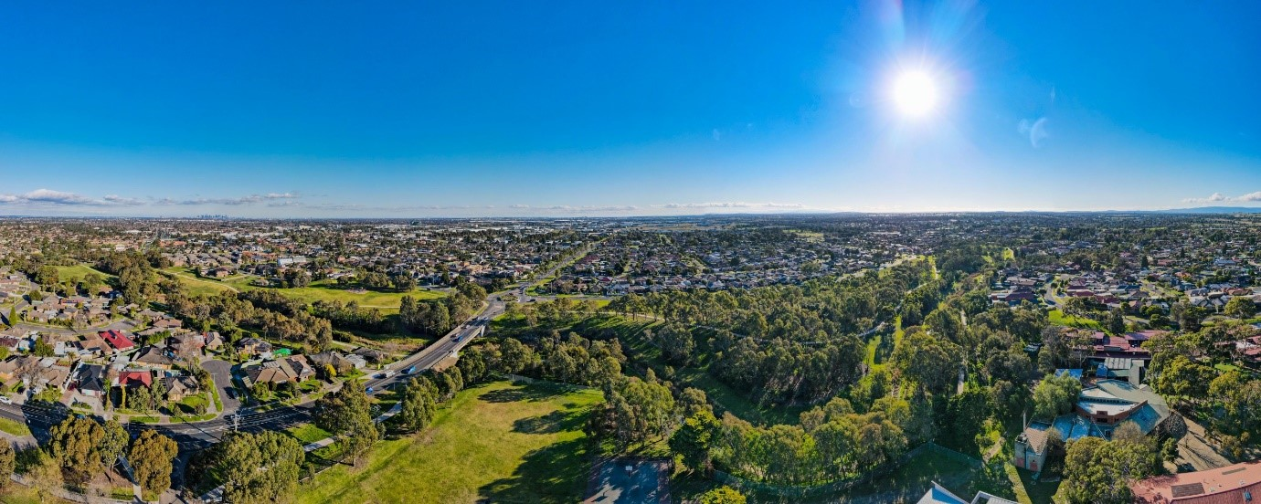
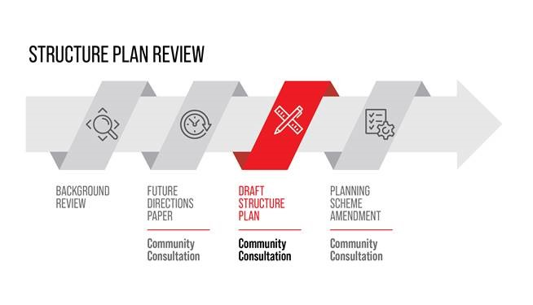
Introduction
Council is currently reviewing the Epping Central Structure Plan to ensure that Epping Central continues to grow as a liveable, diverse and thriving Metropolitan Activity Centre. The refreshed Structure Plan will be used to guide and manage future development in Epping Central to ensure it meets the current and future needs of the people who live work and visit Epping Central.
The Epping Central Structure Plan review is being developed in four stages.

Community consultation for Stage 3 of the Structure Plan review was undertaken between 24 October and 4 December 2022 and included both broad community engagement and more targeted discussions with key stakeholders on the draft refreshed Epping Central Structure Plan. The draft Structure Plan presented to community sets out the land use and development vision for Epping Central and will be used to guide and manage future planning and decision making over the next 15-20 years, subject to its adoption by Council.

The aim of the stage 3 community engagement was to inform and consult with the community on the vision, objectives and strategies contained within the draft Structure Plan to ensure that the activity centre continues to meet the current and future needs of the people who live, work and visit Epping Central.
Feedback received in response to the Structure Plan will be considered, and where appropriate, changes made to the Structure Plan.

How we engaged you
The Epping Central Structure Plan stage 3 community engagement was open for community comment from 24 October to 4 December 2022.
Community feedback was sought online through Council’s Engage Whittlesea platform and through direct conversation and activities at community pop-ups and meetings with key stakeholders.
The project Engage page featured a survey, a voting tool for participants to identify their top three strategic directions and a poll on any of the nine precincts highlighted on the precinct map.
The project team hosted four community pop-ups in high foot traffic locations within the surrounding area. At the pop-ups, participants were encouraged to identify their top two out of the five key themes of the plan and make comment on anything within the precinct.
The community pop-ups held were:
- Epping Village (High Street) on Thursday 10 November from 11.30am-1.30pm
- Pacific Epping Saturday 12 November 2022 from 10am-12pm
- Pacific Epping on Thursday 17 November from 3.30-6.30pm
- South Morang Farmers and Makers Market on Saturday 19 November from 9am-1pm.
The community engagement was promoted through a range of tactics including:
- Council digital engage platform Engage Whittlesea
- Social media – we shared posts across Council’s channels (Facebook, LinkedIn and Twitter) seven times, reaching people.
- Direct mail to owners and occupiers of land within Epping Central – around 2,900 letters were dropped to surrounding owners and occupiers
- Email to key stakeholder groups including schools, kindergartens and aged care facilities – we emailed 80 stakeholders in this group
- Email to those that provided feedback during stage 2 engagement activities – we emailed 59 people that had previously provided feedback
- Notices to government departments/agencies
- Emails to business owners via Council’s Business Newsletter
- Presentation to Councils Business Advisory Panel
- Meetings with key stakeholders – seven face-to-face meetings were held.

Participation
Throughout the course of this consultation, we pertained the following participant data:
- there were 110 contributions through digital engagement and 154 contributions at community pop-ups
- 60% of participants identified as female and 40% identified as male
- majority of participants were aged 26 – 35 years or 36 – 45 years (33% each)
- half of the participants live in Epping
- over 62% of participants are rate payers within the City of Whittlesea
- over 15% of participants work within the City of Whittlesea.

What we heard
We have separated what we heard through the digital engagement with what we heard through Community pop-ups and meetings with key stakeholders.

Digital engagement – survey
A total of 45 surveys were completed, with 78% of respondents identifying that they ‘liked’ or ‘liked a lot’ the shared vision for Epping Central.

Respondents were presented with the key themes below and asked to rank the importance of urban living, movement and transport, employment and investment, community facilities and services and public realm, design and natural environment. What we heard through this exercise is explained below.
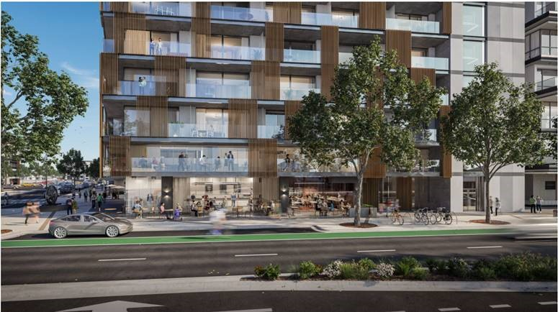

Urban Living rankings
- 62.22% of people voted increasing the provision and diversity of housing (including affordable housing), as important
- 60% of people voted directing higher density housing to locations close to the train station and existing services and facilities, as important
- 77.27% of people voted providing frontages at ground level that add interest and encourage activation of the street, as important
- 73.33% of people voted provision of new built form guidelines that encourage high quality development that provide an attractive outlook to the street and provide for landscaping
- 66.67% of people voted inclusion of New Epping (which is to be redeveloped for a mix of residential and employment activities) into the Structure Plan boundary, as important.
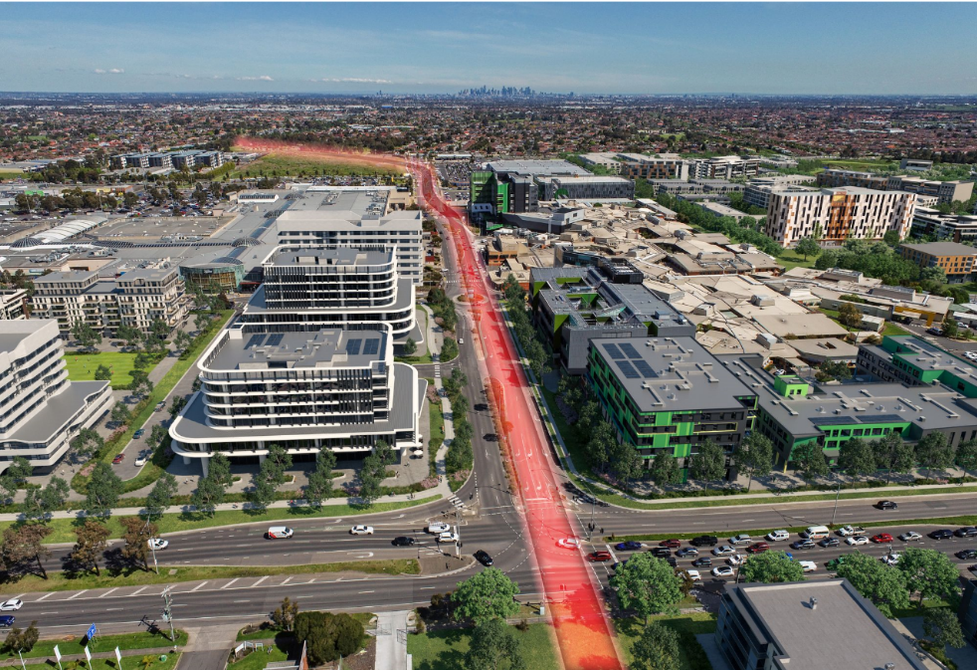

Movement and transport
- 65.5% of people voted planning that prioritises walking, cycling and public transport over private vehicle use, as important
- 95.56% of people voted enhancing pedestrian paths between key destinations (Epping Station, Epping Hub, Pacific Epping and the Northern Hospital) with wider footpaths, seating, lighting and wide footpaths, as important
- 84.09% of people voted provision of the Wollert Rail Corridor and new station within Epping Central, as important
- 26.67% of people voted reducing the speed along High Street, as important.

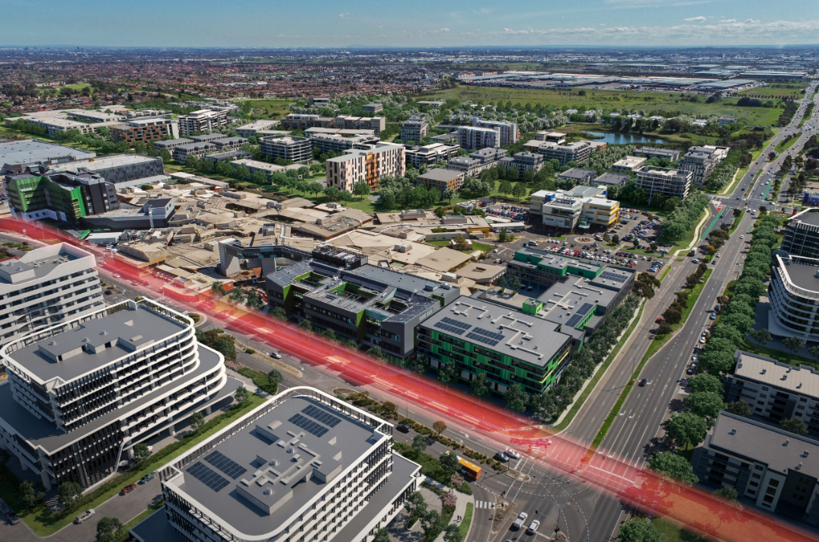

Employment
- 80.00% of people voted supporting a broad range of business, industries and jobs, as important
- 88.89% of people voted supporting the centre’s role as an expanded Health Hub building on the Northern Hospital, as important
- 64.44% of people voted supporting the centre’s role as an expanded Food Hub building on its proximity to Melbourne Markets, as important
- 64.44% of people voted ensuring new development in employment precincts are well designed with high quality finishes, as important.

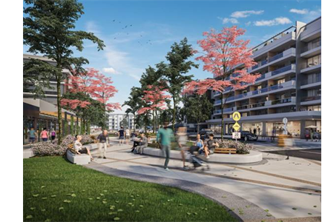

Public Realm
- 77.27% of people voted providing opportunities for open space and urban squares, as important.
- 84.44% of people voted encouraging significant greening including planting of canopy trees along streets and as part of the re development of large privately owned sites, as important
- 52.27% of people voted providing public art and other artistic elements within open space and along the street, as important
- 66.67% of people voted ensuring new development in employment precincts are well designed with high quality finishes as important.

Digital engagement – Vote It
A total of 14 people that participated through digital engagement opted to contribute to the vote it tool. Participants were presented with the ten strategic directions contained within the plan and asked to identify which was most important to them.

Strategic Direction 1 - Supporting the ‘urban core’ by encouraging the intensification of development and a greater diversity of uses; and Strategic Direction 2 - Supports the development of an expanded health precinct anchored by the Northern Hospital, were the two direction that attracted the most votes.

Digital engagement – Quick Poll
A total of 37 participants contributed to the quick poll activity online. Respondents were asked to indicate whether they supported the ideas presented for each of the precincts identified in the plan and offered the chance to provide comment.

Precinct 1 – High Street Village
86% of respondents indicated that they’re supportive of the ideas presented.
‘As a property owner in precinct 1 I would love to see the area become more developed and unused land bring more residential and commercial opportunities to liven the area. The urban square and added landscaping and pathways would shape the area into somewhere residents would spend more time and build connections with their local community’.

The only respondent that was not supportive of the ideas felt that
‘rather than scaling back mixed-use development along cooper street towards the Epping train line a further expansion of mixed use and building heights will be more appropriate and encourage development’.
Precinct 2 – High Street north
71% of respondents indicated that they supported the ideas raised. Respondents that weren’t supportive indicated a need for additional community facilities including a park, library and all ability swimming pool with women’s only pool facilities.
‘We strongly need a library here as the locals have to go Mill park or Lalor and is highly inconvenient. Wollert and Epping are Muslims majority areas, so we desperately need a swimming pool offering women’s only facility as we have to travel at least 15km to Preston just to suit a basic need of ours’.

Precinct 3 – Epping Station Hub
82% of respondents indicated they support the ideas presented for this precinct.
‘Encouraging 2-4 stories in the northern part of the suburb is a great way to ensure there's opportunities for student housing, affordable housing and medium/high density housing options. A great way to provide inclusive housing’.
‘Definitely agree the Melb Poly and Epping Station Cooper Street intersection needs a grand spruce up to make it fully functioning for all’.
Respondents also offered ideas for the area
‘…White Lady Funeral Home, incorporates the original bluestone walls of the original farmhouse, I guess over 150 yrs old. This should be retained’.
One respondent raised a previously shared concern around the high density planned for Guila Court, flagging concerns with parking and traffic congestion.
Precinct 4 – Regional demand
Of the seven respondents, six support alternative rail alignment and station location, sharing that it makes sense to connect the transport hub to the shopping hub.
Concerns raised in this precinct centred around the need to preserve the reserve to provide nature spaces for people and animals.
Precinct 6 -Employment & Precinct 7 – Epping renewal
The ideas presented were supported by all respondents. The only comment added was for Precinct 7 and related to the need to upgrade public transport options around the area to minimise the need to use a car before adding additional business and residential dwellings.
Precinct 8 – Dalton Road neighbourhood
Three people responded to this poll, with two supporting he ideas and the other indicating that they were undecided.

Precinct 9 – Childs Road employment
All respondents supported the ideas highlighting the need for the area to be made safer.

Key themes at the Pop Ups
A total of 154 contributions were made at the community pop-ups.
Participants at community pop-ups were presented with the five key themes and asked to identify the two themes they saw a priority.
The theme identified as the top priority by participants was Movement and Transport, followed by Community Facilities and Services. The full results of this activity are detailed below.
Theme | Pacific Epping | Pacific Epping | Epping Village | Farmers Market | Total Votes
Urban Living | 7 | 18 | 12 | 4 | 41
Movement and Transport | 10 | 29 | 10 | 12 | 61
Employment and Investment | 6 | 11 | 14 | 5 | 36
Community Facilities and Services | 13 | 19 | 10 | 9 | 51
Public Realm, Design and Natural Environment | 8 | 7 | 7 | 9 | 31

Comments captured at the pop-up stalls
Movement and Transport
Many of the conversations were general in nature and focussed on support for improved public transport, including more bus routes/services/infrastructure together with better road infrastructure. Several residents identified site specific transport improvements including the continuation of Memorial Street and provision of a round-a-bout at Houston Street.

Community Facilities and Services
Comments provided by the community indicate support for additional services, support and/or activities for older people in addition to younger people. Several people commented on the need to provide more affordable or free services for people who are financially disadvantaged such as young people or people with a disability. Providing opportunities for people to congregate within their community was also considered important. The provision of a library in Epping was identified as a specific need by several respondents.

Employment and Investment
Whilst there was significant support for this priority, there were few comments attributed to this theme, although respondents supported the provision of more local jobs, so people don’t have to travel as far to their place of employment.

Urban Living
Housing affordability was mentioned in several of the comments. Ensuring high quality internal design with large living areas, located close to open space and which contribute positively to residents’ mental health. Officers also had discussions with residents indicated past difficulties with getting the appropriate approvals for higher density development.

Public Realm, Design and Natural Environment
A variety of issues were captured tin respect to this priority including the need for open space in walking distance of new housing, better pedestrian paths, better lighting in streets and provision of amenities at play area. At least one respondent indicated support for the retention of the green space in Coulstock Street being retained given the lack of open space elsewhere within the centre.

Next steps
Thank you again to everyone that participated in the community engagement by sharing feedback, completing a survey, voting or commenting on the quick poll.
Feedback gathered from the community is being used to finalise the structure plan. The structure plan will then be presented for endorsement by Council in mid-2023.
Should Council endorse the updated Structure Plan, the next stage of the project will include an amendment to the Whittlesea Planning Scheme to implement the Structure Plan. As part of this process there will be a requirement for the amendment to be publicly exhibited.
For further information on the project please contact the Strategic Futures Department on 9217 2556 or visit Epping Central structure plan engage page.
We encourage you to register and follow the project Engage page to keep updated on the project.

