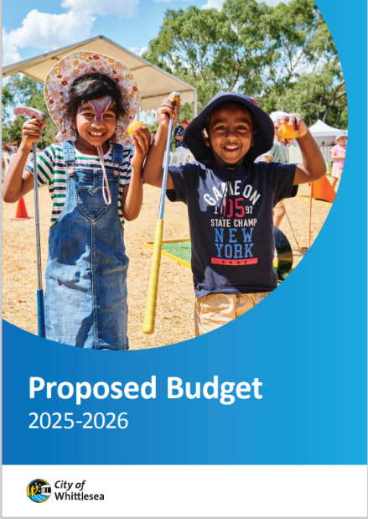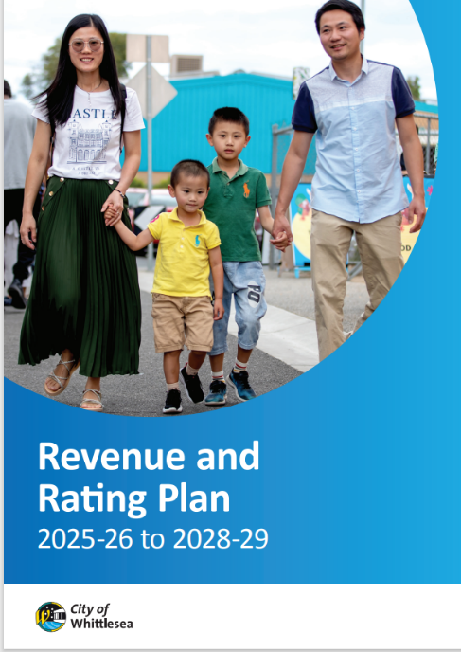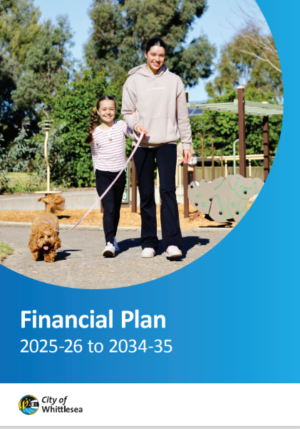
16 April – 7 May 2025
Engagement Summary

PROPOSED bUDGET 2025-26
PROPOSED FINANCIAL PLAN 2025-26 TO 2034-35
pROPOSED rEVENUE AND RATING PLAN 2025-26 TO 2028-29

Introduction
The City of Whittlesea’s Proposed Budget 2025-26 outlines Council’s commitment to invest in essential services and infrastructure while ensuring the long-term financial sustainability. Council has also developed the Proposed Financial Plan 2025-26 to 2034-35 and Proposed Revenue and Rating Plan 2025-26 to 2028-29. Together with the Proposed Budget, these documents ensure Council remains financially responsible while meeting the needs of our community now and into the future.

The proposed key financial documents were developed considering feedback received during a comprehensive Community Priorities engagement program that included feedback from over 900 participants across 13 community-based pop-ups and five Focus Groups held between August 2024 and February 2025.

The proposed documents were presented to community for feedback between 16 April and 7 May 2025 with participants asked whether they supported the documents and if they didn’t to explain why. This summary provides the detail of this final phase of the consultation. Participation was available online through the Engage Whittlesea platform or in-person at a series of eight community-based pop-up stalls scheduled across the municipality in high foot traffic locations.

To avoid consultation fatigue, the project was co-located with the Proposed Asset Plan 2025-26 to 2034-35 and Community Vision Review projects that were also open for comment.

Seventy-eight people participated in the final phase of consultation and told us that majority (85%) supported the Proposed Budget 2025-26, the Proposed Financial Plan 2025-26 to 2034-35 (89%) and the Proposed Rates and Revenue Plan 2025-26 to 2028-29 (81%). Those that were not supportive of the proposed documents identified specific budget item requests local to their area or a proposed rate freeze to ease the cost-of-living pressure as their reason.

Project Promotion
The opportunity to participate in this phase of the community engagement was promoted through a range of channels to have a widespread reach across the municipality including:

- Council’s digital engagement platform Engage Whittlesea
- Social media – organic posts accounted for 30% of traffic to the Engage page
- Engage Whittlesea email campaign to 1520 platform users - the campaign had a click-through rate of 5%
- Promotion on screens at Civic Centre, libraries and aquatic centres.
- An e-newsletter or personalised email with direct link to the project page, which accounted for 42% of traffic to the page, was sent to:
- People who engage with Ageing Well services
- Registered multicultural groups
- Sports and Aquatic Clubs
- Youth Services network
- Library and Community Hubs users Whittlesea Disability Network (WDN) via the WDN Hub on the Engage Whittlesea platform
- First Peoples network
- Community Priorities Focus Group participants

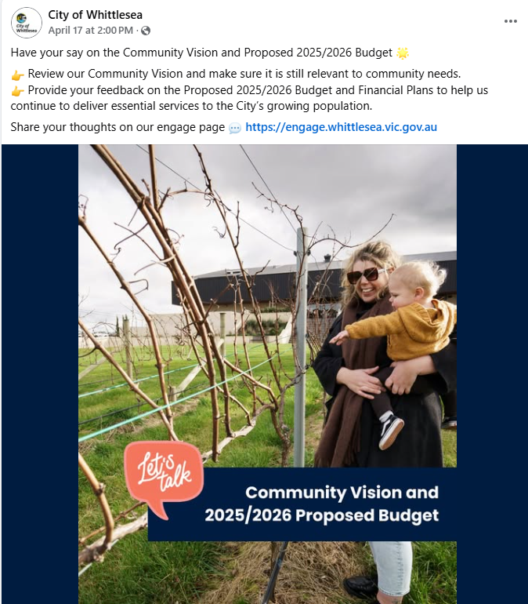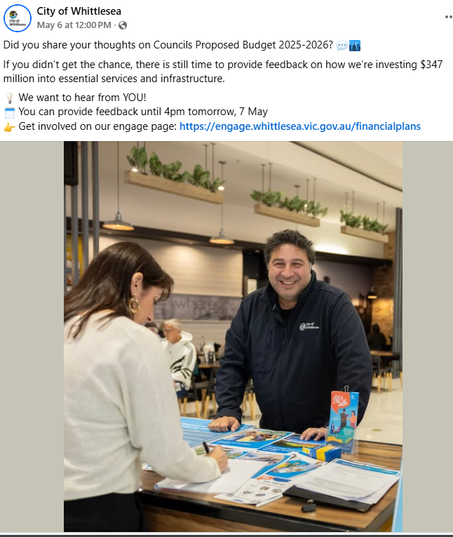
Above: Images of social media posts/reels

How we engaged you
The Proposed Budget 2025-26 and Financial Plans project page on the Engage Whittlesea platform encouraged participants to share whether they supported the proposed documents. There was also free text space provided for participants to add further comments if the selected no as a response for any of the draft documents.
The Engage Whittlesea platform utilises an accessibility add-on ensuring that it is as accessible as possible for all users. The platform also has an in-built translation tool to mitigate any language barriers to participation, allowing the page to be translated into the top fifteen languages spoken within the municipality. ​
As the proposed documents being presented are detailed financial documents, we made it easy for community to easily identify key inclusions and understand them. Activity boards (viewable in Appendix 1) were used at in-person engagement activities that presented key inclusions as an infographic and dot points to provide a snapshot of the purpose of the document. This information was mirrored on the project Engage Whittlesea page.
To inform community and to ​hear from a diverse range of community members and increase participation, the project team hosted eight in-person engagement activities across the municipality, details of these are in the table below. The engagement activity at the pop-up stalls mirrored those on the Engage Whittlesea platform.
Date | Time | Where | Address/location
16 April 2025 | 5pm-7pm | Kirrip Community Centre | 135 De Rossi Blvd, Wollert
28 April 2025 | 9.30am -11.30am | Lalor Library | 2a May Rd, Lalor
28 April 2025 | 2.30pm -4.30pm | Thomastown Library | 52 Main St, Thomastown
29 April 2025 | 9.30am -11.30am | Westfield Plenty Valley | 415 McDonalds Rd, South Morang
29 April 2025 | 2.30pm -4.30pm | Laurimar Shopping Centre | 101 Hazel Glen Drive, Doreen
30 April 2025 | 9.30am -11.30am | Shared Cup Café | 995 Donnybrook Rd, Donnybrook
30 April 2025 | 2.30pm- 4.30pm | Mernda Village Shopping Centre | 59 Mernda Village Drive, Mernda
2/5/2025 | 9.30am -11.30am | Coles University Hill | 2 Janefield Drive, Bundoora

Participation
Snapshot of Community Participation in the final phase of consultation
Key highlights from the community consultation included:

Downloads | Community-based  Pop-Ups | Digital Engagement
 |  | 
308 Downloads of the proposed documents | Hosted 8 community-based pop-ups  62 in-person contributions | 688 views  610 visits  16 contributions
Snapshot of demographics of the broader community consultation in this phase
Below is a snapshot of the diversity of participation in the community engagement, which is representative of our broader community:
Gender Identity | Age | Suburb
 |  | 
46% Female, 50% Male  1% non-Binary | All age brackets participated with the most represented being 45-54 years (22%) and 35-44 years (21%) | Participants came from 13 suburbs, with the highest participation coming from Mernda (19%) and Wollert (15%)
LGBTIQA+ Community | Multiculatural community
 | 
4% of participants identified as members of the LGBTIQA+ community | 50% of participants spoke English as a second language
First Peoples | People with disability
 | 
6% of participants identified as First Peoples | 8% of participants were people with a disability or carers of a person with disability
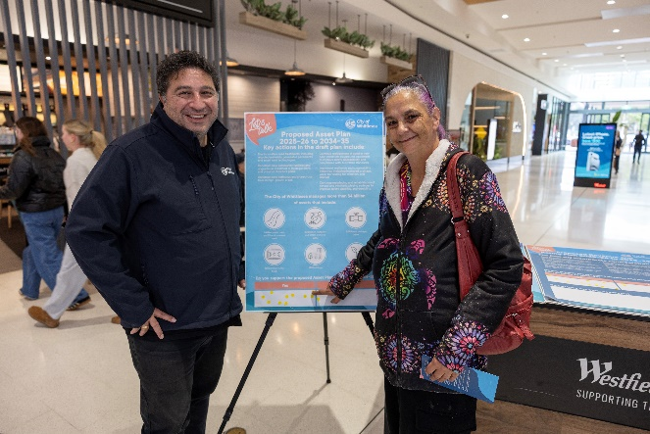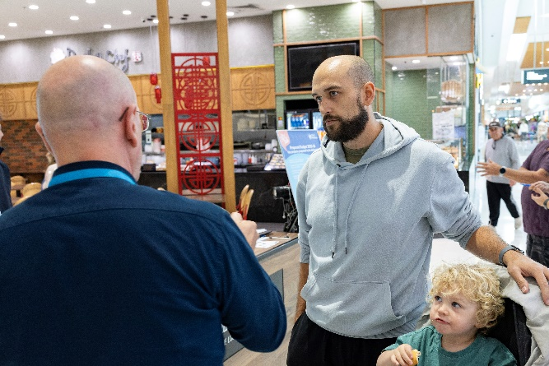
Above: Images from the community-based pop-up stalls

What we heard from the community consultation
Do you support the Proposed Budget 2025-26?
Majority of participants were supportive of the Proposed Budget 2025-26. What we heard is as below:
 
85% Yes 15% No

Do you support the Proposed Financial Plan 2025-26 to 2034-35?
Majority of participants were supportive of the Proposed Financial Plan 2025-26 to 2034-35. What we heard is as below:
89% Yes 11% No

Do you support the Proposed Rates and Revenue Plan 2025-26 to 2028-29?
Majority of participants were supportive of the Proposed Rates and Revenue Plan 2025-26 to 2028-29. A breakdown of the level of support is as below:
81% Yes 19% No

Which aspects of the proposed documents do you support or oppose?
In total, fourteen participants identified the reason they opposed any of the proposed documents. The comments outlined specific budget requests or called for a reduction in spending to reduce or freeze rates.
“Why is Lowalde Recreation Reserve Master Plan not budget? Area doesn’t get any love”
“Massive waste in all areas. Cut spending across the board….”
“Please invest more funding for young people in the City of Whittlesea.”
“No rate rises!!!”.

A further two participants took the opportunity to outline the reason they supported the proposed documents.
“This seems fair and reasonable given growth in population and community needs”.
“[group name]…commends the City of Whittlesea for their commitment to delivering quality community sport and recreation infrastructure”.

Other community comments captured at the community-based pop-up stalls
There were 14 additional comments captured at in-person engagement activities that focused on themes such as community safety, cleaner more appealing neighbourhoods, key services for the community and cost of living.
“Increase in crime - need to increase safety in the community and neighbourhoods”
“Shared pathways on Plenty Road not used properly by e-scooters. they need to have a horn to warn others when travelling fast past pedestrians. Plus, they should have speed limits to abide by”
“Need cleaner, neater neighbourhoods”
“Beautifying the environment decreases Domestic Violence”
“More health services for first peoples, with a focus on domestic violence and safety”
“Affordable housing needed in area”
“Homelessness – there are squatters in vacant houses”.

Next Steps
Thank you to everyone that shared feedback in this final phase of an extensive engagement program that informed the Proposed Financial Plans either in-person at a community-based pop-up or online through the Engage Whittlesea platform. Your feedback will be considered as we prepare the final documents that will be presented to Council for endorsement at the Council Meeting scheduled 17 June 2025. We will share the final documents and encourage you to follow the project Engage page
(engage.whittlesea.vic.gov.au/financialplans ) to be kept up to date as these are finalised.

Appendix 1: activity boards used at in-person engagement activities
