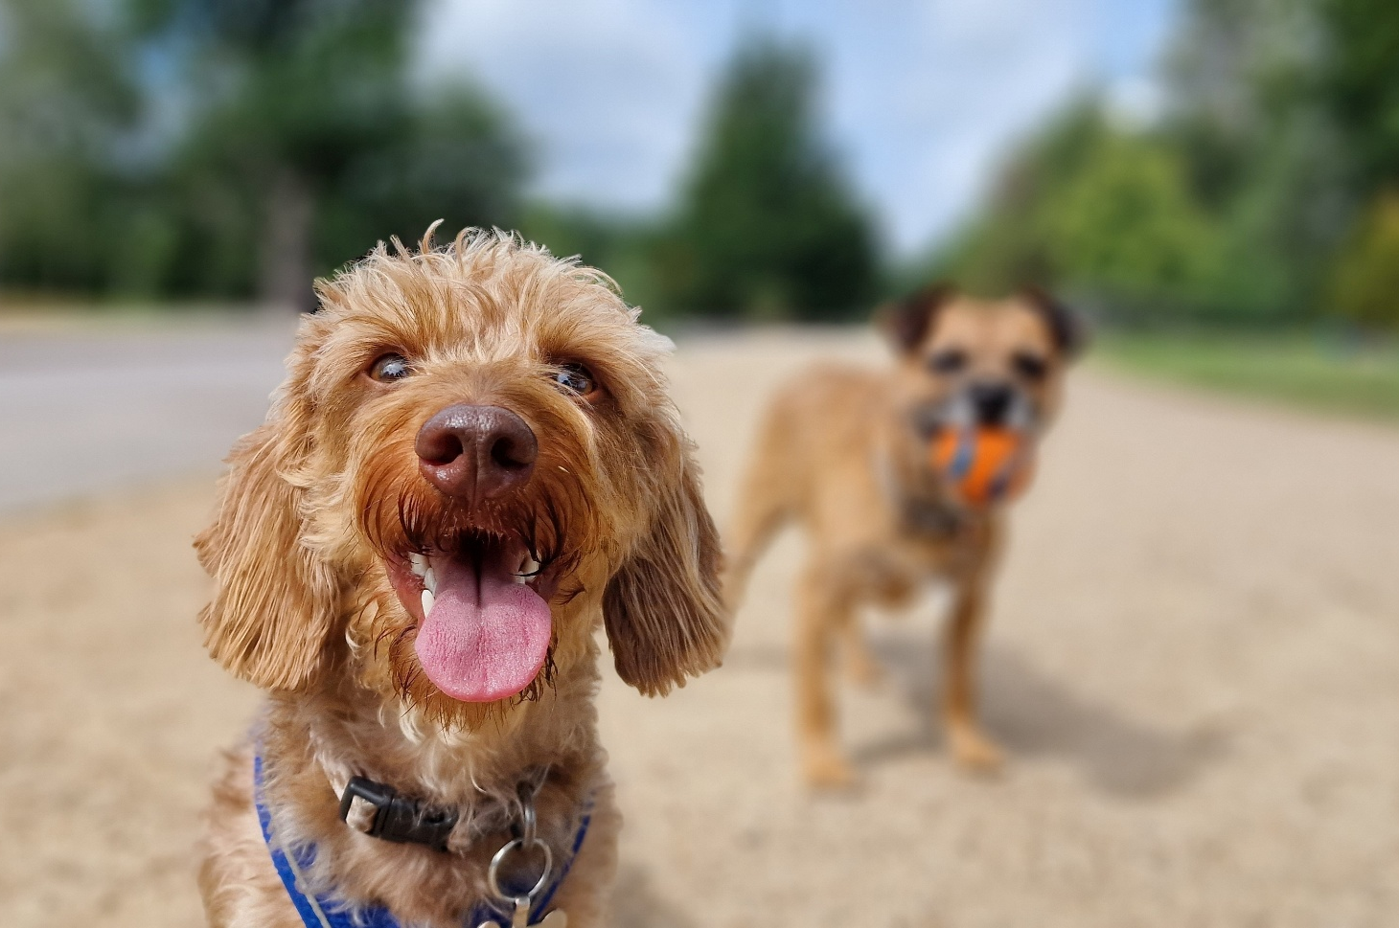

VR MICHAEL RESERVE – DOG OFF-LEASH PARK
Engagement Summary
13 October 2025 – 23 November 2025

Introduction
Council has secured funding from the Victorian Government’s New and Upgraded Dog Park Program to deliver a new off-leash dog park at VR Michael Reserve in Lalor. This initiative responds directly to community feedback gathered through the VR Michael Reserve Master plan and the Domestic Animal Management Plan consultations, through which many residents expressed the need for more spaces to support our growing community and their canine pets.
Council sought feedback from people who live near of visit the reserve to gauge support for the proposed concept plan and understand the needs of users and their pets when prioritising features. The insights gathered through this engagement will inform any final adjustments to the design before works commence.

How we engaged you
The VR Michael Reserve Dog off-leash park consultation was open for community comment from 13 October to 23 November 2025. Community feedback was sought online through Council’s Engage Whittlesea platform, direct email to registered dog owners in Lalor, Epping and Thomastown, and through direct conversations in person at two pop-up events and an informal information session held at Lalor United Bocce Club (located within VR Michael Reserve).

The Engage Whittlesea platform utilises an accessibility add-on ensuring that it is as accessible as possible for all users. The platform also has an in-built translation tool to mitigate any language barriers to participation, allowing the page to be translated into the top fifteen languages spoken within the municipality.

In-person engagement activities
The project team hosted two community pop-up sessions, one at Whittlesea Public Gardens dog park, the closest existing dog park to the proposed site, and the other at the proposed new dog park location, at VR Michael Reserve in Lalor. The team also held an informal information session with Lalor United Bocce Club members, who are the main users of the existing space.
These in-person activities mirrored the questions asked in the online consultation, aiming to understand what the community valued most and to identify preferred features for the new off-leash area. Participants were invited to place three sticky dots on their top priorities, share additional suggestions, and discuss any concerns with staff about the proposed design.
Details of the community-based session are as below:
Date | Time | Where | Address/location
Thursday 16 October | 4.30pm - 6.30pm | Whittlesea Public Gardens | Barry Road, Lalor
Sunday 26 October | 10am - 12pm | VR Michael Reserve | 479 High Street, Lalor
Tuesday 28 October | 10am – 12pm | Lalor United Bocce Club | 479 High Street, Lalor

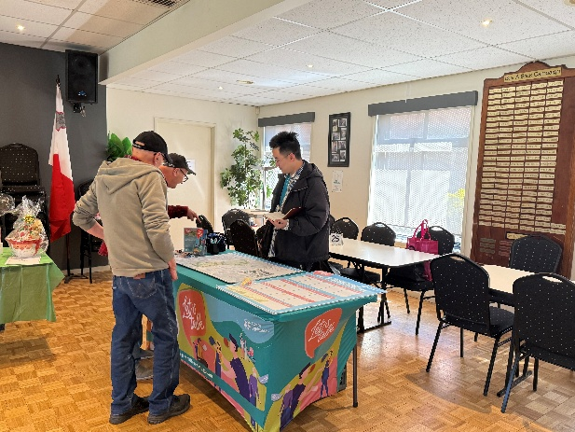
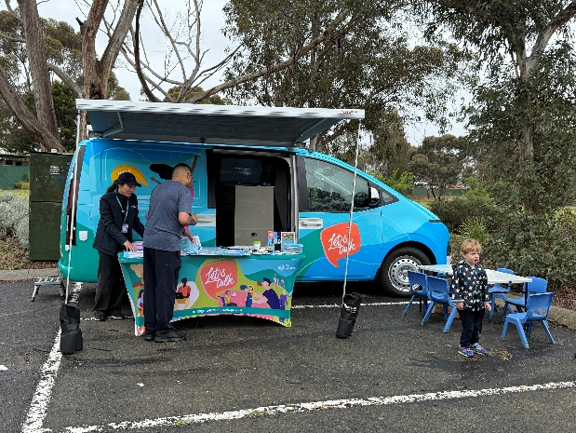

Above: Images of the project team engaging with the community

Project promotion
The opportunity to participate in the community engagement was promoted through a range of channels to have a widespread reach across the target area including:
- A dedicated project page on Council’s digital engagement platform Engage Whittlesea
- Engage Whittlesea campaign to 1,518 registered users who have expressed interest in the topic or location
- Direct email to registered pet owners in Lalor, Epping and Thomastown (approx. 6,000 residents)
- Five A2 signs with QR code to participate in the project at various locations around VR Michael Reserve
- Social media posts on Council’s social media channels
- Direct email sent by key internal staff to their networks.
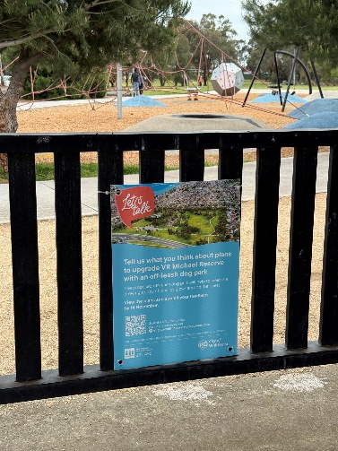
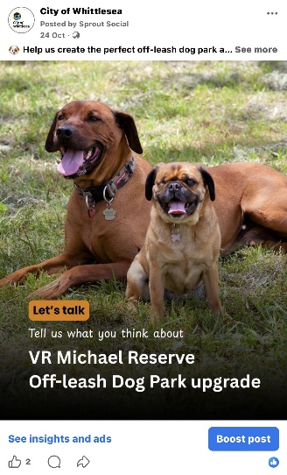
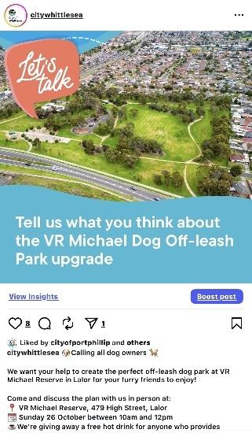

Above L–R: Social media posts promoting the VR Michael Reserve Dog Off-leash Park consultation - two video stories, and two posts were shared over a five-week period, receiving 3,619 views, 20 interactions, and two shares on Facebook, and1,590 views and 20 interactions on Instagram. The third image is an example of signage displayed at VR Michael Reserve.

Participation
A total of 101 community contributions were received as part of the VR Michael Reserve Dog off-leash park project community engagement. Below is a snapshot of the demographics of participants in the engagement.

Snapshot of community participation
 | 
29 people participated in-person across the  two pop-up events and informal information session held across the municipality. | 72 people contributed online via the Engage Whittlesea platform from 415 views and 352 visits to the page.

Snapshot of participant demographics
Gender Identity | Age | Suburb
 | 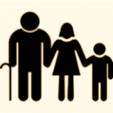 | 
66% Female, 28% Male, and 5% preferred not to say. | All age brackets participated with the most represented being 35-44 years (23%), 45-54 years (21%), and 55-64 years and 65-74 years (18% each). | Highest participation came from the targeted suburbs of Lalor (50%), Epping (28%) and Thomastown (14%).

LGBTIQA+ Community | First Nations Community | Multicultural Community | Community members living with or caring for someone with a disability
 |  |  | 
23% of participants identified as members of the LGBTIQA+ community. | 6% of participants identified as being an Aboriginal or Torres Strait Islander person. | 17% of participants spoke English as a second language. | 40% of participants identified as living with a disability or an unpaid carer of an older person or someone living with a disability.

What we heard
Community members were shown the concept plan and asked to rate their level of support on a scale from “I like it a lot” to “I don’t like it at all.” They were also invited to select their top three preferred features. Feedback was collected through both the Engage Whittlesea online platform and two community pop-up sessions held at Whittlesea Public Gardens dog park (the closest existing dog park to the site) and one at VR Michael Reserve, along with an informal information session with the Lalor United Bocce Club.
The following section summarises what we heard from the community across all engagement activities. Additional comments provided through surveys and in-person discussions have been themed, with selected quotes included to highlight common views and experiences.

 | What do you think of the proposed concept plan for this off-leash dog park at VR Michael Reserve, Lalor?  Feedback on the draft dog park concept plan was strongly positive across both online and in-person engagement. Most participants said they “like it a lot” or “like it” (ranging from 60% online to 58% in person), with only a small proportion feeling neutral and very few expressing non-support. Overall, the results show strong community support for the proposed dog park concept, with majority of participants responding favourably.
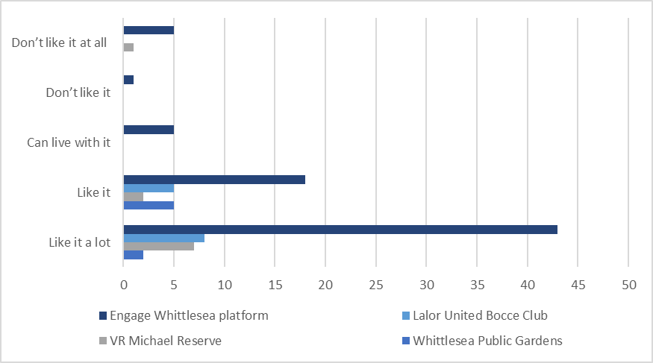

 | What are your top three features in the concept plan?  Across both online and in-person engagement, participants prioritised a safe and well-equipped dog park. Secure fencing and entrances were consistently rated as top priorities, alongside shade/shelter, bins, drinking water and seating. In-person feedback placed slightly higher emphasis on lighting, while online participants prioritised fencing. Features such as trees, garden beds and landscaping were less frequently selected but still valued. Overall, the feedback reflects a strong preference for a safe, shaded and practical dog park.  “Most important thing to me is that there are double gates, and they have secure locks. When you go to a fairly new park and the locks are broken or damaged, it’s really disappointing. Also, with that park being on the corner of a very busy intersection, its crucial dogs can’t get out and people open/close the gates properly.”  "This is an excellent plan, and I know the dog park will be put to good use. I live in Lalor very close to the park and many of my neighbours and I have dogs. I would like to reiterate that having a table in the park is very important and would be better in place of the garden beds or outer seats if adding tables are not within the budget."  "Lighting on back path needs better visibility - very dangerous for seniors."  “Ensure fencing gaps are not too big so dogs don’t escape.”  “Fence height needs to be high enough that dogs can’t jump out.”

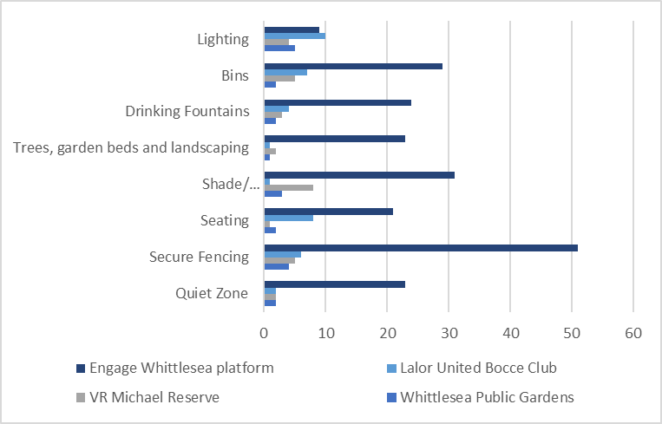
How could the proposal be improved?
Feedback on the dog park concept plan was constructive and wide-ranging, with comments focusing largely on safety, shade and comfort, surface materials, park layout, and general amenity.
Safety, fencing and access
Many participants emphasised the importance of secure fencing, self-closing gates, and clear separation of dog types (e.g., small/shy vs large/active dogs). Several referenced issues at existing parks. Some would like the “quiet zone” more clearly defined, with many interpreting it as an area for small or shy dogs.

“There must be exit doors with an easy-closing mechanism like Mill Park…Thomastown doors are often left open.”

“Smaller or even shy dogs can be intimidated by bigger dogs, by having them separated it will hopefully avoid this.”

 | Shade, trees and comfort  A strong theme was the need for more shade, whether from mature trees or built shelters. Many raised concerns about heat, comfort, and usability in summer. Seating, tables in sheltered areas, and accessible layouts were also important to users.  “Please put very tall trees - good for shading.”  “It would be great if the trees could be established ones so that shade is provided from the very beginning.”
 | Ground surface and materials  Concerns about gravel hurting dogs’ paws appeared frequently. Many preferred grass, softer surfacing, or more sustainable alternatives. Some also suggested minimising concrete to reduce heat.  “The off-lead park at Barry Rd tore up my dog’s paws…we need a grass area large enough to throw a ball.”  “I would reduce the amount of gravel and use something more paw-friendly.”  “Is concrete really the best option? It’s not great for dogs, especially in heat.”
 | Amenities including water taps, bins and signage  Practical amenities were a consistent focus:  - additional drinking fountains spread across the park  - more dog waste bins, with some noting current bins are too far from gates, leading to littering  - clear signage around on-leash requirements in surrounding areas to prevent conflict on shared paths.  “I think it’s important to encourage people to clean up after their dogs - maybe by adding more signage and dog waste bins.”  "Ensure clear signage re use of the space (cleaning up, dog behaviour etc.)"
 | Park layout, size and activities  Some residents questioned whether the planned area was large enough for dogs that like to run or whether garden beds may reduce usable space.  “My dog loves to run…the plan adds trees and garden beds that won’t leave enough room for full-speed play.”  “Possibly having some dog obstacle/agility equipment would be great.”  “Have an area for big dogs and an area for small dogs as well. Separated but close together like the park at Edwards Lake in Reservoir.”
Do you have any further feedback on the VR Michael Reserve off-leash dog park?
Feedback on the VR Michael Reserve dog park concept plan was generally supportive, with most participants welcoming a fenced, dedicated off-leash space. Comments focused on responsible dog ownership, safety, accessibility, shade and comfort and park maintenance.
 | Responsible dog ownership and cleanliness  A strong theme was the need for clear rules and better management to ensure the park remains clean and safe. Several participants expressed concern about dog owners not picking up waste or supervising their pets properly.  “Please install LARGE signs reminding owners they are responsible and must actively monitor their dogs.”  “Rubbish bins are essential, so lazy dog owners have no excuse.”  “Supply pooper scoopers at dog parks to encourage clean up.”
Safety, fencing and gate reliability
Participants emphasised the importance of secure, double-gated entry systems, robust locks, and fencing that prevents dogs from escaping, particularly given the park’s proximity to busy roads. Some also supported the concept of separate areas but noted that the “quiet zone” must be clearly fenced to function effectively.

“Most important thing to me is that there are double gates… it’s crucial dogs can’t get out.”

“Make sure the gates cope with ground movement – many parks end up with gates that don’t close properly.”

 | Shade, seating and comfort  Consistent feedback highlighted the need for adequate shade, shelter facing the right direction, and comfortable, functional seating. Many noted that both dogs and owners need relief from heat, and that park usability depends on comfortable places to rest.  “Ensure shade/shelter takes advantage of shade in hot weather.”  “Please ensure there are enough benches instead of tree logs.”
 | Accessibility and DDA considerations  Some participants raised concerns about access to and through the reserve, including the lack of sealed paths and safe pedestrian crossings. Improving active transport access (e.g., safer crossings on High Street) was also mentioned as a way to reduce reliance on cars.  “Make it simple and DDA capable.”  “There is currently no sealed path from Bellarine Dr… important for mobility devices.”
 | General Park maintenance  Regular maintenance, particularly mowing and cleaning, was raised as essential for safety and enjoyment.  “Will the park be maintained consistently? The grass gets so long it’s hard to find a ball.”  “There is a lot of broken glass around the entrances - this needs addressing.”  “Bins are helpful and maybe a dog poo bag dispenser attendees can add rolls too would be good.”
 | Lighting, paths, and general safety  - Participants liked the new path connections, noting they improve safety.  - Lighting along the back path requires upgrading to improve visibility, especially for seniors.  - Large trees near the rear car park need trimming as they may pose a safety risk.  - Public toilets need upgrade, especially lighting to feel safer.  “Existing paths at rear of Bocce club are dark and slippery.”  “Love that there are paths connecting all areas - much safer!”
 | Parking and accessibility  - Strong concern about limited parking, with the area already shared by the playground and Bocce Club.  - Requests for additional disability parking due to high use by seniors – this was a very strong sentiment from the Lalor United Bocce Club.  “Need more disability parking as many seniors use the space.”
 | Concerns and differing views  A small number of participants expressed concerns about:  - potential barking noise near homes  - safety in off-leash areas due to dog behaviour  - broader Council spending or priorities (e.g., fence repairs, high-density development)  - personal discomfort with dog parks generally.  These comments highlight the importance of sensitive implementation and ongoing communication, ensuring the park meets local expectations and minimises impacts.  “My concern is that it might be a bit noisy due to excessive barking for the houses on Columbia Road that are next to the park.”  “Yes, when will the council start paying for boundary fence repair!!”

Next Steps
Thank you again to everyone who contributed to this community engagement by sharing comments, feedback and participating in activities.
The feedback captured will inform any changes or adjustment to the VR Michael Reserve Dog off-leash concept plan. We encourage you to follow engage.whittlesea.vic.gov.au/vrm-dolp to keep up to date on the progress of this project.
Community feedback captured may also support the development of other key Council plans, strategies and projects, contributing to the vision of making Whittlesea A Place for All.

