Fortress Park landscape Improvement plan
Engagement Summary
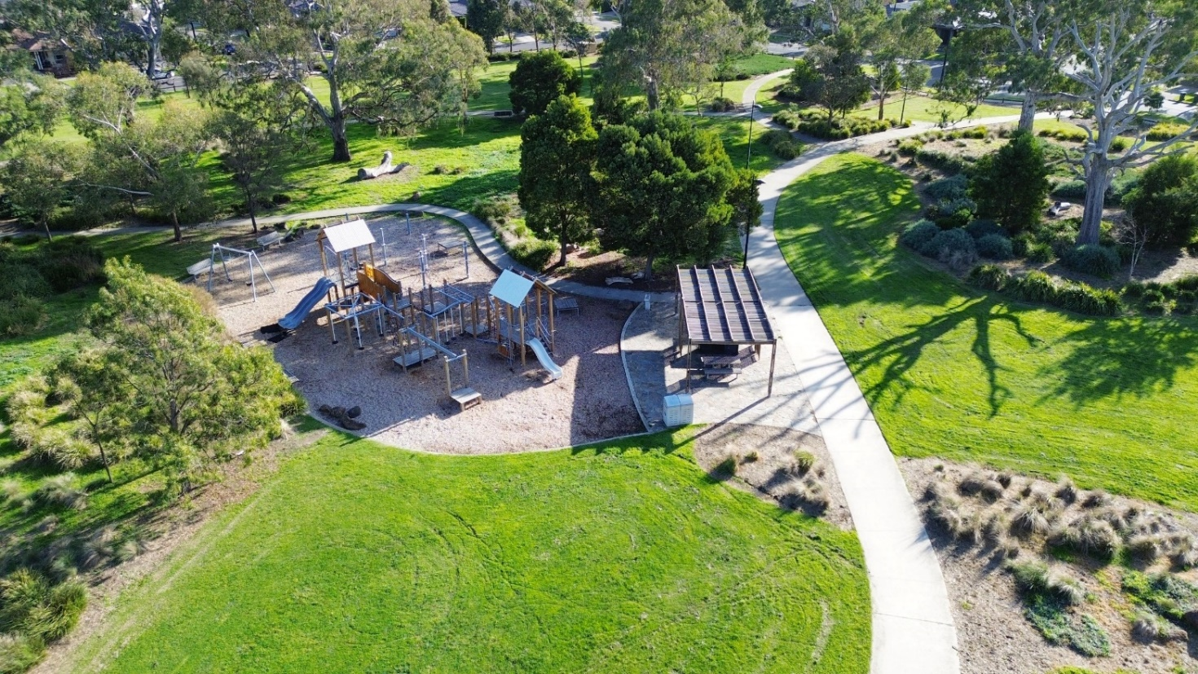
August 2024

Introduction
The City of Whittlesea is developing a draft improvement plan for Fortress Park, one of Council’s open spaces in Doreen, an established area of the municipality. The reserve has an area of approximately four hectares with an open grassed area, play space, picnic area, half basketball court, exercise station and walking tracks.
We are developing a Landscape Improvement Plan that aims to:
- Improve Park Facilities such as the play space, picnic area, fitness station and walking tracks to ensure the safety and accessibility of all users, including children, the elderly, and people with disabilities.
- Enhance the character of the park to create a visually appealing environment for residents and visitors.
- Creating opportunities to connect such as walking paths and leisure areas to promote healthy lifestyle and community interaction.
- Enhancement of Play Experience by Improving the quality and variety of play experiences offered at the park by introducing new and innovative play equipment, features, and layouts.

Feedback from the community and stakeholders will inform the Fortress Park Landscape Improvement Plan.

How we engaged you
We consulted with our community to inform the development of the Fortress Park Landscape Improvement Plan to understand how community feel about the park, what they value and ideas to improve the area. This report summarises the community engagement undertaken for developing a Landscape Improvement Plan.
Community consultation– Wednesday 26 June to Wednesday 24 July 2024
The Fortress Park Landscape Improvement plan consultation was open for community comment from Wednesday 26 June to Wednesday 24 July 2024.
The purpose of this engagement was to assist Council to identify key issues, challenges and opportunities of the site and discover the key ideas for improvement.
Community feedback was sought online through Council’s Engage Whittlesea platform and through direct conversations and activities at two community-based pop-ups.
The Engage Whittlesea platform utilises an accessibility add-on ensuring that it is as accessible as possible for all users. The platform also has an in-built translation tool to mitigate any language barriers to participation, allowing the page to be translated into the top ten languages spoken within the municipality.
Residents within 400m of the park, received a letter to update them on project status and invited them to share their feedback through the project Engage Whittlesea page or at one of the community-based pop-ups.

Engage page
On the project’s Engage page, community were invited to participate in two engagement activities. The first asked them to drop a pin on a map of the park and share any issues and what facilities, play experiences and recreation opportunities they would like to see at the park. The second activity was a survey to determine the current use of the park, how community travel to the park, any site issues and top priorities for improvement. The survey questions were designed to help Council understand what is most important to the community when creating the draft improvement plan for Fortress Park. See survey questions below:
- How often do you visit Fortress Park?
- What do you use Fortress Park for?
- How do you get to Fortress Park?
- What do you like/value most about the park?
- What are the park’s issues?
- What would make you visit the park more?
- What are your top features you would like to see improved or added to the park?
  - Enhanced play space
  - Nature play area
  - Upgraded public toilet
  - Additional informal sports facilities
  - Additional amenities (e.g., Shelter, seating area, drinking fountain)
  - Passive surveillance
  - Additional lighting
  - More greenery (more trees, plants, shrubs)
  - Signage
  - No improvements necessary
  - Other
- Are there any special events or programs that you would like to see offered at Fortress Park?
- How would you rate the park overall? (Very good to very poor)
- Do you have any further comments about the future of Fortress Park?

Community-based pop-ups
The project team co-facilitated two community-based pop-ups in Doreen. The in-person consultation allowed deeper discussion with project team members with an opportunity to add additional suggestions.
Activities presented at the community- based pop-up mirrored the online engagement activities, where community had a choice to participate in the dot board activity or fill out a survey.

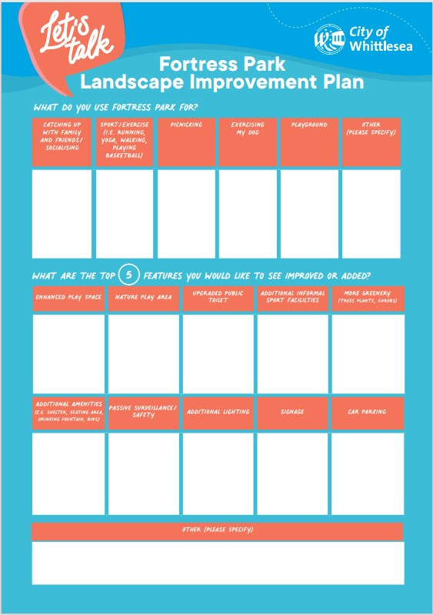

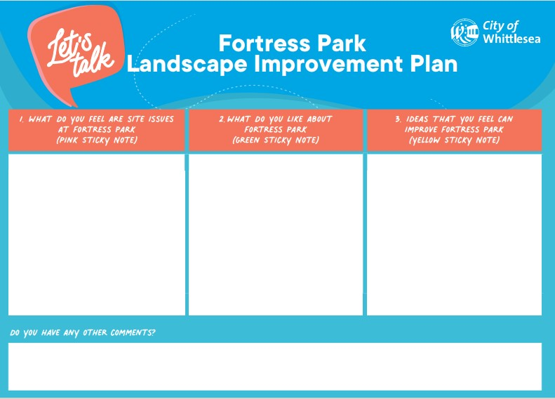

Above: Dot boards used at Community based pop-up for Fortress Park

The community-based pop-ups were held on the following dates in the following locations:
Date | Location
Wednesday 3 July, 10.30am -12.30pm | Fortress Park, Doreen
Friday 19 July, 2.30pm -4.30pm | Mernda Town Centre, Mernda
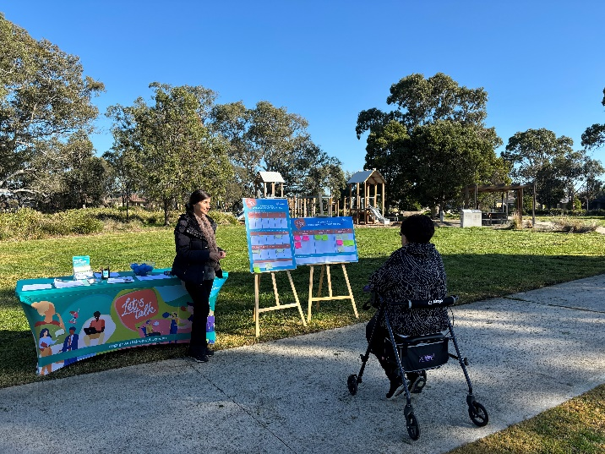
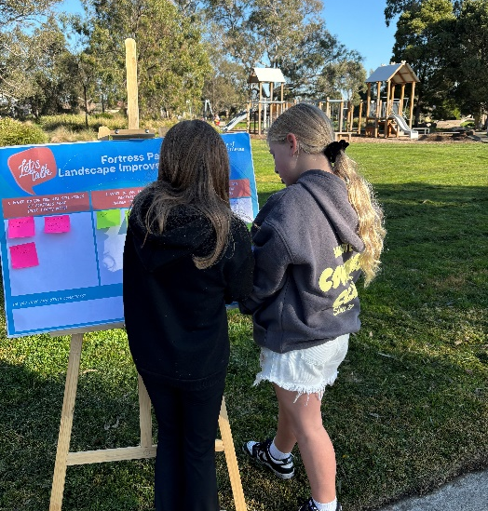

Above: Fortress Park pop-up at Fortress Park in Doreen on Wednesday 3 July

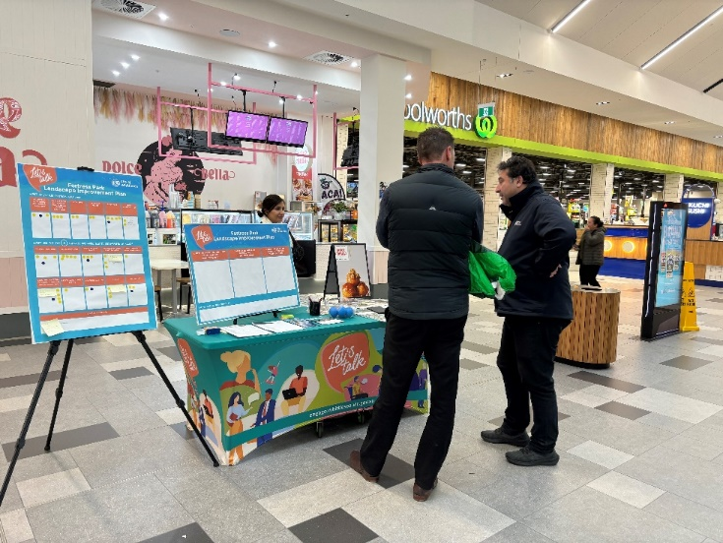
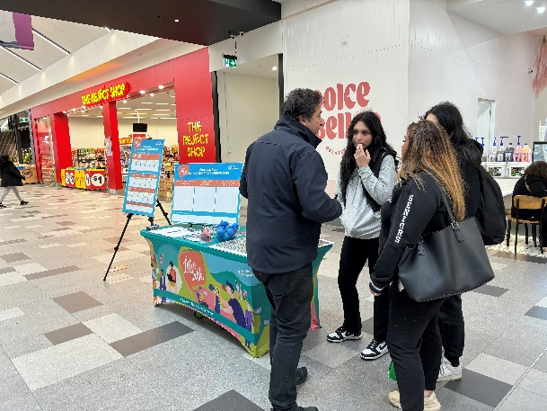
Above: Fortress Park pop-up at Mernda Town Centre on Friday 19 July

Project promotion
The opportunity to participate in the community engagement was promoted through a range of channels to have a widespread reach across the municipality including:
- Council’s digital engagement platform Engage Whittlesea
- Social media – we shared two posts across Council’s social media channels (Facebook, and Instagram)
- Doreen Area Newsletter
- Letterbox drop to residents within 400m of the park
- Large corflute signage installed at the main entry point to the park and at the entrance of Mernda Community Centre
- Flyers and posters displayed at Council facilities and libraries.

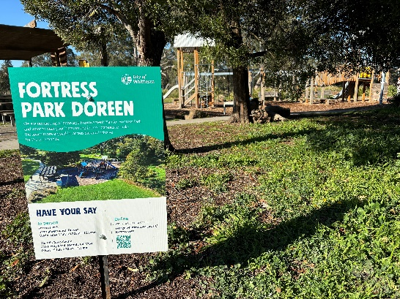
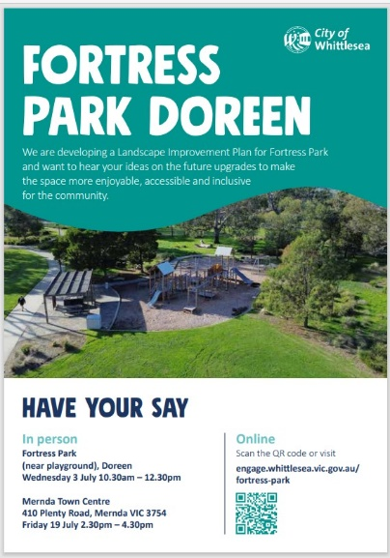
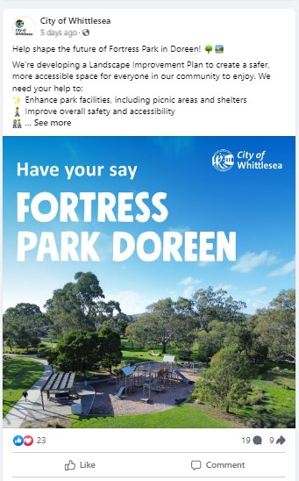

Above: Facebook Fortress Park social post, Flyer, and corflute signage at the park

- Media Release
- Help Shape Future Of Fortress Park | The National Tribune
- Help shape the future of Fortress Park | City of Whittlesea
- Council wants community input | Northern (starweekly.com.au).

Participation
A total of 152 community members contributed to the consultation. Participants were given the opportunity to contribute in two ways; in person and online via the Engage Whittlesea. 44 community members attended in person at scheduled pop-up locations and 108 community members contributed online via the Engage Whittlesea platform, which included a social pinpoint map activity and an online survey. The survey was designed to find out the current use and issues of Fortress Park and community’s top priorities for improvement.
Community participation
 | 67% female, 30% male and 3% preferred not to say.
 | Almost half of participants were aged between 36 and 55 years of age.  - Under 18 years of age – 14%  - 18 -35 years of age 22%  - 36-55 years of age – 48%  - Over 56 years of age – 16%
 | A total of 85% of participants reside in Doreen with 11% living in Mernda. Other participants were from Eden Park, Epping, Humevale, and Thomastown.
 | Five organic posts across Facebook, LinkedIn and Instagram reached 22,829 people and were engaged with 1940 times, generating 38% of traffic to the online Engage page. The Engage campaign received 693 direct views from our community.
 | We hosted two community-based pop-ups in Doreen with 44 people sharing their feedback through surveys, dot boards and conversations with Council staff.  - 29 completed a dot board activity  - 26 completed a survey  - 45 additional comments shared on how we can improve Fortress Park
 | The Engage Whittlesea page was viewed 673 times during the consultation period, with 78 people participating in the online survey and 30 participants sharing their feedback via the social map activity. A further 12 people opted to follow the page to receive project updates.

What we heard
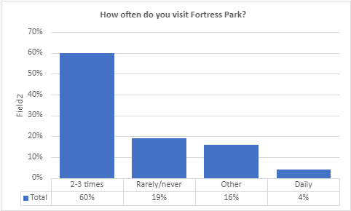
Survey results
Of the 104 who completed the survey, 88% of indicated that they have visited Fortress Park before and 64% said they visit the park daily or 2-3 times a week. Active transport is important to nearby residents of Fortress Park, with 87% going to the park on foot and 11% ride a scooter, bike, or skateboard to the park. A total of 35% of visitors drive to the park reflecting in the comments from community that carparking is needed in the area. See charts below for full breakdown of figures.
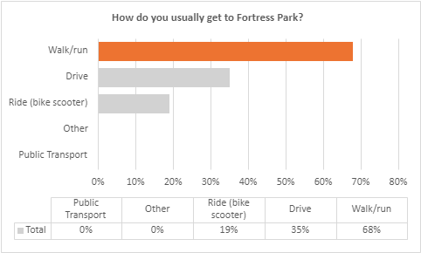
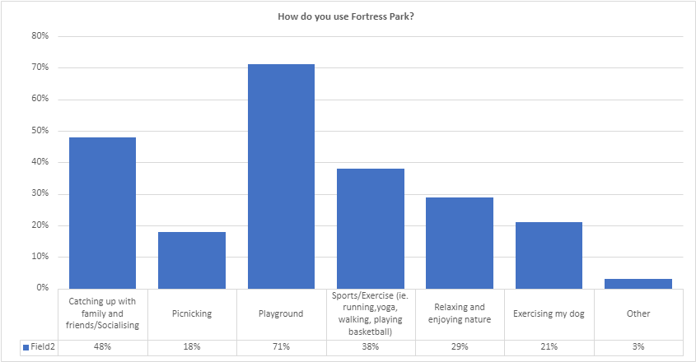
When we asked the community how they use Fortress Park, 71% enjoy taking their children/grandchildren to the playground, while 48% catch up with friends and friends at the park and 38% like to walk/run around the park, play basketball or other ball sports in the green open space area at the park.
Above: Breakdown of how community use Fortress Park
When asked what they like or most value about the park, green open space and an environment that encourages nature play was the common theme amongst contributors. A park that caters for children of different ages was also valued as was the locality of the park for nearby residents.

“The openness around it enabling kids to explore nature without being too close to the road and that it’s various age inclusive with the playground and sporting areas”
“The park area is very large so has a lot of potential for further improvements. The nature play aspects are fantastic and are always one of the things the kids play, playing on the fallen logs, making little cubbies under trees”
“My girls love the bushes and trees in the area. We love playing in and around them”
See below for more positive sentiments from the community about Fortress Park.
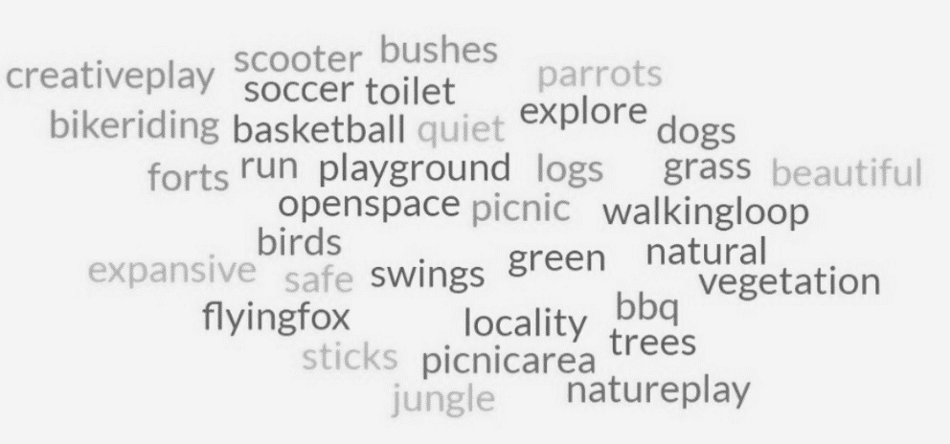
Above: positives sentiments for Fortress Park
The regular users of Fortress Park shared their feedback via the survey and in-person conversations with Council Staff on issues that they feel need to be addressed at the park and what would make them visit the park more. A common issue felt by many regular users is the lack of cover on the existing shelter to provide protection on hot and rainy days, and irregular maintenance of the park grounds.
With the increasing popularity of basketball, participants have expressed the need for an update to the current court and an additional court to meet demand. Vandalism of the toilet block was also a common issue, with community seeking a solution to deter vandals.
The main issues identified by the community are listed below.
- Lack of Shelter and gathering facilities
“Need more shelter/canopies so the park can be also utilised more for kids parties”
“No proper cover if there is extreme weather”
“More picnic tables scattered in far corners and may be another under cover area for the basketball side of the park with BBQ and picnic table”
“The BBQ area is small, and the slatted roof provides poor cover in wet weather”
- Irregular Maintenance
“Sometimes the grass is not mowed frequently enough and then because of the length of the grass when it's mown, there's too much loose grass after its tended”
“Park grass has not been cut on a timely manner, so it becomes unsafe with tall grass for children / snakes during summer months”
“The gardens under the trees. We used to use these as nature play areas with our kids, but they are now so overgrown and unkept that this is no longer possible”

- Deteriorating Playground and Inadequate Play Equipment for All Age Groups
“Damaged and over used equipment”
“Lacks play equipment for 8-13yrs age group like a tall climbing ladder/ slide or a more challenging type of play equipment designed for older children”
“Not enough activities for older children”

“Not enough play spaces especially for the younger kids”

“The soccer goals are damaged and not easily used, including some of the equipment in the actual playground”

“The playground needs upgrading/more equipment, for such a large area there could definitely be more equipment”

“Often parts of the playground have been broken. The two play spaces are too far apart sometimes making supervision difficult”

- Single Basketball court

“Needs another basketball court. My girls love basketball but never get an opportunity to utilise the court”

“Only 1 basketball ring and it’s always busy”

- Lack of parking
“Close parking facilities major issue”

“Not having accessible parking now”

“No car parking area close to park equipment. Parking area for small disability bus/van”

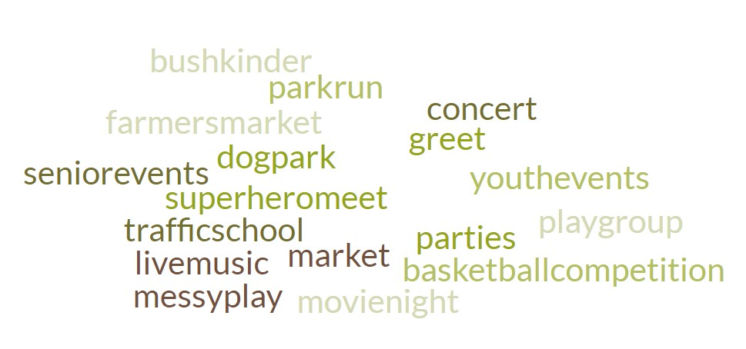
When asked if there are any programs that community would like to see offered at the park, youth focused events, a basketball/netball related event, a farmers’ market, park run, a movie in the park and pop-up playgroup were suggested by community to increase connections in the area and provide opportunities for our youth to gather in a safe environment. See below for more suggested programs and events that the community would like to see at the park.

Participants were asked to rate Fortress Park, indicating if they think the current state of the park, and facilities are very good, good, ok, poor, or very poor. A total of 62% of contributors shared that they feel the area in its current state is in a very good or good condition, 35% feel the park is ok and 4% that the area is very poor/poor and in need of an upgrade.
  62% |   35% |   4%
Very good/good | Ok | Very poor/poor

When asked to choose their top five features they would like to see improved or added to the park, participants told us:
- Enhanced play space (59%)
- Additional Amenities (e.g., Shelter, seating area, drinking fountain, bins) (58%)
- Nature play area (53%)
- Upgrade public toilet (48%)
- Additional informal sports facilities (38%)

Below is a breakdown of priorities for improvement at Fortress Park below:
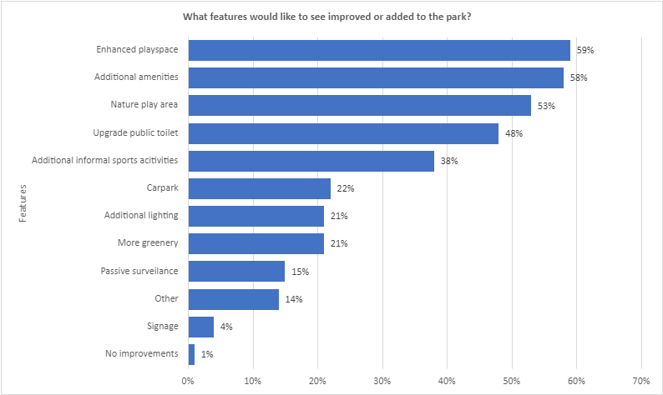

Social Pinpoint results
Thirty community members contributed to the online social map activity (pictured below), by adding a marker to the map to comment on things that they like about the site, any issues, and any ideas for improvement.
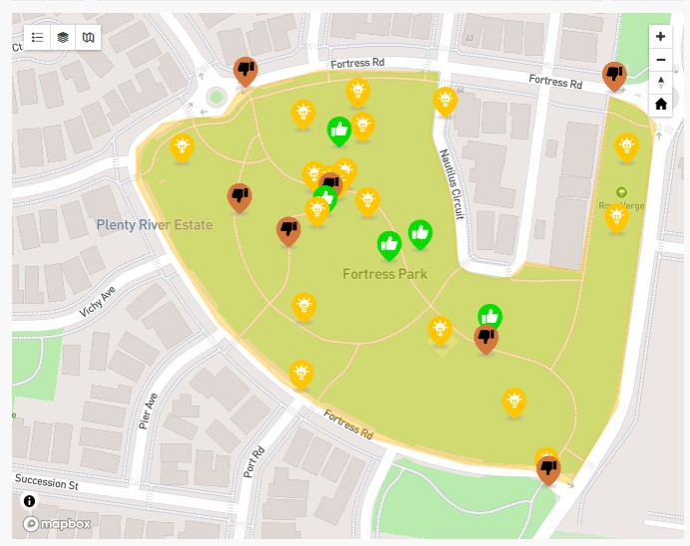
A total of 23% of participants indicated that they like Fortress Park.
“Flying fox is loved by all, please do a longer one with the upgrade”
“Keep this grassy area as is - it's great for play & picnic”
“The loop track is almost exactly 400m which is great for a quick run”

A total of 87% of the social map participants feel that the park needs improving and shared the issues they feel need addressing at the park:
- Broken and outdated play equipment
- Safety concerns with lack of lighting and pedestrian
- Needs regular grounds maintenance
- Currently no protection from extreme weather conditions
- Need for more all-abilities sports and exercise equipment such as soccer goal posts and exercise equipment.
Key messages from community feedback
Participants were invited to share what they like, any issues and any potential future opportunities for Fortress Park, some of which may be out of scope of this project. Below are the themed comments received through both online and in-person engagement activities.
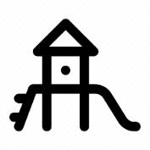 | Playground & Nature-play area–upgrading the existing playground with a play space for all ages and abilities was a priority for respondents.  “Add an adventure playground area. It could have a log that kids run on top of with rails to hold onto, in this area. A maze. Logs to jump over and run-on top of. Trees along the back to block the view from the street”  “More stuff for the kids to explore. Like the playground in mill park near the pool”  “Multiple swings. I have a toddler and baby who argue over the belted seat. We often walk to the park near Orchard Road because there are 4 swings side by side.  “Small town with roads for me to play with my toy cars”  “A dedicated toddler playground. What's there now is great for big kids, but what about some equipment/ area for 1 - 3-year-olds too. There are so many young families who could use this”  “Enhanced play space! Utilising nature and risky play elements”  “More of a play space for children of all ages and abilities. More of an inviting play space for everyone. Park equipment for children and adults to enjoy together”  “Broader range of play space and equipment for grandkids”  “Skate Park”  “Sandpit”  “Water sanctuary or water play area”  “Natural play area with water play like Diamond Creek Play space. Trampolines built into the ground.  “Bush/nature playground”  “It is currently good to take my kid to learn to ride his bike there however a little traffic school there would be amazing.  “It's pretty great the way it is. I'd rather you didn't remove the playground as it is working great as it is, and there's a chance a new one might work less well.  Please protect the trees, they are an important part of making the park enjoyable due to the birds they house”  “If the seesaw was returned. Maybe even a sand pit or music toys”  “Paths for bikes and scooters”  “Maybe just a little preschool area”  “A netball ring”  “Large covers or sail shades over the playgrounds to protect from sun and rain”  “Rope ladder is difficult for younger children to use. Use a small wood ladder instead”
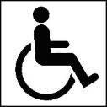 | Inclusive Recreation Facilities– upgrading paths and adding all ability car parks and equipment to make the playground and other park facilities accessible to all. Currently there are no Disability Discrimination Act (DDA) compliant car park bays.  “Lack of accessible parking”  “Lack of accessible equipment for people with disability”
 | Sport/Exercise - residents would like more opportunities to play sport and exercise in Fortress Park.  “Pickle Ball”  “Open/flexible areas where little kids can kick football. And exercise area with fixed equipment would be fantastic”  “Build some all-abilities sports facilities. They could be informal but multi-functional. Basketball, badminton, table tennis, running track and more”.  “There are no badminton courts anywhere in Doreen or Mernda. it will be good to have a court enabled in this area.  We can have some proper workout setup with some body weight exercise options”  “We would love to see a small bike/scooter riding section for younger children. (Like the traffic schools etc, pretend big roads). We'd also love the soccer goals to return”  “More facilities for older children like soccer nets”  “If it had exercise equipment for seniors”  “A proper running track which has lights - think like mini-Tan”  “More equipment”  “Vibrant colours”  “Utilise this space for soccer/football/cricket adding goal posts one way, soccer goals the other and possibly even a cricket pitch in the middle. This would allow older children to play sport while toddlers/less sporty children can play in the playground in group situations such as a park party”  “It will be good to have a proper footpath or a jogging path around the park. Given the area it will be good to utilise the park area to build circuit jogging track”  “The play area needs a roundabout for little kids and the teenage area a big roundabout, bars to hang on to do pull ups and swings for the teenagers. A mini work out area with permanent work out things”
 | Park Maintenance & Landscape Enhancement – community would like to see the existing grassed area regularly maintained.  “Watering system for the plants to establish themselves”  “Highlight the natural features especially the trees - incorporate first nation perspectives”  “Unkept so space cannot often be used”  “Upkeep and maintenance of the area”  “Litter”  “The grass gets quite long, and I always worry about snakes being around (quite a few get spotted in the area).  “Very overgrown and outdated”  “Ensure regular mowing and maintenance of grass and bushland areas so the area is kept snake safe for kids and adults when playing”  “More flowering natives to give the area more colour”  ” The scrubby garden so close to the play area is a haven for snakes”  “I've only been a few times but like most parks in Doreen, they are just slapped together and forgotten about. You go to surrounding areas, Kinglake, Eltham etc and the parks are nicely looked after, and they have modern exciting things for kids to play on and do. Their Gardner's and lawn mowing teams take pride in their work, they are inviting and make families want to spend more time there to picnic etc.  Ours are always overgrown - Bushes, long grass, run down. It's so disappointing”
   | Facilities – participants highlighted the need for additional shade, seating areas and drinking fountains to encourage family and friend gatherings at the park.  “More BBQ facilities also to celebrate birthday parties particularly in an area where some homes, such as mine, don’t have yards and are high density”  “A fire pit area to gather with friends and family”  “No proper shade covering over the BBQ area”  “More areas for families to sit”  “No proper cover if there is extreme weather”  “Not enough tables”  “Not enough seating and shade structures”  “More amenities and activities for the whole family”  “More shelters, picnic benches where parents can socialise”  “Needs more fully undercover areas for inclement weather”  Safety – particpoants took the opportunity to highlight safety concerns and offer suggested improvements to safety.
“Softfall mulch is never at an adequate height, therefor concrete is always exposed making it extremely dangerous for children”

“The basketball court & the BBQ area need night lighting. often the only time I can make it to the basketball court with my children is at night. the pathway lights are not fixed when they break. there is no lighting on the south side pathway.

“It's very dark of an evening and attracts a lot of unsavoury behaviour at night, especially since the public toilet was installed”

“No security cameras”

“Near road”

“The park as many people speed along Independence Blvd. Would be great to have pedestrian crossings put in place, especially on Independence Blvd or other surrounding roads. Can also be a lot of youth causing trouble near the toilet block at night”

“The spinning equipment at the back of the park near the basketball court and flying fox needs to be removed immediately. It is such a safety hazard and resulted in a child receiving a head injury a couple of weeks ago. Had the child been smaller and younger in age it would have likely to have been fatal. I don’t know how this apparatus has passed any safety inspection”

“One piece of equipment closest to the basketball court, which requires a person to sit on the large arm and be pushed then let go. Would love to see removed as have witness two teens on separate occasions be concussed by being hit by it and required visits to the hospital and have also witnessed an adult being hit in the head, would like to see either a safer alternative or gates around it does that children don’t run through it”

“The large swinging apparatus is dangerous”

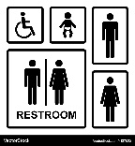 | Public Toilet – participants shared their concerns with anti-social activity surrounding the public toilet as well as the locality of the toilet block.  “Need toilets near main playground (fortress park not south end)”  “More toilets”  “Having better toilets closer to the playground”  “Toilets are dirty”  “No bins in the toilet”  “Toilet needs fixing”  “Toilets opposite end of park to BBQs”  “The toilets could be better, but the airiness of them means they don't smell. Please don't put in enclosed toilets that look modern but smell bad because they don't get enough air. The toilets that are there are nicer to use, but just need some work on the doors and external”  “Hand soap in bathroom”  “The biggest issue is where council placed the toilet, it encourages illegal and dangerous parking. Trades trucks and members of the public including council staff all park in Nautilus circuit to use the toilet, they were built without any thought or consultation”  “Signage near the toilet block informing community of opening hours”
 | Parking – some participants highlighted the need for additional off-street parking at Fortress Park.  “Accessible parking to ratepayers”  “A carpark”  “Closing parking facilities major issue”  “Not having accessible parking now”  “No car parking area close to park equipment. Parking area for small disability bus/van close to toilets and seating area is needed”  “We need this park to be accessible to be used in the manner a park should be we need parking”  “Council cannot remove the car park and then make it inaccessible to ratepayers it’s a joke”  “Add a parking area if there isn't already one to reduce parking stress on the local streets”
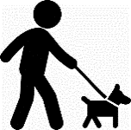 | Dog Walking – residents shared that they often walk their dogs around Fortress Park. For safety concerns, others suggested introducing an off lead dog park for dog owners who currently let their dogs off lead in the open grassed area of the park.  “The fact it is a dog on leash area is great! so much better and safe for children and protects us from dog owners with not well-trained dogs that create incidents with other dogs and children”  “Big and small dog off leash areas”  “People unleash their dogs in this park. If this can be strictly restricted, that will give peace of mind to people to take a walk without the fear of some dog jump at us out of nowhere”

Other comments and suggestions from Community
Further suggestions received from community were:
- Paths from surrounding streets to the park
- Traffic school with traffic symbols
- Seating not too low for seniors
- Community Farmer’s Market
- Dog bins and bags
- Community garden on the east side of the park which is underutilised currently
- Additional play equipment including see saw, Merry-go-round, trampoline, swings and monkey bars.

Next steps
The feedback captured through consultation will inform the development of the Fortress Park Landscape Improvement Plan which is expected to be considered by Council in February 2025. The insights captured will also be used to inform the development of other key plans and strategies Council are working on to make Whittlesea A Place for All.
Thank you again to everyone who participated in the community engagement by sharing comments, feedback and participating in activities and focus groups. The community will be updated on further developments via the Fortress Park Engage Page.

