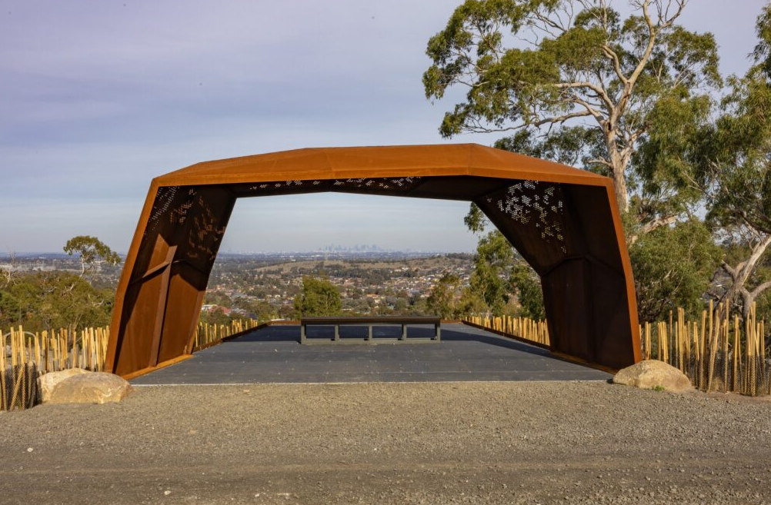

1 September – 5 October 2025
community priorities 2026
phase 1
Engagement Summary

Introduction
Each year Council releases an annual Budget for the investment and delivery of critical services and essential infrastructure to support our rapidly growing community. We need to balance the delivery of ongoing services and programs while also building infrastructure and facilities to cater to our growing population.

The budget is developed to align to our long-term financial plan which balances our current spending on projects and services for the community and strengthens our long-term financial sustainability.
We need to know what services and assets our community value most now and for the future to help us shape key documents that will guide Council’s activities over the next 5-10 years.

Council undertook community consultation with people who live, work, study or visit the City of Whittlesea to understand community issues and needs across the municipality. As the municipality has diverse residents and needs, the consultation was designed to understand what is most important to the community and areas that they felt budget funding would be best allocated.

The feedback received will inform the 2026-27 Budget, Community Action Plan 2026-27, Economic Growth Strategy 2026-36 and other important plans for our community.

This first phase of consultation included online digital engagement via the Engage Whittlesea platform and 26 in-person engagement activities across the municipality. The opportunity to participate was promoted using traditional and digital communications channels and via direct correspondence to targeted stakeholders.

Phase one saw a total of 1,052 participants from a diverse cross-section of our community contribute 1,075 comments. They told us that their top five priorities for our community are:

- Roads, public transport and footpaths
    - Local road maintenance and renewal was identified as the most important service
- Community safety
    - Lighting of public spaces was identified as the most important service
- Ageing well services
    - Positive ageing programs were identified as the most important service, closely followed by home support services and social connection programs
- Community facilities
    - Libraries and sporting facilities were the highest priority service areas with community activity centres and aquatic facilities following
- Community wellbeing
    - Mental health and social connection- access to supports and programs designed to strengthen social connection was identified as the most important service area.

Project promotion
The opportunity to participate in the community engagement was promoted through a variety of channels to ensure widespread reach across the municipality including:
- Council’s digital engagement platform Engage Whittlesea
- Engage Whittlesea campaign to 1,500 platform users
- promotion on screens at Civic Centre, libraries and recreation facilities.
- e-newsletters or personalised email with direct link to the project page sent to an array of stakeholders including:
- 80 registered senior clubs & 485 contacts of registered multicultural groups
- over 3,000 contacts on the Ageing Well database
- over 70 registered sports and aquatic clubs
- Youth Services network
- 200 Library and community hubs regular user group
- 176 subscribers of the Whittlesea Disability Network newsletter
- 3,857 subscribers of Council’s Business e-newsletter
- 1,504 subscribers of Creative Catch Up, the arts and culture newsletter
- 326 subscribers of Council’s Your City of Whittlesea e-newsletter
- Council’s First Peoples network
- In total eight social media posts were published, four on both Facebook and Instagram, as well as a boosted post on each platform. These posts generated a total of 28,615 views and reached 14,955 accounts resulting in 256 interactions and 167 clicks to links provided.

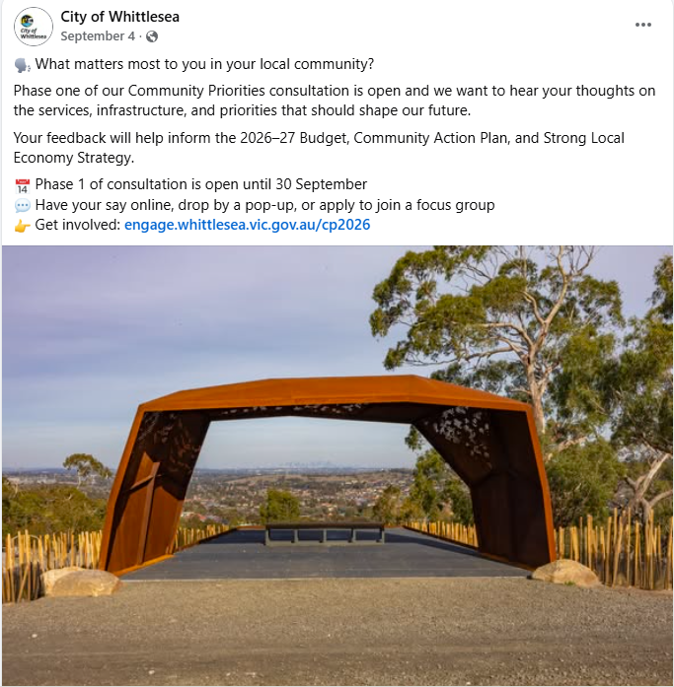
Image 1: Image of Facebook post

How we engaged you
The community engagement to inform these key documents will be delivered in five phases as below:
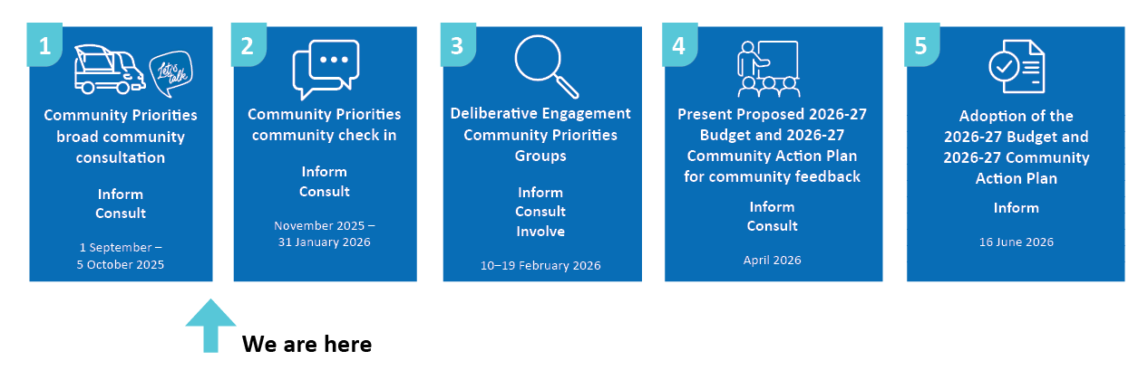
Digital engagement
On the Community Priorities Engage page, participants were invited to share their priorities for the future through a survey and/or submit their interest in being a part of a focus group to be held in early 2026.

The survey offered participants to select up to three areas they felt were most important to them from the possible thirteen and were then asked additional questions based on their selection. The additional questions were designed to delve deeper into the communities’ priorities to understand the specific areas of importance for each of the priority areas they selected. There was free text space provided for participants to add further comment as part of the additional questions.

The Engage Whittlesea platform utilises an accessibility add-on ensuring that it is as accessible as possible for all users. The platform also has an in-built translation tool to mitigate any language barriers to participation, allowing the page to be translated into the top fifteen languages spoken within the municipality.
In-person engagement ​
Council hosted 15 staffed community-based pop-up stalls at targeted high foot traffic locations within the municipality. The in-person consultation activity mirrored the digital engagement online survey activity; with participants offered the chance to select by placing a sticky dot on up to three areas they felt were most important to them from the possible thirteen. Alternatively, participants could choose to complete a short survey activity sheet providing an extra level of feedback through the free text comment box.

Short survey activities were available at an additional 11 locations or events across the municipality. This approach provided the opportunity for community to participate with additional support from place-based staff. This was evident in the increased numbers of respondents from the ageing, multicultural and youth community where this participation option was targeted. The surveys were conducted by positive ageing staff at social support group programs, by community facility operations officers and community development officers who were based at a community facility with visitors and regular user groups of the facilities. Surveys were also completed by community members who attended the Whittlesea Disability Network meeting and Community Grants information sessions.
To inform community and to ​hear from a diverse range of community members Council hosted 26 in-person engagement activities across the municipality as below:
Below are details of the community-based pop-up stalls held:
Date | Time | Where | Address
Thursday 4 September | 10am - 12pm and 1pm-3pm | Pacific Epping, outside Big W | 571-583 High St, Epping
Saturday 6 September | 11am -1pm | Bundoora Square, outside Gotham Doughnuts | 5 Dennison Mall, Bundoora
Monday 8 September | 9.30am -11.30am | Mill Park Library, English conversation session | 394 Plenty Road, Mill Park
Tuesday 9 September | 10am -12pm | Westfield Plenty Valley | 415 McDonalds Road, South Morang
Wednesday 10 September | 11am -1pm | Lalor, outside One Way bakery | 348 Station Street, Lalor
Thursday 11 September | 9.30am -11.30am | Thomastown Recreation and Aquatic Centre | 52 Main St, Thomastown
Friday 12 September | 10am -12pm | Galada Community Centre (Immunisation) | 10A Forum Way, Epping
Saturday 13 September | 11am –1pm | Cedar Street Park | Cedar St, Donnybrook
Tuesday 16 September | 10am –12.30pm | Whittlesea Disability Network Meeting | 25 Ferres Boulevard, South Morang
Wednesday 17 September | 10am -12pm | Mill Park Lakes Promenade | The Promenade, South Morang
Wednesday 17 September | 5pm -7pm | Kirrip Community Activity Centre (Immunisation) | 135 De Rossi Blvd, Wollert
Wednesday 18 September | 10am -12pm | Mernda Town Centre | 180 Riverdale Blvd, Mernda
Friday 19 September | 10am -12pm | Whittlesea Services Hub (street front) | 63 Church St, Whittlesea
Friday 19 September | 2.30pm - 4.30pm | Laurimar shops, outside Woolworths | 95 Hazel Glen Drive, Doreen
Thursday 25 September | 2.30pm - 3.30pm | Meet your neighbour day | Galada Community Centre, 10A Forum Way, Epping
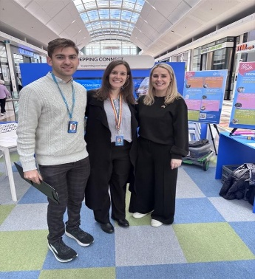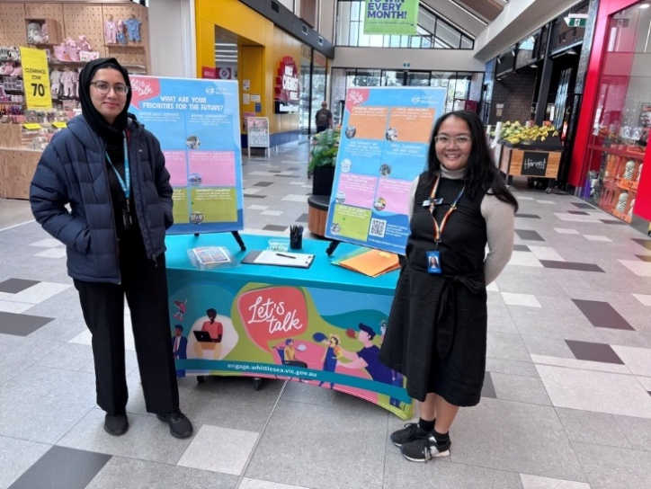
Figure 2: Images of project staff at pop up stalls
Below are details of the 11 short survey activities:
Date | Activity | Address
1-30 September 2025 | Whittlesea Community Activity Centre survey post | 57-61 Laurel St, Whittlesea
1-30 September 2025 | Mernda Village Community Activity Centre survey post | 70 Mernda Village Drive, Mernda
1-30 September 2025 | Galada Community Centre survey post | 10A Forum Way, Epping
1-30 September 2025 | Ageing Well team direct surveys | Municipal Wide
1-30 September 2025 | Economic Development team direct surveys | Municipal Wide
11 September 2025 | Youth Summit | 25 Ferres Boulevard, South Morang
16 September 2025 | Community Grants Information Session | 25 Ferres Boulevard, South Morang
25 September 2025 | Family Day at Millers Community Centre | 11 Mill Park Drive, Mill Park
25 September 2025 | Family Day at Galada Community Centre | 10A Forum Way, Epping
29 September 2025 | Youth Plan engagement stall at Pacific Epping | 571-583 High St, Epping
4 October 2025 | Blessing of the Fleet event | 25 Ferres Blvd, South Morang

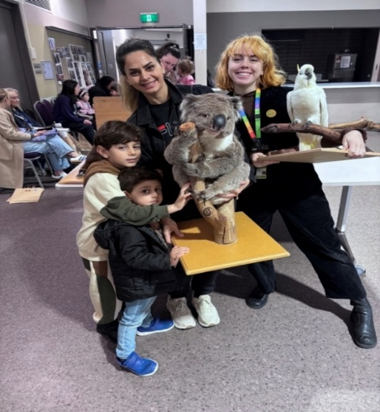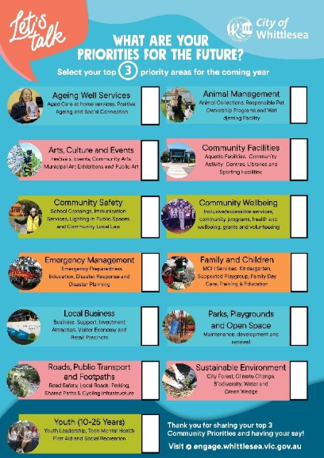
Figure 3: Images of direct survey activity and survey sheet

Participation
In phase one there was a total of 1,052 contributions, 870 of these were from in-person activities and 182 were made via the Engage Whittlesea platform. Below are highlights of the consultation.
Snapshot of community participation

Downloads | In-person activities | Digital engagement | In-person participation
 |  |  | 
75 downloads, Including prize Draw T&Cs, Community Focus Group EOI and Terms of Reference | Hosted 26 in-person engagement activities,  15 community-based pop-up stalls and 11 short survey activities | Engage Whittlesea platform saw  1247 views  701 visitors  182 contributions | 870 in-person contributions, 522 short surveys and 348 dot board activities

Snapshot of demographics
Below is a snapshot of the diversity of participation in the community engagement:
Gender Identity |  | Age |  |  | Suburb
 |  |  |  |  | 
63% Female, 32% Male,  3% Non-binary |  | All age brackets participated with the most represented being over 65 years (27%),36-45 years (21%), and 46-55 years (15%) |  |  | Participants came from 15 suburbs across the municipality, with the highest participation coming from Epping (12%), Doreen & Mernda (10%)
LGBTIQA+ community | Multicultural  Communites |  |  | People with disabilities |  | First Nations
 |  |  |  |  |  | 
43 (4%) participants identified as members of the LGBTIQA+ community | 367 (35%) participants spoke English as a second language |  | 163 (11%) participants were people with a disability and or carers |  |  | 18 (2%) participants identified as Aboriginal and Torres Strait Islander
What we heard
The 1,052 community members that participated in the community engagement told us that their top five priorities for our community are:

- Community safety including school crossings, Immunisation services, lighting in public spaces, prevention of violence against women and community local law.
- Roads, public transport and footpaths including road safety, local roads, parking, shared user paths, cycling infrastructure and public transport advocacy
- Ageing well services including aged care at home services, positive ageing and social connection.
- Community facilities including aquatic facilities, community activity centres, libraries and sporting facilities.
- Community wellbeing including inclusive and accessible services, community programs, health and wellbeing, grants and volunteering.

The graph below shows the number of responses received for each priority area.

The 552 participants who completed the short survey activity also had the opportunity to share why they chose their top three priority areas.

The 182 participants who completed the online survey activity had the opportunity to provide further feedback based on their selection of top priorities. These additional questions were designed to delve deeper into the communities’ priorities to understand the specific areas of importance for each of the priority areas they selected.

On the following pages are the results for each of the sub-categories as well as a summary of what we heard through the free text. A total of 1,075 comments were shared by community through the free text area. Graphs showing what we heard for each priority area can be found in Appendix 2.

Ageing well services

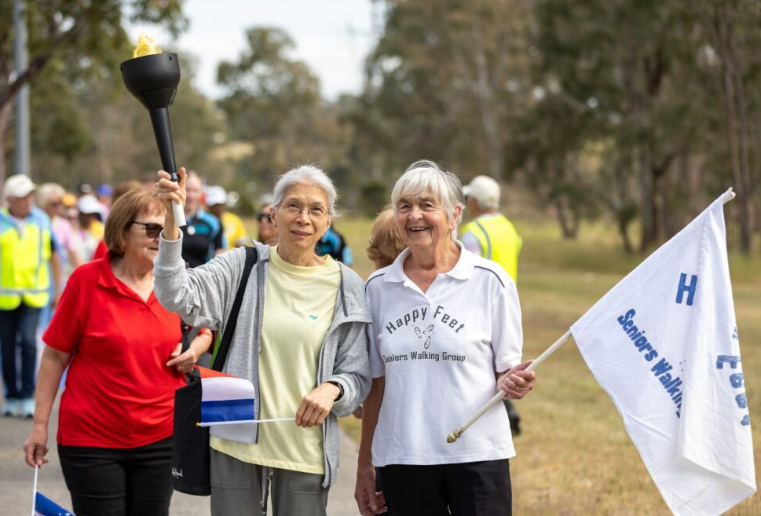

Selected by 33% of all participants (350)

Of the 350 participants that selected this area as priority, 29 were captured online and 321 in-person. The twenty-nine online participants that selected aging well as a priority area were asked to identify which service type was most important to them. Positive ageing programs (86%) were identified as the most important service, closely followed by home support services (75%) and social connection programs (72%). Age friendly initiatives such as intergenerational programs and senior exercise parks was not as important (52%). Other suggestions included support for navigating services for seniors and providing safe accessible spaces.

A total of fifty-eight additional comments were shared recognising the need for more free social connection opportunities, access to more in-home services and healthy eating and exercise opportunities.

“I would like to do singing at Greenbrook but cannot afford it”

“As an older person I access the LEAP program and think opportunities to exercise and socialize are very important. Safety for older people is important”

“I would like senior exercise equipment for Epping Reserve, corner High and Park St. This reserve has great football, soccer, cricket and tennis facilities but seniors and young children have been left behind.”

Animal management

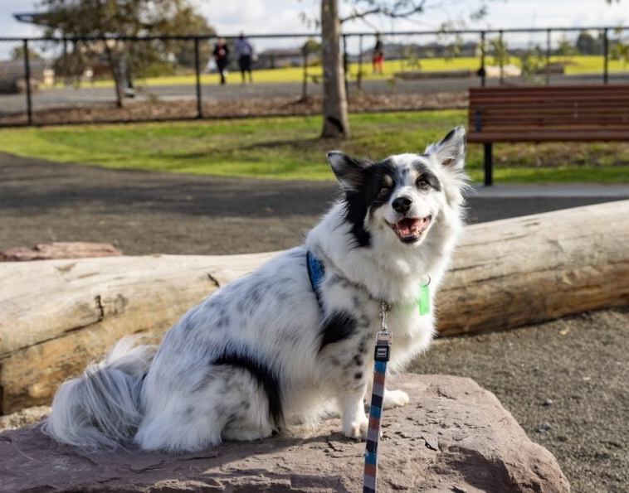

Selected by 10% of all participants (101)

Of the 101 participants that selected this area as priority, 33 were captured online and 68 in-person. The 23 online participants were asked to identify which service type was most important to them. Responsible pet ownership programs (81%) were the most important followed by animal management (57%), wat djerring Animal Facility (54%) and animal collections (42%). Nine participants suggested other service areas including new dog parks, pet therapy programs, services for the rural community to assist with stray larger animals such as goats and wildlife, and enforcing pet laws such as picking up after your dog, walking dogs on leads and roaming cats.
A total of twenty-seven additional comments were shared about animal management, highlighting the desire for increased enforcement of pet related laws, adopt a pet initiative, more education and promotion of responsible pet ownership, reporting of stray animals and animal safety in public areas.

“Get on top of people who consistently fail to manage their animals in public places”

“I would like to see the animals that are in wat djerring animal facility promoted more on different sites such as the council website. Happy ending stories and promotion of animals especially the ones that have been in the facility for a while”

“More information sessions to be held in seniors’ groups to inform of importance of desexing pets especially older non-English speaking groups”

“Secure dog play areas”.

Arts, culture and events
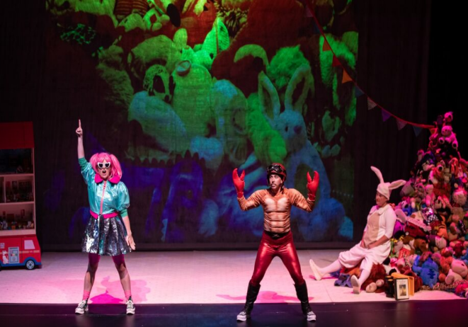

Selected by 20% of all participants (208)

Of the 208 participants that selected this area as a priority, 58 were captured online and 150 in-person. The 58 online participants were asked which arts, culture and events service is most important to them. The top three services were Plenty Ranges Arts and Convention Centre (74%), major festivals and events such as the Community Festival, Walking Thomastown and Carols by Candlelight (74%), local neighbourhood festivals and pop-up events (72%). Other services identified were support to local artists and creative industries (48%), creative workshops and opportunities to perform (44%).

A total of forty-two additional comments were shared through this priority area highlighting the need for PRACC to be refurbished, for events to be promoted, for more creative spaces and support for artists and for additional community art and performing art opportunities.

“I’ve been going to PRACC for years. It’s the only place near me to see live shows. The building feels old now and needs fixing up”

“Need a music club for young people”

“More local events”

“There aren't enough visual arts exhibitions”.

Community facilities
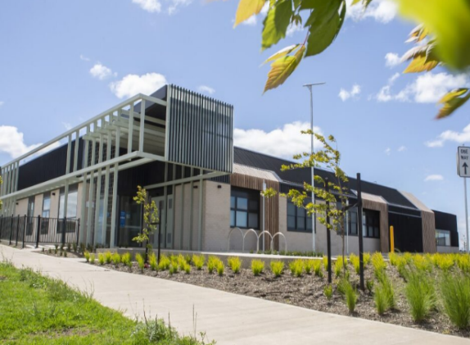

Selected by 32% of all participants (332)

Of the 332 participants that selected this as a priority area, 56 were captured online and 276 in-person. The 56 online participants were asked to identify which service type was most important to them. Libraries (61%) and sporting facilities (58%) were the highest priority service areas with community activity centres (55%) and aquatic facilities (53%) following. Eight participants suggested creative spaces such as artist studios, radio broadcasting and gymnasiums.

Additionally, the online participants were also asked which specific type of facility they used most with:
- Whittlesea swimming pool being the most used aquatic facility,
- Whittlesea Community Activity Centre the most used community centre,
- Whittlesea and Mill Park the most used libraries and
- Walkers Reserve, Mill Park Stadium and Hazel Glen named as sporting facilities.
There were several comments requesting more sporting facilities in Mernda and Wollert.

A total of seventy-six extra comments were shared that focused on having appropriate sporting or community facilities close to home, facilities as being old and run down, suggestions on improving or updating facilities, improving programming and accessibility, youth focused facilities and libraries.

“More facilities”

“Facilities require improvement”

“More programs for people with mental health disabilities”

“Community facilities for kids getting them into sports”

“Mernda library is so well used but it is so small”.

Community safety
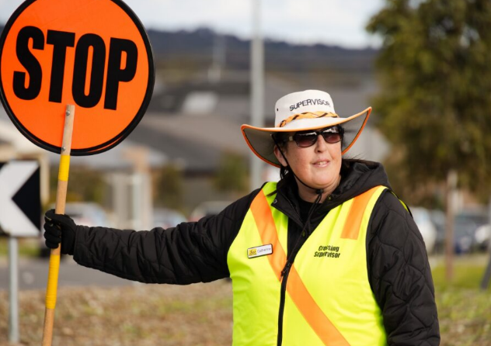

Selected by 35% of all participants (356)

Of the 365 participants that selected this as a priority area, 43 were captured online and 322 in-person. The 43 online participants were asked to identify which service type was most important to them. Lighting of public spaces (77%) was identified as the most important community safety service, followed by education and enforcement of Community Local Law (60%) and the prevention of violence against women - access to prevention programs (44%). School crossings (39%) and immunisation services (23%) were the least important services. Twelve participants suggested other ideas including prevention of violence, 24-hour policing, prevention of crime, hoon driving and tougher laws for youth crimes.

Online participants were also asked what made them feel safe and comments included more lighting in public spaces, police and community presence, tougher sentencing, contact with neighbours and community groups, CCTV, safe driving practices and more social tolerance.

A total of sixty-three extra comments were shared with key topics raised being road safety, local law enforcement, lighting, need for education and crime prevention strategies and that people deserve to feel safe.

“Cars drive down our street every night spinning their wheels”

“That offenders are punished accordingly”

“More lighting needed around most streets”

” More information and promotion of Neighbourhood Safety Housing in the community”

“We should feel safe where we live”.

Community wellbeing
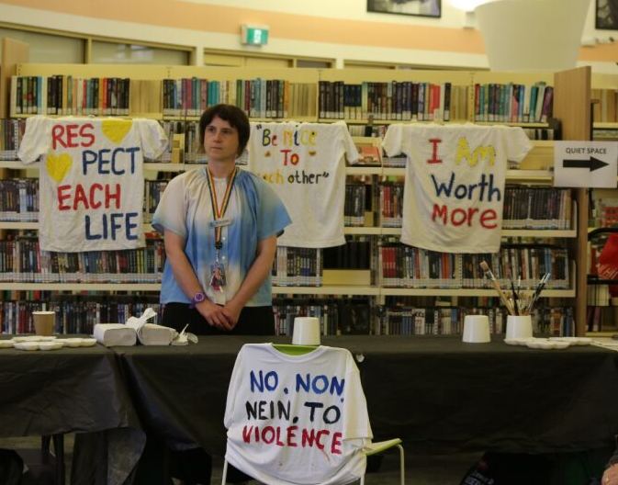

Selected by 27% of all participants (282)

Of the 282 participants that selected this as a priority area, 41 were captured online and 241 in-person. The 41 online participants were asked which Community Wellbeing service is most important to them. The results were Mental health and social connection- access to supports and programs designed to strengthen social connection (76%), financial vulnerability/cost-of-living support and preventative programs (58%) community grants (56%), inclusion and participation of persons with a disability (54%), community participation and leadership programs and training (54%), inclusive and accessible services including Aboriginal services, CALD, disability and LGBTIQ+ (51%), were the most important service areas to those that identified community wellbeing as a priority area.

Other service areas seen as most important within this priority area were food insecurity and healthy eating - access and education (41%), volunteering (39%), and homelessness and affordable housing advocacy (34%). and gambling harm minimisation preventative programs and advocacy (27%) were also important to participants. Five participants suggested education, feeling safer in the community and providing safe wellbeing spaces.

A total of sixty-one extra comments were shared asking for more support services and activities, more promotion of inclusive services and how to connect, access to free and low-cost education programs and support for housing and family violence.

“Would love more community wellbeing events. E.g. free yoga, meditation days Tai chi in the park”

"I feel wellbeing programs structured at specific groups need to be better organised”

“More free, affordable workshops, wellbeing sessions available for young persons, women, new migrants & seniors. Free Mental first aid sessions available for the vulnerable community“

“Women over the age of 45 are the fastest growing demographic at risk of housing insecurity and homelessness. This is because of factors like family violence, lack of superannuation due to unpaid care-giving responsibilities, among others”.

Emergency management
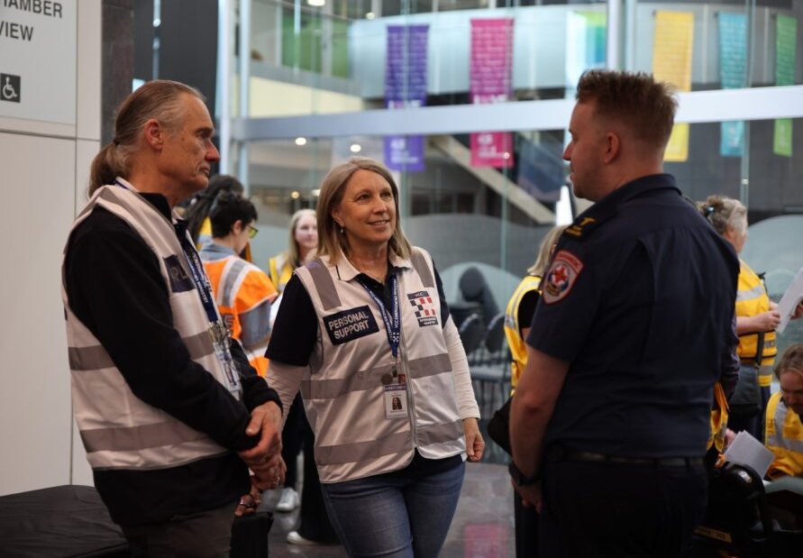

Selected by 14% of all participants (148)

Of the 148 participants that selected this as a priority area, 17 were captured online and 131 in-person. The 17 online participants were asked which Emergency Management service was most important to them. Disaster planning – preparation and mitigation (58%) and Emergency activation and response to disasters (55%) were equally the most important followed by preparedness education and resilience (35%). Two participants suggested more funding through rates to emergency services for equipment and keeping waterways for high-risk bushfire areas.

Of the five participants who responded to the question do you feel prepared in the event of an emergency, 20% responding they were, 20% were unsure and 60% were not prepared.

A total of fourteen additional comments were shared asking for more emergency services in the area, more funding for additional fire stations and equipment, more promotion and education of emergency processes and more fire prevention initiatives.

“Emergency services especially police take hours to get here”

“Brochures educating about emergencies to be translated in different languages, so it caters for different ethnic backgrounds”

“It would be great if the council provided support - free gutter cleaning/gutter guard, low fire risk vegetation seedlings etc to those in fire prone areas like Whittlesea township”

Family and children

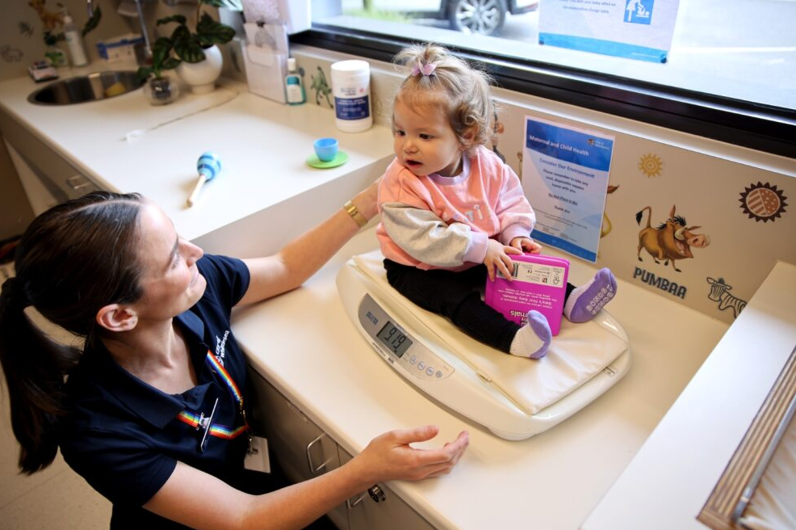

Selected by 22% of all participants (232)

Of the 232 participants that selected this as a priority area, 16 were captured online and 216 in-person. The 16 online participants were asked which Family and Children services were most important to them. Kindergarten (81%) and Maternal Child Health services (75%) were most important with training. and education (43%) supported playgroups (37%), and family day care (18%) following.

A total of thirty-six extra comments were shared on topics such as improving and providing play group activities and programs and prioritising families.

“The playgroup facilities are run down and need upgrading/toys replaced”

“I would like to see more facilitated bush playgroup offered every term for at least 2 different days, catering for more families”

“Families are the cornerstone of any society so they must be prioritised”.

Local business and employment

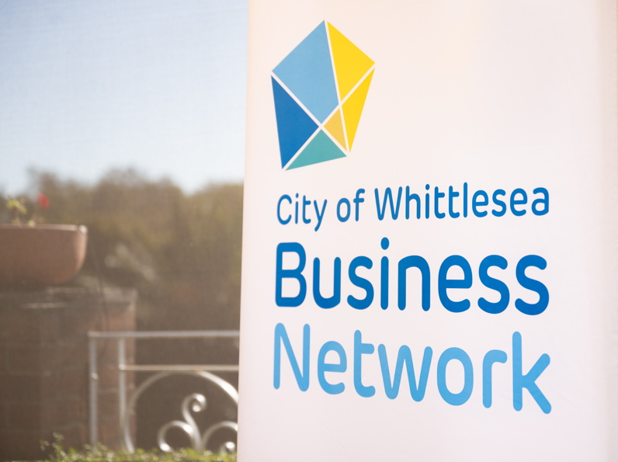

Selected by 12% of all participants (130)

Of the 130 participants that selected this as a priority area, 24 were captured online and 106 in-person. The 24 online participants were asked which Local Business and Employment service was most important to them. Local employment opportunities (83%) were identified as the most important followed by business support (58%) investment attraction (50%) and retail precincts including night-time economy (50%) and visitor economy followed (33%). Two people listed other things of importance including cleaning laneways behind shops.

A total of twenty-eight extra comments were shared such as local employment opportunities, variety of shops/ business support, the importance of visual aesthetics and cleanliness in business area surrounds, network events, local employment support and work experience opportunities and access to shops.

“Local employment and support for local businesses”

“There are not enough shops or options in Mernda”
“Clean laneway behind Station Street Lalor”
“How about having an expo show of local businesses at a venue that the community can come in to see who's running what and what they can do for the local community perhaps?”.

Parks, playgrounds and open space
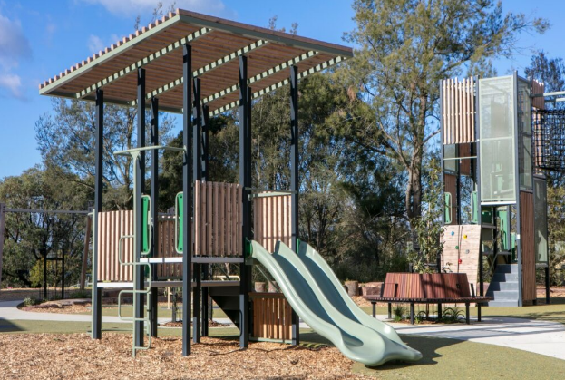

Selected by 26% of all participants (270)

Of the 270 participants that selected this as a priority area, 57 were captured online and 213 in-person. The 57 online participants were asked to identify which service type was most important to them. Walking paths and places for quiet relaxation and reflection (77%) was identified as the most important followed by maintenance (68%), social spaces like shelters, groups of seats and picnic settings (60%), play spaces and nature play for young children (46%), informal recreation opportunities (44%), renewal of existing playgrounds (39%) and the development of new playgrounds (22%). Nine participants had other suggestions such as the development of a rail trail between Mernda and Whittlesea Township, more toilets, off-leash parks and more sporting facilities.

Forty-five people told us what their favourite park, playground or open space was and the top three within the municipality were Plenty Gorge Parklands, Mill Park All Abilities Playground, Redleap Reserve and Doreen Waterways.

Seventeen people told us which existing playground needs renewing or where a new playground established with 4 comments in relation to new playgrounds in the Whittlesea Township.

A total of ninety-three extra comments were shared for parks, playgrounds and open space. These comments related to maintenance, updating existing parks, toilets, bins and other facilities, rubbish, wildlife and tree/plant diversity, signage and dog parks. There also comments of a positive nature commending the parks they visit.

“Keep it simple and maintained”

“Can you please build a proper park in Whittlesea with proper facilities such as toilets”

“I keep seeing newer parks being upgraded while the older ones get nothing”

“I would like to see more plant diversity in the parks. There are trees but our biodiversity benefits from multiple layers of flora”

“A lot of time there is rubbish in the nature strips and open spaces”

“Signage and education about the cultural and ecological heritage of our area is important”

“Really would appreciate a fetch and retrieve small dog securely fenced play area”

“Lots of options for play for kids of all ages mixed with nature experiences, toilets and shelter and socialising spaces”.

Roads, public transport and footpaths

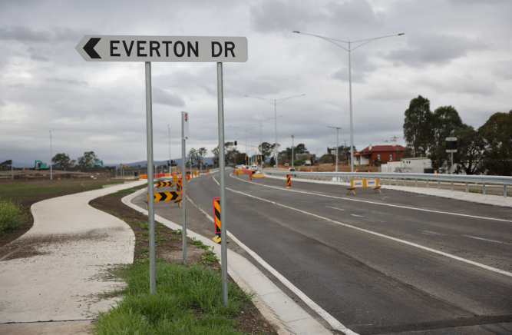

Selected by 34% of all participants (362)

Of the 362 participants that selected this as a priority area, 70 were captured online and 292 in-person. The 70 online participants were asked to identify which service type was most important to them. Local road maintenance and renewal (80%) is the most important service area, this is followed by road safety and traffic management (53%) and footpath and shared user path maintenance and renewal (51%) . Transport planning (35%), public transport advocacy (26%), parking (24%) and cycling infrastructure and new shared user paths (17%) followed. Six participants suggested lighting up footpaths, trucks using local roads, widening main roads prior to selling land in new estates and parking in local roads being limited due to not being allowed to park on nature strips.

Thirty-seven participants responded to the question of which local roads need renewing or maintaining with Grants Rd, Plenty Rd, Epping Rd, Yan Yean Rd drawing the most comments.

Eighteen participants responded to the question of which footpaths or shared user paths need renewing or maintaining with each participant identifying specific locations across the municipality.

“Kingsway Drive needs significant work to improve connectivity to Lalor station. Both the road surface, walking and cycling paths require improvement”

“Virtually all in the Mernda Village area”.

Fourteen participants responded to the question of where parking is a priority with most comments identifying schools and shopping centres.

“Around schools”

“Lalor Station parking needs more vehicle spaces”.

Eight participants responded to the question of where they would like to see new cycling infrastructure or shared user paths with each participant identifying specific locations across the municipality.

“Cycling lanes is needed on the arterial roads Donnybrook Rd, Merriang Rd & Epping Rd”

“Along Edgar's Creek, between German Ln and Kingsway Dr”.

Fourteen participants responded to the question of what public transport they would like to see Council advocating for with more frequent trains including the Wollert rail extension drawing the most comments alongside other comments such as extending the number 86 tram to South Morang and improving the frequency of bus services.

“Tram 86 extension! Simply extending it to South Morang Station would open up a huge network of transport connections”

“Wollert Rail is really essential”

“More buses servicing hubs such as rail and tram routes”.

A total of one hundred and twenty-five extra comments were shared for roads, public transport and footpaths that related to road maintenance, road safety, traffic management, car parking, improving walking/cycling paths, improving public transport, and road signage.

“Local back roads in the older part of South Morang need more regular proactive maintenance”

“Road needed to connect Mernda and Wollert from inside”

“I think residents should be able to park on their nature strips to help traffic flow better”

“I walk daily with my dog and baby in pram, and I am thankful that I do not have a disability and need a walking aid or wheelchair because the footpaths are atrocious”

“Public transport is not great in this area whatsoever in the whole city of Whittlesea”

“We need time restrictions signs on Nickson street”.

Sustainable Environment

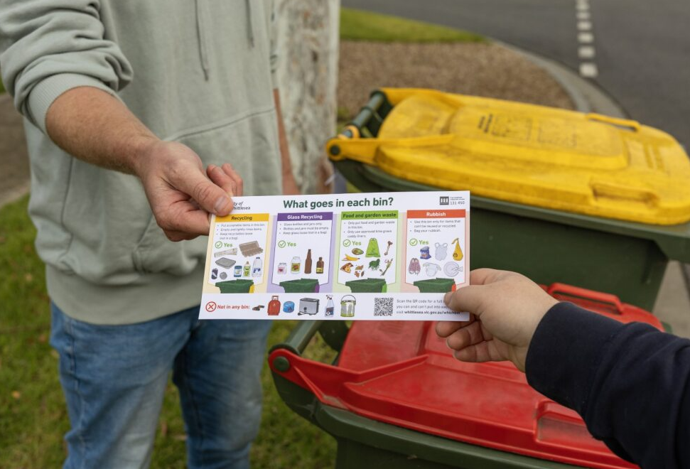

Selected by 14% of all participants (149)

Of the 149 participants that selected this as a priority area, 32 were captured online and 117 in-person. The 32 online participants identified biodiversity-natural environment (81%), waste and recycling (75%) and city forest - urban greening (71%) as the most important service areas followed by climate change (69%), green wedge (59%), water (53%). Three participants had other suggestions including more green spaces for people and animals and education in relation to environment, wildlife and sustainability.

They also identified education and awareness campaigns (87%), dumped rubbish (83%) recycling (79%) and kerbside rubbish collection (71%) as priorities in relation to waste and recycling followed by hard waste collections (58%), landfill (58%) and bundled branch collection (33%). Two participants had other suggestions including a reduce before reuse and recycle economy and education and information for recycling materials.

Nine participants suggested places they’d like to see additional planting that included locations such as Edgars and Darebin Creek, parks, nature strips and in Lalor/ Thomastown.
A total of forty-nine extra comments were shared for sustainable environment that related which included topics such as recycling, environmental consideration, tree planting, dumped rubbish and education campaigns, preserving green spaces and creating new green spaces.

“Use of plastic packaging is in excess in the community”

“We care about our environment and can't stand seeing rubbing dumped on the side of the roads”

“Environment - there is no future if there is no sustainable environment”

“Educating children and young adults”

“Can you create a natural environment that people wanted to hang spend time in? Forest bathing, picnics, riding bikes along a shaded bike path… diversity in local fauna and fauna, beautiful flowers all year round, useable, practical spaces please”.

Youth (10-25 years)

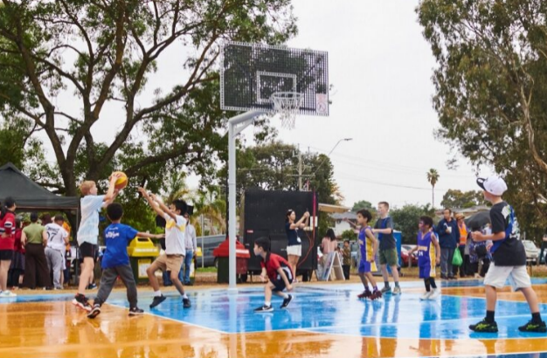

Selected by 19% of all participants (203)

Of the 203 participants that selected this as a priority area, 43 were captured online and 160 in-person. The 43 online participants were asked what the top five most important issues are for young people with bullying and abuse (65%), safety and crime in the community (63%) and mental health and wellbeing (58%) cost of living (42%) and drugs and alcohol (35%) as the top five issues. This was followed by family and relationship issues (33%), smoking and vaping (33%), school, TAFE or university challenges (28%), loneliness 19%, discrimination (17%), racism (12%), LGBTIQA (9%), climate change (7%) and world events (2%). One participant suggested that boredom with no direction or discipline was an issue

They were also asked what the top three areas the City of Whittlesea should support young people with, the results were free low-cost youth events (58%), employment and career pathways (56%) and social connection- regular programs and groups (44%). Mental health and wellbeing support (40%), school visits to deliver workshops and programs (23%) and volunteering opportunities (23%) were other areas of importance.
They were also asked what specific youth focused activities, programs or events you would like to see more of in the City of Whittlesea. Sports and recreational activities (77%), skill development opportunities (67%) and entertainment and youth friendly events (63%) were the most supported, followed by activities during school holidays (53%), weekly programs and social groups (51%), school workshops and programs (46%) and arts and creative programs (40%). Two participants suggested youth committees, and compulsory long term community service/ training for youth criminals.

A total of forty-two extra comments were shared for youth with key themes being more sporting opportunities, championing/supporting youth, safe and inclusive places, program promotion, and youth crime.

“Would love to see more good quality outdoor public basketball courts in residential areas for the immense number of youths who play basketball”

“I believe that youth are a priority as they are our future. Assisting in the younger years may lead them to a brighter future”

“Some areas of Whittlesea are not accepting of LGBTIQA+ youth”

“Specific groups for those over 18, as I really feel this age group is left to their own devices way too much”

“There’s a youth crime problem”.
Next Steps
Thank you again to everyone that participated in the community engagement online or in-person or by registering their interest to be a part of a future community focus group. The information captured through the consultation will inform the development of the 2026-27 Budget, Community Action Plan 2026-27 and Economic Growth Strategy 2026-35. Your valuable insights will also inform the development of other key plans and strategies Council develops to make Whittlesea A Place for All.

Phase two of the community engagement will run predominantly online at www.engage.whittlesea.vic.gov.au/cp2026 between November 2025 and January 2026. During this phase we will present back what we heard through this first phase of consultation to check that we haven’t missed anything.

Our community focus groups make up the third phase of the community engagement before we share the draft 2026-27 Budget and draft Community Action Plan 2026-27 with community for feedback in the fourth phase. We encourage you to follow the project engage page at www.engage.whittlesea.vic.gov.au/cp2026 to keep updated on the progress of this important annual community engagement.

Appendix 1
Options presented for participants to select from when identifying their top three priorities (13 options to choose from) as well as the sub-categories presented through the digital survey.

Ageing Well services
We support older adults (50 years of age plus) to safely age in place, live independently and have strong social connections by providing home support services, care, and wellbeing programs.
Home support services include:
- Domestic Assistance provides practical support to keep a person’s house clean and safe.
- Delivered Meals provides a range of freshly cooked nutritious meals.
- Personal Care helps with activities of daily living including assistance with self-care tasks.
- Property maintenance helps with home maintenance services and minor repairs.
- Individual Social Support provides access to a direct care worker who can assist with accessing services/places in the community.
- Flexible respite gives carers a break from their role in caring for an older person.
- Home Modifications assists with making minor changes to a person’s home to increase independence such as installation of handrails.

Social Connection and Positive Ageing Programs:
We are committed to supporting and fostering inclusion of people of all ages and recognise that ageing in place is important. We provide a range of opportunities for people 50+ to strengthen their social connections which in turn enhances quality of life. We also understand that carers of ageing parents and spouses also need support. Therefore, our programs include:

- Social support programs for those over the age of 65 that aim to build relationships, reduce isolation, and engage with community through group activities and shared interests. e.g. social connection programs, centre-based respite to support carers.
- Seniors Clubs for people over age of 55.
- Positive Ageing programs for people 50+ that are enjoyable, social, and affordable that include sports and recreation, exercise classes, health and wellbeing classes and opportunities for social connections.
- Seniors Events & Information such as Seniors Festival, Ageing Well Expo, come and try events and advice and information relating to older people.

Animal Management
We contribute towards liveable neighbourhoods, support a more connected community and help maintain our community’s health and wellbeing through education around responsible animal management. We provide:
- Animal Collections – Services such as reuniting lost pets with their owners and attending to stray dogs and cats.
- Animal Management - Responding to and investigating animal-related incidents, nuisances, and auditing animal businesses to ensure welfare standards are upheld.
- Responsible pet ownership programs - Encouragement for people to enjoy the pleasure derived from animal companionship, within a framework of responsible pet ownership. This includes conducting pet adoptions, education on pet registrations, microchipping, and desexing pets, while keeping your pet, other pets and the public safe
- wat djerring Animal Facility - The wat djerring Animal Facility is our city’s animal pound. We conduct pet adoptions and manage the facility in partnership with Merri-bek and Darebin councils.

Arts, Culture and Events
Arts, culture and events enables people to be creative, improves health & wellbeing, fosters community pride, contributes to the local economy, and promotes social cohesion. To achieve this, we provide:
- Creative places and facilities for people to learn, express themselves and be creative
- Support through networks, funding, permits and training to uplift the creative sector
- Programs and events for residents to attend and enjoy artistic, cultural or heritage experiences
- Activate neighbourhoods through public art and events.

Which Arts, Culture and Events service is most important to you? (select all that apply)
- Local neighbourhood festivals and pop-up events
- Major festivals and events such as Community Festival, Carols by Candlelight and Walking Thomastown
- Public art, sculptures and murals
- Visual art exhibitions and collections
- Ziebell’s Farmhouse Museum and Heritage Garden
- Performances at Plenty Ranges Arts and Convention Centre (PRACC)
- Creative Workshops and opportunities to perform and be creative
- Music workshops and performances
- Support local artists and the creative industries (guidance, grants)
- Support to community led creative projects.

Is there anything extra you would like to tell us about Arts, Culture and Events?

Community Facilities
City of Whittlesea has a range of Community Facilities available for public use, including:
- Aquatic Facilities - we offer three local pools and leisure centres that cater to all your fitness and recreational needs
- Community Activity Centres - we have many community centres, offering unique spaces and services. From halls to community hubs, these centres provide facilities, activities and resources to support and connect the local community
- Libraries - we have five library branches and two hubs which are open, accessible, inclusive and free to all residents of Victoria.
- Sporting Facilities - we offer an extensive array of sports and leisure facilities to promote an active lifestyle for all residents. From well-maintained grounds for football, cricket, soccer, and basketball to accessible tennis courts and programs, our facilities cater to various interests and age groups.

Emergency Management
The Emergency Management & Regulatory Programs department provides various services to the community. In line with council’s goal of creating liveable neighbourhoods, we help ensure that our communities are protected from public health risks and physical hazards.
Our services include:
- Emergency preparedness education and resilience - we ensure communities are safer, better prepared and more resilient through improved, more inclusive and diverse partnerships as well as increased access to information, education and connections
- Emergency activation and response to disasters - we ensure Council staff are trained, available, and able to respond appropriately to emergency events.
- Disaster planning - we ensure emergency preparedness and response plans are fit for purpose, multi-hazard, gender sensitive and guide integrated preparedness, response and recovery actions.

Community Safety
Feeling safe in your home and neighbourhood is an important part of everyone's health and wellbeing, and we know that safety is an important issue for our residents.
- School Crossings - our city has 160 children’s school crossings. Most are supervised by School Crossing Supervisors, who help young children cross the road safely on their way to and from school
- Immunisation Services - community vaccination services from birth to adulthood
- Education and enforcement of Community Local Law with a focus on community amenity and public safety - the Law aims to make the community safer by taking care of public property and enhancing local neighbourhoods in turn making the City of Whittlesea a welcoming place for everyone
- Lighting of public spaces
- Prevention of Violence Against Women - Access to prevention programs.

Community Wellbeing
The City of Whittlesea is a vibrant and inclusive community, home to people of all ages and backgrounds. We provide a wide array of services, programs and events designed to meet the needs of our diverse population.

Community Wellbeing services include:
- Inclusive and accessible services including Aboriginal Services, CALD, disability and LGBTIQ+
- Food Insecurity and Healthy Eating - access and education
- Financial Vulnerability/Cost of Living - support and preventative programs
- Community Participation and Leadership - programs and training
- Gambling Harm Minimisation - preventative programs and advocacy
- Inclusion and participation of persons with a disability
- Community grants
- Mental Health and Social Connection – access to programs designed to strengthen social connection
- Family Violence Response – support and referral pathways (e.g. Orange Door, Whittlesea Community Connections)
- Volunteering
- Homelessness and affordable housing advocacy

Family and Children
The City of Whittlesea is a great place for children and families. We offer a wide range of services, programs and resources to support the health and development of our youngest residents, ensuring a nurturing environment for your family to thrive. Some of the services we offer include:
- Maternal and Child Health (MCH) services - our MCH service provides free and confidential support for families with children from newborn to school age.
- Kindergarten - kindergarten (also called preschool) is an educational program for children delivered by qualified early childhood teachers. It's delivered in the two years before children start school.
- Supported playgroup - playgroup is a group of parents or caregivers with their babies, toddlers and preschool children who get together regularly for play and social interaction. Playgroups meet in a range of community venues, offering a supportive space where guardians and caregivers stay with their children, allowing them to connect with other families and build a sense of community.
- Family Day care - family day care is a registered service providing home-based childcare for a small group of children, aged from 6 weeks to 12 years old.
- Training and education - our training and education sessions help families and professionals learn new skills. We run programs for parents and carers and a separate professional development program for early childhood educators.

Youth (aged 10-25 years)
This section will help us understand which areas the City of Whittlesea should focus on to best support young people.

What do you think are the 5 most important issues for young people in the City of Whittlesea?
- Mental health and wellbeing
- Bullying or abuse
- Family and relationship issues
- Discrimination
- Racism
- LGBTIQA+
- Cost of living
- Drugs and Alcohol
- Smoking and Vaping
- Safety and crime in the community
- Homelessness
- School, TAFE or uni challenges
- Loneliness
- Climate change/environment
- World events
- Social media and online life

What do you think are the top 3 areas the City of Whittlesea should support young people with?
- Mental health and wellbeing support
- Employment and career pathways
- One-on-one support from a youth worker
- LGBTIQA+ inclusion and support
- School visits to deliver workshops and programs
- Social connection (regular programs and groups)
- Volunteering opportunities
- Advocacy for young people’s voices and needs
- Free/low-cost youth events
- Sharing relevant information online for young people
- Helping parents/carers better understand young people

What specific youth focused activities, programs or events would you like to see more of in the City of Whittlesea?

- Arts and creative programs
- Entertainment and youth-friendly events
- Activities during school holidays
- Weekly programs or social groups
- School workshops and programs
- Sports and recreational activities
- Skill development opportunities

Local employment and support for local business
A thriving local business sector benefits the whole community. We're committed to supporting and nurturing our local business community. Some of the services we support include:
- Business support - including business grants, networking and business promotions and concierge assistance with the permit process
- Investment attraction - increase local job opportunities and career pathways by attracting more business to the area
- Visitor economy (tourism)- attract visitors and raise awareness of the unique experiences, attractions, and activities available to see and do in the area
- Retail precincts - growth and vibrancy of the retail areas, shopping, dining and night-time economy.
- Local employment opportunities – engaging and collaborating with industry, education providers and agencies to help identify employment opportunities for our community

Parks, playgrounds and open spaces
We provide and maintain many local parks, playgrounds and open spaces so you can spend quality time in the great outdoors. They're designed to provide safe, convenient and accessible spaces for relaxation, play and exercise right in your neighbourhood.

Park, playground and open space services include:
- Maintenance
- Development of new playgrounds and renewal of existing playgrounds
- Play Spaces, and nature play for young children
- Social Spaces, like shelters, groups of seats and picnic settings
- Informal recreation opportunities, like fitness equipment, skating and rolling, multi-purpose courts
- Walking paths and places for quiet relaxation and reflection

Which existing playground needs renewing or where would you like to see a new playground established?

Roads, public transport and footpaths
The City of Whittlesea is a well-connected and sustainable city, which allows everyone to easily and safely move around the municipality and beyond.
Some of our services include:
- Road safety and traffic management
- Local road maintenance and renewal
- Footpath and shared user path maintenance and renewal on Council owned land
- Cycling infrastructure and new shared user paths - cycling is a healthy and sustainable travel option and we have a network of bicycle lanes and paths
- Transport planning - identifying and planning for future transport needs for our growing community
- Parking - parking permits, regulations for long and heavy vehicles and safety around schools.
- Public Transport advocacy - we advocate to the Victorian Government regularly on behalf of our residents to improve the public transport services in the municipality.

Which local road/s do you think need renewing or maintaining?
Which footpath or shared user path do you think needs renewing or maintaining?
Where would you like to see new cycling infrastructure or new shared user paths?

Sustainable environment
Council delivers important services that help achieve a sustainable environment, including:
- Waste and recycling - supporting the community to avoid unnecessary waste to landfill, improving resource recovery and supporting the circular economy
- City forest (urban greening)- increasing tree canopy and vegetation in open spaces and our streets
- Climate change - the long-term shift in the Earth’s temperature and weather patterns, primarily caused by human activities such as burning fossil fuels, waste generation, land clearing and farming. Our overarching vision is by 2036, the City of Whittlesea is a net zero emissions municipality
- Biodiversity – biodiversity is the number and variety of living things on the planet. It is the mix of plants, animals, and other organisms that make up landscapes from deserts to oceans. Our goal is to protect and improve local biodiversity
- Water – water is an essential element to support life, healthy landscapes and ecosystems, as well as the community’s wellbeing. Humanity’s interference with the water cycle demands this precious resource to be managed in an integrated way, considering freshwater security, stormwater management and wastewater treatment amongst priorities
- Green wedge – protected area outside the Urban Growth Boundary that supports productive agricultural land, scenic landscapes, heritage places, National Parks, rural living, waterways and reservoirs as well as significant flora and fauna.

Appendix 2
Graphs showing what we heard for each of the 13 priority areas and the sub-categories presented through the digital survey.
Ageing Well
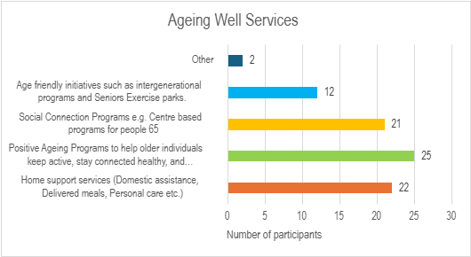

Animal Management
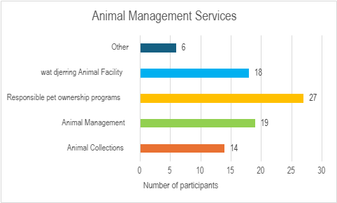

Arts, Culture and Events

Community Facilities

Community Safety

Community Wellbeing

Emergency Management

Family and Children

Local Business and Employment

Parks, playgrounds and open spaces

Roads, public transport and footpaths

Sustainable environment

Youth

