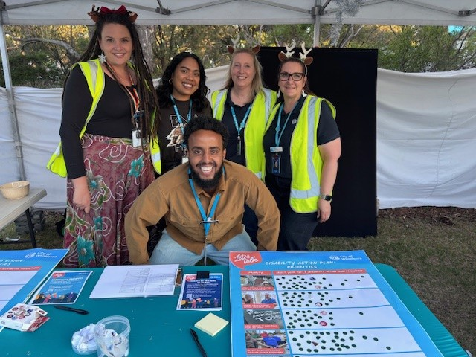
Health and Wellbeing priorities
Phase 1 Engagement Summary

2 December 2024 – 30 January 2025

Introduction
Combined, the Municipal Public Health and Wellbeing Plan (MPHWP) and the Disability Action Plan (DAP) aim to address the health and wellbeing priorities of the City of Whittlesea’s diverse community. The plans form part of the Council (Community) Plan being developed and will drive annual Council (Community) Plan Action Plans. The priorities of our community will be at the forefront of these key documents.
Council undertook community consultation with people who live, work, study or visit the City of Whittlesea to understand community issues and needs across the municipality in relation to health and wellbeing. As the municipality has diverse residents and needs, the consultation was designed to understand what is most important to the community and the health and wellbeing areas, they felt Council should focus on.
The feedback received will inform the Municipal Public Health and Wellbeing Plan (MPHWP) and the Disability Action Plan (DAP) which form part of the Council (Community) Plan being developed by Council.
The first phase of consultation included digital engagement and five targeted community-based pop-ups. The opportunity to participate was promoted via social media, emails to targeted stakeholder groups and flyers. During phase one there was a total of 496 contributions from a diverse cross-section of our community. Of these, the 279 contributions to the Municipal Public Health and Wellbeing plan told us that the top five health and wellbeing priorities across the municipality are:
- Improving mental wellbeing and social connection
- Preventing all forms of violence
- Increasing active living
- Increasing healthy eating
- Improving financial wellbeing.
The 217 contributions to the Disability Action Plan told us that the top five disability action priorities across the municipality are:
- Increase services that enable people with disability to live safely and independently in the community
- Create pathways to work experience and viable employment opportunities for young people with disability.
- Reduce barriers for people with disability to access public places and spaces
- Support initiatives that increase the social economic participation of people with disability and reduce discrimination
- Address attitudes and practices that drive discrimination against people with disability.

How we engaged you

The Health and Wellbeing Priorities project page on the Engage Whittlesea platform encouraged participants to share their health priorities for the future through a survey. The survey presented thirteen priority health and wellbeing areas, requiring participants to select the three areas most important to them, as well as presenting five priority areas in the Disability Action Plan, requiring participants to select their top three. Participants were then asked additional questions designed to delve deeper to understand the specific areas of importance for each of the priority areas they had selected. There was free text space provided for participants to add further comment as part of the additional questions.

The thirteen health and wellbeing priority areas presented through the survey are as below:
- Improving sexual and reproductive health
- Reducing harm from tobacco and e-cigarette use
- Improving mental wellbeing and social connection
- Increasing healthy eating
- Increasing active living
- Reducing harm from alcohol and drug use
- Tackling climate change and its impacts on health
- Preventing all forms of violence
- Reducing harm from gambling
- Improving financial wellbeing
- Reducing homelessness
- Reducing drug resistance in people or animals (also referred to as antimicrobial resistance) which includes antibiotic, antiviral, and antifungal resistance
- Reducing injury

The five priority areas in the Disability action Plan presented through the survey were:
- Reduce barriers to people with disability to access public places and spaces
- Create pathways to work experience and viable employment opportunities for young people with disability
- Increase services that enable people with disability to live safely and independently in the community
- Support initiatives that increase the social economic participation of people with disability and reduce discrimination against people with disability
- Address attitudes and practices that drive discrimination against people with disability.

Online participants were asked to provide commentary around why they selected the priority areas as well as suggest other possible priority areas. Visitors to the project Engage page were also presented with an opportunity to submit their interest in being part of a community focus group to be held in February 2025.

The Engage Whittlesea platform utilises an accessibility add-on ensuring that it is as accessible as possible for all users. The platform also has an in-built translation tool to mitigate any language barriers to participation, allowing the page to be translated into the top fifteen languages spoken within the municipality.

The project team also hosted five community-based pop-up stalls at targeted high foot traffic locations within the municipality. The in-person consultation activity mirrored the information being sought through the digital consultation; specifically, capturing their top three priorities for each plan with participants asked to place a sticky dot on their choices and add any further comment if they wanted to.

Engagement Activities
To hear from a diverse range of community members and increase participation, the project team hosted an in-person engagement activity at Council’s Carols by Candlelight event which was attended by over 2,000 diverse community members. Targeting children and youth, the team hosted a pop-up stall at the skate park launch at Whittlesea Public Gardens and at Mill Park Library next to the social enterprise café which is staffed by people with disabilities and visited by many young families. Focussing on increasing participation by older people and those with disabilities the team hosted a pop-up stall at Thomastown Recreation and Aquatic Centre which is regularly frequented by older people and those living with a disability.
The community-based pop-up sessions held are as below:
Date | Time | Where | Address/location
13/12/2024 | 6pm- 9pm | Carols by Candlelight | 25 Ferres Boulevard, South Morang
16/01/2025 | 12pm – 2.30pm | Mill Park Library School Holiday Program | 394 Plenty Road, Mill Park
20/01/2025 | 12pm - 2.30pm | Mernda Village Activity Centre Immunisation Program | 70 Mernda Village Drive, Mernda
21/01/2025 | 9.30am- 11.30am | Thomastown Recreation Activity Centre | 52-54 Main Street, Thomastown
24/1/2025 | 4pm -7pm | Whittlesea Public Gardens Skate Park Launch | 158 Barry Road, Lalor
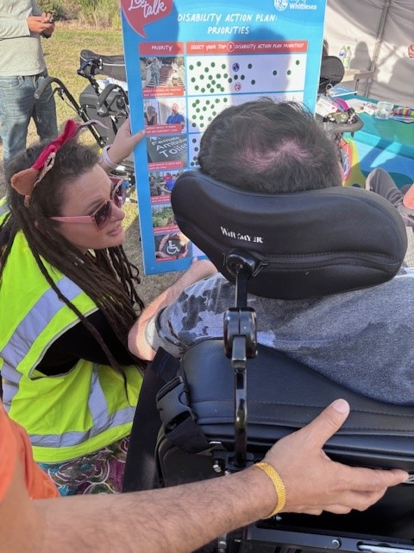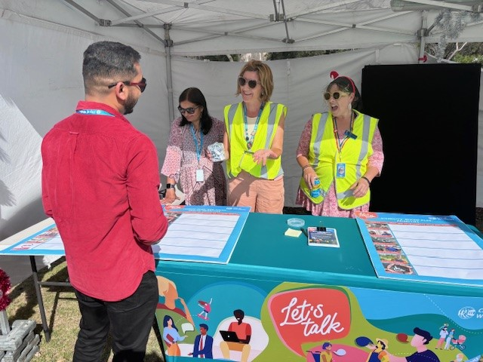
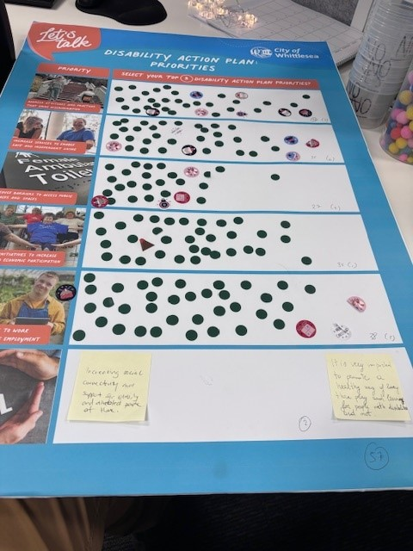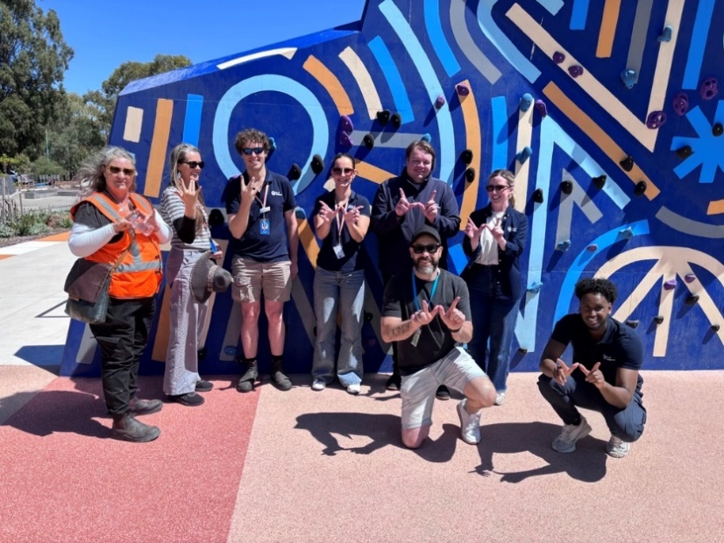
Above: 1 Images of the project team engaging with the community at the Carols by Candlelight and skate park launch event

Project Promotion
The opportunity to participate in the community engagement was promoted through a range of channels to have a widespread reach across the municipality including:
- Council’s digital engagement platform Engage Whittlesea
- Social media – Social media posts were used during the consultation period to promote the upcoming focus group
- Notification to Engage Whittlesea platform members
- Direct email sent by key internal staff to their networks including the Whittlesea Disability Network and community groups.

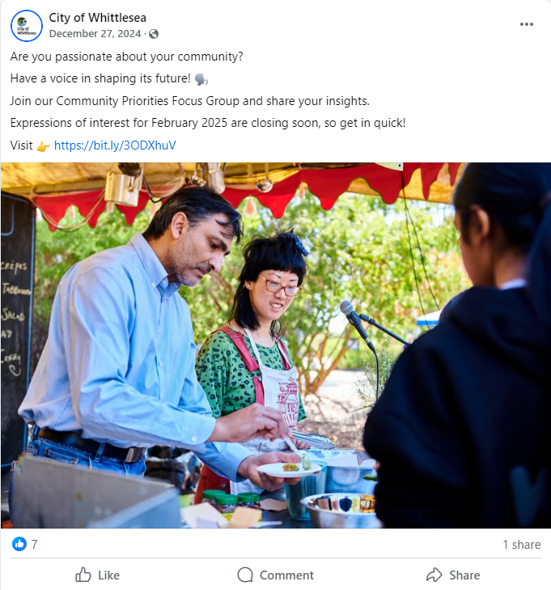
Above: 2 A social media post promoting the upcoming Community Priorities Focus Group that will include an activity on Health and Wellbeing priorities to help shape the draft MPHWP and DAP.

Participation
In phase one of community consultation a total of 496 contributions were received as part of the Health and Wellbeing Priorities engagement. Of these, 279 were on the Municipal Public Health and Wellbeing plan and 217 contributions on the Disability Action plan.

Snapshot of Community Participation
Highlights from the community consultation included:
 |  |  | 
Three social media posts | 191 people participated in-person | 88 people participated online | 16% of participants were people with a disability
Snapshot of Demographics
Below is a snapshot of the diversity of participation in the community engagement:
Gender Identity | Age | Suburb
 |  | 
56% Female, 31% Male, 12% Preferred not to say and 2% non-Binary | All age brackets participated with the most represented being 10% under 25 (10%), 25-34 years (25%) and 35-44 years (18%). | Participants came from 13 suburbs across the municipality, with the highest participation coming from Epping (14%), South Morang and Thomastown (both 13%).
LGBTQIA+ Community | CALD Community | Aboriginal or Torres Strait Islander
 |  | 
8% of participants identified as members of the LGBTQIA+ community | 33% of participants spoke English as a second language | 4 participants identified as First People

What we heard
A total of 279 participants voted for their top three priorities for the Municipal Public Health and Wellbeing plan with ‘Improving mental wellbeing and social connection’ the highest priority with 46% of people ranking it in their top 3.
A total of 217 participants voted for their top three priorities for the Disability Action Plan with ‘Increasing services to enable safe and independent living’ the highest priority with 67% of people ranking it in their top 3.
Refer to the graphs below to see the full results of what we heard.

Community Consultation Results for the Municipal Public Health and Wellbeing Plan
Graph displaying in highest to lowest priority.

Community Consultation Results for the Disability Action Plan
Graph displaying highest to lowest priority.
Key themes from community feedback specific to the Municipal Public Health and Wellbeing Plan
Participants were offered the opportunity to provide additional commentary to explain why they had selected particular priorities. Below is what we heard for each of the sub-categories as well as some of the anecdotal feedback which we have themed and used quotes to highlight.
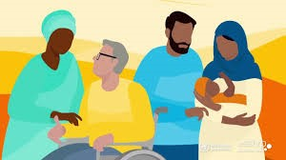 | Improving sexual and reproductive health  One response and one comment received  “I am a member of the LGBTI community and generally under serviced but health services and / or not tailored to our needs. Also because I’m scared that what is happening in the us will happen here and I want strong foundations of repro health that will be difficult to dismantle. “
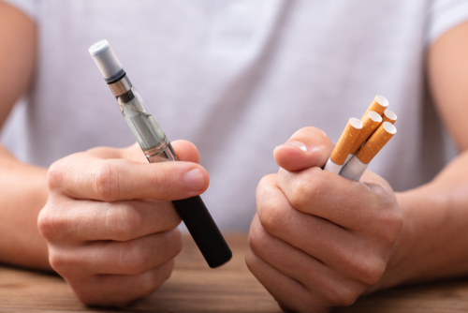 | Reducing harm from tobacco and e-cigarette use  Six responses and six comments received.  Main themes:  - concerns around youth health (3),  - harm from second hand smoke (3)  - lack of education (1).  “My teen is around other teens who regularly use vapes and has told me that he can buy vapes easily. temptation is always around him and he is easily targeted by those who profit from them due to availability and lack of control over their supply. Also not enough is being done to educate and inform young people. “
 | Improving mental wellbeing and social connection  57 responses and 47 comments received.  Main themes:  - improves overall health and wellbeing (31)  - social connection is important (11)  - isolation and loneliness (13)  - effects a lot of people (11).  “Because strong social connections reduce loneliness and isolation and mental wellbeing helps to make life bigger not smaller helps you to thrive not just survive”  “It impacts me personally, and I can see how getting help helps, but there are barriers that I’m lucky to not face against like cost and wait lists”  “A community that has effective systems in place to support the improvement of mental Wellbeing and social connection is essential in ensuring that the city of Whittlesea residents are functioning members of society. They contribute financially to the economy, have pride in themselves and their homes, meaning our local children are provided with the best possible mentoring and leadership from adults - not becoming a burden on society.”
 | Increasing healthy eating  20 responses and 19 comments received.  Main themes:  - good health (11)  - prevents disease (10).  “Healthy eating costs way too much, if you want your community to be healthy, you need to make healthy eating the affordable choice.”  “What we consume builds us and sets us up for a healthy life. The availability of healthy food will decrease the risk of a range of diseases, improve mental health as well as physical health.”
 | Increasing active living  42 responses and 33 comments received.  Main themes:  - Improve physical health (14)  - increase wellbeing (13)  - healthy ageing (10)  - improves mental health (9).  “Active living has proven benefits to mental physical and social health. It can connect people, improve mood and it reduces the risks of illness and disease.”  “Physical and mental health now and long-term benefits. Reduction in reliance on healthcare system. Combating obesity, increasing community connection.”
 | Reducing harm from alcohol and drug use  18 responses and 15 comments received.  Main themes:  - community impact (8)  - Crime and violence including domestic violence (7)  - Addiction/Abuse (7)  - overall health impact (6).  “Leads to a more stable community and less crime”  “These are some of the root causes of violence, anti-social behaviour and homelessness. (Evident in pockets of Epping)”
 | Tackling climate change with its impact on health  15 responses and 14 comments received.  Main themes:  - climate/Planet impact (9)  - health impact (4).  “Because we live in this world and there’s only one of it”  “We have been talking about climate change for years but have done little about it. It is a world issue, and the rich countries must do more to help the poor. Climate affects our health, our productivity etc”
 | Preventing all forms of violence  36 responses and 28 comments received.  Main themes:  - feeling safe/Security (13)  - family Violence (12).  “Children, women and some men live with violence on a daily basis is abhorrent, in a civilised society we should all feel safe”  “Every person is entitled to feel safe in their community, the prevalence of family violence and deaths in the Victorian community must be prevented.”
 | Reducing harm from gambling  12 responses and ten comments received.  Main themes:  - family impact (6)  - financial impact (5)  - addiction/abuse (5).  “Causes financial, family and personal distress. Whittlesea has too many opportunities for vulnerable people to lose money.”
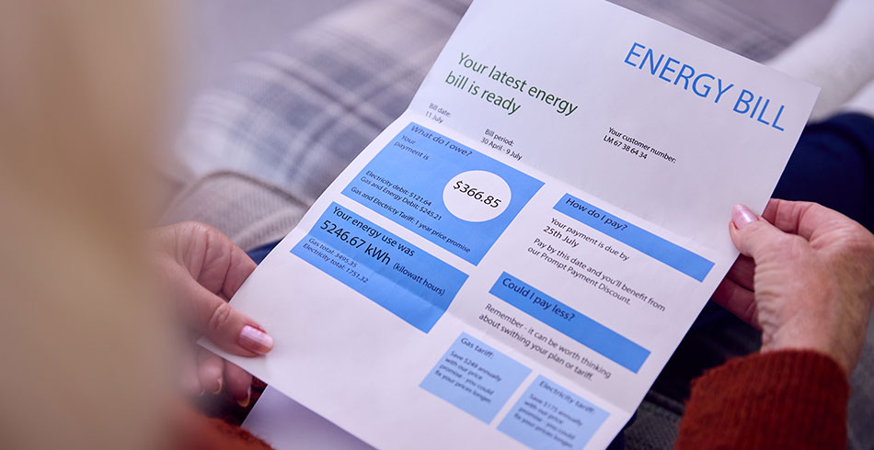 | Improving financial wellbeing  18 responses and 15 comments received.  Main themes:  - cost of living (10)  - improve money management (5).  “Due to the cost-of-living community are really feeling the side effects with less money to live on which impacts your wellbeing and mental health.”  “To cope with current economic conditions. Cost of living has increased significantly salaries have remained stagnant or salaries increase at a relatively lower & insignificant rate”
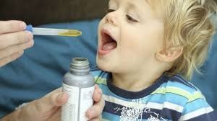 | Reducing drug resistance in people and animals (also referred to as antimicrobial resistance) which includes antibiotic, anti-viral and antifungal resistance  Six responses and five comments received.  "Too many Dr’s prescribing medication too readily and this also goes hand in hand with overuse of drugs to treat allergies!”  “The environment effects of drug use is becoming more prevalent, so many people are suffering from hay fever, thunderstorm asthma and eczema. I think the lack of keeping our environment clean from rubbish, no under clearing of our suburbs and all the long grasses in this municipality does not help in the least!"  “If we build up a resistance disease will spread, and we will have nothing to combat it”  “WHO raised it as one of the top threats to public health. This is a long-term problem that requires global effort and so I'm voting for it. Plain and simple.”
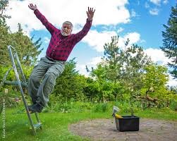 | Reducing Injury  Seven responses and six comments received.  Main themes:  - positive ageing (4)  - health impacts (3).  “As I age, I am increasingly concerned with the risk of injury to myself and wife and the ability to recover and manage injuries.”
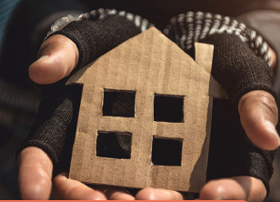 | Reducing homelessness  18 responses and 16 comments received.  Main themes:  - basic human right/need (7)  - support options (5)  - affordable housing (4).  “Everyone deserves access to basic human needs, such as safe housing. Without this, it's not possible for people to thrive and seek employment etc. We should not have street sleepers in Australia. We can do better.”  “In a (once) prosperous country, we have a social responsibility to provide a basic standard of living to all who want it.”

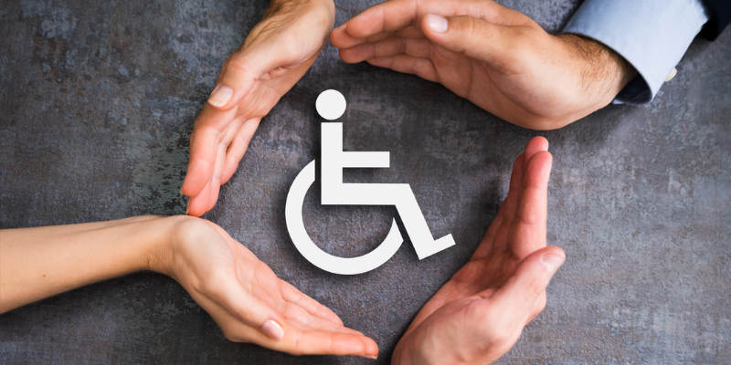 | Other suggestions of priorities  - Green spaces to exercise in lots of shady trees and opportunity to exercise and walking streets without being sunburned  - Improving Fitness for The Aged Communities  - Healthy ageing  - Removing gendered language from healthcare messaging. It's not only women who have a uterus. Non-binary people, boys and men can also have a uterus. Inclusivity will save lives.  - Pain management.

Key themes from Community feedback specific to the Disability Action Plan
Below are the results for each of the sub-categories as well as the themes from free text comments.
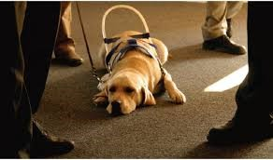 | Reduce barriers to people with disability access public places and spaces  58 responses and 398 comments received.  Main themes  - having accessible places and spaces is important for accessibility (21)  - basic human right to have same accessibility for all people (16)  - important for Inclusion (9)  - important for community connection (8).  “A person with a disability shouldn't need to wait for a passer-by to walk past to open a heavy door for them to enter a building. Everywhere should be accessible for everyone.”  “Ensuring our public spaces are safe for our low vision and wheelchair bound, through fixing foot paths as an example.”  “If they don't have access to all places, they are only limited to what's available which may cause a sense of isolation, disengagement and impact their physical, mental and social health.”
 | Create pathways to work experience and viable employment opportunities for young people with disability  50 responses and 31 comments received.  Main themes  - opportunities and pathways should be available for all (15)  - creates independence (14)  - contributes to confidence (12)  - community participation (7).  “People living with disability face more barriers to work experience and employment than those not living with disability. We need to support and create pathways into employment.”  “Getting people with disabilities into a working environment gives them a purpose, making them feel lest ostracised, also creates awareness and acceptance in others!”  “Working and doing something that feels valuable and productive, and feeling like you have a purpose is essential for good mental health”
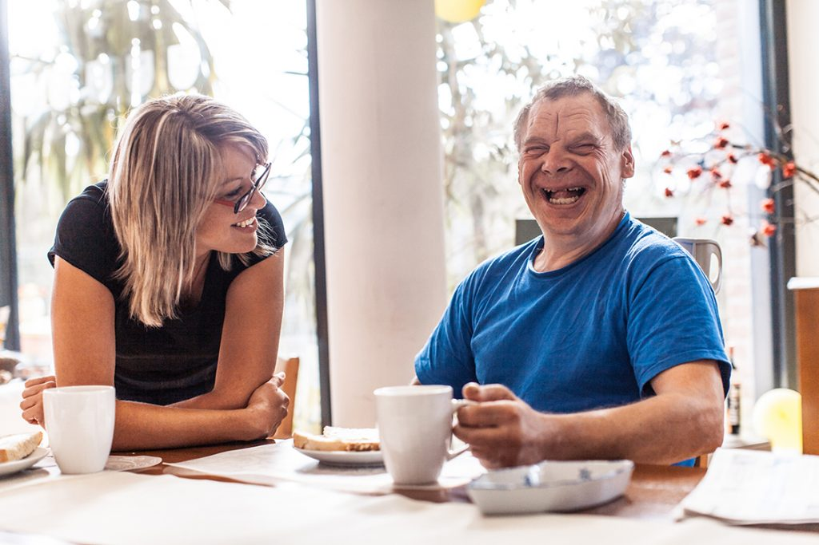 | Increase services that enable people with disability to live safely and independently in the community  66 responses and 39 comments received.  Main themes  - it is a basic human right (16)  - increases self-worth and confidence (12)  - commented about feeling safe (8).  “Because people with disabilities deserve support to have autonomy over their own lives and choices and not be forced to live at home with their parents as adults due to their support needs when - with some support - they could live independently”  “Cuts down on having to have independent living arrangements for people with disability, goes a long way to promote independence and health and mental wellbeing.”  “It empowers people with disability and gives them a sense of purpose”
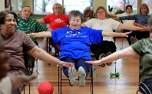 | Support initiatives that increase the social and economic participation of people with disability and reduce discrimination  49 responses and 27 comments received.  Main themes  - related to community participation (11)  - basic human right for all (10)  - increased sense of belonging and self-worth (9)  - reducing discrimination (9).  “Self-determination without fear, prejudice or discrimination matters, there's so much that the broader community needs to learn. I put myself in the category too, despite having learnt and continuing to. It's also important to reduce the impact of social isolation for the benefits to mental and physical health. Economic participation: earning income, where possible, or receiving the DSP to be able to cover the basics of daily living as well as having enough to socialise.”  “We can learn a lot from everyone around us. By having different people around us fears and discrimination will reduce because people will have a person experience rather than an imagined experience.”
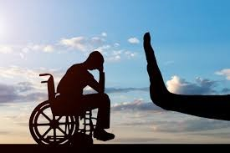 | Address attitudes and practices that drive discrimination against people with a disability  38 responses and 25 comments received.  Main themes:  - education and Increase awareness (10)  - important to everyone not to feel discriminated (9)  - inclusion is important (8)  - Other themes included having equality, providing opportunity and mental health and wellbeing  “Discrimination hurts, causes trauma, prevents people from getting the support needed, participating in, and contributing to, society. Every person has the right to be treated with respect.”  “Education is the key to stopping discrimination. People that do not have the exposure to people with a disability use discrimination because they are scared of the unknown”

Next Steps
Thank you to everyone that participated in the community engagement by completing our health and wellbeing priorities activity and/or registering their interest to be a part of our community focus groups.

The information captured through phase 1 consultation will inform the development of the draft Municipal Public Health and Wellbeing Plan and the draft Disability Action Plan which are expected to be considered by Council as part of the Council (Community) Plan in June/July 2025. The draft Council (Community) Plan will be shared with community for feedback. The feedback captured will also help to inform the development of other key plans and strategies Council are working on to make Whittlesea A Place for All.
The Municipal Public Health and Wellbeing Plan and the Disability Action Plan will also feature as one of two activities in the upcoming Community Priorities Focus Groups scheduled for February 2025. The draft plans will also be presented to our Youth Council and Aboriginal Communities team for further feedback.

Thank you again to everyone who participated in phase 1 of the community engagement by sharing comments, feedback and participating in online activities and community-based pop-up sessions. The community will be updated on further developments via the Health and Wellbeing priorities | Engage City of Whittlesea. We encourage you to register and follow the page to be kept updated on the project.

