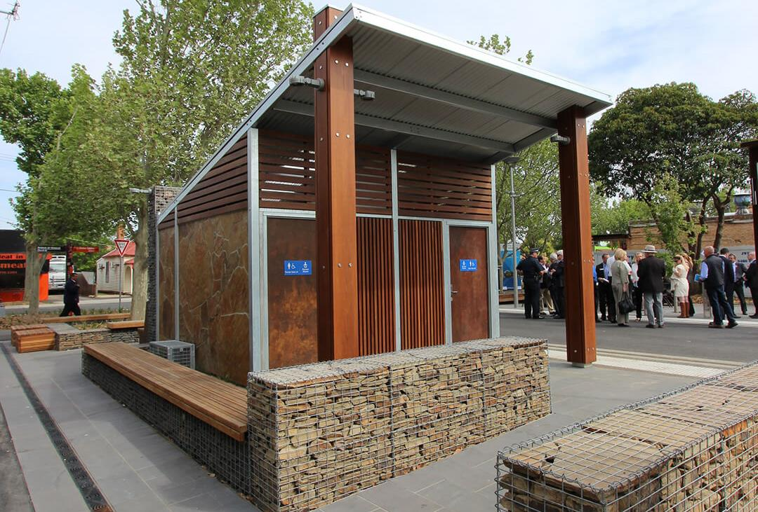

Engagement Summary
17 June 2025 – 19 July 2025
PUBLIC TOILET AMENITY PLAN

Introduction
The City of Whittlesea has undertaken community engagement to inform and consult with residents on the review of the Public Toilet Amenity Plan. The plan sets out the vision and framework for the future planning and provision of public toilets across the City of Whittlesea. Community feedback gathered during this process will directly shape the final plan, including:
- Priority recommendations for public toilet provision
- Potential locations for new and upgraded facilities
- Design features and configurations that best meet community needs.
The review aims to ensure that public toilets are inclusive, accessible, and reflective of the diverse needs of our community.
Council undertook community consultation with people who live, work, study or visit the City of Whittlesea. The engagement was designed to capture high-quality input from a broad cross-section of the community on priority recommendations and potential locations for new and upgraded public toilet facilities. It also aimed to educate residents about the inclusion of Changing Places and all-gender facilities, strengthen understanding and support for the updated planning framework, and gather feedback on preferred design features and configurations. In doing so, the process sought to develop a practical and actionable list for the updated plan, including building new toilets, upgrading those identified as needing attention, and potentially removing under-utilised facilities, as well as establishing clear guidelines for the types of toilets to be provided, such as all-gender and accessible facilities. A key objective was to ensure that all consultation opportunities were accessible and inclusive, enabling community members to easily to share their feedback.
The consultation included digital engagement through the Engage Whittlesea platform and ten targeted community-based pop-ups across the municipality. The opportunity to participate was promoted via Council’s social media channels to reach diverse audiences, emails to targeted stakeholder groups, posters displayed around the municipality and flyers provided to community members who were unable to participate when they were at community-based pop-up sessions. There was a total of 426 contributions captured from a diverse cross-section of our community.

How we engaged you
The Public Toilet Amenity Plan project page on the Engage Whittlesea platform encouraged participants to use the social map tool to drop a pin on locations of proposed new toilets and existing toilets needing attention. A survey also asked a variety of questions relating to how people located a public toilet and what types of features they used, or thought were important to have in a public toilet in the City of Whittlesea. There was free text space provided for participants to add further comment as part of the questions.

The Engage Whittlesea platform utilises an accessibility add-on ensuring that it is as accessible as possible for all users. The platform also has an in-built translation tool to mitigate any language barriers to participation, allowing the page to be translated into the top fifteen languages spoken within the municipality.

In-person engagement activities
To reach a diverse range of community members and encourage participation, Council hosted ten in-person engagement sessions across the municipality. These were held at various locations including immunisation sessions, shopping centres, and parks, resulting in 86 contributions.
The community-based pop-up sessions held were as below:
Date | Time | Where | Address/location
Tuesday 17 June | 10.30am – 12.30pm | Thomastown Library Social Space | 54 Main Street, Thomastown
Wednesday 18 June | 5pm – 7pm | Kirrip Community Activity Centre  (Immunisation Session) | 135 De Rossi Blvd, Wollert
Friday 20 June | 10am - 12pm | Whittlesea Service Hub | 63 Church Street, Whittlesea
Tuesday 24 June | 10.30am - 12.30pm | Westfield Plenty Valley (community space opposite Coffee Club) | 415 McDonalds Road, South Morang
Thursday 3 July | 3pm – 5pm | Alexander Avenue Shopping Strip | Alexander Avenue Shopping Strip, Thomastown
Wednesday 9 July | 10am – 12pm | Mill Park All Abilities Play Space and Splash Park | 40 Morang Drive, Mill Park
Thursday 10 July | 3pm - 5pm | Laurimar Shopping Centre (Woolworths) | 101 Hazel Glen Drive, Doreen
Friday 11 July | 10am - 12pm | Galada Community Activity Centre  (Immunisation Session) | 10A Forum Way, Epping
Friday 18 July | 3pm - 5pm | Mernda Junction Shopping Centre | 1435 Plenty Road, Mernda
Saturday 19 July | 10am – 12pm | Shared Cup Cafe | 995 Donnybrook Road, Donnybrook

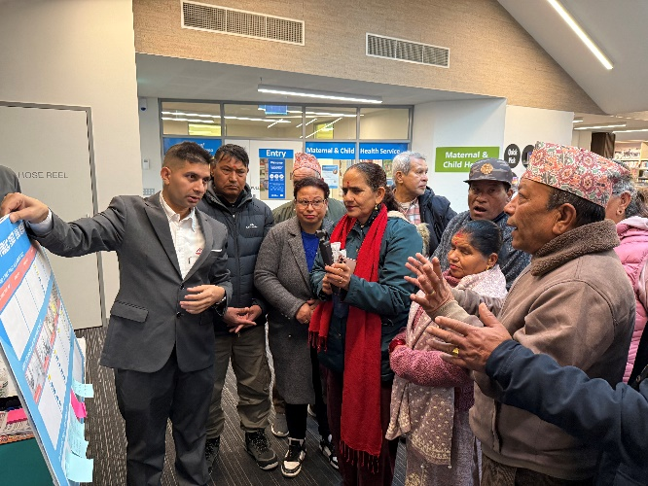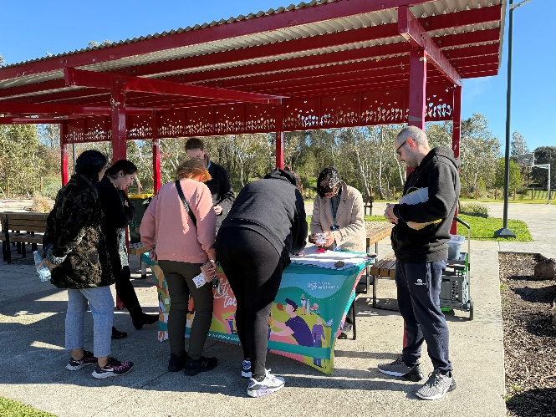
Above: Images of the project team engaging with the community, L – R Nepalese Community Group at Galada Community Activity Centre, Epping and Mill Park All Abilities Playground, Mill Park.

Project promotion
The opportunity to participate in the community engagement was promoted through a range of channels to have a widespread reach across the municipality including:
- Council’s digital engagement platform Engage Whittlesea
- Council’s social media channels
- Direct email sent by key internal staff to their networks, key stakeholder groups and local Members of Parliament to share with their community.
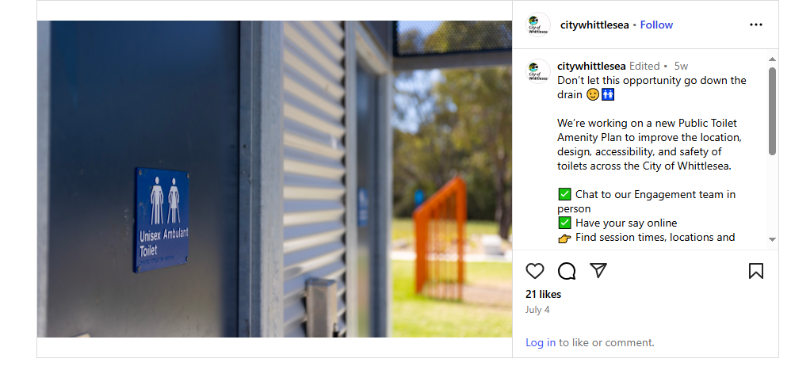
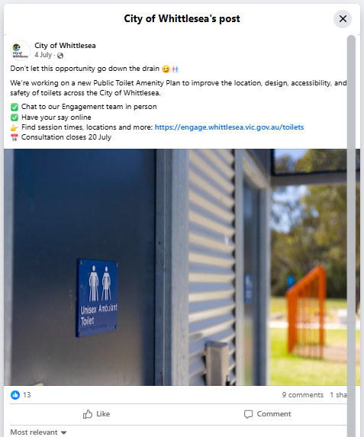
Above: Social media posts promoting the Public Toilet Amenity Plan (Four social posts over a four-week period with 15,618 views and 87 interactions.

Participation
A total of 426 community contributions were received as part of the Public Toilet Amenity Plan engagement.

Snapshot of community participation

 | 
86 people participated in-person across the  ten community-based pop-up events. | 340 people participated  online via the Engage Whittlesea platform.

Snapshot of participant demographics
Gender Identity | Age | Suburb
 |  | 
55% Female, 40% Male, 2% Non-binary, and 3% preferred not to say. | All age brackets participated with the most represented being 35-44 years (29%), 45-54 years (19%) and 25-34 years (15%). | Participants were represented well across wards in the municipality, with the highest participation coming from the suburbs of Donnybrook (15%), Doreen (14%) and Wollert (13%).

LGBTIQA+ Community | First Nations Community | Multicultural Community | Community members living with or caring for someone with a disability
 |  |  | 
5% of participants identified as members of the LGBTIQA+ community. | 3% of participants identified as being an Aboriginal or Torres Strait Islander person. | 19% of participants spoke English as a second language. | 20% of participants identified as living with a disability or an unpaid carer of an older person or someone living with a disability.

What we heard
Below is a summary of what we heard from the community through online engagement and in-person engagement activities.

Participants were invited to share additional comments at the community-based pop-up sessions, and as part of the survey. The feedback received has been grouped into key themes, with selected quotes and graphs included below to illustrate common views and experiences captured.
 | Likelihood of visiting locations with public toilets  Many respondents indicated they would be very likely to visit various locations if public toilets were available. This strong preference was consistent across all categories, including local shopping areas, cafés, council-owned facilities, local parks, and sports facilities.  - Council-owned facilities, local shopping areas and sports facilities had the highest “very likely” responses.  - Local cafés and local parks also received a high proportion of “very likely” responses, though a slightly larger share of participants were “likely” or “not sure” compared to shopping areas and sports facilities.  - “Unlikely” and “very unlikely” responses were minimal across all categories, showing overall strong community support for accessible public toilets in a wide range of public places.  “Use the local parks after school/kinder need toilets so they can stay longer.”  “More toilets in Shopping Centres - Laurimar has no internal toilet, only outside which is always vandalised.”  “Peppercorn park - great park but no toilets!”
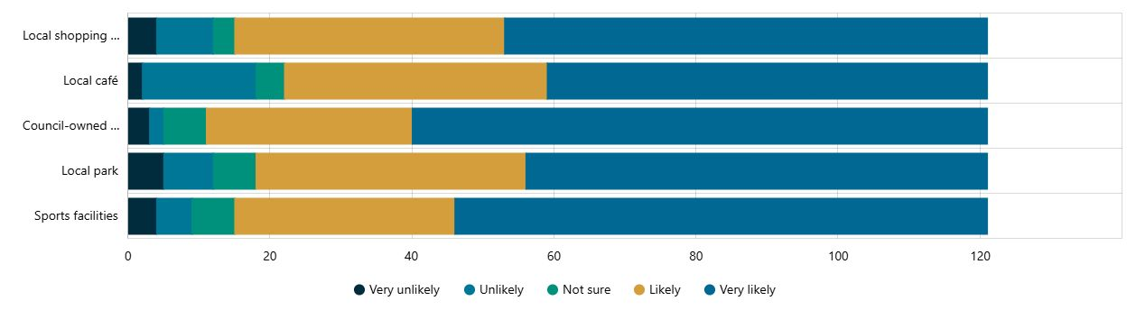
 | Wayfinding of public toilets  When asked how they usually locate public toilets, the top methods were street signage (around 65% of respondents) and Google Maps (about 60%). Far fewer participants reported using the National Public Toilet Map (about 15%) or the Council website (around 7%). About 12% mentioned other methods, such as word of mouth or local knowledge.  “Better lighting and signage (Tuttle Reserve).”  “Better signage to find toilets.”  “Yes, you have completely missed public toilets at the mosaic shopping village / playground. The sign says the nearest toilet is at least a 10-minute walk… add young children who just had something to eat and drink at the shops and it’s a long walk.”
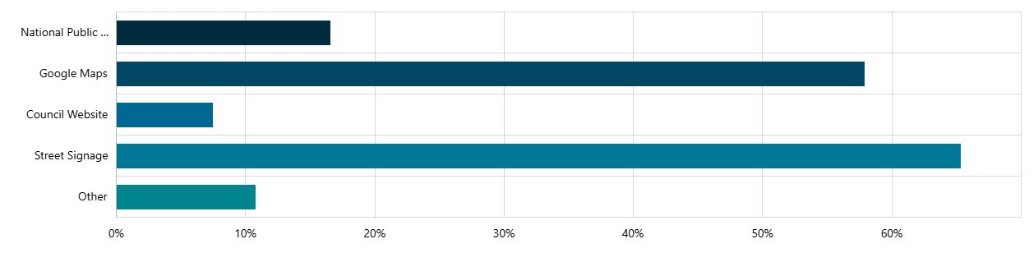
 | Public toilet features  Cleanliness and maintenance  Strong emphasis on toilets being clean, regularly maintained, and monitored. Requests for soap and handwashing facilities for hygiene.  Space and accessibility  Need for larger cubicles to fit prams, multiple children, and mobility aids. Calls for family/all-gender toilets, some people would prefer separate gender toilets, with ambulant doors and handrails to improve accessibility coming through strongly.  Child and family-friendly features  High demand for child-sized toilets, toddler seats, and baby change areas.  Fixtures and practical additions  Frequent requests for multiple bag hooks, shelving, and clear signage (both to find toilets and for automated toilet use).  Location needs  More toilets needed in large parks.  “Parent with child toilets that have enough space for a pram and multiple kids.”  “More clear signage on how to use (Automated ones).”  “All gender and family toilets”
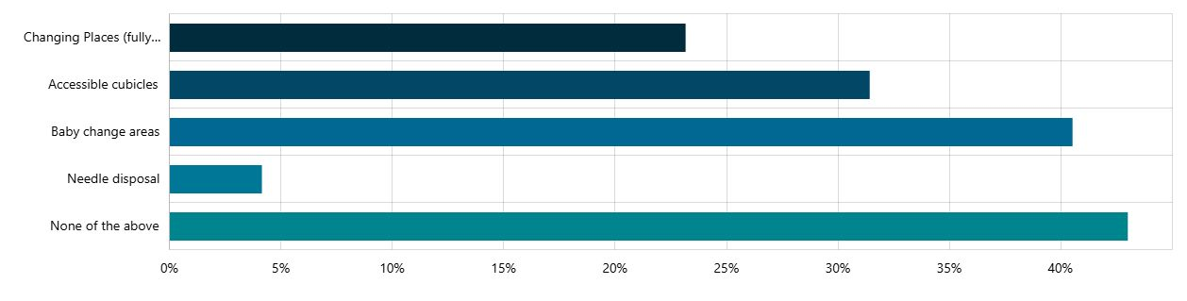
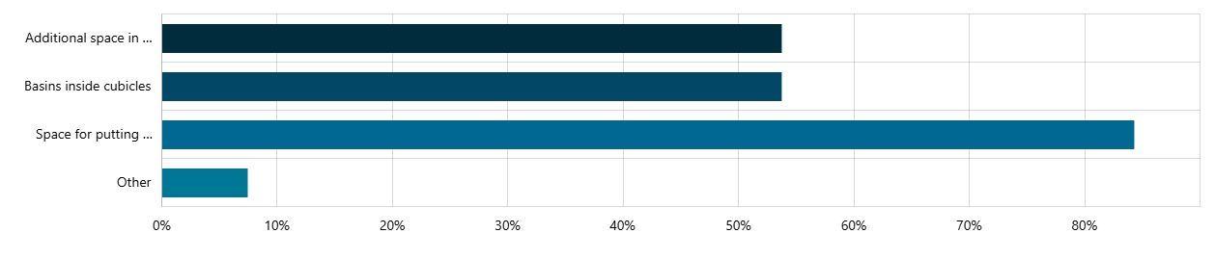
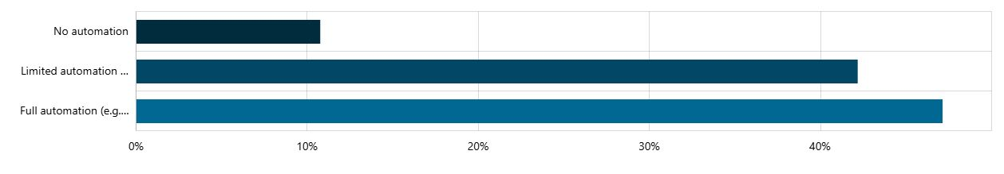
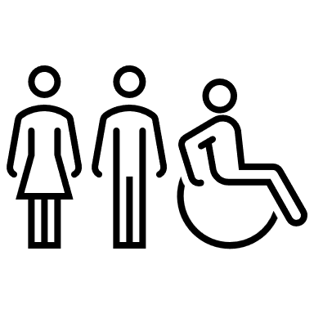 | Urgent need for more accessible and clean public toilets  Community feedback overwhelmingly highlights a critical shortage of accessible and well-maintained public toilets across various locations in the municipality, but particularly in Whittlesea Township and surrounding areas. Key concerns centre on the lack of toilets in parks, playgrounds, and near popular amenities like shopping centres, train stations, and sporting grounds. Many respondents cite cleanliness issues, including lack of toilet paper, soap, and working locks, as significant deterrents. The absence of child-sized facilities, accessible toilets for people with disabilities, and adequate lighting and signage are also frequently mentioned. The need for more gender-neutral and family-friendly options was raised, along with concerns about safety and vandalism. Several comments suggest that the lack of toilets impacts the usability of parks and other public spaces, particularly for families with young children and elderly individuals. The recurring theme is the urgent need for increased provision, improved maintenance, and better design of public toilet facilities to meet community needs.  “Barriers - toilets are dirty, no locks and no toilet paper”  “Build toilets that a suitable for a child, mother with children/baby, elderly, person with a disability whether they have a walking stick or are in a mobility scooter.”  “Upgrade toilet facilities and make sure toilets are cleaned regularly.”
 | Reducing barriers to using public toilets  Participants highlighted several issues with public toilets in the municipality. The most common concern was toilet condition, followed closely by perceived lack of safety. Other frequently mentioned issues included missing toilet seats and lack of space. Less common concerns were heavy doors and lack of appropriate facilities, while a small proportion of respondents indicated they did not experience any issues.  “A regular schedule of maintenance and cleaning which means that the toilets are kept clean for anyone who should use it.”  “Build more public toilets and employ more staff to maintain them.”  “Well lit, single cubicles”
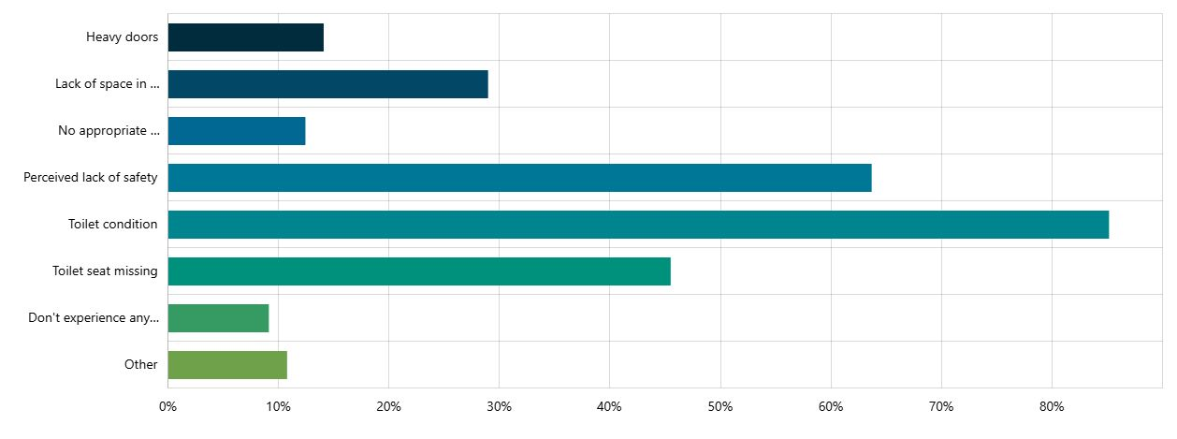
Results of social mapping tool
As part of the engagement, residents were invited to use a mapping tool to identify preferred locations for new public toilets based on community use. The Engage Whittlesea project page featured a Social Mapping tool, while in-person pop-up sessions used localised maps and sticky dots to replicate the activity. The combined results have been compiled into a comprehensive map of all suggested locations, included in Appendix 1.
Community feedback through pin drops has highlighted several priority areas where residents indicated a need for additional council-run public toilet facilities:
- Highest demand was recorded in Donnybrook (44 pins), followed by Doreen (29 pins), South Morang (24 pins), Wollert (22 pins), and Mernda (20 pins). These five suburbs alone account for over 65% of all identified locations.
- Moderate levels of demand were seen in Epping (19 pins), Thomastown (17 pins), Whittlesea (17 pins), Lalor (9 pins), and Mill Park (9 pins).
- Minimal demand (1 pin each) was recorded in Eden Park and Woodstock, while no demand was identified in Beveridge, Bundoora, Humevale, Kinglake West, and Yan Yean.
Overall, the data suggests that rapidly growing northern suburbs that are generally home to families with children such as Donnybrook, Doreen, Wollert, Mernda, and South Morang have the strongest community-identified need, likely reflecting population growth and limited existing facilities. Established suburbs show steady but lower levels of demand, while rural and fringe areas recorded little to no need.

Next Steps
Thank you to everyone who participated in the community engagement by sharing comments, feedback and participating in activities.
The insights gathered through the consultation will help shape the review and development of the Public Toilet Amenity Plan for the next four years. The revised plan will be released for public exhibition before being presented to Council for consideration and adoption in late 2025. Community feedback will also support the development of other key Council plans and strategies, contributing to the vision of making Whittlesea A Place for All.
Well-planned public toilets enhance the liveability of our city by supporting participation in public life, recreation, and local commerce. On the other hand, insufficient or inaccessible facilities can limit community use of parks, activity centres, and public spaces - particularly for families, carers, older residents, and people with disabilities. The City of Whittlesea’s diverse population has varied needs, and the updated Public Toilet Amenity Plan aims to ensure equitable access across all areas of the municipality.

Appendix 1 – Social Mapping Tool Public Toilet pins
Residents were invited to identify preferred locations for new public toilets using a mapping tool online and localised maps at pop-up sessions. The combined feedback has been collated into a comprehensive map of suggested locations shown below.
