Doreen Dirt Jumps
Engagement Summary
April 2024

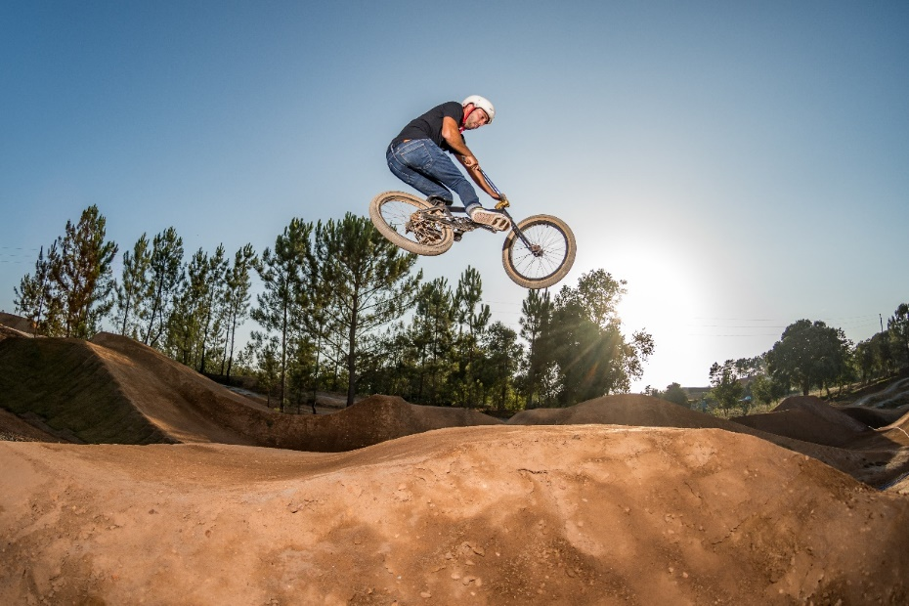

Introduction
City of Whittlesea has worked with Youth Services Australia, as well as local riders, to develop a draft concept plan for dirt jumps track suitable for beginner, intermediate and advanced riders. Dirt jumps are structures made from compacted soil that are used primarily by BMX and mountain bike riders to perform tricks on.
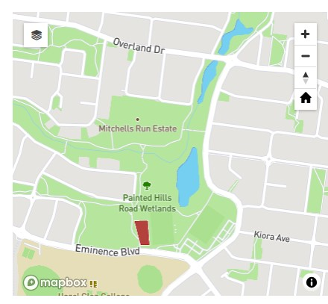
The dirt jumps track, to be located at the Painted Hills Recreation Reserve on Painted Hills Road in Doreen will be made permanent should the 12-month pilot program prove a success. Painted Hills Recreation Reserve was chosen as the site for the pilot program due to its central location and proximity to shared path networks and public transport.
Once the dirt jumps track at Painted Hills Recreation Reserve is built, Council will remove unauthorised jumps at Lauries Field Conservation Area in Gosford Court, Doreen. Under the 12-month pilot program, the track will be regularly inspected, and feedback encouraged from users and residents.
The dirt jumps will provide the following benefits to the community including:

- a safe area for the growing number of residents who take part in off-road cycling sports such as BMX, mountain bike and dirt jumping to go and connect with other riders
- promote local ownership of assets in public open space
- promote a healthy lifestyle to residents within the catchment of the reserve
- promote a sense of community by developing an area within the community where residents can go to meet, socialise, and interact.

How we engaged you
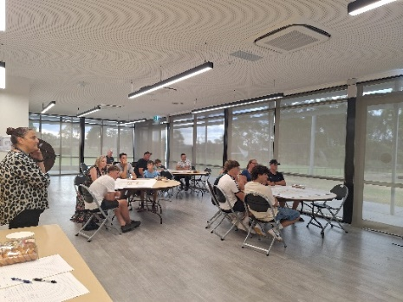
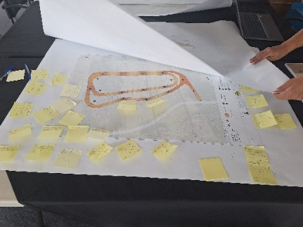
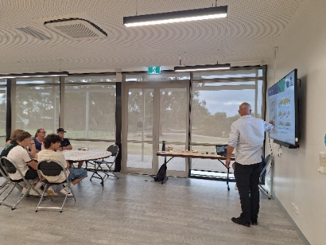
Targeted consultation - workshop sessions: Thursday 22 February 2024
Two workshop sessions were run by Jason Cousins, Director at Youth Services Australia. The sessions held on Thursday 22 February, involved key stakeholder groups, including the Dirt Jumps Advocacy Group, initial petitioners, experienced local riders, and Hazel Glen College students.
Above: Workshop sessions lead by the Director of Youth Services Australia at Painted Hills Reserve on 22 February 2024 at Painted Hills Reserve and Hazel Glen College
Community consultation - gathering Ideas: Wednesday 14 March to Monday 5 April 2024
Consultation for the Doreen Dirt Jumps 12-month pilot program was open for community comment from Wednesday 14 March to Friday 5 April 2024.
The purpose of this engagement was to assist Council to identify the types of jumps that community would like to see at Doreen dirt jumps and to identify any concerns they may have with the proposed site and plan. The community was able to have their say via the project Engage page or in-person at two community-based pop-ups.

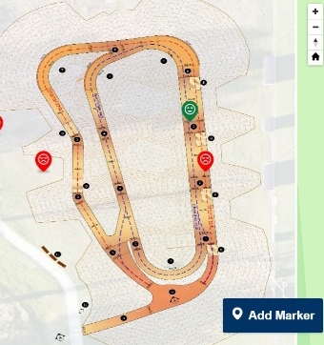
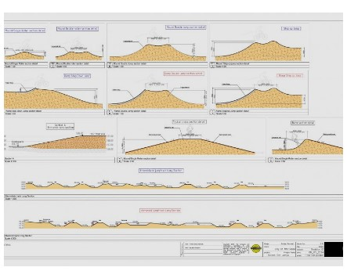
The project Engage page included the concept plan of the track and examples of proposed jumps (see images below). Two consultation activities were featured, a survey, and a pinpoint map.

The online and in-person survey consisted of sixteen questions applicable to beginner, intermediate and advanced riders, as well as non-riding residents. The feedback captured included riding

frequency, skill, type of jumps and general feedback on what they like or don’t like about dirt jumps. See survey questions below:
- How often do you ride dirt jumps?
- What level of rider do you consider yourself to be?
- What features do you enjoy the most in a dirt jump track?
- Do you enjoy maintaining dirt jumps?
- What do you most like about the proposal?
- What do you like about the proposal?
- What could be improved?
- How likely are you to visit the dirt jumps once it’s constructed?
- Do you have any further feedback?
The online pinpoint map of the track enabled respondents to drop a pin and make a comment on a specific point within the project area and provide feedback or an improvement idea for concept plan.

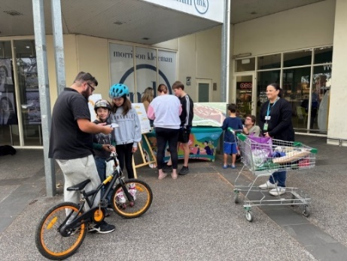
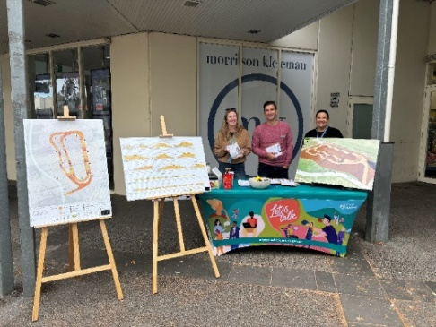
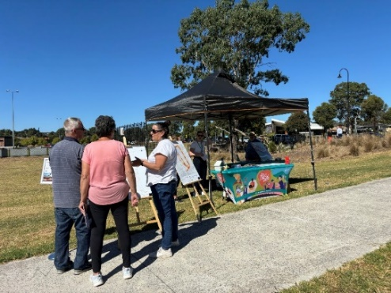
During this period, the project team held staffed community-based pop-ups on Thursday 21 March 2024 at Painted Hills Reserve from 3pm to 6pm and on Saturday 23 March 2024 at Laurimar Town Centre from 9am to 12pm.
Above (L-R): Camilla, Parks Project Manager with residents at Doreen Dirt Jumps pop-up at Painted Hills Reserve on 21 March 2024 and Project Team, Camilla, Alex and Adrian with residents at Doreen Dirt Jumps pop-up at Laurimar Town Centre Community Pop-up on 23 March 2024
Participants at the in-person engagement activities were invited to view the dirt track concept plan and fill in a survey that mirrored the online survey.
Flyers with a QR code directing community to the project Engage Whittlesea page were available at all in-person activities and participants were encouraged to share the opportunity to participate in the engagement with neighbours, family, and friends.
Residents within 400 metres of the reserve, received a letter to update them on project status and invite them to share their feedback through the project Engage page or at one of the community-based pop-ups.
Visitors to the Painted Hills site were alerted to the consultation through large corflute signage installed at the main entry point. The signage featured the QR code directing them to the project Engage Whittlesea page.

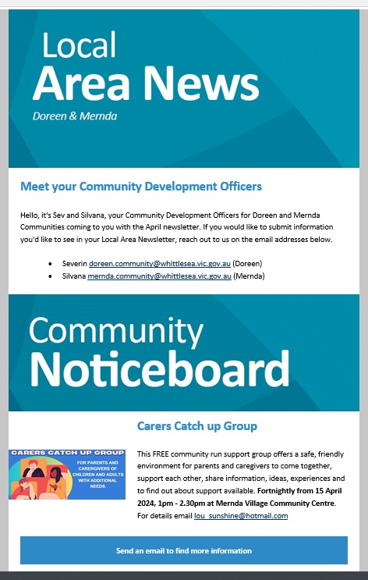

The opportunity to participate in the community engagement and community-based pop-ups were shared on Council’s social media channels including Facebook and Instagram. The Mernda and Doreen Community Development Officers and Placed Based Coordinator shared details with local community groups.
Above: Local Area Newsletter and Doreen Dirt Jumps Facebook event
The Engage Whittlesea platform utilises an accessibility add-on which enables users to easily switch to screen reader mode or easily adjust settings such as font size, contrast, dyslexia friendly options to improve the overall accessibility of the site. The platform also has an in-built translation tool to reduce language barriers to participation, allowing the page to be translated into the top ten languages spoken within the municipality.
Subscribers to the Engage Whittlesea platform that had previously indicated an interest in parks and/or Doreen area were sent a project update email and encouraged to visit the project page and share their feedback.

Participation
During phase 1 consultation, a total of 134 contributions were received, 111 of which were captured in-person at the community-based pop-ups (81) and in the two workshops hosted by Youth Service Australia (30). The remaining 23 contributions were captured through the project Engage Whittlesea page 16 community members completed the online survey and seven placed a pin on the social map.
A total of 549 people visited the project Engage page, 13 of whom opted to follow the page to receive project updates.

Below is a snapshot of combined in-person and online community consultation:


A total of 134 in-person and online contributions.

 | We saw 37 engagements across two event listings on Facebook. Two Facebook stories linked to the Whittlesea Engage page reached approximately 440 people per story.
 | We saw 81 people share their feedback at in-person community-based pop-ups and 30 at the workshop sessions.
 | The project Engage page was viewed 809 times during the four-week engagement period with 369 unique visitors.
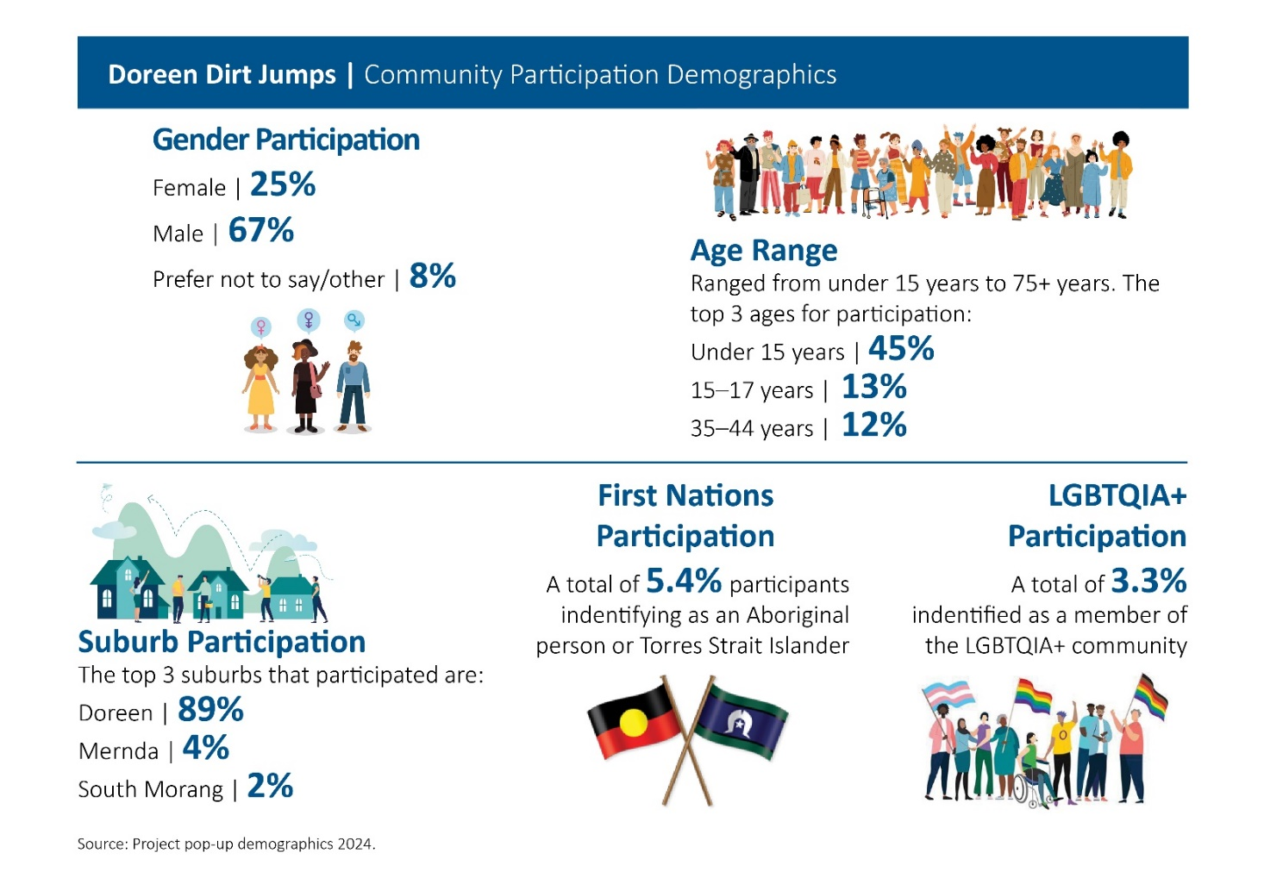

What we heard

Workshops
Council provided opportunities for residents, riders and other stakeholders to provide feedback on the proposed concept designs at two onsite consultation sessions. The community responded with feedback which helped Youth Services Australia to fine tune the designs before the draft plans were shared with the wider community online and at the two community-based pop-ups.
Online and in-person consultation
Of the 97 participants who completed an online or in- person survey, 73% indicated that they are bike riders. Of these, 18% ride daily, 17% a few times a week, 13% ride on weekends only and 44% ride occasionally. Just under half of riders consider themselves to ride at an intermediate level and 32% rate their ability as advanced or an expert.

When asked what features they most enjoy in a dirt jump track 68% would like to see tabletop jumps included in the track and 56% like step up jumps and berms. See full breakdown of preferences below.
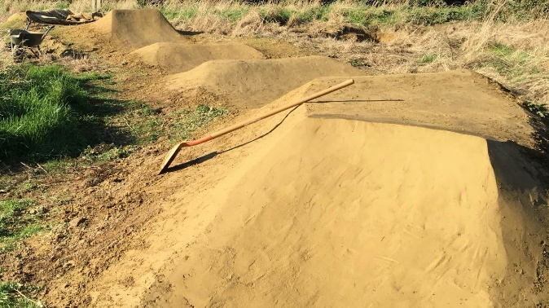
Over 80% indicated that they are happy to keep the dirt jumps maintained.
Above: 1Favourite feature in a dirt jump track graph and image of a dirt jump
Of the 70 who answered the question, how happy are you with the proposal, only 1% responded with a negative sentiment, while 93% are very happy or happy with the proposed dirt jumps.
 |  | 
93% Positive | 6% Neutral | 1% Negative

Below are some of the comments we heard from our community when asked if they are happy with the proposal.
“Since I like biking, I’m happy more jumps are being built”
“It will give me and my friends something to do on the weekend that’s close to home”
“It’s close to home and deliberately built”
“To get the kids out on their bikes”
“Good to fill up the space and gets kids outdoors and promotes physical activity”
“Fantastic use of space and great idea to entertain the kids”
“Something for kids, mums and dads”

Seven non riders shared a pin and commented on the online social map activity. All of these contributors were over the age of 25 years, and all reside in Doreen. One participant expressed that she is looking forward to a track being built for the local bike riders. Others raised concerns about the flooding problem in the area, ongoing maintenance of the track and potential anti-social behaviour.
Of the 97 who completed an online or in-person survey, 70 answered the question how likely are you to visit the dirt jump park once it’s constructed? An overwhelming 96% of respondents are very likely or likely to visit the track.

Opportunities
Participants were invited to share their thoughts on the proposed draft concept plan and offered potential future opportunities for Doreen Dirt Jumps, some of which may be out of scope of this project. Below are the themed comments received through both online and in-person engagement activities.
 | Facilities – Respondents highlighted the need for additional shade and seating areas to encourage spectating  “A shelter and toilets”  “Could add a few more spectator seats”  “Ensure the drainage is adequate and more bins”  “Toilets, bike stands, shade and seats”  “Having a water fountain for drinks and lots of rubbish bins or waste”
 | Safety – Participants suggested additional measures, such as signage and lighting to ensure security in the area  “Safety for young children”  “Little one’s safety with experienced riders, like a roller rink”  “First Aid Facility / Fire Blanket / Extinguisher”  “Signage for different skill levels”
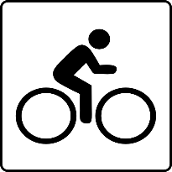 | Track – Respondents made suggestions on ways we can improve the proposed track to make it more inclusive and accessible to all ages  “Beginner friendly jumps”  “Space between jumps”  “More advanced jumps”  “Small bitumen pump track”  “Small track for little kids”  “bike pumps”  “bike repair station”

Next steps
Thank you to everyone that completed the survey online, attended a community-based pop-up or participated in one of the workshop sessions.
Council has engaged a contractor and construction will commence in June 2024. The community will be kept updated on learn to dig days and the Grand Opening via the Doreen Dirt Jumps Project Engage Page.
The 12-month pilot program will be reviewed throughout the year. As part of the pilot program, a committee will be established, and a maintenance manual created. Riders and residents are encouraged to provide feedback during the trial period.

