Mill park place framework
Engagement Summary
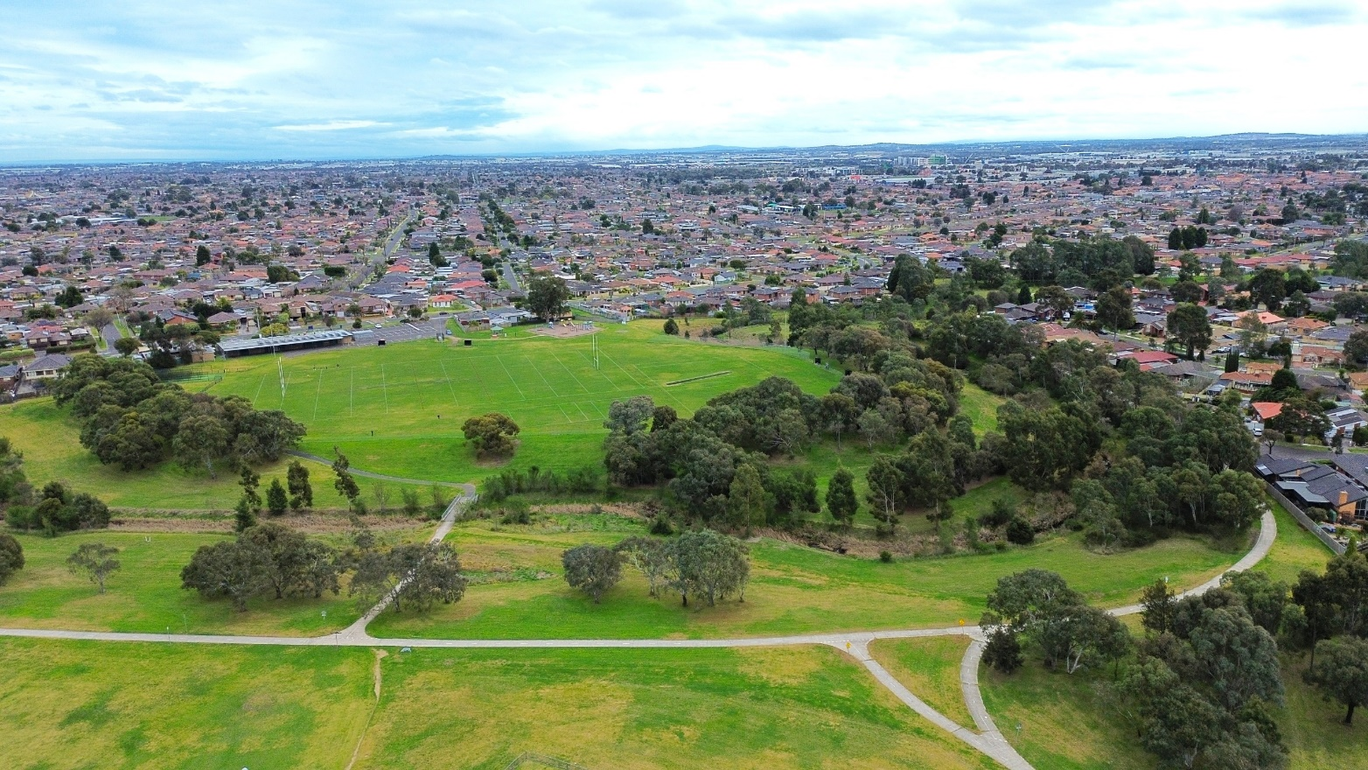

Phase 2 Community Consultation August 2024

Introduction
The City of Whittlesea developed a draft place framework for the Mill Park area, a shared community and Council plan to guide the future development of the area. This framework strives to recognise priority opportunities identified by the community, shaping local spaces, and establishing connections to implement a series of improvements gradually over time.

The project is an ongoing collaborative approach to improve streets, public spaces, community precincts and infrastructure. The implementation of the framework will be subject to further detailed design, availability of funding, consultation with stakeholders and the community.

The place framework is designed to support and deliver concepts and strategic directions from the following:
- Whittlesea’s 2040 Vision: A Place for All
- Plan Melbourne
- Urban Design and Placemaking related research
- Other relevant State and local policies.

The draft Mill Park Place Framework focuses on six key projects in the short-term including:
- Safer streets to walk and cycle to school
- Enhancing community hubs
- Revitalising key destinations
- Reimagining transmission easements
- Upgrading parks
- Increasing the walkability through future development.

In the long term, the project focuses on advocating for improvements to key roads, waterway corridors and town centres.

Feedback from the community and stakeholders will inform the final Mill Park Place Framework Plan. The community engagement included two phases:
- Phase One, Information Gathering – Completed
- Phase Two, Draft Place Framework Plan Exhibition – Completed

This report summarises the community engagement undertaken as part of phase two, Draft Mill Park Place Framework exhibition which was open for community comment from Monday 22 July to Monday 26 August 2024.

How we engaged you
In phase two, we shared our draft Mill Park Place Framework Plan with the community to determine two things:
- How important the six short-term projects (listed below) are to community
  - Safer streets to walk and cycle to school
  - Enhance community hubs
  - Revitalise key destinations
  - Reimagine transmission easements
  - Upgrading parks improving residential interfaces
  - Increasing the walkability through future development.

- How the community feels about the proposed draft Mill Park Place Framework selecting from the scale below.
  - Like it a lot
  - Like it
  - Neutral
  - Don’t like it
  - Don’t like it at all

Community feedback was sought online through Council’s Engage Whittlesea platform and through direct conversations and a dot board activity at five community-based pop-ups.
The Engage Whittlesea platform utilises an accessibility add-on ensuring that it is as accessible as possible for all users. The platform also has an in-built translation tool to mitigate any language barriers to participation, allowing the page to be translated into the top ten languages spoken within the municipality.
Engage page
On the project’s Engage page, community were invited to participate in a short survey, or provide more detailed responses in a longer survey to find out more about their connection to Mill Park, their usage, any issues and ideas for key destinations, transmission easements, green corridors and walkability around the Mill Park area.

Survey Questions
In the brief survey, participants were asked the following questions:
- What is your connection to Mill Park?
- How frequently do you visit the suburb?
- How important is the six short-term projects to you?
- Do you like the draft Place Framework?

Participants were invited to contribute to a longer survey to provide more details about the six short-term proposed projects to understand their connection to Mill Park. The short-term projects are:

- Safer streets to walk and cycle to school

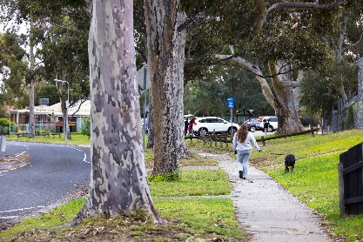
Providing safe streets for our young people to walk and cycle to school is a priority for Council. Survey questions helped determine what mode of transport community use to get to school and which areas are most congested.

- Enhance community hubs
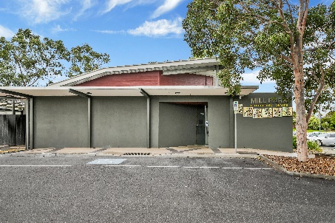
Strengthening community connections by enhancing our community hubs is also a priority project for Council, survey questions help us understand the current use and feelings about the Miller Community Centre.

- Revitalise key destinations
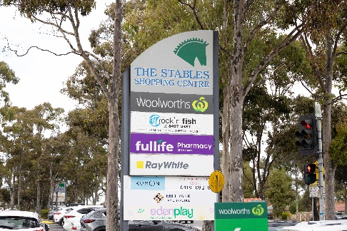
Another priority project is revitalising key destinations in the Mill Park area. We asked community if they visit any of the following key destinations in the Mill Park area and how frequently they use and feel about each location?
- Mill Park Stables (pictured left)
- Mill Park Library
- Mill Park Leisure Centre
- Miller Community Centre
- Development Boulevard Shops
- Plenty Valley Westfield.

- Reimagine transmission easements

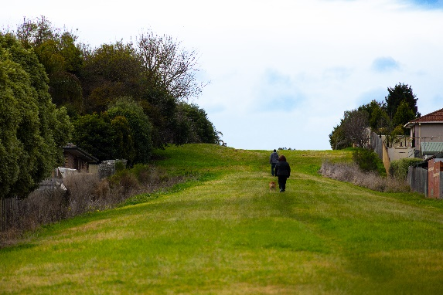
To determine usage and community sentiment for the transmission easements, open space areas beneath and around transmission lines, the survey included questions about the usage and feelings about the following:
- Transmission Line Easement
- Yan Yean Pipe Track (pictured left)
- Darebin Creek Corridor
- Plenty River Corridor
- Area reserved for E6 Corridor.

- Upgrading parks and residential interfaces

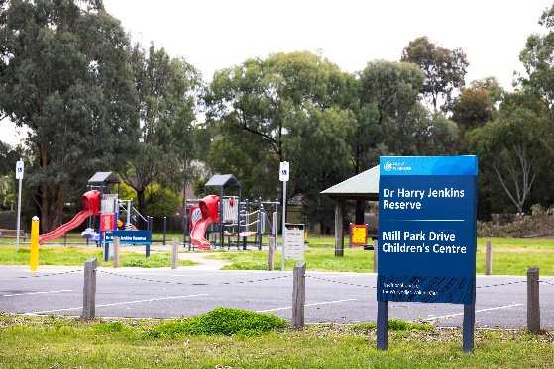
To ascertain which parks are most liked and used,
Participants were invited to share which parks or other spaces that they visit and identify which is their preferred park and why. They were also asked if they feel safe when visiting a park.

- Identify ways to improve walkability through future development
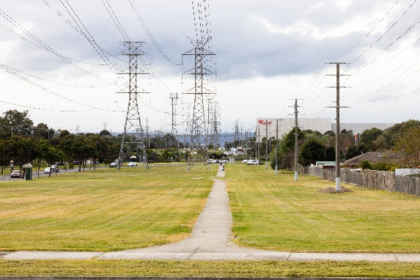

To determine ways to improve walkability in the area, participants were asked how easy it is to travel around Mill Park for short trips to shop, visit parks or daily walks and if the introduction of more pedestrian cut throughs would it make it easier to reach destinations?

Community-based pop-ups
The project team co-facilitated five community-based pop-ups in the Mill Park area. The in-person activities enabled deeper discussion with the project team and offered an opportunity to add additional suggestions.
The pop-ups were held on the following dates in the following locations:
Stables Shopping Centre | Thursday 8 August, 2.30-4.30pm
Millers Community Centre | Monday 12 August, 2.30pm to 4.30pm
Mill Park Library | Thursday 15 August, 5.30pm – 7.30pm
Mill Park Leisure Centre | Tuesday 20 August, 9.30am -11.30am
Plenty Valley Westfield | Friday 23 August, 11.30am – 1.30pm

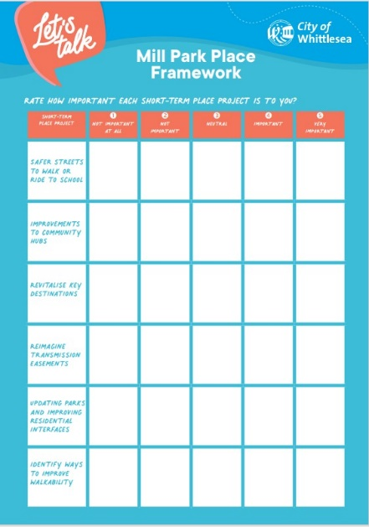
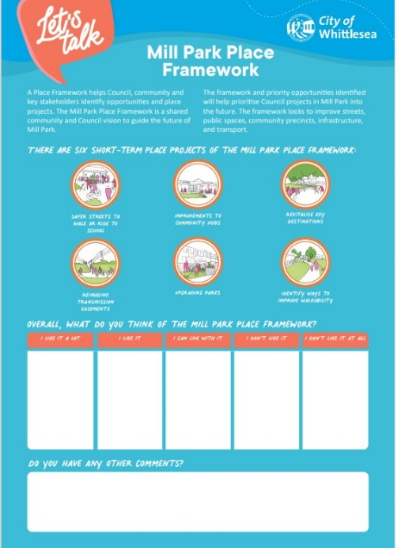
Activities presented at the community- based pop-up mirrored the online engagement activities, where community had a choice to participate in the dot board activity below or fill out a brief or longer survey.
Above: Dot boards used at Community based pop-up for Mill Park Place Framework consultation

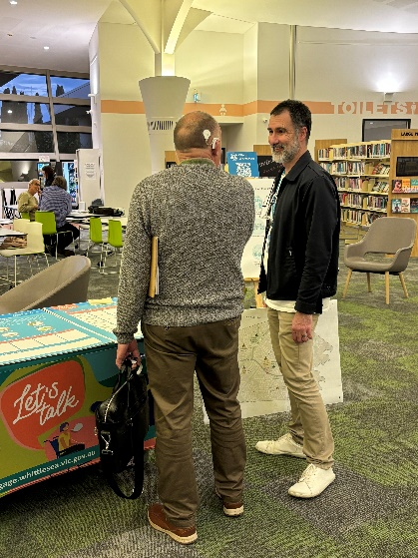
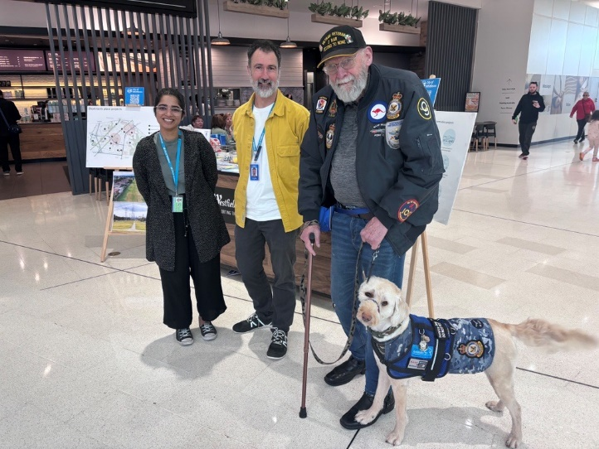
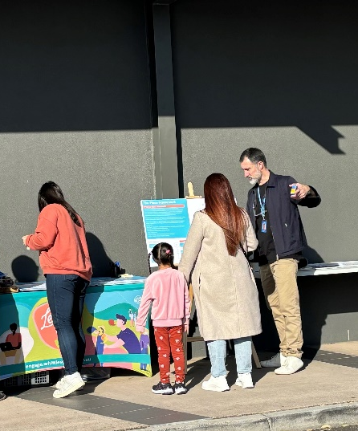
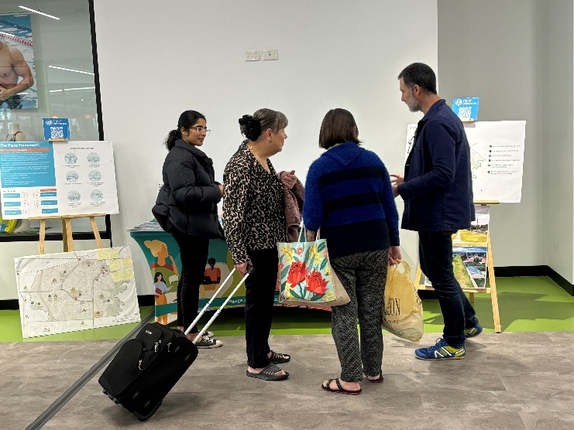
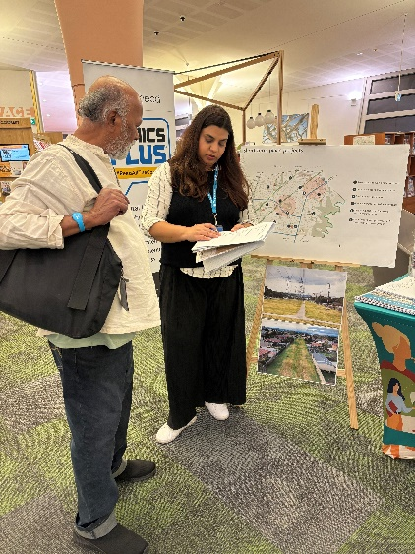
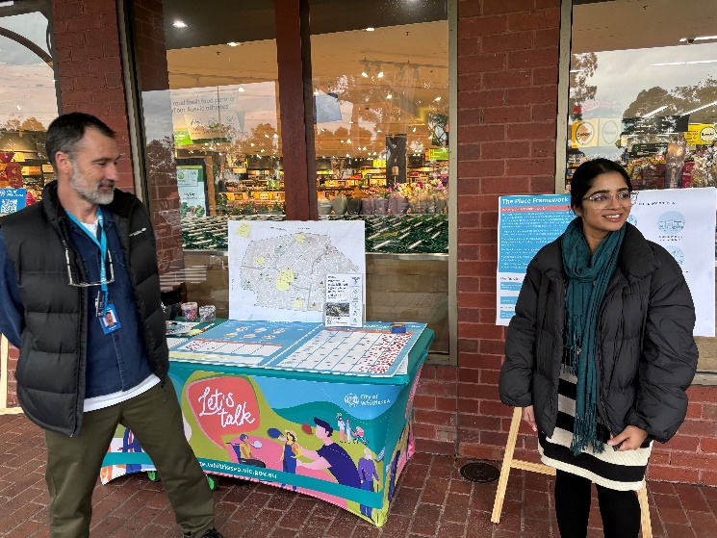
Below: Mill Park Place Framework community pop-ups held at key destinations around Mill Park

Project promotion
The opportunity to participate in the community engagement was promoted through a range of channels to have a widespread reach across the targeted area and wider municipality including:
- Council’s digital engagement platform Engage Whittlesea
- Social media – we shared four posts across Council’s social media channels (Facebook and Instagram)
- Plenty Valley FM
- Flyers and posters displayed at Council facilities and libraries.
- Media articles
  - Help Shape Future Of Mill Park | The National Tribune
  - Help Shape Future Of Mill Park | Mirage News
  - Help determine the future of Mill Park | Northern (starweekly.com.au).
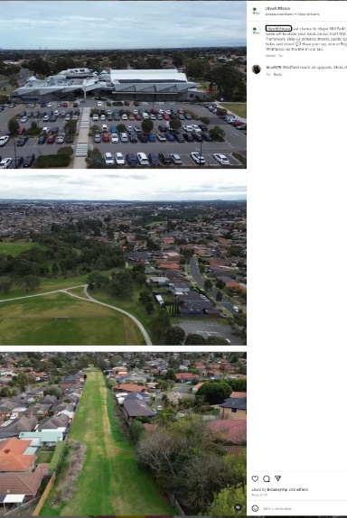
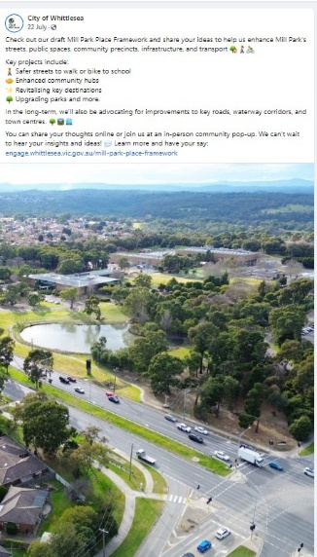
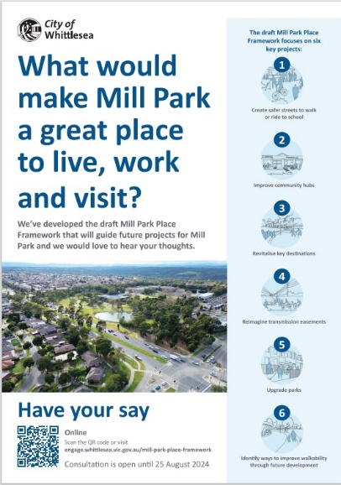
Above: Mill Park Framework Instagram and Facebook posts and flyer promoting the consultation

Participation
A total of 213 community members participated in phase two consultation. Participants were given the opportunity to contribute in two ways; 118 community members participated in person at community-based pop-ups and 95 community members contributed online via the Engage Whittlesea platform by filling out a survey.

 |  | 
A total of 46% identified as female and 53% as male. One percent of participants identified as non-binary. | A total of 43% of participants were over the age of 55 years and 38% between the age of 35 -54 years. Twenty-three percent were aged 18-34 years and six percent were aged under 18. | A total of 75% of participants reside in Mill Park with 8% living in neighbouring South Morang.
 |  | 
English as a second language is spoken by 39% of respondents, with Hindi, Macedonian and Greek being the top three languages also spoken at home. | A total of 3% identified as a member of the LBGTQIA+ community. | A total of 2% identified as Aboriginal or Torres Strait Islander.

Below is a snapshot of the demographics of participants.

Below is a snapshot of community participation in the engagement.
 |  | 
Three organic and one paid social media post reached 20,021 accounts and were engaged with 2,874 times, generating 48% of traffic to the online Engage page. | We hosted five community-based pop-ups in the Mill Park area with 98 people sharing their feedback through surveys (20), dot boards (78) and conversations with Council staff. | The Engage Whittlesea page was viewed 1755 times during the consultation period, with 95 people participating in the online survey. Eighteen people opted to follow the page to receive project updates.
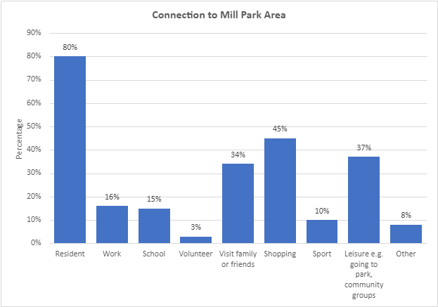
What we heard
Of the 115 people we surveyed, 80% live in the Mill Park area, while others travel from surrounding suburbs to shop (45%), to school (15%) and to work (16%). Some also travel from outside the municipality to visit family and friends (34%) and to use facilities such as Mill Park Library and Mill Park Leisure Centre. See full breakdown of connections captured below.

A total of 64% of participants visit Mill Park weekly, while 14% visit daily. See below for full figures.
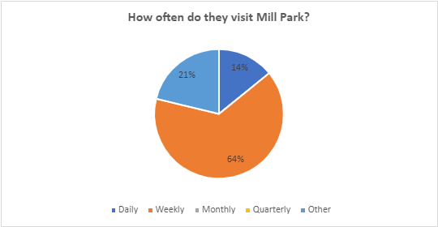

After viewing the six short term proposed projects, survey and dot board activity participants were asked how do they feel about the draft Mill Park Framework? Of the 208 respondents, 88% liked or liked the draft plan a lot. Only 1.5% pf participants provided a negative response to the plan.
I like it alot | I like it | Neutral | I don’t like it | I don’t like it at all
 |  |  |  | 
49% | 39% | 11% | 0.5% | 1%
Participants were offered the opportunity to view the six short term strategies and share how important each project is to them and their families. Responses to this question will assist Council to determine priorities when finalising the Mill Park Place Framework. The top three most important projects for participants are safer streets to ride to school (158), updating parks and improving residential interfaces (126) and identifying ways to improve walkability (116). Below is the full breakdown of the importance participants placed on each of the projects.
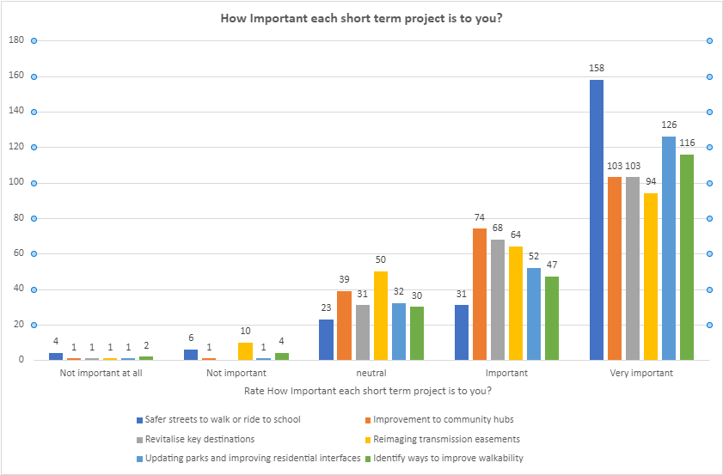

Many of the respondents reside in Mill Park area (80%). However, a large number (45%) visit from other suburbs to shop in the area (key destinations such as the Mill Park LiNot all participants of the Mill Park Framework consultation reside

A total of 80 participants provided additional comments about the proposed short-term projects.
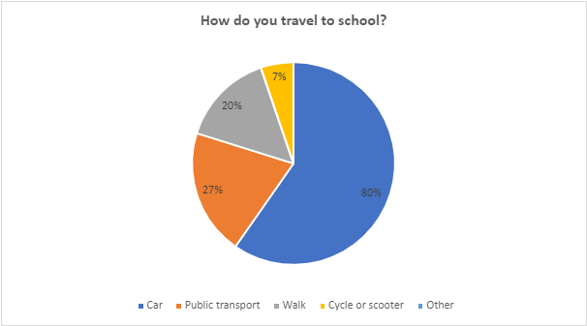
Short term project 1: Safer streets to walk or ride to school
A total of 39% of participants had a member of their household currently attending school in Mill Park, with 80% of these young people commuting to school by car. See how others travel to school below.

When asked if they would consider walking or cycling to school if the path is safe, 87% said yes. Distance was the main reason for the 13% who said they wouldn’t consider this as an option.
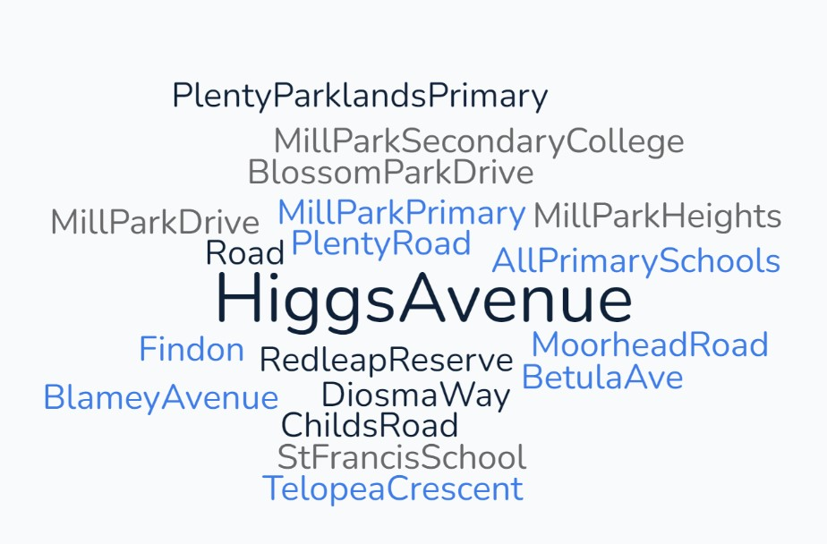
Traffic congestion Is an issue for 92% of participants. See below for some of the streets and schools that were identified as being congested during drop off and pick up times.

Below is a selection of comments made about the short-term project safer streets to walk or ride to school.
“Many school now have annual bike incursions”
“Bike tracks to link Primary Schools together”
“School crossing areas, more parking should be available for pick up and drop off this will stop people parking illegally close to the crossings and stopping on crossings + get more parking officers around these type of parking issues so drivers can be booked, the disrespect to School Crossing Supervisors trying to keep people safe is a disgrace in Mill Park”
“Childs road becomes super busy 24 hours a day. There need to be slower speed limits and no entry to trucks or heavy vehicles so the residents along Childs Road feel less disturbed by vehicle noise especially after sunset and before sunrise”
“Safer paths to encourage walkability”
“I hope council can looking to improve to have a safe crossing at the intersection of Betula Avenue and McKimmies Rd during both morning and afternoon when school finish. I saw students on bicycle trying to cross the busy intersection before & after school. It seemed posting a risk and no encouraging bike riding to school initiative”
“Bike paths are missing in Mill Park primary school area”

Short term project 2: Improve Community Hubs
A total of 27% of participants attend the Miller Community centre weekly. Others (9%) attend once every few months.
The reason shared for visiting the centre was:
- Events
- To make connections with older community members through Senior Citizens groups
- Cultural gatherings
- Various programs
- Resident drop in.

Below is a selection of what participants told us about the short-term project Improve Community Hubs.
“Improvement to Community Hubs - like the possibility of libraries in hubs to help build the literacy in the community”
“More activities for kids at the Mill Park community centre or a centre where these activities could help as well as a meeting place for other members of the community”
“I rarely visit Miller Community Centre as it doesn’t offer any programs I would likely be involved in, however I walk past it daily”

“It is important to create destinations that are attractive and that will entice community members to want to connect with other people and their local environment. It is also important to enable these destinations to be able to be accessed by the public by means of transport other than the car e.g., walking, bike riding or public transport”
“Its a shame the Mill Park Library is isolated from major hubs. It would be better if community facilities and services were co-located and easily accessed by public transport. Ideally, they should also be in town centres”

Short term project 3: Revitalise Key destinations
Participants were asked if they visit any key destinations in Mill Park. The top three most visited destinations were Westfield Plenty Valley (90%), Mill Park Stables (88%) and Mill Park Library (85%). The full breakdown of what we heard can be seen below.
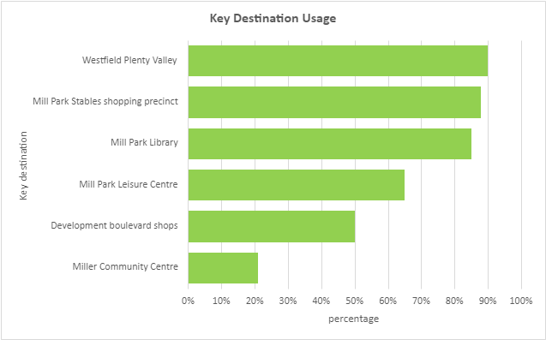

Participants were asked how often they visit key destinations, see below for breakdown of frequency of usage for The Stables, Mill Park Library, Mill Park Leisure Centre, Miller Community Centre, Development Boulevard Shops and Westfield Plenty Valley. The Stables was visited daily by 26% and weekly by 43%. A total of 60% of participants visit Plenty Valley weekly.

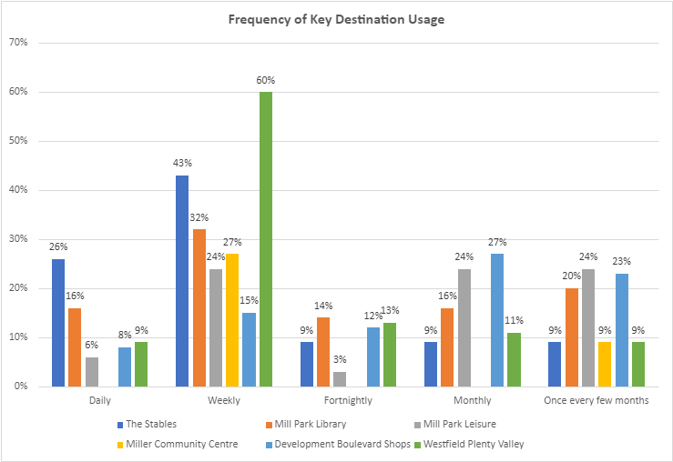

To help Council gauge the community sentiment of key destinations, participants were offered the opportunity to share how they feel about key destinations including the Stables, Mill Park Library, Mill Park Leisure, Miller Community Centre, Development Boulevard Shops and Westfield Plenty Valley. Participants were asked to indicate if they like it a lot, like it, can live with it, don’t like it, and don’t like it at all.

Of all six key destinations the Stables shopping area received the most negative feedback from participants, with 35% indicating that they don’t like or don’t like the destination at all. Mill Park library was a favourite destination for many within and outside of the municipality (84%), as well as Westfield Plenty Valley (72%). Below is what we heard for each destination through the activity.

Key Destination | Like a lot/Like | I can live with it | Don’t like/ don’t like at all
 |  |  | 
The Stables | 34% | 31% | 35%
Mill Park Library | 84% | 13% | 3%
Mill Park Leisure | 66% | 25% | 9%
Miller Community Centre | 40% | 40% | 20%
Development Boulevard Shops | 39% | 50% | 12%
Westfield Plenty Valley | 72% | 20% | 8%

Below is a selection of what participants told us about the short-term project enhancing key destinations.
“Stables shopping centre upgrade with better security, renovation, and selection of shopping.
This upgrade can also lead to tenancy options for NFPs creating job opportunities for residents”

“As I need to use the library every day from morning to night, it is expected that the Council increase the open times, on the weekends and Fridays”

“We often walk to the Stables at least twice a week, but the infrastructure is aging, pedestrian access is poor, parking is impossible at peak times and there are no facilities for children”

“I attend The Stables 4-5 times a week. It really needs a renovation, removal of op shops and old stores to encourage improvement of local demographic. Resurfacing car park. Brunch style cafes to give it a more community feel”

“The library is a great facility but is difficult to get to by public transport. It would have been a great community hub if it had been placed near a major shopping precinct”

“Love the outdoor area and the community cafe and community and kids’ activities in library”
“Need to improve accessibility by bicycle and/or public transport to the library”
“Gym equipment needs an update in Mill Park Leisure Centre”
“Mill Park Leisure - great centre and good facilities!”
“The traffic on Development Boulevarde can get very congested. The footpath leading to the shops from both Plenty Road and Development Boulevard needs to be made continuous”

“Honestly, the outdoor area outside the cinema is great, and it's a feel that I wish was replicated in places like Stables and Mill Park Library. But without the burden of giant shopping centre”
“Access by bike to Plenty Valley could be improved. Need to consider provision of secure bike parking rather than just providing the current hoops”.

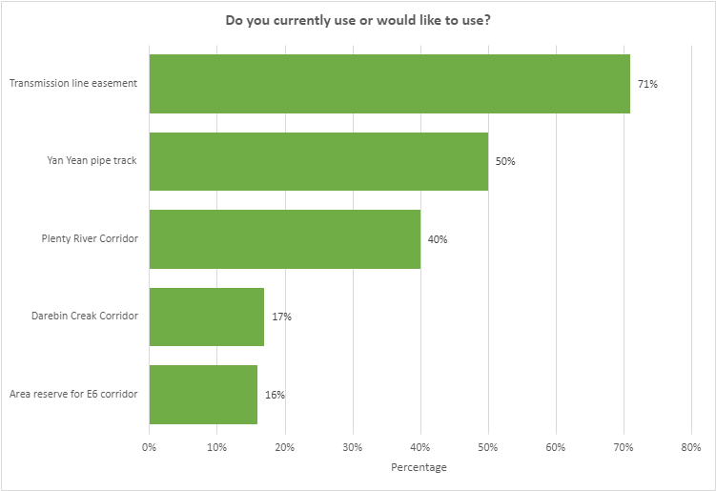
Short term project 4: Reimagine Transmission Easements
Participants were asked if they currently use or would like to use any of the following, Transmission Line Easement, Yan Yean Pipe Track, Darebin Street Corridor, Plenty River Corridor, or the Area Reserved for E6 Corridor, for activities? The Transmission Line Easement was the most popular, with 72% of participants currently using or wanting to use this area.

Participants were then asked how frequently they use each transmission easement and green corridors. From the full data captured (below), we can conclude that transmission easements and green corridors need to be reimagined to improve usage amongst the community.

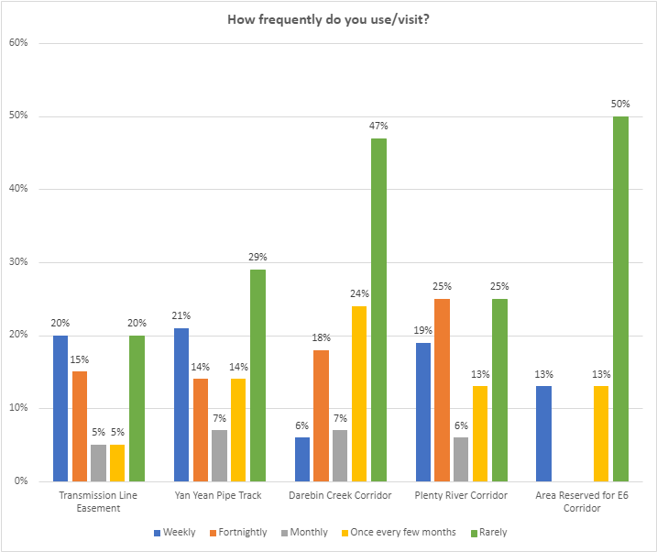

Participants were given the opportunity to share how they feel about the transmission easements and green corridors, indicating if they like it a lot, like it, I can live with it, don’t like it, and don’t like it at all. See chart below for sentiment.

Transmission Easements | Like a lot/Like | I can live with it | Don’t like/ don’t like at all
Transmission line Easement | 53% | 18% | 30%
Yan Yean Pipe Track | 38% | 23% | 38%
Darebin Street Corridor | 13% | 33% | 54%
Plenty River Corridor | 14% | 29% | 57%
Area reserved for E6 Corridor | 50% | 50%

Below is a selection of what participants told us about the short-term project Reimagine Transmission Easements.
“I live next to the green corridor under transmission lines. It is frequently overgrown and ignored or used by dirt bikes when mown. Would be nice to give the spaces purpose and more attention”
“Transmission easement areas should be focused, even walkways are not properly set and many times cars are being parked/left in these areas. This area makes the neighbourhood feel very unwelcoming and unliveable”

“I walk up Yan Yean Pipe Track to get there. Would love to cycle but there's no path. Also it's a bit ugly”

“Utilising the Yan Yean pipeline division, much like the new added path between Darebin creek all the way up to the Stables shopping centre via the pipeline was a fantastic addition. The space is already there and will always be there so relatively cheap to make use of these open spaces”

“The transmission easements are depressing, so I’m glad you’re looking at those. The one on Morang Drive could be an amazing gardens and paths wonderland. You could have precincts and excellent natural features with plants and rocks common to the area. Same with the big strip between plenty valley and houses, and the north south one next to the high school”
“Path with fitness equipment somewhere? Along transmission corridor?”
“Although the Yan Yean Pipe Track corridor is a lot narrower it has far more opportunity to benefit the community. It's hits so many of your key projects at the same time. By improving the walkability of that specific green corridor, you hit so many of the project goals: Improving green corridors, school walkability (Mill Park Secondary College) and parks (via walkability to the Redleap Reserve) while
also making it easier for people to walk to both The Stables Shopping Centre, South Morang Station and Westfield”
“Something I'd like to contest is the importance of the green corridor along Morang Drive. Yes, it's a very large, unused area but it doesn't connect anything to anywhere other than the Mill Park Leisure Centre, South Morang Train Station, and a few minor parks”

Short term project 5: Updating Parks and improving residential interfaces
Participants shared some of the parks and reserves that they visit in the Mill Park area with family and friends. Some of the favourites of participants include the Mill Park All Abilities Play Spay, Dr Harry Jenkins Reserve, Redleap Reserve, Buckmaster Drive Park, Telopea Park, WA Smith and Sycamore Reserves.
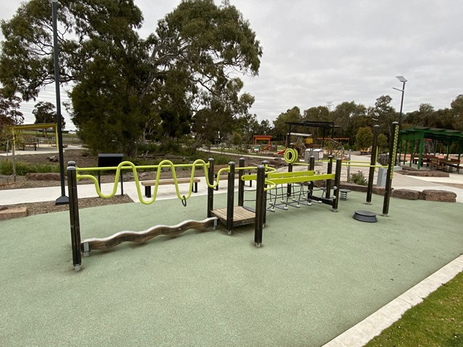
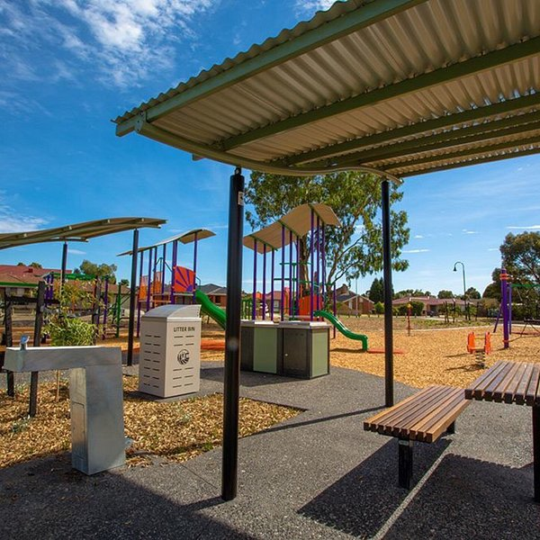
When asked if they feel safe when visiting parks in the area, 75% of respondents said yes, they feel safe and 25% don’t feel safe.
Above: the popular Redleap Reserve and Mill Park All Abilities Playground

Below is a selection of what we heard about the short-term project Updating Parks and improving residential interfaces?
“Engaging, well designed, and maintained public infrastructure, particularly walking, and cycling paths and public playgrounds with quiet spots for people to engage with their community is important. Particularly as houses occupy more and more of their block and or people living in small, shared units/townhouses”
“The park behind the Stables Shopping Centre needs an upgrade. Unsafe because people use drugs in the park and leave empty nitrogen canisters everywhere”
“The park and reserve place should be safe and clean for families. All playgrounds for kid should be upgraded, not just for some playgrounds near big houses and rich people. People can see the big different in playground between 2 sides of plenty road”
“More and improved playground around the area would be great. I would love for my kids to grow up being surrounded by things that bring the community together”
“More access to park exercise equipment would be fantastic”
“Safer play spaces for children”

Short term project 6: Identify ways to improve walkability
Participants shared how they currently travel around the Mill Park area for short trips such as to go shopping or visit parks. A total of 85% of respondents travel by car for short trips and just over half of respondents also walk. Only 11% ride their bicycle to the shops or park. See below for full figures.
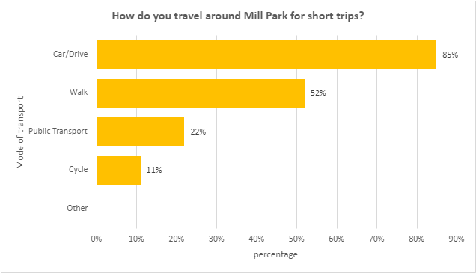

To identify how community feel about the walkability in the Mill Park area, respondents were asked to rate if they feel it is very easy, easy, it is ok, it is not easy, it is not easy at all to get to their destination on foot. Just under half (48%) feel it is easy or very easy to walk around Mill Park.
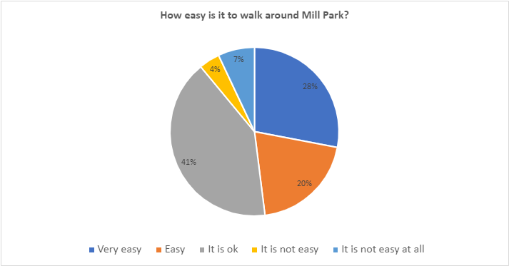

Below is a selection of what participants told us about the short-term project Identify ways to improve walkability.
“Walkability is an issue in a few places with lack of pedestrian footpaths and crossings. Two places in particular: roundabout at Morang Dr and Childs Rd with no signalised pedestrian crossing, and westbound on McDonalds Rd to the west of Morang Dr with no footpath”
“Walkability is really important, as are bike lanes, which get people out of cars. I live on Higgs Ave, and if more people from here could ride uninterrupted to Stables, either under or over Child’s rd., then this would take cars off the road. Need to think big because you can’t direct bikes to footpaths, and no one wants to die on Child’s rd. I would suggest an elevated bridge that lifts of from Doctor Harry Jenkins park over to the median strip. Then up toward stables and over or under the child’s rd. Redleap intersection to land on the grassy corner, which is converted into a park and bike terminus”
“Increase walkability of E-W routes. Living West of Plenty Rd feels disconnected to Stables and all those other places due to the largeness of Plenty Rd and also because the walkability of these routes are bad. e.g. Childs Rd is really bad for walking - very narrow and bumpy. Same for Mckimmies Rd”
“Use current resources to improve walkability, safe accessible walking paths especially across main roads”
“It is important to create destinations that are attractive and that will entice community members to want to connect with other people and their local environment. It is also important to enable these destinations to be able to be accessed by the public by means of transport other than the car e.g., walking, bike riding or public transport. This is particularly important for our young people attending
school, where you can help to shape the culture by decreasing dependency on travel by car leading to a more sustainable future”
“Develop all weather walking paths across the paddock from Bean Crt and Stillman Drive to the Food Court”
“Many of us elderly could leave our cars at home and walk across to Westfield. It’s extremely important that us the elderly are able to get exercise and social pleasure each day. Many of us no longer drive so we are trapped at home”

Key messages from community feedback
Participants were invited to share what they like, any issues and any potential future opportunities for the Mill Park area, some of which may be out of scope of this project. Below are the main themes of what was raised along with an accompanying technical response to provide context.

 | Accessible – upgrading key destinations to include Disability Discrimination Act (DDA) compliant ramps and parking facilities.  “Walking paths are very important. Parking at Westfield Plenty Valley is terrible. Disabled parking spots are too few and not policed so anyone parks there.  Many of us are still able to walk a reasonable distance as the crow flies. If we had walking paths, we could leave our cars at home”  “Need disability access at the Stables shopping centre”  “Mill Park Leisure has only 1 bathroom with a hoist - need a booking system for busy times. Some people with disability have physios that attend for an hour session and often too much time is taken up waiting to use the bathroom”  Technical response:  Access to amenities will be addressed in the Framework, including providing walking paths through green corridors and by exploring opportunties to improve pedestrian connections through future developments ensuring equitable access to daily needs.  Council will also explore ways to ensure access to services at Council facilities and in public spaces. Please note that privately-owned properties, including the Stables Shopping Centre and Plenty Valley Westfield, are outside the Council’s scope.
 | Environment and Ground Maintenance - Beautify the Mill Park area by increasing the frequency of maintaining the grounds and planting more trees, as well as protecting wildlife.  “Beautify walk through areas with gardens/trees  “Mill Park Drive Trees very overgrown, need maintenance”  “Biodiversity and use of native plants throughout the plan is good”  “Mill Park Drive Trees very overgrown, need maintenance”  “More gum trees and protection for the existing gum trees and birds. Better maintenance of the parks around mill park drive (mowing). Establishment of a community garden or other community third places for recreation”  “Council needs to invest more resources and place a greater priority on caring for wildlife. For example, kangaroos are at risk and suffering as a result of neglecting proper wildlife management. Priority should be given to re locating wildlife that are trapped by road and building development in Mill Park”  “Keep gutters clean of leaf litter and grass to allow rainwater to flow. Allow 40-year-old nature strip trees to be pruned or replaced instead of causing house leaf litter to increase home maintenance”  “Keep the Peter hopper lake footpaths clean of rubbish and leaf litter”  “Beautify the shared path between Morang station and Pindari over bridge. Bushes are taking over the path restricting access. Place beautiful bottle brush trees along there (like McDonald’s Road)”  Technical response:  Kangaroos, like all native wildlife, are protected in Victoria under the Wildlife Act 1975. The City of Whittlesea is advocating to Department of Energy, Environment and Climate Action for a regional approach to kangaroo management to reduce the risk of landlocking kangaroo populations and ensure the ongoing health and viability of kangaroos in the municipality.  Kangaroos are not easily able to be moved as translocation of Eastern Grey Kangaroos is technically challenging and can be very stressful for the animal. They are very attached to their home ranges and may experience dislocation and even attempt to return making translocation unfeasible in many cases.  We also have a dedicated tree management plan for the maintenance and upkeep of trees in the municipality.
 | Facilities – Respondents highlighted the need for additional facilities in key destination spaces to increase usage and enhance experience.  “A gym circuit around the lake”  “Provide quiet reading room for private study at Mill Park Library”  “Put a cafe or kiosk at Peter hopper lake”  Technical response:  Council will investigate opportunities to improve facilities to accommodate the needs of our community. Opportunities to activate public spaces will form a part of the revitalisation of key destinations and will provide more choice of activities for community.
 | Safety and lighting – introducing additional lighting in parks, carparks and walking tracks to make users feel safe and help to deter anti-social behaviour.  “More lighting in outdoor sport grounds car parks. And lighting in park areas”  “Please invest in ensuring street lighting is safe and working”  “Please don't forget the safety aspect around our community. Lighting down walking tracks is important because they are useless after dark yet we still wish to walk our dogs after work or in the evenings. Safety for children and adults no matter what projects are being designed. I have been afraid to live in my own home lately with all the home invasions and car jackings. Please work towards keeping this community safe for our children especially”  “Upgrade lighting in residential areas to meet Australian standards”  “All new infrastructure needs to be properly maintained. Consider lighting needs for paths around activity centres to enable residents to feel safe if needing to use paths after dark”  “Safety cameras and lighting to stop anti-social behaviour at the back of the Stables”  Technical response:  Council will be investigating additional lighting opportunities for open spaces as part of its Public Realm Lighting Plan. Lighting opportunities are also being considered for selected shared paths in Mill Park.
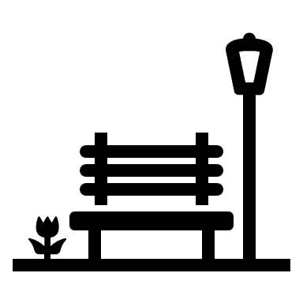 | Playground – respondents highlighted the need for upgraded parks in the area to encourage community to spend more time outside to help improve community well-being.  “More and improved playground around the area would be great. I would love for my kids to grow up being surrounded by things that bring the community together”  “Need rubbish bins in parks, playground”  “Add some lids to the bins. Rubbish flies everywhere! Add dog poo bins or free bags to encourage Redleap Reserve dog walkers to pick up their poo”  “They are important as it allows for the suburb to improve for its citizens and be more visually appealing allowing more outdoor participation, improving citizens physical wellbeing”  “The park and reserve place should be safe and clean for families. All playgrounds for kid should be upgraded, not just for some playgrounds near big houses and rich people. People can see the big different in playground between 2 sides of plenty road”  Technical response:  Council has a park and playground renewal program to manage renewal of playgrounds across the municipality. This program prioritises parks to be upgraded based on the annual safety audit, equipment age, and community impact. We are currently working to put this information on our website to keep the community  informed. We are currently working to put this information in a publicly accessible webpage to keep the community informed
 | Public Transport– residents highlighted the need for additional and more frequent public transport.  “More frequent public transport”  “The key concern is missing the tram line. The tram 86 needs to be extended”  “Consideration for improvements to future public transport in the area, connecting from the Plenty Road end through to Epping Central”  Technical response:  Whittlesea is advocating for better public transport services across the municipality as outlined in our Advocacy Priorities 2023-2025. Safer and better public transport options are also identified as a priority in our Integrated Transport Plan 2024-2034. Extension of the route 86 tram line and better bus connections across the municipality are identified as key opportunity areas for advocacy.
Next steps
The information captured through phase two consultation will inform the Mill Park Place Framework to be considered by Council in February 2025. The feedback captured will also help to inform the development of other key plans and strategies Council are working on Whittlesea’s 2040 Vision: A Place for All.
Thank you to everyone who participated in phase two of the community engagement by sharing comments, feedback and participating in online and community-based pop-up sessions. The community will be updated on further developments via the Mill Park Place Framework project page.

