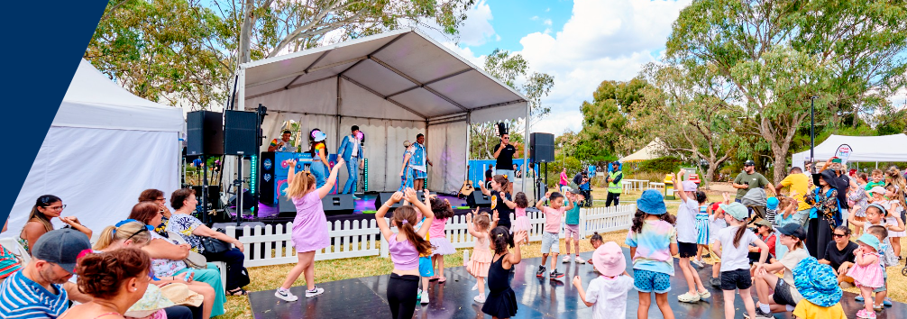

Community Priorities
Phase 2 Community Check in Engagement Summary
2 December 2024 – 31 January 2025

Introduction
With a newly elected Council, we are developing a new Community Plan, which is Council’s main medium-term strategic planning document. It will expand on the long-term community vision, Whittlesea 2040: A place for all, to include key outcome priorities, services, and initiatives over the next four years. It plays a central role in Council’s overall strategic planning and reporting framework.

Each year Council develops a Community Plan Action Plan (CPAP) which is an annual supplement to the Community Plan. This action plan outlines the key actions to be completed over the next financial year to build towards achieving the Community Plan and ultimately our Whittlesea 2040 goals. These goals are for a Connected Community, Liveable Neighbourhoods, a Strong Local Economy, a Sustainable Environment, and a High-Performing Organisation.

Similarly, each year Council releases an annual Budget for the investment and delivery of critical services and essential infrastructure to support our rapidly growing community. We need to balance the delivery of ongoing services and programs while also building infrastructure and facilities to cater to our growing population.
The budget is developed to align to our long-term financial plan which balances our current spending on projects and services for the community and strengthens our long-term financial sustainability. Understanding what services and assets our community value most now and for the future helps us shape key documents that will guide Council’s activities over the next 5-10 years.
Council undertook community consultation with people who live, work, study or visit the City of Whittlesea to understand community issues and needs across the municipality. As the municipality has diverse residents and needs, the consultation was designed to understand what is most important to the community and areas that they felt budget funding would be best allocated.
The feedback received will inform the 2025-26 Budget, Community Plan 2026-29, Asset Plan 2026-35, Financial Plan 2026-35, Road Management Plan 2026-29 and Revenue and Rating Plan 2026-29.
This first phase of consultation included digital engagement, 13 community-based pop-ups and two stakeholder group presentations. The opportunity to participate was promoted via social media, emails to targeted stakeholder groups and flyers. During phase one a total of 881 contributions were made from a diverse cross-section of our community who told us that the top five priorities for our community across the municipality are:
1. Roads, public transport and footpaths 2. Parks, playgrounds and open space 3. Community facilities 4. Community safety 5. Arts, culture and events.
Throughout December 2024 and January 2025, we shared with the community the priorities we had heard through phase one consultation in order of priority and asked them if they agreed with the order, if we had missed anything and for any other comments. This phase was conducted online through the Engage Whittlesea platform; however, we also held the same activity in-person at Council’s Carols by Candlelight event in December. Deliberative engagement is scheduled for phase three of consultation, with community focus groups scheduled for February. The opportunity to submit an EOI for the focus groups formed part of the promotion of this phase of consultation.

How we engaged you
The Community Priorities project page on the Engage Whittlesea platform encouraged participants to agree or disagree with the order of priorities captured in the first phase of consultation. There was free text space provided for participants to add further comment as part of the additional questions. Visitors to the project Engage page were also presented with an opportunity to submit their interest in being part of a community focus group to be held in February 2025. The Engage Whittlesea platform utilises an accessibility add-on ensuring that it is as accessible as possible for all users. The platform also has an in-built translation tool to mitigate any language barriers to participation, allowing the page to be translated into the top fifteen languages spoken within the municipality.

Engagement Activities
To hear from a diverse range of community members and increase participation, the project team hosted an in-person engagement activity at Council’s Carols by Candlelight event which was attended by over 2,000 diverse community members.
The community- based consultation was held at:
Date | Time | Where | Address/location
13/12/2024 | 5pm-9pm | Civic Lawns | 25 Ferres Boulevard South Morang
Below: dot boards used at community-based pop-up
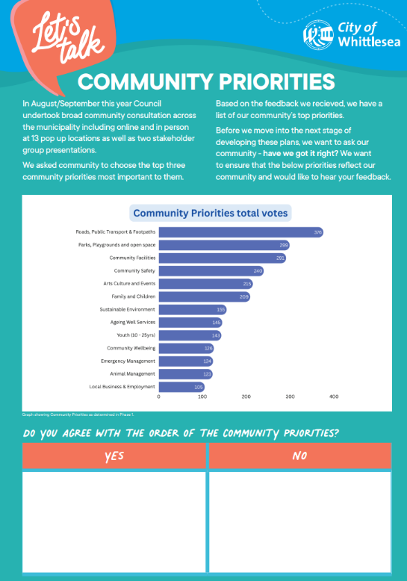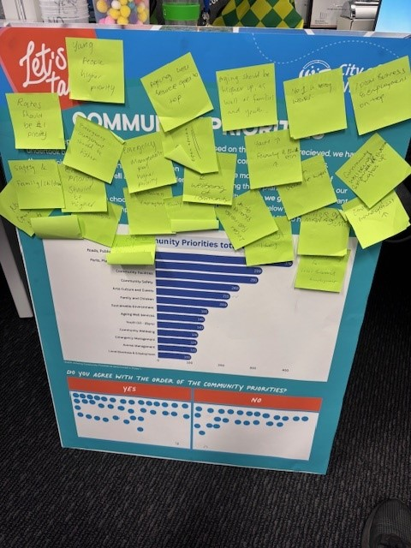
Below: L-R flyer used to promote the consultation and project team at the pop-up
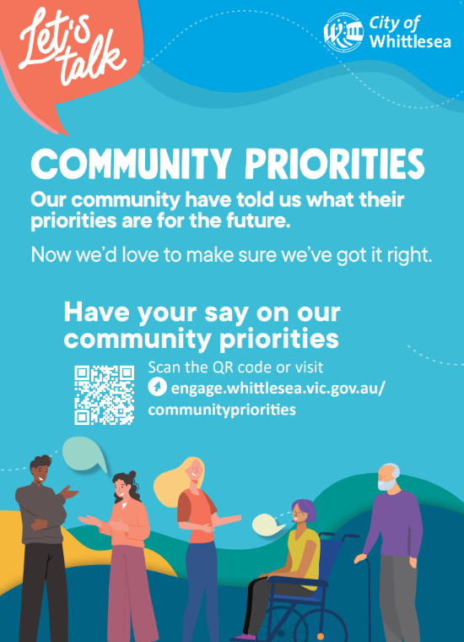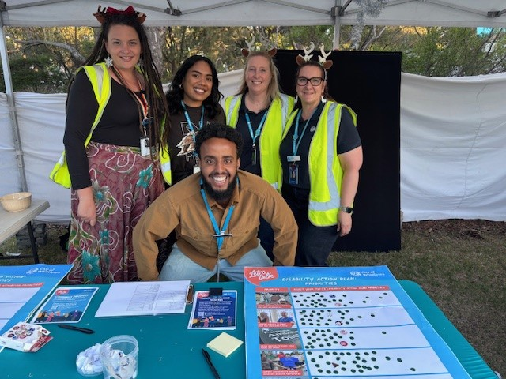

Project Promotion
The opportunity to participate in the community engagement as well as to submit an EOI to be a part of the Community Priorities Focus Groups was promoted through a range of channels to have a widespread reach across the municipality including:
- Council’s social media channels
- Engage Whittlesea campaign to platform users were invited to participate
- Direct email-sent by project teams to their community networks.

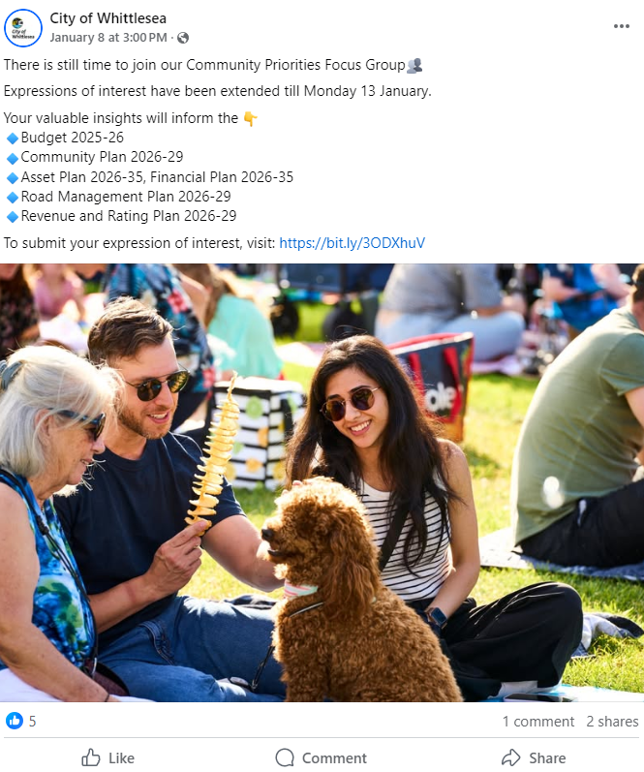
Above: A social media post advertising the upcoming Community Priorities focus group

Participation
In phase two we heard from 133 participants.

Snapshot of Community Participation
Highlights from the community consultation included:
 |  |  | 
Community-based pop-up | 60 people participated in-person | 77 people participated online | 23% carers of and or people with a disability

Snapshot of Demographics
Below is a snapshot of the diversity of participation:
Gender Identity | Age | Suburb
 |  | 
53% Female, 40 % Male and 7% Preferred not to say | 29% aged 36-45, 23% 26-35 and 18% 46-55 | 16% South Morang, 12% Epping, Mill Park and Doreen
LGBTQIA+ Community | CALD Community | Aboriginal or Torres Strait Islander
 |  | 
8% of participants identified as member of the LGTBQIA+ community | 27% spoke English as a second language | Two participants identified as First People

What we heard

Community Consultation Results
We asked the 133 participants if they agreed with the top three priorities that were captured through the first phase of consultation. Below is what we heard:
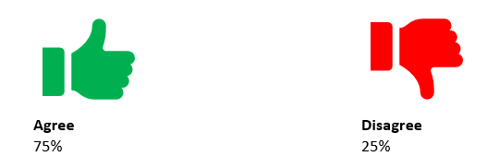
Key themes from Community feedback
Online participants were given the opportunity to share how they may order the priorities differently, whether we missed any priorities or add any other comments.
We have themed the feedback we captured for each of the questions below:

 | Do you agree with the order of the Community Priorities?  A total of 11 people responded that they did not agree with the order of priorities and suggested the below amendments:  Four thought community safety should be higher é  Two believed parks playgrounds and open space should be higher é  One thought arts, culture and events should be lower ê  One believed sustainable environment should be lower ê  One thought community wellbeing should be higher é  One felt parks playgrounds and open spaces should be lower ê  One thought community Facilities should be Higher é  One believed ageing Well Services should be higher é  One thought sustainable environment should be higher é  One felt emergency management should be higher é  One thought youth Services should be higher é  The reasons provided for their response included:  - Sustainable Environment goes hand in hand with footpaths and playgrounds. If you focus on increasing and improving the landscape by creating natural shade and attractive landscape, people automatically want to be more walking and on bikes.  - Community safety and associated initiatives/infrastructure/enforcement projects should rank higher on councils’ priorities
Have we missed anything?
A total of 29 contributions were made to this question and these have been themed below:

Nine participants commented about the maintenance and upgrade of existing assets including facilities, roads, footpaths and parks.
- "Maintenance Management of Facilities, Equipment, structures, Trees/Plants/Shrubs planted anything else the CoW has initiated or placed or installed."
- “Priority should be given to existing old facilities before investing in a new one. Distances between facilities should also be a consideration before building a new one.”
- “Footpaths are really bad, a lot in Thomastown haven't been renewed since 1960's only patched up.”

Five participants commented about the need for more services in Wollert specifically.
- Need health and wellness priority such as gym, swimming etc not even close to Wollert such large crowd living in the locality.
- Wollert lacks shopping and cafe facilities especially in the St Claire’s estate area. It’s like it’s been neglected. A group of shops was mentioned years ago on the cnr of De Rossi and Highpark (the vacant land across from Wollert primary and secondary Schools.

Four respondents commented about Community Safety.
- I think since the survey was completed crime in the area has increased tenfold. We need more police presence and more youth engagement to deter crime.

Four respondents commented about waste related services.
- Rubbish and management of illegal dumping
- Rubbish, General waste drop off at Bridge Inn Road tip. Difficult to work out how to go about doing it.

Other comments related to disability services (2), lack of social activities for people in their 20’s (1), transport (1) and sustainability (1).

Do you have any other comments?
A total of 27 participants took the opportunity to provide additional comments.

Nine comments related to maintenance and cleanliness of areas in the municipality including parks, gardens and kerbsides.
- I hope that cleanliness of the roadsides and green spaces is part of the consideration for those top two priorities, as that lets our suburbs down at the moment - dumped rubbish, but also just loose trash floating around brings down the feeling of quality in the area.
- Parks and kerbside in Doreen need much more attention and more clean-up on a more regular basis.

Six comments related to traffic management, particularly in areas of Thomastown and Mill Park. Improvement suggestions included installations of traffic calming measures such as speed humps and chicanes and reducing speed limits.
Other comments included suggestions on council processes, acknowledgement of inclusivity and diversity of respondents, public transport and education about waste and recycling.
- In an area like Whittlesea that is so large and diverse opinions will vary greatly
- All external priorities are fine, however will there also be a focus on streamlining council processes for cost and time efficiency, and with a view to containing or reducing Rates and improving value to rate payers?

Next Steps

Thank you to everyone who participated in the community engagement by completing our community priorities activity and/or registering their interest to be a part of our community focus groups. The priorities were supported by majority of participants (75%) and there was no change required to the order of the community priorities captured.

The information captured through the different phases of consultation will inform the development of the draft 2025-26 Budget, Council (Community) Plan 2025- 29, Financial Plan 2026-35, Road Management Plan 2026-29 and Revenue and rating Plan 2026-29. The draft Community Plan 2025-29 will be shared with community for feedback. The feedback captured will also help to inform the development of other key plans and strategies Council are working on to make Whittlesea A Place for All.
The Community Plan will feature as one of two activities in the upcoming Community Priorities Focus Groups scheduled for February 2025. Once drafted, the plan will also be presented to our Youth Council and Aboriginal Communities team for further feedback.

The community will be updated on further developments via the Community Priorities | Engage City of Whittlesea. We encourage you to register and follow the page to be kept updated on the project.

