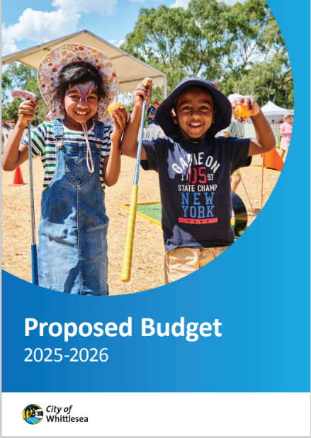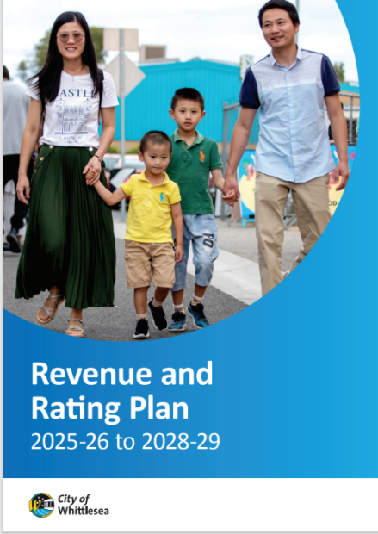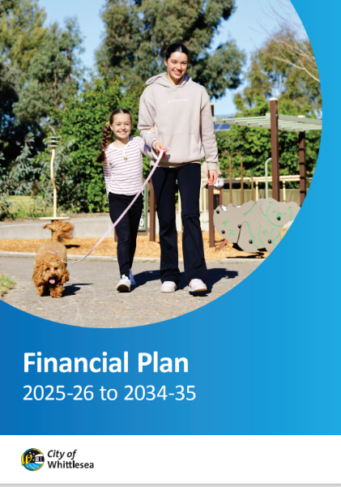
STRATEGIC FINANCIAL DOCUMENTS
Engagement Summary Report
August 2024 to May 2025

Introduction
The City of Whittlesea has developed its Proposed Financial Plan 2025-26 to 2034-35 and Proposed Budget 2025-26 which outline Council’s commitment to invest in essential services and infrastructure while ensuring long-term financial sustainability. The Financial Plan (Plan) is a key strategic document that guides Council in managing its resources effectively to meet its strategic objectives and the needs of the community over the next 10 years. It provides a long-term financial framework that supports Council's ability to meet both current and future financial capacity to deliver the required level of services and infrastructure for a growing community, while ensuring that Council is financially sustainable now and in the future.

Council has also developed its Proposed Revenue and Rating Plan 2025-26 to 2028-29 which establishes the guiding principles for calculating and raising the revenue necessary to fund Council’s operations. It also outlines how the funding will be equitably distributed among ratepayers and other users of Council facilities and services. While the Plan does not set specific revenue targets, it provides the strategic framework and key decisions that determine how revenue will be calculated and collected to ensure Council’s financial sustainability and its ability to deliver essential services and infrastructure for the community.

These key financial documents were developed considering feedback received during a comprehensive multi-phased Community Priorities engagement program that ran from August 2024 to May 2025 and included feedback online or in-person from over 1,100 participants across 21 community-based pop-ups, two key stakeholder group presentations and three focus groups with 46 participants.

In the final phase of the consultation the proposed documents were presented to community for feedback between 16 April and 7 May 2025 with participants asked whether they supported the documents and if they didn’t to explain why. Participation was available online through the Engage Whittlesea platform or in-person at a series of eight community-based pop-up stalls scheduled across the municipality in high foot traffic locations.

To avoid consultation fatigue, the project was co-located with the Proposed Asset Plan 2025-26 to 2034-35 and Community Vision Review projects that were also open for comment.

Project promotion
The opportunity to participate in the community engagement was promoted through a range of channels to have a widespread reach across the municipality including:
- Council’s digital engagement platform Engage Whittlesea
- Social media – generating 28% of traffic to the Engage page
- Engage Whittlesea email campaign to 1520 platform users
- Promotion on screens at Civic Centre, libraries and aquatic centres
- An e-newsletter or personalised email with direct link to the project page, which accounted for 42% of traffic to the page, was sent to:
- People who engage with Ageing Well services
- Registered multicultural and seniors groups
- Sports and recreation clubs
- Aquatic Centre operators
- Youth Services network
- Library and community hubs users
- Whittlesea Disability Network
- First Peoples network
- Community Priorities Focus Group participants
Above: Images of social media posts/reels

How we engaged you
The community engagement to inform these key financial documents has been delivered in phases as below:
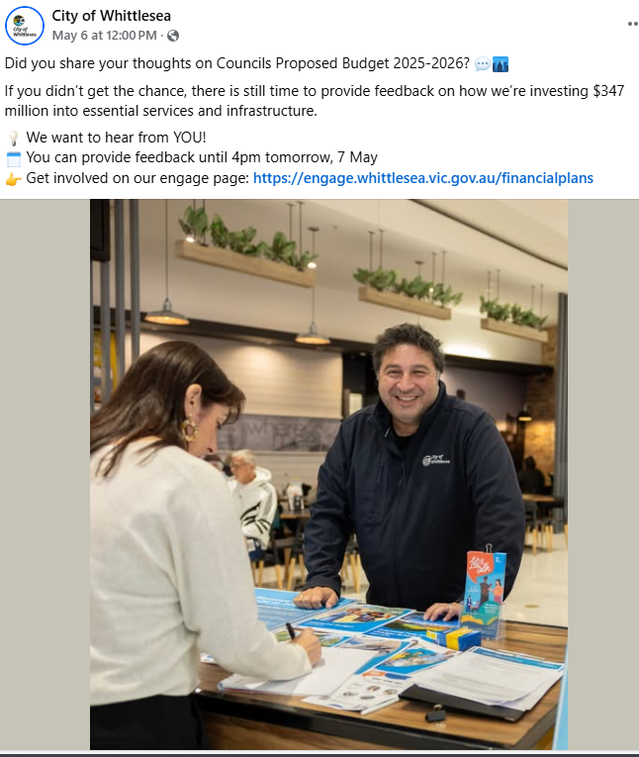
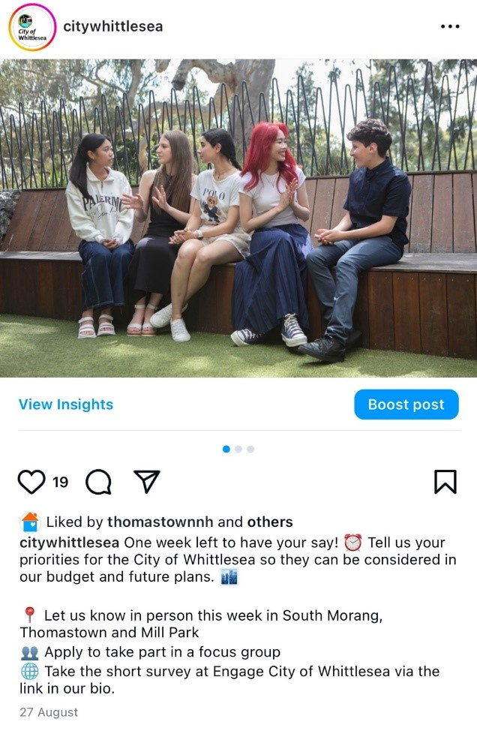
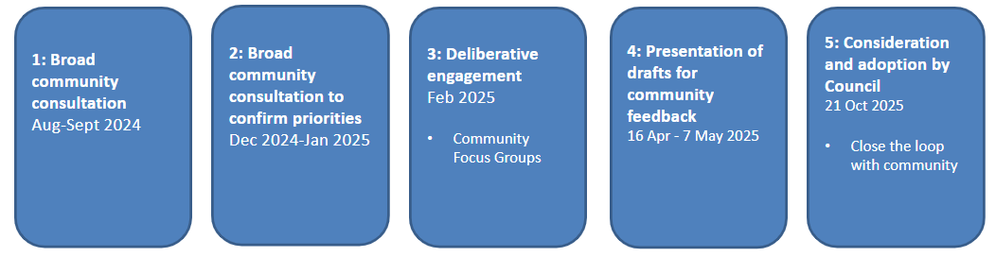
A mix of online and in-person opportunities were utilised across the four phases of consultation. Community-based pop-up stalls were held in high foot traffic areas across the municipality, presentations were made to key targeted stakeholder groups and facilitated community focus groups were undertaken to offer an opportunity for deliberation at a deeper level on the topic. Digital engagement was hosted on the Engage Whittlesea platform which utilises an accessibility add-on ensuring that it is as accessible as possible for all users. The platform also has an in-built translation tool to mitigate any language barriers to participation, allowing the page to be translated into the top fifteen languages spoken within the municipality.
As the proposed documents being presented are detailed financial documents, we sought to make it easy for community to understand them. Activity boards (viewable in Appendix 1) were used at in-person engagement activities that presented key inclusions as an infographic and dot points to provide a snapshot of the purpose of the document. This information was mirrored on the project Engage Whittlesea page.

Highlights from across the four phases of consultation are as below:
 |  |  |  | 
Hosted 21 community-based pop-ups | Two stakeholder group presentations | 46 participants across 3 community focus groups | 428 digital contributions | 710 in-person contributions

Below is a snapshot of the participation in the four phases of consultation, which is representative of our broader community:
 |  | 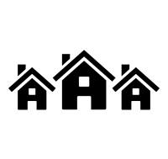 | 
57% female, 40% male and 3% prefer not to answer | All ages groups were represented with the largest being those aged 35-44 years | 94% of participants live in the City of Whittlesea with 15 suburbs represented | 16% indicated they are a person with a disability or an unpaid carer of a person with a disability or older person

 |  | 
2% identified as Aboriginal or Torres Strait Islander | 6% identified as members of the LGBTIQA+ community. | 58% speak a language other than English at home
Phase 1
Between 5 August and 4 September 2024 the community was invited to share their priorities for the future through an online survey or in-person at one of 13 community-based pop-up stalls. The online survey required participants to select the three areas most important to them from the possible thirteen and were then asked additional questions based on their selection. The additional questions were designed to delve deeper into the communities’ priorities to understand the specific areas of importance for each of the priority areas they selected. There was free text space provided for participants to add further comment as part of the additional questions.

The in-person consultation activity mirrored the information being sought through the digital consultation survey activity; specifically, capturing their top three priorities with participants asked to place a sticky dot on their choices and then encouraged to complete a hard copy survey or complete the survey on an available iPad to provide a deeper level of insight.

Details of the community-based pop-ups are below:

Date | Time | Where | Address/location
Friday 9 August | 10- 1pm | Galada Community Activity Centre (Immunisation session) | 10a Forum Way, Epping
Tuesday 13 August | 10am-1pm | Outside Whittlesea Service Hub | 63 Church St, Whittlesea
Thursday 15 August | 10am-2pm | Lalor Library | 2A May Rd, Lalor
Thursday 15 August | 5.30pm-7.30pm | Mill Park Library | 394 Plenty Road, Mill Park
Friday 16 August | 11am-2pm | Coles Uni Hill | 224 Plenty Road, Bundoora
Tuesday 20 August | 1.30pm-4.30pm | Mernda Town Centre | 180 Riverdale Blvd, Mernda
Wednesday 21 August | 5pm-7pm | Kirrip Community Activity Centre (Immunisation session) | 135 DeRossi Blvd, Wollert
Friday 23 August | 2.30pm-4.30pm | Laurimar shops, outside Woolworths | 95 Hazel Glen Rd, Doreen
Monday 26 August | 9.30am-12.30pm | Olivine Estate outside Shared Cup Café | 995 Olivine Blvd, Donnybrook
Tuesday 27 August | 1.30pm-4.30pm | Westfield Plenty Valley | 415 McDonalds Road, South Morang
Wednesday 28 August | 9am-12pm | Thomastown Recreation and Aquatic Centre | 52 Main St, Thomastown
Friday 30 August | 2.30pm-4.30pm | Mill Park Stables Shopping Centre | 314-360 Childs Rd, Mill Park
Saturday 31 August | 6pm – 9pm | Walking Thomastown | Main Street Recreation Reserve, Thomastown

Phase 2
Throughout December 2024 and January 2025, we shared with the community the priorities we had heard through phase one consultation in order of priority and asked them if they agreed with the order, if we had missed anything and for any other comments. This phase was conducted online through the Engage Whittlesea platform; however, we also held the same activity in-person at Council’s Carols by Candlelight event in December
Phase 3
To involve the community in shaping these key plans, focus groups were established to provide opportunity for valuable insights to be shared that will help identify, assess, and prioritise community interests. This approach enabled us to achieve balanced outcomes that are informed by the community's perspectives.

We held three identical community focus groups held in different locations across the municipality reducing travel for participants and enabling a place-based lens to the feedback captured. Recruitment for the focus groups took place via an Expression of Interest (EOI) from 5 August 2024 to 13 January 2025 with recruitment placed on hold during the official caretaker period between 17 September and 26 October 2024. Participants were chosen to reflect the diversity of the City of Whittlesea community, including ages, genders, abilities, cultural backgrounds, suburbs and household structures.

Details of the community focus groups are below:
- Whittlesea Community Activity Centre, Tuesday 11 February, 6-9pm
- Civic Centre, South Morang, Saturday 15 February, 9am – 12pm
- Lalor Library, Thursday 20 February, 6-9pm.

Phase 4
In April-May 2025 the Proposed Budget 2025-26 and Financial Plans were shared on the project page on the Engage Whittlesea platform and encouraged participants to share whether they supported the proposed documents. There was also free text space provided for participants to add further comments if they selected no as a response for any of the draft documents.

Participation was available online through the Engage Whittlesea platform or in-person at a series of eight community-based pop-up stalls scheduled across the municipality in high foot traffic locations. Details of the community-based pop-ups are below:

Date | Time | Where | Address/location
16 April 2025 | 5pm-7pm | Kirrip Community Centre | 135 De Rossi Blvd, Wollert
28 April 2025 | 9.30am -11.30am | Lalor Library | 2a May Rd, Lalor
28 April 2025 | 2.30pm -4.30pm | Thomastown Library | 52 Main St, Thomastown
29 April 2025 | 9.30am -11.30am | Westfield Plenty Valley | 415 McDonalds Rd, South Morang
29 April 2025 | 2.30pm -4.30pm | Laurimar Shopping Centre | 101 Hazel Glen Drive, Doreen
30 April 2025 | 9.30am -11.30am | Shared Cup Café | 995 Donnybrook Rd, Donnybrook
30 April 2025 | 2.30pm- 4.30pm | Mernda Village Shopping Centre | 59 Mernda Village Drive, Mernda
2/5/2025 | 9.30am -11.30am | Coles University Hill | 2 Janefield Drive, Bundoora
A formal submission process also formed part of this phase of consultation and was open from 16 April to 4 May. Community members were able to make a formal submission and offered the ability to speak to their submission at the Hearing of Submissions Committee of Council which was established to consider submissions received. A total of five formal submissions were received, with four people electing to speak to their submission on 6 May 2025.

What we heard and how we have responded
Phase 1
In the first phase of consultation, we heard from 881 people representing a diverse cross-section of our community who told us that the top five priorities for our community across the municipality are:
- Roads, public transport and footpaths
- Parks, playgrounds and open space
- Community facilities
- Community safety
- Arts, culture and events.
Phase 2
Throughout December 2024 and January 2025, we heard from 133 people with 75 percent agreeing with the priorities we’d captured. Participants took the opportunity to identify anything they felt we’d missed, with the maintenance and upgrade of existing assets including facilities, roads, footpaths and parks the most prevalent theme. Other comments related to community safety and waste related services.
Phase 3
In February 2025 forty-six community members participated in one of three community focus groups. Participants deliberated with other community members, gaining a better understanding of the service categories level expectations and challenges faced. They told us they’d like to see an increased focus on:

- local business
- youth services
- public health and safety
- waste management
- ageing well.

Council considered the feedback captured through the three phases of community engagement as we drafted the Budget 2025-56, Financial Plan, and Rates and Revenue Plan. The proposed documents reaffirmed our focus on increasing our investment in the future and has addressed the top priorities identified by community through the consultation as below:

- Roads, public transport and footpaths
The proposed Budget 2025-26 has allocated over $57 million to roads and footpaths making it the service category with the highest funding and supporting it as the top priority as identified by the community. The proposed 10-year Financial Plan has allocated almost $715 million to roads, public transport and footpaths which will support our growing community. Council will continue advocating for improved public transport across the municipality.

- Parks, playgrounds and open space
Over $51 million has been allocated to parks, playground and open space in the proposed Budget 2025-26 and over $611 million allocated in the proposed 10-year Financial Plan. This allocation affirms the service area as a top priority of Council and is the second highest funded over the next ten years.

- Community facilities including recreation and leisure facilities
Almost $50 million has been allocated to community facilities in the proposed Budget 2025-26 and over $40 million over the next ten years in the proposed Financial Plan, future proofing these valuable community assets.

- Community safety
Over $8.5 million has been allocated to community safety in the proposed Budget 2025-26 and a total of over $100 million proposed over the next ten years. Of this, $2.89 million has been allocated over the next ten years for new and improved lighting along pathways.
- Arts, culture and events
The proposed Budget 2025-26 has allocated almost $2 million to arts, culture and events and almost $24 million proposed over the next ten years to help those who work, live, and play in the City of Whittlesea to be creative and share their culture and stories.

- Waste management
Council has recently made an investment in illegal dumping with anew waste taskforce established and almost $38 million allocated in the proposed Budget 2025-26.
Phase 4
The proposed documents were shared with the community in April and May 2025. Seventy-eight people participated in this phase of consultation and told us that majority (85%) supported the Proposed Budget 2025-26, the Proposed Financial Plan 2025-26 to 2034-35 (89%) and the Proposed Rates and Revenue Plan 2025-26 to 2028-29 (81%). Those that were not supportive of the proposed documents identified specific budget item requests local to their area or a proposed rate freeze to ease the cost-of-living pressure as their reason.

Next Steps
Thank you to everyone who shared feedback though our Proposed Financial Plans consultation either in-person as part of a focus group, at a community-based pop-up or online through the Engage Whittlesea platform. We are finalising the documents that will be presented to Council for consideration and adoption at the Council Meeting scheduled 17 June 2025. We will share the final documents and encourage you to follow the project Engage page
(engage.whittlesea.vic.gov.au/financialplans ) to be kept up to date as these are finalised.

