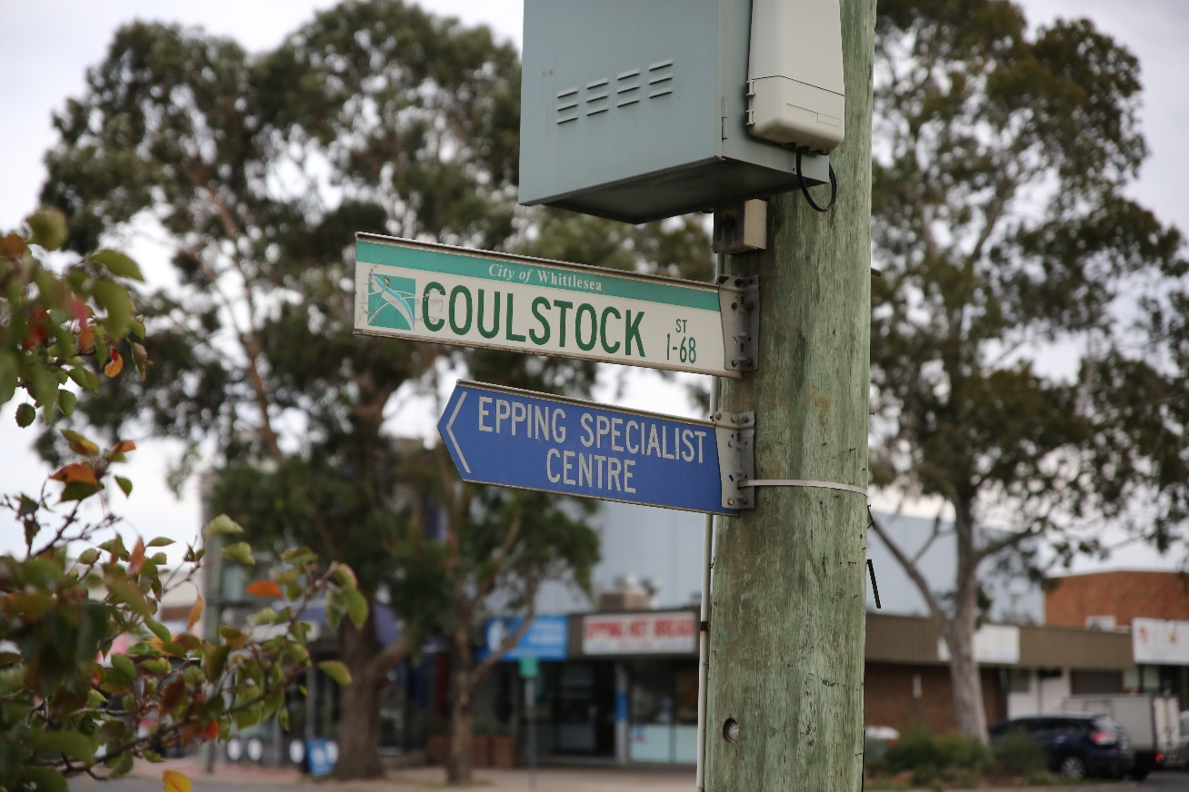

COULSTOCK STREET PLACE PLAN
COMMUNITY REFERENCE GROUP
Session 1: Summary Report

The City of Whittlesea is preparing the Coulstock Street Place Plan to guide the future of Coulstock Street and its surrounding precinct in Epping—an area identified for significant growth under the Epping Central Structure Plan (2023) and the Victorian Government’s Metropolitan Activity Centre designation. As the population increases, Council is planning ahead to ensure the precinct has the services, infrastructure and public spaces it needs.

To support this work, Council has formed the Coulstock Street Place Plan Community Reference Group, bringing together local residents to share insights and help shape the draft plan. This summary reflects what was heard at the group’s first session.

What the Community Values
Participants highlighted many strengths of the area, including:
- proximity and ease of access to key services such as shops, hospitals and business centres
- multicultural food and retail offerings along High Street
- strong public transport connections and walkability
- quiet, wide streets with greenery and public art
- significant potential for future development, including mixed-use opportunities.

Community vision for the future
Across activities, participants expressed a desire for a more connected, greener and people-friendly precinct. Key themes included:
Better transport and connectivity
- Safer walking and cycling routes
- Improved street links, including Duffy Street and Coulstock Street
- Traffic management upgrades and clearer parking arrangements.

More parks and green spaces
- New parks, playgrounds and shaded areas
- Off-leash dog parks
- Community gardens and native landscaping.

A vibrant public realm
- More public art, markets and cultural activities
- Attractive streetscapes with trees, seating and lighting
- Spaces for community gatherings and events.

A lively mixed-use neighbourhood
- More housing options close to shops and services
- Mixed residential and commercial development
- A civic square or community hub.

Top community priorities - public spaces, environment and transport
From group voting, the most supported ideas included:
Natural Environment
- Multi-use green spaces with paths, art, water play and recreation
- Vertical gardens
- Better walking connections between Houston Street and Cooper Street.

Public Spaces
- Rooftop gardens on multi-storey buildings
- Fixing the Wedge Street ‘sand pit’
- More active and artistic public spaces.

Transport
- Improved safety at the Wedge Street intersection
- Exploring options like an overpass/monorail for north–south movement
- Additional parking solutions, including use of the former Bunnings site.

Key Challenges Identified
Participants raised several issues that need attention:
- flooding, particularly around Duffy, Coulstock and Sand Wedge Streets
- road and footpath maintenance, including potholes and incomplete infrastructure
- safety concerns, especially at night and around vacant buildings
- limited open space and lack of public toilets
- parking pressures near the station and shops.

Next Steps
We sincerely thank those community members who participated in the Coulstock Street Place Plan Community Reference Group. We appreciate the considered and valuable feedback and ideas shared, all of which will help shape and inform the development of the Coulstock Street Place Plan. A second Community Reference Group meeting will take place later this year as will broader community engagement opportunities.
Feedback captured throughout the Coulstock Street Place Plan broader community engagement may also support the development of other key Council plans, strategies and projects, contributing to the vision of making the City of Whittlesea A Place for All.
To stay up to date with the progress of this project, please visit engage.whittlesea.vic.gov.au/coulstockst.

