Lowalde Recreation Reserve Master plan

Engagement Summary
April 2023
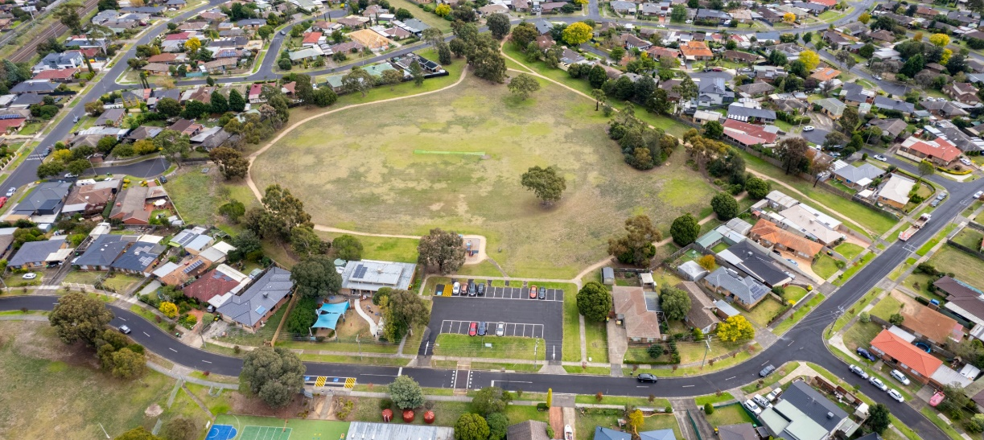

Project summary
Council is planning to upgrade Lowalde Recreation Reserve with features that help residents to get active, socialise and enjoy the outdoors. This Master plan seeks to improve the aesthetic of the space and increase community participation at Lowalde Recreation Reserve.

The Lowalde Recreation Reserve Master plan is a high level-document providing a broad vision for the entire reserve. The master plan does not focus on one specific item or user group, but instead looks at all the reserve’s features, equipment, and users. The master plan aims to balance the needs of all user groups and the facilities required for the different activities undertaken in the reserve. It will outline any improvements required to achieve this balance in a staged action plan. The plan will also be developed in such a way that it meets the needs of both the current and future users.

The Master plan will look at issues such as:
- Out of date sports and park equipment
- Public access and connections to pathways
- Visibility and safety.

The Master plan will also consider ways to increase active and passive activities in the reserve. These may include:
- Circuit walking paths
- Picnic shelters and seating
- Informal multi-sports courts (i.e.: half-court basketball, table tennis, volleyball, or bocce)
- Fitness stations.

How we engaged you?
The Lowalde Recreation Reserve consultation was open for community comment from 29 April to 6 June 2022. During this phase we undertook broad community engagement to understand how the community and sporting groups use the space, what could be done to improve current experiences and how they would like to use the space in the future.
The project Engage page was launched on Tuesday 3 May with a community survey and pinpoint map. Subscribers to the Engage Whittlesea platform that had previously expressed interest in the parks or Epping area were notified via email of the new project page.
This was followed by a letter box drop to residents who live within a 700-metre radius of the reserve to inform them of the development of the Master plan and encourage feedback through community consultation.
We commenced face to face consultation in May, meeting with local schools and cricket clubs who regularly use the reserve.
Visitors to the reserve were informed about the consultation through large corflute signage installed at the main entry point.
The community consultation and community pop-ups were shared on Council’s social channels including Facebook, Twitter, and Instagram. The eight posts (four on Facebook) were viewed by a combined total of 13,562, with 415 of these people interacting with it in some way (sharing, commenting, or leaving a reaction).
A morning and afternoon pop-up was held at the reserve in May where community members were invited to participate in a survey via hardcopy or online using the QR code or iPad available. Participants received incentive vouchers from a local business owner. Younger children were also invited to illustrate their vision for the park.
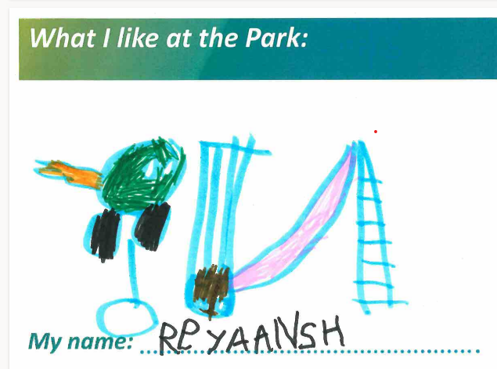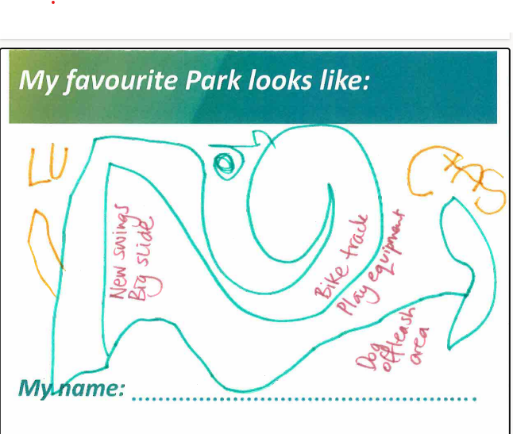

Participation
Engage Whittlesea project page and community pop-up online surveys
The Lowalde Recreation Reserve Master plan project Engage page attracted 246 visitors during the consultation period, 18 of which opted to follow the project page to remain updated on the project.
- 84 community members contributed to the online engagement by completing the survey
- 77 members shared their thoughts on the interactive map.
- Community members aged 26-35 years made up 25% of contributors
- 52% of those who contributed to the engagement were female
- 7% of contributors preferred not to mention their gender
- Most contributors (77.8%) lived in Epping
- 76% live within walking distance of the reserve.

Community pop-ups – paper surveys
A total of 25 community members filled in the paper survey at the pop-ups providing a great insight into their priorities.

What we heard
Just over 88% of contributors have visited the Lowalde Recreation Reserve before. Of these, 33% visited the reserve daily and almost 26% frequented the reserve two or three times a week. The remainder visit the reserve Weekly (10%), fortnightly (4%), monthly (5.5%), more than a few times a year (9.7%).
The ten respondents that indicated that they hadn’t ever visited Lowalde Reserve revealed the reason for not visiting is the outdated facilities.
The majority of respondents indicated their connection to the reserve is that they are a local resident (89%). Almost 68% of respondents live within walking distance from the reserve, however only 4% ride a bike or scooter to access the reserve. 24% of contributors drive to access the reserve when they visit.
The playground is the facility most used by respondents, with almost 62% indicating that they use the playground when visiting Lowalde. Just over half of community members engaged (54%) visit Lowalde to use the oval and close to 38% of visitors utilise the carpark.
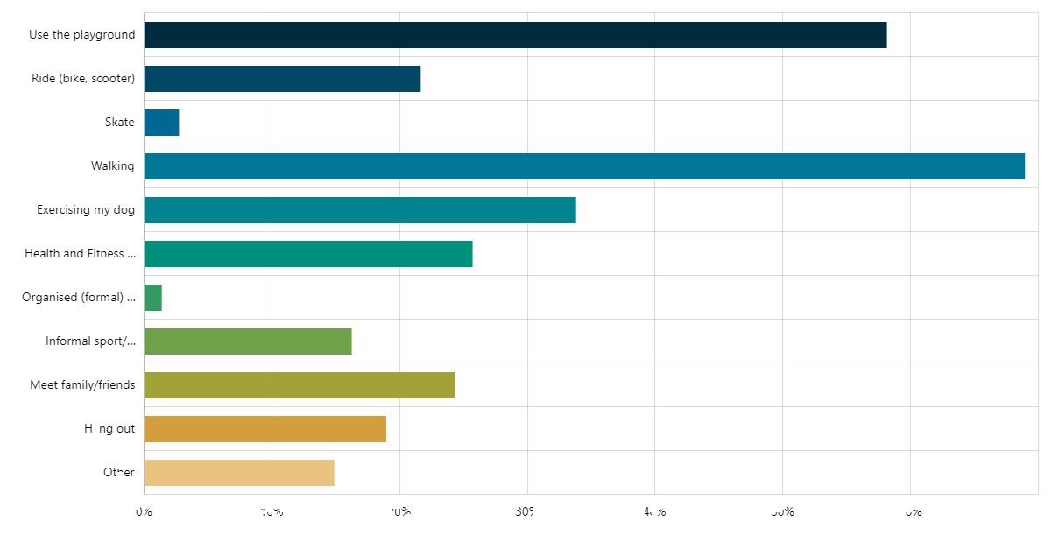
The main reason respondents visit the reserve is to use the walking trails with almost 69% indicating that they visit Lowalde reserve to go for walks. The playground is also well utilised with 58% of contributors visiting the reserve with children to use the playground. A lesser number use the reserve to partake in casual sport/activities (kick to kick, ball games with friends) and formal organised sport (1.35%). Refer to the graph below for all figures.
The feedback received was reflected in the overall rating of the facility. When presented with a scale of one to five stars, one being very poor and 5 being very good, 67% of respondents rated the reserve as very poor or poor.
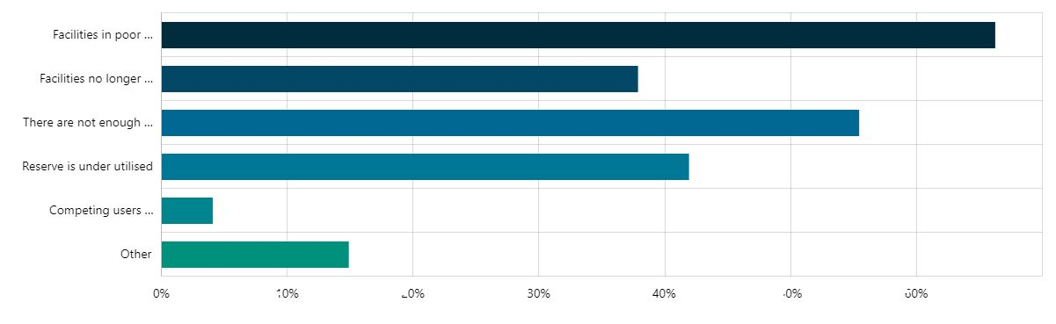
Many respondents (66%) feel that the facilities at the Lowalde reserve are in poor condition and there are not enough facilities for the number of people who visit the reserve (55%). A lesser number of respondents felt that the key issue is the competing users across the reserve. Refer to graph below.
The three most important features in local parks/reserves for respondents are play spaces (74%), pathways and trails (53%) and places to gather with family and friends (53%). Fewer people feel that carparking or accessibility are important features in local parks.
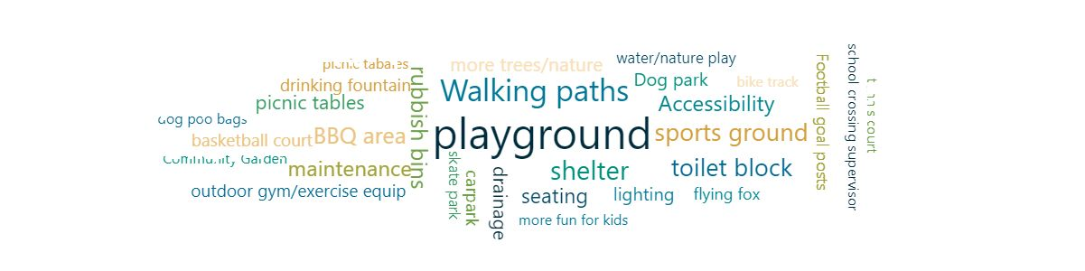When asked if they had any further comments about Lowalde reserve, 19% of respondents left positive comments and 24% had negative views of the reserve. See some improvements that respondents would like to see below.

Opportunities
Respondents shared many potential future opportunities for Lowalde Recreation Reserve, some of which may be out of scope of this project. These have been grouped below.

Playground – replacing the existing playground with a play space for all ages and abilities was a priority for respondents. Some suggestions included, a mini traffic school, a half basketball court, flying fox, splash play area, obstacle course and upgraded play equipment.
“Ninja training playground i.e., like the one in Albion”
“Splash park - they are a good alternative to the lack of public outdoor pools”
“A mini racetrack for those who have scooters, bikes, rollerblades, etc”


Walking, running and cycling – community members suggested a running/walking track around the oval and upgrade paths to concrete. Flooding is an issue in the area.
“Upgrade of the path to concrete which is higher that the level it is currently at to negate flooding”
“Can the footpath be concreted so it connects with Darebin Creek path?”

Sports and Fitness – multiple community members highlighted improvements needed to the existing oval such as the installation of goal posts and offered suggestions for suitable additions to be considered, including hockey, basketball and netball half court, volleyball net and a ping pong table. Others would like to see more fitness facilities for all age groups including a Bocce rink and outdoor fitness equipment.
“Football goals on either end of the oval”
“Exercise and chin up stations and parallel bars south of the playground”
“Outdoor ping pong tables. Half-court basketball. Bocce run for seniors and Outdoor gym equipment”
“Grass Volleyball court. grass volleyball is regularly played here in Summer”
“Informal Bocce and Lawn Bowling area”


Facilities - replacing or introducing new facilities including toilets, seating, picnic areas, BBQ and bins. Many residents would like to see a gated dog park on the reserve and a fence surrounding the playground.
“Sheltered area and picnic tables would be fantastic”
“Toilets, sheltered tables, benches and BBQ”
“Drinking fountain with dog bowl”
“Water Tap/With Dog bowl”
“BBQ facilities with shelter. Rubbish bins, shelter, seating, and litter bins”


Safety - introducing additional lighting, new fencing, and car park improvements to make users feel safe. Contributors expressed concerns about anti-social behaviour in the reserve emphasising the importance of lighting. Several residents are concerned about the ageing gum trees and potential danger that falling branches can cause.
“Old gum trees have heavy branches that come down. Arborist is required to assess and make safe”
“Remove medium to large tree around the reserve. Branches snap in strong winds”
“Current trees grow straight up and don’t provide shade”
“Sufficient lighting to ensure the park is a safer space and deters bad behaviour”


Natural Environment – community members suggested incorporating a community garden in the plan. Others would like the existing trees retained.
“A community garden space would be pretty awesome”

Next Steps
Thank you to everyone that participated in phase 1 of our consultation by completing the survey, dropping a pin and participating in the community engagement.
Feedback gathered from the community is being used to develop the design and will be incorporated into the decision-making process. While we are not able to accommodate everyone’s comments, the project team will provide solutions to the issues raised and balance them with the requirements of Council.
A draft Master plan design will be presented in the second phase of community consultation, providing the opportunity for the community to see how the feedback provided has helped shape the Master plan. The draft Master plan and concept design will be endorsed by Council prior to phase 2 of consultation.

