# 

# **Doreen Splash Park Engagement Summary** **January 2024**water jets coming up from ground

# Introduction Council is proposing to upgrade Hilltop Park’s reserve and playground in Doreen to include a splashpad and supporting facilities. This will be one of two free public access splashpads in the City of Whittlesea along with a water play area at Norris Bank Reserve, providing a new type of outdoor recreation facility for the residents of Doreen and surrounds. In addition, the project will improve the play provision in the park to address the changing demographic of the area, bringing the play experiences in line with current best practice and introducing nature play elements.

# The project will be delivered by the City of Whittlesea and supported by the Federal Government through the Investing in Our Communities Program, and the Victorian Government through the Better Parks and Playgrounds Program and the Community Support Fund.

The upgraded play space and new splashpad will provide the following benefits to the community including:

* a safe area for structured and unstructured play
* a safe social gathering space for both active and passive recreation
* promote local ownership of assets in public open space
* promote a healthy lifestyle to residents within the catchment of the playground
* promote a sense of community by developing play spaces with the community, places residents can go to meet, socialise, and interact
* enable a stronger connection between the playground and the park
* improve accessibility to play equipment for mobility impaired members of the community, such as the Disability Discrimination Act (DDA) compliant paths and surfaces
* improve play provision for children with sensory impairment, such as quiet spaces for autism, and high contrast colours for vision impairments.

Feedback from the community and stakeholders will inform the Doreen Splash Park master plan.

# How we engaged you

**Phase 1: Gathering Ideas - Monday 13 November to Monday 18 December 2023**

# The Doreen Splash Park Phase 1 consultation was open for community comment from Monday 13 November to Monday 18 December 2023.

The purpose of this engagement was to assist Council to identify the type of play equipment and splash park features that community would like to see in the park and to identify any concerns they may have with the proposed site and plan.

The community was able to have their say via the [project Engage page](https://engage.whittlesea.vic.gov.au/hilltopsplash)) or in-person at two community-based pop-ups.

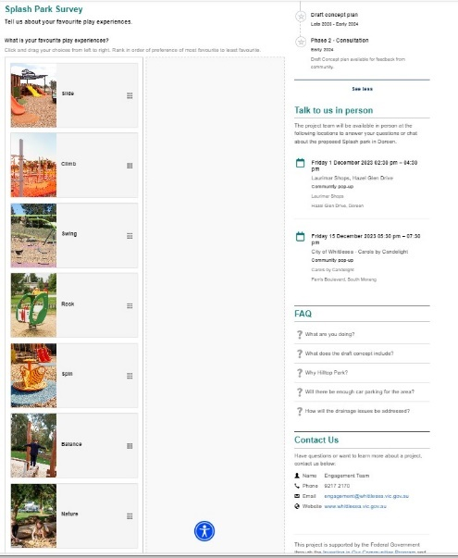The project Engage page presented six images of different splash park equipment and six images of playground equipment. Participants were asked to rank their top five equipment, with 1 being their favourite. They were also able to offer any additional comments about the project.

*Left: engagement activity on* [*project Engage page*](https://engage.whittlesea.vic.gov.au/hilltopsplash))

During this period, the project team held staffed community pop-ups on Friday 1 December 2023 at Laurimar shops from 2.30pm - 4.30pm and on Friday 15 December 2023 at City of Whittlesea Christmas Carols from 5.30pm at the Civic Centre in South Morang. A further information session specifically for invited neighbouring residents of Hilltop Park was held on Wednesday 7 February 2024 ,6.00pm.

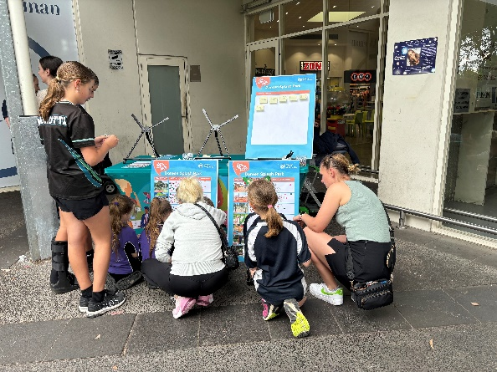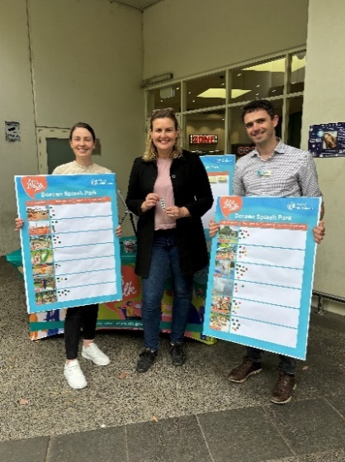*Above (L-R): Project team with Lauren Kathage MP and community participating in consultation at Laurimar Shops on 1 December*

Participant of in-person engagement activities were invited to rank their top five (out of six) splash park and playground equipment and offer any additional comments about the project.

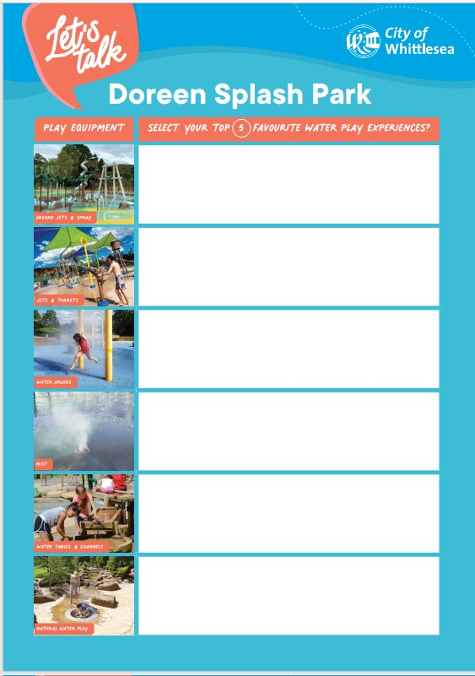The available splash park equipment options were:

Above: 1 Dot Board Activity for in- person consultation for Doreen Splash Park

1. *Ground jets and spray*
2. *Jets and turrets*
3. *Water arches*
4. *Mist*
5. *Water tables and channels*
6. *Natural water play*

The available playground equipment options were:

1. Slide
2. *Climbing equipment*
3. *Swings*
4. *Rocking equipment*
5. *Spinning equipment*
6. *Nature play*

Flyers with a QR code directing community to the project Engage Whittlesea page were available at all in-person activities and participants were encouraged to share the opportunity to participate in the engagement with neighbours, family, and friends.

Residents within 400m of the reserve, received a letter to update them on project status and invite them to share their feedback through the project Engage page or at one of the community-based pop-ups.

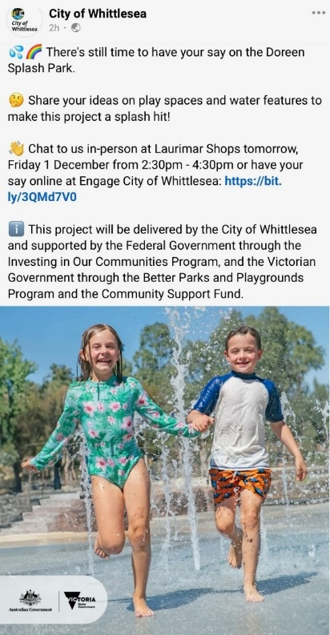Visitors to Hilltop Park were alerted to the consultation through large corflute signage installed at the main entry point. The signage featured the QR code directing them to the project Engage Whittlesea page.

The opportunity to participate in the community engagement and community-based pop-ups were shared on Council’s social media channels including Facebook and Instagram.

The Mernda and Doreen Community Development Officers and Placed Based Coordinator shared details with their connections, including:

* Home Education Network
* Seniors Groups
* Doreen Community Voice (30k followers)
* Mums of Doreen and Mernda (700 members)
* Playgroup facilitators who have playgroups in Doreen, Mernda, and Epping
* Whittlesea Swim Centre, Thomastown Recreation and Aquatic Centres and Mill Park Leisure
* Libraries

The Engage Whittlesea platform utilises an accessibility add-on which enables users to easily switch to screen reader mode or easily adjust settings such as font size, contrast, dyslexia friendly options to improve the overall accessibility of the site. The platform also has an in-built translation tool to reduce language barriers to participation, allowing the page to be translated into the top ten languages spoken within the municipality.

Subscribers to the Engage Whittlesea platform that had previously indicated an interest in parks and/or Doreen area were sent a project update email and encouraged to visit the project page and share their feedback.

The project page on the Engage Whittlesea platform featured three consultation activities, a survey, an ideas board, and a pinpoint map. The survey captured feedback on how respondents use the area as well as any insights on how we could best improve the area. The pinpoint map enabled respondents to drop a pin and make a comment on a specific point within the project area and provide feedback or an improvement idea for that location. At in-person consultations respondents were presented with the same survey and offered the opportunity to share their thoughts on large activity boards.

# Participation

During phase 1 consultation a total of 735 contributions were received, 156 of which were captured at community-based pop-ups, 559 online through the [project Engage Whittlesea page](https://engage.whittlesea.vic.gov.au/hilltopsplash)) and 23 (of 175 who were invited to attend) at an Information sessions for residents living near the reserve

A total of 3293 people visited the project Engage page, 103 of whom opted to follow the page to receive project updates.

*Below is a snapshot of community consultation*:

|  |  |
| --- | --- |
|  | Five social posts reached close to 27,000 accounts and saw over 4,700 people engaged with 386 reactions and 272 comments. |
|  | Two community-based pop-ups were held and saw 156 people share their feedback. Most participants were under the age of 15 (84%). An in-person information session was held for residents living near to the reserve. 175 residents were invited and 23 registered to attend the session.  The project Engage page was viewed 4.251 times during the four-week engagement period with 3205 unique visitors. A total of 529 participants completed the online survey, of which 74.5% indicated they reside in Doreen. |

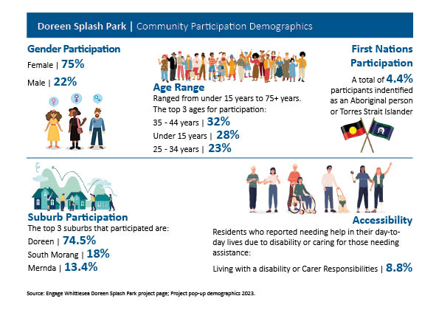

*Above: A snapshot of community who participated in Doreen Splash Park Consultation*

What we heard

**In-person Engagement**

The in-person engagement opportunities attracted 156 participants, with 85% of participants aged fifteen years and under.

When participants at in-person engagement activities were asked to rank their favourite splash park equipment to be included, the youth in Doreen told us that they would most like to see *ground jets and spray* included in the master plan for the Doreen Splash Park. The next most popular equipment was *jets and turrets* and *water arches* as their third preference. When ranking their favourite play equipment, *climbing equipment* was the favourite amongst participants, followed by *swings* as their second preference. The full breakdown of preferences can be seen in the graphs below.

*Below: The full breakdown of in-person playground equipment and splash park equipment preferences below*

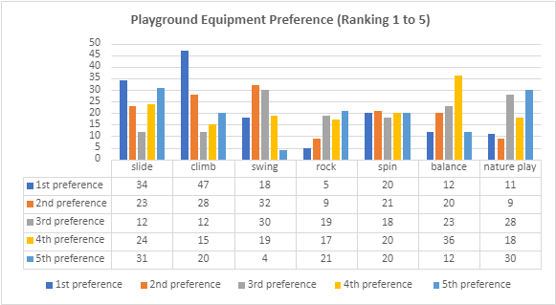

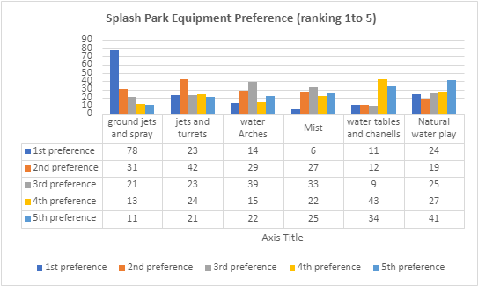

**In-person Information session for residents**

175 immediate residents were invited to attend the information session, with 16 of the 23 registered residents attend on the night.

Over a 2-hour period, Council provided an overview of the project, the rationale to the proposed location of the splash pad, and residents shared their concerns with the project team.

The major concerns we heard were:

* Traffic and parking impacts to the locality residents are concerned about the potential impact to traffic flow, availability of on-street parking, likelihood of cars parking on nature strips in front of their houses, and potential for being blocked in their driveways by visitors.
* Noise Residents are concerned about the increase in noise by park users and splash pad infrastructure.
* Safety and participationResidents are concerned about the potential increase of anti-social behaviour in the park, especially with the bigger on-site carpark.

**Online engagement**

We heard from 536 through the online survey. Just under half (44%) of all respondents answered the question *Is there anything you would like to share with us about the proposed splash park*, of these, 79% responded with a positive sentiment, while 5.4% were not in favour of the Doreen Splash Park and responded with a negative sentiment.

|  |  |  |
| --- | --- | --- |
|  |  |  |
| 78.8% Positive | 15.8% Mixed and Neutral | 5.4% Negative |

*Below: A snapshot of some of the sentiments expressed through the survey*.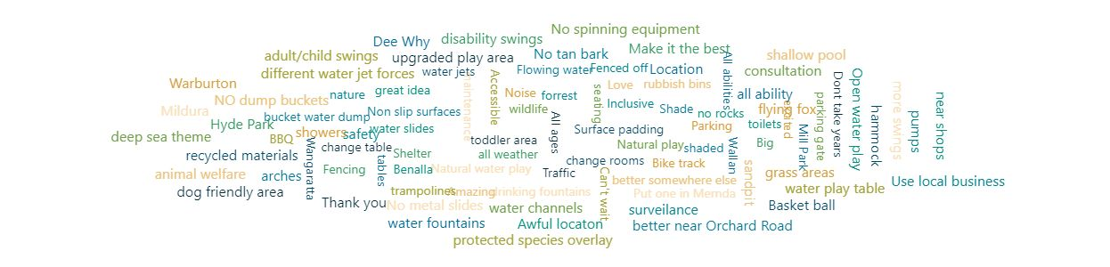

Our online participants were also asked to rank from 1 to 5, with one being their favourite, the splash park and playground equipment that they would like to see included in Doreen Splash Park.

Just under a third of participants (31.7%) chose *ground jets and spray* as their first preference, closely followed by 30% who said they want to see a *natural water play area* included in the splash park.

The inclusion of *slides* in the park was the most popular, with 36% of community selecting this as their favourite equipment to use at a park. *Climbing equipment* was also a favourite choice, with over 50% of participants choosing this as their first, second or third preference.

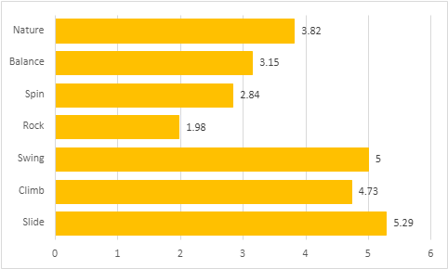***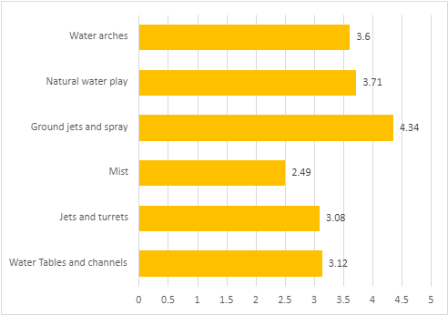****Below: Full breakdown of playground and Splash Park equipment that our community indicated online that they would most like to see at the splash park*

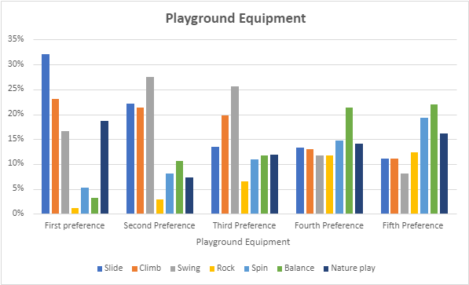**In-person and online combined data graphs**

Overall, 32% of all participants (combined online and in-person) told us their preferred playground equipment to be included in the proposed splash park is a *slide*, followed by a *nature play area* (18.6%) and *swings* (16.6%). See full breakdown of community preferences for playground equipment above.

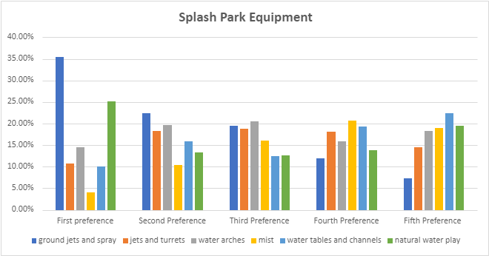

*A ground jets and spray s*plash element was the overwhelming favourite piece of equipment, with 36% of community wanting to see this in the proposed Splash Park in Doreen. A quarter of participants (25%) would also like to see a nature water play area and 15% would like water arches included in the park. See full breakdown of community preferences for splashpad equipment above.

**Opportunities**

Participants were invited to share their thoughts on the proposed draft master plan and offered potential future opportunities for Doreen Splash Park, some of which may be out of scope of this project. Below are the themed comments received through both online and in-person engagement activities.

|  |  |
| --- | --- |
|  | **Playground**– upgrading the existing playground with a play space for all ages and abilities was a priority for respondents. Some new suggestions included a rock-climbing area, monkey bars, trampoline and an adult and child swing and a flying fox. The resources used in upgrading the park was also suggested, such as surface padding, recycled materials, and no tanbark.  *“Please make sure the surrounding area to the splash park also has a flooring that isn't slippery when wet. It's such a great idea and much needed in Doreen”*  “*Creative water play and natural aesthetic”*  *“Playgrounds for all ages and abilities”*  *“Play spaces and equipment for kids of all ages, younger and older kids. I have 4 children, eldest 9 and youngest 2. I want a plays pace that has something for all my kids to be engaged not just feel like the eldest is only there for the younger ones”*  *“Please also consider, areas for quiet play”* |
|  | **Accessible** – upgrading paths and adding additional all ability car parks and equipment to make the playground accessible to all is a priority for respondents.  *“Access for disabled participants”*  *“More parking particularly for disabled”*  *“Easy and accessible for people with walkers and wheelchairs”*  *“I use a mobility scooter and a walker would like to be able to take my kids and use the park with them”* |
|  | **Sustainability-**community would like to see recycled materials used in the upgrade and the existing grassed area maintained.  *“Please consider keeping the tree forest area already in the park. It is a favourite for the local kids who build stick forts and go on bear hunts!”*  *“The more natural looking the better. My son loves playing in nature”*  *“Nature and sustainability in mind please”*  *“We love the nature play forest area at this venue already. The trees and the round bollards would be wonderful to keep”*  *“Please consider infrastructure that is sustainable in the long term. Both for the environment and financially.*  *“Please add signage to encourage people to take their rubbish back home and dispose responsibly”*  *“To ensure the ongoing success of the splash park, regular litter management and frequent cleaning of toilet facilities are essential. This will contribute to a clean and inviting environments for all visitors”* |
|  | **Facilities –** Respondents highlighted the need for additional shade and seating areas to encourage family and friend gatherings at the park.  *“More BBQ and shaded areas for families to relax for the day*  *Increased parking space”*  *“Plenty of shade for the kids and older generation. Drinking fountains and grassed are for picnics”*  *“We want a basketball ring to remain within the vicinity”*  *“Water bottle filling station”*  *“A space for food/coffee vendor”*  *“Concerned about traffic, parking and maintenance costs. Also concerned that there is insufficient infrastructure for older children/teenagers”*  *“Toilets/change rooms would be helpful”*  *“There will need to be adequate parking spaces and also good, shaded areas as it will get very busy”*  *“Doreen local and we love the setup of the Mill Park All Abilities Playground! Would be awesome to add a bike track around the*  *playground for children to ride their bikes and scooters with working traffic lights and pedestrian crossing to help teach kids road rules and safety but giving them a safe place to ride their bike and scooter”*  “*Toilets with change tables for babies”*  *“Incorporating ample shade throughout the park is essential. Parents and*  *Providing plenty of seating areas with shaded options is crucial. Families often gather for picnics or celebrations, and having grass areas that are segregated by native planting would give groups a space and enhance the overall appeal of the park”* |
|  | **Safety -** introducing additional lighting, new fencing, safe playground equipment and car park improvements to make users feel safe and help to prevent anti-social behaviour.  *“The existing car park has an automatic gate which closes at a set time of day restricting additional traffic through local areas at night and past houses in the local streets + stops after hours use / other unnecessary activity within the car park not associated with the park. Can it please be confirmed that this restriction will remain in place as part of this proposal so as not to impact amenity?*  *“All parks should be fenced for ease of families and care givers”*  *“To ensure the safety of children and provide peace of mind for parents, it would be beneficial to consider fencing around the park. This would prevent children from venturing onto nearby roads, allowing parents to relax while their children play freely”*  *“I think it's important to consider the ground surface for younger children”*  *“Anti-social behaviour currently in the park - we need additional security - cameras and lighting”* |
|  | **Transport** – Respondents highlighted the need for an increase in the frequency of public transport to the playground and the introduction of bike racks  *“Increase the quality and frequency (every 20 minutes from 6am till midnight 7 days per week on linear routes) of the public transport to increase accessibility”*  *“Also include bike racks”* |

Next steps  
Thank you to everyone that completed the survey online, attended a community pop-up and attended an information session to participate in the community engagement.

Ideas gathered from the community in Phase 1 are being used to develop the master plan design and will be incorporated into the decision-making process. While we are not able to accommodate everyone’s comments, the project team will provide solutions to the issues raised and balance them with the requirements of Council.

The draft master plan for phase two of community consultation will be presented to Council for endorsement before providing the community with an opportunity to see how their feedback has helped shape the master plan and to provide any further feedback. The community will be kept updated on further developments via the [Doreen Splash Park Project Engage page](https://engage.whittlesea.vic.gov.au/hilltopsplash)