# Asset Plan Focus Group Digital Pulse Check Survey Engagement Summary 1– 31 August 2024

# A building with trees and plants

# Overview Council held three community focus groups as well as an internal focus group between 20 May and 4 June 2024. The community focus groups were held in different locations across the municipality reducing travel for participants and enabling a place-based lens to the feedback captured. We’d like to thank the 59 participants who provided valuable insights that will help shape the draft Asset Plan 2026- 35.

Following the workshops, we collated all feedback and invited participants as well as the broader community to have their say on whether they agreed with the focus group findings by participating in a quick digital pulse check survey activity that took less than ten minutes to complete.

The pulse check survey activity was added to the Asset Plan 2026-36 *Engage Whittlesea* project page along with the focus group engagement summary report and a series of frequently asked questions.

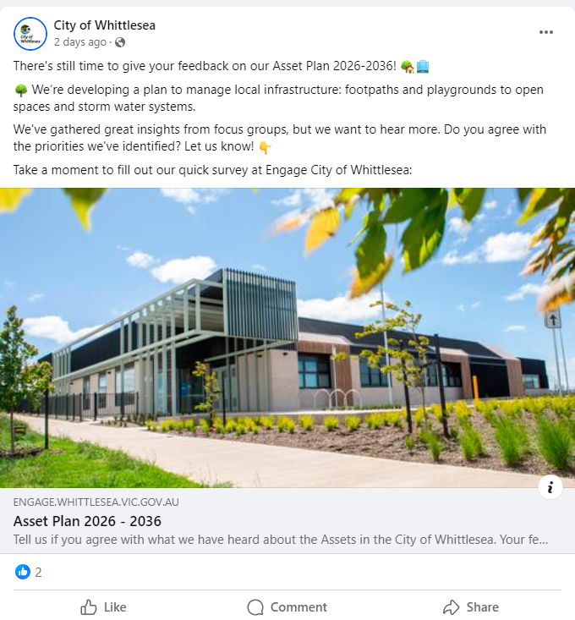

Above: sample social media post

How we engaged   
The first part of the survey presented the findings from the levels of service activity undertaken by focus group participants which asked whether they agreed with the recommended top four asset categories that required an increase to the level of servicing. To capture the community’s level of support they were asked to select their level of agreement on a five-point scale ranging from strongly agree to strongly disagree. There was also opportunity for additional comments to be made.

The second part of the survey presented the preferred asset management principles identified through the focus groups and asked whether they agreed with the recommended top four.

Participants were asked to select their level of agreement on a five-point scale ranging from strongly agree to strongly disagree. There was also opportunity for additional comments to be made.

The third part of the survey presented four new asset management principles that were developed based on feedback captured through the community focus groups. Participants were asked to select their level of agreement for each of the new principles on a five-point scale ranging from strongly agree to strongly disagree. There was also opportunity for additional comments to be made.

The Community Priorities 2024 consultation was open for community consultation at a similar time as the digital pulse check survey. This consultation captured the community’s top priorities now and into the future to help shape key Council plans and documents including the 2025-26 Budget. The feedback captured through this consultation will be shared with the project team for consideration.

To learn more about the Community Priorities 2025 consultation visit https://engage.whittlesea,vic.gov.au/priorities2025.

The opportunity to participate in the pulse check survey was promoted through a range of channels including

* Council’s digital engagement platform *Engage Whittlesea*
* Social media posts on Facebook and LinkedIn
* Electronic direct mail to all focus group participants
* Electronic direct mail sent to internal stakeholders to pass on to their networks that include registered CALD groups, Senior Clubs, Disability Network, Regular User Groups at the Hubs, Aboriginal Communities team, Youth, HWLLEN, Whittlesea Community Futures Partnership and YPRL
* Inclusion in *Local Area Network* newsletters across the municipality
* A5 flyers were also made available at the Community Priorities, Mill Park Framework and Dog Off Leash Park engagement pop up stalls during the month of August.

# Participation A total of 72 community members completed the digital pulse check survey. The Engage Whittlesea project page had 541 visitors where the focus group engagement summary as downloaded 34 times.

**   **

33% aged 35 – 44,    
 35% aged 55+

22% living with/ caring for a person with a disability

21% CALD community members

48% Female, 50% Male

|  |
| --- |
|  |

 

7% Aboriginal or Torres Strait Islanders

3% identified as members of the LGBTQIA+ community and 3% preferred not to say

Participants represented a total of 13 suburbs within the municipality

What we heard **Asset categories levels of service.**  
Half of the participants supported the levels of service presented by selecting strongly agree or agree. Fourteen percent indicated a neutral level of support while the remaining 36% who disagreed with the levels of service presented.

|  |  |  |  |  |
| --- | --- | --- | --- | --- |
| **Strongly agree** | **Agree** | **Neither agree nor disagree** | **Disagree** | **Strongly disagree** |
| **21%** | **29%** | **14%** | **26%** | **10%** |

A total of 46 participants took the opportunity to provide additional comments on the asset categories levels of service. The assets community use daily at no direct costs such as open spaces, public toilets, parks and playground, as well as roads and paths were mentioned 28 times.  
*“Open Space requires the top level of service. This is space that is available to the entire community unlike Aquatic & Sporting Facilities which are not used by all due to requiring an entry fee or because they are committed to sporting clubs and groups.”*

The additional comments also demonstrated significant support for more sporting facilities, community buildings and lighting with 14 comments focussed on this.  
 *“I will probably never use the aquatic facilities, but I certainly agree it’s a top priority for the whole community. I feel the focus groups have made considered decisions based on all the information available and keeping within budget is a high priority.”*

**Asset Management Principles**A total of 65% of participants supported the top four asset management principles presented by selecting strongly agree or agree. Twenty-two percent indicated a neutral level of support while the remaining 13% disagreed with the top four principles.

|  |  |  |  |  |
| --- | --- | --- | --- | --- |
| **Strongly agree** | **Agree** | **Neither agree nor disagree** | **Disagree** | **Strongly disagree** |
| **29%** | **36%** | **22%** | **13%** | **0%** |

A total of 21 participants took the opportunity to provide additional comment on the asset management principles, with most questioning the priority order of the principles. None of the comments suggested eliminating any of the principles.  
*“Best practice and innovation should be in the top 4, because with best practice they should be equitable and accessible and promote community connectivity, whilst also being sustainable and utilising fresh ideas”*

*“Assets need to be visually maintained in good order and aesthetically pleasing to support the development and value homeowners are investing in homes and new development. All assets should be maintained for safety…”*

**New Asset Management Principles**The table below shows the level of support for the four proposed new principles. All new principles had a high level of support with majority of participants indication that they agree of strongly agree with three of the four proposed new principles.

|  |  |  |  |  |  |
| --- | --- | --- | --- | --- | --- |
| **Proposed asset management principle** | **Strongly agree** | **Agree** | **Neither agree nor disagree** | **Disagree** | **Strongly disagree** |
| Assets meet the diverse and changing needs of the community | 32% | 46% | 17% | 5% | 0% |
| Assets demonstrate connection to First Peoples | 22% | 21% | 36% | 11% | 10% |
| Infrastructure decisions consider environmental, social and financial sustainability | 40% | 29% | 25% | 4% | 2% |
| Assets are optimised for useability | 46% | 37% | 13% | 3% | 1% |

Eighteen participants took the opportunity to comment further on the asset plan. Many of the comments focused on specific issues within the community including six comments on arts culture and inclusiveness and three comments on clarity around connection to First Peoples.  
*“I find it hard to understand in a real-world sense ‘Assets demonstrate connection to First Peoples’. How does that relate to building a road or erecting a toilet block? (Unless there is the rare situation of, say, a tree of indigenous significance.) I think this Principal because it IS important should be a more general one governing all Council decisions.”*

*“Love these 4 principles”*

*“Further assets are needed for the music industry in Whittlesea, especially for bands. “*

*“Cultural differences should be addressed also, e.g., people with disabilities, people with heightened sensitivity like autism, women from the Muslim cultures, etc.”*

**Youth Council**The project team presented to the City of Whittlesea Youth Council at its meeting on Monday 5 August. Youth Councillors participated in the levels of service undertaken as part of community focus groups. Thirteen youth councillors deliberated and provided formal written feedback to the project team. Areas of interest to the Youth Council included:

* Safety - *“Improving public lighting to enhance safety for young people, particularly those travelling at night in suburban neighbourhoods and near public transport stops”*
* Public facilities - *“The focus on public facilities such as toilets, was another area where our priorities aligned closely with those of the broader community. As frequent users of these facilities, young people understand the importance of these amenities and strongly support their inclusion in the Asset Plan.”*

Overall, the Youth Council stated that the process “reinforced our confidence that the council is effectively identifying ways to use its budget to support youth and manage community assets in a balanced and thoughtful manner”.

Next steps  
The project team will now continue to develop the draft Asset Plan 2026-2035. The team aims to meet with the newly elected councillors prior to presenting the draft for endorsements in early 2025. The draft Asset Plan 2026-35, once endorsed by Council for community consultation will then be shared for community feedback before being presented for final endorsement by Council in mid-2025.

Thank you again to everyone who participated in the first two phases of community engagement by participating in a focus group or sharing feedback. We encourage you to follow the project Engage page to be kept up to date on this project – <https://engage.whittlesea.vic.gov.au/passetplan25>