**Local Area Transport Management South Morang**

**Engagement Summary**

**July 2024**

**Introduction**

The City of Whittlesea is developing a draft traffic management and streetscape improvement plan (TMSIP) for the area bound by Gordons Road/Jardier Terrace, Plenty Road, Findon Road and The Lakes Boulevard, South Morang. The TMSIP aims to enhance the streetscape, address road safety, parking and traffic concerns and improve connectivity to public open spaces, public transport, and community activity centres in the area.

Initial investigations shaped the concept plan, which considers traffic conditions (i.e.: speeds and volumes), accidents, existing streetscapes, activity generators in the area (i.e.: schools, shops etc) and current/future land uses.

Community feedback will help us prioritise our actions and finalise the traffic management and streetscape improvement plan (TMSIP) for the area.

**How we engaged you**

The TMSIP consultation was open for community comment from 26 April to 24 May 2024. will help Council shared the concept plan with who live, work, study or visit the targeted area. Community feedback was sought online through Council’s *Engage Whittlesea* platform and through direct conversation at two community-based pop-ups. The *Engage Whittlesea* platform utilises an accessibility add-on ensuring that it is as accessible as possible for all users. The platform also has an in-built translation tool to mitigate any language barriers to participation, allowing the page to be translated into the top ten languages spoken within the municipality.

**Engage page**

On the project’s Engage page, participants could view the concept plan in the form of a map of the area with the proposed improvements included and an explanation and images of the type of upgrades planned for the area. Visitors to the page were invited to complete a survey that asked participants *if they* *support traffic and streetscape improvements in particular streets* and *if they had* *any other road safety concerns, or ideas for road safety improvements in their street or neighbourhood.* Feedback captured through the survey will assist the project team in understanding the main road safety priorities of the local community.

**Community Pop-ups**

The project team hosted two community-based pop-ups nearby to the targeted area. The first session was held at the Civic Centre on Tuesday 14 May in the evening, and then a second at The Promenade shops in South Morang on Thursday 16 May mid-morning, which capitalised on the varied visitors to the space during this peak period.

Initially a third dedicated information session was planned to be held at Arilla Retirement Village in Gordons Road, South Morang, which is home to around 300 residents, however. This was not able to be facilitated by the retirement village so instead all residents received a letter as per the local area mailout with an invitation to attend one of the planned community-based pop-ups or to participate in the online survey.

At the pop-ups the project team displayed large scale maps of the area and concept plan and spoke with residents in detail about any concerns they had. The pop-up was a good opportunity to educate the community on the planning process and how decisions were made. There was also opportunity for participants to suggest additional ideas to the project team.

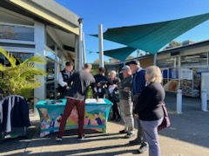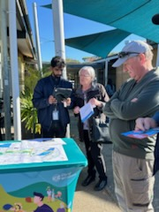

*Above: TMSIP pop-up at The Promenade, South Morang*

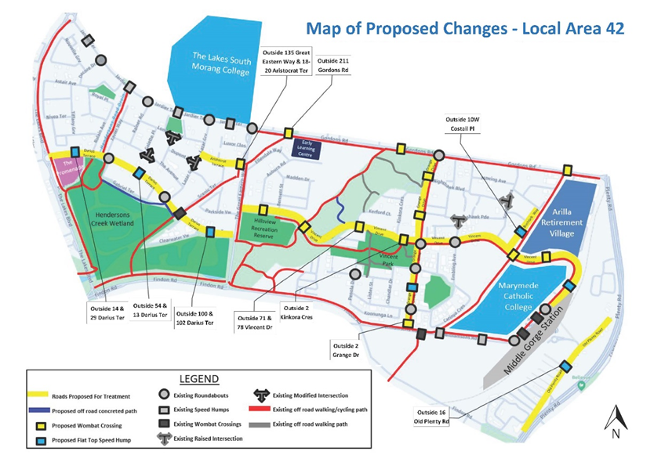

*Above: Map of proposed changes used at the community-based pop-ups*

**Project Promotion**

The opportunity to participate in the community engagement was promoted through a range of channels to have a widespread reach across the targeted area including:

* Council’s digital engagement platform *Engage Whittlesea*
* Social media – we shared two posts across Council’s social media channels (Facebook and Instagram)
* Direct email to key stakeholder groups (including education facilities within the targeted area for inclusion in newsletters)
* Direct mail through a letterbox drop to 2,267 homes within the project area
* Flyers and posters displayed at Council facilities and libraries.

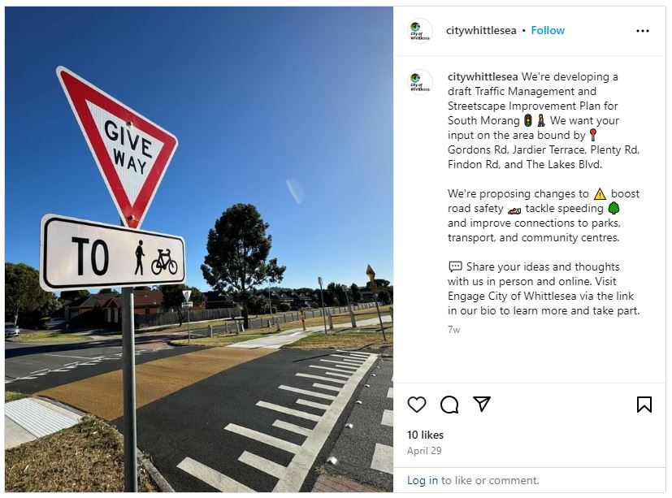

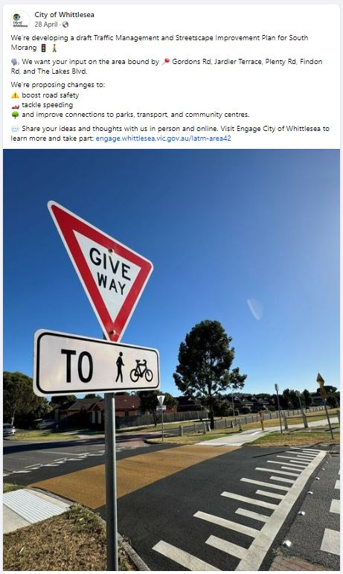

*Above: Local Area Transport Management South Morang social posts.*

**Participation**

Below is a snapshot of community participation in the consultation.

**Community participation**

|  |  |
| --- | --- |
| A hand icon holding a cell phone | Organic social posts reached 18,600 people and were engaged with 1,361 times which generated 32% of traffic to the online Engage page. The Engage campaign received 145 direct views from our community generating 40% of contributions. |
| A black and white line drawing icon of a pop up stall | We hosted two community-based pop-up with over 25 residents taking the opportunity to speak with the project team. |
| A computer icon with a check mark | A total of 53 participants completed the online survey. |

**What we heard**

Overall, the feedback captured through the community engagement indicates a strong desire for comprehensive improvements in traffic management, safety, environmental protection, and infrastructure to enhance the quality of life for residents.

Comments received through the survey have been themed below with a project officer technical response provided for context.

|  |  |
| --- | --- |
|  | ***Traffic Calming and Speed Management***   * Participants suggested replacing chicanes with speed humps, lowering speed limits and installing additional traffic calming measures to reduce speed and enhance road safety in residential streets and near schools. Various locations were suggested including Lazar Grove and The Great Eastern Way. Participants also raised concerns about reckless driving, such as hooning and running red lights identifying the intersection of Findon Road and Williamson Road and requested red light cameras be installed and an increased police presence.   *“Plenty Road needs red-light and speed-detection cameras installed”.*  *“The safety device directly adjacent to the promenade shops on Darius Terrace should be a wombat crossing rather than a speed hump. The promenade is a popular area for kids and adults meaning a large number of people are crossing the road from Darius Terrace to the playground / shops. I note at least one street parking will be lost with this but I believe safety of adults and children is more important so this should be considered.”*  *“Further slowing of traffic and deterrence needs to occur on Gordons Road”.*  **Technical response:**  Following the review of traffic volumes and speeds in the area, traffic calming devices have only been proposed for locations where the operating speed is over the posted speed limit and/or a strategic pedestrian/cyclist link can be provided without a significant reduction in on street parking. The replacement of existing traffic calming devices such as chicanes is not currently required as operating speeds were found to be below the speed limit.  Concerns regarding reckless driving, hooning and speeding have all been referred to Victoria Police for review and potential enforcement. This includes the request for red light cameras which are not in the scope of Council’s role. |
| No Driving outline | ***Parking Management and Enforcement***   * Participants raised concerns with illegal parking around schools during school drop-off and pick-up times, identifying Vincent Drive and Bushlark Way as streets of concern. They called for stricter enforcement of current parking restrictions and the introduction of additional parking restrictions to manage congestion and improve safety near schools and busy areas.   *“Parking restrictions (no parking during school drop-off periods) in Bushlark Way; not permitting the crossing staff to park so close to the intersection of Bushlark Way and Vincent Drive and parking inspectors during school drop-off hours as parents park in the road and across driveways”.*  *“What would make Bushlark Way safer and be more helpful in managing the traffic would be to have parking bays along the eastern side of the street so that we can still drive in and out of our properties when parked cars are waiting to pick up children”.*  *“Illegal parking on grass at Auburn Road Red Gum Reserve during 10am to 1pm time frame on weekends (Sat & Sun), match days and during school holidays”.*  **Technical response:**  Parking enforcement matters have been referred to Council’s parking enforcement team for review and additional parking restrictions are being considered on an individual basis.  The request for indented parking is not a service Council provides. Any request for indented parking in established areas is reviewed on an individual basis with all costs borne by the applicant. |
| Traffic light outline | ***Intersection and Road Design Improvements***   * Intersection improvements were raised including adding slip lanes and right turn lanes at the Findon and Williamson Road intersection and installing traffic lights at problematic intersections such as at Findon Road and The Great Eastern Way. Participants felt that improvements to intersections are necessary to enhance traffic flow, reduce congestion, and prevent accidents.   *“Get rid of the temporary traffic lights at Findon and Williamsons Rd. Permanent lights activated by traffic presence are needed”.*  *“The right turn from Findon Road to The Great Eastern Way is becoming difficult specially after dark and there were few near misses- we need traffic lights or something"*  *“I drive on these streets multiple times a day and the biggest concern by far is the disaster on where Findon Rd joins the extension up to plenty road - where there are currently temporary lights and you would turn left to head up to middle gorge station/Marymede college. I thought this was supposed to have already been fixed. It definitely can’t afford to wait until next year”.*  *“Permanent lights activated by traffic presence are needed”.*  **Technical response:**  The Findon Road/Williamsons Road intersection is a current Capital Works project being delivered by Council and is not part of this project. Once completed, the new intersection will allow for all turning movements.  The upgrade of the Findon Road/The Great Eastern Way intersection is a new Capital Works project that wlll be designed by Council in 2024/2025 with potential implementation in 2025/2026 and is not in the scope of this project. |
| Walk outline | ***Pedestrian Safety and Infrastructure***   * Participants indicated that enhancing pedestrian safety through additional crossings and better lighting is a priority to protect residents, especially children, walking in busy areas. There were suggestions for additional pedestrian crossings near schools and recreational areas (i.e.: along Darius Terrace).   *“A pedestrian crossing needs to be moved outside Marymede to line up with the entrance gates - parents are crossing at non designated areas because the pedestrian crossings are in the wrong location”.*  *“There is no pedestrian crossing on The Great Eastern Way near Vincent Dr for any child walking home from Marymede or The Lakes’.*  *“On streets like Applegum Dr and Jardier Tce you have road humps that also have a pedestrian crossing point but are only signed/line marked as a road hump and aren’t very DDA friendly as drain runs through it”.*  **Technical response:**  Pedestrian/cyclist crossings have been proposed where there is a strategic link and it can be provided without a significant reduction in on street parking. Lighting is considered at each crossing point to meet Australian Standards.  Raised crossing points can only be proposed on roads with a speed limit of 50km/h or less, this excludes The Great Eastern Way due to its posted speed limit of 60km/h. A speed limit reduction is being considered for The Great Eastern Way however this would require approval by the Department of Transport and Planning and would need to align with the *Speed Zoning Guidelines* which specify that signs alone is not adequate if the operating speed limit is higher than the proposed. Therefore, the speed reduction would require a standalone project as physical measures (such as speed humps or roundabouts) would also be required along the road to maintain safe operating speeds and to adhere to the *Speed Zoning Guidelines*. |
| Open hand with plant outline | ***Environmental and Aesthetic Enhancements***   * Participants felt incorporating green spaces and protecting local wildlife are important for improving the area’s aesthetics and environmental health. They suggested planting more green, leafy trees and protecting local wildlife for instance birds on Gabriel Terrace as well as local kangaroos.   *“Need more trees, vandals have been chopping with axes. Random trees here and Hawkestowe”.*  *“kangaroo need protection fences and signs to advise dogs on leads as often this is what initiates kangaroo running into traffic”.*  *“Signs warning drivers of the bird life on Gabriel Tce. The birds are often sun-baking on the road or crossing back and forward from the lake to the nature strip”.*  **Technical response:**  Streetscape improvements are being considered on an individual basis and along proposed footpaths. Signs for wildlife protections are considered on an individual basis as well. |
| Cycling outline | ***Public Transport and Cycling Infrastructure***   * There is a need for enhanced cycling infrastructure and public transport services to provide sustainable travel options and reduce traffic congestion. Participants suggested better cycling links to shopping areas and improved public transport connections, particularly to alleviate congestion near Middle Gorge Station.   *“Better cycling links from residential areas to shopping areas. Ie Westfield”.*  *“The crossing across the drain in particular vehicles don’t seem to stop for pedestrians very often (This should also be changed to a SUP crossing rather than zebra as it makes it illegal to cross on a bike but you have an SUP either side so it’s essentially designed non-compliance)”.*  **Technical response:**  Shared user paths are proposed at all locations where there is a shared user path on either side of the road. |
| Home outline | ***Community and Residential Impact***   * Participants raised concerns around the impact of proposed traffic measures on residents, such as noise from speed humps. There were suggestions for incentives to encourage alternative modes of transport and reduce car use particularly for school children.   *“Improved traffic flow on arterial roads to reduce motorists taking short cuts through residential streets”.*  *“I'm concerned that the speed control devices to be put ins Darius Cres & Jardier Terrace will increase the hoon factor in Lazar Grove as it becomes more of a rat-run between the 2 other streets. Additionally more people will 'short-cut' into Lazar Gr via Aristocrat Tce as a consequence. Please include speed humps/Wombat crossings in Lazar Grove”.*  *“If the flow of traffic around Marymede College and the local area 42 is to be improved then the new intersection at Findon and Williams Road needs to be improved. The design of this intersection appears to have only taken into account through traffic and completely disregarded the needs of local traffic”.*  **Technical response:**  All traffic calming devices will be installed as per Australian Standards specifications and will meet EPA guidelines. The post implementation review will consider if other roads require treatment due to new ‘rat running’ routes emerging which could not be accounted for.  This project aims to provide safe pedestrian/cyclist infrastructure within this area to promote walking and cycling. |
| Traffic cone outline | ***Road Maintenance and Upgrades***   * Participants felt that upgrading and maintaining roads is important to ensure smooth and safe travel for residents. There were requests for road duplications (i.e.: The Lakes Boulevard) and better maintenance to address potholes and improve driving conditions.   *“A slip lane is needed for traffic, travelling in the direction of Plenty Road, wanting to turn into Williams Road and a right turn lane is needed for traffic, travelling along Findon Road from Plenty Road to turn into Williams Road.”.*  *“Findon Road at Williamsons Rd needs to have a right hand turn lane added for traffic coming from Plenty Road. The no right turn at this temporary intersection causes all traffic going to Marymede to travel via Ferres Blvd or Vincent Drive”.*  *“The southbound lane needs to be duplicated to allow the traffic to turn left and right at Findon without the need to queue for hundreds of metres back past Darius and Vincent Drive”.*  **Technical response:**  Treatments on Findon Road and Plenty Road are not within scope of the project and concerns around the Findon Road/Williamsons Road and Findon Road/The Great Eastern Way intersections are being addressed through Council’s separate Capital Delivery projects.  The potential duplication of Findon Road is being reviewed as part of a recent corridor study of the area to determine if/when the duplication would be considered. It is worth noting that responsibility of Findon Road will be transferred to the Department of Transport and Planning in the future as it will be reclassified as an arterial road and will no longer be a Council asset when this occurs. |

**Next steps**   
The valuable feedback captured through this community consultation will inform the finalisation of the traffic management and streetscape improvement plan (TMSIP) for the area. Feedback may also be used to inform the development of other key plans and strategies Council are working on to make Whittlesea *A Place for All*.

Thank you again to everyone who participated in the community engagement by sharing their valuable feedback online or at one of the community-based pop-ups. The community will be updated on further developments via the [Local Area Traffic Management - South Morang | Engage City of Whittlesea](https://engage.whittlesea.vic.gov.au/latm-area42).