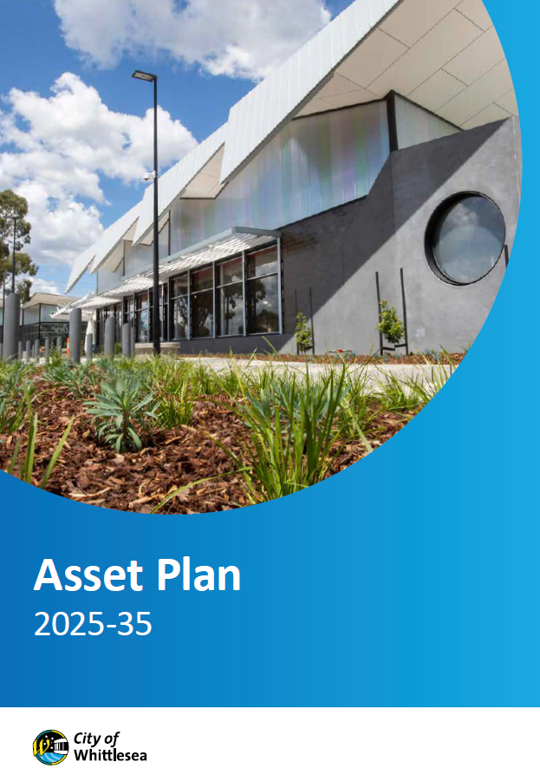

May 2024 – May 2025
draft ASSET Plan 2025-35
Engagement Summary Overview

Introduction
The City of Whittlesea’s draft Asset Plan 2025-26 to 2034-35 is a community facing document that outlines how the City of Whittlesea will plan, build, manage and maintain our assets over the next ten years to ensure they meet the needs of our growing community now and into the future. This document is the update to our Asset Plan 2022-32 and outlines how Council will prioritise, deliver and manage our infrastructure and assets. The plan covers all of Council’s physical assets including roads, footpaths, playgrounds, storm water, open spaces and buildings.

Previous community consultations and research including the annual Community Priorities community engagement informed early planning on the new Asset Plan before we embarked on a robust deliberative engagement program. A total of 122 people contributed during the engagement program, with 50 community members participating across four focus groups and 72 participating via the digital survey on the Engage Whittlesea platform.

The draft Asset Plan was then presented to community for feedback between 16 April and 11 May 2025 where community were asked whether they supported the proposed Asset Plan and if they didn’t to explain why. Participation was available online through the Engage Whittlesea platform or in-person at a series of eight community-based pop-up stalls scheduled across the municipality in high foot traffic locations.

To avoid consultation fatigue, the project was co-located with the Proposed Budget 2025-26, Proposed Financial Plan 2025-26 to 2034-35, Proposed Revenue and Rating Plan 2025-26 to 2028-29 and Community Vision Review projects that were also open for comment.

Sixty-six people participated in the consultation and told us that majority (95%) supported the proposed Asset Plan 2025-26 to 2034-35. Those that were not supportive of the draft indicated a need to address community safety, cleaner neighbourhoods and cost of living via the use of our assets as their reason.

Project promotion
The opportunity to participate in the community engagement was promoted through a range of channels to have a widespread reach across the municipality including:

- Council’s digital engagement platform Engage Whittlesea
- Social media
- Promotion on screens at Civic Centre, Libraries and aquatic centres
  - An e-newsletter or personalised email with direct link to the project page and was sent to:
- People who engage with Ageing Well services
- Registered multicultural and seniors groups
- Sports and recreation clubs
- Aquatic Centre operators
- Youth Services network
- Library and community hubs users
- Whittlesea Disability Network
- First Peoples network
- Community Priorities Focus Group participants.
How we engaged you
The community engagement on the draft Asset Plan 2025-26 to 2034-35 has been delivered in phases as detailed below:
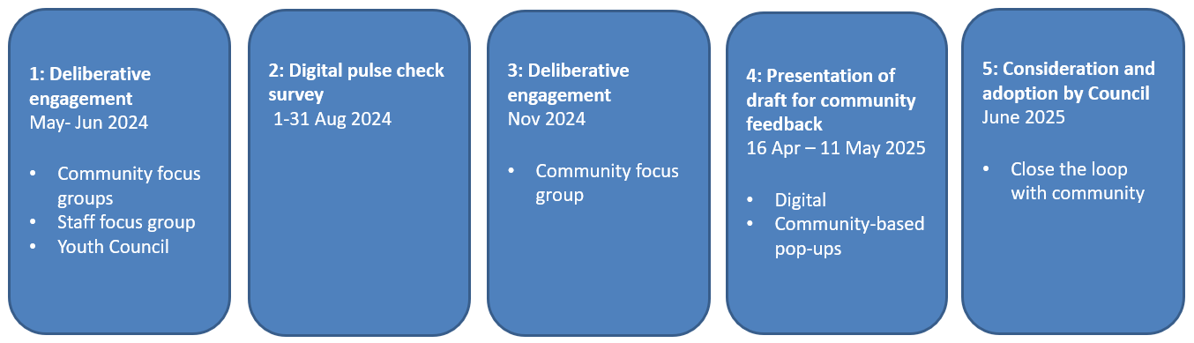
A mix of online and in-person opportunities were utilised across the four phases of consultation.
Community-based pop-up stalls were held in high foot traffic areas across the municipality and facilitated community focus groups were undertaken to offer an opportunity for deliberation at a deeper level on the topic. Digital engagement including a survey was hosted on the Engage Whittlesea platform which utilises an accessibility add-on ensuring that it is as accessible as possible for all users. The platform also has an in-built translation tool to mitigate any language barriers to participation, allowing the page to be translated into the top fifteen languages spoken within the municipality.
As the Asset Plan is a technical document, we sought to make it easy for community to understand the plan. Activity boards (image below) were used at in-person engagement activities that presented six key inclusions as dot points and used an infographic to highlight the types of assets Council manages. This information was mirrored on the project Engage Whittlesea page.
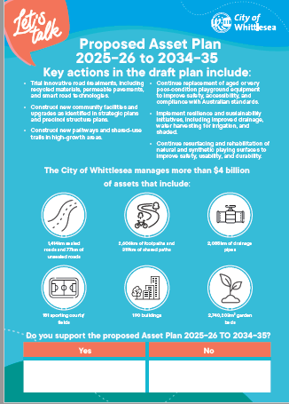
Left: Image of the activity board used at community-based pop-up stalls

Highlights from across the four phases of consultation are below:
 |  |  |  | 
Hosted 8 community-based pop-ups | Youth Council presentation | 4 community focus groups | 76 digital contributions | 112 in-person contributions

Below is a snapshot of the participation in the consultation, which is predominantly representative of our broader community:
 |  |  | 
48% female, 50% male and 2% prefer not to answer | All ages groups were represented with the largest being 29% of those aged 35-44 years and over 55 | 94% of participants live in the City of Whittlesea with 13 suburbs represented | 27% indicated they are a person with a disability or an unpaid carer of a person with a disability or older person

 |  | 
3% identified as Aboriginal or Torres Strait Islander | 5% identified as members of the LGBTIQA+ community. | 39% speak a language other than English at home

Phase 1
In May 2024 Council embarked on a deliberative engagement program to inform the development of a new Asset Plan, commencing consultation with three community focus groups as well as an internal staff workshop. The community focus groups were held in different locations across the municipality to reduce travel for the 34 participants and enable a place-based lens to the feedback captured. Details of the focus groups are below:
- Civic Centre Fountain View Room, South Morang, Monday 20 May, 7pm – 9pm
- Galada Community Centre, Epping, Wednesday 22 May, 7pm – 9pm
- Whittlesea Community Activity Centre, Tuesday 28 May, 7pm –9pm

During the two-hour sessions, participants contributed to an icebreaker, two small group activities, and two individual surveys. The first activity focused on the levels of servicing assets to determine which asset types they saw as a higher priority or wanted to see have increased service. The second activity focused on the proposed 12 asset management principles and participants level of agreement of the principles and which they saw as of the highest priority
Phase 2
Once we’d collated feedback from the deliberative engagement, we presented this to the wider community in August 2024 and invited them to have their say on whether they agreed with the focus group findings and recommendations by participating in a quick digital pulse check survey activity that took less than ten minutes to complete.

The survey presented the recommended service levels, the top four asset management principles as well as sharing four new asset management principles developed following community engagement. The survey was housed on the project Engage Whittlesea page along with the Community Engagement Report and a series of frequently asked questions.

Phase 3
In November 2024 we reconvened available members of the phase one community focus groups to deliberate specifically on renewing versus maintaining assets. Working in small groups, participants were asked when considering the management of our community assets which approach would you prefer Council to adopt for future budgets?
- Continue maintaining current assets at their current standard, with any significant upgrades to be funded by combination of grants plus increased rates
- Continue to maintain current assets at their current standard, with any significant upgrades to be funded in full by only by grants
- Reduce and consolidate some services now to pay for new and upgraded infrastructure in future
Phase 4
Based on the feedback from the first three phases of consultation the draft Asset Plan was created and in April-May 2025, we shared it with the community to see if it was supported. Participation was available online through the Engage Whittlesea platform or in-person at a series of eight community-based pop-up stalls scheduled across the municipality in high foot traffic locations. Details of the community-based pop-ups are below:

Date | Time | Where | Address/location
16 April 2025 | 5pm-7pm | Kirrip Community Centre | 135 De Rossi Blvd, Wollert
28 April 2025 | 9.30am -11.30am | Lalor Library | 2a May Rd, Lalor
28 April 2025 | 2.30pm -4.30pm | Thomastown Library | 52 Main St, Thomastown
29 April 2025 | 9.30am -11.30am | Westfield Plenty Valley | 415 McDonalds Rd, South Morang
29 April 2025 | 2.30pm -4.30pm | Laurimar Shopping Centre | 101 Hazel Glen Drive, Doreen
30 April 2025 | 9.30am -11.30am | Shared Cup Café | 995 Donnybrook Rd, Donnybrook
30 April 2025 | 2.30pm- 4.30pm | Mernda Village Shopping Centre | 59 Mernda Village Drive, Mernda
2 May 2025 | 9.30am -11.30am | Coles University Hill | 2 Janefield Drive, Bundoora

What we heard and what we’ve done since
Phase 1
In the first phase of deliberative engagement, participants deliberated with other community members and project staff and gained a better understanding of the service level expectations and challenges faced. Participants told us, that they wanted to see an increase in service for aquatic centres (swimming pools and splash parks), lighting, sports pavilions, and public toilets; and that they were happy for a lower level of service for shelters, park furniture, kerbs and community buildings such as Community Activity Centres.
Participants also told us their top four asset management principles were:
- Assets promote an active and healthy community
- Asset risks are minimised to keep the community safe
- Assets are equitable and accessible to the whole community
- Assets promote community connectivity.
Through the first phase of community consultation four new asset management principles were developed. The new principles were:
- Assets meet the diverse and changing needs of the community
- Assets demonstrate connection to First Peoples
- Infrastructure decisions consider environmental, social and financial sustainability
- Assets are optimised for useability.
Phase 2
In August 2024 we heard from 72 people through the digital survey; half of the participants were supportive of the level of service the focus groups had recommended. A further 14% were neutral of the recommendation.
When presented with the top four asset management principles identified by the focus groups, 65% of participants in this phase of consultation agreed with the recommendation and a further 22% were neutral. We also presented the additional four new principles developed following the initial phase of consultation. All new principles presented had a high level of support with majority of participants indicating that they agreed or strongly agreed with three of the four proposed new principles.

Phase 3
Sixteen participants were available when we reconvened the community focus group in November 2024. The group were presented with the four newly developed principles which completed a suite of eight Asset Management Principles. All eight principles were strongly supported.

The group deliberated on their preferred funding approach for managing key assets. based on the following three options:
- Continue maintaining current assets at their current standard, with any significant upgrades to be funded by combination of grants plus increased rates
- Continue to maintain current assets at their current standard, with any significant upgrades to be funded in full by only by grants
- Reduce and consolidate some services now to pay for new and upgrades infrastructure in future.
The group told us that the approach they would prefer Council adopts for future budgets differs depending on the asset type.
- Public toilets
  - Deliberations on managing public toilets saw options B and C as the most appropriate. The challenges of each of the options was discussed and the group unanimously agreed that maintenance was a better option than renewing.
- Play equipment at parks
  - Deliberations on managing park play equipment saw options B and C as the most appropriate. Challenges discussed by the group included defining grants, change management opportunities and prioritising based on demographics. Discussion focused on new playgrounds built by developers and handed to council to maintain adding to ongoing costs. The group questions what role Council could play in ensuring the same standard of park being bult by developers as many use materials that are not long lasting and have higher maintenance costs. The group also suggested Council exploring sharing responsibility of parks with the community such as the recently opened Doreen Dirt Jumps which saw Council develop the area and community maintaining it. Another suggestion by the group focussed on community fundraising initiatives with funds used to develop the playground and council maintaining it from there on.
- Sporting pavilions
  - Deliberations on maintaining sporting pavilions saw options B and C as the most appropriate, with option B seen as the preferred. The challenges discussed by the group included whether Council could rely on grants for funding with the group suggesting that Council report on the number of grants applied for and not just the number of successful grant applications. There was also discussion around the challenge of equity across the municipality given its size and population.
Phase 4
The draft Asset Plan was shared with the community in April and May 2025. Sixty-six people participated in this phase of consultation and told us that majority (94%) supported the proposed Asset Plan 2025-26 to 2034-35. Those that were not supportive of the draft indicated a need to address community safety, cleaner neighbourhoods and cost of living via the use of our assets as their reason.

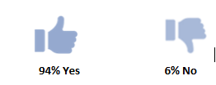

The following table outlines key feedback we heard through the four phases undertaken of the community engagement program and how we responded in the draft of the new Asset Plan.

What we heard | Our Response
Desire for an increased level of service for Aquatic Centres (swimming pools and splash parks), lighting, sports pavilions, and public toilets.  Happy with lowering service level for shelters, park furniture, kerbs, and community buildings. | Section 6.4 of the Asset Plan outlines that the service levels set by Council are based on community expectation, legislated levels of service and subject matter standards, and are detailed within the respective Asset Management Plans based against affordability.  We acknowledge that where a higher service level provision is required due to higher need and utilisation, it will increase the level of service of that particular asset.  Section B of the Asset Plan details the funding decisions that were made with consideration to feedback from the community.
Through the first two phases of consultation, we heard that the top four asset management principles were:  - Assets promote an active and healthy community  - Asset risks are minimised to keep the community safe  - Assets are equitable & accessible to the whole community  - Assets promote community connectivity. | Section 4.7 of the Asset Plan includes the top four principles as strongly supported by the community.
Through community consultation four new asset management principles were developed and supported when presented back. These were:  - Assets meet the diverse and changing needs of the community  - Assets demonstrate connection to First Peoples  - Infrastructure decisions consider environmental, social and financial sustainability  - Assets are optimised for useability. | Section 4.7 of the Asset Plan includes all four newly developed principles to complete a suite of eight Asset Management Principles. The eight principles were presented to the reconvened focus group during the third phase of consultation and were strongly supported.
When presented with the dilemma of renewing vs maintaining assets, focus group participants opted Continuing to maintain current assets at their current standard, with any significant upgrades to be funded in full by only by grants or to Reduce and consolidate some services now to pay for new and upgrades infrastructure in future as their preferred means of managing assets into the future. | Section 7 focuses on ‘funding for the future’ where Section 7.1 highlights that the 10-year Asset Plan is aligned and integrated to the 10-year Financial Plan. This is a critical approach when responding to the dilemma of renewing vs maintaining assets.  Section 7.2 of the Asset Plan looks at our asset investment strategies. Our asset investment strategies align and integrate with our asset management and financial planning principles.  We will aspire to:  •Optimise asset life through timely and effective maintenance  • Continue to place a high priority on renewing our ageing assets  • Manage the impacts of growth by being strategic in how we plan for our future asset needs  • Comply with our obligations by actioning legislated standards in asset planning and development  • Provide affordable services by balancing community needs and aspirations with what ratepayers can afford  • Build resilient assets that not only deliver the best outcome for our community but also the best outcome for the environment.
Community belief that First Peoples inclusion in the plan should be a given and not just an asset management principle that is prioritised up against other principles. | Section 3.3 of the Asset Plan outlines a ‘caring for country’ approach towards asset planning. The City of Whittlesea is committed to delivering our asset management practices and processes respectfully, with an awareness of the relationship between First Peoples and Country, inclusive of land, water, plants, animals and cultures.  By including the asset management principle Assets demonstrate connection to First Peoples, ensures that any decisions related to new, renewal or upgrade of Council assets will have a lens to consider First Peoples and any potential cultural impacts and future connections.

Next steps
Thank you to everyone who shared feedback though our Asset Plan consultation either in-person as part of a community focus group, at a community-based pop-up or online through the Engage Whittlesea platform. We are finalising the Asset Plan that will be presented to Council for consideration and adoption at the Council Meeting on Tuesday17 June 2025. We will share the final plan when it is adopted and encourage you to follow the project Engage page (www.engage.whittlesea.vic.gov.au/assetplan25 ) to be kept up to date.

