To change the main landscape picture and add alt text:
- Double click in the header.
- Hover over the City of Whittlesea logo and right click once.
- Select ‘Send to back’
- Hover over the main picture and select right click once.
- Select ‘Change picture’
- Navigate to and select the picture you want to replace it with.
- Hover over the main picture and select right click once.
- Select Format Picture, and the select Alt Text. In the description box briefly describe the image. E.g. Children’s playground, Taunton Park. Select Close.
- Hover over the main picture and select right click once.
- Select ‘Send to back’
- Close Header and Footer.
- Delete this box once complete.

Quarry Hills Regional Parkland Future Directions Plan

Phase 2 – community consultation
Engagement Summary Report
January 2023
Introduction

The City of Whittlesea, in partnership with traditional land owners the Wurundjeri Woi-wurrung and funding partner, the Department of Energy, Environment and Climate Action (DEECA) are developing the Quarry Hills Parkland Future Directions Plan (The Plan). Quarry Hills Parklands is the City of Whittlesea’s largest park and the defining landscape feature of the municipality, contributing strongly to the character of the Mernda and Wollert growth corridor.

Through an established set of principles, the Future Directions Plan will guide the future planning, development and operations of the Parklands. These principles are informed by the values and significance of the landscape, traditional owner and stakeholder consultations, and will be implemented through long-term initiatives that Council has set out to protect and enhance open space for the community.
Feedback from the community and key stakeholders will inform The Plan. Engagement was undertaken in two phases, 1) key stakeholder engagement, and 2) wider community consultation.
Initial targeted consultation was undertaken with diverse representation from a range of key stakeholders including landowners within the parkland, on the 12 September 2022. The purpose of this engagement was to assist Council to identify the key values, issues and opportunities of the parkland and discover the key components of the vision for Quarry Hills Regional Parkland.

The second phase of consultation was undertaken throughout December 2022 and January 2023 and involved engaging the wider community through pop-up sessions and on Council’s digital engagement platform. The purpose of this engagement was to hear community feedback on the Draft Future Directions Plan to ensure that the future of the parkland reflects our community’s vision.

How we engaged you
The Quarry Hills Parkland Future Directions Plan phase 2 consultation was open for community comment ran from 28 November 2022 to 20 January 2023.
Community feedback was sought online through Council’s Engage platform and through direct conversation and activities at community pop-ups that were scheduled in high foot traffic areas in proximity of Quarry Hills Regional Parkland.
The project’s Engage page featured three activities/tools including a survey, social map and a gather tool.
Seven community pop-ups were scheduled, unfortunately due to inclement weather one of the onsite consultation was cancelled. The community pop-ups run were:
- City of Whittlesea Carols by Candlelight event at the Civic Centre on Friday 9 December from 6-8pm
- Administrator Meet & Greet event at Mernda Village Community Activity Centre on Monday 12 December 2022 from 6-7.15pm
- Westfield Plenty Valley on Thursday 15 December 2022 from 4.30-7pm
- Coles Mill Park Lakes on 16 January 2023 from 9.30-11.30am
- Mill Park All Abilities Play Space on 17 January 2023 from 9.30-11.30am
- Westfield Plenty Valley on Tuesday 17 January 2023 from 1-3pm.
The community consultation was promoted trough a range of tactics including:
- Direct mail to adjacent property owners - a letter was mailed prior to wider community consultation commencing, inviting them to provide their feedback on the draft plan through the projects Engage page and/or directly contacting the Open Space Planning Team.
- Direct mail to targeted residents - residents within a 400m radius of the parkland were letterbox dropped in November to inform them of the draft Future Directions plan and encourage them to share their feedback on the draft plan through the projects engage page or at one of the planned community pop-ups.

Email to previously consulted stakeholders – anyone who participated in the first phase of consultation was emailed to inform them of the Draft Future Direction Plan and encourage them to provide feedback.
- Social media – we shared posts across Council’s channels 16 times, engaging with over 2,300 people while reaching over 35,000 people.
It’s worth noting that Council’s social channels, including Facebook, Twitter and Instagram, were the most successful in generating contributions to the online engagement, with almost 50% of all visitors referred by a social channel.
The remaining visitors accessed the project Engage page directly (39%), through Council’s webpage (6%), or via a search engine (5%).

Participation
The Quarry Hills Regional Parkland Future Directions Plan project page on Council’s online engagement platform received 1186 visitors with 179 community members providing feedback or completing the survey during the consultation period.
Council Officers spoke with a further 44 people across the six community pop-ups, with the majority of the conversations taking place at Coles Mill Park and Mill Park All Abilities Play Space in January 2023.
Almost 84% of those that participated lived within South Morang, Epping or Mernda with a large majority residing within 400m of Quarry Hills Regional Parkland.

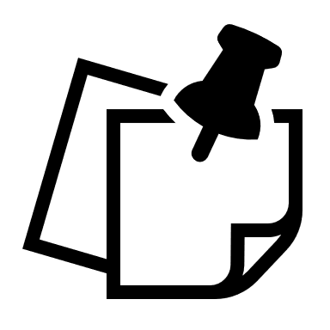
115 community members contributed to the engagement by completing the survey or sharing their thoughts on the social or through gathering tool
Of those participating online, 69 community members completed the survey
44 community members attended pop up sessions
Of those participating online, 42 community members provided comments on the social map
Of those participating online, 31 community members shared their thoughts through gather tool

What we heard

Survey Results
There were 73 contributions to the online survey and the results provide a good indication of the communities’ thoughts on the vision and future direction statements.
When asked which values for Quarry Hills Regional Parkland were most important to them, the majority of responders (58%) ranked Health and well-being as the most important.
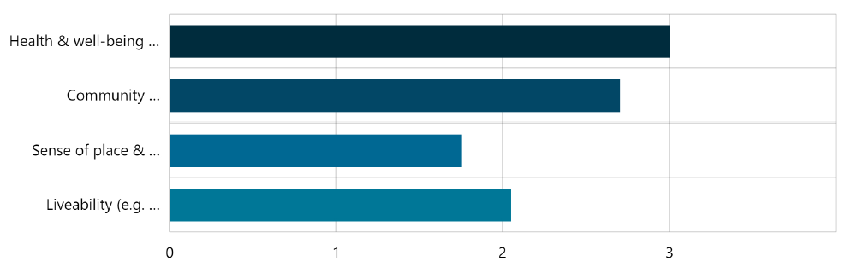
Score






Respondents were asked if they like the vision for the parkland, with 89% indicating they felt neutral or positive toward the vision.
25% Like the vision a lot
42% Like the vision
22% Can live with the vision
5.5% Don’t like the vision
5.5% Don’t like the vision at all
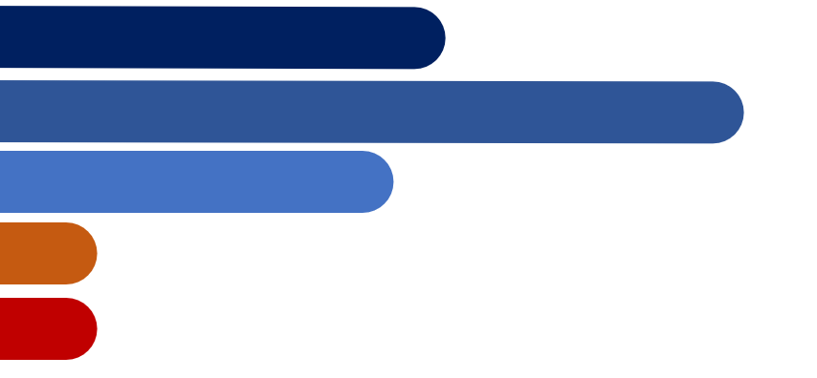
89% of community members felt neutral or positive toward the vision.

When asked if they would make changes to the vision, majority of respondents (77%) skipped the question as they were supportive of the vision. Of those the 17 answers provided 10 participants (58% of responders to this question) requested changes to the vision.

Comments related to suggested changes to the vision reflected the need to emphasise on the existing natural environment and retain and regenerate the ecological health of Quarry Hills Regional Parkland. Additionally, some of the feedback requested mention and inclusion of a variety of cultures within and surrounding Quarry Hills Parkland.
The following word cloud illustrates the most commonly requested changes.
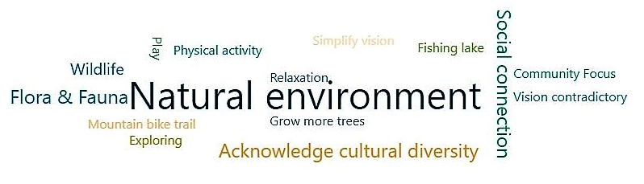
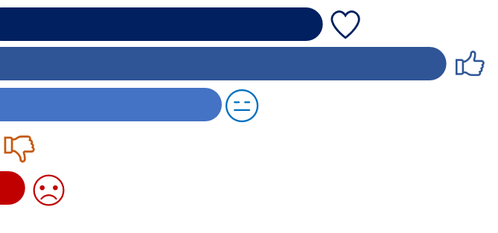
31% Like the People Statement a lot
44% Like the People Statement
22% Can live with the People Statement
3% Don’t like the People Statement at all
When presented with the ‘People’ direction statement, majority of respondents felt neutral or supportive of it.
Again, majority of respondents (78%) skipped the question that asked if they would make any changes to the ‘People’ direction statement. Of the 16 answers provided, only 5 respondents requested changes. Comments received reflected a need to emphasise people's connection to nature and appreciation of the parkland.

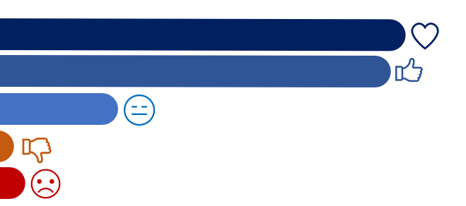
43% Like the Place Statement a lot
41% Like the Place Statement
12% Can live with the Place Statement
3% Don’t like the Place Statement at all
1% Don’t like the Place Statement
When presented with the ‘Place’ direction statement, majority of respondents felt neutral or supportive of it.
Most respondents (88%) skipped the question when asked what changes they would make to the ‘Place’ Statement. Of the 9 answers provided only 5 suggested changes. Comments reflected the connection of the parkland to the surrounding environment and emphasising the uniqueness of the parkland.

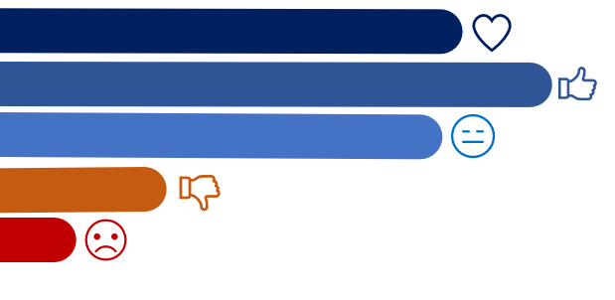
27% Like the Economy Statement a lot
33% Like the Economy Statement
26% Can live with the Statement
4% Don’t like the Economy Statement at all
10% Don’t like the Economy Statement
When presented with the ‘Economy’ direction statement most respondents felt neutral or positive toward it (86%).
Almost 74% of participants skipped the question that asked what changes they would make to the ‘Economy’ statement. From 19 answers, only 3 participants requested changes to the statement. These comments reflected the need for clarification of economically sustainable and the risk of overdevelopment due to economic gain.

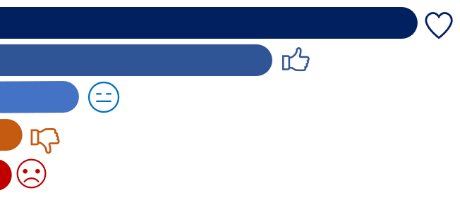
52% Like the environment Statement a lot
34% Like the statement
10% Can live with the Environment Statement
1% Don’t like the Environment Statement at all
3% Don’t like the Environment Statement
When presented with the ‘Environment’ direction statement majority of respondents felt neutral or positive toward it (96%).
Unsurprisingly, only seven respondents chose to answer the question that asked what changes they would make to the statement. Of these only three people suggested a change with comments focussed on emphasising the protection of the parkland, local wildlife and proactive stance and a need for stronger language in caring for the environment.
Overall, majority of respondents were supportive of the Vision and directions statements, however community feedback also reflected the need for simplicity and an easy to follow structure.
Social Map, Gather Tool & Community pop-ups
- Social Map
The community contributed 61 pins (comments) to the social map. These detailed comments delve deeper into the perceived issues and ideas for improving Quarry Hills Regional Parkland. These have been categorised and are outlined in Table 1.
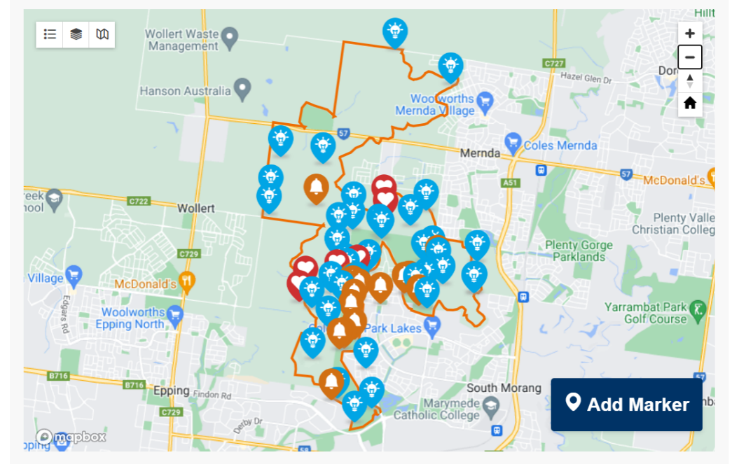

Image 01: Social map, project Engage page, 2023

- Gather tool
A total of 31 community members posted feedback on the digital ideas board on the projects Engage page. These detailed comments delve deeper into the perceived issues and ideas for improving Quarry Hills Regional Parkland.
The commonly mentioned items focussed on protecting the environmental landscape, providing recreation facilities including Mountain Bike Trails, raising community awareness about the history and current facilities of the parkland and protecting the environmental landscape and wildlife in the parkland.
There was strong support from respondents to retain Quarry Hills Regional Parkland as a place among nature to enjoy peace and tranquillity with supportive facilities for families and community events. Respondents also strongly supported the idea of protecting flora and fauna, maintaining the natural habitat and introducing a community environment farm to increase interaction with nature and to support the local food system towards a sustainable economy.

Below are some of the comments shared through the gather tool:
Protect the local flora and fauna and tranquillity
“Please aim to conserve and protect the natural environment above trying to develop infrastructure for our entertainment e.g. mountain bike paths throughout. Quarry Hills attracts people with its tranquillity and natural values, adding excessive recreation will not only dampen the serenity but may pose a risk to local wildlife and endangered flora species. More signage is necessary to ensure dogs are on leash, and fines should be imposable for people found littering”
Family, friends and nature
“To have a place to visit to be among nature and natural beauty with the added resources of toilets, water, BBQ area, shelter and safe place for children, families and friends to picnic or attend community events!”
Animal farm
Every suburb needs their own animal farm that is easily accessible every day. With a cafe like the community farm in Eltham”
Place to connect with nature and to enjoy beautiful views
“I love walking through the park and enjoying its peace and tranquillity. Please don't make it too urban.
Cycling through it is currently a struggle - would definitely be nice to see more bike friendly tracs around.
More footpaths in general are needed.
Would be nice to have a track all around the perimeter of the park area, and to connect it from all directions to the existing ridge track.”
Animal farm
Every suburb needs their own animal farm that is easily accessible every day. With a cafe like the community farm in Eltham”
- Pop-up Sessions
Council Officers spoke to 44 people across the six community pop-ups held in December 2022 and January 2023.

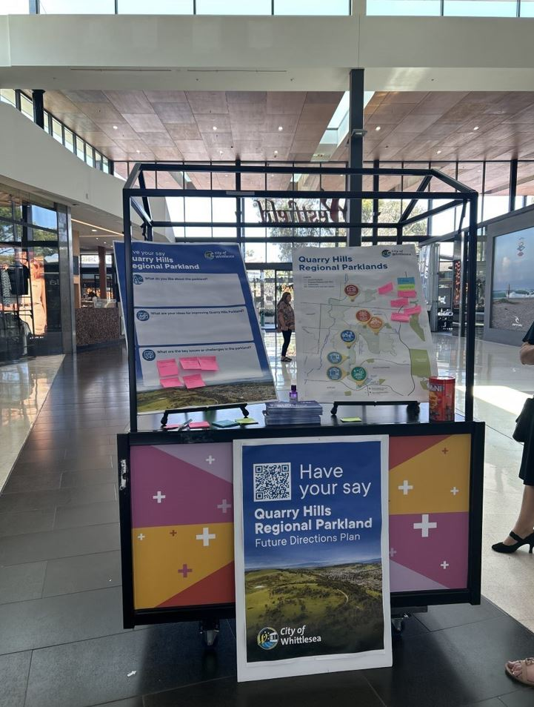
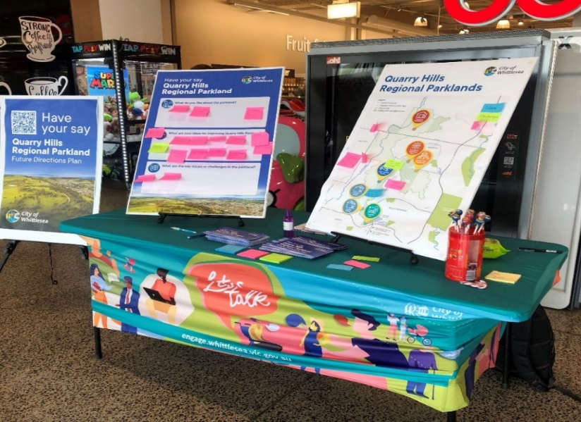

Image 02 (above): Pop-up at Coles Mill Park Lakes, January 2023
Image 03 (right): Pop-up at Westfield Plenty Valley, January 2023

Key comments raised through the social map, gather tool and community pop-ups.
The commonly mentioned items raised through the social maps, gathering tool and during pop-up sessions have been summarised and themed under 11 main categories in the table below.
As identified in the table, some of the comments raised are more detailed and can be addressed in the future Quarry Hills Precinct Plans and some will be addressed by the other current projects in the Quarry Hills Regional Parklands such as Connecting Trails, Wayfinding and Interpretive Signage.

Category  Summarised comments |  | Feedback to be addressed in:
 |  | Quarry Hills Regional Parkland (QHRP) Future Directions Plan | Future Precinct Master plans | Other Council related projects  In Progress (IP) Future (F)
Facilities | - Recreation facilities such as a playground, nature play area, water park, exercise equipment, café, bike education park and mountain bike  - Supportive facilities such as toilets, bins, picnic facilities, benches and shelters |  | ü  ü | üGranite Hills major community park (IP)
Events and activities | - Community groups/events including tree planting days and workshops  - Friends groups | ü  ü | ü
Access and connection | - Provide entrances from surrounding suburbs into the parkland  - More carparking  - Connecting trails between destinations across the parkland  - Connect the east and west sides of Darebin Creek  - Access from surrounding public transport to the parkland | ü  ü | ü  ü  ü | üGranite Hills major community park (IP)  üGranite Hills major community park (IP)  üQHRP Connecting Trails (IP)
Paths/Trails & lookouts | - Passive recreation facilities such as safe walking, hiking and cycling paths  - More established paths including loop-sealed paths and smooth paths  - Improve lookouts |  | ü | üQHRP Connecting Trails (IP)  üQHRP Connecting Trails (IP)  üQHRP Connecting Trails (IP)
Infrastructure and maintenance | - Stormwater management  - Rubbish management | ü  ü |  | üIntegrated Water Management Strategy (2020)  üIntegrated waste management plan (F)

Ecological health | - Protection of environmental landscape through expansion of conservation area, planting native trees, increased canopy cover  - Protection of wildlife, habitats and indigenous flora and fauna  - Avoid inappropriate infrastructure and development that erodes the parkland values  - Prioritise ecological health of the parkland | ü  ü  ü  ü |  | üConservation Services Contract to address high threat weeds & pest animal management (IP)  üRevegetation and habitat connectivity via Greening Whittlesea (IP)  üEcological burning program (IP)  üAnnual fauna monitoring (IP)  üRegular citizen science community engagement activities (IP)
Community connection to nature | - Community farm including kid's friendly education farm, animal sanctuary and animal farm |  | ü
Promotion of the parkland | - Raise awareness of the parkland through social media, posters, events and informative signage |  | ü
Indigenous cultural awareness | - Acknowledge and uphold Traditional Owners  - Awareness about the history and current facilities of the parkland | ü  ü | ü | üQHRP Wayfinding and Interpretive Signage (IP)
Signage | - Improve signage such as wayfinding, informative, interpretative and educational signage |  | ü | üQHRP Wayfinding and Interpretive Signage (IP) & QHRP Signage management plan (F)
Safety and security | - Improve parkland safety through signage, safety buttons, passive surveillance and regular patrolling |  | ü | üQHRP Signage management plan
Table 01: Summarised comments from social map, gather tool and pop-up sessions
Other comments raised online and during in-person discussions include:
- Linkages with community and academic research
- Memorial plan for the parkland
- Library and community spaces to enable our community to learn, connect and reflect
- Upgrade Foothill Park playground
- Fenced areas so people can enjoy the space without fearing nearby kangaroos.
The community was also invited through the digital social map and at community pop-ups to provide what they saw as the key issues and challenges they currently face in the parkland.
The most common issues/challenges identified were:
- Lack of supportive facilities
- Lack of signage
- Poor maintenance (overgrown spots, rubbish and Stormwater runoff management)
- Dumped rubbish
- Limited access and usable spaces due to the steepness of the natural terrain
- Gravel path along powerline between two existing shelters
- Anti-social behaviour near the existing carpark
- Balancing nature with new development and infrastructure
- Protection of natural habitats and wildlife in mine with increasing visitor numbers
- Conflicting recreational activities to the main feature of the park
- Controlling keeping dogs on leads

Next Steps
Thank you to all community members who provided feedback and have engaged with the project team.
Feedback gathered from the community is being used to develop the final Quarry Hills Regional Parkland Future Directions Plan. The project team and its consultant will review the feedback received and develop a revised plan with amendments that where possible address the concerns raised by the community.
The finalised Quarry Hills Regional Parkland Future Directions Plan will be made available on the projects Engage page - https://engage.whittlesea.vic.gov.au/quarry-hills-regional-parkland

