Lalor Recreation Reserve Master plan
Engagement Summary
August 2023
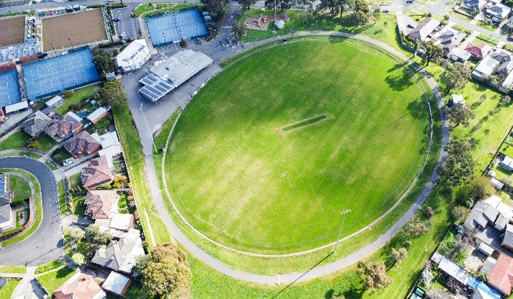

Introduction
Council is planning to upgrade Lalor Recreation Reserve with features that help our community get active, socialise and enjoy the outdoors. We are developing a master plan to create a vision and direction for the reserve’s future. The master plan will include short- and long-term improvements to be delivered over the next 10 years.
The Lalor Recreation Reserve master plan is a high-level document providing a broad vision for the entire reserve. The master plan does not focus on one specific item or user group, but instead looks at all of the reserve’s features, equipment and users. The master plan aims to find a balance for the needs of all the user groups and the facilities required by the different types of activities. It will outline the improvements required to achieve this balance in a staged action plan. In addition, the plan will need to meet the needs of current and future community and users.
The master plan will look at issues such as:
- Out of date sports and park equipment (including the playground)
- Public access and connections to pathways
- Visibility and safety (including lighting).

The master plan will also consider ways to increase active and passive activities in the reserve. These may include:
- Circuit walking paths
- Picnic shelters and seating
- Informal multi-sport courts (for example, half-court basketball, table tennis, volleyball or bocce)
- Fitness stations.

How we engaged you
The Lalor Recreation Reserve Master Plan consultation was open for community comment from 5 July to 31 July 2022.
On 22 June an in-person walk through with Victoria Police was held at the Reserve. A further consultation session with Lalor Bloods Football Club and Lalor Warriors Cricket Club was postponed and will be held at a later date.
Residents within 400m were letterbox dropped in early August to inform them of the development of the master plan and encourage them to share their feedback through the community consultation. Sporting clubs were contacted via direct mail and encouraged to promote the consultation to their membership.
Visitors to the reserve were alerted to the consultation through large corflute signage installed at the main entry point.
Subscribers to the Engage Whittlesea platform that had previously indicated an interest in parks and/or the Lalor area were notified via email of the new project page (total 583 subscribers). Of these, recipients 387 opened the email with 35, or 6 percent clicking through to view the Lalor Recreation Reserve Master Plan Engage page.
The community consultation and community pop-up were shared on Councils social channels including Facebook, Twitter and Instagram. The seven posts (four on Facebook) were viewed by a combined total of 24,758 with 1,740 of these people interacting with it in some way (sharing, commenting or leaving a reaction).

Participation
The Lalor Recreation Reserve Master Plan page on Council's Engage platform attracted 469 visitors during the consultation period. In that time 15 community members opted to follow the project page to remain abreast of developments.
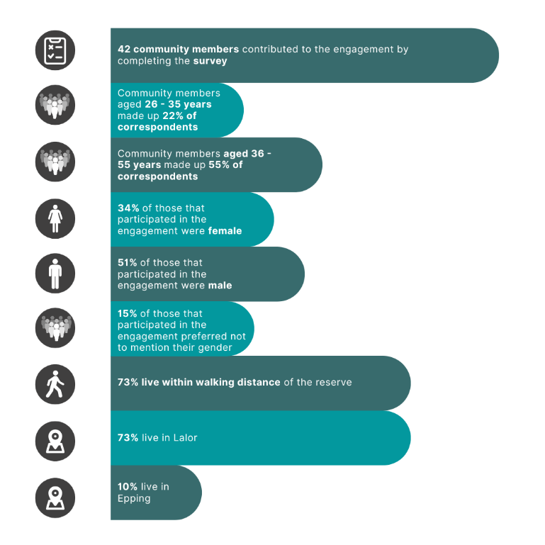
In total, 51 community members contributed to the engagement by completing the survey or sharing their thoughts on the interactive map. Below is a snapshot of participation in the consultation.

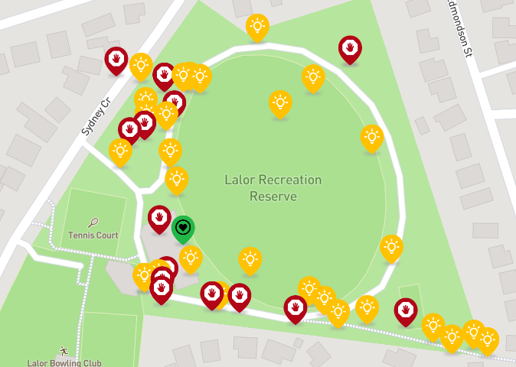
Participants dropped 45 pins on the interactive map and shared their insights and ideas.

What we heard
Around 95% of respondents have been to Lalor Recreation Reserve previously.
The two respondents that indicated they hadn’t ever visited Lalor Recreation Reserve indicated that they had “No reason” or “other” for not visiting the Reserve.
Of the 40 respondents that had visited Lalor Recreation Reserve 30% indicated they visit the reserve 2-3 times per week, and 28% visit the reserve weekly. Eighteen percent indicated they visit the reserve daily, while the remainnig18% indicated they visit a few times per year.
Majority of respondents indicated their connection to the reserve is that they are a local resident (80%), and 25% indicated that they belong to a community organisation/club. A large number of participants (73%) walk or run to access the reserve, which aligns with the 73% who indicated they live within walking distance.
The oval is the facility most used by participants, with 75% indicating they use the oval when visiting Lalor Recreation Reserve. Use of the carpark (43%), followed by the playground (37.5%) and the toilets (13%) are the next most used facilities of within the reserve. Using ‘other’ facilities and spaces when visiting the reserve was selected by 33% of participants.
The main reason participants visit the reserve is to exercise (65%). The next most popular reasons for visitation were to partake in casual sport/activities (38%), to use the playground (38%) and to meet family and friends (35%). A lesser number play sport with a local club, hang out, exercise their dog or use the playground. Refer to graph below for full figures of what we heard.

The perception of safety is important when planning park upgrades. Positively, 63% of respondents feel safe or very safe visiting the reserve in its current state during the day and only25% report feeling very unsafe or a bit unsafe when visiting during the day. Until now,13% haven’t thought about how safe they feel visiting the reserve during the day.
These figures are reversed when respondents were asked to reflect on how safe they feel visiting the reserve in the evening/night, with only 11% indicating they felt safe or very safe. Lack of lighting, antisocial behaviour and drug or alcohol use, minimal passive surveillance and broken glass were the main reasons 68% of respondents indicated they feel a bit unsafe or very unsafe visiting the reserve at night. Until now, 21% hadn’t thought about how safe they feel visiting the reserve at night.
Overall, when presented with a scale of one to five stars, with one being very poor and five being very good, 48% rated the reserve with 3 stars, followed by 28% rating 2 stars. Participants tended not to rate at either end of the scale, with 1 star and 5 stars receiving 5% and 3% of the ratings respectively. Only 8% of participants gave the reserve a 4 star rating.
Most respondents (75%) indicated facilities in need of repair as being the key issue at Lalor Recreation Reserve. There not being enough facilities for the number of park users and other issues including security issues, lack of shelter/undercover seating, and no stable walking track were the other key issues raised (38% each). Refer to graph below for the full breakdown of responses.

Facilities including toilets, change rooms and shelters were the most important feature of parks and reserves in general to respondents. Other important features are pathways and trails, places to gather with other such as picnic areas and seating, and play spaces. Refer to graph below for further figures.

Opportunities and concerns
Numerous respondents noted the potential for the Lalor Recreation Reserve to be a successful community space if it received well-planned investment and upgrades:
“There is a huge opportunity here to create a really good community space with the location of this reserve.”
“There is so much potential for these types of parks to really change the area.”
The following opportunities and concerns shared by participants have been grouped into themes below:
Safety and access
   | “Safety is the number one limiting factor that holds back a lot of the open public spaces in the vicinity”  Walking access – numerous respondents reported the need for safer, well-signed walking paths with better drainage.  “It’s an important space that needs to be better connected all the way to the train station and Rochdale square.“  “The walking path from the alley way DEFINATELY needs improvement.”
Spending longer at the Reserve
 | Playground – replacing the existing playground with a play space for all ages and abilities was a recurring theme through the consultation. Respondents also suggested that there be equipment for toddlers and separate equipment for older children and that the area be fenced off to help keep users safe.
 | Other facilities - replacing or introducing new facilities including fencing, lighting, toilets, seating, picnic tables BBQs and bins.  “We have had to leave many times as my kids have needed to use toilets.”
Local disruptions
 | Traffic congestion - “The access area at Edmonson Street is problematic for many reasons and should be closed.”  Noise management - Many respondents noted the noise impacts to nearby residents from social and club functions.  “All night parties causing noise disturbance need addressing - multiple complaints to police and council regarding this.”  “…spend money and invest time into addressing the current problems/issues that residents face whose houses back onto the reserve”

Next steps
Thank you to everyone that completed the survey, dropped a pin and participated in the community engagement.
Feedback gathered from the community is being used to develop the design and will be incorporated into the decision-making process. While we are not able to accommodate everyone’s comments, the project team will provide solutions to the issues raised and balance them with the requirements of Council.
A draft master plan design will be presented in the second phase of community consultation, providing an opportunity for the community to see how the feedback provided has helped shape the master plan. The draft master plan and concept design will be endorsed by Council prior to community consultation which is expected in the next few months.

