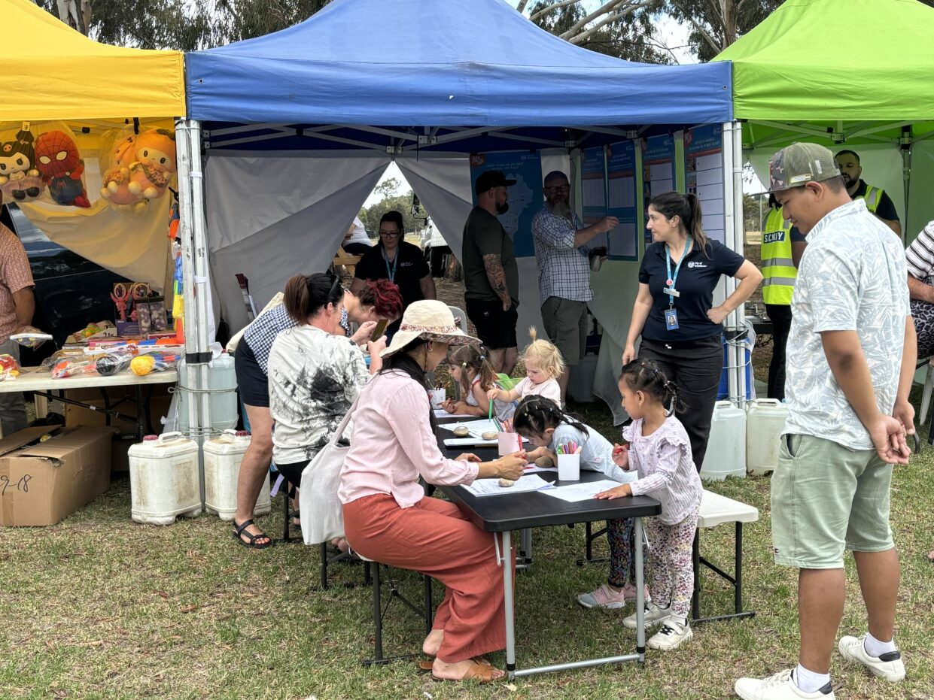
STRATEGIC HEAT MANAGEMENT PLAN
Engagement Summary

21 February 2025 – 31 March 2025

Introduction
The City of Whittlesea is developing an Extreme Heat Discussion Paper that will inform the Strategic Heat Management Plan 2025, a critical component of its Integrated Extreme Heat Planning Framework. This initiative addresses the increasing frequency and intensity of extreme heat events driven by climate change. The report will guide Council's actions over the next five, 10, 50, and 100 years, focusing on public health, urban planning and climate resilience.
Council undertook community consultation with people who live, work, study or visit the City of Whittlesea to understand current community heat health knowledge to enable enhancement of community resilience and preparedness for heatwaves. As the municipality has diverse residents and needs, the consultation was designed to discuss what heat health means to our residents to gain a better understanding of what is most important to the community to help inform the development of Extreme Heat Guidelines and Strategic Heat Management Plan.
The consultation included digital engagement and two targeted community-based pop-ups. The opportunity to participate was promoted via social media, emails to targeted stakeholder groups and flyers. There was a total of 92 contributions from a diverse cross-section of our community.
Ninety-two people participated in the consultation and told us that they know a lot (40%) or some things but not everything (36%) about the risks of extreme heat and how to stay safe. The majority of participants are very familiar (36%) or know some ways (52%) to protect themselves from extreme heat and stay cool. Participants tended to use insulation, block-out curtains, air conditioning and tree cover to keep themselves and their home cool in extreme heat with more than half able to keep their home cool easily during a heat wave. Many participants (86%) would like to see Council increase green spaces to assist our community to manage in extreme heat conditions.
Participants also took the opportunity to drop a pin on the map to identify hot places (those they avoid on hot days) such as exposed walking paths and parks with minimal tree canopy cover, as well as cool places that they may seek refuge at including Council-managed facilities such as Community Activity Centres, aquatic/leisure centres and libraries, as well as shopping centres, and, parks with good tree canopy and access to drinking fountains.

How we engaged you
The Strategic Heat Management plan project page on the Engage Whittlesea platform encouraged participants to share their knowledge of heat health through a survey. The survey presented three priority heat health areas including heat health risk awareness, personal protection in extreme heat knowledge, and whether they are able to stay cool on very hot days. There was free text space provided for participants to add further comment as part of the questions. Participants were also asked to drop a pin on the interactive map to identify areas in the municipality that they see as a cool place or somewhere they avoided on extreme heat days.

The Engage Whittlesea platform utilises an accessibility add-on ensuring that it is as accessible as possible for all users. The platform also has an in-built translation tool to mitigate any language barriers to participation, allowing the page to be translated into the top fifteen languages spoken within the municipality.

In-person engagement activities
To hear from a diverse range of community members and increase participation, Council hosted in-person engagement activities at both the Holi Festival and Community Festival events held at Civic Centre which are usually attended by large numbers of diverse community members. Unfortunately, the Holi Festival was an extreme heat day with low numbers and the Community Festival was impacted by heavy rain and cancelled part way through the day, so also did not have the expected numbers. The community-based pop-up sessions held are as below:
Date | Time | Where | Address/location
23/02/2025 | 12pm- 6pm | Holi Festival | 25 Ferres Boulevard, South Morang
16/03/2025 | 11am – 2.30pm | Community Festival | 25 Ferres Boulevard, South Morang
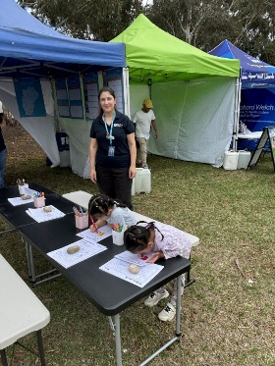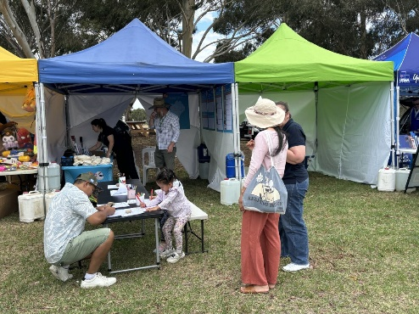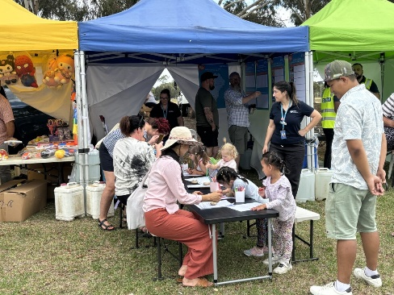
Above: Images of the project team engaging with the community at the Holi Festival event

Project promotion
The opportunity to participate in the community engagement was promoted through a range of channels to have a widespread reach across the municipality including:
- Council’s digital engagement platform Engage Whittlesea
- Social media
- Direct email sent by key internal staff to their networks including the Municipal Emergency Management Planning Committee (MEMP) and community groups.
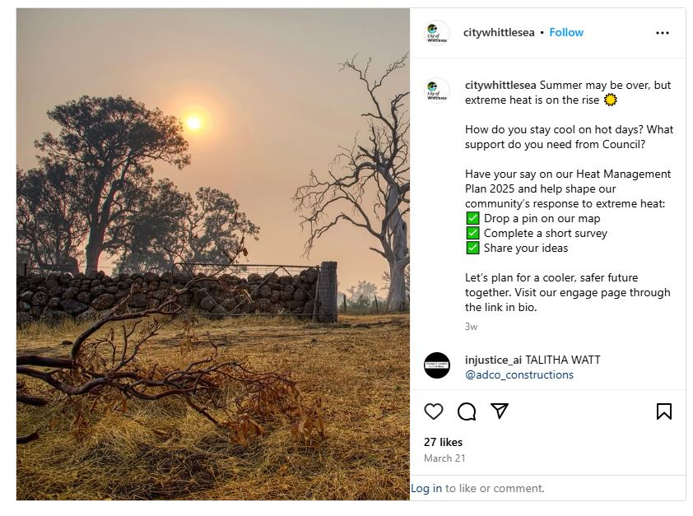
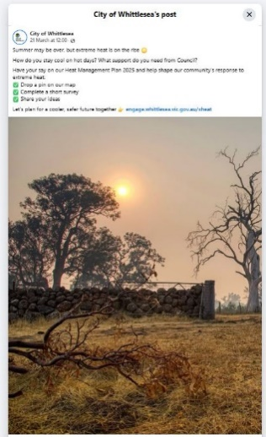

Left: Social media posts promoting the Strategic Heat Management Plan.

Participation
A total of 92 community contributions were received as part of the Strategic Heat Health Management Plan engagement.

Snapshot of Community Participation

 | 
Nine people participated in-person at pop-up events | 83 people participated online

Snapshot of Demographics
Below is a snapshot of the diversity of participation in the community engagement:
Gender Identity | Age | Suburb
 |  | 
36% Female, 52% Male, 4% Non-binary, and 8% preferred not to say | All age brackets participated with the most represented being 35-44 years (36%), 45-54 years (20%) and 55-35 years (16%). | Participants came from 10 suburbs across the municipality, with the highest participation coming from Epping and Lalor (20% each) and Mill Park (16%).

LGBTIQA+ Community | CALD Community
 | 
8% of participants identified as members of the LGBTIQA+ community | 48% of participants spoke English as a second language

What we heard
Below are the questions asked during the consultation along with what we heard from the community for each.
How much do you know about the health risks of extreme heat? Do you know how heat affects the body, who is most at risk, or how to stay safe?

How familiar are you with ways to protect yourself from extreme heat? Do you know how to stay cool, when to avoid outdoor activities, or how to help others in hot weather?

Are you able to keep your home cool on very hot days or during a heatwave? For example, do you have air conditioning or fans, use blinds or curtains to block heat, or have other ways to stay cool?

Select your top 3 methods to keep yourself and your home cool? Choices were insulation, light coloured roof, black out curtains, fans, air conditioning, tree cover, and awning/shade cloths.

What would you like to see Council do to help you manage in extreme heat situations?

There were 56 contributions made through the pin drop activity with respondents sharing both cool places they visit in the municipality and hot places that they avoid in extreme heat:
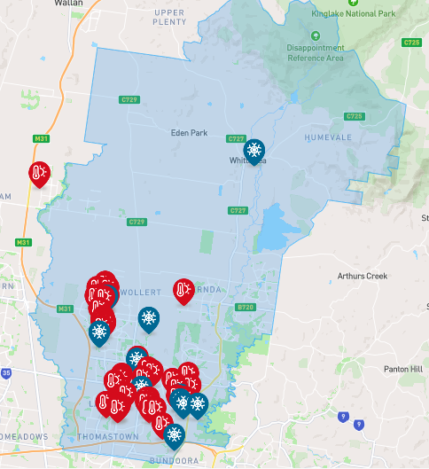

Majority of the pin drops were in Wollert (29%), Mill Park (25%) and in Epping (22%). The types of hot places identified were exposed walking paths and parks/playgrounds with minimal tree canopy cover that had little protection from the elements. The cool places identified were Council managed facilities such as Community Activity Centres, aquatic/leisure centres and libraries were frequently noted, as well as shopping centres, and parks with good tree canopy and access to drinking fountains were noted multiple times.

Key themes from community feedback relating to Extreme Heat and Heat Health Knowledge
Participants were offered the opportunity to provide additional commentary in the survey. Comments received have been themed below, as accompanied by some of the anecdotal feedback captured.
 | Transport and access to cool spaces  Community suggested the introduction of a community bus service to help vulnerable residents access cooler environments.  “Community bus to help those in need to get to cooler spaces”.
 | Greening and Urban Design  Suggestions included increasing tree planting around the municipality and improving streetscape shading, particularly in areas such as Lalor East. Community also suggested exploring the use of copper materials, especially around water sources, possibly as a cooling or antimicrobial measure.  “Lalor East - streetscape is severely lacking shade trees on nature strip”.  “Apply copper everywhere particularly around water sources”
 | Facilities and infrastructure  Community suggested an investment in building new swimming pools and leisure/splash parks to provide accessible cooling options for all residents.  “Build a swimming pool leisure centre”.  “More swimming pools & splash Parks”.
 | Education and awareness  Suggestions focussed on providing more community education on how to stay safe and healthy during extreme heat events.  “Educate regarding the safe living through extreme heat & avoiding heat conditions”.
 | Innovative work practices  Community suggested that Council could advocate and encourage flexible or adjusted work hours (i.e.: 5.00am to 11.00 am shifts) to avoid peak heat periods.  “Introduce an innovative work hours 5.00am - 11.00am for instance with afternoon breaks”.

Next Steps
The information captured through the consultation will inform the development of the Extreme Heat Guidelines and Strategic Heat Management Plan, which is expected to be considered by Council later in 2025. The feedback captured will also be used to inform the development of other key plans and strategies Council are working on to make Whittlesea A Place for All.
Thank you again to everyone who participated in the community engagement by sharing comments, feedback and participating in activities.

