The Boulevard Shops Streetscape Concept Plan
Engagement Summary
13 November – 10 December 2023

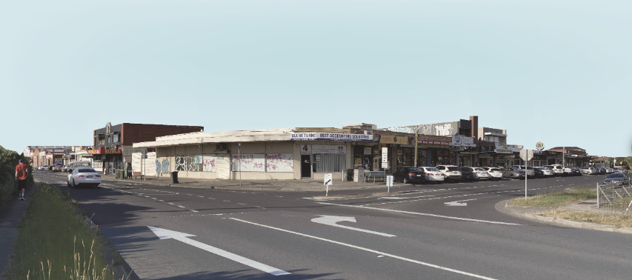

Introduction
The Boulevard shop’s streetscape and local precinct located at the corner of The Boulevard and Station Street Thomastown, are due for a revitalisation. The shops are looking outdated and so too is the streetscape.

The City of Whittlesea plans to improve The Boulevard shops’ streetscape and walking and cycling connections to and from Thomastown Train Station. A draft streetscape concept plan has been developed and includes the following eight key design elements that were presented to community for feedback and include:
- Wider footpaths and trading area
- Bike path
- Seating
- Trees
- Pedestrian crossings
- Safer intersection (raised)
- Car parking spaces
- Bus stops located closer to shops.

How we engaged you
The draft concept plan was presented for community feedback (13 November to 10 December 2023)

The City of Whittlesea presented the draft concept plan to the community for feedback between 13 November and 10 December 2023. Feedback was sought online through Council’s Engage Whittlesea platform, through direct consultation with shop keepers and at community-based pop-ups. A letter to residents within a 400-metre radius (on the right side of the train track) was delivered informing them of the consultation with information of the popup dates and times and a link to the online project page to encourage feedback.

Using large A1 posters, participants at community-based pop-ups were presented with a visual of the concept plan that featured the eight key design elements. A survey was available for community to complete providing an opportunity to also comment on any improvements to the design or general area.

The Engage Whittlesea platform presented the same short survey. All face-to-face surveys were then entered onto the digital page for data collection purposes.

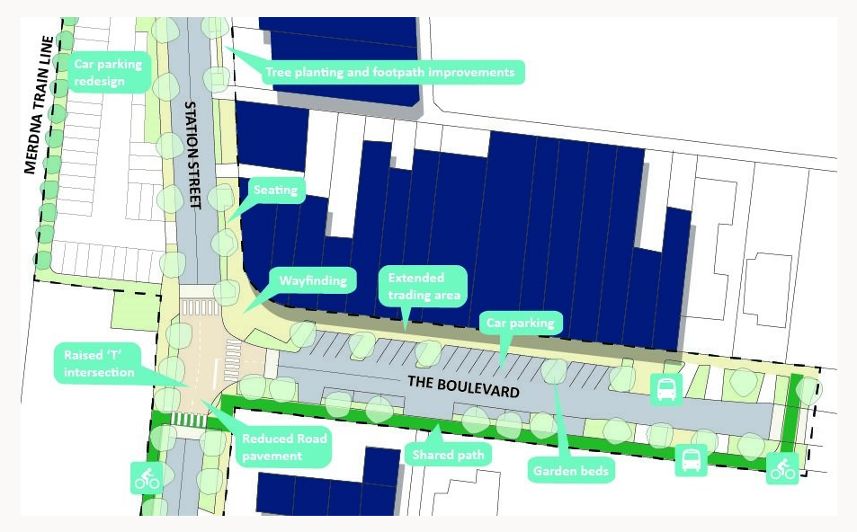

Above: the concept plan used at the community-based pop-ups.

Making our engagement accessible
The Engage Whittlesea platform utilises an accessibility add-on which enables users to easily switch to screen reader mode or easily adjust settings such as font size, contrast, dyslexia friendly options to improve the overall accessibility of the site. The platform also has an in-built translation tool to reduce language barriers to participation, allowing the page to be translated into the top ten languages spoken within the municipality. Additionally, bi-lingual staff attended targeted community-based pop-up sessions to support in person communication. Community-based pop-ups were held on different days and times of the week to offer varied opportunities for community participation.

Inviting participation
Key stakeholders and the wider community were informed of the consultation through a range of channels including direct mail, email, social media posts, marketing, media and flyers. Key stakeholders were all included in the electronic direct mail that included a link to the project Engage page where the draft concept design could be accessed.

Targeted stakeholders included:
- Shop keepers and landlords
- Residents within a 400 m radius on the right side of the train track
- Visitors to the shops during lunch and dinner times
- Residents using car park to access the train station and nearby mosque
- Friends of Westgarthtown
- Mosque visitors
- Thomastown East Primary School
- First people health and wellbeing in Thomastown
- Thomastown Library
- Thomastown Recreation and Aquatic Centre
- Local Area Network email subscribers
- Registered CALD groups based in Thomastown and Lalor.

Four pop-ups were held at the Boulevard shops on:

- Thursday 16 November from 11am – 1pm (lunch shoppers)
- Friday 24 November from 1pm – 3pm (mosque visitors) and then 4pm -6pm (dinner shoppers)
- Saturday 2 December from 10am – 1pm (street party).

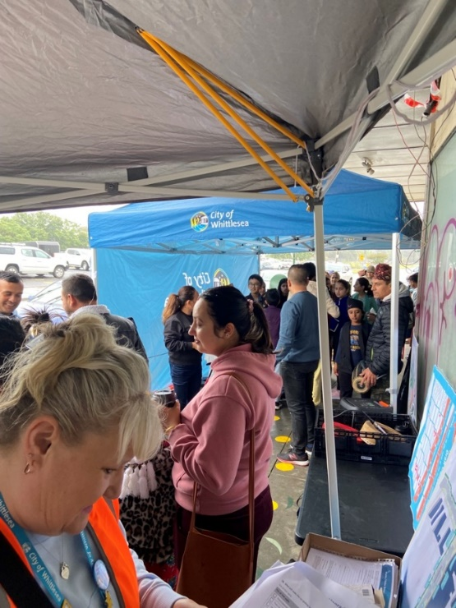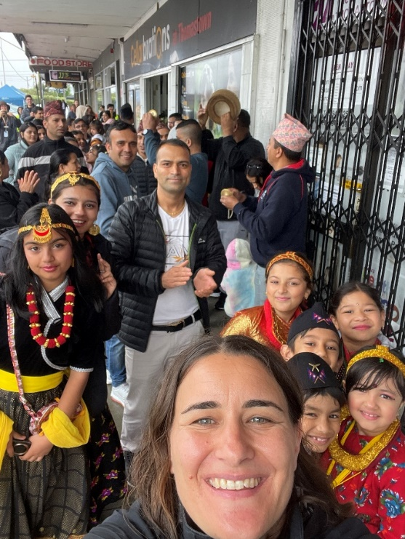
Above: Project team engaging at the Boulevard shops street party, featuring Nepalese dancing performance

Street Party
The project team hosted a street party with shop keepers, stall holders, the Nepalese community, and visitors to the shops on 10 December 2023. The aim of the street party was to activate the car park allowing for community to visualise how the area can be utilised in the future.
Due to rain, the street party was modified, and had to relocate from the car park to the shop's footpath. The Nepalese community dancers performed, food was served, and market stalls holders attended along with a Thomastown Walking Group stall. Over 100 people attended the event where the engagement team were on hand to complete 49 surveys.

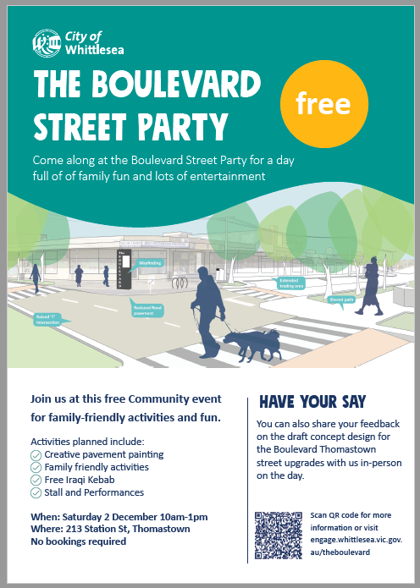
Above: The Boulevard Street Party flyer and QR code/ link to project Engage page.

Participation
A total of 169 people completed the survey during the consultation, with 57% of these captured at community-based pop-ups.
A snapshot of consultation activities and community participation is below:
 |  |  |  | 
4 community-based pop-ups | 96 in-person contributions | 686 visitors to the project Engage page | 73 digital contributions | Draft document downloaded 22 times

 |  | 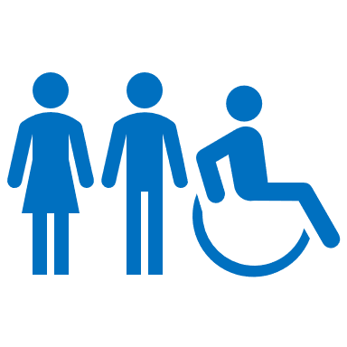 | 
44% Female, 47% Male, 1% Non-binary, 7% Prefer not to say | 26% aged 35 - 44  20% aged 45- 54 | 9% person living with a disability | 49% CALD community members

What we heard
Survey responses (169 contributions)
A total of 169 people completed the survey. Not all questions were answered and some of the questions allowed for more than one possible response to be selected.

Question 1 How often do you visit the area?
A total of 167 participants answered this question, with 34% visiting the shops daily and 29% once a week.

Question 2 How do you get to the area?
Of the 169 participants who provided an answer, 65% drive to shops and 41% walk.

Question 3 How safe do you feel moving through the area?
A total of 159 participants responded to this question, with 26% saying they feel safe and 20% feeling very safe travelling through the area.

Question 4 What would make you feel safer?
Of the 157 participants who responded, 33% identified that more pedestrian crossings would make them feel safer and 32% identified more lighting would make them feel safer.

Question 5 Overall, what do you think of the proposed concept design?
A total of 169 participants responded to this question as below.

 |  |  | 
(31%)  I like it a lot | (43%)  I like it | (20%)  I can live with it | (4%)  I don’t like it | (2%)  I don’t like it at all
Question 6 How important are these elements of the design to you?
For the 169 participants that responded to this question, pedestrian crossings, car parking spaces and trees were the top three elements of the design that were important to them.

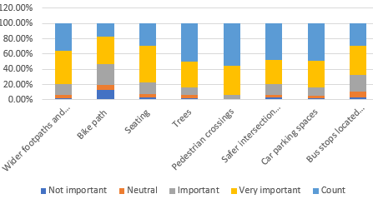

Question 7 What do you think of the design for the Council owned car parking area?
A total of 130 participants responded to this question as below.
(18%)  I like it a lot | (29%)  I like it | (32%)  I can live with it | (11%)  I don’t like it | (10%)  I don’t like it at all

Question 8 What will make the car parking area a better place?
Of the 158 participants that responded, 59% said better lighting and 56 % said a direct pedestrian crossing would make the car park a better place.

Question 9 Would you like the car parking area to be used for other activities on the weekend?
Of the 146 participants that responded, 72% would like the car park to be used for a farmers market and 46% would like to see it used for a crafter market.

Question 10 Do you have any further comments or ideas to improve the design or general area further?
Participants had the opportunity to provide further comments, with 52 opting to do so. The main themes emerging from the responses provided included greening, safety and lighting, car parking, traffic management, playground and markets, redevelopment, rubbish and maintenance, outdoor seating and wider footpaths and quality of shops.
There needs to be more restrictions to parking in the area to turn over parking spots for everyone.

The area needs to be better lit and safer.

I support the council upgrading areas, however they need to be regularly maintained.

Creating a more treelined space is great with thoughtful seating options is welcomed.

A diversity of businesses should be encouraged to attract people to the area.

Probably openings for a nice cafe, outdoor dining for the cafe. Think of how nice Europe does it, we can do the same not only here but in many places of local government area

Comment Pins on Social Map (21 contributions)
Participants had the opportunity to pin a comment digitally onto the social pinpoint map, with 21 participants taking advantage of the opportunity. The main themes emerging from the comments pinned included greening, safety and lighting, car parking, traffic management, playground and markets, redevelopment, rubbish and maintenance, outdoor seating and wider footpaths and quality of shops.
The shops there now look really run down and there’s often people socialising with nowhere to sit which makes it appear intimidating
Not another bloody raised intersection!!
Love to see more parking and trees alongside the railway line and lights.
Always trash dumped here .
It would be great to have some outdoor seating and landscaping around the Boulevard shops

What we heard from shopkeepers and landowners.
The project team partnered with Council’s Economic Development Retail Activity Centre Officer to consult with shop keepers directly. The consultation included a brief survey to capture feedback in relation to the proposed draft concept plan for the streetscape as well as providing information in relation to grants that are available through the shop front improvement program.
A total of 13 shopkeepers participated in the consultation. The main themes emerging from the consultation included safety and lighting, car parking, traffic management, rubbish and maintenance.
In addition, the project team organised an in-person workshop with the business owners of the industrial properties located on Main Street. The session included a short presentation and two design options for the section of Station Street fronting the industrial properties.
A total of four business owner/landowners participated in the workshop. The preferred design option for the southern block includes the shifting of the public pedestrian footpath and future tree verge outside the private properties into the council owned road reserve. Suitable driveways will need to be delivered to each property along with the resurfacing of the front yard, and the delivery of a quality low and transparent front fence. The preferred design option for the northern block will mimic the southern block treatment with some exceptions due to the heavier industrial vehicles' usage. An additional workshop will be organised to present the discussed design solution.
Changes to the draft following community consultation
The constructive feedback from the shopkeeper's consultation and feedback captured through broader community engagement has been provided to the project team for consideration and plays a crucial role in shaping the final concept plan. The below key changes have been implemented in the final design.
Shop frontages and surrounding areas maintenance - Residents, visitors, and traders all agreed that the public spaces are now poorly maintained and subject to vandalism.
- The proposed design is easy to maintain and will look good.
- The new footpath fronting the shops is going to be wider, allowing more trading spaces and a safer movement for users.
- New public garbage bins are provided away from shops main entrances.

Tree planting and car park spaces - Visitors highlighted the need for trees for both shading and amenity purposes and the proposed tree planting was welcomed. Traders however raised a concern about the losing of car parking spaces. Business owners along Station Street indicated that trees planted by council have not survived.
- New 14 large trees and 8 garden beds are proposed with minimal car parking spaces loss.
- New 90 degree on-street parking bays are safer and accessible from both directions.

Intersection design
Both traders and visitors highlighted the need to improve the area to make both pedestrian and vehicular movements safer.
- Street lanes’ width have been reduced by way of reducing the right-of-way into The Boulevard.
- New car parking at 90 degree is safer to access from both street directions
- Three raised crossings are being delivered.
- More lighting will be installed to provide safer movement for people.

Next steps
The final concept plan will be presented to Council for consideration. Once adopted the final document will be shared with the community to close the loop post consultation. This will be shared through digital communications, direct contact with stakeholders, and updates on the project Engage Whittlesea page.

